This text was adapted by The Saylor Foundation under a Creative Commons Attribution-NonCommercial-ShareAlike 3.0 License without attribution as requested by the work’s original creator or licensee.

Preface
When I first started teaching social psychology, I had trouble figuring out how the various topics in this expansive field fit together. I felt like I was presenting a laundry list of ideas, research studies, and phenomena, rather than an integrated set of principles and knowledge. Of course, what was difficult for me was harder still for my students. How could they be expected to understand and remember all of the many topics that we social psychologists study? And how could they tell what was most important? Something was needed to structure and integrate their learning.
It took me some time, but eventually, I realized that the missing piece in my lectures was a consistent focus on the basic principles of social psychology. Once I started thinking and talking about principles, then it all fell into place. I knew that when I got to my lecture on altruism, most of my students already knew what I was about to tell them. They understood that, although there were always some tweaks to keep things interesting, altruism was going to be understood using the same ideas that conformity and person perception had been in earlier lectures—in terms of the underlying fundamentals—they were truly thinking like social psychologists!
I wrote this book to help students organize their thinking about social psychology at a conceptual level. Five or ten years from now, I do not expect my students to remember the details of a study published in 2011, or even to remember most of the definitions in this book. I do hope, however, that they will remember some basic ideas, for it is these principles that will allow them to critically analyze new situations and really put their knowledge to use.
My text is therefore based on a critical thinking approach—its aim is to get students thinking actively and conceptually—with more of a focus on the forest than on the trees. Although there are right and wrong answers, the answers are not the only thing. What is perhaps even more important is how we get to those answers—the thinking process itself. My efforts are successful when my students have that “aha” moment, in which they find new ideas fitting snugly into the basic concepts of social psychology.
To help students better grasp the big picture of social psychology and to provide you with a theme that you can use to organize your lectures, my text has a consistent pedagogy across the chapters. I organize my presentation around two underlying principles that are essential to social psychology:
- Person and situation (the classic treatment)
- The ABCs of social psychology (affect, behavior, and cognition)
I also frame much of my discussion around the two human motivations of self-concernand other-concern. I use these fundamental motivations to frame discussions on a variety of dimensions including altruism, aggression, prejudice, gender differences, and cultural differences. You can incorporate these dimensions into your teaching as you see fit.
My years of teaching have convinced me that these dimensions are fundamental, that they are extremely heuristic, and that they are what I hope my students will learn and remember. I think that you may find that this organization represents a more explicit representation of what you’re already doing in your lectures. Although my pedagogy is consistent, it is not constraining. You will use these dimensions more in some lectures than in others, and you will find them more useful for some topics than others. But they will always work for you when you are ready for them. Use them to reinforce your presentation as you see fit.
Perhaps most important, a focus on these dimensions helps us bridge the gap between the textbook, the real-life experiences of our students, and our class presentations. We can’t cover every phenomenon in our lectures—we naturally let the textbook fill in the details. The goal of my book is to allow you to rest assured that the text has provided your students with the foundations—the fundamental language of social psychology—from which you can build as you see fit. And when you turn to ask students to apply their learning to real life, you can know that they will be doing this as social psychologists do—using a basic underlying framework.

Organization
The text moves systematically from lower to higher levels of analysis—a method that I have found makes sense to students. On the other hand, the chapter order should not constrain you—choose a different order if you wish. Chapter 1 "Introducing Social Psychology" presents an introduction to social psychology and the research methods in social psychology, Chapter 2 "Social Learning and Social Cognition" presents the fundamental principles of social cognition, and Chapter 3 "Social Affect" focuses on social affect. The remainder of the text is organized around three levels of analysis, moving systematically from the individual level (Chapter 4 "The Self" through Chapter 6 "Perceiving Others"), to the level of social interaction (Chapter 7 "Influencing and Conforming" through Chapter 10 "Aggression"), to the group and cultural level (Chapter 11 "Working Groups: Performance and Decision Making" through Chapter 13 "Competition and Cooperation in Our Social Worlds").
Rather than relying on “modules” or “appendices” of applied materials, my text integrates applied concepts into the text itself. This approach is consistent with my underlying belief that if students learn to think like social psychologists they will easily and naturally apply that knowledge to any and all applications. The following applications are woven throughout the text:
- Business and consumer behavior (see, for instance, Chapter 5 "Attitudes, Behavior, and Persuasion" on marketing and persuasion and Chapter 11 "Working Groups: Performance and Decision Making" on group decision-making)
- Health and Behavior (see, for instance, Chapter 3 "Social Affect" on stress andChapter 6 "Perceiving Others" on attributional styles)
- Law (see, for instance, Chapter 2 "Social Learning and Social Cognition" on eyewitness testimony and Chapter 10 "Aggression" on Terrorism)

Pedagogy
Principles of Social Psychology contains a number of pedagogical features designed to help students develop an active, integrative understanding of the many topics of social psychology and to think like social psychologists.

Research Foci
Research is of course the heart of social psychology, and the research foci provide detailed information about a study or research program. I’ve chosen a mix of classic and contemporary research, with a focus on both what’s interesting and what’s pedagogical. Rather than boxing these findings, they are part of the running text—simply highlighted with a heading and light shading.

Social Psychology in the Public Interest
Social psychological findings interest students in large part because they relate so directly to everyday experience. The Social Psychology in the Public Interest Feature reinforces these links. Topics include Does High Self-Esteem Cause Happiness or Other Positive Outcomes? (Chapter 3 "Social Affect"), Detecting Deception (Chapter 6 "Perceiving Others"), Terrorism as Instrumental Aggression (Chapter 10 "Aggression"), and Stereotype Threat in Schools (Chapter 12 "Stereotypes, Prejudice, and Discrimination"). The goal here is to include these applied topics within the relevant conceptual discussions to provide students with a richer understanding within the context of the presentation.

Thinking Like a Social Psychologist
Each chapter ends with a section that summarizes how the material presented in the chapter can help the student think about contemporary issues using social psychological principles. This section is designed to work with the chapter summary to allow a better integration of fundamental concepts.

Chapter 1

Introducing Social Psychology

Mass Suicide of 39 Cult Members Shocks Nation
On March 26, 1997, people were found dead in a house on a hilltop in San Diego, California. The people were members of a cult and were part of a carefully orchestrated suicide that involved sedatives, vodka, and plastic bags. There were 21 women and 18 men, and they had come to California from across the country. Most of the victims were in their 40s, but ages ranged from 26 to 72.
The name of the cult was “Heaven’s Gate,” and it also operated a computer web service called “Higher Source.” The victims evidently believed that they were going to meet a UFO hiding behind the comet Hale-Bopp, and the suicides occurred during the time that the comet was closest to earth.
The suicide probably took place over three days and seemed to have been calm and ritualistic. One group of cult members apparently helped some other members die, cleaned up after them, and then went on to take their own doses of poison, which was mixed with apple sauce or pudding. The last two victims had plastic bags over their heads.
“It seemed to be a group decision,” said Dr. Brian Blackbourne, San Diego County medical examiner.
“There were different stages, suggesting it was planned. They all had IDs. The house was immaculate.”
“We’re not talking about a drug-crazed, party-time situation…The drugs were taken for a very specific purpose and that was to take their own lives.”
The victims all wore black pants and black Nike sports shoes, and their faces and chests were covered in purple shrouds. The victims had carefully packed their bags and placed their few possessions at their sides. Most of the victims had a $5 bill and some quarters in their pockets.
There was no blood found at the scene, and the only weapon in the home was a 9 mm pistol packed in a bag.
Jerry Lipscomb of the San Diego Sheriff’s Department told CNN, “What we’re finding is that each and every one of the members of the organization, prior to their death, gave a brief statement…The essence of those statements was that they were going to a better place.”
“It’s our opinion that it was their intent—they planned to do this.”
Source: Mass suicide involved sedatives, vodka and careful planning. CNN.com. Retrieved from http://edition.cnn.com/US/9703/27/suicide/index.html.
Social psychology is the scientific study of how we feel about, think about, and behave toward the people around us and how our feelings, thoughts, and behaviors are influenced by those people. As this definition suggests, the subject matter of social psychology is very broad and can be found in just about everything that we do every day. Social psychologists study why we are often helpful to other people and why we may at other times be unfriendly or aggressive. Social psychologists study both the benefits of having good relationships with other people and the costs of being lonely. Social psychologists study what factors lead people to purchase one product rather than another, how men and women behave differently in social settings, how juries work together to make important group decisions, and what makes some people more likely to recycle and engage in other environmentally friendly behaviors than others. And social psychologists also study more unusual events, such as how some people can be persuaded that a UFO is hiding behind a comet, leading them to take their own lives as part of a suicide cult.
The goal of this book is to help you learn to think about social behaviors in the same way that social psychologists do. I believe you will find this approach useful because it will allow you to think about human behavior more critically and more objectively and to gain insight into your own relationships with other people. Social psychologists study everyday behavior scientifically, and their research creates a useful body of knowledge about our everyday social interactions.

1.1 Defining Social Psychology: History and Principles

LEARNING OBJECTIVES
- Define social psychology.
- Review the history of the field of social psychology and the topics that social psychologists study.
- Summarize the principles of evolutionary psychology.
- Describe and provide examples of the person-situation interaction.
- Review the concepts of (a) social norms and (b) cultures.
The field of social psychology is growing rapidly and is having an increasingly important influence on how we think about human behavior. Newspapers, websites, and other media frequently report the findings of social psychologists, and the results of social psychological research are influencing decisions in a wide variety of areas. Let’s begin with a short history of the field of social psychology and then turn to a review of the basic principles of the science of social psychology.

The History of Social Psychology
The science of social psychology began when scientists first started to systematically and formally measure the thoughts, feelings, and behaviors of human beings (Kruglanski & Stroebe, 2011). ^{[1]} The earliest social psychology experiments on group behavior were conducted before 1900 (Triplett, 1898), ^{[2]} and the first social psychology textbooks were published in 1908 (McDougall, 1908/2003; Ross, 1908/1974). ^{[3]} During the 1940s and 1950s, the social psychologists Kurt Lewin and Leon Festinger refined the experimental approach to studying behavior, creating social psychology as a rigorous scientific discipline. Lewin is sometimes known as “the father of social psychology” because he initially developed many of the important ideas of the discipline, including a focus on the dynamic interactions among people. In 1954, Festinger edited an influential book called Research Methods in the Behavioral Sciences, in which he and other social psychologists stressed the need to measure variables and to use laboratory experiments to systematically test research hypotheses about social behavior. He also noted that it might be necessary in these experiments to deceive the participants about the true nature of the research.
Social psychology was energized by researchers who attempted to understand how the German dictator Adolf Hitler could have produced such extreme obedience and horrendous behaviors in his followers during the Second World War. The studies on conformity conducted by Muzafir Sherif (1936) ^{[4]} and Solomon Asch (1952), ^{[5]}as well as those on obedience by Stanley Milgram (1974), ^{[6]} showed the importance of conformity pressures in social groups and how people in authority could create obedience, even to the extent of leading people to cause severe harm to others. Philip Zimbardo, in his well-known “prison experiment” (Haney, Banks, & Zimbardo, 1973), ^{[7]} found that ordinary male college students who were recruited to play the roles of guards and prisoners in a simulated prison became so involved in their assignments, and their interaction became so violent, that the study had to be terminated early (Note 1.4 "Video Clip 1"). This research again demonstrated the power of the social setting.

Video Clip 1
The Stanford prison experiment conducted by Philip Zimbardo in the 1960s demonstrated the powerful role of the social situation on human behavior.
Social psychology quickly expanded to study other topics. John Darley and Bibb Latané (1968) ^{[8]} developed a model that helped explain when people do and do not help others in need, and Leonard Berkowitz (1974) ^{[9]} pioneered the study of human aggression. Meanwhile, other social psychologists, including Irving Janis (1972), ^{[10]}focused on group behavior, studying why intelligent people sometimes made decisions that led to disastrous results when they worked together. Still other social psychologists, including Gordon Allport and Muzafir Sherif, focused on intergroup relations, with the goal of understanding and potentially reducing the occurrence of stereotyping, prejudice, and discrimination. Social psychologists gave their opinions in the 1954 Brown v. Board of Education Supreme Court case that helped end racial segregation in U.S. public schools, and social psychologists still frequently serve as expert witnesses on these and other topics (Fiske, Bersoff, Borgida, Deaux, & Heilman, 1991). ^{[11]}
The latter part of the 20th century saw an expansion of social psychology into the field of attitudes, with a particular emphasis on cognitive processes. During this time, social psychologists developed the first formal models of persuasion, with the goal of understanding how advertisers and other people could present their messages to make them most effective (Eagly & Chaiken, 1993; Hovland, Janis, & Kelley, 1963). ^{[12]}These approaches to attitudes focused on the cognitive processes that people use when evaluating messages and on the relationship between attitudes and behavior. Leon Festinger’s (1957) ^{[13]} important cognitive dissonance theory was developed during this time and became a model for later research.
In the 1970s and 1980s, social psychology became even more cognitive in orientation as social psychologists used advances in cognitive psychology, which were themselves based largely on advances in computer technology, to inform the field (Fiske & Taylor, 2008). ^{[14]} The focus of these researchers, including Alice Eagly, Susan Fiske, E. Tory Higgins, Richard Nisbett, Lee Ross, Shelley Taylor, and many others, was on social cognition—an understanding of how our knowledge about our social worlds develops through experience and the influence of these knowledge structures on memory, information processing, attitudes, and judgment. Furthermore, the extent to which humans’ decision making could be flawed by both cognitive and motivational processes was documented (Kahneman, Slovic, & Tversky, 1982). ^{[15]}
In the 21st century, the field of social psychology has been expanding into still other areas. Examples that we will consider in this book include an interest in how social situations influence our health and happiness, the important roles of evolutionary experiences and cultures on our behavior, and the field of social neuroscience—the study of how our social behavior both influences and is influenced by the activities of our brain (Lieberman, 2010). ^{[16]} Social psychologists continue to seek new ways to measure and understand social behavior, and the field continues to evolve. I cannot predict where social psychology will be directed in the future, but I have no doubt that it will still be alive and vibrant.

The Person and the Social Situation
Social psychology is the study of the dynamic relationship between individuals and the people around them (see Figure 1.1 "The Person-Situation Interaction"). Each of us is different, and our individual characteristics, including our personality traits, desires, motivations, and emotions, have an important impact on our social behavior. But our behavior is also profoundly influenced by the social situation—the people with whom we interact every day. These people include our friends and family, our fraternity brothers or sorority sisters, our religious groups, the people we see on TV or read about or interact with on the web, as well as people we think about, remember, or even imagine.

Figure 1.1 The Person-Situation Interaction
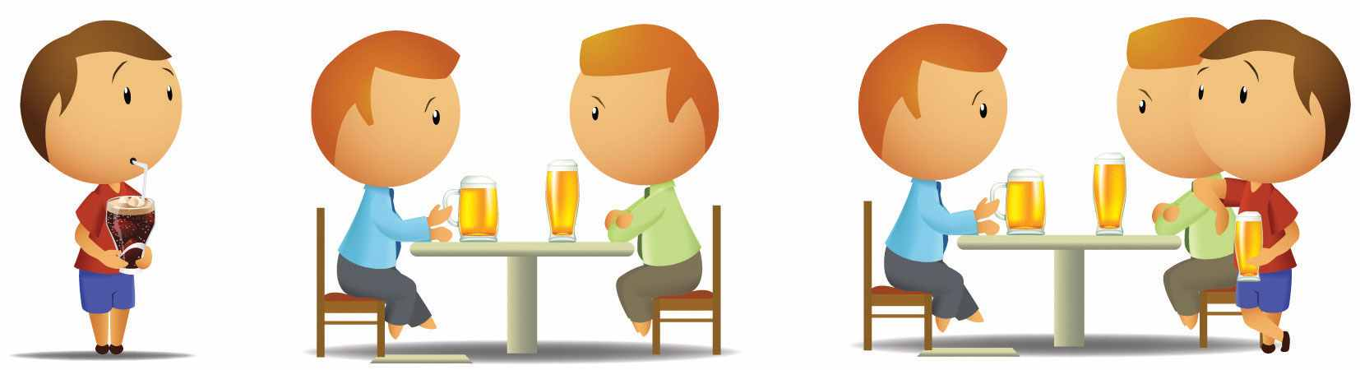
Social psychologists believe that human behavior is determined by both a person’s characteristics and the social situation. They also believe that the social situation is frequently a stronger influence on behavior than are a person’s characteristics.
Social psychology is largely the study of the social situation. Our social situations create social influence, the process through which other people change our thoughts, feelings, and behaviors and through which we change theirs. Maybe you can already see how the social influence provided by the members of the Heaven’s Gate cult was at work in the Hale-Bopp suicide.
Kurt Lewin formalized the joint influence of person variables and situational variables, which is known as the person-situation interaction, in an important equation:
Behavior = f (person, social situation).
Lewin’s equation indicates that the behavior of a given person at any given time is a function of (depends on) both the characteristics of the person and the influence of the social situation.

Evolutionary Adaptation and Human Characteristics
In Lewin’s equation, person refers to the characteristics of the individual human being. People are born with skills that allow them to successfully interact with others in their social world. Newborns are able to recognize faces and to respond to human voices, young children learn language and develop friendships with other children, adolescents become interested in sex and are destined to fall in love, most adults marry and have children, and most people usually get along with others.
People have these particular characteristics because we have all been similarly shaped through human evolution. The genetic code that defines human beings has provided us with specialized social skills that are important to survival. Just as keen eyesight, physical strength, and resistance to disease helped our ancestors survive, so too did the tendency to engage in social behaviors. We quickly make judgments about other people, help other people who are in need, and enjoy working together in social groups because these behaviors helped our ancestors to adapt and were passed along on their genes to the next generation (Ackerman & Kenrick, 2008; Barrett & Kurzban, 2006; Pinker, 2002). ^{[17]} Our extraordinary social skills are primarily due to our large brains and the social intelligence that they provide us with (Herrmann, Call, Hernández-Lloreda, Hare, & Tomasello, 2007). ^{[18]}
The assumption that human nature, including much of our social behavior, is determined largely by our evolutionary past is known as evolutionary adaptation(Buss & Kenrick, 1998; Workman & Reader, 2008). ^{[19]} In evolutionary theory,fitnessrefers to the extent to which having a given characteristic helps the individual organism to survive and to reproduce at a higher rate than do other members of the species who do not have the characteristic. Fitter organisms pass on their genes more successfully to later generations, making the characteristics that produce fitness more likely to become part of the organisms’ nature than are characteristics that do not produce fitness. For example, it has been argued that the emotion of jealousy has survived over time in men because men who experience jealousy are more fit than men who do not. According to this idea, the experience of jealousy leads men to protect their mates and guard against rivals, which increases their reproductive success (Buss, 2000). ^{[20]}
Although our biological makeup prepares us to be human beings, it is important to remember that our genes do not really determine who we are. Rather, genes provide us with our human characteristics, and these characteristics give us the tendency to behave in a “human” way. And yet each human being is different from every other human being.
Evolutionary adaption has provided us with two fundamental motivations that guide us and help us lead productive and effective lives. One of these motivations relates to the self—the motivation to protect and enhance the self and the people who are psychologically close to us; the other relates to the social situation—the motivation toaffiliate with, accept, and be accepted by others. We will refer to these two motivations as self-concern and other-concern respectively.

Self-Concern
The most basic tendency of all living organisms, and the focus of the first human motivation, is the desire to protect and enhance one’s own life and the lives of the people who are close to us. Humans are motivated to find food and water, to obtain adequate shelter, and to protect themselves from danger. Doing so is necessary because we can survive only if we are able to meet these fundamental goals.
The desire to maintain and enhance the self also leads us to do the same for our relatives—those people who are genetically related to us. Human beings, like other animals, exhibit kin selection—strategies that favor the reproductive success of one’s relatives, sometimes even at a cost to the individual’s own survival. According to evolutionary principles, kin selection occurs because behaviors that enhance the fitness of relatives, even if they lower the fitness of the individual himself or herself, may nevertheless increase the survival of the group as a whole.
In addition to our kin, we desire to protect, improve, and enhance the well-being of our ingroup: those whom we view as being similar and important to us and with whom we share close social connections, even if those people do not actually share our genes. Perhaps you remember a time when you helped friends move all their furniture into a new apartment, even when you would have preferred to be doing something more beneficial for yourself, such as studying or relaxing. You wouldn’t have helped strangers in this way, but you did it for your friends because you felt close to and cared about them. The tendency to help the people we feel close to, even if they are not related to us, is probably due in part to our evolutionary past: The people we were closest to were usually those we were related to.

Other-Concern
Although we are primarily concerned with the survival of ourselves, our kin, and those who we feel are similar and important to us, we also desire to connect with and be accepted by other people more generally—the goal of other-concern. We live together in communities, we work together in work groups, we may worship together in religious groups, and we may play together on sports teams and through clubs. Affiliating with other people—even strangers—helps us meet a fundamental goal: that of finding a romantic partner with whom we can have children. Our connections with others also provide us with other opportunities that we would not have on our own. We can go to the grocery to buy milk or eggs, and we can hire a carpenter to build a house for us. And we ourselves do work that provides goods and services for others. This mutual cooperation is beneficial both for us and for the people around us. We also affiliate because we enjoy being with others, being part of social groups, and contributing to social discourse (Leary & Cox, 2008). ^{[21]}
What the other-concern motive means is that we do not always put ourselves first. Being human also involves caring about, helping, and cooperating with other people. Although our genes are themselves “selfish” (Dawkins, 2006), ^{[22]} this does not mean that individuals always are. The survival of our own genes may be improved by helping others, even those who are not related to us (Krebs, 2008; Park, Schaller, & Van Vugt, 2008). ^{[23]} Just as birds and other animals may give out alarm calls to other animals to indicate that a predator is nearby, humans engage in altruistic behaviors in which they help others, sometimes at a potential cost to themselves.
In short, human beings behave morally toward others—they understand that it is wrong to harm other people without a strong reason for doing so, and they display compassion and even altruism toward others (Goetz, Keltner, & Simon-Thomas, 2010; Turiel, 1983). ^{[24]} As a result, negative behaviors toward others, such as bullying, cheating, stealing, and aggression, are unusual, unexpected, and socially disapproved. Of course this does not mean that people are always friendly, helpful, and nice to each other—powerful social situations can and do create negative behaviors. But the fundamental human motivation of other-concern does mean that hostility and violence are the exception rather than the rule of human behavior.
Sometimes the goals of self-concern and other-concern go hand in hand. When we fall in love with another person, it is in part about a concern for connecting with someone else but is also about self-concern—falling in love makes us feel good about ourselves. And when we volunteer to help others who are in need, it is in part for their benefit but also for us. We feel good when we help others. At other times, however, the goals of self-concern and other-concern conflict. Imagine that you are walking across campus and you see a man with a knife threatening another person. Do you intervene, or do you turn away? In this case, your desire to help the other person (other-concern) is in direct conflict with your desire to protect yourself from the danger posed by the situation (self-concern), and you must decide which goal to put first. We will see many more examples of the motives of self-concern and other-concern, both working together and working against each other, throughout this book.

The Social Situation Creates Powerful Social Influence
When people are asked to indicate the things that they value the most, they usually mention their social situation—that is, their relationships with other people (Baumeister & Leary, 1995; Fiske & Haslam, 1996). ^{[25]}When we work together on a class project, volunteer at a homeless shelter, or serve on a jury in a courtroom trial, we count on others to work with us to get the job done. We develop social bonds with those people, and we expect that they will come through to help us meet our goals. The importance of others shows up in every aspect of our lives—other people teach us what we should and shouldn’t do, what we should and shouldn’t think, and even what we should and shouldn’t like and dislike.
In addition to the people with whom we are currently interacting, we are influenced by people who are not physically present but who are nevertheless part of our thoughts and feelings. Imagine that you are driving home on a deserted country road late at night. No cars are visible in any direction, and you can see for miles. You come to a stop sign. What do you do? Most likely, you stop at the sign, or at least slow down. You do so because the behavior has been internalized: Even though no one is there to watch you, others are still influencing you—you’ve learned about the rules and laws of society, what’s right and what’s wrong, and you tend to obey them. We carry our own personal social situations—our experiences with our parents, teachers, leaders, authorities, and friends—around with us every day.
An important principle of social psychology, one that will be with us throughout this book, is that although individuals’ characteristics do matter, the social situation is often a stronger determinant of behavior than is personality. When social psychologists analyze an event such as a cult suicide, they are likely to focus more on the characteristics of the situation (e.g., the strong leader and the group pressure provided by the other group members) than on the characteristics of the cult members themselves. As an example, we will see that even ordinary people who are neither bad nor evil in any way can nevertheless be placed in situations in which an authority figure is able to lead them to engage in evil behaviors, such as applying potentially lethal levels of electrical shock (Milgram, 1974). ^{[26]}
In addition to discovering the remarkable extent to which our behavior is influenced by our social situation, social psychologists have discovered that we often do not recognize how important the social situation is in determining behavior. We often wrongly think that we and others act entirely on our own accord, without any external influences. It is tempting to assume that the people who commit extreme acts, such as terrorists or members of suicide cults, are unusual or extreme people. And yet much research suggests that these behaviors are caused more by the social situation than they are by the characteristics of the individuals and that it is wrong to focus so strongly on explanations of individuals’ characteristics (Gilbert & Malone, 1995). ^{[27]}
There is perhaps no clearer example of the powerful influence of the social situation than that found in research showing the enormous role that others play in our physical and mental health. Social support refers to the comfort that we receive from the people around us—for instance, our family, friends, classmates, and coworkers(Diener, Suh, Lucas, & Smith, 1999; Diener, Tamir, & Scollon, 2006). ^{[28]}

Social Psychology in the Public Interest
How the Social Situation Influences Our Mental and Physical Health
In comparison with those who do not feel that they have a network of others they can rely on, people who feel that they have adequate social support report being happier and have also been found to have fewer psychological problems, including eating disorders and mental illness (Diener, Suh, Lucas, & Smith, 1999; Diener, Tamir, & Scollon, 2006). ^{[29]}
People with social support are less depressed overall, recover faster from negative events, and are less likely to commit suicide (Au, Lau, & Lee, 2009; Bertera, 2007; Compton, Thompson, & Kaslow, 2005; Skärsäter, Langius, Ågren, Häagström, & Dencker, 2005). ^{[30]} Married people report being happier than unmarried people (Pew, 2006), ^{[31]} and overall, a happy marriage is an excellent form of social support. One of the goals of effective psychotherapy is to help people generate better social support networks because such relationships have such a positive effect on mental health.
In addition to having better mental health, people who have adequate social support are more physically healthy. They have fewer diseases (such as tuberculosis, heart attacks, and cancer), live longer, have lower blood pressure, and have fewer deaths at all ages (Cohen & Wills, 1985; Stroebe & Stroebe, 1996).^{[32]} Sports psychologists have even found that individuals with higher levels of social support are less likely to be injured playing sports and recover more quickly from injuries they do receive (Hardy, Richman, & Rosenfeld, 1991). ^{[33]} These differences appear to be due to the positive effects of social support upon physiological functioning, including the immune system.
The opposite of social support is the feeling of being excluded or ostracized. Feeling that others are excluding us is painful, and the pain of rejection may linger even longer than physical pain. People who were asked to recall an event that caused them social pain (e.g., betrayal by a person very close to them) rated the pain as more intense than they rated their memories of intense physical pain (Chen, Williams, Fitness, & Newton, 2008). ^{[34]} When people are threatened with social exclusion, they subsequently express greater interest in making new friends, increase their desire to work cooperatively with others, form more positive first impressions of new potential interaction partners, and even become more able to discriminate between real smiles and fake smiles (Bernstein, Young, Brown, Sacco, & Claypool, 2008; Maner, DeWall, Baumeister, & Schaller, 2007).^{[35]}
Because connecting with others is such an important part of human experience, we may sometimes withhold affiliation from or ostracize other people in order to attempt to force them to conform to our wishes. When individuals of the Amish religion violate the rulings of an elder, they are placed under a Meidung. During this time, and until they make amends, they are not spoken to by community members. And people frequently use the “silent treatment” to express their disapproval of a friend’s or partner’s behavior. The pain of ostracism is particularly strong in adolescents (Sebastian, Viding, Williams, & Blakemore, 2010). ^{[36]}
The use of ostracism has also been observed in parents and children, and even in Internet games and chat rooms (Williams, Cheung, & Choi, 2000). ^{[37]} The silent treatment and other forms of ostracism are popular because they work. Withholding social communication and interaction is a powerful weapon for punishing individuals and forcing them to change their behaviors. Individuals who are ostracized report feeling alone, frustrated, sad, and unworthy and having lower self-esteem (Bastian & Haslam, 2010). ^{[38]}
Taken together, then, social psychological research results suggest that one of the most important things you can do for yourself is to develop a stable support network. Reaching out to other people benefits those who become your friends (because you are in their support network) and has substantial benefits for you.

Social Influence Creates Social Norms
In some cases, social influence occurs rather passively, without any obvious intent of one person to influence the other, such as when we learn about and adopt the beliefs and behaviors of the people around us, often without really being aware that we are doing so. Social influence occurs when a young child adopts the beliefs and values of his or her parents or when we start liking jazz music, without really being aware of it, because our roommate plays a lot of it. In other cases, social influence is anything but subtle; it involves one or more individuals actively attempting to change the beliefs or behaviors of others, as is evident in the attempts of the members of a jury to get a dissenting member to change his or her opinion, the use of a popular sports figure to encourage children to buy products, or the messages that cult leaders give to their followers to encourage them to engage in the behaviors required of the group.
One outcome of social influence is the development of social norms—the ways of thinking, feeling, or behaving that are shared by group members and perceived by them as appropriate (Asch, 1955; Cialdini, 1993). ^{[39]} Norms include customs, traditions, standards, and rules, as well as the general values of the group. Through norms, we learn what people actually do (“people in the United States are more likely to eat scrambled eggs in the morning and spaghetti in the evening, rather than vice versa”) and also what we should do (“do unto others as you would have them do unto you”) and shouldn’t do (“do not make racist jokes”). There are norms about almost every possible social behavior, and these norms have a big influence on our actions.

Different Cultures Have Different Norms
The social norms that guide our everyday behaviors and that create social influence derive in large part from our culture. A culture represents a group of people, normally living within a given geographical region, who share a common set of social norms, including religious and family values and moral beliefs (Fiske, Kitayama, Markus, & Nisbett, 1998; Matsumoto, 2001). ^{[40]} The culture in which we live affects our thoughts, feelings, and behavior through teaching, imitation, and other forms of social transmission (Mesoudi, 2009). ^{[41]} It is not inappropriate to say that our culture defines our lives just as much as our evolutionary experience does.
Cultures differ in terms of the particular norms that they find important and that guide the behavior of the group members. Social psychologists have found that there is a fundamental difference in social norms between Western cultures (including the United States, Canada, Western Europe, Australia, and New Zealand) and East Asian cultures (including China, Japan, Taiwan, Korea, India, and Southeast Asia). Norms in Western cultures are primarily oriented toward individualism—cultural norms, common in Western societies, that focus primarily on self-enhancement and independence. Children in Western cultures are taught to develop and value a sense of their personal self and to see themselves as largely separate from the people around them. Children in Western cultures feel special about themselves—they enjoy getting gold stars on their projects and the best grade in the class (Markus, Mullally, & Kitayama, 1997). ^{[42]} Adults in Western cultures are oriented toward promoting their own individual success, frequently in comparison with (or even at the expense of) others. When asked to describe themselves, individuals in Western cultures generally tend to indicate that they like to “do their own thing,” prefer to live their lives independently, and base their happiness and self-worth upon their own personal achievements. In short, in Western cultures the emphasis is on self-concern.
Norms in the East Asian cultures, on the other hand, are more focused on other-concern. These norms indicate that people should be more fundamentally connected with others and thus are more oriented toward interdependence, or collectivism. In East Asian cultures, children are taught to focus on developing harmonious social relationships with others, and the predominant norms relate to group togetherness, connectedness, and duty and responsibility to one’s family. The members of East Asian cultures, when asked to describe themselves, indicate that they are particularly concerned about the interests of others, including their close friends and their colleagues. As one example of these cultural differences, research conducted by Shinobu Kitayama and his colleagues (Uchida, Norasakkunkit, & Kitayama, 2004)^{[43]} found that East Asians were more likely than Westerners to experience happiness as a result of their connections with other people, whereas Westerners were more likely to experience happiness as a result of their own personal accomplishments.
Other researchers have studied other cultural differences, such as variations in orientations toward time. Some cultures are more concerned with arriving and departing according to a fixed schedule, whereas others consider time in a more flexible manner (Levine & Norenzayan, 1999). ^{[44]} Levine and colleagues (1999) ^{[45]} found that “the pace of life,” as assessed by average walking speed in downtown locations and the speed with which postal clerks completed a simple request, was fastest in Western countries (but also including Japan) and slowest in economically undeveloped countries. It has also been argued that there are differences in the extent to which people in different cultures are bound by social norms and customs, rather than being free to express their own individuality without regard to considering social norms (Gelfand et al., 1996). ^{[46]} And there are also cultural differences regarding personal space, such as how close individuals stand to each other when talking, as well as differences in the communication styles individuals employ.
It is important to be aware of cultures and cultural differences, at least in part because people with different cultural backgrounds are increasingly coming into contact with each other as a result of increased travel and immigration and the development of the Internet and other forms of communication. In the United States, for instance, there are many different ethnic groups, and the proportion of the population that comes from minority (non-White) groups is increasing from year to year. Minorities will account for a much larger proportion of the total new entries into the U.S. workforce over the next decades. In fact, minorities, which are now roughly one third of the U.S. population, are expected to become the majority by 2042, and the United States is expected to be 54% minority by 2050. By 2023, more than half of all children will be minorities (U.S. Census Bureau, n.d.). These changes will result in considerable growth in cultural diversity in the United States, and although this will create the potential for useful cooperation and productive interaction, it may also produce unwanted social conflict. Being aware of cultural differences and considering their influence on how we behave toward others is an important part of a basic understanding of social psychology and a topic that we will return to frequently in this book.

KEY TAKEAWAYS
- The history of social psychology includes the study of attitudes, group behavior, altruism and aggression, culture, prejudice, and many other topics.
- Social psychologists study real-world problems using a scientific approach.
- Thinking about your own interpersonal interactions from the point of view of social psychology can help you better understand and respond to them.
- Social psychologists study the person-situation interaction: how characteristics of the person and characteristics of the social situation interact to determine behavior.
- Many human social behaviors have been selected by evolutionary adaptation.
- The social situation creates social norms—shared ways of thinking, feeling, and behaving.
- Cultural differences—for instance, in individualistic versus collectivistic orientations—guide our everyday behavior.

EXERCISES AND CRITICAL THINKING
- Go to the website http://www.socialpsychology.org/social-figures.htm and choose one of the important figures in social psychology listed there. Prepare a brief report about how this person contributed to the field of social psychology.
- Consider a recent situation from your personal experience in which you took into consideration the person and the situation as causes of a behavior. Do you think you might have underestimated the power of the social situation?
- Consider the potential person and situational variables that might have contributed to teach of the following events. Do you think the behavior was determined by the person, by the social situation, or by both? You may want to consider the role of culture in your responses.
  - On March 13, 1964, 28-year-old Kitty Genovese was attacked and killed by a male attacker within a few yards of her apartment building in New York City. When 38 of Kitty’s neighbors in the apartment building were later interviewed by the police, they said that they had seen or heard the attack occurring. And yet not one of these 38 people had bothered to intervene, and only one person had called the police, but that was long after Genovese was dead.
  - After Hurricane Katrina hit the southern coast of the United States in 2005, thousands of people came from across the country, and even from around the world, to clean up the mess and repair the damage that the storm had caused on the streets of New Orleans and other Southern towns. Many of these volunteers had been to New Orleans and some had families there. Yet others came simply because they had heard about the disaster and wanted to help the people of New Orleans.
  - In the early part of 2004, U.S. soldiers at the Abu Ghraib prison in Iraq tortured their Iraqi captives, for instance, by immersing them in water so they would think they were drowning and by sexually humiliating them. Yet the soldiers were in Iraq in part to prevent torture by the ruthless dictator Saddam Hussein.
  - The worst school shooting in U.S. history was the Virginia Tech massacre that occurred on April 16, 2007. The perpetrator, Seung-Hui Cho, killed 32 people and wounded many more before committing suicide.
  - When the global financial services firm Lehman Brothers collapsed in 2008, it marked the largest corporate bankruptcy in U.S. history. The collapse precipitated a major decline in real estate prices across the country and a global recession. A March 2010 report by a court-appointed examiner indicated that Lehman executives had regularly used accounting gimmicks to make the company’s finances appear better than they really were, creating a misleading picture of the firm’s financial condition.
- Go to one of the following two websites, and browse the information that it presents about social psychology. Prepare a brief presentation for your class on one of the interesting topics that you found.
http://www.socialpsychology.org
http://jonathan.mueller.faculty.noctrl.edu/crow/student.htm

[1] Kruglanski, A., & Stroebe, W. (2011). Handbook of the history of social psychology.Philadelphia, PA: Psychology Press.
[2] Triplett, N. (1898). The dynamogenic factors in pacemaking and competition. American Journal of Psychology, 9(4), 507–533.
[3] McDougall, W. (2003; original published 1908). An introduction to social psychology.Mineola, NY: Dover; Ross, E. A. (1974; original published 1908). Social psychology. New York, NY: Arno Press.
[4] Sherif, M. (1936). The psychology of social norms. New York, NY: Harper & Row.
[5] Asch, S. E. (1952). Social psychology. Englewood Cliffs, NJ: Prentice-Hall.
[6] Milgram, S. (1974). Obedience to authority: An experimental view. New York, NY: Harper & Row.
[7] Haney, C., Banks, C., & Zimbardo, P. (1973). Interpersonal dynamics in a simulated prison.International Journal of Criminology and Penology, 1, 69–87.
[8] Darley, J. M., & Latané, B. (1968). Bystander intervention in emergencies: Diffusion of responsibility. Journal of Personality and Social Psychology, 8(4, Pt. 1), 377–383.
[9] Berkowitz, L. (1974). Aggression: A social psychological analysis. New York, NY: McGraw-Hill.
[10] Janis, I. L. (1972). Victims of groupthink: A psychological study of foreign policy decisions and fiascos. Boston, MA: Houghton-Mifflin.
[11] Fiske, S. T., Bersoff, D. N., Borgida, E., Deaux, K., & Heilman, M. E. (1991). Social science research on trial: The use of sex stereotyping research in Price Waterhouse vs. Hopkins.American Psychologist, 46, 1049–1060.
[12] Eagly, A. H., & Chaiken, S. (1993). The psychology of attitudes. Fort Worth, TX: Harcourt Brace Jovanovich; Hovland, C. I., Janis, I. L., & Kelley, H. H. (1963). Communication and persuasion. Oxford, England: Yale University Press.
[13] Festinger, L. (1957). A theory of cognitive dissonance. Evanston, IL: Row, Peterson.
[14] Fiske, S. T., & Taylor, S. E. (2008). Social cognition: From brains to culture. Boston, MA: McGraw-Hill.
[15] Kahneman, D., Slovic, P., & Tversky, A. (1982). Judgment under uncertainty: Heuristics and biases. Cambridge, England: Cambridge University Press.
[16] Lieberman, M. D. (2010). Social cognitive neuroscience. In S. T. Fiske, D. T. Gilbert, & G. Lindzey (Eds.), Handbook of social psychology (5th ed., Vol. 1, pp. 143–193). Hoboken, NJ: John Wiley & Sons.
[17] Ackerman, J. M., & Kenrick, D. T. (2008). The costs of benefits: Help-refusals highlight key trade-offs of social life. Personality and Social Psychology Review, 12(2), 118–140; Barrett, H. C., & Kurzban, R. (2006). Modularity in cognition: Framing the debate. Psychological Review, 113(3), 628–647; Pinker, S. (2002). The blank slate: The modern denial of human nature. New York, NY: Penguin Putnam.
[18] Herrmann, E., Call, J., Hernández-Lloreda, M. V., Hare, B., & Tomasello, M. (2007). Humans have evolved specialized skills of social cognition: The cultural intelligence hypothesis.Science, 317(5843), 1360–1366.
[19] Buss, D., & Kenrick, D. (1998). Evolutionary social psychology. In D. T. Gilbert, S. T. Fiske, & G. Lindzey (Eds.), Handbook of social psychology (4th ed., Vol. 2, pp. 982–1026). Boston, MA: McGraw-Hill; Workman, L., & Reader, W. (2008). Evolutionary psychology: An introduction (2nd ed.).. New York, NY: Cambridge University Press.
[20] Buss, D. M. (2000). The dangerous passion: Why jealousy is as necessary as love and sex. New York, NY: Free Press.
[21] Leary, M. R., & Cox, C. B. (Eds.). (2008). Belongingness motivation: A mainspring of social action. New York, NY: Guilford Press.
[22] Dawkins, R. (2006). The selfish gene. Oxford, England: Oxford University Press.
[23] Krebs, D. L. (2008). Morality: An evolutionary account. Perspectives on Psychological Science, 3(3), 149–172; Park, J. H., Schaller, M., & Van Vugt, M. (2008). Psychology of human kin recognition: Heuristic cues, erroneous inferences, and their implications. Review of General Psychology, 12(3), 215–235.
[24] Goetz, J. L., Keltner, D., & Simon-Thomas, E. (2010). Compassion: An evolutionary analysis and empirical review. Psychological Bulletin, 136(3), 351–374; Turiel, E. (1983). The development of social knowledge: Morality and convention. Cambridge, England: Cambridge University Press.
[25] Baumeister, R., & Leary, M. (1995). The need to belong: Desire for interpersonal attachments as a fundamental human motivation. Psychological Bulletin, 117, 497–529; Fiske, A. P., & Haslam, N. (1996). Social cognition is thinking about relationships. Current Directions in Psychological Science, 5(5), 137–142.
[26] Milgram, S. (1974). Obedience to authority: An experimental view. New York, NY: Harper & Row.
[27] Gilbert, D., & Malone, P. (1995). The correspondence bias. Psychological Review, 117, 21–38.
[28] Diener, E., Suh, E. M., Lucas, R. E., & Smith, H. L. (1999). Subjective well-being: Three decades of progress. Psychological Bulletin, 125(2), 276–302; Diener, E., Tamir, M., & Scollon, C. N. (2006). Happiness, life satisfaction, and fulfillment: The social psychology of subjective well-being. In P. A. M. Van Lange (Ed.), Bridging social psychology: Benefits of transdisciplinary approaches. Mahwah, NJ: Lawrence Erlbaum Associates.
[29] Diener, E., Suh, E. M., Lucas, R. E., & Smith, H. L. (1999). Subjective well-being: Three decades of progress. Psychological Bulletin, 125(2), 276–302; Diener, E., Tamir, M., & Scollon, C. N. (2006). Happiness, life satisfaction, and fulfillment: The social psychology of subjective well-being. In P. A. M. Van Lange (Ed.), Bridging social psychology: Benefits of transdisciplinary approaches. Mahwah, NJ: Lawrence Erlbaum and Associates.
[30] Au, A., Lau, S., & Lee, M. (2009). Suicide ideation and depression: The moderation effects of family cohesion and social self-concept. Adolescence, 44(176), 851–868. Retrieved from Academic Search Premier Database; Bertera, E. (2007). The role of positive and negative social exchanges between adolescents, their peers and family as predictors of suicide ideation. Child & Adolescent Social Work Journal, 24(6), 523–538. doi:10.1007/s10560-007-0104-y; Compton, M., Thompson, N., & Kaslow, N. (2005). Social environment factors associated with suicide attempt among low-income African Americans: The protective role of family relationships and social support. Social Psychiatry & Psychiatric Epidemiology, 40(3), 175–185. doi:10.1007/s00127-005-0865-6; Skärsäter, I., Langius, A., Ågren, H., Häggström, L., & Dencker, K. (2005). Sense of coherence and social support in relation to recovery in first-episode patients with major depression: A one-year prospective study. International Journal of Mental Health Nursing, 14(4), 258–264. doi:10.1111/j.1440-0979.2005.00390
[31] Pew Research Center. (2006, February 13). Are we happy yet? Retrieved fromhttp://pewresearch.org/pubs/301/are-we-happy-yet
[32] Cohen, S., & Wills, T. (1985). Stress, social support, and the buffering hypothesis.Psychological Bulletin, 98, 310–357; Stroebe, W., & Stroebe, M. (1996). The social psychology of social support. In E. T. Higgins & A. W. Kruglanski (Eds.), Social psychology: Handbook of basic principles (pp. 597–621). New York, NY: Guilford Press.
[33] Hardy, C. J., Richman, J. M., & Rosenfeld, L. B. (1991). The role of social support in the life stress/injury relationship. The Sports Psychologist, 5, 128–139.
[34] Chen, Z., Williams, K. D., Fitness, J., & Newton, N. C. (2008). When hurt will not heal: Exploring the capacity to relive social and physical pain. Psychological Science, 19(8), 789–795.
[35] Bernstein, M. J., Young, S. G., Brown, C. M., Sacco, D. F., & Claypool, H. M. (2008). Adaptive responses to social exclusion: Social rejection improves detection of real and fake smiles. Psychological Science, 19(10), 981–983; Maner, J. K., DeWall, C. N., Baumeister, R. F., & Schaller, M. (2007). Does social exclusion motivate interpersonal reconnection? Resolving the “porcupine problem.” Journal of Personality and Social Psychology, 92(1), 42–55.
[36] Sebastian, C., Viding, E., Williams, K. D., & Blakemore, S.-J. (2010). Social brain development and the affective consequences of ostracism in adolescence. Brain and Cognition, 72(1), 134–145.
[37] Williams, K. D., Cheung, C. K. T., & Choi, W. (2000). Cyberostracism: Effects of being ignored over the Internet. Journal of Personality & Social Psychology, 79(5), 748–762.
[38] Bastian, B., & Haslam, N. (2010). Excluded from humanity: The dehumanizing effects of social ostracism. Journal of Experimental Social Psychology, 46(1), 107–113.
[39] Asch, S. (1955). Opinions and social pressure. Scientific American, 11, 32; Cialdini, R. B. (1993). Influence: Science and practice (3rd ed.). New York, NY: HarperCollins College Publishers.
[40] Fiske, A., Kitayama, S., Markus, H., & Nisbett, R. (1998). The cultural matrix of social psychology. In D. Gilbert, S. Fiske, & G. Lindzey (Eds.), The handbook of social psychology (4th ed., pp. 915–981). New York, NY: McGraw-Hill; Matsumoto, D. (Ed.). (2001). The handbook of culture and psychology. New York, NY: Oxford University Press.
[41] Mesoudi, A. (2009) How cultural evolutionary theory can inform social psychology, and vice versa. Psychological Review, 116, 929–952.
[42] Markus, H. R., Mullally, P., & Kitayama, S. (1997). Selfways: Diversity in modes of cultural participation. In U. Neisser & D. A. Jopling (Eds.), The conceptual self in context: Culture, experience, self-understanding (pp. 13–61). New York, NY: Cambridge University Press.
[43] Uchida, Y., Norasakkunkit, V., & Kitayama, S. (2004). Cultural constructions of happiness: Theory and empirical evidence. Journal of Happiness Studies, 5(3), 223–239.
[44] Levine, R. V., & Norenzayan, A. (1999). The pace of life in 31 countries. Journal of Cross-Cultural Psychology, 30(2), 178–205.
[45] Levine, R. V., & Norenzayan, A. (1999). The pace of life in 31 countries. Journal of Cross-Cultural Psychology, 30(2), 178–205.
[46] Gelfand, M. J., Raver, J. L., Nishii, L., Leslie, L. M., Lun, J., Lim, B. C.,…Yamagushi, S. (2011). Differences between tight and loose cultures: A 33-nation study. Science, 332(6033), 1100–1104.

1.2 Affect, Behavior, and Cognition

LEARNING OBJECTIVES
- Define and differentiate affect, behavior, and cognition as considered by social psychologists.
- Summarize the principles of social cognition.
Social psychology is based on the ABCs of affect, behavior, and cognition (Figure 1.2 "The ABCs of Affect, Behavior, and Cognition"). In order to effectively maintain and enhance our own lives through successful interaction with others, we rely on these three basic and interrelated human capacities:
- Affect (feelings)
- Behavior (interactions)
- Cognition (thought)

Figure 1.2 The ABCs of Affect, Behavior, and Cognition
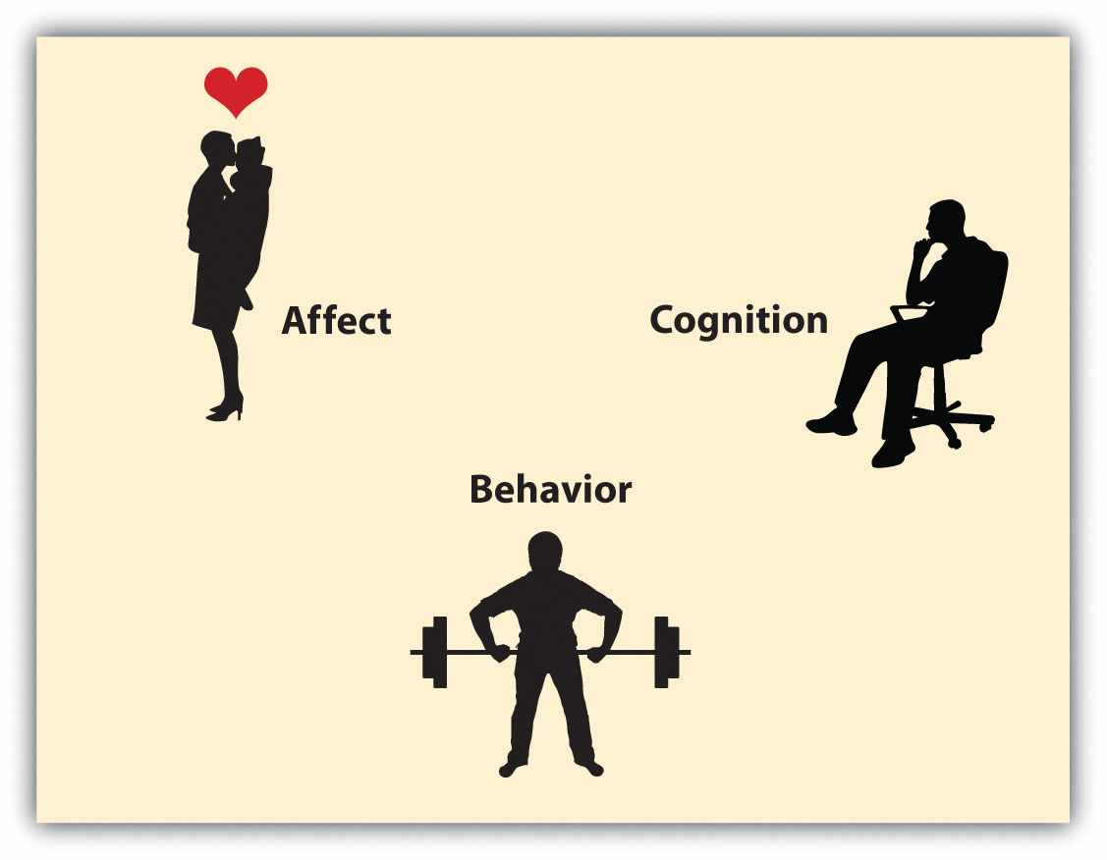
Human beings rely on the three capacities of affect, behavior, and cognition, which work together to help them create successful social interactions.
You can see that these three aspects directly reflect the idea in our definition of social psychology—the study of the feelings, behaviors, and thoughts of individuals in the social situation. Although we will frequently discuss each of the capacities separately, keep in mind that all three work together to produce human experience. Now let’s consider separately the roles of cognition, affect, and behavior.

Social Cognition: Thinking and Learning About Others
The human brain contains about 100 billion neurons, each of which can make contact with tens of thousands of other neurons. The distinguishing brain feature in mammals, including humans, is the more recently evolved cerebral cortex—the part of the brain that is involved in thinking (Figure 1.3 "The Cerebral Cortex"). Humans are highly intelligent, and they use cognition in every part of their social lives. Psychologists refer to cognition as the mental activity of processing information and using that information in judgment. Social cognition is cognition that relates to social activities and that helps us understand and predict the behavior of ourselves and others.
Over time, people develop a set of social knowledge that contains information about the self, other people, social relationships, and social groups. Two types of knowledge are particularly important in social psychology: schemas and attitudes. A schema is a knowledge representation that includes information about a person or group (e.g., our knowledge that Joe is a friendly guy or that Italians are romantic). An attitude is a knowledge representation that includes primarily our liking or disliking of a person, thing, or group (“I really like Julie”; I dislike my new apartment”). Once we have formed them, both schemas and attitudes allow us to judge quickly and without much thought whether someone or something we encounter is good or bad, helpful or hurtful, to be sought out or avoided. Thus schemas and attitudes have an important influence on our social information processing and social behavior.
Social cognition involves the active interpretation of events. As a result, different people may draw different conclusions about the same events. When Odette smiles at Robert, he might think that she is romantically attracted to him, whereas she might think that she’s just being friendly. When Mike tells a joke about Polish people, he might think it’s funny, but Wanda might think he is being prejudiced. The 12 members of a jury who are deliberating about the outcome in a trial have all heard the same evidence, but each juror’s own schemas and attitudes may lead him or her to interpret the evidence differently. The fact that different people interpret the same events differently makes life interesting, but it can sometimes lead to disagreement and conflict. Social psychologists study how people interpret and understand their worlds and, particularly, how they make judgments about the causes of other peoples’ behavior.

Social Affect: Feelings About Ourselves and Others
Affect refers to the feelings we experience as part of our everyday lives. As our day progresses, we may find ourselves feeling happy or sad, jealous or grateful, proud or embarrassed. Although affect can be harmful if it is unregulated or unchecked, our affective experiences normally help us to function efficiently and in a way that increases our chances of survival. Affect signals us that things are going OK (e.g., because we are in a good mood or are experiencing joy or serenity) or that things are not going so well (we are in a bad mood, anxious, upset, or angry). Affect can also lead us to engage in behaviors that are appropriate to our perceptions of a given situation. When we are happy, we may seek out and socialize with others; when we are angry, we may attack; and when we are fearful, we may run away.
We experience affect in the form of mood and emotions. Mood refers to the positive or negative feelings that are in the background of our everyday experiences. Most of the time, we are in a relatively good mood, and positive mood has some positive consequences—it encourages us to do what needs to be done and to make the most of the situations we are in (Isen, 2003). ^{[1]} When we are in a good mood, our thought processes open up, and we are more likely to approach others. We are more friendly and helpful to others when we are in a good mood than when we are in a bad mood, and we may think more creatively (De Dreu, Baas, & Nijstad, 2008). ^{[2]} On the other hand, when we are in a bad mood, we are more likely to prefer to remain by ourselves rather than interact with others, and our creativity suffers.
Emotions are brief, but often intense, mental and physiological feeling states. In comparison with moods, emotions are shorter lived, stronger, and more specific forms of affect. Emotions are caused by specific events (things that make us, for instance, jealous or angry), and they are accompanied by high levels of arousal. Whereas we experience moods in normal, everyday situations, we experience emotions only when things are out of the ordinary or unusual. Emotions serve an adaptive role in helping us guide our social behaviors. Just as we run from a snake because the snake elicits fear, we may try to make amends with other people when we feel guilty.

Social Behavior: Interacting With Others
Because humans interact with and influence each other every day, we have developed the ability to make these interactions proceed efficiently and effectively. We cooperate with other people to gain outcomes that we could not obtain on our own, and we exchange goods, services, and other benefits with other people. These behaviors are essential for survival in any society (Kameda, Takezawa, & Hastie, 2003; Kameda, Takezawa, Tindale, & Smith, 2002). ^{[3]}
The sharing of goods, services, emotions, and other social outcomes is known associal exchange. Social rewards (the positive outcomes that we give and receive when we interact with others) include such benefits as attention, praise, affection, love, and financial support. Social costs (the negative outcomes that we give and receive when we interact with others), on the other hand, include, for instance, the frustrations that accrue when disagreements with others develop, the guilt that results if we perceive that we have acted inappropriately, and the effort involved in developing and maintaining harmonious interpersonal relationships.
Imagine a first-year student at your college or university who is trying to decide whether or not to pledge a fraternity. Joining the fraternity has costs, in terms of the dues that have to be paid, the need to make friends with each of the other fraternity members and to attend fraternity meetings, and so forth. On the other hand, there are the potential benefits of group membership, including having a group of friends with similar interests and a social network to help find activities to participate in. To determine whether or not to pledge, the student has to weigh both the social and the material costs and benefits before coming to a conclusion (Moreland & Levine, 2006).^{[4]}
People generally prefer to maximize their own outcomes by attempting to gain as many social rewards as possible and by attempting to minimize their social costs. Such behavior is consistent with the goal of protecting and enhancing the self. But although people do behave according to the goals of self-concern, these goals are tempered by other-concern: the goals of respecting, accepting, and cooperating with others. As a result, social exchange is generally fair and equitable, at least in the long run. Imagine, for example, that I ask you to do a favor for me, and you do it. If I were only concerned about my own self-enhancement, I might simply accept the favor without any thought of paying you back. Yet both you and I would realize that you would most certainly expect me to be willing to do the same type of favor for you, should you ask me at some later time.
One of the outcomes of living together in small groups over thousands of years is that humans have learned to cooperate by giving benefits to those who are in need, with the expectation of a return of benefits at a future time. This mutual, and generally equitable, exchange of benefits is known as reciprocal altruism. An individual who is temporarily sick or injured will benefit from the help that he or she might get from others during this time. And according to the principle of reciprocal altruism, other group members will be willing to give that help to the needy individual because they expect that similar help will be given to them should they need it. However, in order for reciprocal altruism to work, people have to keep track of how benefits are exchanged, to be sure that everyone plays by the rules. If one person starts to take benefits without paying them back, this violates the principle of reciprocity and should not be allowed to continue for very long. In fact, research has shown that people seem to be particularly good at detecting “cheaters”—those who do not live up to their obligations in reciprocal altruism—and that these individuals are judged extremely negatively (Mealey, Daood, & Krage, 1996; Tooby & Cosmides, 1992). ^{[5]}

KEY TAKEAWAYS
- We use affect, behavior, and cognition to help us successfully interact with others.
- Social cognition refers to our thoughts about and interpretations of ourselves and other people. Over time, we develop schemas and attitudes to help us better understand and more successfully interact with others.
- Affect refers to the feelings that we experience as part of life and includes both moods and emotions.
- Social behavior is determined by principles of reciprocal altruism and social exchange.

EXERCISE AND CRITICAL THINKING
- Consider a time when you had an important social interaction or made an important decision. Analyze your responses to the situation in terms of affect, behavior, and cognition.

[1] Isen, A. M. (2003). Positive affect as a source of human strength. In A psychology of human strengths: Fundamental questions and future directions for a positive psychology (pp. 179–195). Washington, DC: American Psychological Association.
[2] De Dreu, C. K. W., Baas, M., & Nijstad, B. A. (2008). Hedonic tone and activation level in the mood-creativity link: Toward a dual pathway to creativity model. Journal of Personality and Social Psychology, 94(5), 739–756.
[3] Kameda, T., Takezawa, M., & Hastie, R. (2003). The logic of social sharing: An evolutionary game analysis of adaptive norm development. Personality & Social Psychology Review, 7(1), 2–19.; Kameda, T., Takezawa, M., Tindale, R. S., & Smith, C. M. (2002). Social sharing and risk reduction: Exploring a computational algorithm for the psychology of windfall gains. Evolution & Human Behavior, 23(1), 11–33.
[4] Moreland, R. L., & Levine, J. M. (Eds.). (2006). Socialization in organizations and work groups. New York, NY: Psychology Press.
[5] Mealey, L., Daood, C., & Krage, M. (1996). Enhanced memory for faces of cheaters.Ethology & Sociobiology, 7(2), 119–128; Tooby, J., & Cosmides, L. (1992). The psychological foundations of culture. In J. H. Barkow & L. Cosmides (Eds.), The adapted mind: Evolutionary psychology and the generation of culture (p. 666). New York, NY: Oxford University Press.

1.3 Conducting Research in Social Psychology

LEARNING OBJECTIVES
- Explain why social psychologists rely on empirical methods to study social behavior.
- Provide examples of how social psychologists measure the variables they are interested in.
- Review the three types of research designs, and evaluate the strengths and limitations of each type.
- Consider the role of validity in research, and describe how research programs should be evaluated.
Social psychologists are not the only people interested in understanding and predicting social behavior or the only people who study it. Social behavior is also considered by religious leaders, philosophers, politicians, novelists, and others, and it is a common topic on TV shows. But the social psychological approach to understanding social behavior goes beyond the mere observation of human actions. Social psychologists believe that a true understanding of the causes of social behavior can only be obtained through a systematic scientific approach, and that is why they conduct scientific research. Social psychologists believe that the study of social behavior should beempirical—that is, based on the collection and systematic analysis of observable data.

The Importance of Scientific Research
Because social psychology concerns the relationships among people, and because we can frequently find answers to questions about human behavior by using our own common sense or intuition, many people think that it is not necessary to study it empirically (Lilienfeld, 2011). ^{[1]} But although we do learn about people by observing others and therefore social psychology is in fact partly common sense, social psychology is not entirely common sense.
In case you are not convinced about this, perhaps you would be willing to test whether or not social psychology is just common sense by taking a short true-or-false quiz. If so, please have a look at Table 1.1 "Is Social Psychology Just Common Sense?" and respond with either “True” or “False.” Based on your past observations of people’s behavior, along with your own common sense, you will likely have answers to each of the questions on the quiz. But how sure are you? Would you be willing to bet that all, or even most, of your answers have been shown to be correct by scientific research? Would you be willing to accept your score on this quiz for your final grade in this class? If you are like most of the students in my classes, you will get at least some of these answers wrong. (To see the answers and a brief description of the scientific research supporting each of these topics, please go to the Chapter Summary at the end of this chapter.)

Table 1.1 Is Social Psychology Just Common Sense?
Answer each of the following questions, using your own initution, as either true or false.
Opposites attract.
An athlete who wins the bronze medal (third place) in an event is happier about his or her performance than the athlete who wins the silver medal (second place).
Having good friends you can count on can keep you from catching colds.
Subliminal advertising (i.e., persuasive messages that are displayed out of our awareness on TV or movie screens) is very effective in getting us to buy products.
The greater the reward promised for an activity, the more one will come to enjoy engaging in that activity.
Physically attractive people are seen as less intelligent than less attractive people.
Punching a pillow or screaming out loud is a good way to reduce frustration and aggressive tendencies.
People pull harder in a tug-of-war when they’re pulling alone than when pulling in a group.
One of the reasons we might think that social psychology is common sense is that once we learn about the outcome of a given event (e.g., when we read about the results of a research project), we frequently believe that we would have been able to predict the outcome ahead of time. For instance, if half of a class of students is told that research concerning attraction between people has demonstrated that “opposites attract,” and if the other half is told that research has demonstrated that “birds of a feather flock together,” most of the students in both groups will report believing that the outcome is true and that they would have predicted the outcome before they had heard about it. Of course, both of these contradictory outcomes cannot be true. The problem is that just reading a description of research findings leads us to think of the many cases that we know that support the findings and thus makes them seem believable. The tendency to think that we could have predicted something that we probably would not have been able to predict is called the hindsight bias.
Our common sense also leads us to believe that we know why we engage in the behaviors that we engage in, when in fact we may not. Social psychologist Daniel Wegner and his colleagues have conducted a variety of studies showing that we do not always understand the causes of our own actions. When we think about a behavior before we engage in it, we believe that the thinking guided our behavior, even when it did not (Morewedge, Gray, & Wegner, 2010). ^{[2]} People also report that they contribute more to solving a problem when they are led to believe that they have been working harder on it, even though the effort did not increase their contribution to the outcome (Preston & Wegner, 2007). ^{[3]} These findings, and many others like them, demonstrate that our beliefs about the causes of social events, and even of our own actions, do not always match the true causes of those events.
Social psychologists conduct research because it often uncovers results that could not have been predicted ahead of time. Putting our hunches to the test exposes our ideas to scrutiny. The scientific approach brings a lot of surprises, but it also helps us test our explanations about behavior in a rigorous manner. It is important for you to understand the research methods used in psychology so that you can evaluate the validity of the research that you read about here, in other courses, and in your everyday life.
Social psychologists publish their research in scientific journals, and your instructor may require you to read some of these research articles. The most important social psychology journals are listed in Table 1.2 "Social Psychology Journals". If you are asked to do a literature search on research in social psychology, you should look for articles from these journals.

Table 1.2 Social Psychology Journals
Journal of Personality and Social Psychology
Journal of Experimental Social Psychology
Personality and Social Psychology Bulletin
Social Psychology and Personality Science
Social Cognition
European Journal of Social Psychology
Social Psychology Quarterly
Basic and Applied Social Psychology
Journal of Applied Social Psychology
Note. The research articles in these journals are likely to be available in your college library. A fuller list can be found here:http://www.socialpsychology.org/journals.htm#social
We’ll discuss the empirical approach and review the findings of many research projects throughout this book, but for now let’s take a look at the basics of how scientists use research to draw overall conclusions about social behavior. Keep in mind as you read this book, however, that although social psychologists are pretty good at understanding the causes of behavior, our predictions are a long way from perfect. We are not able to control the minds or the behaviors of others or to predict exactly what they will do in any given situation. Human behavior is complicated because people are complicated and because the social situations that they find themselves in every day are also complex. It is this complexity—at least for me—that makes studying people so interesting and fun.

Measuring Affect, Behavior, and Cognition
One important aspect of using an empirical approach to understand social behavior is that the concepts of interest must be measured (Figure 1.4 "The Operational Definition"). If we are interested in learning how much Sarah likes Robert, then we need to have a measure of her liking for him. But how, exactly, should we measure the broad idea of “liking”? In scientific terms, the characteristics that we are trying to measure are known as conceptual variables, and the particular method that we use to measure a variable of interest is called an operational definition.
For anything that we might wish to measure, there are many different operational definitions, and which one we use depends on the goal of the research and the type of situation we are studying. To better understand this, let’s look at an example of how we might operationally define “Sarah likes Robert.”

Figure 1.4 The Operational Definition
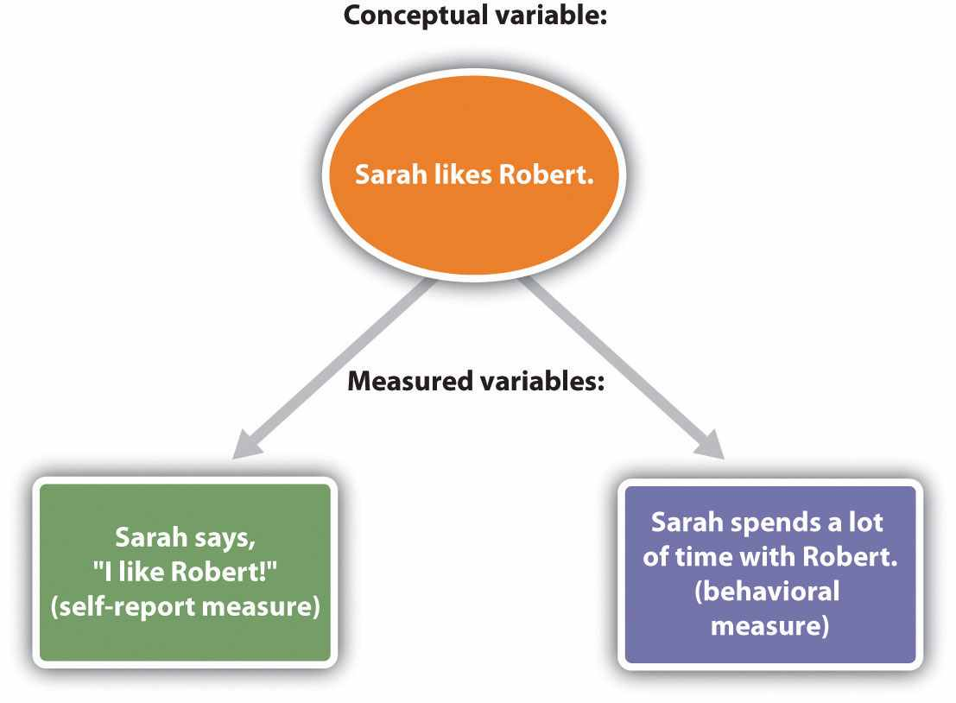
An idea or conceptual variable (such as “how much Sarah likes Robert”) is turned into a measure through an operational definition.
One approach to measurement involves directly asking people about their perceptions using self-report measures. Self-report measures are measures in which individuals are asked to respond to questions posed by an interviewer or on a questionnaire. Generally, because any one question might be misunderstood or answered incorrectly, in order to provide a better measure, more than one question is asked and the responses to the questions are averaged together. For example, an operational definition of Sarah’s liking for Robert might involve asking her to complete the following measure:
- I enjoy being around Robert.
Strongly disagree 1 2 3 4 5 6 Strongly agree
- I get along well with Robert.
Strongly disagree 1 2 3 4 5 6 Strongly agree
- I like Robert.
Strongly disagree 1 2 3 4 5 6 Strongly agree
The operational definition would be the average of her responses across the three questions. Because each question assesses the attitude differently, and yet each question should nevertheless measure Sarah’s attitude toward Robert in some way, the average of the three questions will generally be a better measure than would any one question on its own.
Although it is easy to ask many questions on self-report measures, these measures have a potential disadvantage. As we have seen, people’s insights into their own opinions and their own behaviors may not be perfect, and they might also not want to tell the truth—perhaps Sarah really likes Robert, but she is unwilling or unable to tell us so. Therefore, an alternative to self-report that can sometimes provide a more valid measure is to measure behavior itself. Behavioral measures are measures designed to directly assess what people do. Instead of asking Sara how much she likes Robert, we might instead measure her liking by assessing how much time she spends with Robert or by coding how much she smiles at him when she talks to him. Some examples of behavioral measures that have been used in social psychological research are shown in Table 1.3 "Examples of Operational Definitions of Conceptual Variables That Have Been Used in Social Psychological Research".

Table 1.3 Examples of Operational Definitions of Conceptual Variables That Have Been Used in Social Psychological Research
Conceptual variable | Operational definitions
Aggression | • Number of presses of a button that administers shock to another student
 | • Number of seconds taken to honk the horn at the car ahead after a stoplight turns green
Interpersonal attraction | • Number of times that a person looks at another person
 | • Number of millimeters of pupil dilation when one person looks at another
Altruism | • Number of pieces of paper a person helps another pick up
 | • Number of hours of volunteering per week that a person engages in
Group decision-making skills | • Number of groups able to correctly solve a group performance task
 | • Number of seconds in which a group correctly solves a problem
Prejudice | • Number of negative words used in a creative story about another person
 | • Number of inches that a person places their chair away from another person

Social Neuroscience: Measuring Social Responses in the Brain
Still another approach to measuring our thoughts and feelings is to measure brain activity, and recent advances in brain science have created a wide variety of new techniques for doing so. One approach, known as electroencephalography (EEG), is a technique that records the electrical activity produced by the brain’s neurons through the use of electrodes that are placed around the research participant’s head. An electroencephalogram (EEG) can show if a person is asleep, awake, or anesthetized because the brain wave patterns are known to differ during each state. An EEG can also track the waves that are produced when a person is reading, writing, and speaking with others. A particular advantage of the technique is that the participant can move around while the recordings are being taken, which is useful when measuring brain activity in children who often have difficulty keeping still. Furthermore, by following electrical impulses across the surface of the brain, researchers can observe changes over very fast time periods.
Although EEGs can provide information about the general patterns of electrical activity within the brain, and although they allow the researcher to see these changes quickly as they occur in real time, the electrodes must be placed on the surface of the skull, and each electrode measures brain waves from large areas of the brain. As a result, EEGs do not provide a very clear picture of the structure of the brain.
But techniques exist to provide more specific brain images. Functional magnetic resonance imaging (fMRI) is a neuroimaging technique that uses a magnetic field to create images of brain structure and function. In research studies that use the fMRI, the research participant lies on a bed within a large cylindrical structure containing a very strong magnet. Nerve cells in the brain that are active use more oxygen, and the need for oxygen increases blood flow to the area. The fMRI detects the amount of blood flow in each brain region and thus is an indicator of which parts of the brain are active.
Very clear and detailed pictures of brain structures (see Figure 1.5 "Functional Magnetic Resonance Imaging (fMRI)") can be produced via fMRI. Often, the images take the form of cross-sectional “slices” that are obtained as the magnetic field is passed across the brain. The images of these slices are taken repeatedly and are superimposed on images of the brain structure itself to show how activity changes in different brain structures over time. Normally, the research participant is asked to engage in tasks while in the scanner, for instance, to make judgments about pictures of people, to solve problems, or to make decisions about appropriate behaviors. The fMRI images show which parts of the brain are associated with which types of tasks. Another advantage of the fMRI is that is it noninvasive. The research participant simply enters the machine and the scans begin.
Although the scanners themselves are expensive, the advantages of fMRIs are substantial, and scanners are now available in many university and hospital settings. The fMRI is now the most commonly used method of learning about brain structure, and it has been employed by social psychologists to study social cognition, attitudes, morality, emotions, responses to being rejected by others, and racial prejudice, to name just a few topics (Eisenberger, Lieberman, & Williams, 2003; Greene, Sommerville, Nystrom, Darley, & Cohen, 2001; Lieberman, Hariri, Jarcho, Eisenberger, & Bookheimer, 2005; Ochsner, Bunge, Gross, & Gabrieli, 2002; Richeson et al., 2003). ^{[4]}

Observational Research
Once we have decided how to measure our variables, we can begin the process of research itself. As you can see in Table 1.4 "Three Major Research Designs Used by Social Psychologists", there are three major approaches to conducting research that are used by social psychologists—the observational approach, the correlational approach, and the experimental approach. Each approach has some advantages and disadvantages.

Table 1.4 Three Major Research Designs Used by Social Psychologists
Research Design | Goal | Advantages | Disadvantages
Observational | To create a snapshot of the current state of affairs | Provides a relatively complete picture of what is occurring at a given time. Allows the development of questions for further study. | Does not assess relationships between variables.
Correlational | To assess the relationships between two or more variables | Allows the testing of expected relationships between variables and the making of predictions. Can assess these relationships in everyday life events. | Cannot be used to draw inferences about the causal relationships between the variables.
Experimental | To assess the causal impact of one or more experimental manipulations on a dependent variable | Allows the drawing of conclusions about the causal relationships among variables. | Cannot experimentally manipulate many important variables. May be expensive and take much time to conduct.
The most basic research design, observational research, is research that involves making observations of behavior and recording those observations in an objective manner. Although it is possible in some cases to use observational data to draw conclusions about the relationships between variables (e.g., by comparing the behaviors of older versus younger children on a playground), in many cases the observational approach is used only to get a picture of what is happening to a given set of people at a given time and how they are responding to the social situation. In these cases, the observational approach involves creating a type of “snapshot” of the current state of affairs.
One advantage of observational research is that in many cases it is the only possible approach to collecting data about the topic of interest. A researcher who is interested in studying the impact of a hurricane on the residents of New Orleans, the reactions of New Yorkers to a terrorist attack, or the activities of the members of a religious cult cannot create such situations in a laboratory but must be ready to make observations in a systematic way when such events occur on their own. Thus observational research allows the study of unique situations that could not be created by the researcher. Another advantage of observational research is that the people whose behavior is being measured are doing the things they do every day, and in some cases they may not even know that their behavior is being recorded.
One early observational study that made an important contribution to understanding human behavior was reported in a book by Leon Festinger and his colleagues (Festinger, Riecken, & Schachter, 1956). ^{[5]} The book, called When Prophecy Fails, reported an observational study of the members of a “doomsday” cult. The cult members believed that they had received information, supposedly sent through “automatic writing” from a planet called “Clarion,” that the world was going to end. More specifically, the group members were convinced that the earth would be destroyed, as the result of a gigantic flood, sometime before dawn on December 21, 1954.
When Festinger learned about the cult, he thought that it would be an interesting way to study how individuals in groups communicate with each other to reinforce their extreme beliefs. He and his colleagues observed the members of the cult over a period of several months, beginning in July of the year in which the flood was expected. The researchers collected a variety of behavioral and self-report measures by observing the cult, recording the conversations among the group members, and conducting detailed interviews with them. Festinger and his colleagues also recorded the reactions of the cult members, beginning on December 21, when the world did not end as they had predicted. This observational research provided a wealth of information about the indoctrination patterns of cult members and their reactions to disconfirmed predictions. This research also helped Festinger develop his important theory of cognitive dissonance.
Despite their advantages, observational research designs also have some limitations. Most important, because the data that are collected in observational studies are only a description of the events that are occurring, they do not tell us anything about the relationship between different variables. However, it is exactly this question that correlational research and experimental research are designed to answer.

The Research Hypothesis
Because social psychologists are generally interested in looking at relationships among variables, they begin by stating their predictions in the form of a precise statement known as a research hypothesis. A research hypothesis is a statement about the relationship between the variables of interest and about the specific direction of that relationship. For instance, the research hypothesis “People who are more similar to each other will be more attracted to each other” predicts that there is a relationship between a variable called similarity and another variable called attraction. In the research hypothesis “The attitudes of cult members become more extreme when their beliefs are challenged,” the variables that are expected to be related are extremity of beliefs and the degree to which the cults’ beliefs are challenged.
Because the research hypothesis states both that there is a relationship between the variables and the direction of that relationship, it is said to be falsifiable. Being falsifiable means that the outcome of the research can demonstrate empirically either that there is support for the hypothesis (i.e., the relationship between the variables was correctly specified) or that there is actually no relationship between the variables or that the actual relationship is not in the direction that was predicted. Thus the research hypothesis that “people will be more attracted to others who are similar to them” is falsifiable because the research could show either that there was no relationship between similarity and attraction or that people we see as similar to us are seen as less attractive than those who are dissimilar.

Correlational Research
The goal of correlational research is to search for and test hypotheses about the relationships between two or more variables. In the simplest case, the correlation is between only two variables, such as that between similarity and liking, or between gender (male versus female) and helping.
In a correlational design, the research hypothesis is that there is an association (i.e., a correlation) between the variables that are being measured. For instance, many researchers have tested the research hypothesis that a positive correlation exists between the use of violent video games and the incidence of aggressive behavior, such that people who play violent video games more frequently would also display more aggressive behavior.
A statistic known as the Pearson correlation coefficient (symbolized by the letter r) is normally used to summarize the association, or correlation, between two variables. The correlation coefficient can range from −1 (indicating a very strong negative relationship between the variables) to +1 (indicating a very strong positive relationship between the variables). Research has found that there is a positive correlation between the use of violent video games and the incidence of aggressive behavior and that the size of the correlation is about r = .30 (Bushman & Huesmann, 2010). ^{[6]}
One advantage of correlational research designs is that, like observational research (and in comparison with experimental research designs in which the researcher frequently creates relatively artificial situations in a laboratory setting), they are often used to study people doing the things that they do every day. And correlational research designs also have the advantage of allowing prediction. When two or more variables are correlated, we can use our knowledge of a person’s score on one of the variables to predict his or her likely score on another variable. Because high-school grade point averages are correlated with college grade point averages, if we know a person’s high-school grade point average, we can predict his or her likely college grade point average. Similarly, if we know how many violent video games a child plays, we can predict how aggressively he or she will behave. These predictions will not be perfect, but they will allow us to make a better guess than we would have been able to if we had not known the person’s score on the first variable ahead of time.
Despite their advantages, correlational designs have a very important limitation. This limitation is that they cannot be used to draw conclusions about the causal relationships among the variables that have been measured. An observed correlation between two variables does not necessarily indicate that either one of the variables caused the other. Although many studies have found a correlation between the number of violent video games that people play and the amount of aggressive behaviors they engage in, this does not mean that viewing the video games necessarily caused the aggression. Although one possibility is that playing violent games increases aggression,
another possibility is that the causal direction is exactly opposite to what has been hypothesized. Perhaps increased aggressiveness causes more interest in, and thus increased viewing of, violent games. Although this causal relationship might not seem as logical to you, there is no way to rule out the possibility of such reverse causationon the basis of the observed correlation.
Still another possible explanation for the observed correlation is that it has been produced by the presence of another variable that was not measured in the research.Common-causal variables (also known as third variables) are variables that are not part of the research hypothesis but that cause both the predictor and the outcome variable and thus produce the observed correlation between them (Figure 1.6 "Correlation and Causality"). It has been observed that students who sit in the front of a large class get better grades than those who sit in the back of the class. Although this could be because sitting in the front causes the student to take better notes or to understand the material better, the relationship could also be due to a common-causal variable, such as the interest or motivation of the students to do well in the class. Because a student’s interest in the class leads him or her to both get better grades and sit nearer to the teacher, seating position and class grade are correlated, even though neither one caused the other.

Figure 1.6 Correlation and Causality
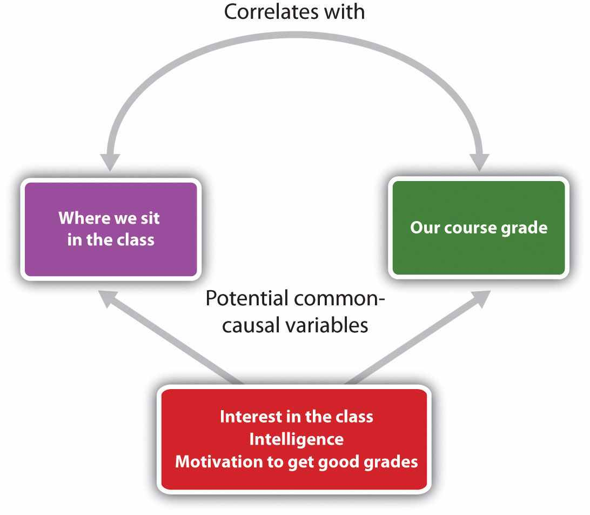
The correlation between where we sit in a large class and our grade in the class is likely caused by the influence of one or more common-causal variables.
The possibility of common-causal variables must always be taken into account when considering correlational research designs. For instance, in a study that finds a correlation between playing violent video games and aggression, it is possible that a common-causal variable is producing the relationship. Some possibilities include the family background, diet, and hormone levels of the children. Any or all of these potential common-causal variables might be creating the observed correlation between playing violent video games and aggression. Higher levels of the male sex hormone testosterone, for instance, may cause children to both watch more violent TV and behave more aggressively.
I like to think of common-causal variables in correlational research designs as “mystery” variables, since their presence and identity is usually unknown to the researcher because they have not been measured. Because it is not possible to measure every variable that could possibly cause both variables, it is always possible that there is an unknown common-causal variable. For this reason, we are left with the basic limitation of correlational research: Correlation does not imply causation.

Experimental Research
The goal of much research in social psychology is to understand the causal relationships among variables, and for this we use experiments. Experimental research designs are research designs that include the manipulation of a given situation or experience for two or more groups of individuals who are initially created to be equivalent, followed by a measurement of the effect of that experience.
In an experimental research design, the variables of interest are called the independent variables and the dependent variables. The independent variable refers to the situation that is created by the experimenter through the experimental manipulations, and the dependent variable refers to the variable that is measured after the manipulations have occurred. In an experimental research design, the research hypothesis is that the manipulated independent variable (or variables) causes changes in the measured dependent variable (or variables). We can diagram the prediction like this, using an arrow that points in one direction to demonstrate the expected direction of causality:
viewing violence (independent variable) → aggressive behavior (dependent variable)
Consider an experiment conducted by Anderson and Dill (2000), ^{[7]} which was designed to directly test the hypothesis that viewing violent video games would cause increased aggressive behavior. In this research, male and female undergraduates from Iowa State University were given a chance to play either a violent video game (Wolfenstein 3D) or a nonviolent video game (Myst). During the experimental session, the participants played the video game that they had been given for 15 minutes. Then, after the play, they participated in a competitive task with another student in which they had a chance to deliver blasts of white noise through the earphones of their opponent. The operational definition of the dependent variable (aggressive behavior) was the level and duration of noise delivered to the opponent. The design and the results of the experiment are shown in Figure 1.7 "An Experimental Research Design (After Anderson & Dill, 2000)".

Figure 1.7 An Experimental Research Design (After Anderson & Dill, 2000)
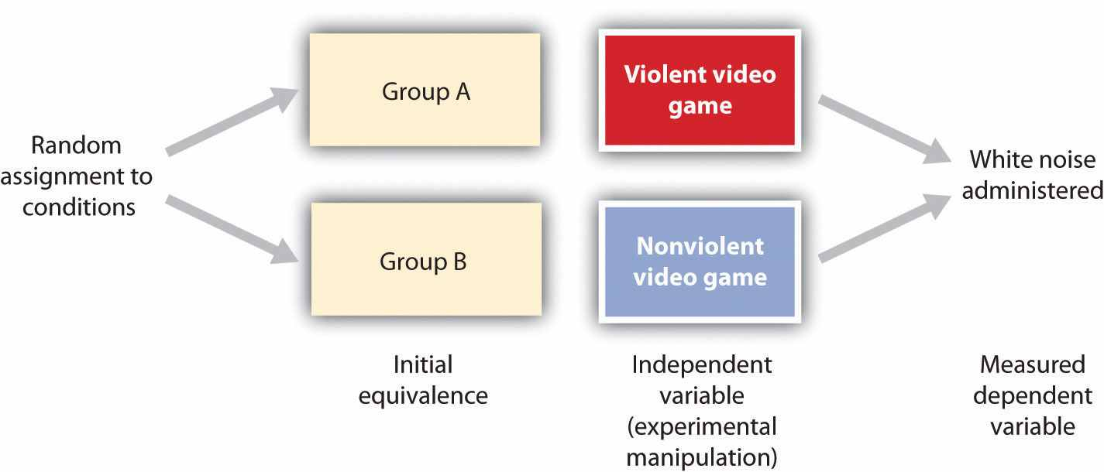
Two advantages of the experimental research design are (a) an assurance that the independent variable (also known as the experimental manipulation) occurs prior to the measured dependent variable and (b) the creation of initial equivalence between the conditions of the experiment (in this case, by using random assignment to conditions).
Experimental designs have two very nice features. For one, they guarantee that the independent variable occurs prior to measuring the dependent variable. This eliminates the possibility of reverse causation. Second, the experimental manipulation allows ruling out the possibility of common-causal variables that cause both the independent variable and the dependent variable. In experimental designs, the influence of common-causal variables is controlled, and thus eliminated, by creating equivalence among the participants in each of the experimental conditions before the manipulation occurs.
The most common method of creating equivalence among the experimental conditions is through random assignment to conditions, which involves determining separately for each participant which condition he or she will experience through a random process, such as drawing numbers out of an envelope or using a website such as http://randomizer.org. Anderson and Dill first randomly assigned about 100 participants to each of their two groups. Let’s call them Group A and Group B. Because they used random assignment to conditions, they could be confident that before the experimental manipulation occurred, the students in Group A were, on average, equivalent to the students in Group B on every possible variable, including variables that are likely to be related to aggression, such as family, peers, hormone levels, and diet—and, in fact, everything else.
Then, after they had created initial equivalence, Anderson and Dill created the experimental manipulation—they had the participants in Group A play the violent video game and the participants in Group B the nonviolent video game. Then they compared the dependent variable (the white noise blasts) between the two groups and found that the students who had viewed the violent video game gave significantly longer noise blasts than did the students who had played the nonviolent game. Because they had created initial equivalence between the groups, when the researchers observed differences in the duration of white noise blasts between the two groups after the experimental manipulation, they could draw the conclusion that it was the independent variable (and not some other variable) that caused these differences. The idea is that the only thing that was different between the students in the two groups was which video game they had played.
When we create a situation in which the groups of participants are expected to be equivalent before the experiment begins, when we manipulate the independent variable before we measure the dependent variable, and when we change only the nature of independent variables between the conditions, then we can be confident that it is the independent variable that caused the differences in the dependent variable. Such experiments are said to have high internal validity, where internal validityrefers to the confidence with which we can draw conclusions about the causal relationship between the variables.
Despite the advantage of determining causation, experimental research designs do have limitations. One is that the experiments are usually conducted in laboratory situations rather than in the everyday lives of people. Therefore, we do not know whether results that we find in a laboratory setting will necessarily hold up in everyday life. To counter this, in some cases experiments are conducted in everyday settings—for instance, in schools or other organizations. Such field experiments are difficult to conduct because they require a means of creating random assignment to conditions, and this is frequently not possible in natural settings.
A second and perhaps more important limitation of experimental research designs is that some of the most interesting and important social variables cannot be experimentally manipulated. If we want to study the influence of the size of a mob on the destructiveness of its behavior, or to compare the personality characteristics of people who join suicide cults with those of people who do not join suicide cults, these relationships must be assessed using correlational designs because it is simply not possible to manipulate mob size or cult membership.

Factorial Research Designs
Social psychological experiments are frequently designed to simultaneously study the effects of more than one independent variable on a dependent variable. Factorial research designs are experimental designs that have two or more independent variables. By using a factorial design, the scientist can study the influence of each variable on the dependent variable (known as the main effects of the variables) as well as how the variables work together to influence the dependent variable (known as theinteraction between the variables). Factorial designs sometimes demonstrate the person by situation interaction.
In one such study, Brian Meier and his colleagues (Meier, Robinson, & Wilkowski, 2006) ^{[8]} tested the hypothesis that exposure to aggression-related words would increase aggressive responses toward others. Although they did not directly manipulate the social context, they used a technique common in social psychology in which they primed (i.e., activated) thoughts relating to social settings. In their research, half of their participants were randomly assigned to see words relating to aggression and the other half were assigned to view neutral words that did not relate to aggression. The participants in the study also completed a measure of individual differences in agreeableness—a personality variable that assesses the extent to which the person sees themselves as compassionate, cooperative, and high on other-concern.
Then the research participants completed a task in which they thought they were competing with another student. Participants were told that they should press the space bar on the computer as soon as they heard a tone over their headphones, and the person who pressed the button the fastest would be the winner of the trial. Before the first trial, participants set the intensity of a blast of white noise that would be delivered to the loser of the trial. The participants could choose an intensity ranging from 0 (no noise) to the most aggressive response (10, or 105 decibels). In essence, participants controlled a “weapon” that could be used to blast the opponent with aversive noise, and this setting became the dependent variable. At this point, the experiment ended.

Figure 1.8 A Person-Situation Interaction
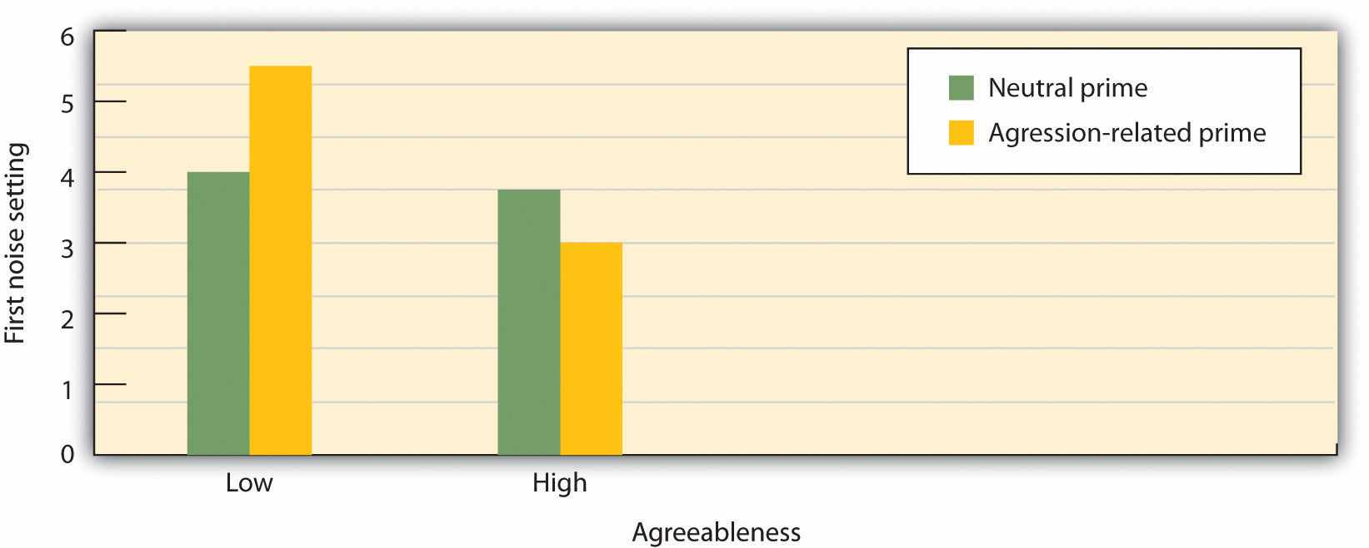
In this experiment by Meier, Robinson, and Wilkowski (2006) ^{[9]} the independent variables are type of priming (aggression or neutral) and participant agreeableness (high or low). The dependent variable is the white noise level selected (a measure of aggression). The participants who were low in agreeableness became significantly more aggressive after seeing aggressive words, but those high in agreeableness did not.
As you can see in Figure 1.8 "A Person-Situation Interaction", there was a person by situation interaction. Priming with aggression-related words (the situational variable) increased the noise levels selected by participants who were low on agreeableness, but priming did not increase aggression (in fact, it decreased it a bit) for students who were high on agreeableness. In this study, the social situation was important in creating aggression, but it had different effects for different people.

Deception in Social Psychology Experiments
You may have wondered whether the participants in the video game study and that we just discussed were told about the research hypothesis ahead of time. In fact, these experiments both used a cover story—a false statement of what the research was really about. The students in the video game study were not told that the study was about the effects of violent video games on aggression, but rather that it was an investigation of how people learn and develop skills at motor tasks like video games and how these skills affect other tasks, such as competitive games. The participants in the task performance study were not told that the research was about task performance. In some experiments, the researcher also makes use of anexperimental confederate—a person who is actually part of the experimental team but who pretends to be another participant in the study. The confederate helps create the right “feel” of the study, making the cover story seem more real.
In many cases, it is not possible in social psychology experiments to tell the research participants about the real hypotheses in the study, and so cover stories or other types of deception may be used. You can imagine, for instance, that if a researcher wanted to study racial prejudice, he or she could not simply tell the participants that this was the topic of the research because people may not want to admit that they are prejudiced, even if they really are. Although the participants are always told—through the process of informed consent—as much as is possible about the study before the study begins, they may nevertheless sometimes be deceived to some extent. At the end of every research project, however, participants should always receive a complete debriefing in which all relevant information is given, including the real hypothesis, the nature of any deception used, and how the data are going to be used.

Interpreting Research
No matter how carefully it is conducted or what type of design is used, all research has limitations. Any given research project is conducted in only one setting and assesses only one or a few dependent variables. And any one study uses only one set of research participants. Social psychology research is sometimes criticized because it frequently uses college students from Western cultures as participants (Henrich, Heine, & Norenzayan, 2010). ^{[10]} But relationships between variables are only really important if they can be expected to be found again when tested using other research designs, other operational definitions of the variables, other participants, and other experimenters, and in other times and settings.
External validity refers to the extent to which relationships can be expected to hold up when they are tested again in different ways and for different people. Science relies primarily upon replication—that is, the repeating of research—to study the external validity of research findings. Sometimes the original research is replicated exactly, but more often, replications involve using new operational definitions of the independent or dependent variables, or designs in which new conditions or variables are added to the original design. And to test whether a finding is limited to the particular participants used in a given research project, scientists may test the same hypotheses using people from different ages, backgrounds, or cultures. Replication allows scientists to test the external validity as well as the limitations of research findings.
In some cases, researchers may test their hypotheses, not by conducting their own study, but rather by looking at the results of many existing studies, using a meta-analysis—a statistical procedure in which the results of existing studies are combined to determine what conclusions can be drawn on the basis of all the studies considered together. For instance, in one meta-analysis, Anderson and Bushman (2001) ^{[11]} found that across all the studies they could locate that included both children and adults, college students and people who were not in college, and people from a variety of different cultures, there was a clear positive correlation (about r = .30) between playing violent video games and acting aggressively. The summary information gained through a meta-analysis allows researchers to draw even clearer conclusions about the external validity of a research finding.

Figure 1.9 Some Important Aspects of the Scientific Approach
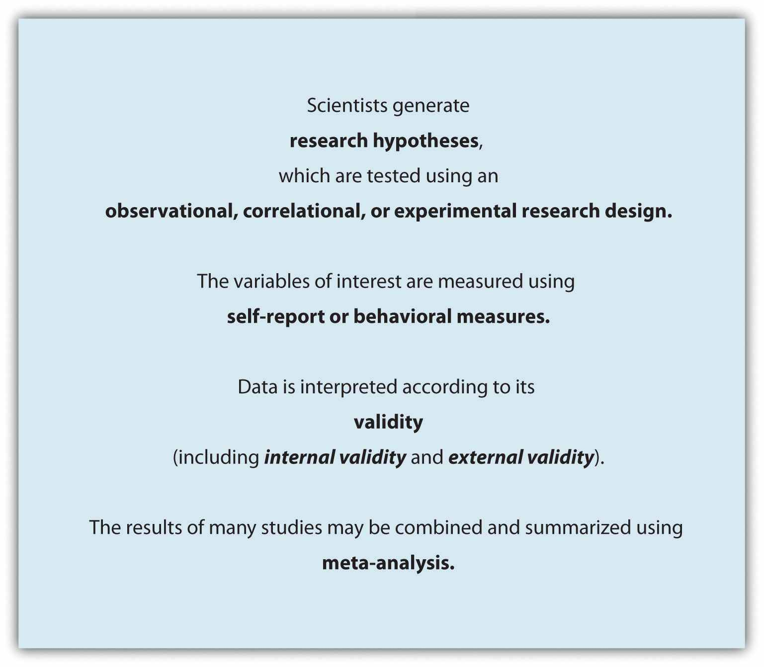
It is important to realize that the understanding of social behavior that we gain by conducting research is a slow, gradual, and cumulative process. The research findings of one scientist or one experiment do not stand alone—no one study “proves” a theory or a research hypothesis. Rather, research is designed to build on, add to, and expand the existing research that has been conducted by other scientists. That is why whenever a scientist decides to conduct research, he or she first reads journal articles and book chapters describing existing research in the domain and then designs his or her research on the basis of the prior findings. The result of this cumulative process is that over time, research findings are used to create a systematic set of knowledge about social psychology (Figure 1.9 "Some Important Aspects of the Scientific Approach").

KEY TAKEAWAYS
- Social psychologists study social behavior using an empirical approach. This allows them to discover results that could not have been reliably predicted ahead of time and that may violate our common sense and intuition.
- The variables that form the research hypothesis, known as conceptual variables, are assessed using measured variables by using, for instance, self-report, behavioral, or neuroimaging measures.
- Observational research is research that involves making observations of behavior and recording those observations in an objective manner. In some cases, it may be the only approach to studying behavior.
- Correlational and experimental research designs are based on developing falsifiable research hypotheses.
- Correlational research designs allow prediction but cannot be used to make statements about causality. Experimental research designs in which the independent variable is manipulated can be used to make statements about causality.
- Social psychological experiments are frequently factorial research designs in which the effects of more than one independent variable on a dependent variable are studied.
- All research has limitations, which is why scientists attempt to replicate their results using different measures, populations, and settings and to summarize those results using meta-analyses.

EXERCISES AND CRITICAL THINKING
- Find journal articles that report observational, correlational, and experimental research designs. Specify the research design, the research hypothesis, and the conceptual and measured variables in each design.
- Consider the following variables that might have contributed to teach of the following events. For each one, (a) propose a research hypothesis in which the variable serves as an independent variable and (b) propose a research hypothesis in which the variable serves as a dependent variable.
  - Helping
  - Aggression
  - Prejudice
  - Liking another person
  - Life satisfaction

[1] Lilienfeld, S. O. (2011, June 13). Public skepticism of psychology: Why many people perceive the study of human behavior as unscientific. American Psychologist. doi: 10.1037/a0023963
[2] Morewedge, C. K., Gray, K., & Wegner, D. M. (2010). Perish the forethought: Premeditation engenders misperceptions of personal control. In R. R. Hassin, K. N. Ochsner, & Y. Trope (Eds.), Self-control in society, mind, and brain (pp. 260–278). New York, NY: Oxford University Press.
[3] Preston, J., & Wegner, D. M. (2007). The eureka error: Inadvertent plagiarism by misattributions of effort. Journal of Personality and Social Psychology, 92(4), 575–584.
[4] Eisenberger, N. I., Lieberman, M. D., & Williams, K. D. (2003). Does rejection hurt? An fMRI study of social exclusion. Science, 302(5643), 290–292; Greene, J. D., Sommerville, R. B., Nystrom, L. E., Darley, J. M., & Cohen, J. D. (2001). An fMRI investigation of emotional engagement in moral judgment. Science, 293(5537), 2105–2108; Lieberman, M. D., Hariri, A., Jarcho, J. M., Eisenberger, N. I., & Bookheimer, S. Y. (2005). An fMRI investigation of race-related amygdala activity in African-American and Caucasian-American individuals. Nature Neuroscience, 8(6), 720–722; Ochsner, K. N., Bunge, S. A., Gross, J. J., & Gabrieli, J. D. E. (2002). Rethinking feelings: An fMRI study of the cognitive regulation of emotion. Journal of Cognitive Neuroscience, 14(8), 1215–1229; Richeson, J. A., Baird, A. A., Gordon, H. L., Heatherton, T. F., Wyland, C. L., Trawalter, S., Richeson, J. A., Baird, A. A., Gordon, H. L., Heatherton, T. F., Wyland, C. L., Trawalter, S., et al.#8230;Shelton, J. N. (2003). An fMRI investigation of the impact of interracial contact on executive function. Nature Neuroscience, 6(12), 1323–1328.
[5] Festinger, L., Riecken, H. W., & Schachter, S. (1956). When prophecy fails: A social and psychological study of a modern group that predicted the destruction of the world. Minneapolis, MN: University of Minnesota Press.
[6] Bushman, B. J., & Huesmann, L. R. (2010). Aggression. In S. T. Fiske, D. T. Gilbert, & G. Lindzey (Eds.), Handbook of social psychology (5th ed., Vol. 2, pp. 833–863). Hoboken, NJ: John Wiley & Sons.
[7] Anderson, C. A., & Dill, K. E. (2000). Video games and aggressive thoughts, feelings, and behavior in the laboratory and in life. Journal of Personality and Social Psychology, 78(4), 772–790.
[8] Meier, B. P., Robinson, M. D., & Wilkowski, B. M. (2006). Turning the other cheek: Agreeableness and the regulation of aggression-related crimes. Psychological Science, 17(2), 136–142.
[9] Meier, B. P., Robinson, M. D., & Wilkowski, B. M. (2006). Turning the other cheek: Agreeableness and the regulation of aggression-related crimes. Psychological Science, 17(2), 136–142.
[10] Henrich, J., Heine, S. J., & Norenzayan, A. (2010). The weirdest people in the world?Behavioral and Brain Sciences, 33(2–3), 61–83.
[11] Anderson, C. A., & Bushman, B. J. (2001). Effects of violent video games on aggressive behavior, aggressive cognition, aggressive affect, physiological arousal, and prosocial behavior: A meta-analytic review of the scientific literature. Psychological Science, 12(5), 353–359.

1.4 Chapter Summary
The science of social psychology began when scientists first started to systematically and formally measure the thoughts, feelings, and behaviors of human beings. Social psychology was energized by a number of researchers who came to the United States from Germany during the Second World War. The 1950s and 1960s saw an expansion of social psychology into the field of attitudes and group processes. In the 1970s and 1980s, the discipline became more cognitive in orientation. Today, the field of social psychology is expanding into still other areas, such as evolutionary psychology, the study of culture, and social neuroscience.
Social psychology is the scientific study of how we think about, feel about, and behave toward the people in our lives and how our thoughts, feelings, and behaviors are influenced by those people. The goal of this book is to help you learn to think like a social psychologist to enable you to use social psychological principles to better understand social relationships.
Social psychology concerns the interplay between the individual person and the social situation. The social situation refers to the other people we interact with every day. The key aspect of the social situation is that the people around us produce social influence, or the processes through which other people change our thoughts, feelings, and behaviors, and through which we change theirs. Social influence operates largely through social norms.
The most basic tendency of all living organisms is the desire to protect and enhance one’s own life and the lives of important others—self-concern. People also desire to affiliate with others, a motive known as other-concern, and doing so is an important part of human behavior.
An important source of our common human experiences is our culture—a group of people, normally living within a given geographical region, who share a common set of social norms. Norms in Western cultures are primarily oriented toward individualism and self-concern, whereas norms in East Asian cultures are more focused on collectivism and other-concern.
Three fundamental capacities of human beings are affect, behavior, and cognition—the ABCs of social psychology. Affect refers to the feelings we experience as part of our everyday lives. The basic component of affect is mood—the positive or negative feelings that are in the background of our everyday experiences. Emotions are mental states like moods, but they are shorter-lived, stronger, more intense, and more specific forms of affect.
Human beings exchange goods, services, and other benefits with other people in the process of social exchange. The mutual, and generally equitable, exchange of benefits is known as reciprocal altruism.
Social cognition relates to social activities and helps us understand and predict the behavior of ourselves and others. Two types of knowledge particularly important in social psychology are schemas and attitudes.
Although common sense is useful for getting ideas, and although our intuitions are sometimes correct, they are not perfect. Thus social psychologists conduct empirical research to test their ideas. The concepts of interest must be measured using operational definitions. Both self-report and behavioral measures can be used.
One approach to learning about social psychology involves using observational research to make observations of behavior. In some cases, this approach is the only way to learn about and study social events.
Because social psychologists are generally interested in looking at relationships between variables, they begin by stating their predictions in the form of a precise statement known as a research hypothesis.
The goal of correlational research is to search for and test hypotheses about the relationships between two or more variables. In these studies, a statistic known as the Pearson correlation coefficient is used to summarize the association, or correlation, between the variables.
Because scientists are interested in determining the causal relationships among variables, they frequently use experimental research designs. In experiments, the variables of interest are called the independent variable and the dependent variable. The most common method of creating equivalence among the experimental conditions, and thus increasing internal validity, is through random assignment to conditions.
External validity refers to the extent to which relationships can be expected to hold up when they are tested again in different ways and for different people. Meta-analyses can be used to assess the observed relationships among variables across many studies.
See Table 1.5 "Is Social Psychology Just Common Sense? Answers and Explanations"for the answers and for explanations to the questions raised in Table 1.1 "Is Social Psychology Just Common Sense?".

Table 1.5 Is Social Psychology Just Common Sense? Answers and Explanations
Opposites attract. | False | The opposite is more the case. Similarity, particularly in values and beliefs, is an important determinant of liking.
An athlete who wins the bronze medal (third place) in an event is happier about his or her performance than the athlete who won the silver medal (second place). | True | We frequently compare our actual outcomes with what “might have been.” This leads the silver medalist to compare the possibility of having won the gold, whereas the bronze medalist compares the possibility of having won no medal at all.
Having good friends you can count on can keep you from catching colds. | True | Social support—the perception that we have people we can count on and talk to—provides many positive benefits to our mental and physical health.
Subliminal advertising (i.e., persuasive messages that are presented out of our awareness on TV or movie screens) is very effective in getting us to buy products. | False | Although there is evidence that events that occur out of our awareness can influence our behavior, there is little evidence that subliminal advertising is effective.
The greater the reward promised for an activity, the more one will come to enjoy engaging in that activity. | False | In fact, providing a reward for an activity that is already enjoyed (such as paying a child to get good grades) can undermine a person’s enjoyment of the activity.
Physically attractive people are seen as less intelligent than less attractive people. | False | You of course know that this must be false. Why else would you look your very best when you go for a job interview?
Punching a pillow or screaming out loud is a good way to reduce frustration and aggressive tendencies. | False | There is no evidence that engaging in violent behavior can ever reduce the desire to be aggressive. The opposite is much more common. Engaging in aggression leads to more aggression.
People pull harder in a tug-of-war when they’re pulling alone than when pulling in a group. | True | Social loafing (reducing our effort because we think that others in the group will make up for us) is more likely.

Chapter 2

Social Learning and Social Cognition

DNA Evidence Sets Free Another Mistakenly Identified Prisoner
On July 12, 1982, a woman in northwest Louisiana was held at gunpoint and raped. During the four hours that the rapist stayed in her house, he identified himself as Marcus Johnson from Leesville, Louisiana.
When the victim reported the attack, the police could find no information about a Marcus Johnson, but they did find a Rickie Johnson who had once been arrested on a minor traffic charge. Mr. Johnson became the only suspect in the case.
The victim was shown a photo lineup of three men who were listed as potential perpetrators, although the image of Johnson was eight years old. The victim identified Johnson as the perpetrator, even though he looked very little like the description she had given of the attacker after the rape.
Johnson was charged with aggravated sexual assault and was tried in Sabine Parish, Louisiana. During the trial the victim told the jury that she was “positive” that he was the perpetrator and there was “no question in [her] mind.”
In 2007, however, Johnson’s innocence was determined with forensic DNA testing, a technology that was not available at the time of the crime.
Rickie Johnson’s case is only one of many recent DNA exonerations, most of which stem from eyewitness misidentifications. In fact, eyewitness misidentification is the single greatest cause of wrongful convictions. Over the past 10 years, almost 400 people have been released from prison when DNA evidence confirmed that they could not have committed the crime for which they had been convicted. And in more than three-quarters of these cases, the cause of the innocent people being falsely convicted was erroneous eyewitness testimony (Wells, Memon, & Penrod, 2006). ^{[1]}
According to the Innocence Project (http://www.innocenceproject.org), “The human mind is not like a tape recorder; we neither record events exactly as we see them, nor recall them like a tape that has been rewound.”
In October 1999, the U.S. Department of Justice released the first national guide for collecting and preserving eyewitness evidence. The guide was commissioned by U.S. Attorney General Janet Reno (http://www.wic.org/bio/jreno.htm) and consisted of a panel of experts, including social psychologist Gary Wells (http://www.psychology.iastate.edu/~glwells/bio2001.html), the world’s foremost authority on the psychology of eyewitness identification.
Sources: http://www.innocenceproject.org/Content/Rickie_Johnson.php.
Although being able to correctly identify the perpetrator of a crime that we have observed is fortunately not part of our everyday social activities, we do need to be able to accurately learn about the people that we interact with every day. Our remarkable abilities to size up and remember other people are enhanced by our affective and cognitive capacities. In this chapter, our focus will be on cognition, and we will consider how we learn about, remember information about, and judge others (Fiske & Taylor, 2007; Macrae & Quadflieg, 2010). ^{[2]} Then, in Chapter 3 "Social Affect", we will turn to a focus on the role of affect in these same processes.
Most generally, this chapter is about social cognition, the mental activity that relates to social activities and helps us meet the goal of understanding and predicting the behavior of ourselves and others. A fundamental part of social cognition involves learning—the relatively permanent change in knowledge that is acquired through experience. We will see that a good part of our learning and our judgments of other people operates out of our awareness—we are profoundly affected by things that we do not know are influencing us. But we also consciously think about and analyze our lives and our relationships with others, seeking out the best ways to fulfill our goals and aspirations.
As we investigate the role of cognition in everyday life, we’ll consider the ways that people use their cognitive abilities to make good decisions and to inform their behavior in a useful and accurate way. We’ll also consider the potential for mistakes and biases in human judgment. We’ll see that although we are generally pretty good at sizing up other people and creating effective social interactions, we are not perfect. And we’ll see that the errors we make frequently occur because of our reliance on our schemas and attitudes and a general tendency to take shortcuts through the use of cognitive heuristics: information-processing rules of thumb that enable us to think in ways that are quick and easy but that may sometimes lead to error. In short, although our cognitive abilities are “good enough,” there are definitely some things we could do better.

[1] Wells, G. L., Memon, A., & Penrod, S. D. (2006). Eyewitness evidence: Improving its probative value. Psychological Science in the Public Interest, 7(2), 45–75.
[2] Fiske, S. T., & Taylor, S. E. (2007). Social cognition, from brains to culture. New York, NY: McGraw-Hill; Macrae, C. N., & Quadflieg, S. (2010). Perceiving people. In S. T. Fiske, D. T. Gilbert, & G. Lindzey (Eds.), Handbook of social psychology (5th ed., Vol. 1, pp. 428–463). Hoboken, NJ: John Wiley & Sons.

2.1 Sources of Social Knowledge

LEARNING OBJECTIVES
- Review the principles of operant, associational, and observational learning, and explain the similarities and differences among them.
- Explain how and when schemas and attitudes do and do not change as a result of the operation of accommodation and assimilation.
- Outline the ways that schemas are likely to be maintained through processes that create assimilation.
Human beings have very large brains and highly developed cognitive capacities. Thus it will come as no surprise that we meet the challenges that we face in everyday life largely by thinking about them and then planning what to do about them. Over time, people develop a huge amount of knowledge about the self, other people, social relationships, and social groups. This knowledge guides our responses to the people we interact with every day.

Our Knowledge Accumulates as a Result of Learning
People have many memories about their experiences with other people, and they use this information to make predictions about what people will do in the future. This knowledge is gained through learning. The study of learning is closely associated with the behaviorist school of psychology, which includes the psychologists John B. Watson and B. F. Skinner. For behaviorists, the fundamental aspect of learning is the process of conditioning—the ability to connect stimuli (the changes that occur in the environment) with responses (behaviors or other actions). The behaviorists described two types of conditioning that are particularly important in behaviorism:operant conditioning (also known as instrumental conditioning) and classical conditioning (also known as respondent conditioning). When applied to human behavior, these two processes are frequently called, respectively, operant learning andassociational learning.

Operant Learning
If a child touches a hot radiator, she quickly learns that the radiator is dangerous and is not likely to touch it again. If we have unpleasant experiences with people from a certain state or country, or a positive relationship with a person who has blonde hair or green eyes, we may develop negative or positive attitudes about people with these particular characteristics and attempt to reduce or increase our interactions with them. These changes in our understanding of our environments represent operant learning—the principle that we learn new information as a result of the consequences of our behavior. According to operant learning principles, experiences that are followed by positive emotions (reinforcements or rewards) are likely to be repeated, whereas experiences that are followed by negative emotions (punishments) are less likely to be repeated. In operant learning, the person learns from the consequences of his or her own actions.
Although its principles are very simple, operant learning is probably the most important form of human learning. Operant learning occurs when a schoolroom bully threatens his classmates because doing so allows him to get his way, when a child gets good grades because her parents threaten to punish her if she doesn’t, when we begin to like someone who smiles at us frequently, and in hundreds of other cases every day. Operant learning can also be used to explain how people learn complex behaviors, such as how to read, and to understand complex social behaviors, such as the development of social norms and culture.
The application of operant learning to social psychology is straightforward: How do we know which behaviors are most appropriate in a social situation? We learn, in part, because we have positively reinforced for engaging in the appropriate ones and negatively reinforced for engaging in the inappropriate ones. It does not take us long to learn that Margette is more likely to give us the kiss we have been hoping for if we are nice to her or that our children are more likely to share their toys with others if we reward them for doing it. Operant learning has even been used to explain why some people choose to become criminals. According to this approach, criminal behavior is determined by the reinforcements and punishments that the individual experiences (e.g., with peers and with parents) as a result of his or her behavior (Akers, 1998). ^{[1]}

Associational Learning
Associational learning occurs when an object or event comes to be associated with a natural response, such as an automatic behavior or a positive or negative emotion. If you’ve ever become hungry when you drive by one of your favorite pizza stores, it is probably because the sight of the pizzeria has become associated with your experiences of enjoying the pizzas. We may enjoy smoking cigarettes, drinking coffee, and eating not only because they give us pleasure themselves but also because they have been associated with pleasant social experiences in the past.
Associational learning also influences our knowledge and judgments about other people. For instance, research has shown that people view men and women who are seen alongside other people who are attractive, or who are said to have attractive girlfriends or boyfriends, more favorably than they do the same people who are seen alongside more average-looking others (Sigall & Landy, 1973). ^{[2]} This liking is due to associational learning—we have positive feelings toward the people simply because those people are associated with the positive features of the attractive others.
Associational learning has long been, and continues to be, an effective tool in marketing and advertising (Hawkins, Best, & Coney, 1998). ^{[3]} The general idea is to create an advertisement that has positive features so that it creates enjoyment in the person exposed to it. Because the product being advertised is mentioned in the ad, it becomes associated with the positive feelings that the ad creates. In the end, if everything has gone well, seeing the product online or in a store will then create a positive response in the buyer, leading him or her to be more likely to purchase the product.

Video Clip 1
A similar strategy is used by corporations that sponsor teams or events. For instance, if people enjoy watching a college basketball team playing basketball, and if that team is sponsored by a product, such as Pepsi, then people may end up experiencing positive feelings when they view a can of Pepsi. Of course, the sponsor wants to sponsor only good teams and good athletes because these create more pleasurable responses.
Advertisers use a variety of techniques to create positive advertisements, including enjoyable music, cute babies, attractive models, and funny spokespeople. In one study, Gorn (1982) ^{[4]} showed research participants pictures of writing pens of different colors, but paired one of the pens with pleasant music and another with unpleasant music. When given a choice as a free gift, more people chose the pen that had been associated with the pleasant music. In another study, Schemer, Matthes, Wirth, and Textor (2008) ^{[5]} found that people were more interested in products that had been embedded in music videos of artists that they liked and less likely to be interested when the products were in videos featuring artists that they did not like.
Another type of ad that is based on principles of classical conditioning is one that associates fear with the use of a product or behavior, such as those that show pictures of deadly automobile accidents to encourage seatbelt use or images of lung cancer surgery to discourage smoking. These ads have also been found to be effective (Das, de Wit, & Stroebe, 2003; Perloff, 2003; Witte & Allen, 2000), ^{[6]} largely because of conditioning.
Recently, the U.S. government created new negative and graphic images to place on cigarette packs in order to increase an association between negative responses and cigarettes. The idea is that when we see a cigarette and the fear of dying is associated with it, we will be less likely to light up.
Taken together then, research studies provide ample evidence of the utility of associational learning in advertising, in ads using positive stimuli and in those using negative stimuli. This does not mean, however, that we are always influenced by these ads. The likelihood that associational learning will be successful is greater when we do not know much about the products, where the differences between products are relatively minor, and when we do not think too carefully about the choices (Schemer et al., 2008). ^{[7]}
Associational learning is also implicated in the development of unfair and unjustified racial prejudices. We may dislike people from certain racial or ethnic groups because we frequently see them portrayed in the media as associated with violence, drug use, or terrorism. And we may avoid people with certain physical characteristics simply because they remind us of other people we do not like.
Lewicki (1985) ^{[8]} conducted research that demonstrated the influence of associational learning and how quickly and easily such learning can happen. In his experiment, high school students first had a brief interaction with a female experimenter who had short hair and wore glasses. The study was set up so that the students had to ask the experimenter a question, and (according to random assignment) the experimenter responded in either a negative way or a neutral way toward the participants. Then the students were told to go into a second room in which two experimenters were present and to approach either one of them. The researchers arranged it so that one of the two experimenters looked a lot like the original experimenter and the other one did not (she had longer hair and did not wear glasses). The students were significantly more likely to avoid the experimenter who looked like the original experimenter when that experimenter had been negative to them than when she had treated them neutrally. As a result of associational learning, the negative behavior of the first experimenter unfairly “rubbed off” onto the second.
Donal Carlston and his colleagues (Mae & Carlston, 2005; Skowronski, Carlston, Mae, & Crawford, 1998) ^{[9]} discovered still another way that associational learning can occur: When we say good or bad things about another person in public, the people who hear us say these things associate those characteristics with us, such that they like people who say positive things and dislike people who say negative things. The moral is clear—associational learning is powerful, so be careful what you do and say.

Observational Learning
In addition to operant and associational learning, people learn by observing the behavior of others. This is known as observational learning (modeling). To demonstrate the importance of observational learning in children, Bandura and Walters (1959) ^{[10]} made a film of a young woman beating up a bobo doll—an inflatable balloon with a weight in the bottom that makes it bob back up when you knock it down. The woman violently hit the doll, shouting “sockeroo!” She also kicked it, sat on it, and hit it with a hammer.
Bandura showed his film to groups of nursery school children and then let them play in a room in which there were some really fun toys. To create some frustration in the children, Bandura let the children play with the fun toys for only a couple of minutes before taking them away. Then Bandura gave the children a chance to play with the bobo doll. You probably won’t be surprised to hear that many of the children imitated the young woman in the film. They punched the bobo doll, shouted “sockeroo,” and hit the doll with a hammer.

Video Clip 2
Take a moment to see how Albert Bandura explains his research into the modeling of aggression in children.
For some of the children, the female model was shown being rewarded for engaging in the behavior, and for other children, she was punished. In support of the principles of operant learning, Bandura’s study found that the children were more likely to be aggressive when the model had been rewarded for the behavior and were less likely to be so when the model had been punished. But even the children who did not see the model receive any reward nevertheless imitated the behavior to some extent. One of the major contributions of this study is the demonstration that children learned new types of aggressive behaviors simply by observing and imitating others.
Observational learning is involved in much of our learning about our social worlds. Observational learning teaches us that Hank is friendly, that Joanna is selfish, and that Frankie has a crush on Malik. In other cases, our knowledge comes more indirectly, from what we read in books or see on TV, or from what our friends tell us, for instance.
Observational learning is useful because it allows people to learn without having to actually engage in what might be a risky behavior. As Bandura put it,
the prospects for [human] survival would be slim indeed if one could learn only by suffering the consequences of trial and error. For this reason, one does not teach children to swim, adolescents to drive automobiles, and novice medical students to perform surgery by having them discover the appropriate behavior through the consequences of their successes and failures. The more costly and hazardous the possible mistakes, the heavier is the reliance on observational learning from competent learners. (1977, p. 12). ^{[11]}
Bandura considered observational learning to be a fundamental determinant of all social behavior and argued that it is most likely to lead to learning when people pay attention to the behavior of models and are highly motivated to imitate the models.

Schemas as Social Knowledge
The outcome of learning is knowledge, and this knowledge is stored in schemas. In the brain, our schemas reside primarily in the prefrontal cortex, the part of the brain that lies in front of the motor areas of the cortex and that helps us remember the characteristics and actions of other people, plan complex social behaviors, and coordinate our behaviors with those of others (Mitchell, Mason, Macrae, & Banaji, 2006). ^{[12]} The prefrontal cortex is the “social” part of the brain. It is also the newest part of the brain, evolutionarily speaking, and has enlarged as the social relationships among humans have become more frequent, important, and complex. Demonstrating its importance in social behaviors, people with damage to the prefrontal cortex are likely to experience changes in social behaviors, including memory, personality, planning, and morality (Koenigs et al., 2007). ^{[13]}
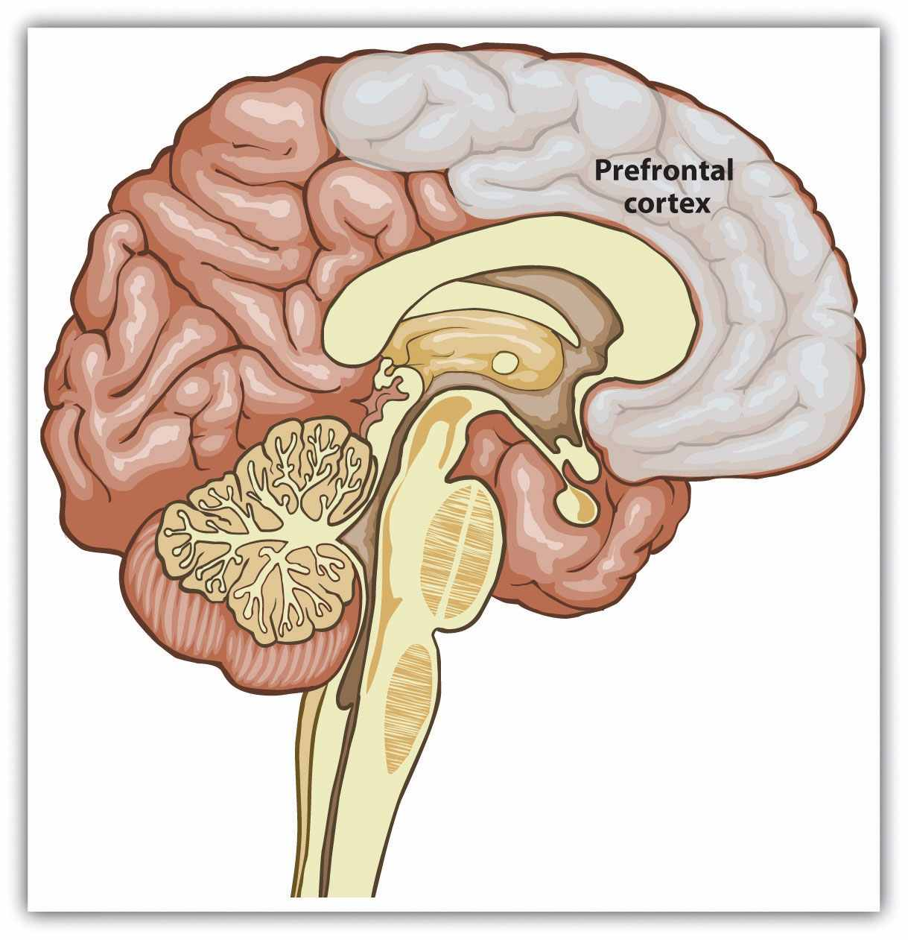
The prefrontal cortex is the area of the brain that stores information about people and about our interactions with them.

How Schemas Develop: Accommodation and Assimilation
Because they represent our past experience, and because past experience is useful for prediction, our schemas serve as expectations about future events. For instance, if you have watched Italian movies or if you have visited Italy, you might have come to the conclusion that Italians frequently gesture a lot with their hands when they talk—that they are quite expressive. This knowledge will be contained in your group schema about Italians. Therefore, when you meet someone who is Italian, or even when you meet someone who reminds you of an Italian person, you may well expect that they will gesture when they talk.
Having a database of social knowledge to draw on is obviously extremely useful. If we didn’t know or couldn’t remember anything about anyone or about anything that we had encountered in the past, our life would be difficult indeed because we would continually have to start our learning over again. Our schemas allow us to better understand people and help us make sense of information, particularly when the information is unclear or ambiguous. They also allow us to “fill in the blanks” by making guesses about what other people are probably like or probably going to do in cases where things are uncertain. Furthermore, the fact that different people have different past experiences—and thus that their schemas and attitudes are different—helps explain why different people draw different conclusions about the same events.
Once they have developed, schemas influence our subsequent learning, such that the new people and situations we encounter are interpreted and understood in terms of our existing knowledge (Piaget & Inhelder, 1966; Taylor & Crocker, 1981). ^{[14]} Imagine, for instance, that you have a schema—and thus an expectation—that Italians are very expressive, and you now meet Bianca, who has arrived at your school directly from Rome, Italy. You immediately expect her to be outgoing and expressive. However, as you get to know Bianca, you discover that she is not at all expressive and does not “talk with her hands.” In fact, she is quite shy and reserved. How does existing information influence how we react to the new information that we receive?
One possibility is that the new information simply updates our existing expectations. We might decide, for instance, that there is more variation among Italians in terms of expressiveness than we had previously realized, and we might resolve that Italians can sometimes be very shy and thoughtful. Or perhaps we might note that although Bianca is Italian, she is also a woman. This might lead us change our schema such that we now believe that although Italian men are expressive, Italian women are not. When existing schemas change on the basis of new information, we call the processaccommodation.
In other cases, however, we engage in assimilation, a process in which our existing knowledge influences new conflicting information to better fit with our existing knowledge, thus reducing the likelihood of schema change. If we used assimilation, instead of changing our expectations about Italians, we might try to reinterpret Bianca’s unexpected behavior to make it more consistent with our expectations. For instance, we might decide that Bianca’s behavior is actually more expressive than we thought it was at first, or that she is acting in a more shy and reserved manner because she is trying to impress us with her thoughtfulness or because she is not yet comfortable at the new school. Or we might assume that she is expressive at home with her family but not around us. In these cases, the process of assimilation has led us to process the new information about Bianca in a way that allows us to keep our existing expectations about Italians more generally intact.

How Schemas Maintain Themselves: The Power of Assimilation
As we have seen in our earlier discussion, accommodation (i.e., the changing of beliefs on the basis of new information) does occur—it is the process of learning itself. Our beliefs about Italians may well change through our encounters with Bianca. However, there are many factors that lead us to assimilate information to our expectations rather than to accommodate our expectations to fit new information. In fact, we can say that in most cases, once a schema is developed, it will be difficult to change it because the expectation leads us to process new information in ways that serve to strengthen it rather than to weaken it.
The tendency toward assimilation is so strong that it has substantial effects on our everyday social cognition. One outcome of assimilation is the confirmation bias—the tendency for people to favor information that confirms their expectations, regardless of whether the information is true.

Research Focus
The Confirmation Bias
Consider the results of a research study conducted by Ross, Lepper, and Hubbard (1975) ^{[15]} that demonstrated the confirmation bias. In this research, high school students were asked to read a set of 25 pairs of cards, in which each pair supposedly contained one real and one fake suicide note. The students’ task was to examine both cards and to decide which of the two notes was written by an actual suicide victim. After the participants read each card and made their decision, the experimenter told them whether their decision was correct or incorrect. However, the feedback was not at all based on the participants’ responses. Rather, the experimenters arranged the feedback so that, on the basis of random assignment, different participants were told either that they were successful at the task (they got 24 out of 25 correct), average at the task (they got 17 out of 25 correct), or poor at the task (they got 10 out of 25 correct), regardless of their actual choices.
At this point, the experimenters stopped the experiment and completely explained to the participants what had happened, including how the feedback they had received was predetermined so that they would learn that they were either successful, average, or poor at the task. They were even shown the schedule that the experimenters had used to give them the feedback. Then the participants were asked, as a check on their reactions to the experiment, to indicate how many answers they thought they would get correct on a subsequent—and real—series of 25 card pairs.
As you can see in the following figure, the results of this experiment showed a clear tendency for expectations to be maintained even in the face of information that should have discredited them. Students who had been told that they were successful at the task indicated that they thought they would get more responses correct in a real test of their ability than those who thought they were average at the task, and students who thought they were average thought they would do better than those told they were poor at the task. In short, once students had been convinced that they were either good or bad at the task, they really believed it. It then became very difficult to remove their beliefs, even by providing information that should have effectively done so.

Figure 2.1The Confirmation Bias
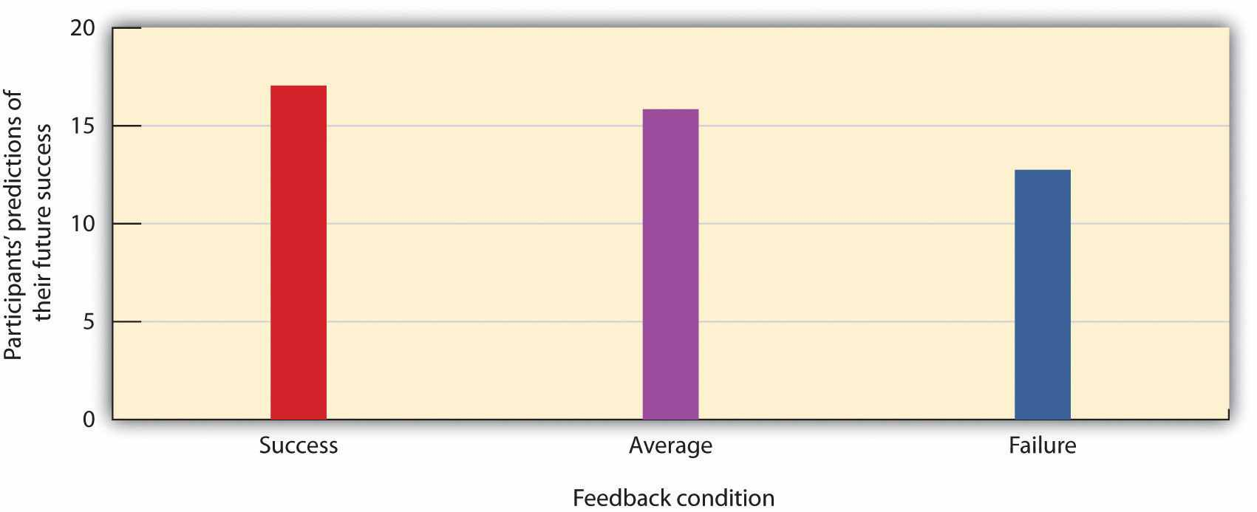
In this demonstration of the power of assimilation, participants were given initial feedback that they were good, average, or poor on a task but then told that the feedback was entirely false. The feedback, which should have been discounted, nevertheless continued to influence participants’ estimates of how well they would do on a future task. Data are from Ross, Lepper, and Hubbard (1975). ^{[16]}
Why do we tend to hold onto our beliefs rather than change them? One reason that our beliefs often outlive the evidence on which they are supposed to be based is that people come up with reasons to support their beliefs. People who learned that they were good at detecting real suicide notes probably thought of a lot of reasons why this might be the case—“Geez, I predicted that Suzy would break up with Billy” or “I knew that my Mom was going to be sad after I left for college”—whereas the people who learned that they were not good at the task probably thought of the opposite types of reasons—“I had no idea that Jean was going to drop out of high school.” You can see that these tendencies will produce assimilation—the interpretation of our experiences in ways that support our existing beliefs. Indeed, research has found that perhaps the only way to reduce our tendencies to assimilate information into our existing belief is to explicitly force people to think about exactly the opposite belief (Anderson & Sechler, 1986).^{[17]}
In some cases, our existing knowledge acts to direct our attention toward information that matches our expectations and prevents us from attempting to attend to or acknowledge conflicting information (Fiske & Neuberg, 1990). ^{[18]} To return to our example of Bianca from Rome, when we first meet her, we may immediately begin to look for signs of expressiveness in her behavior and personality. Because we expect people to confirm our expectations, we frequently respond to new people as if we already know what they are going to be like. Yaacov Trope and Erik Thompson (1997)^{[19]} found in their research that individuals addressed fewer questions to people about whom they already had strong expectations and that the questions they did ask were likely to confirm the expectations they already had. Because we believe that Italians are expressive, we expect to see that behavior in Bianca, we preferentially attend to information that confirms those beliefs, and we tend to ignore any disconfirming information. The outcome is that our expectations resist change (Fazio, Ledbetter, & Towles-Schwen, 2000). ^{[20]}
Our reliance on schemas can also make it more difficult for us to “think outside the box.” Peter Wason (1960) ^{[21]} asked college students to determine the rule that was used to generate the numbers 2-4-6 by asking them to generate possible sequences and then telling them if those numbers followed the rule. The first guess that students made was usually “consecutive ascending even numbers,” and they then asked questions designed to confirm their hypothesis (“Does 102-104-106 fit?” “What about 434-436-438?”). Upon receiving information that those guesses did fit the rule, the students stated that the rule was “consecutive ascending even numbers.” But the students’ use of the confirmation bias led them to ask only about instances that confirmed their hypothesis and not about those that would disconfirm it. They never bothered to ask whether 1-2-3 or 3-11-200 would fit; if they had, they would have learned that the rule was not “consecutive ascending even numbers” but simply “any three ascending numbers.” Again, you can see that once we have a schema (in this case, a hypothesis), we continually retrieve that schema from memory rather than other relevant ones, leading us to act in ways that tend to confirm our beliefs.
Because expectations influence what we attend to, they also influence what we remember. One frequent outcome is that information that confirms our expectations is more easily processed, is more easily understood, and thus has a bigger impact than does information that disconfirms our expectations. There is substantial research evidence indicating that when processing information about social groups, individuals tend to particularly remember information better that confirms their existing beliefs about those groups (Fyock & Stangor, 1994; Van Knippenberg & Dijksterhuis, 1996).^{[22]} If we have the (statistically erroneous) stereotype that women are bad drivers, we tend to remember the cases where we see a woman driving poorly but to forget the cases where we see a woman driving well. This of course strengthens and maintains our beliefs and produces even more assimilation. And our schemas may also be maintained because when people get together, they talk about other people in ways that tend to express and confirm existing beliefs (Ruscher & Duval, 1998; Schaller & Conway, 1999). ^{[23]}
Darley and Gross (1983) ^{[24]} demonstrated how schemas about social class could influence memory. In their research, they gave participants a picture and some information about a fourth-grade girl named Hannah. To activate a schema about her social class, Hannah was pictured sitting in front of a nice suburban house for one half of the participants and was pictured in front of an impoverished house in an urban area for the other half. Then the participants watched a video that showed Hannah taking an intelligence test. As the test went on, Hannah got some of the questions right and some of them wrong, but the number of correct and incorrect answers was the same in both conditions. Then the participants were asked to remember how many questions Hannah got right and wrong. Demonstrating that stereotypes had influenced memory, the participants who thought that Hannah had come from an upper-class background judged that she had gotten more correct answers than those who thought she was from a lower-class background.
This is not to say that we only remember information that matches our expectations. Sometimes we encounter information that is so extreme and so conflicting with our expectations that we cannot help but attend to and remember it (Srull & Wyer, 1989).^{[25]} Imagine that you have formed an impression of a good friend of yours as a very honest person. One day you discover, however, that he has taken some money from your wallet without getting your permission or even telling you. It is likely that this new information—because it is so personally involving and important—will have a dramatic effect on your perception of your friend and that you will remember it for a long time. In short, information that is either consistent with, or very inconsistent with, an existing schema or attitude is likely to be well remembered.
Still another way that our expectations tend to maintain themselves is by leading us to act toward others on the basis of our expectations, creating a self-fulfilling prophecy. A self-fulfilling prophecy is a process that occurs when our expectations about others lead us to behave toward those others in ways that make those expectations come true. If I have a stereotype that Italians are fun, then I may act toward Bianca in a friendly way. My friendly behavior may be reciprocated by Bianca, and if many other people also engage in the same positive behaviors with her, in the long run she may actually become a friendlier person, thus confirming our initial expectations. Of course, the opposite is also possible—if I believe that short people are boring or that women are overly emotional, my behavior toward short people and women may lead me to maintain those more negative, and probably inaccurate, beliefs as well.
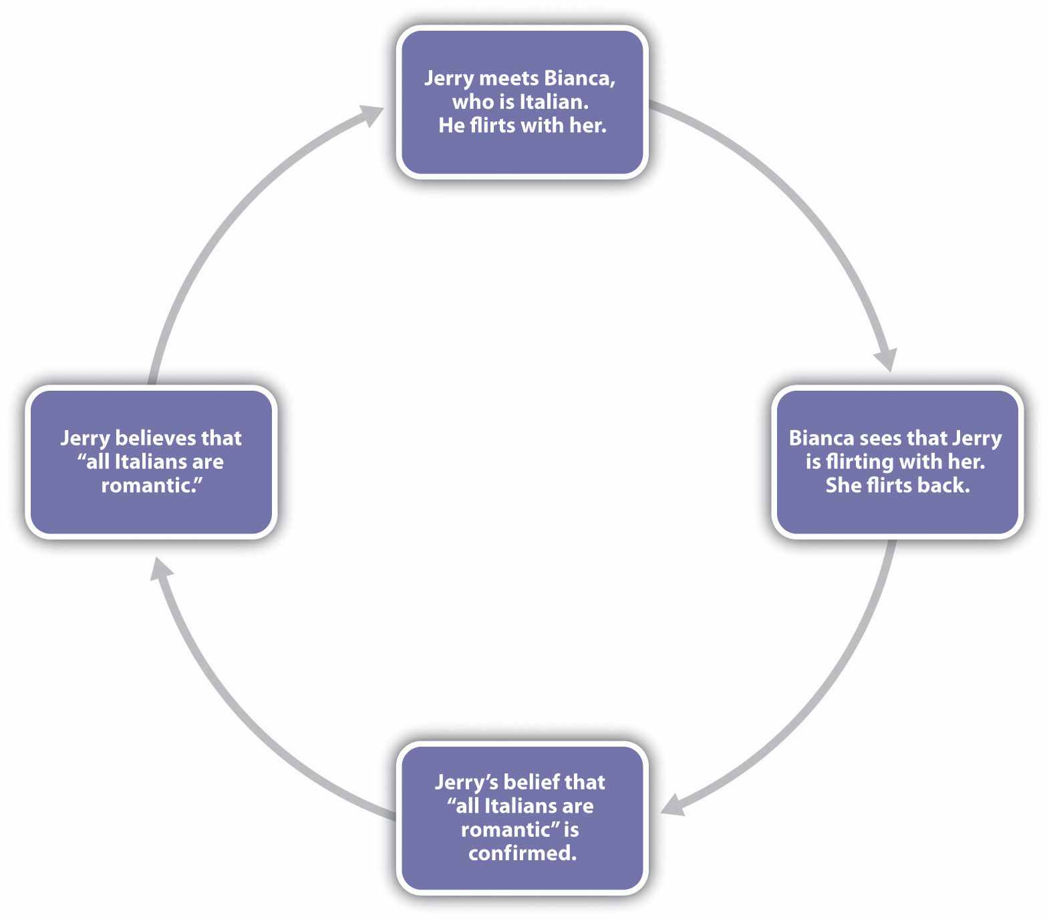
Self-fulfilling prophecies occur when our existing expectations influence our behavior toward others, thereby creating responses in those others that reinforce our existing expectations.
We can now begin to see why an individual who initially makes a judgment that a person has engaged in a given behavior (e.g., an eyewitness who believes that they saw a given person commit a crime) will find it very difficult to change his or her mind about that decision later. Even if the individual is provided with evidence that suggests that he or she was wrong, that individual will likely assimilate that information to the existing belief. Assimilation is thus one of many factors that help account for the inaccuracy of eyewitness testimony.

Research Focus
Schemas as Energy Savers
If schemas serve in part to help us make sense of the world around us, then we should be particularly likely to use them in situations where there is a lot of information to learn about, or when we have few cognitive resources available to process information. Schemas function like energy-savers, to help us keep track of things when information processing gets complicated.
Stangor and Duan (1991) ^{[26]} tested the hypothesis that people would be more likely to develop schemas when they had a lot of information to learn about. In the research, participants were shown information describing the behaviors of people who supposedly belonged to different social groups, although the groups were actually fictitious and were labeled only as the “red group,” the “blue group,” the “yellow group,” and the “green group.” Each group engaged in behaviors that were primarily either honest, dishonest, intelligent, or unintelligent. Then, after they had read about the groups, the participants were asked to judge the groups and to recall as much information that they had read about them as they could.
Stangor and Duan found that participants remembered more stereotype-supporting information about the groups, when they were required to learn about four different groups than when they only needed to learn about one group or two groups. This result is consistent with the idea that we use our stereotypes more when “the going gets rough”—that is, when we need to rely on them to help us make sense of new information.
Bodenhausen (1990) ^{[27]} presented research participants with information about court cases in jury trials. Furthermore, he had obtained self-reports from the participants about whether they considered themselves to be primarily “morning people” (those who feel better and are more alert in the morning) or “evening people” (those who are more alert in the evening). As shown in the following figure, Bodenhausen found that participants were more likely to make use of their stereotypes when they were judging the guilt or innocence of the individuals on trial at the time of day when the participants acknowledged that they were normally more fatigued. People who reported being most alert in the morning stereotyped more at night, and vice versa. This experiment thus provides more support for the idea that schemas—in this case, those about social groups—serve, in part, to make our lives easier and that we rely on them when we need to rely on cognitive efficiency—for instance, when we are tired.

Figure 2.2
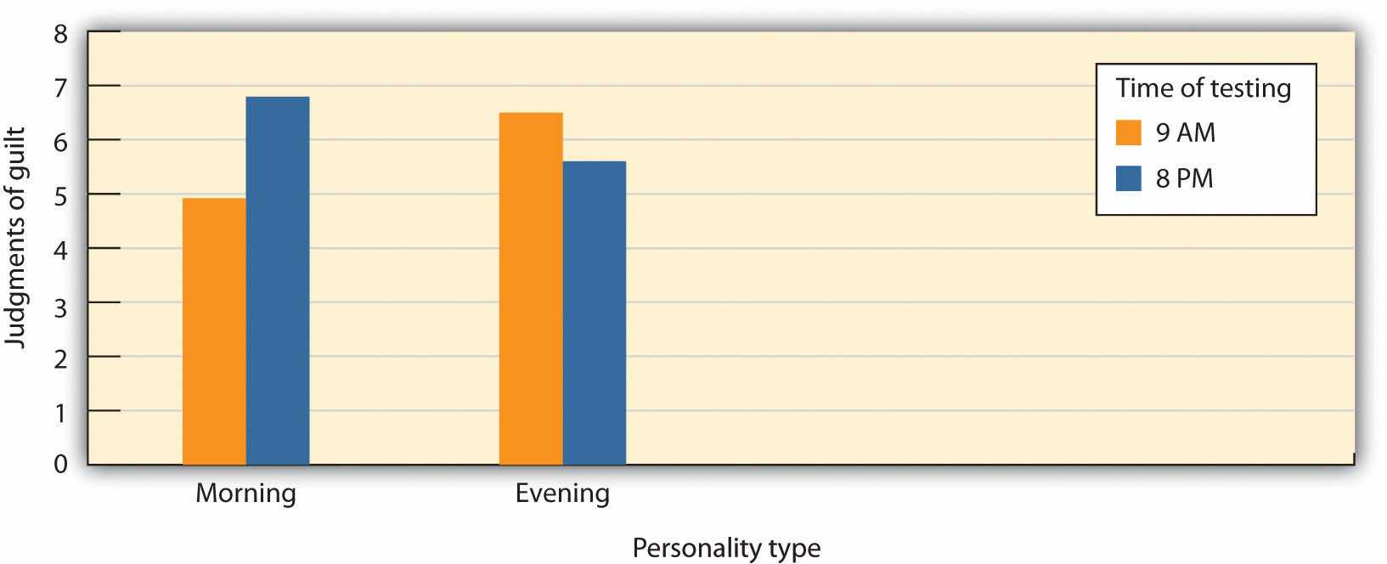
Schemas are particularly powerful when we are tired. Participants were asked to judge the degree to which a defendant was guilty of a crime for which he was accused (however unfairly) and for which the crime fit the stereotype (e.g., that student athletes were likely to cheat on exams). Participants had previously indicated whether they were “morning people” or “night people” on a questionnaire and were tested in either the morning or the evening. Data from Bodenhausen (1990). ^{[28]}

KEY TAKEAWAYS
- Human beings respond to the social challenges they face by relying on their substantial cognitive capacities.
- Our knowledge about and our responses to social events are developed and determined by operant learning, associational learning, and observational learning.
- One outcome of our experiences is the development of mental representations about our environments—schemas and attitudes. Once they have developed, our schemas influence our subsequent learning, such that the new people and situations that we encounter are interpreted and understood in terms of our existing knowledge.
- Accommodation occurs when existing schemas change on the basis of new information. Assimilation occurs when our knowledge acts to influence new information in a way that makes the conflicting information fit with our existing schemas.
- Because our expectations influence our attention and responses to, and our memory for, new information, often in a way that leads our expectations to be maintained, assimilation is generally more likely than accommodation.
- Schemas serve as energy savers. We are particularly likely to use them when we are tired or when the situation that we must analyze is complex.

EXERCISES AND CRITICAL THINKING
- Describe a time when you learned new information or new behaviors through operant, associational, or observational learning.
- Think about a time when you made a snap judgment about another person. Did your expectations about people influence your judgment of this person? Was the judgment fair or unfair?
- Consider some of your beliefs about the people you know. Were these beliefs formed through assimilation, accommodation, or a combination of both? Do you think that your expectations now influence how you respond to these people?
- Describe a time when you might have unfairly used an expectation about another person. Did the expectation serve as an energy saver?

[1] Akers, R. L. (1998). Social learning and social structure: A general theory of crime and deviance. Boston, MA: Northeastern University Press.
[2] Sigall, H., & Landy, D. (1973). Radiating beauty: Effects of having a physically attractive partner on person perception. Journal of Personality and Social Psychology, 28(2), 218–224.
[3] Hawkins, D., Best, R., & Coney, K. (1998.) Consumer behavior: Building marketing strategy(7th ed.). Boston, MA: McGraw-Hill
[4] Gorn, G. J. (1982). The effects of music in advertising on choice behavior: A classical conditioning approach. Journal of Marketing, 46(1), 94–101.
[5] Schemer, C., Matthes, J. R., Wirth, W., & Textor, S. (2008). Does “passing the Courvoisier” always pay off? Positive and negative evaluative conditioning effects of brand placements in music videos. Psychology & Marketing, 25(10), 923–943.
[6] Das, E. H. H. J., de Wit, J. B. F., & Stroebe, W. (2003). Fear appeals motivate acceptance of action recommendations: Evidence for a positive bias in the processing of persuasive messages. Personality and Social Psychology Bulletin, 29(5), 650–664; Perloff, R. M. (2003).The dynamics of persuasion: Communication and attitudes in the 21st century (2nd ed.). Mahwah, NJ: Lawrence Erlbaum Associates; Witte, K., & Allen, M. (2000). A meta-analysis of fear appeals: Implications for effective public health campaigns. Health Education & Behavior, 27(5), 591–615.
[7] Schemer, C., Matthes, J. R., Wirth, W., & Textor, S. (2008). Does “passing the Courvoisier” always pay off? Positive and negative evaluative conditioning effects of brand placements in music videos. Psychology & Marketing, 25(10), 923–943.
[8] Lewicki, P. (1985). Nonconscious biasing effects of single instances on subsequent judgments. Journal of Personality and Social Psychology, 48, 563–574.
[9] Mae, L., & Carlston, D. E. (2005). Hoist on your own petard: When prejudiced remarks are recognized and backfire on speakers. Journal of Experimental Social Psychology, 41(3), 240–255; Skowronski, J. J., Carlston, D. E., Mae, L., & Crawford, M. T. (1998). Spontaneous trait transference: Communicators take on the qualities they describe in others. Journal of Personality and Social Psychology, 74(4), 837–848.
[10] Bandura, A., & Walters, R. H. (1959). Adolescent aggression. New York, NY: Ronald Press.
[11] Bandura, A. (1977). Self-efficacy: Toward a unifying theory of behavior change.Psychological Review, 84, 191–215.
[12] Mitchell, J. P., Mason, M. F., Macrae, C. N., & Banaji, M. R. (2006). Thinking about others: The neural substrates of social cognition. In J. T. Cacioppo, P. S. Visser, & C. L. Pickett (Eds.),Social neuroscience: People thinking about thinking people (pp. 63–82). Cambridge, MA: MIT Press.
[13] Koenigs, M., Young, L., Adolphs, R., Tranel, D., Cushman, F., Hauser, M., & Damasio, A. (2007). Damage to the prefontal cortex increases utilitarian moral judgments. Nature, 446(7138), 908–911.
[14] Piaget, J., and Inhelder, B. (1962). The psychology of the child. New York, NY: Basic Books; Taylor, S. E., & Crocker, J. (1981). Schematic bases of social information processing. In E. T. Higgins, C. P. Herman, & M. P. Zanna (Eds.), Social cognition: The Ontario symposium (Vol. 1, pp. 89–134). Hillsdale, NJ: Lawrence Erlbaum Associates.
[15] Ross, L., Lepper, M. R., & Hubbard, M. (1975). Perseverance in self-perception and social perception: Biased attributional processes in the debriefing paradigm. Journal of Personality & Social Psychology, 32, 880–892.
[16] Ross, L., Lepper, M. R., & Hubbard, M. (1975). Perseverance in self-perception and social perception: Biased attributional processes in the debriefing paradigm. Journal of Personality and Social Psychology, 32, 880–892.
[17] Anderson, C. A., & Sechler, E. S. (1986). Effects of explanation and counterexplanation on the development and use of social theories. Journal of Personality and Social Psychology, 50(1), 24–34.
[18] Fiske, S. T., & Neuberg, S. L. (1990). A continuum of impression formation, from category based to individuating processes: Influences of information and motivation on attention and interpretation. In M. P. Zanna (Ed.), Advances in experimental social psychology (Vol. 23, pp. 1–74). New York, NY: Academic.
[19] Trope, Y., & Thompson, E. (1997). Looking for truth in all the wrong places? Asymmetric search of individuating information about stereotyped group members. Journal of Personality and Social Psychology, 73, 229–241.
[20] Fazio, R. H., Ledbetter, J. E., & Towles-Schwen, T. (2000). On the costs of accessible attitudes: Detecting that the attitude object has changed. Journal of Personality and Social Psychology, 78(2), 197–210.
[21] Wason, P. (1960). On the failure to eliminate hypotheses in a conceptual task. The Quarterly Journal of Experimental Psychology, 12(3), 129–140.
[22] Fyock, J., & Stangor, C. (1994). The role of memory biases in stereotype maintenance.British Journal of Social Psychology, 33, 331–343; Van Knippenberg, A., & Dijksterhuis, A. (1996). A posteriori sterotype activation: The preservation of sterotypes through memory distortion. Social Cognition, 14, 21–54.
[23] Ruscher, J. B., & Duval, L. L. (1998). Multiple communicators with unique target information transmit less stereotypical impressions. Journal of Personality and Social Psychology, 74(2), 329–344; Schaller, M., & Conway, G. (1999). Influence of impression-management goals on the emerging content of group stereotypes: Support for a social-evolutionary perspective. Personality and Social Psychology Bulletin, 25, 819–833.
[24] Darley, J. M., & Gross, P. H. (1983). A hypothesis-confirming bias in labeling effects.Journal of Personality and Social Psychology, 44, 20–33.
[25] Srull, T., & Wyer, R. (1989). Person memory and judgment. Psychological Review, 96(1), 58–83.
[26] Stangor, C., & Duan, C. (1991). Effects of multiple task demands upon memory for information about social groups. Journal of Experimental Social Psychology, 27, 357–378.
[27] Bodenhausen, G. V. (1990). Stereotypes as judgmental heuristics: Evidence of circadian variations in discrimination. Psychological Science, 1, 319–322.
[28] Bodenhausen, G. V. (1990). Stereotypes as judgmental heuristics: Evidence of circadian variations in discrimination. Psychological Science, 1, 319–322.

2.2 How We Use Our Expectations

LEARNING OBJECTIVES
- Provide examples of how salience and accessibility influence information processing.
- Review, differentiate, and give examples of the cognitive heuristics that influence social judgment.
- Summarize and give examples of the importance of social cognition in everyday life.
Once we have developed a set of schemas and attitudes, we naturally use that information to help us judge and respond to others. Our expectations help us think about, size up, and make sense of individuals, groups of people, and the relationships among people. If we have learned, for example, that someone is friendly and interested in us, we are likely to approach them; if we have learned that they are threatening or unlikable, we will be more likely to withdraw. And if we believe that a person has committed a crime, we may process new information in a manner that helps convince us that our judgment was correct. In this section, we will consider how we use our stored knowledge to come to accurate (and sometimes inaccurate) conclusions about our social worlds. Table 2.1 "How Expectations Influence Our Social Cognition"summarizes the concepts that we will discuss, some of the many ways that our existing schemas and attitudes influence how we respond to the information around us.

Table 2.1 How Expectations Influence Our Social Cognition
Cognitive Process | Description | Example
Cognitive accessibility | Some schemas and attitudes are more accessible than others. | We may think a lot about our new haircut because it is important to us.
Salience | Some stimuli, such as those that are unusual, colorful, or moving, grab our attention. | We may base our judgments on a single unusual event and ignore hundreds of other events that are more usual.
Representativeness heuristic | We tend to make judgments according to how well the event matches our expectations. | After a coin has come up heads many times in a row, we may erroneously think that the next flip is more likely to be tails.
Availability heuristic | Things that come to mind easily tend to be seen as more common. | We may overestimate the crime statistics in our own area because these crimes are so easy to recall.
Anchoring and adjustment | Although we try to adjust our judgments away from them, our decisions are overly based on the things that are most highly accessible in memory. | We may buy more of a product when it is advertised in bulk than when it is advertised as a single item.
Counterfactual thinking | We may “replay” events such that they turn out differently—especially when only minor changes in the events leading up to them make a difference. | We may feel particularly bad about events that might not have occurred if only a small change might have prevented them.
False consensus bias | We tend to see other people as similar to us. | We are surprised when other people have different political opinions or values.
Overconfidence | We tend to have more confidence in our skills, abilities, and judgments than is objectively warranted. | Eyewitnesses are often extremely confident that their identifications are accurate, even when they are not.

Automatic Versus Controlled Cognition
A good part of both cognition and social cognition is spontaneous or automatic.Automatic cognition refers to thinking that occurs out of our awareness, quickly, and without taking much effort (Ferguson & Bargh, 2003; Ferguson, Hassin, & Bargh, 2008). ^{[1]} The things that we do most frequently tend to become more automatic each time we do them, until they reach a level where they don’t really require us to think about them very much. Most of us can ride a bike and operate a television remote control in an automatic way. Even though it took some work to do these things when we were first learning them, it just doesn’t take much effort anymore. And because we spend a lot of time making judgments about others, many of these judgments (and particularly those about people we don’t know very well and who don’t matter much to us) are made automatically (Willis & Todorov, 2006). ^{[2]}
Because automatic thinking occurs outside of our conscious awareness, we frequently have no idea that it is occurring and influencing our judgments or behaviors. You might remember a time when you came back from your classes, opened the door to your dorm room, and 30 seconds later couldn’t remember where you had put your keys! You know that you must have used the keys to get in, and you know you must have put them somewhere, but you simply don’t remember a thing about it. Because many of our everyday judgments and behaviors are performed “on automatic,” we may not always be aware that they are occurring or influencing us.
It is of course a good thing that many things operate automatically because it would be a real pain to have to think about them all the time. If you couldn’t drive a car automatically, you wouldn’t be able to talk to the other people riding with you or listen to the radio at the same time—you’d have to be putting most of your attention into driving. On the other hand, relying on our snap judgments about Bianca—that she’s likely to be expressive, for instance—can be erroneous. Sometimes we need to—and should—go beyond automatic cognition and consider people more carefully. When we deliberately size up and think about something—for instance another person—we call it thoughtful cognition or controlled cognition.
Although you might think that controlled cognition would be more common and that automatic thinking would be less likely, that is not always the case. The problem is that thinking takes effort and time, and we often don’t have too much of those things available. As a result, we frequently rely on automatic cognition, and these processes—acting outside of our awareness—have a big effect on our behaviors. In the following Research Focus, we will consider an example of a study that uses a common social cognitive procedure known as priming—a technique in which information is temporarily brought into memory through exposure to situational events—and that shows that priming can influence judgments entirely out of awareness.

Research Focus
Behavioral Effects of Priming
In one demonstration of how automatic cognition can influence our behaviors without us being aware of them, John Bargh and his colleagues (Bargh, Chen, & Burrows, 1996) ^{[3]} conducted two studies, each with the exact same procedure. In the experiments, they showed college students sets of five scrambled words. The students were to unscramble the five words in each set to make a sentence. Furthermore, for half of the research participants, the words were related to the stereotype of the elderly. These participants saw words such as “in Florida retired live people” and “bingo man the forgetful plays.”
The other half of the research participants also made sentences but did so out of words that had nothing to do with the elderly stereotype. The purpose of this task was to prime (activate) the schema of elderly people in memory for some of the participants but not for others.
The experimenters then assessed whether the priming of elderly stereotypes would have any effect on the students’ behavior—and indeed it did. When each research participant had gathered all his or her belongings, thinking that the experiment was over, the experimenter thanked him or her for participating and gave directions to the closest elevator. Then, without the participant knowing it, the experimenters recorded the amount of time that the participant spent walking from the doorway of the experimental room toward the elevator. As you can see in the following figure, the same results were found in both experiments—the participants who had made sentences using words related to the elderly stereotype took on the behaviors of the elderly—they walked significantly more slowly (in fact, about 12% more slowly across the two studies) as they left the experimental room.

Figure 2.3Automatic Priming and Behavior
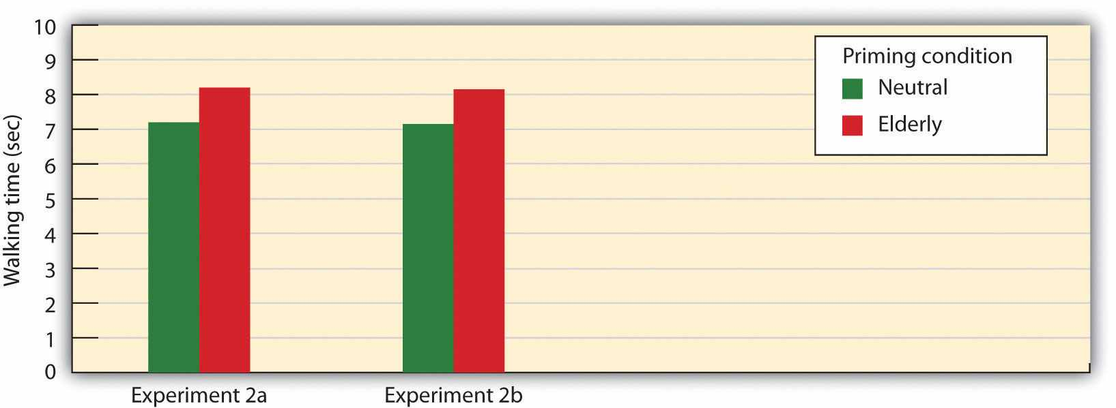
In two separate experiments, Bargh, Chen, and Borroughs (1996) ^{[4]} found that students who had been exposed to words related to the elderly stereotype walked more slowly than those who had been exposed to more neutral words.
To determine if these priming effects occurred out of the conscious awareness of the participants, Bargh and his colleagues asked a third group of students to complete the priming task and then to indicate whether they thought the words they had used to make the sentences had any relationship to each other or could possibly have influenced their behavior in any way. These students had no awareness of the possibility that the words might have been related to the elderly or could have influenced their behavior.
The point of these experiments, and many others like them, is clear—it is quite possible that our judgments and behaviors are influenced by our social situations, and this influence may be entirely outside of our conscious awareness. To return again to Bianca, it is even possible that we notice her nationality and that our beliefs about Italians influence our responses to her, even though we have no idea that they are doing so and really believe that they have not. It is in this way that our stereotypes may have their insidious effects, and it is exactly these processes that may have led to a mistaken eyewitness account in the case of Rickie Johnson.

Salience and Accessibility Determine Which Expectations We Use
We each have a large number of schemas that we might bring to bear on any type of judgment we might make. When thinking about Bianca, for instance, we might focus on her nationality, her gender, her physical attractiveness, her intelligence, or any of many other possible features. And we will react to Bianca differently depending on which schemas we use. Schema activation is determined both by characteristics of the person we are judging—the salience of the characteristics—and by the current activation of the schema in the individual—the cognitive accessibility of the schema.

Salience
One determinant of which schemas are likely to be used in social judgment is the extent to which we attend to particular features of the person or situation that we are responding to. We are more likely to judge people on the basis of characteristics that are salient, meaning that they attract our attention when we see something or someone with them. Things that are unusual, negative, colorful, bright, and moving are more salient and thus more likely to be attended to than are things that do not have these characteristics (McArthur & Post, 1977; Taylor & Fiske, 1978). ^{[5]}
We are more likely to initially judge people on the basis of their sex, race, age, and physical attractiveness, rather than on, say, their religious orientation or their political beliefs, in part because these features are so salient when we see them (Brewer, 1988). ^{[6]} Another thing that makes something particularly salient is its infrequency or unusualness. Because Bianca is from Italy and very few other people in our school are, that characteristic is something that we notice—it is salient, and we are therefore likely to attend to it. That she is also a woman is—at least in this context—less salient.
The salience of the stimuli in our social worlds may sometimes lead us to make judgments on the basis of information that is actually less informative than is other less salient information. Imagine, for instance, that you wanted to buy a new music player for yourself. You’ve been trying to decide whether to get the iPod or the Zune. You went online and checked out Consumer Reports, and you found that although the players differed on many dimensions, including price, battery life, ability to share music, and so forth, the Zune was nevertheless rated significantly higher by the owners than was the iPod. As a result, you decide to go purchase one the next day. That night, however, you go to a party, and a friend of yours shows you her iPod. You check it out, and it seems really great. You tell her that you were thinking of buying a Zune, and she tells you that you are crazy. She says she knows someone who had one and had a lot of problems—it didn’t download music right, the battery went out right after it went out of warranty, and so forth—and that she would never buy one. Would you still buy the Zune, or would you switch your plans?
If you think about this question logically, the information that you just got from your friend isn’t really all that important—you now know the opinions of one more person, but that can’t really change the overall consumer ratings of the two machines very much. On the other hand, the information your friend gives you and the chance to use her iPod are highly salient. The information is right there in front of you, in your hand, whereas the statistical information from Consumer Reports is only in the form of a table that you saw on your computer. The outcome in cases such as this is that people frequently ignore the less salient, but more important, information, such as the likelihood that events occur across a large population—these statistics are known asbase rates—in favor of the actually less important, but nevertheless more salient, information.
Another case in which we ignore base-rate information occurs when we use therepresentativeness heuristic (remember that heuristic refers to a simplifying strategy that we use to make judgments). The representativeness heuristic occurs when we base our judgments on information that seems to represent, or match, what we expect will happen while ignoring more informative base-rate information. Consider, for instance, the following puzzle. Let’s say that you went to a hospital, and you checked the records of the babies that were born today (Table 2.2 "Using the Representativeness Heuristic"). Which pattern of births do you think that you are most likely to find?

Table 2.2 Using the Representativeness Heuristic
List A |  | List B
6:31 a.m. | Girl | 6:31 a.m. | Boy
8:15 a.m. | Girl | 8:15 a.m. | Girl
9:42 a.m. | Girl | 9:42 a.m. | Boy
1:13 p.m. | Girl | 1:13 p.m. | Girl
3:39 p.m. | Boy | 3:39 p.m. | Girl
5:12 p.m. | Boy | 5:12 p.m. | Boy
7:42 p.m. | Boy | 7:42 p.m. | Girl
11:44 p.m. | Boy | 11:44 p.m. | Boy
Most people think that list B is more likely, probably because list B looks more random and thus matches (is “representative of”) our ideas about randomness. But statisticians know that any pattern of four girls and four boys is equally likely and thus that List B is no more likely than List A. The problem is that we have an image of what randomness should be, which doesn’t always match what is rationally the case. Similarly, people who see a coin that comes up heads five times in a row will frequently predict (and perhaps even bet!) that tails will be next—it just seems like it has to be. But mathematically, this erroneous expectation (known as the gambler’s fallacy) is simply not true: The base-rate likelihood of any single coin flip being tails is only 50%, regardless of how many times it has come up heads in the past.
To take one more example, consider the following information:
I have a friend who is short, shy, and writes poetry. Which of the following is she? (Choose one.)
—A professor of psychology
—A professor of Chinese
Can you see how you might be led, potentially incorrectly, into thinking that my friend is a professor of Chinese? Why? Because the description (“short, shy, and writes poetry”) just seems so representative or stereotypical of our expectations about Chinese people. But the base rates tell us something completely different, which might make us wary. For one, because I am a psychology professor, it’s much more likely that I know more psychology professors than Chinese professors. And at least on my campus, the number of professors in the psychology department is much bigger than the number of professors of Chinese. Although base rates suggest that “psychology” would be the right answer, the use of the representative heuristic might lead us (probably incorrectly) to guess “Chinese” instead.

Cognitive Accessibility
Although which characteristics we use to think about objects or people is determined in part by the salience of their characteristics (our perceptions are influenced by our social situation), individual differences in the person who is doing the judging are also important (our perceptions are influenced by person variables). People vary in the schemas that they find important to use when judging others and when thinking about themselves. One way to consider this importance is in terms of the cognitive accessibility of the schema. Cognitive accessibility refers to the extent to which a schema is activated in memory and thus likely to be used in information processing.
You probably know people who are golf nuts (or maybe tennis or some other sport nuts). All they can talk about is golf. For them, we would say that golf is a highly accessible construct. Because they love golf, it is important to their self-concept; they set many of their goals in terms of the sport, and they tend to think about things and people in terms of it (“if he plays golf, he must be a good person!”). Other people have highly accessible schemas about eating healthy food, exercising, environmental issues, or really good coffee, for instance. In short, when a schema is accessible, we are likely to use it to make judgments of ourselves and others.
Although accessibility can be considered a person variable (a given idea is more highly accessible for some people than for others), accessibility can also be influenced by situational factors. When we have recently or frequently thought about a given topic, that topic becomes more accessible and is likely to influence our judgments. This is in fact the explanation for the results of the priming study you read about earlier—people walked slower because the concept of elderly had been primed and thus was currently highly accessible for them.
Because we rely so heavily on our schemas and attitudes—and particularly on those that are salient and accessible—we can sometimes be overly influenced by them. Imagine, for instance, that I asked you to close your eyes and determine whether there are more words in the English language that begin with the letter R or that have the letter R as the third letter. You would probably try to solve this problem by thinking of words that have each of the characteristics. It turns out that most people think there are more words that begin with R, even though there are in fact more words that haveR as the third letter.
You can see that this error can occur as a result of cognitive accessibility. To answer the question, we naturally try to think of all the words that we know that begin with Rand that have R in the third position. The problem is that when we do that, it is much easier to retrieve the former than the latter, because we store words by their first, not by their third, letter. We may also think that our friends are nice people because we see them primarily when they are around us (their friends). And the traffic might seem worse in our own neighborhood than we think it is in other places, in part because nearby traffic jams are more accessible for us than are traffic jams that occur somewhere else. And do you think it is more likely that you will be killed in a plane crash or in a car crash? Many people fear the former, even though the latter is much more likely: Your chances of being involved in an aircraft accident are about 1 in 11 million, whereas your chances of being killed in an automobile accident are 1 in 5,000—over 50,000 people are killed on U.S. highways every year. In this case, the problem is that plane crashes, which are highly salient, are more easily retrieved from our memory than are car crashes, which are less extreme.
The tendency to make judgments of the frequency of an event, or the likelihood that an event will occur, on the basis of the ease with which the event can be retrieved from memory is known as the availability heuristic (Schwarz & Vaughn, 2002; Tversky & Kahneman, 1973). ^{[7]} The idea is that things that are highly accessible (in this case, the term availability is used) come to mind easily and thus may overly influence our judgments. Thus, despite the clear facts, it may be easier to think of plane crashes than of car crashes because the former are so highly salient. If so, the availability heuristic can lead to errors in judgments.
Still another way that the cognitive accessibility of constructs can influence information processing is through their effects on processing fluency. Processing fluency refers to the ease with which we can process information in our environments. When stimuli are highly accessible, they can be quickly attended to and processed, and they therefore have a large influence on our perceptions. This influence is due, in part, to the fact that our body reacts positively to information that we can process quickly, and we use this positive response as a basis of judgment (Reber, Winkielman, & Schwarz, 1998; Winkielman & Cacioppo, 2001). ^{[8]}
In one study demonstrating this effect, Norbert Schwarz and his colleagues (Schwarz et al., 1991) ^{[9]} asked one set of college students to list 6 occasions when they had acted either assertively or unassertively and asked another set of college students to list 12 such examples. Schwarz determined that for most students, it was pretty easy to list 6 examples but pretty hard to list 12.
The researchers then asked the participants to indicate how assertive or unassertive they actually were. You can see from Figure 2.4 "Processing Fluency" that the ease of processing influenced judgments. The participants who had an easy time listing examples of their behavior (because they only had to list 6 instances) judged that they did in fact have the characteristics they were asked about (either assertive or unassertive), in comparison with the participants who had a harder time doing the task (because they had to list 12 instances). Other research has found similar effects—people rate that they ride their bicycles more often after they have been asked to recall only a few rather than many instances of doing so (Aarts & Dijksterhuis, 1999), ^{[10]}and they hold an attitude with more confidence after being asked to generate few rather than many arguments that support it (Haddock, Rothman, Reber, & Schwarz, 1999).^{[11]}

Figure 2.4 Processing Fluency
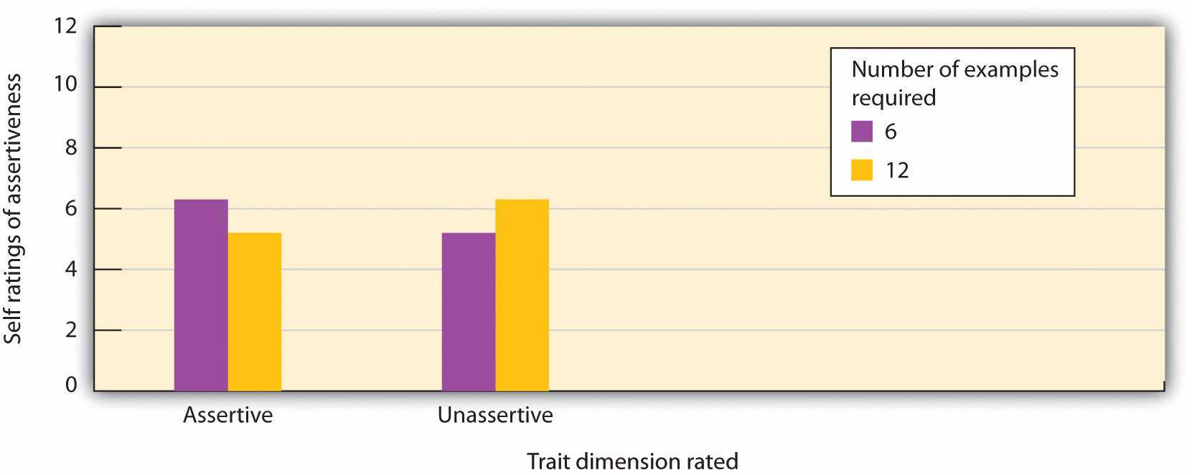
When it was relatively easy to complete the questionnaire (only 6 examples were required), the student participants rated that they had more of the trait than when the task was more difficult (12 answers were required). Data are from Schwarz et al. (1991). ^{[12]}
We are likely to use this type of quick and “intuitive” processing, based on our feelings about how easy it is to complete a task, when we don’t have much time or energy for more in-depth processing, such as when we are under time pressure, tired, or unwilling to process the stimulus in sufficient detail. Of course, it is very adaptive to respond to stimuli quickly (Sloman, 2002; Stanovich & West, 2002; Winkielman, Schwarz, & Nowak, 2002), ^{[13]} and it is not impossible that in at least some cases, we are better off making decisions based on our initial responses than on a more thoughtful cognitive analysis (Loewenstein, weber, Hsee, & Welch, 2001). ^{[14]} For instance, Dijksterhuis, Bos, Nordgren, and van Baaren (2006) ^{[15]} found that when participants were given tasks requiring decisions that were very difficult to make on the basis of a cognitive analysis of the problem, they made better decisions when they didn’t try to analyze the details carefully but simply relied on their unconscious intuition.
In sum, people are influenced not only by the information they get but by how they get it. We are more highly influenced by things that are salient and accessible and thus easily attended to, remembered, and processed. On the other hand, information that is harder to access from memory, is less likely to be attended to, or takes more effort to consider is less likely to be used in our judgments, even if this information is statistically equally informative or even more informative.

The False Consensus Bias Makes Us Think That We Are More Like Others Than We Really Are
The tendency to base our judgments on the accessibility of social constructs can lead to still other errors in judgment. One such error is known as the false consensus bias:the tendency to overestimate the extent to which other people are similar to us. For instance, if you are in favor of abortion rights, opposed to gun control, and prefer rock music to jazz, then you are likely to think that other people share these beliefs (Ross, Greene, & House, 1977). ^{[16]} In one demonstration of the false consensus bias, Joachim Krueger and his colleagues (Krueger & Clement, 1994) ^{[17]} gave their research participants, who were college students, a personality test. Then they asked the same participants to estimate the percentage of other students in their school who would have answered the questions the same way that they did. The students who agreed with the items thought that others would agree with them too, whereas the students who disagreed thought that others would also disagree. You can see that the false consensus bias also occurs through the operation of cognitive accessibility: Once we have indicated our own belief, it becomes highly accessible, and it colors our estimates about other people.
Although it is commonly observed, the false consensus bias does not occur on all dimensions. Specifically, the false consensus bias is not usually observed on judgments of positive personal traits that we highly value as important. People (falsely, of course) report that they have better personalities (e.g., a better sense of humor), that they engage in better behaviors (e.g., they are more likely to wear seat belts), and that they have brighter futures than almost everyone else (Chambers, 2008). ^{[18]} These results suggest that although in most cases we assume that we are similar to others, in cases of valued personal characteristics the goals of self-concern lead us to see ourselves more positively than we see the average person.

Perceptions of What “Might Have Been” Lead to Counterfactual Thinking
In addition to influencing our judgments about ourselves and others, the salience and accessibility of information can have an important effect on our own emotions—for instance, our self-esteem. Our emotional reactions to events are often colored not only by what did happen but also by what might have happened. If we can easily imagine an outcome that is better than what actually happened, then we may experience sadness and disappointment; on the other hand, if we can easily imagine that a result might have been worse that what actually happened, we may be more likely to experience happiness and satisfaction. The tendency to think about events according to what might have been is known as counterfactual thinking (Roese, 1997). ^{[19]}
Imagine, for instance, that you were participating in an important contest, and you won the silver medal. How would you feel? Certainly you would be happy that you won, but wouldn’t you probably also be thinking a lot about what might have happened if you had been just a little bit better—you might have won the gold medal! On the other hand, how might you feel if you won the bronze medal (third place)? If you were thinking about the counterfactual (the “what might have been”), perhaps the idea of not getting any medal at all would have been highly accessible—you’d be happy that you got the medal you did get.
Medvec, Madey, and Gilovich (1995) ^{[20]} investigated exactly this idea by videotaping the responses of athletes who won medals in the 1992 summer Olympic Games. They videotaped the athletes both as they learned that they had won a silver or a bronze medal and again as they were awarded the medal. Then they showed these videos, without any sound, to people who did not know which medal which athlete had won. The raters indicated how they thought the athlete was feeling, on a range from “agony” to “ecstasy.” The results showed that the bronze medalists did indeed seem to be, on average, happier than were the silver medalists. Then in a follow-up study, raters watched interviews with many of these same athletes as they talked about their performance. The raters indicated what we would expect on the basis of counterfactual thinking—the silver medalists talked about their disappointments in having finished second rather than first, whereas the bronze medalists focused on how happy they were to have finished third rather than fourth.
You might have experienced counterfactual thinking in other situations. I remember once that I was driving across the country and my car was having some engine trouble. I really, really wanted to make it home when I got near the end of my journey because I could tell that I was going to be very disappointed if the car broke down only a few miles before I got home (it would have been really easy to have imagined making it the whole way, making it even more painful if I did not). Counterfactual thinking has even been observed on juries—people who are asked to award monetary damages to others who had been in an accident offered them substantially more in compensation if they were almost not injured than they did if the accident did not seem close to not occurring (Miller, Turnbull, & McFarland, 1988). ^{[22]}
Again, the moral of the story is clear—our thinking is frequently influenced by processes that we are not aware of and that may lead us to make judgments that seem reasonable but are objectively inaccurate. In the case of counterfactual thinking, the cognitive accessibility of the potential alternative outcome leads to some very paradoxical effects.

Anchoring and Adjustment Lead Us to Accept Ideas That We Should Revise
In some cases, we may be aware of the danger of acting on our expectations and attempt to adjust for them. Perhaps you have been in a situation where you are beginning a course with a new professor and you know that a good friend of yours does not like him. You may be thinking that you want to go beyond your negative expectation and prevent this knowledge from biasing your judgment. However, the accessibility of the initial information frequently prevents this adjustment from occurring—leading us to anchor on the initial construct and not adjust sufficiently. This is called the problem of anchoring and adjustment.
Tversky and Kahneman (1974) ^{[23]} asked some of the student participants in one of their studies to solve this multiplication problem quickly and without using a calculator:
1 × 2 × 3 × 4 × 5 × 6 × 7 × 8
They asked other participants to solve this problem:
8 × 7 × 6 × 5 × 4 × 3 × 2 × 1
They found that students who saw the first problem gave an estimated answer of about 512, whereas the students who saw the second problem estimated about 2,250. Tversky and Kahneman argued that the students couldn’t solve the whole problem in their head, so they did the first few multiplications and then used the outcome of this preliminary calculation as their starting point, or anchor. Then the participants used their starting estimate to find an answer that sounded plausible. In both cases, the estimates were too low relative to the true value of the product (which is 40,320)—but the first set of guesses were even lower because they started from a lower anchor.
Of course, savvy marketers have long used the anchoring phenomenon to help them. You might not be surprised to hear that people are more likely to buy more products when they are listed as four for $1.00 than when they are listed as $0.25 each (leading people to anchor on the four and perhaps adjust only a bit away) and when a sign says “buy a dozen” rather than “buy one.”
And it is no accident that a car salesperson always starts negotiating with a high price and then works down. The salesperson is trying to get the consumer anchored on the high price with the hope that it will have a big influence on the final sale value.

Overconfidence
Still another potential judgmental bias, and one that has powerful and often negative effects on our judgments, is the tendency to be overconfident in our own skills, abilities, and judgments. We often have little awareness of our own limitations, leading us to act as if we are more certain about things than we should be, particularly on tasks that are difficult. Adams and Adams (1960) ^{[24]} found that for words that were difficult to spell, people were correct in spelling them only about 80% of the time, even though they indicated that they were “100% certain” that they were correct. David Dunning and his colleagues (Dunning, Griffin, Milojkovic, & Ross, 1990) ^{[25]} asked college students to predict how another student would react in various situations. Some participants made predictions about a fellow student whom they had just met and interviewed, and others made predictions about their roommates. In both cases, participants reported their confidence in each prediction, and accuracy was determined by the responses of the target persons themselves. The results were clear: Regardless of whether they judged a stranger or a roommate, the students consistently overestimated the accuracy of their own predictions (Figure 2.5).

Figure 2.5
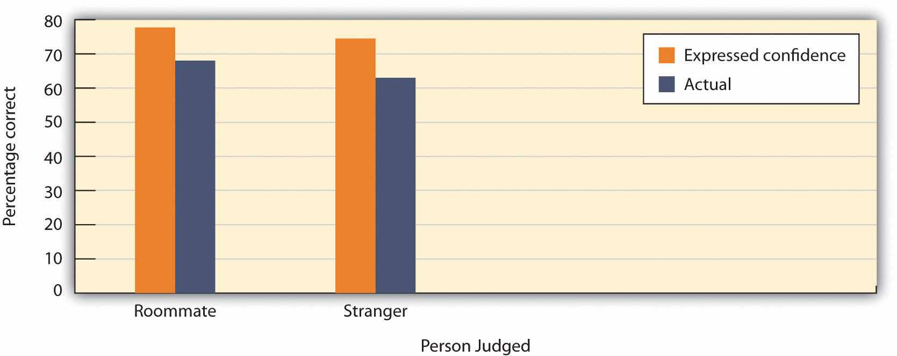
Dunning et al.(1990) ^{[26]} found that, regardless of whether they were judging strangers or their roommates, students were overconfident. The percentage confidence that they assigned to their own predictions was significantly higher than the actual percentage of their predictions that were correct.
Making matters even worse, Kruger and Dunning (1999) ^{[27]} found that people who scored low rather than high on tests of spelling, logic, grammar, and humor appreciation were also most likely to show overconfidence by overestimating how well they would do. Apparently, poor performers are doubly cursed—they not only are unable to predict their own skills but also are the most unaware that they can’t do so (Dunning, Johnson, Ehrlinger, & Kruger, 2003). ^{[28]}
The tendency to be overconfident in our judgments can have some very negative effects. When eyewitnesses testify in courtrooms regarding their memories of a crime, they often are completely sure that they are identifying the right person. But their confidence doesn’t correlate much with their actual accuracy. This is, in part, why so many people have been wrongfully convicted on the basis of inaccurate eyewitness testimony given by overconfident witnesses (Wells & Olson, 2003). ^{[29]}

The Importance of Cognitive Biases in Everyday Life
Perhaps you are thinking that the use of heuristics and the tendency to be influenced by salience and accessibility don’t seem that important—who really cares if we buy an iPod when the Zune is better, or if we think there are more words that begin with the letter R than there actually are? These aren’t big problems in the overall scheme of things. But it turns out that what seem perhaps to be pretty small errors and biases on the surface can have profound consequences for people.
For one, if the errors occur for a lot of people, they can really add up. Why would so many people continue to buy lottery tickets or to gamble their money in casinos when the likelihood of them ever winning is so low? One possibility, of course, is the representative heuristic—people ignore the low base rates of winning and focus their attention on the salient likelihood of winning a huge prize. And the belief in astrology, which all scientific evidence suggests is not accurate, is probably driven in part by the salience of the occasions when the predictions do occur—when a horoscope is correct (which it will of course be sometimes), the correct prediction is highly salient and may allow people to maintain the (overall false) belief.
People may also take more care to prepare for unlikely events than for more likely ones because the unlikely ones are more salient or accessible. For instance, people may think that they are more likely to die from a terrorist attack or as the result of a homicide than they are from diabetes, stroke, or tuberculosis. But the odds are much greater of dying from the health problems than from the terrorism or homicide. Because people don’t accurately calibrate their behaviors to match the true potential risks, the individual and societal costs are quite large (Slovic, 2000). ^{[30]}
Salience and accessibility also color how we perceive our social worlds, which may have a big influence on our behavior. For instance, people who watch a lot of violent television shows also tend to view the world as more dangerous in comparison to those who watch less violent TV (Doob & Macdonald, 1979). ^{[31]} This follows from the idea that our judgments are based on the accessibility of relevant constructs. We also overestimate our contribution to joint projects (Ross & Sicoly, 1979), ^{[32]} perhaps in part because our own contributions are so obvious and salient, whereas the contributions of others are much less so. And the use of cognitive heuristics can even affect our views about global warming. Joireman, Barnes, Truelove, and Duell (2010)^{[33]} found that people were more likely to believe in the existence of global warming when they were asked about it on hotter rather than colder days and when they had first been primed with words relating to heat. Thus the principles of salience and accessibility, because they are such an important part of our social judgments, can create a series of biases that can make a difference.
Research has found that even people who should know better—and who need to know better—are subject to cognitive biases. Economists, stock traders, managers, lawyers, and even doctors have been found to make the same kinds of mistakes in their professional activities that people make in their everyday lives (Byrne & McEleney, 2000; Gilovich, Griffin, & Kahneman, 2002; Hilton, 2001). ^{[34]} And the use of cognitive heuristics is increased when people are under time pressure (Kruglanski & Freund, 1983) ^{[35]} or when they feel threatened (Kassam, Koslov, & Mendes, 2009),^{[36]} exactly the situations that may occur when professionals are required to make their decisions.
Although biases are common, they are not impossible to control, and psychologists and other scientists are working to help people make better decisions. One possibility is to provide people with better feedback. Weather forecasters, for instance, are quite accurate in their decisions, in part because they are able to learn from the clear feedback that they get about the accuracy of their predictions. Other research has found that accessibility biases can be reduced by leading people to consider multiple alternatives rather than focusing only on the most obvious ones, and particularly by leading people to think about exactly the opposite possible outcomes than the ones they are expecting (Hirt, Kardes, & Markman, 2004). ^{[37]} And people can also be trained to make better decisions. For instance, Lehman, Lempert, and Nisbett (1988)^{[38]} found that graduate students in medicine, law, and chemistry, but particularly those in psychology, all showed significant improvement in their ability to reason correctly over the course of their graduate training.

Social Psychology in the Public Interest
The Validity of Eyewitness Testimony
As we have seen in the story of Rickie Johnson that opens this chapter, one social situation in which the accuracy of our person-perception skills is vitally important is the area of eyewitness testimony (Charman & Wells, 2007; Toglia, Read, Ross, & Lindsay, 2007; Wells, Memon, & Penrod, 2006). ^{[39]} Every year, thousands of individuals such as Rickie Johnson are charged with and often convicted of crimes based largely on eyewitness evidence. In fact, more than 100 people who were convicted prior to the existence of forensic DNA have now been exonerated by DNA tests, and more than 75% of these people were victims of mistaken eyewitness identification (Wells, Memon, & Penrod, 2006; Fisher, 2011). ^{[40]}
The judgments of eyewitnesses are often incorrect, and there is only a small correlation between how accurate and how confident an eyewitness is. Witnesses are frequently overconfident, and one who claims to be absolutely certain about his or her identification is not much more likely to be accurate than one who appears much less sure, making it almost impossible to determine whether a particular witness is accurate or not (Wells & Olson, 2003). ^{[41]}
To accurately remember a person or an event at a later time, we must be able to accurately see and store the information in the first place, keep it in memory over time, and then accurately retrieve it later. But the social situation can influence any of these processes, causing errors and biases.
In terms of initial encoding of the memory, crimes normally occur quickly, often in situations that are accompanied by a lot of stress, distraction, and arousal. Typically, the eyewitness gets only a brief glimpse of the person committing the crime, and this may be under poor lighting conditions and from far away. And the eyewitness may not always focus on the most important aspects of the scene. Weapons are highly salient, and if a weapon is present during the crime, the eyewitness may focus on the weapon, which would draw his or her attention away from the individual committing the crime (Steblay, 1997). ^{[42]} In one relevant study, Loftus, Loftus, and Messo (1987) ^{[43]} showed people slides of a customer walking up to a bank teller and pulling out either a pistol or a checkbook. By tracking eye movements, the researchers determined that people were more likely to look at the gun than at the checkbook and that this reduced their ability to accurately identify the criminal in a lineup that was given later.
People may be particularly inaccurate when they are asked to identify members of a race other than their own (Brigham, Bennett, Meissner, & Mitchell, 2007). ^{[44]}In one field study, for example, Meissner and Brigham (2001) ^{[45]} sent White, Black, and Hispanic students into convenience stores in El Paso, Texas. Each of the students made a purchase, and the researchers came in later to ask the clerks to identify photos of the shoppers. Results showed that the White, Black, and Mexican American clerks demonstrated the own-race bias: They were all more accurate at identifying customers belonging to their own racial or ethnic group than they were at identifying people from other groups. There seems to be some truth to the adage that “They all look alike”—at least if an individual is looking at someone who is not of his or her race.
Even if information gets encoded properly, memories may become distorted over time. For one thing, people might discuss what they saw with other people, or they might read information relating to it from other bystanders or in the media. Such postevent information can distort the original memories such that the witnesses are no longer sure what the real information is and what was provided later. The problem is that the new, inaccurate information is highly cognitively accessible, whereas the older information is much less so. Even describing a face makes it more difficult to recognize the face later (Dodson, Johnson, & Schooler, 1997).^{[46]}
In an experiment by Loftus and Palmer (1974), ^{[47]} participants viewed a film of a traffic accident and then, according to random assignment to experimental conditions, answered one of three questions:
- “About how fast were the cars going when they hit each other?”
- “About how fast were the cars going when they smashed each other?”
- “About how fast were the cars going when they contacted each other?”
As you can see in in the following figure, although all the participants saw the same accident, their estimates of the speed of the cars varied by condition. People who had seen the “smashed” question estimated the highest average speed, and those who had seen the “contacted” question estimated the lowest.

Figure 2.6Reconstructive Memory
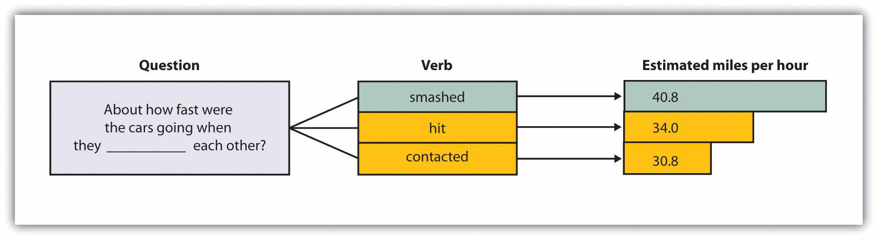
Participants viewed a film of a traffic accident and then answered a question about the accident. According to random assignment, the blank was filled by either “hit,” “smashed,” or “contacted” each other. The wording of the question influenced the participants’ memory of the accident. Data are from Loftus and Palmer (1974). ^{[48]}
The situation is particularly problematic when the eyewitnesses are children, because research has found that children are more likely to make incorrect identifications than are adults (Pozzulo & Lindsay, 1998) ^{[49]} and are also subject to the own-race identification bias (Pezdek, Blandon-Gitlin, & Moore, 2003). ^{[50]}In many cases, when sex abuse charges have been filed against babysitters, teachers, religious officials, and family members, the children are the only source of evidence. The likelihood that children are not accurately remembering the events that have occurred to them creates substantial problems for the legal system.
Another setting in which eyewitnesses may be inaccurate is when they try to identify suspects from mug shots or lineups. A lineup generally includes the suspect and five to seven other innocent people (the fillers), and the eyewitness must pick out the true perpetrator. The problem is that eyewitnesses typically feel pressured to pick a suspect out of the lineup, which increases the likelihood that they will mistakenly pick someone (rather than no one) as the suspect.
Research has attempted to better understand how people remember and potentially misremember the scenes of and people involved in crimes and to attempt to improve how the legal system makes use of eyewitness testimony. In many states, efforts are being made to better inform judges, juries, and lawyers about how inaccurate eyewitness testimony can be. Guidelines have also been proposed to help ensure that child witnesses are questioned in a nonbiasing way (Poole & Lamb, 1998). ^{[51]} Steps can also be taken to ensure that lineups yield more accurate eyewitness identifications. Lineups are more fair when the fillers resemble the suspect, when the interviewer makes it clear that the suspect might or might not be present (Steblay, Dysart, Fulero, & Lindsay, 2001), ^{[52]} and when the eyewitness has not been shown the same pictures in a mug-shot book prior to the lineup decision. And several recent studies have found that witnesses who make accurate identifications from a lineup reach their decision faster than do witnesses who make mistaken identifications, suggesting that authorities must take into consideration not only the response but how fast it is given (Dunning & Perretta, 2002). ^{[53]}
In addition to distorting our memories for events that have actually occurred, misinformation may lead us to falsely remember information that never occurred. Loftus and her colleagues asked parents to provide them with descriptions of events that did (e.g., moving to a new house) and did not (e.g., being lost in a shopping mall) happen to their children. Then (without telling the children which events were real or made-up) the researchers asked the children to imagine both types of events. The children were instructed to “think real hard” about whether the events had occurred (Ceci, Huffman, Smith, & Loftus, 1994). ^{[54]} More than half of the children generated stories regarding at least one of the made-up events, and they remained insistent that the events did in fact occur even when told by the researcher that they could not possibly have occurred (Loftus & Pickrell, 1995).^{[55]} Even college students are susceptible to manipulations that make events that did not actually occur seem as if they did (Mazzoni, Loftus, & Kirsch, 2001). ^{[56]}
The ease with which memories can be created or implanted is particularly problematic when the events to be recalled have important consequences. Therapists often argue that patients may repress memories of traumatic events they experienced as children, such as childhood sexual abuse, and then recover the events years later as the therapist leads them to recall the information—for instance, by using dream interpretation and hypnosis (Brown, Scheflin, & Hammond, 1998). ^{[57]}
But other researchers argue that painful memories such as sexual abuse are usually very well remembered, that few memories are actually repressed, and that even if they are, it is virtually impossible for patients to accurately retrieve them years later (McNally, Bryant, & Ehlers, 2003; Pope, Poliakoff, Parker, Boynes, & Hudson, 2007). ^{[58]} These researchers have argued that the procedures used by the therapists to “retrieve” the memories are more likely to actually implant false memories, leading the patients to erroneously recall events that did not actually occur. Because hundreds of people have been accused, and even imprisoned, on the basis of claims about “recovered memory” of child sexual abuse, the accuracy of these memories has important societal implications. Many psychologists now believe that most of these claims of recovered memories are due to implanted, rather than real, memories (Loftus & Ketcham, 1994). ^{[59]}
Taken together, then, the problems of eyewitness testimony represent another example of how social cognition—the processes that we use to size up and remember other people—may be influenced, sometimes in a way that creates inaccurate perceptions, by the operation of salience, cognitive accessibility, and other information-processing biases.

KEY TAKEAWAYS
- We use our schemas and attitudes to help us judge and respond to others. In many cases, this is appropriate, but our expectations can also lead to biases in our judgments of ourselves and others.
- A good part of our social cognition is spontaneous or automatic, operating without much thought or effort. On the other hand, when we have the time and the motivation to think about things carefully, we may engage in thoughtful, controlled cognition.
- Which expectations we use to judge others is based on both the situational salience of the things we are judging and the cognitive accessibility of our own schemas and attitudes.
- Variations in the accessibility of schemas lead to biases such as the availability heuristic, the representativeness heuristic, the false consensus bias, and biases caused by counterfactual thinking.
- The potential biases that are the result of everyday social cognition can have important consequences, both for us in our everyday lives but even for people who make important decisions affecting many other people. Although biases are common, they are not impossible to control, and psychologists and other scientists are working to help people make better decisions.
- The operation of cognitive biases, including the potential for new information to distort information already in memory, can help explain the tendency for eyewitnesses to be overconfident and frequently inaccurate in their recollections of what occurred at crime scenes.

EXERCISES AND CRITICAL THINKING
- Give an example of a time when you may have committed one of the cognitive errors listed in Table 2.1 "How Expectations Influence Our Social Cognition". What factors (e.g., availability? salience?) caused the error, and what was the outcome of your use of the shortcut or heuristic?
- Go to the website http://thehothand.blogspot.com, which analyzes the extent to which people accurately perceive “streakiness” in sports. Consider how our sports perceptions are influenced by our expectations and the use of cognitive heuristics.

[1] Ferguson, M. J., & Bargh, J. A. (2003). The constructive nature of automatic evaluation. In J. Musch & K. C. Klauer (Eds.), The psychology of evaluation: Affective processes in cognition and emotion (pp. 169–188). Mahwah, NJ: Lawrence Erlbaum Associates Publishers; Ferguson, M. J., Hassin, R., & Bargh, J. A. (2008). Implicit motivation: Past, present, and future. In J. Y. Shah & W. L. Gardner (Eds.), Handbook of motivation science (pp. 150–166). New York, NY: Guilford Press.
[2] Willis, J., & Todorov, A. (2006). First impressions: Making up your mind after a 100-Ms exposure to a face. Psychological Science, 17(7), 592–598.
[3] Bargh, J. A., Chen, M., & Burrows, L. (1996). Automaticity of social behavior: Direct effects of trait construct and stereotype activation on action. Journal of Personality and Social Psychology, 71(2), 230–244.
[4] Bargh, J. A., Chen, M., & Burrows, L. (1996). Automaticity of social behavior: Direct effects of trait construct and stereotype activation on action. Journal of Personality and Social Psychology, 71(2), 230–244.
[5] McArthur, L. Z., & Post, D. L. (1977). Figural emphasis and person perception. Journal of Experimental Social Psychology, 13(6), 520–535; Taylor, S. E., & Fiske, S. T. (1978). Salience, attention and attribution: Top of the head phenomena. Advances in Experimental Social Psychology, 11, 249–288.
[6] Brewer, M. B. (1988). A dual process model of impression formation. In T. K. Srull & R. S. Wyer (Eds.), Advances in social cognition (Vol. 1, pp. 1–36). Hillsdale, NJ: Erlbaum.
[7] Schwarz, N., & Vaughn, L. A. (Eds.). (2002). The availability heuristic revisited: Ease of recall and content of recall as distinct sources of information. New York, NY: Cambridge University Press; Tversky, A., & Kahneman, D. (1973). Availability: A heuristic for judging frequency and probability. Cognitive Psychology, 5, 207–232.
[8] Reber, R., Winkielman, P., & Schwarz, N. (1998). Effects of perceptual fluency on affective judgments. Psychological Science, 9(1), 45–48. Winkielman, P., & Cacioppo, J. T. (2001). Mind at ease puts a smile on the face: Psychophysiological evidence that processing facilitation elicits positive affect. Journal of Personality and Social Psychology, 81(6), 989–1000.
[9] Schwarz, N., Bless, H., Strack, F., Klumpp, G., Rittenauer-Schatka, H., & Simons, A. (1991). Ease of retrieval as information: Another look at the availability heuristic. Journal of Personality and Social Psychology, 61, 195–202.
[10] Aarts, H., & Dijksterhuis, A. (1999). How often did I do it? Experienced ease of retrieval and frequency estimates of past behavior. Acta Psychologica, 103(1–2), 77–89.
[11] Haddock, G., Rothman, A. J., Reber, R., & Schwarz, N. (1999). Forming judgments of attitude certainty, intensity, and importance: The role of subjective experiences. Personality and Social Psychology Bulletin, 25, 771–782.
[12] Schwarz, N., Bless, H., Strack, F., Klumpp, G., Rittenauer-Schatka, H., & Simons, A. (1991). Ease of retrieval as information: Another look at the availability heuristic. Journal of Personality and Social Psychology, 61, 195–202.
[13] Sloman, S. A. (Ed.). (2002). Two systems of reasoning. New York, NY: Cambridge University Press. Stanovich, K. E., & West, R. F. (Eds.). (2002). Individual differences in reasoning: Implications for the rationality debate? New York, NY: Cambridge University Press; Winkielman, P., Schwarz, N., & Nowak, A. (Eds.). (2002). Affect and processing dynamics: Perceptual fluency enhances evaluations. Amsterdam, Netherlands: John Benjamins Publishing Company.
[14] Loewenstein, G. F., weber, E. U., Hsee, C. K., & Welch, N. (2001). Risk as feelings.Psychological Bulletin, 127(2), 267–286.
[15] Dijksterhuis, A., Bos, M. W., Nordgren, L. F., & van Baaren, R. B. (2006). On making the right choice: The deliberation-without-attention effect. Science, 311(5763), 1005–1007.
[16] Ross, L., Greene, D., & House, P. (1977). The false consensus effect: An egocentric bias in social perception and attribution processes. Journal of Experimental Social Psychology, 13(3), 279–301.
[17] Krueger, J., & Clement, R. W. (1994). The truly false consensus effect: An ineradicable and egocentric bias in social perception. Journal of Personality and Social Psychology, 67(4), 596–610.
[18] Chambers, J. R. (2008). Explaining false uniqueness: Why we are both better and worse than others. Social and Personality Psychology Compass, 2(2), 878–894.
[19] Roese, N. J. (1997). Counterfactual thinking. Psychological Bulletin, 121(1), 133–148.
[20] Medvec, V. H., Madey, S. F., & Gilovich, T. (1995). When less is more: Counterfactual thinking and satisfaction among Olympic medalists. Journal of Personality and Social Psychology, 69(4), 603–610.
[21] Medvec, V. H., Madey, S. F., & Gilovich, T. (1995). When less is more: Counterfactual thinking and satisfaction among Olympic medalists. Journal of Personality and Social Psychology, 69(4), 603–610.
[22] Miller, D. T., Turnbull, W., & McFarland, C. (1988). Particularistic and universalistic evaluation in the social comparison process. Journal of Personality and Social Psychology, 55, 908–917.
[23] Tversky, A., & Kahneman, D. (1974). Judgment under uncertainty: Heuristics and biases.Science, 185(4157), 1124–1131.
[24] Adams, P. A., & Adams, J. K. (1960). Confidence in the recognition and reproduction of words difficult to spell. American Journal of Psychology, 73, 544–552.
[25] Dunning, D., Griffin, D. W., Milojkovic, J. D., & Ross, L. (1990). The overconfidence effect in social prediction. Journal of Personality and Social Psychology, 58(4), 568–581.
[26] Dunning, D., Griffin, D. W., Milojkovic, J. D., & Ross, L. (1990). The overconfidence effect in social prediction. Journal of Personality and Social Psychology, 58(4), 568–581.
[27] Kruger, J., & Dunning, D. (1999). Unskilled and unaware of it: How difficulties in recognizing one’s own incompetence lead to inflated self-assessments. Journal of Personality and Social Psychology, 77(6), 1121–1134.
[28] Dunning, D., Johnson, K., Ehrlinger, J., & Kruger, J. (2003). Why people fail to recognize their own incompetence. Current Directions in Psychological Science, 12(3), 83–87.
[29] Wells, G. L., & Olson, E. A. (2003). Eyewitness testimony. Annual Review of Psychology, 54, 277–295.
[30] Slovic, P. (Ed.). (2000). The perception of risk. London, England: Earthscan Publications.
[31] Doob, A. N., & Macdonald, G. E. (1979). Television viewing and fear of victimization: Is the relationship causal? Journal of Personality and Social Psychology, 37(2), 170–179.
[32] Ross, M., & Sicoly, F. (1979). Egocentric biases in availability and attribution. Journal of Personality and Social Psychology, 37(3), 322–336.
[33] Joireman, J., Barnes Truelove, H., & Duell, B. (2010). Effect of outdoor temperature, heat primes and anchoring on belief in global warming. Journal of Environmental Psychology, 30(4), 358–367.
[34] Byrne, R. M. J., & McEleney, A. (2000). Counterfactual thinking about actions and failures to act. Journal of Experimental Psychology: Learning, Memory, and Cognition, 26(5), 1318–1331; Gilovich, T., Griffin, D., & Kahneman, D. (Eds.). (2002). Heuristics and biases: The psychology of intuitive judgment. New York, NY: Cambridge University Press; Hilton, D. J. (2001). The psychology of financial decision-making: Applications to trading, dealing, and investment analysis. Journal of Behavioral Finance, 2, 37–53. doi: 10.1207/S15327760JPFM0201_4
[35] Kruglanski, A. W., & Freund, T. (1983). The freezing and unfreezing of lay inferences: Effects on impressional primacy, ethnic stereotyping, and numerical anchoring. Journal of Experimental Social Psychology, 19, 448–468.
[36] Kassam, K. S., Koslov, K., & Mendes, W. B. (2009). Decisions under distress: Stress profiles influence anchoring and adjustment. Psychological Science, 20(11), 1394–1399.
[37] Hirt, E. R., Kardes, F. R., & Markman, K. D. (2004). Activating a mental simulation mind-set through generation of alternatives: Implications for debiasing in related and unrelated domains. Journal of Experimental Social Psychology, 40(3), 374–383.
[38] Lehman, D. R., Lempert, R. O., & Nisbett, R. E. (1988). The effects of graduate training on reasoning: Formal discipline and thinking about everyday-life events. American Psychologist, 43(6), 431–442.
[39] Charman, S. D., & Wells, G. L. (2007). Eyewitness lineups: Is the appearance-changes instruction a good idea? Law and Human Behavior, 31(1), 3–22; Toglia, M. P., Read, J. D., Ross, D. F., & Lindsay, R. C. L. (Eds.). (2007). The handbook of eyewitness psychology (Vols. 1 & 2). Mahwah, NJ: Lawrence Erlbaum Associates Publishers; Wells, G. L., Memon, A., & Penrod, S. D. (2006). Eyewitness evidence: Improving its probative value. Psychological Science in the Public Interest, 7(2), 45–75.
[40] Wells, G. L., Memon, A., & Penrod, S. D. (2006). Eyewitness evidence: Improving its probative value. Psychological Science in the Public Interest, 7(2), 45–75; Fisher, R. P. (2011). Editor’s introduction: Special issue on psychology and law. Current Directions in Psychological Science, 20, 4. doi:10.1177/0963721410397654
[41] Wells, G. L., & Olson, E. A. (2003). Eyewitness testimony. Annual Review of Psychology, 54, 277–295.
[42] Steblay, N. M. (1997). Social influence in eyewitness recall: A meta-analytic review of lineup instruction effects. Law and Human Behavior, 21(3), 283–297.
[43] Loftus, E. F., Loftus, G. R., & Messo, J. (1987). Some facts about “weapon focus.” Law and Human Behavior, 11(1), 55–62.
[44] Brigham, J. C., Bennett, L. B., Meissner, C. A., & Mitchell, T. L. (Eds.). (2007). The influence of race on eyewitness memory. Mahwah, NJ: Lawrence Erlbaum Associates Publishers.
[45] Meissner, C. A., & Brigham, J. C. (2001). Thirty years of investigating the own-race bias in memory for faces: A meta-analytic review. Psychology, Public Policy, and Law, 7(1), 3–35.
[46] Dodson, C. S., Johnson, M. K., & Schooler, J. W. (1997). The verbal overshadowing effect: Why descriptions impair face recognition. Memory & Cognition, 25(2), 129–139.
[47] Loftus, E. F., & Palmer, J. C. (1974). Reconstruction of automobile destruction: An example of the interaction between language and memory. Journal of Verbal Learning & Verbal Behavior, 13(5), 585–589.
[48] Loftus, E. F., & Palmer, J. C. (1974). Reconstruction of automobile destruction: An example of the interaction between language and memory. Journal of Verbal Learning & Verbal Behavior, 13(5), 585–589.
[49] Pozzulo, J. D., & Lindsay, R. C. L. (1998). Identification accuracy of children versus adults: A meta-analysis. Law and Human Behavior, 22(5), 549–570.
[50] Pezdek, K., Blandon-Gitlin, I., & Moore, C. (2003). Children’s face recognition memory: More evidence for the cross-race effect. Journal of Applied Psychology, 88(4), 760–763.
[51] Poole, D. A., & Lamb, M. E. (1998). The development of interview protocols. Washington, DC: American Psychological Association.
[52] Steblay, N., Dysart, J., Fulero, S., & Lindsay, R. C. L. (2001). Eyewitness accuracy rates in sequential and simultaneous lineup presentations: A meta-analytic comparison. Law and Human Behavior, 25(5), 459–473.
[53] Dunning, D., & Perretta, S. (2002). Automaticity and eyewitness accuracy: A 10- to 12-second rule for distinguishing accurate from inaccurate positive identifications. Journal of Applied Psychology, 87(5), 951–962.
[54] Ceci, S. J., Huffman, M. L. C., Smith, E., & Loftus, E. F. (1994). Repeatedly thinking about a non-event: Source misattributions among preschoolers. Consciousness and Cognition: An International Journal, 3(3–4), 388–407.
[55] Loftus, E. F., & Pickrell, J. E. (1995). The formation of false memories. Psychiatric Annals, 25(12), 720–725.
[56] Mazzoni, G. A. L., Loftus, E. F., & Kirsch, I. (2001). Changing beliefs about implausible autobiographical events: A little plausibility goes a long way. Journal of Experimental Psychology: Applied, 7(1), 51–59.
[57] Brown, D., Scheflin, A. W., & Hammond, D. C. (1998). Memory, trauma treatment, and the law. New York, NY: Norton.
[58] McNally, R. J., Bryant, R. A., & Ehlers, A. (2003). Does early psychological intervention promote recovery from posttraumatic stress? Psychological Science in the Public Interest, 4(2), 45–79; Pope, H. G., Jr., Poliakoff, M. B., Parker, M. P., Boynes, M., & Hudson, J. I. (2007). Is dissociative amnesia a culture-bound syndrome? Findings from a survey of historical literature. Psychological Medicine: A Journal of Research in Psychiatry and the Allied Sciences, 37(2), 225–233.
[59] Loftus, E. F., & Ketcham, K. (1994). The myth of repressed memory: False memories and allegations of sexual abuse (1st ed.). New York, NY: St. Martin’s Press.

2.3 Thinking Like a Social Psychologist About Social Cognition
Consider your schemas and attitudes toward some of the many people you have met in your life—perhaps those you knew in grade school, the people in your family, or those in your church groups or other organizations. And also think about people you have only heard about rather than having met—maybe those from other countries or cultures. Did operant learning influence your opinions about them? Did you model your behavior after them? Or perhaps you had a single negative encounter with one person and disliked that person or his or her social group for a long time after.
Perhaps you can remember some times when you may have misinterpreted events or judged people incorrectly because your opinions were influenced by the operation of your existing expectations. Did you ever falsely assume that someone had a given characteristic and assimilate information into your existing expectations more than you might have? For instance, did you ever find yourself thinking that the referees in a sports game were favoring the other team rather than your own, or that the media was treating the political candidate that you oppose better than the one you prefer? Could this have occurred because your attitudes or beliefs influenced your interpretation of the information?
And perhaps you can remember times when you were influenced by salience, accessibility, or other information-processing biases. Did you ever feel badly when you got a 94 on your test when a 95 would have given you an A or when you changed an answer on an exam rather than sticking with it? In these cases, you might have fallen victim to counterfactual thinking. Perhaps you erroneously judged someone on the basis of your beliefs about what they “should have been like” rather than on the basis of more accurate statistical information—the misuse of the representativeness heuristic.
Finally, think back once more on the story with which we opened this chapter. Can you see now how important social cognition is, and how important it is to understand the ways in which our thinking operates to produce accurate, and yet sometimes inaccurate, judgments? In many ways, our lives are influenced by our social cognition.
I hope that this chapter has provided you with some new and useful ideas about how you and others form impressions and has reminded you how others are forming (potentially erroneous) impressions of you. Most important, perhaps you have learned to be more modest about your judgments. Please remember to consider the possibility that your decisions, no matter how right and accurate they feel to you, may simply be wrong.

2.4 Chapter Summary
This chapter has focused primarily on one of the three ABCs of social psychology, namely, the ways that we learn about and judge other people—our social cognition. The ability to make accurate judgments about our social situation is critical: If we cannot understand others and predict how they will respond to us, our social interactions will be difficult indeed.
We have seen that social cognition is efficient, frequently operating quickly and even out of our awareness, and generally accurate. However, although we are pretty good at sizing up other people and in creating effective social interactions, we are not perfect. The errors we make frequently occur because of our reliance on our mental knowledge (our schemas and attitudes) as well our tendency to take shortcuts through the use of cognitive heuristics. We use schemas and heuristics as energy savers, because we are often overwhelmed by the amount of information we need to process.
Social knowledge is gained as the result of learning—the relatively permanent change in thoughts, feelings, or behavior that occurs as a result of experience. Some learning is based on the principles of operant learning—experiences that are followed by positive emotions (rewards) are more likely to be repeated, whereas experiences that are followed by negative emotions (punishments) are less likely to be repeated. Associational learning occurs when an object or event comes to be associated with a response, such as a behavior or a positive or negative emotion. We also learn through observational learning by modeling the behavior of others.
Accommodation occurs when our existing schemas or attitudes change on the basis of new information. Assimilation, on the other hand, occurs when our existing knowledge influences new information in a way that makes the conflicting information fit with our existing knowledge. Assimilation is often more powerful than is accommodation.
Much of our social cognition is automatic, meaning that it occurs quickly and without taking much effort. In other cases, when we have the time and motivation, we think about things more deliberately and carefully. In this case, we are engaging in more thoughtful, controlled cognition.
We pay particular attention to stimuli that are salient—things that are unique, negative, colorful, bright, and moving. In many cases, we base our judgments on information that seems to represent, or match, what we expect will happen. When we do so, we are using the representativeness heuristic.
Cognitive accessibility refers to the extent to which knowledge is activated in memory and thus likely to be used to guide our reactions to others. The tendency to overuse accessible social constructs can lead to errors in judgment, such as the availability heuristic and the false consensus bias. Counterfactual thinking about what might have happened and the tendency to anchor on an initial construct and not adjust sufficiently from it are also influenced by cognitive accessibility.
You can use your understanding of social cognition to better understand how you think accurately—but also sometimes inaccurately—about yourself and others.

Chapter 3

Social Affect

Huge Fall in Global Markets Causes Fear and Panic for Investors
September 16, 2008, as a result of the failure of over a dozen large banks in the United States, was the beginning of a stock market crisis around the world. On October 11, 2008, the head of the International Monetary Fund (IMF) warned that the world financial system was teetering on “the brink of systemic meltdown.”
The Dow Jones Industrial Average fell 21 percent in one week, and BusinessWeekreferred to the crisis as a “stock market crash–the “Panic of 2008.”
Over the next year, the crash erased $8.3 trillion in shareholder wealth.
Stock traders, bankers, and everyday investors all responded with panic:
“We aren’t dealing with a fundamental economic issue any longer,” said James Paulsen, chief investment strategist for Wells Capital Management. “We are dealing with fear. And that doesn’t respond to economic medicine.”
“I think right now there are just some very powerful negative images that are alive in many people’s minds—images of the Depression, images of people selling apples,” said George Loewenstein, a behavioral economist at Carnegie Mellon University.
Some investors, like software engineer Sandeep Bhanote, did their best to keep their emotions in check: “Fear is the most dangerous emotion. It can really do the market a lot of harm when maybe it is not necessary to be afraid,”
“When investors act purely on emotion, there is greater chance of them sabotaging their financial goals,” said Stuart Ritter, a certified financial planner at T. Rowe Price.
Source: http://www.usatoday.com/money/economy/2008-10-09-145686747_x.htm?csp=34.
Although a good part of our social behavior is determined by cognitive, thoughtful, and rational processes, another part—and particularly those behaviors that have substantial impact on our health and happiness—is the result of affect. Our everyday experiences arouse in us a wide range of moods and emotions, both positive and negative, and these feelings have profound consequences for our lives.
Emotions are particularly social, and that is why they are of such interest to social psychologists. Although we may get angry at our computer, frustrated by our stock trading decisions, or be in love with our car, most emotions have a social component (DeSteno & Salovey, 1996; Keltner & Haidt, 1999). ^{[1]} We experience love, anger, guilt, shame, jealousy, and embarrassment for a reason—because these emotions help us develop and maintain positive relationships with others.
We share our emotions with others through our social behavior, including our facial expressions, touch, voice, and posture, and even in our art, poetry, and music (Hertenstein, 2002; Oatley, 2003; Scherer, Johnstone, & Klasmeyer, 2003). ^{[2]} And emotions influence our social judgments (Howard & Gengler, 2001; Ramanathan & McGill, 2007). ^{[3]} When we are subliminally exposed to a happy facial expression of another person just before we see another stimulus, we perceive that stimulus more positively than we do when angry facial expressions have been primed (Murphy & Zajonc, 1993; Winkielman, Berridge, & Wilbarger, 2005). ^{[4]} Viewing sad faces of other people makes music seem more sad (Strahan, Spencer, & Zanna, 2002), ^{[5]}, and viewing happy faces of others make us like TV shows more (Ravaja & Kallinen, 2004).^{[6]} When we are with another person who is smiling, we rate products more positively (Tanner, Ferraro, Chartrand, Bettman, & Van Baaren, 2008). ^{[7]}
The goal of this chapter is to review the wide influence of affect on our social lives. We’ll see how we use moods and emotions to help us understand our social worlds and how they relate to our current happiness and well-being (our sense of satisfaction with our everyday experience). We’ll consider the negative outcomes of powerful negative affective states, including anxiety, depression, and stress, but also the healing power of positive emotions. And we will review some of the most effective ways to cope with negative emotions in order to improve our everyday affect.

[1] DeSteno, D. A., & Salovey, P. (1996). Jealousy and the characteristics of one’s rival: A self-evaluation maintenance perspective. Personality and Social Psychology Bulletin, 22, 920–932; Keltner, D., & Haidt, J. (1999). Social functions of emotions at four levels of analysis. Cognition & Emotion, 13, 505–521.
[2] Oatley, K. (2003). Emotional expression and experience in the visual and narrative arts. In R. J. Davidson, K. R. Scherer, & H. Goldsmith (Eds.), Handbook of the affective sciences (pp. 481–502). New York, NY: Oxford University Press; Hertenstein, M. J. (2002). Touch: Its communicative functions in infancy. Human Development, 45, 70–94; Scherer, K. R., Johnstone, T., & Klasmeyer, G. (2003). Vocal expression of emotion. In R. J. Davidson, K. R. Scherer, & H. Goldsmith (Eds.), Handbook of the affective sciences (pp. 433–456). New York, NY: Oxford University Press.
[3] Howard, D. J., & Gengler, C. (2001). Emotional contagion effects on product attitudes.Journal of Consumer Research, 28(2), 189–201; Ramanathan, S., & McGill, A. L. (2007). Consuming with others: Social influences on moment-to-moment and retrospective evaluations of an experience. Journal of Consumer Research, 34(4), 506–524.
[4] Murphy, S. T., & Zajonc, R. B. (1993). Affect, cognition, and awareness: Affective priming with optimal and suboptimal stimulus exposures. Journal of Personality and Social Psychology, 64(5), 723–739; Winkielman, P., Berridge, K. C., & Wilbarger, J. L. (2005). Unconscious affective reactions to masked happy versus angry faces influence consumption behavior and judgments of value. Personality and Social Psychology Bulletin, 31(1), 121–135.
[5] Strahan, E. J., Spencer, S. J., & Zanna, M. P. (2002). Subliminal priming and persuasion: Striking while the iron is hot. Journal of Experimental Social Psychology, 38(6), 556–568.
[6] Ravaja, N., & Kallinen, K. (2004). Emotional effects of startling background music during reading news reports: The moderating influence of dispositional BIS and BAS sensitivities.Scandinavian Journal of Psychology, 45(3), 231–238.
[7] Tanner, R. J., Ferraro, R., Chartrand, T. L., Bettman, J. R., & Van Baaren, R. (2008). Of chameleons and consumption: The impact of mimicry on choice and preferences. Journal of Consumer Research, 34(6), 754–766.

3.1 Moods and Emotions in Our Social Lives

LEARNING OBJECTIVES
- Describe the physiology of emotions, including the actions of the sympathetic nervous system, the parasympathetic nervous system, and the amygdala.
- Differentiate the basic and secondary emotions and explain their functions.
- Review the known gender and cultural differences in the experience and expression of emotion.
- Summarize the function and outcomes of our mood states.
- Describe the phenomenon of misattributing arousal and its impact on our emotions.
Although affect can be harmful if it is unregulated or unchecked, our moods and emotions normally help us function efficiently and in a way that increases our chances of survival (Bless, Bohner, Schwarz, & Strack, 1990; Schwarz et al., 1991). ^{[1]} The experience of disgust helps us stay healthy by helping us avoid situations that are likely to carry disease (Oaten, Stevenson, & Case, 2009), ^{[2]}, and the experience of embarrassment helps us respond appropriately to situations in which we may have violated social norms.
Affect signals either that things are going OK (e.g., because we are in a good mood or are experiencing joy or serenity) or that things are not going so well (we are in a bad mood, anxious, upset, or angry). When we are happy, we may seek out and socialize with others; when we are angry, we may attack; and when we are fearful, we are more likely to turn to safety. In short, our emotions help us to determine whether our interactions with others are appropriate, to predict how others are going to respond to us, and to regulate our behavior toward others.

The Physiology of Affect
Our emotions are determined in part by responses of the sympathetic nervous system (SNS)—the division of the autonomic nervous system that is involved in preparing the body to respond to threats by activating the organs and the glands in the endocrine system. The SNS works in opposition to the parasympathetic nervous system (PNS), the division of the autonomic nervous system that is involved in resting, digesting, relaxing, and recovering. When it is activated, the SNS provides us with energy to respond to our environment. The liver puts extra sugar into the bloodstream, the heart pumps more blood, our pupils dilate to help us see better, respiration increases, and we begin to perspire to cool the body. The sympathetic nervous system also acts to release stress hormones including epinephrine andnorepinephrine. At the same time, the action of the PNS is decreased.
We experience the activation of the SNS as arousal—changes in bodily sensations, including increased blood pressure, heart rate, perspiration, and respiration.Arousal is the feeling that accompanies strong emotions. I’m sure you can remember a time when you were in love, angry, afraid, or very sad and experienced the arousal that accompanied the emotion. Perhaps you remember feeling flushed, feeling your heart pounding, feeling sick to your stomach, or having trouble breathing.
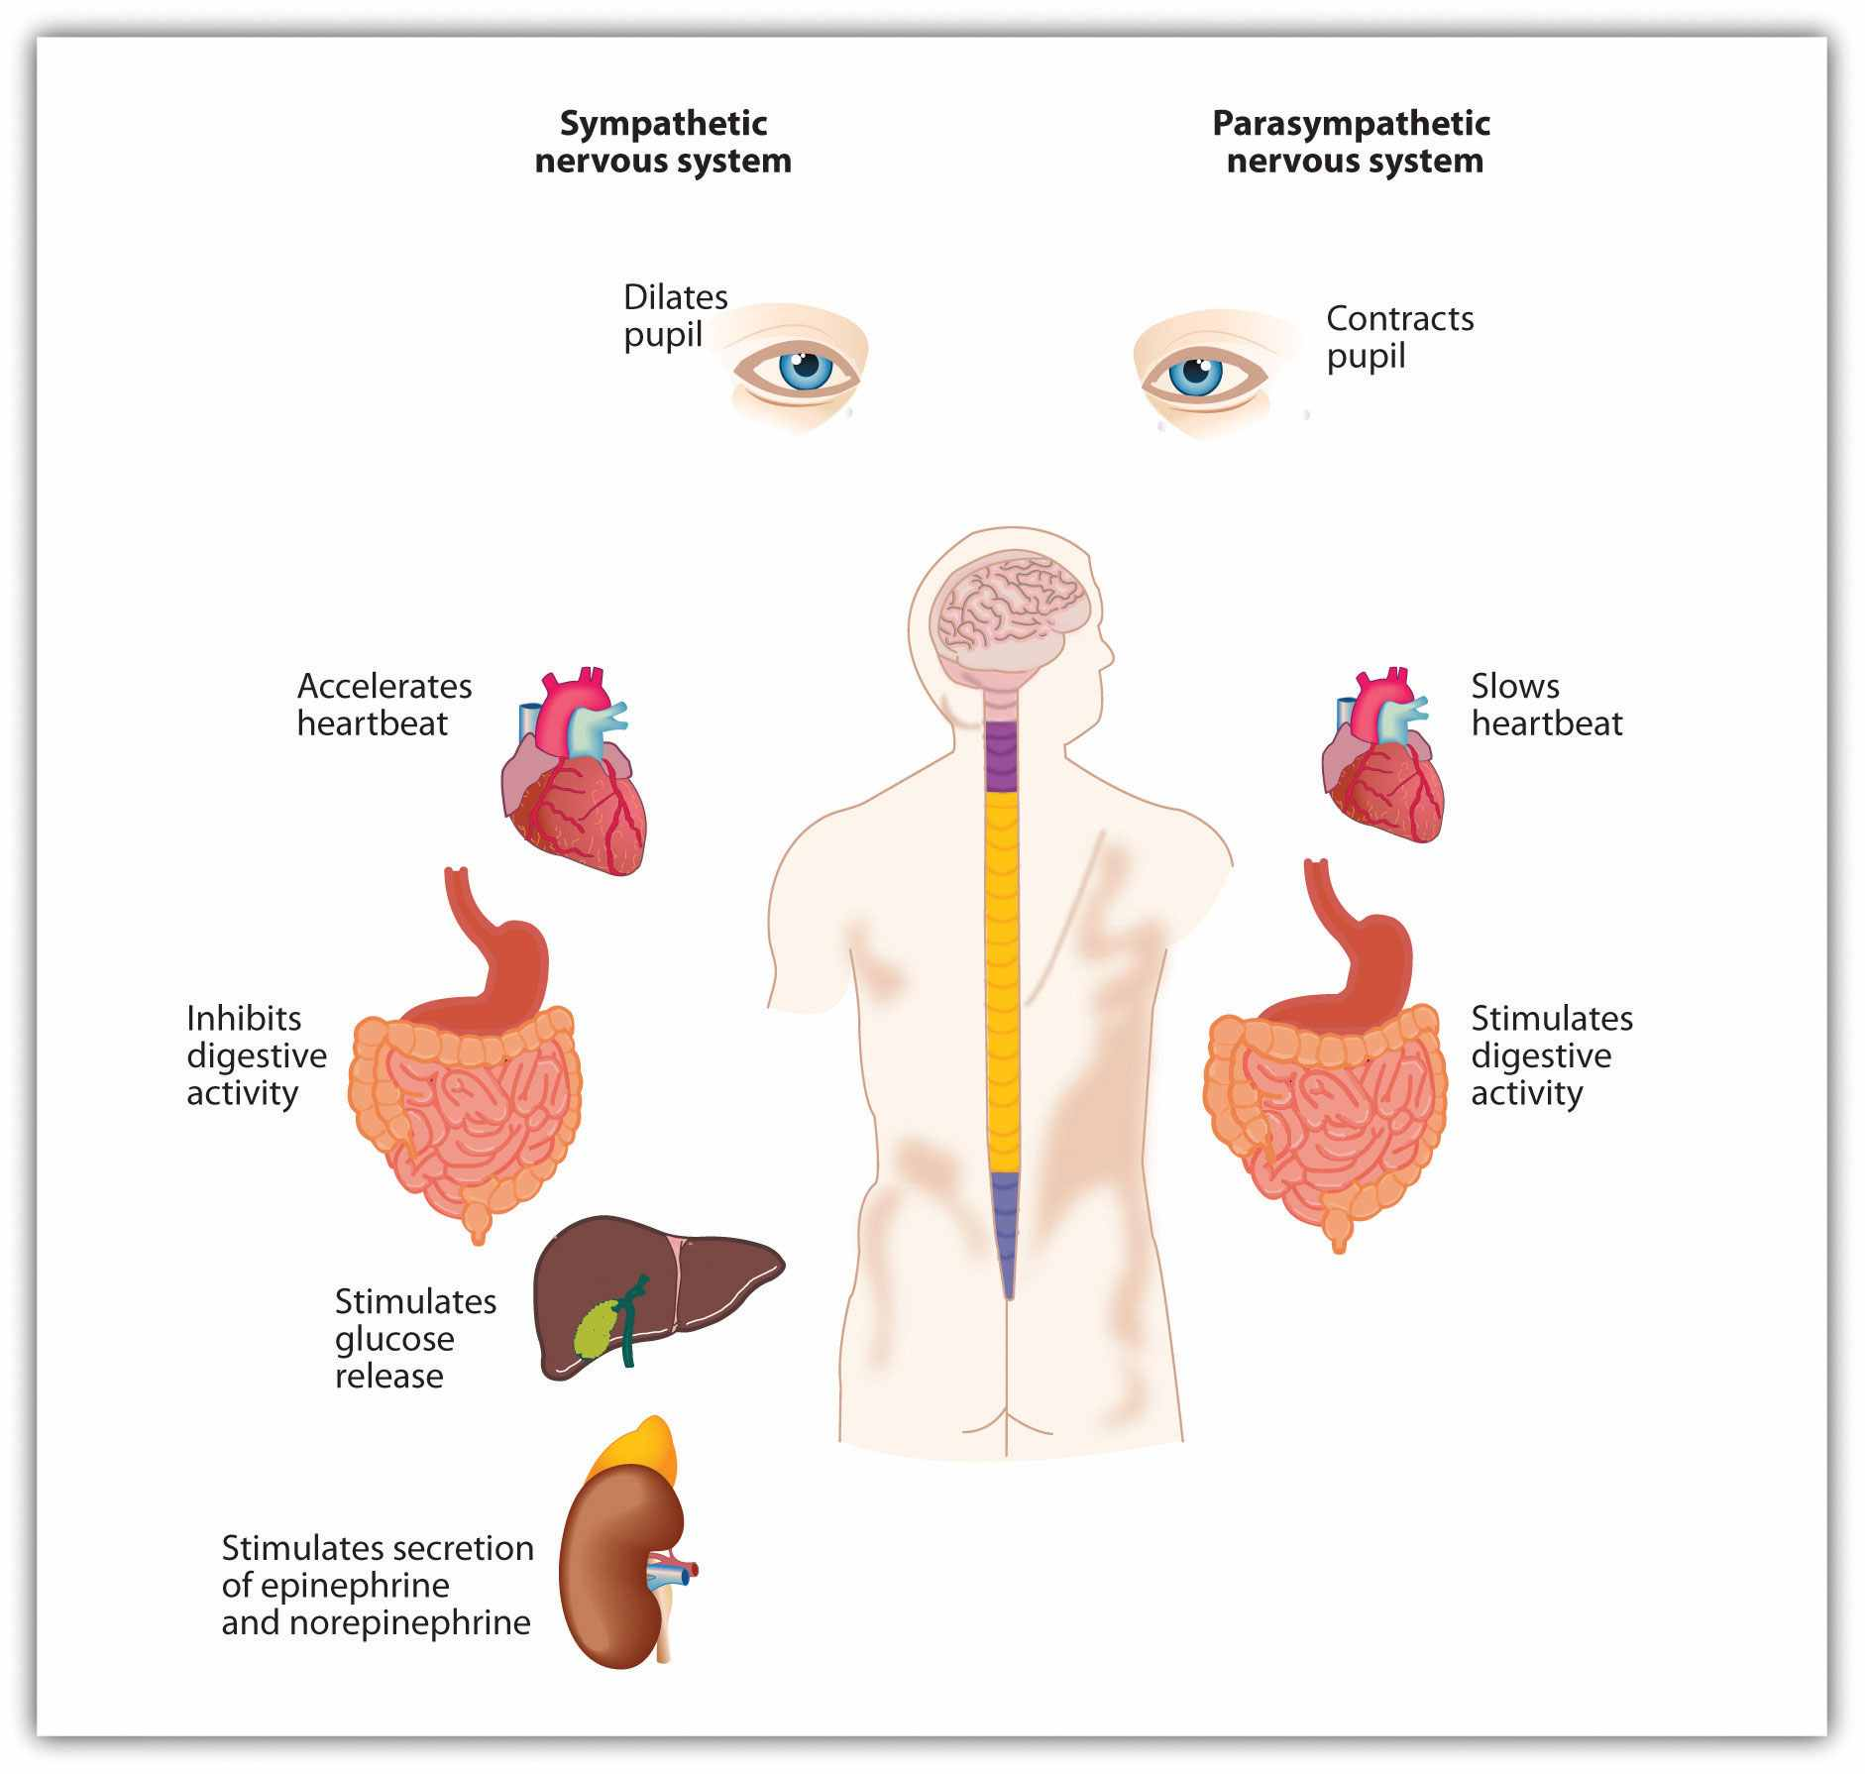
The arousal that we experience as part of our emotional experience is caused by the activation of the sympathetic nervous system.
The experience of emotion is also controlled in part by one of the evolutionarily oldest parts of our brain—the part known as the limbic system—which includes several brain structures that help us experience emotion. Particularly important is the amygdala,the region in the limbic system that is primarily responsible for regulating our perceptions of, and reactions to, aggression and fear. The amygdala has connections to other bodily systems related to emotions, including the facial muscles, which perceive and express emotions, and it also regulates the release of neurotransmitters related to stress and aggression (Best, 2009). ^{[3]} When we experience events that are dangerous, the amygdala stimulates the brain to remember the details of the situation so that we learn to avoid it in the future (Sigurdsson, Doyère, Cain, & LeDoux, 2007; Whalen et al., 2001). ^{[4]}
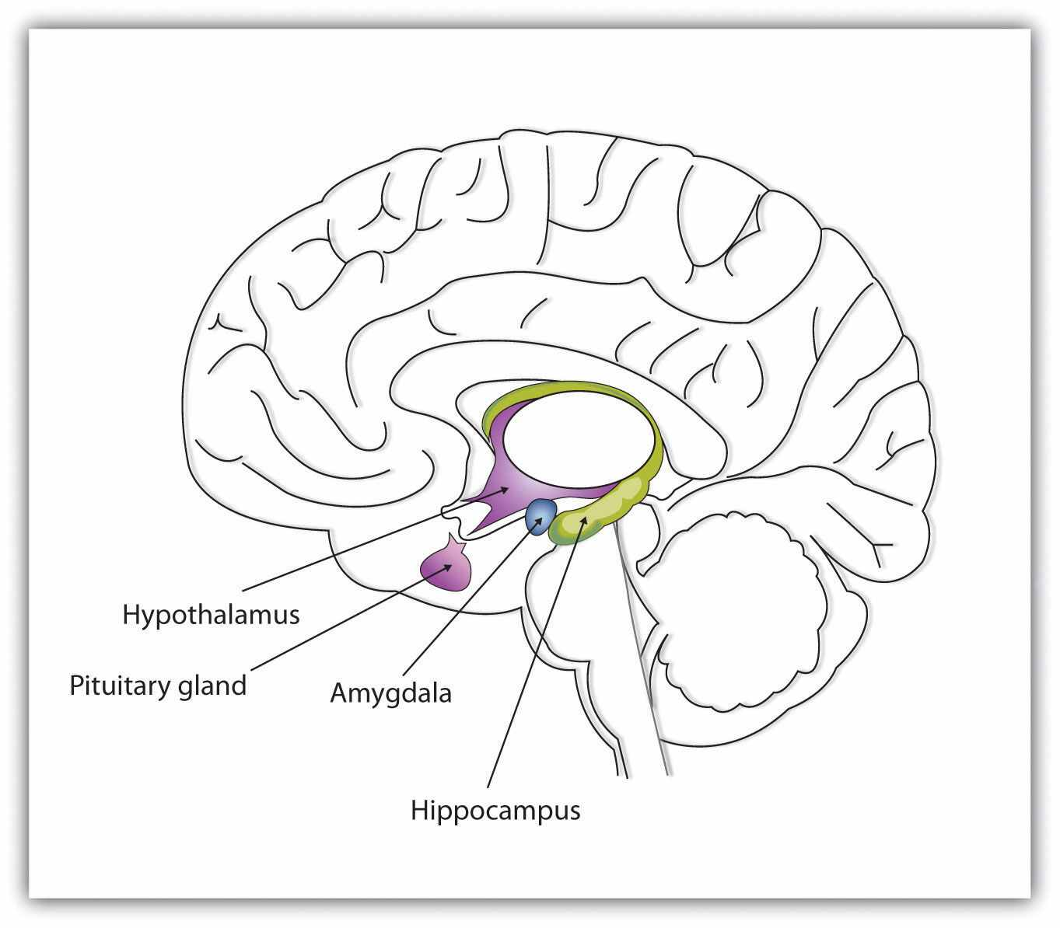
The limbic system is a part of the brain that includes the amygdala. The amygdala is an important regulator of emotions.

Basic and Secondary Emotions
The basic emotions (anger, contempt, disgust, fear, happiness, sadness, and surprise) are emotions that are based primarily on the arousal produced by the SNS and that do not require much cognitive processing. These emotions happen quickly, without the need for a lot of thought or interpretation. Imagine, for instance, your fearful reaction to the sight of a car unexpectedly pulling out in front of you while you are driving, or your happiness in unexpectedly learning that you won an important prize. You immediately experience arousal, and in the case of negative emotions, the arousal may signal that quick action is needed.

Video Clip 1
The Basic Emotions
Paul Ekman and his colleagues (Ekman, 1992; 2003) ^{[5]} studied the expression and interpretation of the basic emotions in a variety of cultures, including those that had had almost no outside contact (such as Papua New Guinea). In his research, he showed people stimuli that would create a given emotion (such as a dead pig on the ground to create disgust) and videotaped the people as they expressed the emotion they would feel in that circumstance.
Ekman then asked people in other cultures to identify the emotions from the videotapes. He found that the basic emotions were cross-cultural in the sense that they are expressed and experienced consistently across many different cultures. A recent meta-analysis examined the perception of the basic emotions in 162 samples, with pictures and raters from many countries, including New Guinea, Malaysia, Germany, and Ethiopia. The analysis found that in only 3% of these samples was even a single basic emotion recognized at rates below chance (Elfenbein & Ambady, 2002). ^{[6]}

Figure 3.1
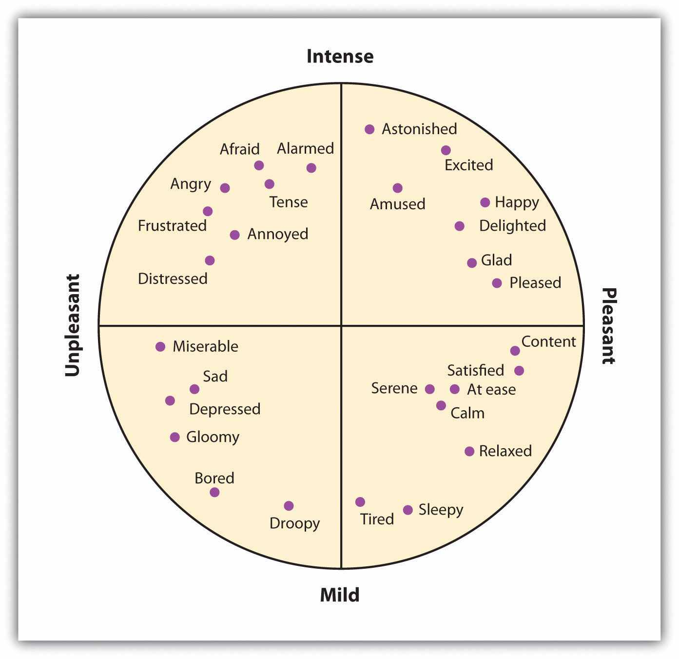
The secondary emotions are derived from the basic emotions but are more cognitive in orientation (Russell, 1980). ^{[7]}
In comparison to the basic emotions, other emotions, such as guilt, shame, and embarrassment, are accompanied by relatively lower levels of arousal and relatively higher levels of cognitive activity. When a close friend of yours wins a prize that you thought you had deserved, you might well feel depressed, angry, resentful, and ashamed. You might mull over the event for weeks or even months, experiencing these negative emotions each time you think about it (Martin & Tesser, 1996). ^{[8]} In this case, although there is at least some arousal, your emotions are more highly determined by your persistent, and negative, thoughts. As you can see in Figure 3.1, there are a large number of these secondary emotions—emotions that provide us with more complex feelings about our social worlds and that are more cognitively based.

Cultural and Gender Differences in Emotional Responses
Although there are many similarities across cultures in how we experience emotions, there are also some differences (Marsh, Elfenbein, & Ambady, 2003). ^{[9]} In Japan, there is a tendency to hide emotions in public, which makes them harder for others to perceive (Markus & Kitayama, 1991; Triandis, 1994). ^{[10]} And as we would expect on the basis of cultural differences between individualism and collectivism, emotions are more focused on other-concern in Eastern cultures, such as Japan and Turkey, but relatively more focused on self-concern in Western cultures (Kitayama, Mesquita, & Karasawa, 2006; Uchida, Kitayama, Mesquita, Reyes, & Morling, 2008). ^{[11]} Ishii, Reyes, and Kitayama (2003) ^{[12]} found that Japanese students paid more attention to the emotional tone of voice of other speakers than did American students, suggesting that the Japanese students were particularly interested in determining the emotions of others. Self-enhancing emotions such as pride and anger are more culturally appropriate emotions to express in Western cultures, whereas other-oriented emotions such as friendliness and shame are seen as more culturally appropriate in Eastern cultures. Similarly, Easterners experience more positive emotions when they are with others, whereas Westerners are more likely to experience positive emotions when they are alone and as a result of their personal accomplishments (Kitayama, Karasawa, & Mesquita, 2004; Masuda & Kitayama, 2004). ^{[13]}
There are also gender differences in emotional experiences. Women report that they are more open to feelings overall (Costa, Terracciano, & McCrae, 2001), ^{[14]} are more likely to express their emotions in public (Kring & Gordon, 1998), ^{[15]} and are more accurate and articulate in reporting the feelings of others (Barrett, Lane, Sechrest, & Schwartz, 2000). ^{[16]} These differences show up particularly in terms of emotions that involve social relationships. Kring and Gordon (1998) ^{[17]} had male and female students watch film clips that portrayed sadness, happiness, or fear and found that the women reacted more visibly to each film. Coats and Feldman (1996) ^{[18]} found that it is easier to read the emotions that women express. Some of these observed gender differences in emotional experiences and expression are biological in orientation, but they are also socialized through experience.

Moods Provide Information About Our Social Worlds
One function of mood is to help us determine how we should evaluate our current situation. Positive moods will likely lead us to maintain our current activities, which seem to be successful, whereas negative moods suggest that we may wish to attempt to change things to improve our situation. And moods have other influences on our cognition and behavior: Positive moods may lead us to think more creatively and to be more flexible in how we respond to opinions that are inconsistent with cultural norms (Ashton-James, Maddux, Galinsky, & Chartrand, 2009). ^{[19]} Ito, Chiao, Devine, Lorig, and Cacioppo (2006) ^{[20]} found that people who were smiling were also less prejudiced.
Mood states are also powerful determinants of our current well-being. To study how people use mood states as information to help them determine their current well-being, Norbert Schwarz and Gerald Clore (1983) ^{[21]} called participants on the telephone, pretending that they were researchers from a different city conducting a survey. Furthermore, they varied the day on which they made the calls, such that some of the participants were interviewed on sunny days and some were interviewed on rainy days. During the course of the interview, the participants were asked to report on their current mood states and also on their general well-being. Schwarz and Clore found that the participants reported better moods and greater well-being on sunny days than they did on rainy days.
Schwarz and Clore wondered whether people were using their current mood (“I feel good today”) to determine how they felt about their life overall. To test this idea, they simply asked half of their respondents about the local weather conditions at the beginning of the interview. The idea was to subtly focus these participants on the fact that the weather might be influencing their mood states. And they found that as soon as they did this, although mood states were still influenced by the weather, the weather no longer influenced perceptions of well-being (Figure 3.2 "Mood as Information"). When the participants were aware that their moods might have been influenced by the weather, they realized that the moods were not informative about their overall well-being, and so they no longer used this information. Similar effects have been found for mood that is induced by music or other sources (Keltner, Locke, & Audrain, 1993; Savitsky, Medvec, Charlton, & Gilovich, 1998). ^{[22]}

Figure 3.2 Mood as Information
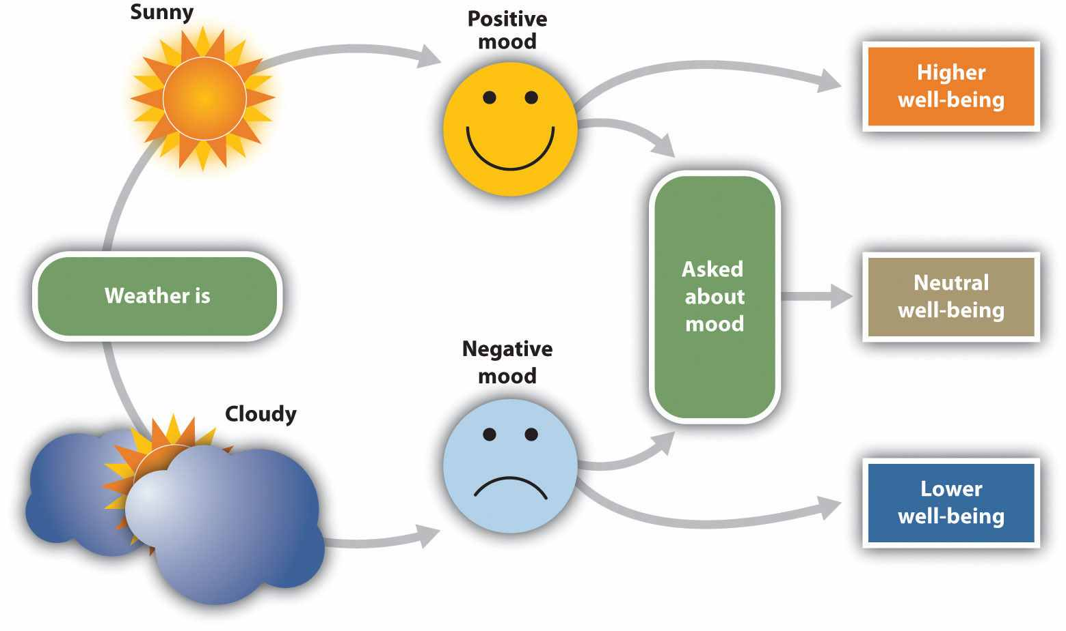
The current weather influences people’s judgments of their well being, but only when they are not aware that it might be doing so. After Schwarz and Clore (1983). ^{[23]}
Even moods that are created very subtly can have effects on perceptions. Fritz Strack and his colleagues (Strack, Martin, & Stepper, 1988) ^{[24]} had participants rate how funny cartoons were while holding a writing pen in their mouth such that it forced them either to use muscles that are associated with smiling or to use muscles that are associated with frowning (Figure 3.3). They found that participants rated the cartoons as funnier when the pen created muscle contractions that are normally used for smiling rather than frowning. And Stepper and Strack (1993) ^{[25]} found that people interpreted events more positively when they were sitting in an upright position rather than a slumped position. Even finding a coin in a pay phone or being offered some milk and cookies is enough to put people in good moods and to make them rate their surroundings more positively (Clark & Isen, 1982; Isen & Levin, 1972; Isen, Shalker, Clark, & Karp, 1978). ^{[26]}
These results show that our body positions, especially our facial expressions, influence our affect. We may smile because we are happy, but we are also happy because we are smiling. And we may stand up straight because we are feeling proud, but we also feel proud because we are standing up straight (Stepper, & Strack, 1993). ^{[28]}

Misattributing Arousal
Although arousal is necessary for emotion, it is not sufficient. Arousal becomes emotion only when it is accompanied by a label or by an explanation for the arousal (Schachter & Singer, 1962). ^{[29]} Thus, although emotions are usually considered to be affective in nature, they really represent an excellent example of the joint influence of affect and cognition. We can say, then, that emotions have two factors—an arousal factor and a cognitive factor (James, 1890; Schachter & Singer, 1962). ^{[30]}
Emotion = arousal + cognition
In some cases, it may be difficult for people who are experiencing a high level of arousal to accurately determine which emotion they are experiencing. That is, they may be certain that they are feeling arousal, but the meaning of the arousal (the cognitive factor) may be less clear. Some romantic relationships, for instance, are characterized by high levels of arousal, and the partners alternately experience extreme highs and lows in the relationship. One day they are madly in love with each other, and the next they are having a huge fight. In situations that are accompanied by high arousal, people may be unsure what emotion they are experiencing. In the high-arousal relationship, for instance, the partners may be uncertain whether the emotion they are feeling is love, hate, or both at the same time. Misattribution of arousaloccurs when people incorrectly label the source of the arousal that they are experiencing.

Figure 3.4 Misattributing Emotion
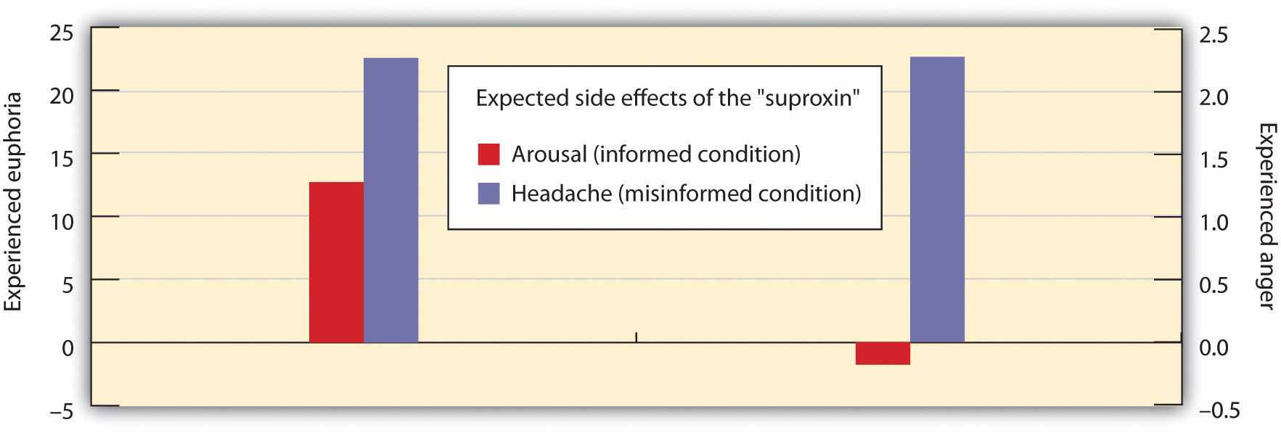
The results of an experiment by Schachter and Singer (1962) ^{[31]} supported the two-factor theory of emotion. The participants who did not have a clear label for their arousal were more likely to take on the emotion of the confederate.

Research Focus
Misattributing Arousal
If you think a bit about your own experiences of different emotions, and if you consider the equation that suggests that emotions are represented by both arousal and cognition, you might start to wonder how much was determined by each. That is, do we know what emotion we are experiencing by monitoring our feelings (arousal) or by monitoring our thoughts (cognition)?
Stanley Schachter and Jerome Singer (1962) ^{[32]} addressed this question in a well-known social psychological experiment. Schachter and Singer believed that the cognitive part of the emotion was critical—in fact, they believed that the arousal that we are experiencing could be interpreted as any emotion, provided we had the right label for it. Thus they hypothesized that if individuals are experiencing arousal for which they have no immediate explanation, they will “label” this state in terms of the cognitions that are most accessible in the environment. On the other hand, they argued that people who already have a clear label for their arousal would have no need to search for a relevant label and therefore should not experience an emotion.
In the research experiment, the male participants were told that they would be participating in a study on the effects of a new drug, called “suproxin,” on vision. On the basis of this cover story, the men were injected with a shot of epinephrine, a drug that produces physiological arousal. The idea was to give all the participants arousal; epinephrine normally creates feelings of tremors, flushing, and accelerated breathing in people.
Then, according to random assignment to conditions, the men were told that the drug would make them feel certain ways. The men in the epinephrine-informed condition were told the truth about the effects of the drug—they were told that other participants had experienced tremors and that their hands would start to shake, their hearts would start to pound, and their faces might get warm and flushed. The participants in the epinephrine-uninformed condition, however, were told something untrue—that their feet would feel numb, that they would have an itching sensation over parts of their body, and that they might get a slight headache. The idea was to make some of the men think that the arousal they were experiencing was caused by the drug (the informed condition), whereas others would be unsure where the arousal came from (the uninformed condition).
Then the men were left alone with a confederate who they thought had received the same injection. While they were waiting for the experiment (which was supposedly about vision) to begin, the confederate behaved in a wild and crazy (Schachter and Singer called it “euphoric”) manner. He wadded up spitballs, flew paper airplanes, and played with a hula hoop. He kept trying to get the participants to join in his games. Then right before the vision experiment was to begin, the participants were asked to indicate their current emotional states on a number of scales. One of the emotions they were asked about was euphoria.
If you are following the story here, you will realize what was expected—that the men who had a label for their arousal (the informed group) would not be experiencing much emotion—they had a label already available for their arousal. The men in the misinformed group, on the other hand, were expected to be unsure about the source of the arousal—they needed to find an explanation for their arousal, and the confederate provided one. Indeed, as you can see in Figure 3.4 "Misattributing Emotion", this is just what the researchers found.
Then Schachter and Singer did another part of the study, using new participants. Everything was exactly the same except for the behavior of the confederate. Rather than being euphoric, he acted angry. He complained about having to complete the questionnaire he had been asked to do, indicating that they questions were stupid and too personal. He ended up tearing up the questionnaire that he was working on, yelling, “I don’t have to tell them that!” Then he grabbed his books and stormed out of the room.
What do you think happened in this condition? The answer, of course, is, exactly the same thing—the misinformed participants experienced more anger than did the informed participants. The idea is that because cognitions are such strong determinants of emotional states, the same state of physiological arousal could be labeled in many different ways, depending entirely on the label provided by the social situation.

KEY TAKEAWAYS
- A major part of our everyday experiences—particularly those behaviors that have substantial impact on our health and happiness—is the result of affect. Affect helps us engage in behaviors that are appropriate to our perceptions of a social situation.
- Our emotions are determined in part by responses of the sympathetic nervous system (SNS) and the limbic system (particularly the amygdala). The outcome of the activation of the SNS is the experience of arousal.
- The basic emotions of anger, contempt, disgust, fear, happiness, sadness, and surprise are expressed and experienced consistently across many different cultures.
- There are also a large number of secondary emotions, such as guilt, shame, and embarrassment, that provide us with more complex feelings about our social worlds and that are more cognitively based.
- There are at least some differences in the experience of emotion between men and women and across cultures.
- We use our mood states as information to help us determine our current situation and our well-being. Mood states influence information processing through their effects on processing fluency.
- In some cases, it may be difficult to accurately determine the source of the arousal we are experiencing, and we may misattribute the arousal.

EXERCISES AND CRITICAL THINKING
- Describe a time when a particular secondary emotion had an important influence on your life.
- Consider a time when your behaviors or judgments were based more on affect than on cognition. Were the outcomes positive or negative?
- Visit the website of Paul Ekman, who has extensively studied the facial expressions of emotion (http://www.paulekman.com). Prepare a report explaining the outcomes of some of his important research.
- Have you ever misattributed an emotion? If so, what was the impact of doing so?

[1] Bless, H., Bohner, G., Schwarz, N., & Strack, F. (1990). Mood and persuasion: A cognitive response analysis. Personality and Social Psychology Bulletin, 16, 331–345; Schwarz, N., Bless, H., Strack, F., Klumpp, G., Rittenauer-Schatka, H., & Simons, A. (1991). Ease of retrieval as information: Another look at the availability heuristic. Journal of Personality and Social Psychology, 61, 195–202.
[2] Oaten, M., Stevenson, R. J., & Case, T. I. (2009). Disgust as a disease-avoidance mechanism.Psychological Bulletin, 135, 303–321.
[3] Best, B. (2009). The amygdala and the emotions. In Anatomy of the mind (chap. 9). Retrieved from Welcome to the World of Ben Best website:http://www.benbest.com/science/anatmind/anatmd9.html
[4] Sigurdsson, T., Doyère, V., Cain, C. K., & LeDoux, J. E. (2007). Long-term potentiation in the amygdala: A cellular mechanism of fear learning and memory. Neuropharmacology,52(1), 215–227; Whalen, P. J., Shin, L. M., McInerney, S. C., Fischer, H., Wright, C. I., & Rauch, S. I. (2001). A functional MRI study of human amygdala responses to facial expressions of fear versus anger. Emotion, 1, 70–83.
[5] Ekman, P. (1992). Are there basic emotions? Psychological Review, 99(3), 550–553; Ekman, P. (2003). Emotions revealed: Recognizing faces and feelings to improve communication and emotional life. New York, NY: Times Books/Henry Holt and Co.
[6] Elfenbein, H. A., & Ambady, N. (2002). On the universality and cultural specificity of emotion recognition: A meta-analysis. Psychological Bulletin, 128(2), 203–235.
[7] Russell, J. A. (1980) A circumplex model of affect. Journal of Personality and Social Psychology, 39, 1161–1178.
[8] Martin, L. L., & Tesser, A. (Eds.). (1996). Some ruminative thoughts. Hillsdale, NJ: Lawrence Erlbaum Associates.
[9] Marsh, A. A., Elfenbein, H. A., & Ambady, N. (2003). Nonverbal “accents”: Cultural differences in facial expressions of emotion. Psychological Science, 14(4), 373–376.
[10] Markus, H., & Kitayama, S. (1991). Culture and the self: Implications for cognition, emotion and motivation. Psychological Review, 2, 224–253; Triandis, H. C. (1994). Culture and social behavior. New York, NY: McGraw-Hill Book Company.
[11] Kitayama, S., Mesquita, B., & Karasawa, M. (2006). Cultural affordances and emotional experience: Socially engaging and disengaging emotions in Japan and the United States.Journal of Personality and Social Psychology, 91, 890–903; Uchida, Y., Kitayama, S., Mesquita, B., Reyes, J. A. S., & Morling, B. (2008). Is perceived emotional support beneficial? Well-being and health in independent and interdependent cultures. Personality and Social Psychology Bulletin, 34, 741–754.
[12] Ishii, K., Reyes, J. A., & Kitayama, S. (2003). Spontaneous attention to word content versus emotional tone: Differences among three cultures. Psychological Science, 14, 39–46.
[13] Kitayama, S., Karasawa, M., & Mesquita, B. (Eds.). (2004). Collective and personal processes in regulating emotions: Emotion and self in Japan and the United States. Mahwah, NJ: Lawrence Erlbaum Associates; Masuda, T., & Kitayama, S. (2004). Perceiver-induced constraint and attitude attribution in Japan and the US: A case for the cultural dependence of the correspondence bias. Journal of Experimental Social Psychology, 40(3), 409–416.
[14] Costa, P., Jr., Terracciano, A., & McCrae, R. R. (2001). Gender differences in personality traits across cultures: Robust and surprising findings. Journal of Personality and Social Psychology, 81, 322–331.
[15] Kring, A. M., & Gordon, A. H. (1998). Sex differences in emotion: Expression, experience, and physiology. Journal of Personality and Social Psychology, 74(3), 686–703.
[16] Barrett, L. F., Lane, R., Sechrest, L., & Schwartz, G. (2000). Sex differences in emotional awareness. Personality and Social Psychology Bulletin, 26, 1027–1035.
[17] Kring, A. M., & Gordon, A. H. (1998). Sex differences in emotion: Expression, experience, and physiology. Journal of Personality and Social Psychology, 74(3), 686–703.
[18] Coats, E. J., & Feldman, R. S. (1996). Gender differences in nonverbal correlates of social status. Personality and Social Psychology Bulletin, 22, 1014–1022.
[19] Ashton-James, C. E., Maddux, W. W., Galinsky, A. D., & Chartrand, T. L. (2009). Who I am depends on how I feel: The role of affect in the expression of culture. Psychological Science, 20(3), 340–346.
[20] Ito, T., Chiao, K., Devine, P. G., Lorig, T., & Cacioppo, J. (2006). The influence of facial feedback on race bias. Psychological Science, 17, 256–61.
[21] Schwarz, N., & Clore, G. L. (1983). Mood, misattribution, and judgments of well-being: Informative and directive functions of affective states. Journal of Personality and Social Psychology, 45, 513–523.
[22] Keltner, D., Locke, K. D., & Audrain, P. C. (1993). The influence of attributions on the relevance of negative feelings to personal satisfaction. Personality and Social Psychology Bulletin, 19(1), 21–29; Savitsky, K., Medvec, V. H., Charlton, A. E., & Gilovich, T. (1998). “What, me worry?” Arousal, misattribution and the effect of temporal distance on confidence.Personality and Social Psychology Bulletin, 24(5), 529–536.
[23] Schwarz, N., & Clore, G. L. (1983). Mood, misattribution, and judgments of well-being: Informative and directive functions of affective states. Journal of Personality and Social Psychology, 45, 513–523.
[24] Strack, F., Martin, L. L., & Stepper, S. (1988). Inhibiting and facilitating conditions of the human smile: A nonobtrusive test of the facial feedback hypothesis. Journal of Personality and Social Psychology, 54, 768–777.
[25] Stepper, S., & Strack, F. (1993). Proprioceptive determinants of emotional and nonemotional feelings. Journal of Personality and Social Psychology, 64(2), 211–220.
[26] Clark, M. S., & Isen, A. M. (1982). Toward understanding the relationship between feeling states and social behavior. In A. H. Hastorf & A. M. Isen (Eds.), Cognitive social psychology(pp. 73–108). New York. NY: Elsevier/North-Holland; Isen, A. M., & Levin, P. F. (1972). Effect of feeling good on helping: Cookies and kindness. Journal of Personality and Social Psychology, 21, 384–388.; Isen, A. M., Shalker, T. E., Clark, M., & Karp, L. (1978). Affect, accessibility of material in memory and behavior: A cognitive loop? Journal of Personality and Social Psychology, 36, 1–12.
[27] Strack, F., Martin, L. L., & Stepper, S. (1988). Inhibiting and facilitating conditions of the human smile: A nonobtrusive test of the facial feedback hypothesis. Journal of Personality and Social Psychology, 54, 768–777.
[28] Stepper, S., & Strack, F. (1993). Proprioceptive determinants of emotional and nonemotional feelings. Journal of Personality and Social Psychology, 64(2), 211–220.
[29] Schachter, S., & Singer, J. (1962). Cognitive, social, and physiological determinants of emotional state. Psychological Review, 69(5), 379–399.
[30] James, W. (1890). The principles of psychology. New York, NY: Dover; Schachter, S., & Singer, J. (1962). Cognitive, social, and physiological determinants of emotional state.Psychological Review, 69(5), 379–399.
[31] Schachter, S., & Singer, J. (1962). Cognitive, social, and physiological determinants of emotional state. Psychological Review, 69(5), 379–399.
[32] Schachter, S., & Singer, J. (1962). Cognitive, social, and physiological determinants of emotional state. Psychological Review, 69(5), 379–399.

3.2 Emotions, Stress, and Well-Being

LEARNING OBJECTIVES
- Review the determinants of stress in everyday life.
- Describe the general adaptation syndrome and how stress influences the HPA axis and the release of hormones.
- Review the negative outcomes of stress on health.
- Explain how the social situation may influence our experiences of depression and anxiety.
People generally feel positive, both about themselves and about the other people around them. In fact, people in almost all nations, both men and women, and people of all ages report that they are satisfied—at least above the neutral point—on ratings of well-being (Diener, Suh, Lucas, & Smith, 1999; Kahneman, Diener, & Schwarz, 1999).^{[1]} Nevertheless, there many social situations that can create negative feelings, and this negative affect can have a variety of negative outcomes on people’s experiences. In this section, we will consider how negative events influence our affective states and how the negative affect we experience can influence our health and happiness. We will also consider how we can use positive affect to cope with the potential negative events that we may experience.

Stress and the Immune System
Emotions matter because they influence our behavior. And there is no emotional experience that has a more powerful influence on us than stress. Social psychologists define stress as the physical and psychological reactions that occur whenever we believe that the demands of a situation threaten our ability to respond to the threat(Lazarus, 2000; Lazarus & Folkman, 1984). ^{[2]} We experience stress when we find ourselves in situations where we are not sure how to respond or whether we are going to be able to adequately cope.
People who have recently experienced negative situations—for example, being the victim of a terrorist attack or a natural disaster, going through a divorce, or experiencing the death of a close loved one—report experiencing stress. Survivors of Hurricane Katrina had a rate of heart attacks that was three times higher than the national average in the years following the disaster, and this was probably due to the stress that the hurricane created (American Medical Association, 2009). ^{[3]} And people in New York City who lived nearer to the site of the 9/11 terrorist attacks reported experiencing more stress in the year following it than those who lived farther away (Lampert, Baron, McPherson, & Lee, 2002; Pulcino et al., 2003). ^{[4]}
Extreme social situations, such as being the victim of a terrorist attack, a natural disaster, or a violent crime, may produce an extreme form of stress known as post-traumatic stress disorder (PTSD), a medical syndrome that includes symptoms of anxiety, sleeplessness, nightmares, and social withdrawal. The syndrome is frequently experienced by soldiers who return home from wars; those who experience more extreme events during a war also experience more severe PTSD.
Stress is accompanied by increases in arousal. When we experience stress, our heart rate, breathing, and blood pressure increase, and our body begins to secrete adrenaline and other hormones. Perspiration increases to cool down the body. In addition, sugar is released to provide energy, and the pupils dilate to improve our vision. At the same time, the less immediately essential body activities controlled by the parasympathetic nervous system (PNS), including digestion, are reduced in order to divert more energy to allow the body to react to the threat.
The experience of stress likely had positive aspects for human beings in an evolutionary sense. When we are attacked, afraid, or concerned about our welfare, the body signals us that we need to react, and the stress response is one of those signals. But problems begin when a threat continues over time. When it is extreme or prolonged, stress can create substantial negative mental and physical effects. In fact, when stress occurs for too long, it can lead to exhaustion and even death.

General Adaptation Syndrome
The physiologist Hans Seyle (1907–1982) studied stress by examining how rats responded to being exposed to stressors such as extreme cold, infection, shock, and excessive exercise. Seyle found that regardless of the source of the stress, the rats experienced the same series of physiological changes as they suffered the prolonged stress. Seyle created the term general adaptation syndrome to refer to the three distinct phases of physiological change that occur in response to long-term stress: alarm, resistance, and exhaustion (Figure 3.5 "General Adaptation Syndrome").

Figure 3.5 General Adaptation Syndrome
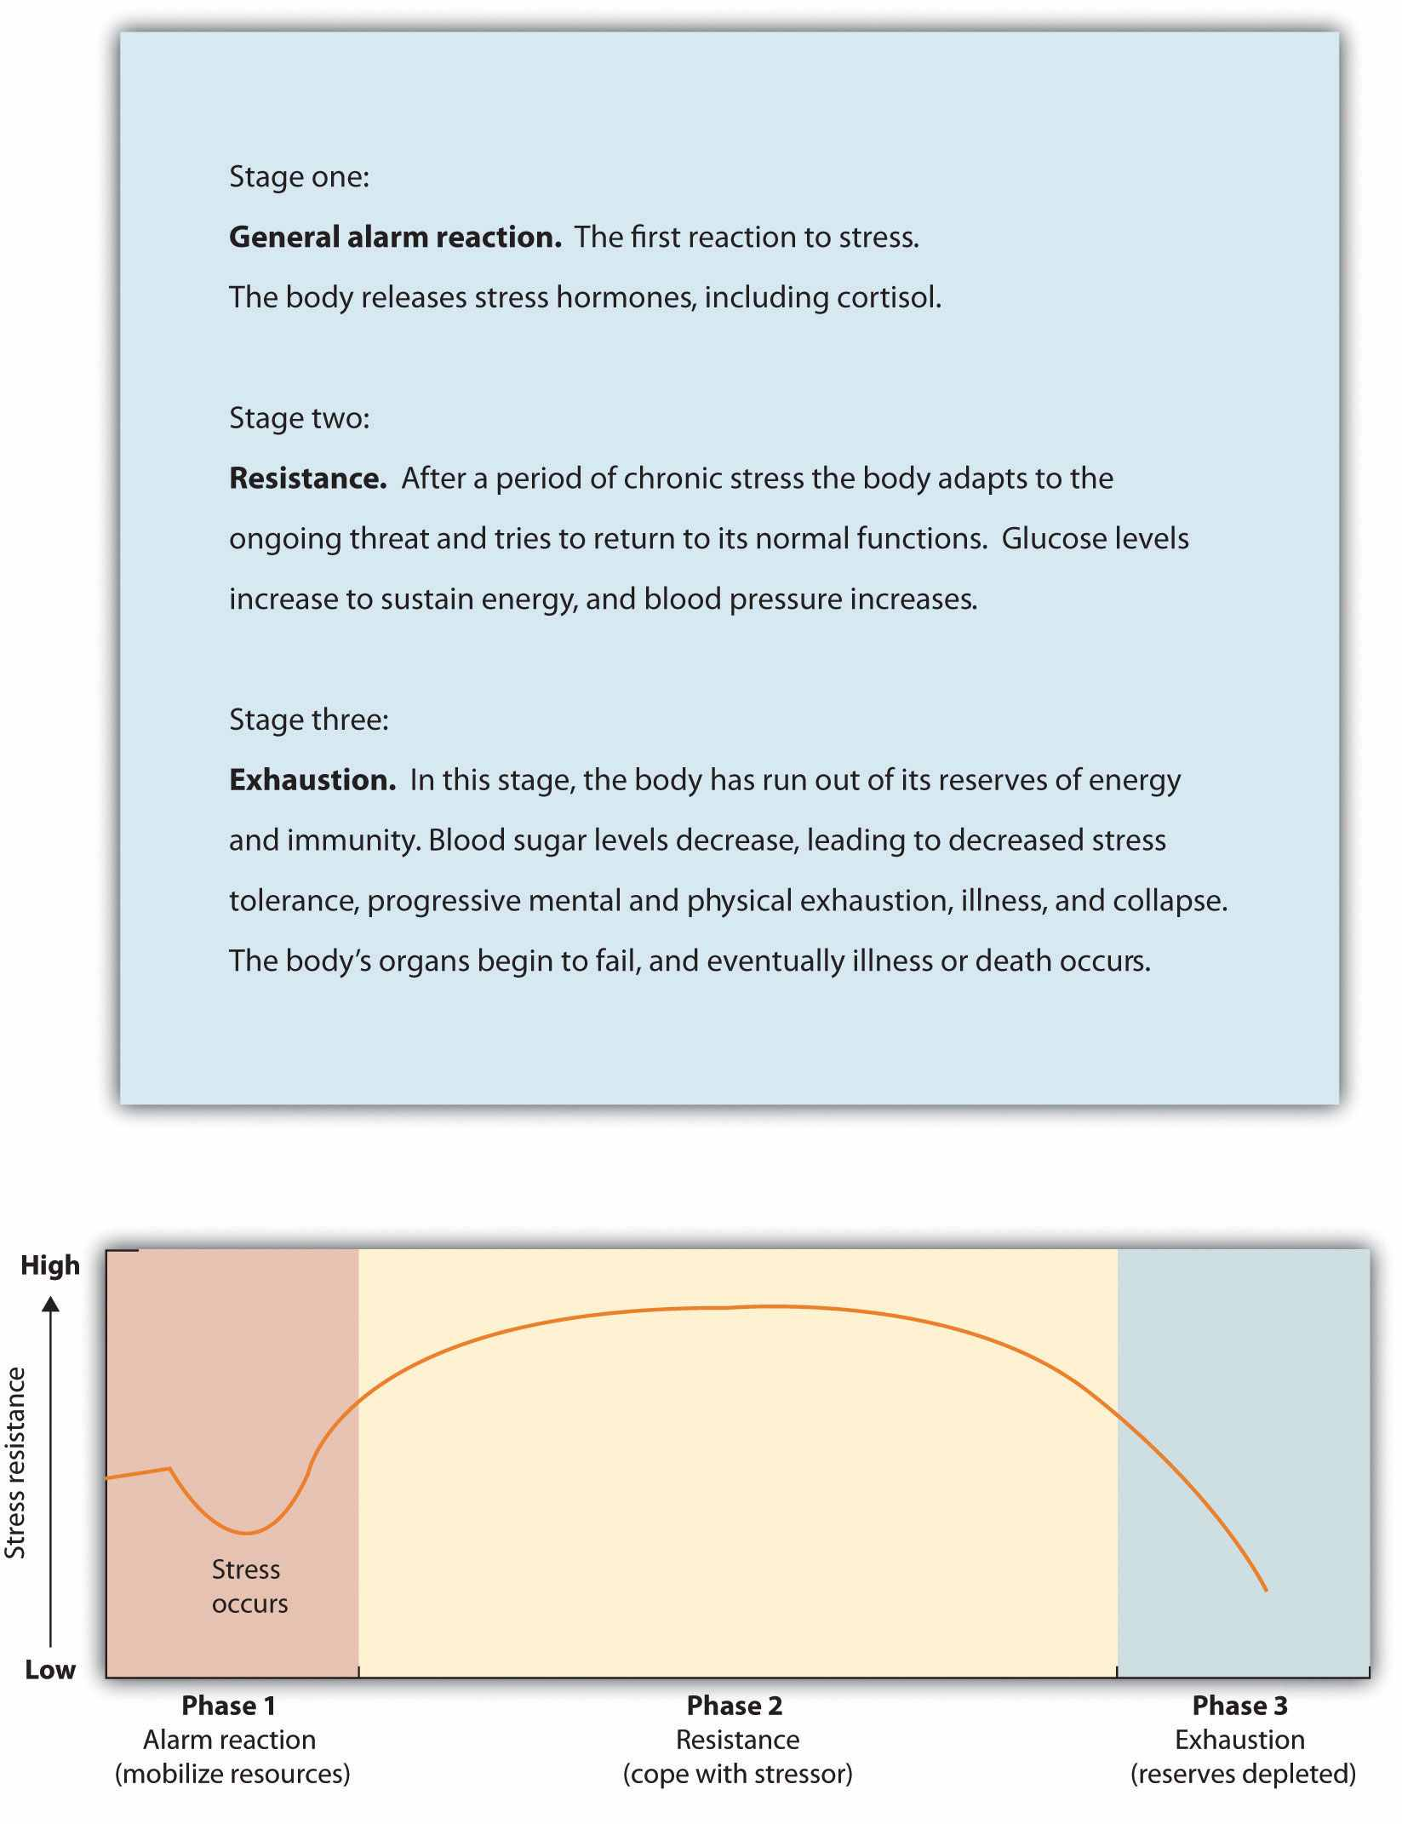
Hans Seyle’s research on the general adaptation syndrome documented the stages of prolonged exposure to stress.
The experience of stress creates both an increase in general arousal in the sympathetic nervous system (SNS) and another, even more complex, system of physiological changes through the HPA axis (Figure 3.6 "HPA Axis"). The HPA axis is a physiological response to stress involving interactions among the hypothalamus, the pituitary gland, and the adrenal glands. The HPA response begins when the hypothalamus secretes hormones that direct the pituitary gland to release the hormoneACTH. The ACTH then directs the adrenal glands to secrete more hormones, includingepinephrine, norepinephrine, and cortisol, a stress hormone that releases sugars into the blood to help prepare the body to respond to threat(Rodrigues, LeDoux, & Sapolsky, 2009). ^{[5]}
Cortisol is frequently referred to as the “stress hormone,” and it is commonly measured by researchers in order to assess the activation of the HPA axis in response to stress. Cortisol is measured by taking a sample of saliva, which is then analyzed to determine cortisol levels. Cortisol increases when people are stressed, for instance, when they are in dancing competitions (Edelstein, Yim, & Quas, 2010), ^{[6]} when they are experiencing public shame (Rohleder, Chen, Wolf, & Miller, 2008), ^{[7]} and (I’m sure you won’t be surprised) when taking school exams (Preuss, Schoofs, Schlotz, & Wolf, 2010). ^{[8]}

Figure 3.6 HPA Axis
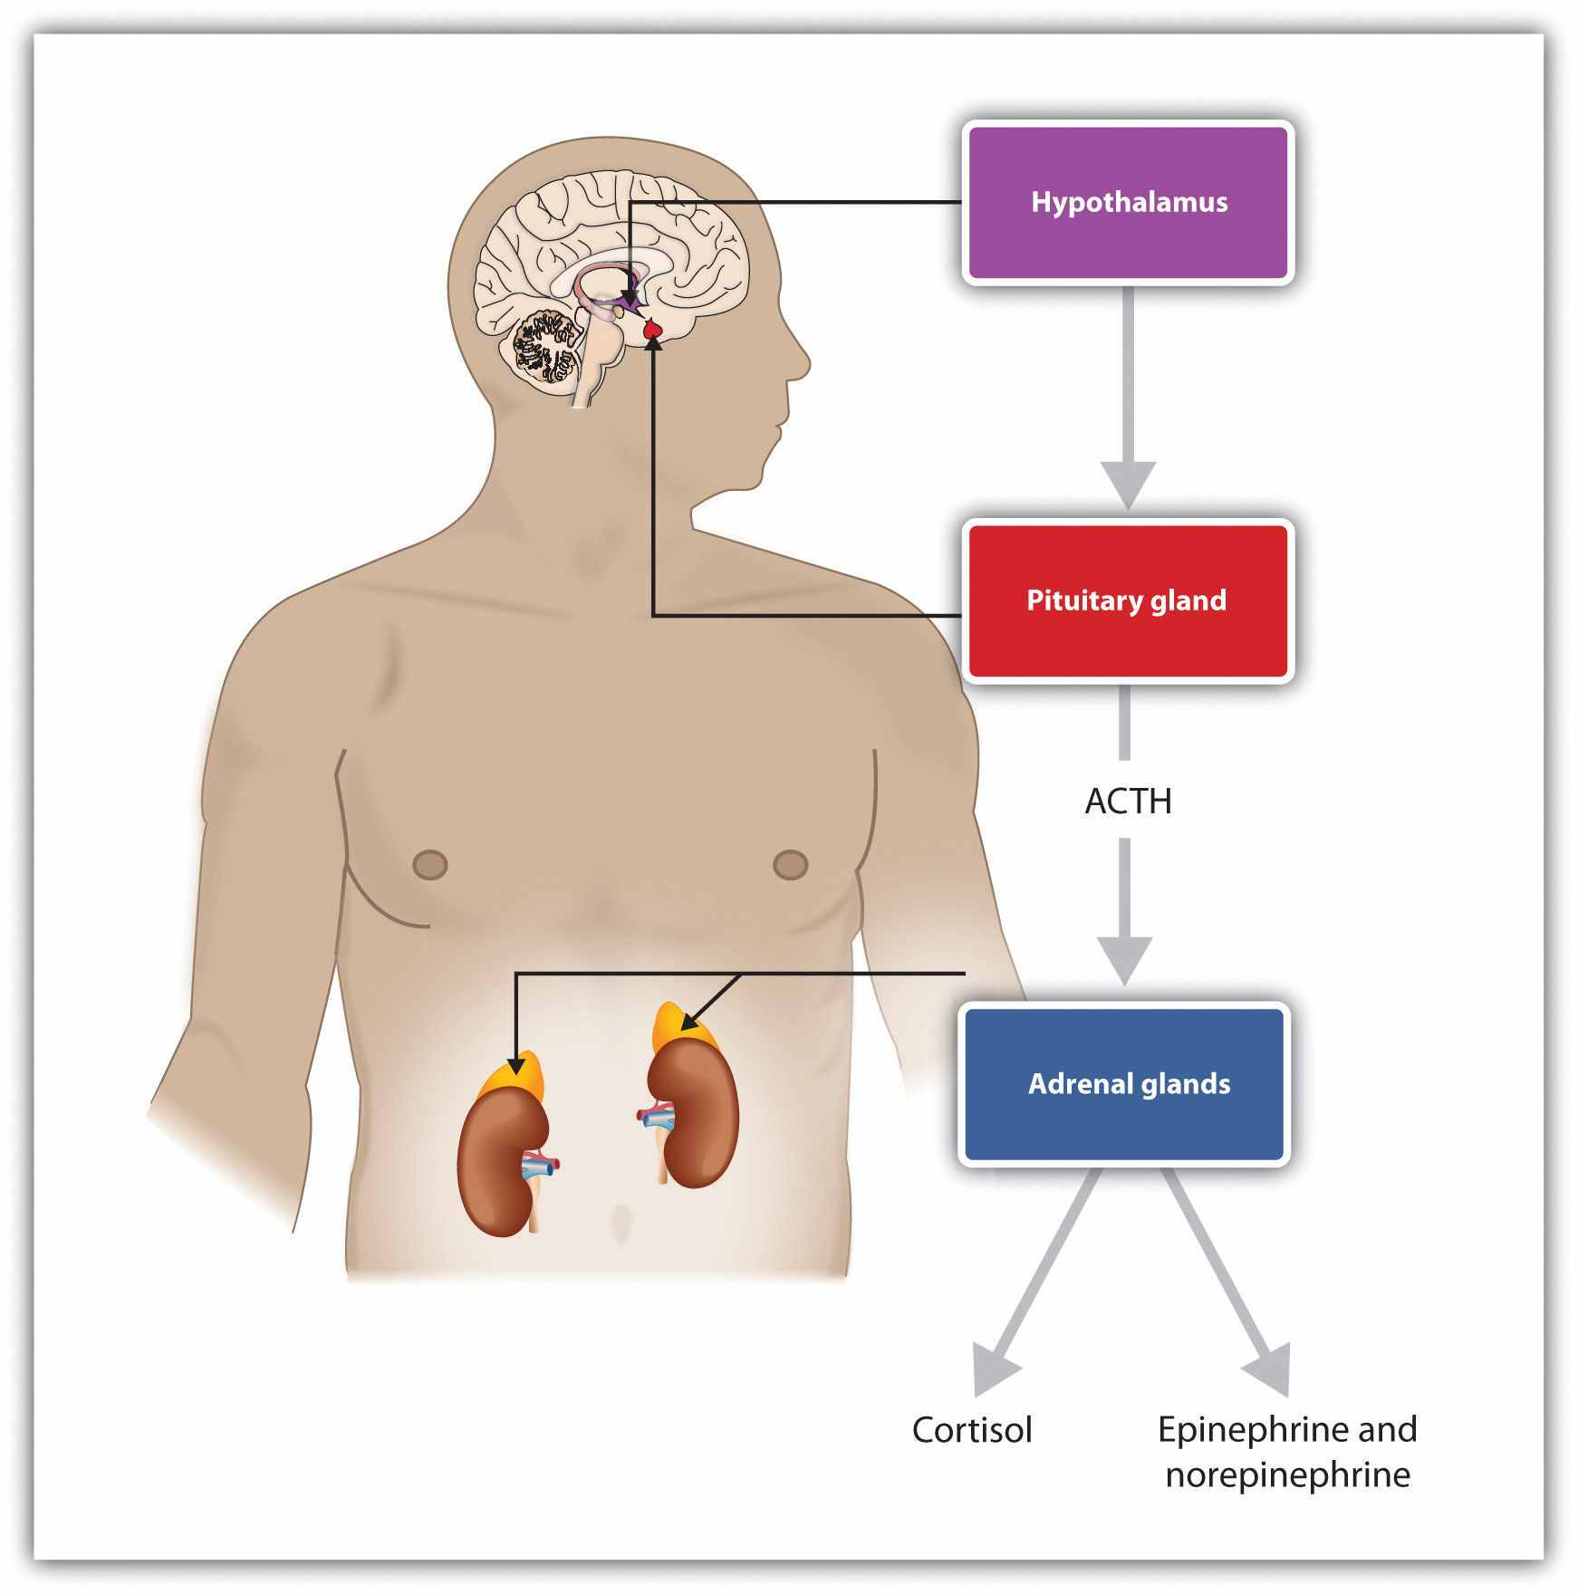
Stress activates the HPA axis. The result is the secretion of epinephrine, norepinephrine, and cortisol.
The experience of prolonged stress has a direct negative influence on our physical health because at the same time that stress increases activity in the SNS, it also suppresses important activity in the PNS. When stress is long-term, the HPA axis remains active and the adrenals continue to produce cortisol. This increased cortisol production exhausts the stress mechanism, leading to fatigue and depression.
The HPA reactions to persistent stress lead to a weakening of the immune system, making us more susceptible to a variety of health problems, including colds and other diseases (Cohen & Herbert, 1996; Faulkner & Smith, 2009; Miller, Chen, & Cole, 2009; Uchino, Smith, Holt-Lunstad, Campo, & Reblin, 2007). ^{[9]} Stress also damages our DNA, making us less likely to be able to repair wounds and respond to the genetic mutations that cause disease (Epel et al., 2006). ^{[10]} As a result, wounds heal more slowly when we are under stress, and we are more likely to get cancer (Kiecolt-Glaser, McGuire, Robles, & Glaser, 2002; Wells, 2006). ^{[11]}
Sheldon Cohen and colleagues (Cohen et al., 1998) ^{[12]} demonstrated experimentally that repeated exposure to threats and stress can increase susceptibility to the common cold virus, revealing the causal link between psychological stress and actual susceptibility to disease. To begin, the researchers had adult volunteers fill out several questionnaires about the stressful experiences in their lives. Then the researchers administered nose drops into each participant’s nose. The control group (the lucky ones!) received a placebo saline solution; the experimental group received a solution containing a cold virus. Over the next week, the participants were examined daily by a nurse. None of the control group participants got a cold. But of those exposed to the cold virus, 82% did get a cold. Furthermore, within this condition, those participants who reported enduring long-term stressors—particularly those who felt that they were underemployed or who had enduring interpersonal difficulties with family or friends—were significantly more likely to catch colds than those who had only short-term stress.
Chronic stress is also a major contributor to heart disease. Although heart disease is caused in part by genetic factors, as well as by high blood pressure, high cholesterol, and cigarette smoking, it is also caused by stress (Krantz & McCeney, 2002). ^{[13]}Long-term stress creates two opposite effects on the coronary system. Stress increases cardiac output (i.e., the heart pumps more blood) at the same time that it reduces the ability of the blood vessels to conduct blood through the arteries, as the increase in levels of cortisol leads to a buildup of plaque on artery walls (Dekker et al., 2008). ^{[14]}The combination of increased blood flow and arterial constriction leads to increased blood pressure (hypertension), which can damage the heart muscle, leading to heart attack and death.

Sources of Stress
The stressors for Seyle’s rats included electric shock and exposure to cold. Although these are probably not on your top-10 list of most common stressors, the stress that we experience in our everyday social interactions can also be taxing. Thomas Holmes and Richard Rahe (1967) ^{[15]} developed a measure of some everyday life events that might lead to stress, and you can assess your own likely stress level by completing the measure in Table 3.1 "The Holmes and Rahe Stress Scale" and calculating your stress level by looking at Table 3.2 "Interpretation of the Holmes and Rahe Stress Scale". You might want to pay particular attention to this score because it can predict the likelihood that you will get sick. Rahe and his colleagues (Rahe, Mahan, Arthur, & Gunderson, 1970) ^{[16]} asked 2,500 members of the military to complete the rating scale and then assessed the health records of the soldiers over the following 6 months. The results were clear: The higher the scale score, the more likely the soldier was to end up in the hospital.

Table 3.1 The Holmes and Rahe Stress Scale
Life Event | Score
Death of spouse | 100
Divorce | 73
Marital separation from mate | 65
Detention in jail, other institution | 63
Death of a close family member | 63
Major personal injury or illness | 53
Marriage | 50
Retirement | 45
Major change in the health or behavior of a family member | 44
Pregnancy | 40
Sexual difficulties | 39
Gaining a new family member (e.g., through birth, adoption, oldster moving) | 39
Major business readjustment (e.g., merger reorganization, bankruptcy) | 39
Major change in financial status | 38
Death of close friend | 37
Change to different line of work | 36
Major change in the number of arguments with spouse | 35
Taking out a mortgage or loan for a major purchase | 31
Foreclosure on a mortgage or loan | 30
Major change in responsibilities at work | 29
Son or daughter leaving home (e.g., marriage, attending college) | 29
Trouble with in-laws | 29
Outstanding personal achievement | 28
Spouse beginning or ceasing to work outside the home | 26
Beginning or ceasing formal schooling | 26
Major change in living conditions | 25
Revision of personal habits (dress, manners, associations, etc.) | 24
Trouble with boss | 23
Major change in working hours or conditions | 20
Change in residence | 20
Change to a new school | 20
Major change in usual type and/or amount of recreation | 19
Major change in church activities (a lot more or less than usual) | 19
Major change in social activities (clubs, dancing, movies, visiting) | 18
Taking out a mortgage or loan for a lesser purchase (e.g., for a car, television, freezer) | 17
Major change in sleeping habits | 16
Major change in the number of family get-togethers | 15
Major change in eating habits | 15
Vacation | 13
Christmas season | 12
Minor violations of the law (e.g., traffic tickets) | 11
Total | ______
Note. You can calculate your score on this scale by adding the total points across each of the events that you have experienced over the past year. Then use Table 3.2 "Interpretation of the Holmes and Rahe Stress Scale" to determine your likelihood of getting ill.

Table 3.2 Interpretation of the Holmes and Rahe Stress Scale
Number of Life-Changing Units | Chance of Developing a Stress-Related Illness (%)
Less than 150 | 30
150–300 | 50
More than 300 | 80
Although some of the items on the Holmes and Rahe scale are major, you can see that even minor stressors add to the total score. Our everyday interactions with the environment that are essentially negative, known as daily hassles, can also create stress, as well as poorer health outcomes (Hutchinson & Williams, 2007). ^{[17]} Events that may seem rather trivial altogether, such as having an argument with a friend or getting cut off by another car in rush-hour traffic, can produce stress (Fiksenbaum, Greenglass, & Eaton, 2006). ^{[18]} Glaser (1985) ^{[19]} found that medical students who were tested during, rather than several weeks before, their school examination periods showed lower immune system functioning. Other research has found that even more minor stressors, such as having to do math problems during an experimental session, can compromise the immune system (Cacioppo et al., 1998). ^{[20]}

Responses to Stress
Not all people experience and respond to stress in the same way, and these differences can be important. The cardiologists Meyer Friedman and R. H. Rosenman (1974) ^{[21]}were among the first to study the link between stress and heart disease. In their research, they noticed that even though the partners in married couples often had similar lifestyles, diet, and exercise patterns, the husbands nevertheless generally had more heart disease than did the wives. As they tried to explain the difference, they focused on the personality characteristics of the partners, finding that the husbands were more likely than the wives to respond to stressors with negative emotions and hostility.
Recent research has shown that the strongest predictor of a physiological stress response from daily hassles is the amount of negative emotion that they evoke. People who experience strong negative emotions as a result of everyday hassles and who respond to stress with hostility experience more negative health outcomes than do those who react in a less negative way (McIntyre, Korn, & Matsuo, 2008; Suls & Bunde, 2005). ^{[22]} Williams and his colleagues (2001) ^{[23]}found that people who scored high on measures of anger were three times more likely to suffer from heart attacks in comparison with those who scored lower on anger.
On average, men are more likely than are women to respond to stress by activating thefight-or-flight response, which is an emotional and behavioral reaction to stress that increases the readiness for action. The arousal that men experience when they are stressed leads them to either go on the attack, in an aggressive or revenging way, or else retreat as quickly as they can to safety from the stressor. The fight-or-flight response allows men to control the source of the stress if they think they can do so, or if that is not possible, it allows them to save face by leaving the situation. The fight-or-flight response is triggered in men by the activation of the HPA axis.
Women, on the other hand, are less likely to take a fight-or-flight response to stress. Rather, they are more likely to take a tend-and-befriend response (Taylor et al., 2000). ^{[24]} The tend-and-befriend response is a behavioral reaction to stress that involves activities designed to create social networks that provide protection from threats. This approach is also self-protective because it allows the individual to talk to others about her concerns as well as to exchange resources, such as child care. The tend-and-befriend response is triggered in women by the release of the hormoneoxytocin, which promotes affiliation. Overall, the tend-and-befriend response is healthier than the flight-or-flight response because it does not produce the elevated levels of arousal related to the HPA, including the negative results that accompany increased levels of cortisol. This may help explain why women, on average, have less heart disease and live longer than men.
The experience of long-term stress—and its potential negative impact on our physical and mental health—represents one example of the powerful influence of the social situation in our everyday lives. These findings represent social psychological principles in action: Our affect, cognition, and behavior are influenced in profound ways by the events that occur to us, and particularly by the people around us. Furthermore, the observed gender differences in response to stress demonstrate another example of the operation of the basic principles of social psychology: Men usually respond to stress by focusing on self-concern (fight or flight) whereas women are more likely to respond by focusing on other-concern (tend-and-befriend).

Depression and Anxiety
Unfortunately, stress is not the only negative health consequence that can be caused by our social interactions. Depression is an affective disorder in which people experience sadness, low self-esteem, negative thoughts, pessimism, and apathy. Physical symptoms, such as loss of appetite and insomnia, may also accompany depression. Almost 3% of the U.S. population—that is, over 7 million people—experience a major depressive event every year, and the incidence is somewhat greater for women than for men (Kessler, McGonagle, Nelson, & Hughes, 1994). ^{[25]} And many, many more people suffer from milder, but also harmful, forms of depression. Minor depression—the everyday negative mood or “blues” that most of us experience—is a part of everyday life for many people. It is no surprise that depression has been termed “the common cold of mental illness.”
Still another mental health outcome that relates to social behavior is anxiety—a psychological disorder that may be accompanied by a number of physical symptoms, including diarrhea, upset stomach, sweaty hands, shortness of breath, poor concentration, and general agitation. As with depression, anxiety may be severe in some cases for some people, but it can also occur in more subtle, minor, and yet nevertheless troubling forms for many people.
Anxiety and depression have many causes. These syndromes are partially genetically inherited and are also determined in part by body chemicals including hormones and neurotransmitters. Nevertheless, depression and anxiety are also largely socially determined, and social psychologists naturally focus on these aspects. To a social psychologist, depression and anxiety are maladies that are caused by our everyday social lives and that can be understood and treated—at least in part—in a social sense.
Depression and anxiety are caused at least partly by the lack of adequate social interactions. Almost half of Americans describe themselves as being shy. Shy people frequently find it difficult to make friends because they evaluate themselves negatively and feel that they cannot succeed in social encounters (Cheek & Melchior, 1990). ^{[26]}Extremely shy people may become lonely, and loneliness is a risk factor for a large range of physical and mental health problems, including depression and anxiety (Cacioppo, Hawley, & Berston, 2003; Christensen & Kashy, 1998). ^{[27]} Depressed people frequently tend to avoid social interactions altogether, whereas shy, anxious people tend to become uncomfortable in public and may overestimate how much people are focusing on them. On the other hand, people who are more extroverted (i.e., who enjoy making friends and being in social situations) are less depressed and have fewer health problems (Diener, Suh, Lucas, & Smith, 1999). ^{[28]}
Depression and anxiety are determined both by how we feel about our own performance and by our social interactions with others. We are more likely to feel good about ourselves when we perceive that we have adequate social interactions and that we are accepted and cared for by others—but we are more likely to feel poorly about ourselves when we perceive that we are not measuring up to the goals and standards that others find important. When we feel that there are discrepancies between our goals and the actual conditions in our lives, we feel more emotion (Carver & Scheier, 1981). ^{[29]}
Tory Higgins and his colleagues (Higgins, Bond, Klein, & Strauman, 1986; Strauman & Higgins, 1988) ^{[30]} have proposed that the types of emotional distress we experience are determined by both our perceptions of how well our own behaviors meet the standards and goals we have provided ourselves (our internal standards) and our perceptions of how others think about us (our external standards). Higgins found in his research that people were more likely to experience sadness, dissatisfaction, and other depression-related emotions when they indicated that their current perception of themselves (the actual self-concept) was discrepant with their hopes and goals (the ideal self-concept). But people were more likely to experience fear, worry, tension, and other anxiety-related emotions when they felt that the actual self-concept was discrepant with their beliefs about important standards regarding duty and obligations (the ought self-concept).
Higgins also found in his research that the same negative emotions resulted when there were discrepancies between the actual self-concept and the ideal self-concept or the ought self-concept provided by other important people, such as parents and friends. That is, the participants felt bad about themselves when they did not meet the goals that other people thought were important (the external standards), just as they felt bad about not meeting their own goals (the internal standards). You might not care that much yourself about achieving in school or meeting your family obligations, but your failure to meet these goals may still produce negative emotions because you realize that your parents do think it is important. Again, the importance of the social situation in creating emotional experience is clear.
As you can see in Figure 3.7 "The Self-Fulfilling Nature of Anxiety and Depression", still another social aspect of anxiety and depression is that they are contagious and self-fulfilling. When we are depressed or anxious, these feelings show up in our behavior. Other people then see our negative states, and they are likely to respond to us negatively. These responses make it more difficult for us to do well in school and at work and lead to negative outcomes. For instance, people who are depressed or anxious are more likely to be divorced and fired from their jobs and are less fun to be around (Coyne & Downey, 1991). ^{[31]} And these negative outcomes naturally create even more negative cognitions and more negative affect, which in turn make us feel even worse about ourselves.

Figure 3.7 The Self-Fulfilling Nature of Anxiety and Depression
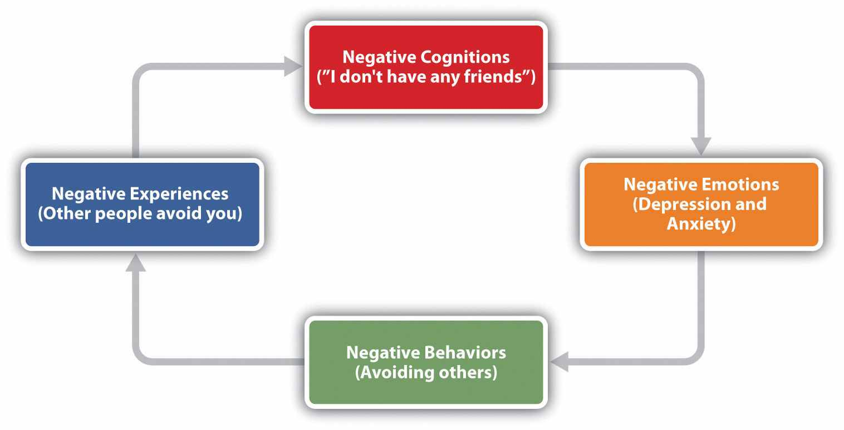
Given the social determinants of depression and anxiety, it will probably not surprise you to hear that one of the more important approaches to reducing anxiety and depression is to attempt to change our social cognitions and to help us improve our social interactions with others. Many current psychological therapies used to help alleviate depression and anxiety are designed to change the thought processes and the social interactions of individuals with psychological difficulties (Ellis, 2004; Beck, Freeman, & Davis, 2004). ^{[32]}

KEY TAKEAWAYS
- Although most people generally experience a sense of everyday well-being, negative affect, particularly stress, can disrupt these feelings.
- The experience of prolonged stress creates an increase in general arousal in the SNS and physiological changes through the HPA axis.
- People who have recently experienced extreme negative situations experience stress, but everyday minor hassles can also create stress.
- Not all people experience and respond to stress in the same way, and these differences can be important. One difference in response is between the fight-or-flight response and the tend-and-befriend response.
- Depression and anxiety are largely socially determined, through a lack of adequate social interactions and the inability to meet standards imposed by others.

EXERCISES AND CRITICAL THINKING
- Describe a time when you experienced stress. Did you know you were experiencing it? What emotional and physiological changes did you experience?
- What advice would you give someone who is experiencing stress that might help them better cope with it?
- Give an example of a time when you or someone you know experienced depression or anxiety that was caused or amplified by his or her social situation.

[1] Diener, E., Suh, E. M., Lucas, R. E., & Smith, H. L. (1999). Subjective well-being: Three decades of progress. Psychological Bulletin, 125(2), 276–302; Kahneman, D., Diener, E., & Schwarz, N. (Eds.). (1999). Well-being: The foundations of hedonic psychology. New York, NY: Russell Sage Foundation.
[2] Lazarus, R. S. (2000) Toward better research on stress and coping. American Psychologist, 55, 665–673; Lazarus, R. S., & Folkman, S. (1984). Stress, appraisal, and coping. New York, NY: Springer Publishing Company.
[3] American Medical Association. (2009). Three-fold heart attack increase in Hurricane Katrina survivors. Retrieved from http://www.ama-assn.org/ama/pub/news/news/heart-attack-katrina-survivors.shtml
[4] Lampert, R., Baron, S. J., McPherson, C. A., & Lee, F. A. (2002). Heart rate variability during the week of September 11, 2001. JAMA, 288, 575; Pulcino, T., Galea, S., Ahern, J., Resnick, H., Foley, M., & Vlahov, D. (2003). Posttraumatic stress in women after the September 11 terrorist attacks in New York City. Journal of Women’s Health, 12(8), 809–820.
[5] Rodrigues, S. M., LeDoux, J. E., & Sapolsky, R. M. (2009). The influence of stress hormones on fear circuitry. Annual Review of Neuroscience, 32, 289–313.
[6] Edelstein, R. S., Yim, I. S., & Quas, J. A. (2010). Narcissism predicts heightened cortisol reactivity to a psychosocial stressor in men. Journal of Research in Personality, 44(5), 565–572.
[7] Rohleder, N., Chen, E., Wolf, J. M., & Miller, G. E. (2008). The psychobiology of trait shame in young women: Extending the social self-preservation theory. Health Psychology, 27(5), 523–532.
[8] Preuss, D., Schoofs, D., Schlotz, W., & Wolf, O. T. (2010). The stressed student: Influence of written examinations and oral presentations on salivary cortisol concentrations in university students. Stress: The International Journal on the Biology of Stress, 13(3), 221–229.
[9] Cohen, S., & Herbert, T. B. (1996). Health psychology: Psychological factors and physical disease from the perspective of human psychoneuroimmunology. Annual Review of Psychology, 47, 113–142; Faulkner, S., & Smith, A. (2009). A prospective diary study of the role of psychological stress and negative mood in the recurrence of herpes simplex virus (HSV1). Stress and Health: Journal of the International Society for the Investigation of Stress, 25(2), 179–187; Miller, G., Chen, E., & Cole, S. W. (2009). Health psychology: Developing biologically plausible models linking the social world and physical health. Annual Review of Psychology, 60, 501–524; Uchino, B. N., Smith, T. W., Holt-Lunstad, J., Campo, R., & Reblin, M. (2007). Stress and illness. In J. T. Cacioppo, L. G. Tassinary, & G. G. Berntson (Eds.), Handbook of psychophysiology (3rd ed., pp. 608–632). New York, NY: Cambridge University Press.
[10] Epel, E., Lin, J., Wilhelm, F., Wolkowitz, O., Cawthon, R., Adler, N.,…Blackburn, E. H. (2006). Cell aging in relation to stress arousal and cardiovascular disease risk factors.Psychoneuroendocrinology, 31(3), 277–287.
[11] Kiecolt-Glaser, J. K., McGuire, L., Robles, T. F., & Glaser, R. (2002). Psychoneuroimmunology: Psychological influences on immune function and health. Journal of Consulting and Clinical Psychology, 70(3), 537–547; Wells, W. (2006). How chronic stress exacerbates cancer. Journal of Cell Biology, 174(4), 476.
[12] Cohen, S., Frank, E., Doyle, W. J., Skoner, D. P., Rabin, B. S., & Gwaltney, J. M. Jr. (1998). Types of stressors that increase susceptibility to the common cold in adults. Health Psychology, 17, 214–23.
[13] Krantz, D. S., & McCeney, M. K. (2002). Effects of psychological and social factors on organic disease: A critical assessment of research on coronary heart disease. Annual Review of Psychology, 53, 341–369.
[14] Dekker, M., Koper, J., van Aken, M., Pols, H., Hofman, A., de Jong, F.,…Tiemeier, H. (2008). Salivary cortisol is related to atherosclerosis of carotid arteries. Journal of Clinical Endocrinology and Metabolism, 93(10), 3741.
[15] Holmes, T. H., & Rahe, R. H. (1967). The social readjustment rating scale. Journal of Psychosomatic Research, 11, 213–218.
[16] Rahe, R. H., Mahan, J., Arthur, R. J., & Gunderson, E. K. E. (1970). The epidemiology of illness in naval environments: I. Illness types, distribution, severities and relationships to life change. Military Medicine, 135, 443–452.
[17] Hutchinson, J. G., & Williams, P. G. (2007). Neuroticism, daily hassles, and depressive symptoms: An examination of moderating and mediating effects. Personality and Individual Differences, 42(7), 1367–1378.
[18] Fiksenbaum, L. M., Greenglass, E. R., & Eaton, J. (2006). Perceived social support, hassles, and coping among the elderly. Journal of Applied Gerontology, 25(1), 17–30.
[19] Glaser, R. (1985). Stress-related impairments in cellular immunity. Psychiatry Research, 16(3), 233–239.
[20] Cacioppo, J. T., Berntson, G. G., Malarkey, W. B., Kiecolt-Glaser, J. K., Sheridan, J. F., Poehlmann, K. M.,…Glaser, R. (1998). Autonomic, neuroendocrine, and immune responses to psychological stress: The reactivity hypothesis. In Annals of the New York Academy of Sciences: Neuroimmunomodulation: Molecular aspects, integrative systems, and clinical advances (Vol. 840, pp. 664–673). New York, NY: New York Academy of Sciences.
[21] Friedman, M., & Rosenman, R. H. (1974). Type A behavior and your heart. New York, NY: Knopf.
[22] McIntyre, K., Korn, J., & Matsuo, H. (2008). Sweating the small stuff: How different types of hassles result in the experience of stress. Stress & Health: Journal of the International Society for the Investigation of Stress, 24(5), 383–392. doi:10.1002/smi.1190; Suls, J., & Bunde, J. (2005). Anger, anxiety, and depression as risk factors for cardiovascular disease: The problems and implications of overlapping affective dispositions. Psychological Bulletin, 131(2), 260–300.
[23] Williams, R. B. (2001). Hostility: Effects on health and the potential for successful behavioral approaches to prevention and treatment. In A. Baum, T. A. Revenson, & J. E. Singer (Eds.), Handbook of health psychology. Mahwah, NJ: Lawrence Erlbaum Associates.
[24] Taylor, S. E., Klein, L. C., Lewis, B. P., Gruenewald, T. L., Gurung, R. A. R., & Updegraff, J. A. (2000). Biobehavioral responses to stress in females: Tend-and-befriend, not fight-or-flight.Psychological Review, 107(3), 411–429.
[25] Kessler, R. C., McGonagle, K. A., Nelson, C. B., & Hughes, M. (1994). Sex and depression in the National Comorbidity Survey: II. Cohort effects. Journal of Affective Disorders, 30(1), 15–26.
[26] Cheek, J. M., & Melchior, L. A. (1990). Shyness, self-esteem, and self-consciousness. InHandbook of social and evaluation anxiety (pp. 47–82). New York, NY: Plenum Press.
[27] Cacioppo, J. T., Hawley, L. C., & Bernston, G. G. (2003). The anatomy of loneliness. Current Directions in Psychological Science, 12(3), 71–74; Christensen, P. N., & Kashy, D. A. (1998). Perceptions of and by lonely people in initial social interaction. Personality and Social Psychology Bulletin, 24(3), 322–329.
[28] Diener, E., Suh, E. M., Lucas, R. E., & Smith, H. L. (1999). Subjective well-being: Three decades of progress. Psychological Bulletin, 125(2), 276–302.
[29] Carver, C. S., & Scheier, M. F. (1981). Attention and self-regulation: A control-theory approach to human behavior. New York, NY: Springer-Verlag.
[30] Higgins, E. T., Bond, R. N., Klein, R., & Strauman, T. (1986). Self-discrepancies and emotional vulnerability: How magnitude, accessibility, and type of discrepancy influence affect.Journal of Personality and Social Psychology, 51(1), 5–15; Strauman, T. J., & Higgins, E. T. (1988). Self-discrepancies as predictors of vulnerability to distinct syndromes of chronic emotional distress. Journal of Personality, 56(4), 685–707.
[31] Coyne, J. C., & Downey, G. (1991). Social factors and psychopathology: Stress, social support, and coping processes. Annual Review of Psychology, 42, 401–425.
[32] Ellis, A. (2004). Why rational emotive behavior therapy is the most comprehensive and effective form of behavior therapy. Journal of Rational-Emotive and Cognitive-Behavior Therapy, 22, 85–92; Beck, A. T., Freeman, A., & Davis, D. D. (2004). Cognitive therapy of personality disorders (2nd ed.). New York, NY: Guilford Press.

3.3 How to Feel Better: Coping With Negative Emotions

LEARNING OBJECTIVES
- Review the behaviors that are effective and those that are not in helping us cope with negative emotions.
- Explain the principles and positive outcomes of self-regulation.
- Describe how positive emotions are related to health and happiness.
- Review theory and research regarding the influence of social support on health and well-being.
- Describe how people overestimate the influence of material wealth on their well-being.
No matter how healthy and happy we are in our everyday lives, there are going to be times when we experience stress, depression, and anxiety. Some of these experiences will be major and some will be minor, and some of us will experience these emotions more than others. Sometimes these feelings will be the result of clear difficulties that pose direct threats to us: We or those we care about may be ill or injured; we may lose our job or have academic difficulties. At other times, these feelings may seem to develop for no apparent reason.
Although it is not possible to prevent the experience of negative emotions entirely (in fact, given their importance in helping us understand and respond to threats, we would not really want to if we could), we can nevertheless learn to respond to and cope with them in the most productive possible ways. We do not need to throw up our hands in despair when things go wrong—rather, we can bring our personal and social resources to bear to help us. We have at our disposal many techniques that we can use to help us deal with negative emotions.

What Doesn’t Work: Distorting and Suppressing Negative Outcomes
Perhaps the most common approach to dealing with negative affect is to attempt to suppress, avoid, or deny it. You probably know people who seem to you to be stressed, depressed, or anxious but who cannot or will not see it in themselves. Perhaps you tried to talk to them about it, to get them to open up to you, but were rebuffed. They seem to act as if there is no problem at all, simply moving on with life without admitting or even trying to deal with the negative feelings. Or perhaps you have taken a similar approach yourself: Have you ever had an important test to study for or an important job interview coming up, and rather than planning and preparing for it, you simply tried put it out of your mind entirely?
Research has found that there are clear difficulties with an approach to negative events and feelings that involves simply trying to ignore them. For one, ignoring our problems does not make them go away. Not being able to get our work done because we are depressed, being too anxious to develop good relationships with others, or experiencing so much stress that we get sick will be detrimental to our life even if we cannot admit that it is occurring.
Suppressing our emotions is also not a very good option, at least in the long run, because it tends to fail (Gross & Levenson, 1997). ^{[1]} If we know that we have a big exam coming up, we have to focus on the exam itself in order to suppress it. We can’t really suppress or deny our thoughts because we actually have to recall and face the event in order to make the attempt to not think about it. Furthermore, we may continually worry that our attempts to suppress will fail. Suppressing our emotions might work out for a short while, but when we run out of energy, the negative emotions may shoot back up into consciousness, causing us to reexperience the negative feelings that we had been trying to avoid.
Daniel Wegner and his colleagues (Wegner, Schneider, Carter, & White, 1987) ^{[2]}directly tested whether people would be able to effectively suppress a simple thought. They asked participants in a study to not think about a white bear for 5 minutes but to ring a bell in case they did. (Try it yourself—can you do it?) The participants were unable to suppress the thought as instructed—the white bear kept popping into mind, even when they were instructed to avoid thinking about it. You might have had a similar experience when you were dieting or staying home to study—the chocolate bar in the kitchen cabinet or the fun time you were missing by staying home kept popping into mind, disrupting your work.
Another poor approach to attempting to escape from our problems is to engage in behaviors designed to distract us from them. Sometimes this approach will be successful in the short term—we might try distracting ourselves from our troubles by going for a run, watching TV, or reading a book, and perhaps this might be useful. But sometimes people go to extremes to avoid self-awareness when it might be better that they face their troubles directly. If we experience discrepancies between our ideal selves and our important self-concepts, if we feel that we cannot ever live up to our or others’ expectations for us, or if we are just really depressed or anxious, we may attempt to escape ourselves entirely. Roy Baumeister (1991) ^{[3]} has speculated that maladaptive behaviors such as drug abuse, sexual masochism, spiritual ecstasy, binge eating, and even suicide are all mechanisms by which people may attempt to escape the self.
Not only does research show that attempting to suppress our negative thoughts does not work, there is even evidence that the opposite is true—that when we are faced with troubles, it is healthy to let the negative thoughts and feelings out by expressing them, either to ourselves or to others. James Pennebaker and his colleagues (Pennebaker, Colder, & Sharp, 1990; Watson & Pennebaker, 1989) ^{[4]} have conducted many correlational and experimental studies that demonstrate the advantages to our mental and physical health of opening up versus bottling our feelings. This research team has found that simply talking about or writing about our emotions or our reactions to negative events provides substantial health benefits.
Pennebaker and Beall (1986) ^{[5]} randomly assigned students to write about either the most traumatic and stressful event of their lives or to write about a trivial topic. Although the students who wrote about the traumas had higher blood pressure and more negative moods immediately after they wrote their essays, they were also less likely to visit the student health center for illnesses during the following 6 months in comparison to those who wrote about more minor issues. Something positive evidently occurred as a result of confronting their negative experiences. Other research studied individuals whose spouses had died in the previous year, finding that the more they talked about the death with others, the less likely they were to become ill during the subsequent year. Daily writing about one’s emotional states has also been found to increase immune system functioning (Petrie, Fontanilla, Thomas, Booth, & Pennebaker, 2004), ^{[6]} and Uysal and Lu (2011) ^{[7]} found that self-expression was associated with experiencing less physical pain.
Opening up probably helps in various ways. For one, expressing our problems allows us to gain information from others and may also bring support from them. And writing or thinking about one’s experiences also seems to help people make sense of the events and may give them a feeling of control over their lives (Pennebaker & Stone, 2004). ^{[8]}

A Better Approach: Self-Regulation
As we have seen, emotions are useful in warning us about potential danger and in helping us to make judgments quickly, so it is a good thing that we have them. However, we also need to learn how to control our emotions, to prevent our emotions from letting our behavior get out of control. The process of setting goals and using our cognitive and affective capacities to reach those goals is known as self-regulation, and a good part of self-regulation involves regulating our emotions.
To be the best people that we possibly can, we have to work hard at it. Succeeding at school, at work, and at our relationships with others takes a lot of effort. When we are successful at self-regulation, we are able to move toward or meet the goals that we set for ourselves. When we fail at self-regulation, we are not able to meet those goals. People who are better able to regulate their behaviors and emotions are more successful in their personal and social encounters (Eisenberg & Fabes, 1992), ^{[9]} and thus self-regulation is a skill we should seek to master.
Being able to exert self-control has some important positive outcomes. Consider, for instance, research by Walter Mischel and his colleagues (Mischel, Shoda, & Rodriguez, 1989). ^{[10]} In their studies, they had 4- and 5-year-old children sit at a table in front of a yummy snack, such as a chocolate chip cookie or a marshmallow. The children were told that they could eat the snack right away if they wanted to. However, they were also told that if they could wait for just a couple of minutes, they’d be able to have two snacks—both the one in front of them and another just like it. However, if they ate the one that was in front of them before the time was up, they would not get a second.
Mischel found that some children were able to self-regulate—they were able to override the impulse to seek immediate gratification in order to obtain a greater reward at a later time. Other children, of course, were not—they just ate the first snack right away. Furthermore, the inability to delay gratification seemed to occur in a spontaneous and emotional manner, without much thought. The children who could not resist simply grabbed the cookie because it looked so yummy, without being able to cognitively stop themselves (Metcalfe & Mischel, 1999; Strack & Deutsch, 2007). ^{[11]} It turns out that these emotional responses are determined in part by particular brain patterns that are influenced by body chemicals. For instance, preferences for small immediate rewards over large later rewards have been linked to low levels of the neurotransmitter serotonin in animals (Bizot, Le Bihan, Peuch, Hamon, & Thiebot, 1999; Wilkinson & Robbins, 2004), ^{[12]} and low levels of serotonin are tied to violence, impulsiveness, and even suicide (Asberg, Traskman, & Thoren, 1976). ^{[13]}
The ability to self-regulate in childhood has important consequences later in life. When Mischel followed up on the children in his original study, he found that those who had been able to self-regulate as children grew up to have some highly positive characteristics—they got better SAT scores, were rated by their friends as more socially adept, and were found to cope with frustration and stress better than those children who could not resist the tempting first cookie at a young age. Effective self-regulation is therefore an important key to success in life (Ayduk et al., 2000; Eigsti et al., 2006; Mischel, Ayduk, & Mendoza-Denton, 2003). ^{[14]}

Research Focus
Emotion Regulation Takes Effort
Self-regulation is particularly difficult when we are tired, depressed, or anxious, and it is under these conditions that we more easily lose our self-control and fail to live up to our goals (Muraven & Baumeister, 2000). ^{[15]} If you are tired and worried about an upcoming exam, you may find yourself getting angry and taking it out on your roommate, even though she really hasn’t done anything to deserve it and you don’t really want to be angry at her. It is no secret that we are more likely to fail at our diets when we are under a lot of stress or at night when we are tired.
Muraven, Tice, and Baumeister (1998) ^{[16]} conducted a study to demonstrate that emotion regulation—that is, either increasing or decreasing our emotional responses—takes work. They speculated that self-control was like a muscle—it just gets tired when it is used too much. In their experiment, they asked their participants to watch a short movie about environmental disasters involving radioactive waste and their negative effects on wildlife. The scenes included sick and dying animals, which were very upsetting. According to random assignment to conditions, one group (the increase-emotional-response condition) was told to really get into the movie and to express emotions in response to it, a second group was to hold back and decrease emotional responses (the decrease-emotional-response condition), and a third (control) group received no instructions on emotion regulation.
Both before and after the movie, the experimenter asked the participants to engage in a measure of physical strength by squeezing as hard as they could on a hand-grip exerciser, a device used for building up hand muscles. The experimenter put a piece of paper in the grip and timed how long the participants could hold the grip together before the paper fell out. The following table shows the results of this study. It seems that emotion regulation does indeed take effort because the participants who had been asked to control their emotions showed significantly less ability to squeeze the hand grip after the movie than before. Thus the effort to regulate emotional responses seems to have consumed resources, leaving the participants less capacity to make use of in performing the hand-grip task.

Table 3.3 Self-Control Takes Effort
Condition | Handgrip strength before movie | Handgrip strength after movie | Change
Increase emotional response | 78.73 | 54.63 | –25.1
No emotional control | 60.09 | 58.52 | –1.57
Decrease emotional response | 70.74 | 52.25 | –18.49
Participants who had been required to either express or refrain from expressing their emotions had less strength to squeeze a hand grip after doing so. Data are from Muraven et al. (1998). ^{[17]}
In other studies, people who had to resist the temptation to eat chocolates and cookies, who made important decisions, or who were forced to conform to others all performed more poorly on subsequent tasks that took energy in comparison to people who had not been emotionally taxed. After controlling their emotions, they gave up on subsequent tasks sooner and failed to resist new temptations (Vohs & Heatherton, 2000). ^{[18]}
Can we improve our emotion regulation? It turns out that training in self-regulation—just like physical training—can help. Students who practiced doing difficult tasks, such as exercising, avoiding swearing, or maintaining good posture, were later found to perform better in laboratory tests of self-regulation (Baumeister, Gailliot, DeWall, & Oaten, 2006; Baumeister, Schmeichel, & Vohs, 2007; Oaten & Cheng, 2006), ^{[19]} such as maintaining a diet or completing a puzzle. And we are also stronger when we are in good moods—people who had watched a funny video clip were better at subsequent self-regulation tasks (Tice, Baumeister, Shmueli, & Muraven, 2007). ^{[20]}

The Power of Positive Emotions
Although stress is an emotional response that can kill us, other emotions can help us cope with and protect ourselves from stress. The stress of the Monday through Friday grind can be offset by the fun that we can have on the weekend, and the concerns that we have about our upcoming chemistry exam can be offset by a positive attitude toward school, life, and other people. Put simply, the best antidote for stress is a happy one: Think positively, have fun, and enjoy the company of others.
You have probably heard about “the power of positive thinking”—the idea that thinking positively helps people meet their goals and keeps them healthy, happy, and able to effectively cope with the negative events that they experience. It turns out that positive thinking really works. People who think positively about their future, who believe that they can control their outcomes, and who are willing to open up and share with others are healthier people (Seligman & Csikszentmihalyi, 2000). ^{[21]}
The power of positive thinking comes in different forms, but they are all helpful. Some researchers have focused on optimism, a general tendency to expect positive outcomes, and have found that optimists are happier and have less stress (Carver & Scheier, 2009). ^{[22]} Others have focused on self-efficacy, the belief in our ability to carry out actions that produce desired outcomes. People with high self-efficacy respond to environmental and other threats in an active, constructive way—by getting information, talking to friends, and attempting to face and reduce the difficulties they are experiencing. These people, too, are better able to ward off their stresses in comparison with people with less self-efficacy (Thompson, 2009). ^{[23]} Self-efficacy helps in part because it leads us to perceive that we can control the potential stressors that may affect us. Workers who have control over their work environment (e.g., by being able to move furniture and control distractions) experience less stress, as do patients in nursing homes who are able to choose their everyday activities (Rodin, 1986). ^{[24]} Glass, Reim, and Singer (1971) ^{[25]} found in a study that participants who believed they could stop a loud noise experienced less stress than those who did not think they could, even though the people who had the option never actually used it. The ability to control our outcomes may help explain why animals and people who have higher social status live longer (Sapolsky, 2005). ^{[26]}
Suzanne Kobasa and her colleagues (Kobasa, Maddi, & Kahn, 1982) ^{[27]} have argued that the tendency to be less affected by life’s stressors can be characterized as an individual-difference measure that has a relationship to both optimism and self-efficacy—a measure known as hardiness. Hardy individuals are those who are more positive overall about potentially stressful life events, who take more direct action to understand the causes of negative events, and who attempt to learn from them what may be of value for the future. Hardy individuals use effective coping strategies, and they take better care of themselves.
Taken together, these various coping skills, including optimism, self-efficacy, perceived control, and hardiness, have been shown to have a wide variety of positive effects on our health. Optimists make faster recoveries from illnesses and surgeries (Carver et al., 2005). ^{[28]} People with high self-efficacy have been found to be better able to quit smoking and lose weight and are more likely to exercise regularly (Cohen & Pressman, 2006). ^{[29]} And hardy individuals seem to cope better with stress and other negative life events (Dolbier, Smith, & Steinhardt, 2007). ^{[30]} The positive effects of positive thinking are particularly important when stress is high. Baker (2007) ^{[31]}found that in periods of low stress, positive thinking made little difference in responses to stress, but that during stressful periods, optimists were less likely to smoke on a day-to-day basis and to respond to stress in more productive ways, such as by exercising.
It is possible to learn to think more positively, and doing so can be beneficial. Antoni et al. (2001) ^{[32]} found that pessimistic cancer patients who were given training in optimism reported more optimistic outlooks after the training and were less fatigued after their treatments. And Maddi, Kahn, and Maddi (1998) ^{[33]} found that a program of “hardiness training” that included focusing on ways to effectively cope with stress was effective in increasing satisfaction and decreasing self-reported stress.
The benefits of taking positive approaches to stress can last a lifetime. Christopher Peterson and his colleagues (Peterson, Seligman, Yurko, Martin, & Friedman, 1998)^{[34]} found that the level of optimism reported by people who had first been interviewed when they were in college during the years between 1936 and 1940 predicted their health over the next 50 years. Students who had a more positive outlook on life in college were less likely to have died up to 50 years later of all causes, and they were particularly likely to have experienced fewer accidental and violent deaths, in comparison with students who were less optimistic. Similar findings were found for older adults. After controlling for loneliness, marital status, economic status, and other correlates of health, Levy and Myers found that older adults with positive attitudes and higher self-efficacy had better health and lived on average almost 8 years longer than their more negative peers (Levy & Myers, 2005; Levy, Slade, & Kasl, 2002). ^{[35]} And Diener, Nickerson, Lucas, and Sandvik (2002) ^{[36]} found that people who had cheerier dispositions earlier in life had higher income levels and less unemployment when they were assessed 19 years later.

Finding Satisfaction Through Our Connections With Others
Well-being is determined in part by genetic factors, such that some people are naturally happier than others (Braungart, Plomin, DeFries, & Fulker, 1992; Lykken, 2000), ^{[37]} but also in part by the situations that we create for ourselves. Psychologists have studied hundreds of variables that influence happiness, but there is one that is by far the most important, and it is one that is particularly social psychological in nature: People who report that they have positive social relationships with others—the perception of social support—also report being happier than those who report having less social support (Diener, Suh, Lucas, & Smith, 1999; Diener, Tamir, & Scollon, 2006). ^{[38]} Married people report being happier than unmarried people (Pew, 2006),^{[39]} and people who are connected with and accepted by others suffer less depression, higher self-esteem, and less social anxiety and jealousy than those who feel more isolated and rejected (Leary, 1990). ^{[40]}
Social support also helps us better cope with stressors. Koopman, Hermanson, Diamond, Angell, and Spiegel (1998) ^{[41]} found that women who reported higher social support experienced less depression when adjusting to a diagnosis of cancer, and Ashton et al. (2005) ^{[42]} found a similar buffering effect of social support for AIDS patients. People with social support are less depressed overall, recover faster from negative events, and are less likely to commit suicide (Au, Lau, & Lee, 2009; Bertera, 2007; Compton, Thompson, & Kaslow, 2005; Skärsäter, Langius, Ågren, Häagström, & Dencker, 2005). ^{[43]}

Research Focus
Cultural Differences in Seeking Social Support
Social support buffers us against stress both directly and emotionally. The direct effects of social support occur, for instance, when one person helps another to better understand and determine how to deal with a stressor or when the other provides direct help or financial assistance. On the other hand, the emotional effects of social support occur simply because we know that others are available if we might need them. Gençöz and Özlale (2004) ^{[44]} found that students with more friends felt less stress and reported that their friends helped them, but they also reported that just having friends made them feel better about themselves.
In some cases, emotional support may be more effective than direct support, in part because the actual seeking of support may itself serve as an additional cause of stress. Asking for help may reduce our own self-esteem and may be seen as unfair to the other (Bolger, Zuckerman, & Kessler 2000; Wethington & Kessler, 1986). ^{[45]}
We have seen that, on average, Westerners tend to view people as independent and separate from others, whereas Easterners tend to view people as fundamentally connected with others. This difference might lead to the prediction that using others for direct social support would be especially common among Easterners, who focus primarily on other-concern. But asking for social support from others to solve one’s problems may be a particularly Western approach. In Eastern cultures, asking others for help in solving one’s personal problems may be seen as too self-concerned and as making inappropriate demands on the others (Kim, Sherman, & Taylor, 2008). ^{[46]}
To test this idea, Shelley Taylor and her colleagues (Taylor et al., 2004) ^{[47]}compared the use of different coping strategies between Korean college students (studying in Seoul, South Korea) and American college students (studying in California). In the first study, the students were all asked the same question—“What are the kind of things you do to relieve stress?”—and the answers were coded into different categories. As you can see in the following table, the American students were significantly more likely to rely on exercise to reduce stress and were also significantly more likely to report using social support. No other coping approaches differed significantly between cultures.

Table 3.4 Percentage of Students Using Stress-Coping Strategies
Coping Strategy | American Students (%) | Korean Students (%)
Social support (e.g., talking with others, being with friends) | 57.1 | 39.3
Exercise | 42.9 | 23.2
Entertainment (e.g., going to a movie) | 51.8 | 50.9
Self-care (e.g., eating, relaxing) | 44.6 | 40.0
Organizing (e.g., cleaning) | 10.7 | 10.9
To assess the reasons for these differences, Taylor and her colleagues then asked a second sample of Korean and American students to indicate, for each of the concerns show in Table 3.5 "Cultural Differences in Perceptions About Social Support", “How important would each of the following concerns be for you in deciding whether or not to seek or use social support or help from others in dealing with a stressor?”
As you can see in the following table, compared with American students, Korean students were significantly more likely to report that seeking social support would disrupt group harmony, make one’s problems worse, elicit criticism, and cause one to lose face.

Table 3.5 Cultural Differences in Perceptions About Social Support
 | American students | Korean students
Asking for help would…
Decrease group harmony | 2.05 | 2.65
Make my problems worse | 1.88 | 2.26
Lead others to criticize me | 1.82 | 2.29
Lead me to lose face with others | 2.03 | 2.51
Although these results may seem counterintuitive to you, they do make sense given our understanding of the differences between people from Eastern and Western cultures. In individualist cultures, relationships are used in part to promote our individual goals, and it is appropriate to ask for help from those in one’s social networks in order to help one do better. In collectivist cultures, individual goals are more likely to be seen as a means for promoting relationships, and pursuing the goals of self-concern may risk straining relationships if one calls on his or her social support network for aid (Markus, Mullally, & Kitayama, 1997). ^{[48]}

Do We Know What Makes Us Happy?
One difficulty that people face when trying to improve their well-being is that they may not always know what will make them happy. As one example, many of us think that if we just had more money, we would be happier. While it is true that we do need money to afford food and adequate shelter for ourselves and our families, after this minimum level of wealth is reached, more money does not generally buy more happiness (Easterlin, 2005). ^{[49]} For instance, as you can see in Figure 3.8 "Income and Happiness", even though income and material success improved dramatically in many countries in past decades, happiness did not. Despite tremendous economic growth in France, Japan, and the United States between 1946 and 1990, there was no increase in reports of well-being by the citizens of these countries. Americans today have several times the buying power they had in the 1950s, and yet overall happiness has not increased.
The problem seems to be that we never seem to have enough money to make us “really” happy. Csikszentmihalyi (1999) ^{[50]} reported that people who earned $30,000 per year felt that they would be happier if they made $50,000 per year, but that people who earned $100,000 per year said that they would need $250,000 per year to make them happy.

Figure 3.8 Income and Happiness
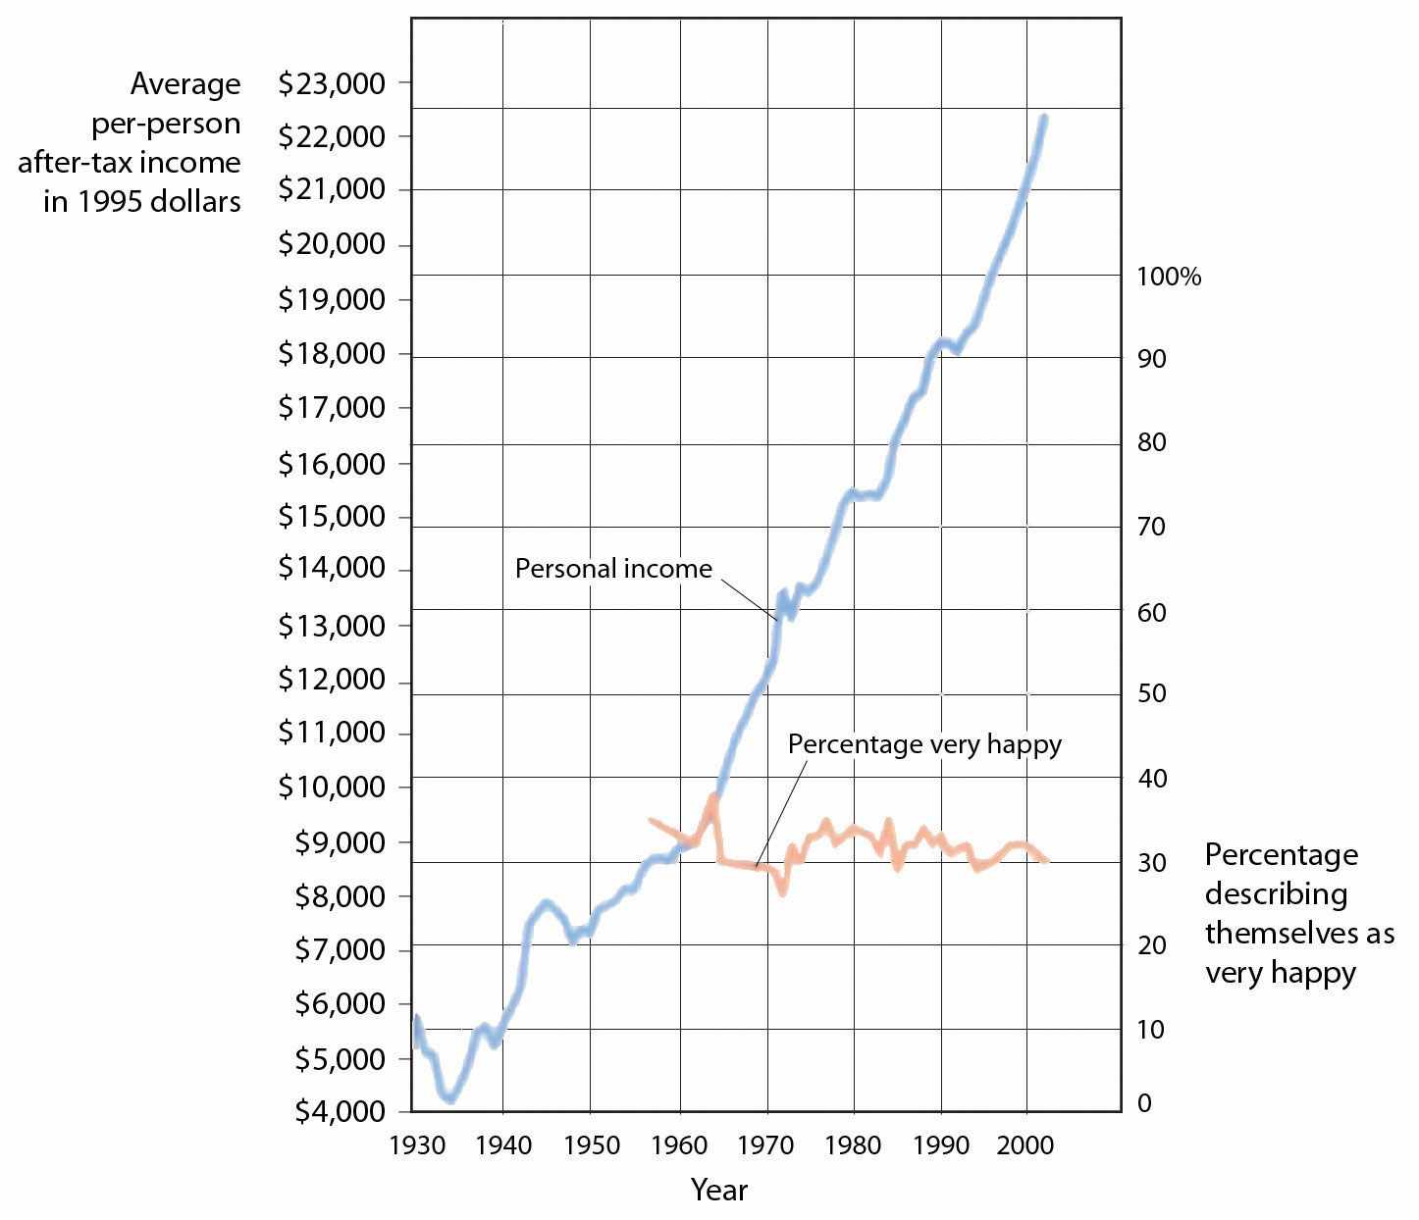
Although personal income keeps rising, happiness does not.
Source: Layard, R. (2005). Happiness: Lessons from a new science. New York, NY: Penguin.
These findings might lead us to conclude that we don’t always know what does or might make us happy, and this seems to be at least partially true. For instance, Jean Twenge and her colleagues (Twenge, Campbell, & Foster, 2003) ^{[51]} reviewed studies relating to the impact of having children on well-being and found that although people with children frequently claim that having children makes them happy, couples who do not have children actually report being happier than those who do.
Psychologists have found that people’s ability to predict their future emotional states is not very accurate (Wilson & Gilbert, 2005). ^{[52]} For one, people overestimate their emotional reactions to events. Although people think that positive and negative events that they might experience will make a huge difference in their lives, and although these changes do make at least some difference in well-being, they tend to be less influential than we think they are going to be. Positive events tend to make us feel good, but their effects wear off pretty quickly, and the same is true for negative events. For instance, Brickman, Coates, and Janoff-Bulman (1978) ^{[53]} interviewed people who had won more than $50,000 in a lottery and found that they were not happier than they had been in the past and were also not happier than a control group of similar people who had not won the lottery. On the other hand, the researchers found that individuals who were paralyzed as a result of accidents were not as unhappy as might be expected.
How can this possibly be? There are several reasons. For one, people are resilient; they bring their coping skills into play when negative events occur, and this makes them feel better. Second, most people do not continually experience very positive or very negative affect over a long period of time but, rather, adapt to their current circumstances. Just as we enjoy the second chocolate bar we eat less than we enjoy the first, as we experience more and more positive outcomes in our daily lives, we habituate to them and our well-being returns to a more moderate level (Small, Zatorre, Dagher, Evans, & Jones-Gotman, 2001). ^{[54]} Another reason we may predict our happiness incorrectly is that our social comparisons change when our own status changes as a result of new events. People who are wealthy compare themselves to other wealthy people, people who are poor tend to compare themselves with other poor people, and people who are ill tend to compare themselves with other ill people. When our comparisons change, our happiness levels are correspondingly influenced. And when people are asked to predict their future emotions, they may focus only on the positive or negative event they are asked about and forget about all the other things that won’t change. Wilson, Wheatley, Meyers, Gilbert, and Axsom (2000) ^{[55]} found that when people were asked to focus on all the more regular things that they will still be doing in the future (working, going to church, socializing with family and friends, etc.), their predictions about how something really good or bad would influence them were less extreme.
If pleasure is fleeting, at least misery shares some of the same quality. We might think we can’t be happy if something terrible, such as the loss of a partner or child, were to happen to us, but after a period of adjustment, most people find that happiness levels return to prior levels (Bonanno et al., 2002). ^{[56]} Health concerns tend to put a damper on our feeling of well-being, and those with a serious disability or illness show slightly lowered mood levels. But even when health is compromised, levels of misery are lower than most people expect (Lucas, 2007; Riis et al., 2005). ^{[57]} For instance, although disabled individuals have more concern about health, safety, and acceptance in the community, they still experience overall positive happiness levels (Marinić & Brkljačić, 2008). ^{[58]} It has been estimated that taken together, our wealth, health, and life circumstances account for only 15% to 20% of well-being scores (Argyle, 1999). ^{[59]}Clearly, the main ingredient in happiness lies beyond, or perhaps beneath, external factors.
Our perceptions of our own well-being depend on both situational and person factors. As we have seen, people who report that they have positive social relationships with others—the perception of social support—also report being happier than those who report that they do not have social support (Diener & Suh, 2000). ^{[60]} On the other hand, there are also individual differences in happiness, and these seem to be in part genetically determined (Baumgart, Plomin, DeFries, & Fulker, 1992; Lykken, 2000).^{[61]} Some people are just naturally happier than others.

Social Psychology in the Public Interest
Regulating Emotions to Improve Our Health
Although smoking cigarettes, drinking alcohol, using recreational drugs, engaging in unsafe sex, and eating too much may produce enjoyable positive emotions in the short term, they are some of the leading causes of negative health outcomes and even death in the long term (Mokdad, Marks, Stroup, & Gerberding, 2004). ^{[62]}
To avoid these negative outcomes, we must use our cognitive resources to plan, guide, and restrain our behaviors. And we can also use our emotion regulation skills to help us do better. Even in an age where the addictive and detrimental health effects of cigarette smoking are well understood, more than 60% of children try smoking before they are 18 years old, and more than half who have smoked have tried and failed to quit (Fryar, Merino, Hirsch, & Porter, 2009). ^{[63]}Although smoking is depicted in movies as sexy and alluring, it is highly addictive and probably the most dangerous thing we can do to our body.
Poor diet and physical inactivity combine to make up the second greatest threat to our health. But we can improve our diet by eating more natural and less processed food and by monitoring our food intake. And we can start and maintain an exercise program. Exercise keeps us happier, improves fitness, and leads to better health and lower mortality (Fogelholm, 2010; Galper, Trivedi, Barlow, Dunn, & Kampert, 2006; Hassmén, Koivula, & Uutela, 2000). ^{[64]} Exercise also has a variety of positive influences on our cognitive processes, including academic performance (Hillman, Erickson, & Kramer, 2008). ^{[65]}
Alcohol abuse, and particularly binge drinking (i.e., having five or more drinks in one sitting), is often the norm among high school and college students, but it has severe negative health consequences. Bingeing leads to deaths from car crashes, drowning, falls, gunshots, and alcohol poisoning (Valencia-Martín, Galán, & Rodríguez-Artalejo, 2008). ^{[66]} Binge-drinking students are also more likely to be involved in other risky behaviors, such as smoking, drug use, dating violence, or attempted suicide (Miller, Naimi, Brewer, & Jones, 2007). ^{[67]} Binge drinking may damage neural pathways in the brain (McQueeny et al., 2009) ^{[68]}and lead to lifelong alcohol abuse and dependency (Kim et al., 2008). ^{[69]} Illicit drug use has also been increasing and is linked to the spread of infectious diseases such as HIV, hepatitis B, and hepatitis C (Monteiro, 2001). ^{[70]}
Some teens abstain from sex entirely, particularly those who are very religious, but most experiment with it. About half of U.S. children under 18 report having had intercourse, a rate much higher than in other parts of the world. Although sex is fun, it can also kill us if we are not careful. Sexual activity can lead to guilt about having engaged in the act itself and may also lead to unwanted pregnancies and sexually transmitted infections, including HIV infection. Alcohol consumption also leads to risky sexual behavior. Sex partners who have been drinking are less likely to practice safe sex and have an increased risk of sexually transmitted infections, including HIV infection (Hutton, McCaul, Santora, & Erbelding 2008; Raj et al., 2009). ^{[71]}
It takes some work to improve and maintain our health and happiness, and our desire for the positive emotional experiences that come from engaging in dangerous behaviors can get in the way of this work. But being aware of the dangers, working to control our emotions, and using our resources to engage in healthy behaviors and avoid unhealthy ones are the best things we can do for ourselves.
However, although people are resilient, this does not mean that they adapt perfectly to all events. For example, Stroebe, Stroebe, Abakoumkin, and Schut (1996) ^{[72]} found that people who had lost their spouses were still more depressed than those who were still married, even after 2 years, although the rate of depression did decline over this period. And Diener, Diener, and Diener (1995)^{[73]} found that respondents in very poor nations such as India and Nigeria reported much lower well-being than did people in wealthier nations.

KEY TAKEAWAYS
- Suppressing or ignoring our problems is usually not successful because it takes effort and does not make them go away. It is healthier to express our negative thoughts and feelings, either to ourselves or to others.
- Being able to effectively regulate our emotions is a skill that has important and positive consequences.
- Positive thinking, including optimism, hardiness, and self-efficacy, is associated with a wide variety of positive effects on our health.
- One difficulty that people face when trying to improve their happiness is that they may not always know what will make them happy.
- Building effective lives requires us to use our cognitive resources to avoid engaging in pleasurable but health-threatening behaviors.

EXERCISES AND CRITICAL THINKING
- Think about your own well-being. What things make you happy and unhappy?
- Do you think you are able to regulate your own emotions well?? What strategies might you use to do better?
- Do you know people who do not effectively regulate their emotions? What are the outcomes for them of this failure to regulate?
- Review the things you do or should do and the things you don’t do or shouldn’t do for yourself to help keep yourself happy and healthy.

[1] Gross, J. J., & Levenson, R. W. (1997). Hiding feelings: The acute effects of inhibiting negative and positive emotion. Journal of Abnormal Psychology, 106(1), 95–103.
[2] Wegner, D. M., Schneider, D. J., Carter, S. R., & White, T. L. (1987). Paradoxical effects of thought suppression. Journal of Personality and Social Psychology, 53(1), 5–13.
[3] Baumeister, R. F. (1991). The self against itself: Escape or defeat? In Relational self: Theoretical convergences in psychoanalysis and social psychology (pp. 238–256). New York, NY: Guilford Press.
[4] Pennebaker, J. W., Colder, M., & Sharp, L. K. (1990). Accelerating the coping process.Journal of Personality and Social Psychology, 58(3), 528–537; Watson, D., & Pennebaker, J. W. (1989). Health complaints, stress, and distress: Exploring the central role of negative affectivity. Psychological Review, 96(2), 234–254.
[5] Pennebaker, J. W., & Beall, S. K. (1986). Confronting a traumatic event: Toward an understanding of inhibition and disease. Journal of Abnormal Psychology, 95(3), 274–281.
[6] Petrie, K. J., Fontanilla, I., Thomas, M. G., Booth, R. J., & Pennebaker, J. W. (2004). Effect of written emotional expression on immune function in patients with human immunodeficiency virus infection: A randomized trial. Psychosomatic Medicine, 66(2), 272–275.
[7] Uysal, A., & Lu, Q. (2011, July 4). Is self-concealment associated with acute and chronic pain? Health Psychology. doi:10.1037/a0024287
[8] Pennebaker, J. W., & Stone, L. D. (Eds.). (2004). Translating traumatic experiences into language: Implications for child abuse and long-term health. Washington, DC: American Psychological Association.
[9] Eisenberg, N., & Fabes, R. A. (1992). Emotion, regulation, and the development of social competence. In Emotion and social behavior (pp. 119–150). Thousand Oaks, CA: Sage Publications.
[10] Mischel, W., Shoda, Y., & Rodriguez, M. L. (1989). Delay of gratification in children.Science, 244, 933–938.
[11] Metcalfe, J., & Mischel, W. (1999). A hot/cool-system analysis of delay of gratification: Dynamics of willpower. Psychological Review, 106(1), 3–19; Strack, F., & Deutsch, R. (2007). The role of impulse in social behavior. In A. W. Kruglanski & E. T. Higgins (Eds.), Social psychology: Handbook of basic principles (Vol. 2). New York, NY: Guilford.
[12] Bizot, J.-C., Le Bihan, C., Peuch, A. J., Hamon, M., & Thiebot, M.-H. (1999). Serotonin and tolerance to delay of reward in rats. Psychopharmacology, 146(4), 400–412; Liu, Y. P., Wilkinson, L. S., & Robbins, T. W. (2004). Effects of acute and chronic buspirone on impulsive choice and efflux of 5-HT and dopamine in hippocampus, nucleus accumbens and prefrontal cortex. Psychopharmacology, 173(1–2), 175–185.
[13] Asberg, M., Traskman, L., & Thoren, P. (1976). 5-HIAA in the cerebrospinal fluid: A biochemical suicide predictor? Archives of General Psychiatry, 33(10), 1193–1197.
[14] Ayduk, O., Mendoza-Denton, R., Mischel, W., Downey, G., Peake, P. K., & Rodriguez, M. (2000). Regulating the interpersonal self: Strategic self-regulation for coping with rejection sensitivity. Journal of Personality and Social Psychology, 79(5), 776–792; Eigsti, I.-M., Zayas, V., Mischel, W., Shoda, Y., Ayduk, O., Dadlani, M. B., et al. (2006). Predicting cognitive control from preschool to late adolescence and young adulthood. Psychological Science, 17(6), 478–484; Mischel, W., Ayduk, O., & Mendoza-Denton, R. (Eds.). (2003). Sustaining delay of gratification over time: A hot-cool systems perspective. New York, NY: Russell Sage Foundation.
[15] Muraven, M., & Baumeister, R. F. (2000). Self-regulation and depletion of limited resources: Does self-control resemble a muscle? Psychological Bulletin, 126, 247–259.
[16] Muraven, M., Tice, D. M., & Baumeister, R. F. (1998). Self-control as a limited resource: Regulatory depletion patterns. Journal of Personality and Social Psychology, 74(3), 774–789.
[17] Muraven, M., Tice, D. M., & Baumeister, R. F. (1998). Self-control as a limited resource: Regulatory depletion patterns. Journal of Personality and Social Psychology, 74(3), 774–789.
[18] Vohs, K. D., & Heatherton, T. F. (2000). Self-regulatory failure: A resource depletion approach. Psychological Science, 11, 249–254.
[19] Baumeister, R. F., Gailliot, M., DeWall, C. N., & Oaten, M. (2006). Self-regulation and personality: How interventions increase regulatory success, and how depletion moderates the effects of traits on behavior. Journal of Personality, 74,1773–1801; Baumeister, R. F., Schmeichel, B., & Vohs, K. D. (2007). Self-regulation and the executive function: The self as controlling agent. In A. W. Kruglanski & E. T. Higgins (Eds.), Social psychology: Handbook of basic principles (Vol. 2). New York, NY: Guilford; Oaten, M., & Cheng, K. (2006). Longitudinal gains in self-regulation from regular physical exercise. British Journal of Health Psychology, 11, 717–733.
[20] Tice, D. M., Baumeister, R. F., Shmueli, D., & Muraven, M. (2007). Restoring the self: Positive affect helps improve self-regulation following ego depletion. Journal of Experimental Social Psychology, 43(3), 379–384.
[21] Seligman, M. E. P., & Csikszentmihalyi, M. (2000). Positive psychology: An introduction.American Psychologist, 55(1), 5–14.
[22] Carver, C. S., & Scheier, M. F. (2009). Optimism. In M. R. Leary & R. H. Hoyle (Eds.),Handbook of individual differences in social behavior (pp. 330–342). New York, NY: Guilford Press.
[23] Thompson, S. C. (2009). The role of personal control in adaptive functioning. In S. J. Lopez & C. R. Snyder (Eds.), Oxford handbook of positive psychology (2nd ed., pp. 271–278). New York, NY: Oxford University Press.
[24] Rodin, J. (1986). Aging and health: Effects of the sense of control. Science, 233(4770), 1271–1276.
[25] Glass, D. C., Reim, B., & Singer, J. E. (1971). Behavioral consequences of adaptation to controllable and uncontrollable noise. Journal of Experimental Social Psychology, 7(2), 244–257.
[26] Sapolsky, R. M. (2005). The influence of social hierarchy on primate health. Science, 308(5722), 648–652.
[27] Kobasa, S. C., Maddi, S. R., & Kahn, S. (1982). Hardiness and health: A prospective study.Journal of Personality and Social Psychology, 42(1), 168–177.
[28] Carver, C. S., Smith, R. G., Antoni, M. H., Petronis, V. M., Weiss, S., & Derhagopian, R. P. (2005). Optimistic personality and psychosocial well-being during treatment predict psychosocial well-being among long-term survivors of breast cancer. Health Psychology, 24(5), 508–516.
[29] Cohen, S., & Pressman, S. D. (2006). Positive affect and health. Current Directions in Psychological Science, 15(3), 122–125.
[30] Dolbier, C. L., Smith, S. E., & Steinhardt, M. A. (2007). Relationships of protective factors to stress and symptoms of illness. American Journal of Health Behavior, 31(4), 423–433.
[31] Baker, S. R. (2007). Dispositional optimism and health status, symptoms, and behaviors: Assessing ideothetic relationships using a prospective daily diary approach. Psychology and Health, 22(4), 431–455.
[32] Antoni, M. H., Lehman, J. M., Klibourn, K. M., Boyers, A. E., Culver, J. L., Alferi, S. M.,…Kilbourn, K. (2001). Cognitive-behavioral stress management intervention decreases the prevalence of depression and enhances benefit finding among women under treatment for early-stage breast cancer. Health Psychology, 20(1), 20–32.
[33] Maddi, S. R., Kahn, S., & Maddi, K. L. (1998). The effectiveness of hardiness training.Consulting Psychology Journal: Practice and Research, 50(2), 78–86.
[34] Peterson, C., Seligman, M. E. P., Yurko, K. H., Martin, L. R., & Friedman, H. S. (1998). Catastrophizing and untimely death. Psychological Science, 9(2), 127–130.
[35] Levy, B., & Myers, L. (2005). Relationship between respiratory mortality and self-perceptions of aging. Psychology & Health, 20(5), 553–564. doi:10.1080/ 14768320500066381; Levy, B., Slade, M., & Kasl, S. (2002). Longitudinal benefit of positive self-perceptions of aging on functional health. Journals of Gerontology Series B: Psychological Sciences & Social Sciences, 57B(5), P409. Retrieved from Academic Search Premier Database.
[36] Diener, E., Nickerson, C., Lucas, R., & Sandvik, E. (2002). Dispositional affect and job outcomes. Social Indicators Research, 59(3), 229. Retrieved from Academic Search Premier Database.
[37] Braungart, J. M., Plomin, R., DeFries, J. C., & Fulker, D. W. (1992). Genetic influence on tester-rated infant temperament as assessed by Bayley’s Infant Behavior Record: Nonadoptive and adoptive siblings and twins. Developmental Psychology, 28(1), 40–47; Lykken, D. T. (2000). Happiness: The nature and nurture of joy and contentment. New York, NY: St. Martin’s Press.
[38] Diener, E., Suh, E. M., Lucas, R. E., & Smith, H. L. (1999). Subjective well-being: Three decades of progress. Psychological Bulletin, 125(2), 276–302; Diener, E., Tamir, M., & Scollon, C. N. (2006). Happiness, life satisfaction, and fulfillment: The social psychology of subjective well-being. In P. A. M. VanLange (Ed.), Bridging social psychology: Benefits of transdisciplinary approaches. Mahwah, NJ: Lawrence Erlbaum Associates.
[39] Pew Research Center (2006, February 13). Are we happy yet? Retrieved fromhttp://pewresearch.org/pubs/301/are-we-happy-yet
[40] Leary, M. R. (1990). Responses to social exclusion: Social anxiety, jealousy, loneliness, depression, and low self-esteem. Journal of Social and Clinical Psychology, 9(2), 221–229.
[41] Koopman, C., Hermanson, K., Diamond, S., Angell, K., & Spiegel, D. (1998). Social support, life stress, pain and emotional adjustment to advanced breast cancer. Psycho-Oncology, 7(2), 101–110.
[42] Ashton, E., Vosvick, M., Chesney, M., Gore-Felton, C., Koopman, C., O’Shea, K.,…Spiegel, D. (2005). Social support and maladaptive coping as predictors of the change in physical health symptoms among persons living with HIV/AIDS. AIDS Patient Care & STDs, 19(9), 587–598. doi:10.1089/apc.2005.19.587
[43] Au, A., Lau, S., & Lee, M. (2009). Suicide ideation and depression: The moderation effects of family cohesion and social self-concept. Adolescence, 44(176), 851–868. Retrieved from Academic Search Premier Database; Bertera, E. (2007). The role of positive and negative social exchanges between adolescents, their peers and family as predictors of suicide ideation. Child & Adolescent Social Work Journal, 24(6), 523–538. doi:10.1007/s10560-007-0104-y; Compton, M., Thompson, N., & Kaslow, N. (2005). Social environment factors associated with suicide attempt among low-income African Americans: The protective role of family relationships and social support. Social Psychiatry & Psychiatric Epidemiology, 40(3), 175–185. doi:10.1007/ s00127-005-0865-6; Skärsäter, I., Langius, A., Ågren, H., Häggström, L., & Dencker, K. (2005). Sense of coherence and social support in relation to recovery in first-episode patients with major depression: A one-year prospective study. International Journal of Mental Health Nursing, 14(4), 258–264. doi:10.1111/j.1440-0979.2005.00390
[44] Gençöz, T., & Özlale, Y. (2004). Direct and indirect effects of social support on psychological well-being. Social Behavior & Personality: An International Journal, 32(5), 449–458.
[45] Bolger, N., Zuckerman, A., & Kessler, R. C. (2000). Invisible support and adjustment to stress. Journal of Personality and Social Psychology, 79(6), 953–961; Wethington, E., & Kessler, R. C. (1986). Perceived support, received support, and adjustment to stressful life events. Journal of Health and Social Behavior, 27(1), 78–89.
[46] Kim, H. S., Sherman, D. K., & Taylor, S. E. (2008). Culture and social support. American Psychologist, 63(6), 518–526.
[47] Taylor, S. E., Sherman, D. K., Kim, H. S., Jarcho, J., Takagi, K., & Dunagan, M. S. (2004). Culture and social support: Who seeks it and why? Journal of Personality and Social Psychology, 87(3), 354–362.
[48] Markus, H. R., Mullally, P. R., & Kitayama, S. (1997). Selfways: Diversity in modes of cultural participation. In U. Neisser & D. A. Jopling (Eds.), The conceptual self in context: Culture, experience, self-understanding (pp. 13–61). New York, NY: Cambridge University Press.
[49] Easterlin, R. (2005). Feeding the illusion of growth and happiness: A reply to Hagerty and Veenhoven. Social Indicators Research, 74(3), 429–443. doi:10.1007/ s11205-004-6170-z
[50] Csikszentmihalyi, M. (1999). If we are so rich, why aren’t we happy? American Psychologist, 54(10), 821–827.
[51] Twenge, J. M., Campbell, W. K., & Foster, C. A. (2003). Parenthood and marital satisfaction: A meta-analytic review. Journal of Marriage and Family, 65(3), 574–583.
[52] Wilson, T. D., & Gilbert, D. T. (2005). Affective forecasting: Knowing what to want. Current Directions in Psychological Science, 14(3), 131–134.
[53] Brickman, P., Coates, D., & Janoff-Bulman, R. (1978). Lottery winners and accident victims: Is happiness relative? Journal of Personality and Social Psychology, 36(8), 917–927.
[54] Small, D. M., Zatorre, R. J., Dagher, A., Evans, A. C., & Jones-Gotman, M. (2001). Changes in brain activity related to eating chocolate. Brain, 124(9), 1720.
[55] Wilson, T. D., Wheatley, T., Meyers, J. M., Gilbert, D. T., & Axsom, D. (2000). Focalism: A source of durability bias in affective forecasting. Journal of Personality and Social Psychology, 78(5), 821–836.
[56] Bonanno, G. A., Wortman, C. B., Lehman, D. R., Tweed, R. G., Haring, M., Sonnega, J., & Nesse, R. M. (2002). Resilience to loss and chronic grief: A prospective study from preloss to 18-months postloss. Journal of Personality and Social Psychology, 83(5), 1150–1164.
[57] Lucas, R. (2007). Long-term disability is associated with lasting changes in subjective well-being: Evidence from two nationally representative longitudinal studies. Journal of Personality and Social Psychology, 92(4), 717–730; Riis, J., Baron, J., Loewenstein, G., Jepson, C., Fagerlin, A., & Ubel, P. (2005). Ignorance of hedonic adaptation to hemodialysis: A study using ecological momentary assessment. Journal of Experimental Psychology/General, 134(1), 3–9. doi:10.1037/0096-3445.134.1.3
[58] Marinić, M., & Brkljačić, T. (2008). Love over gold: The correlation of happiness level with some life satisfaction factors between persons with and without physical disability. Journal of Developmental & Physical Disabilities, 20(6), 527–540. doi:10.1007/s10882-008-9115-7
[59] Argyle, M. (1999). Causes and correlates of happiness. In D. Kahneman, E. Diener, & N. Schwarz (Eds.), Well being: The foundations of hedonic psychology. New York, NY: Russell Sage Foundation.
[60] Diener, E., & Suh, E. M. (Eds.). (2000). Culture and subjective well-being. Cambridge, MA: The MIT Press.
[61] Braungart, J. M., Plomin, R., DeFries, J. C., & Fulker, D. W. (1992). Genetic influence on tester-rated infant temperament as assessed by Bayley’s Infant Behavior Record: Nonadoptive and adoptive siblings and twins. Developmental Psychology, 28(1), 40–47; Lykken, D. T. (2000). Happiness: The nature and nurture of joy and contentment. New York, NY: St. Martin’s Press.
[62] Mokdad, A. H., Marks, J. S., Stroup, D. F., & Gerberding, J. L. (2004). Actual causes of death in the United States, 2000. Journal of the American Medical Association, 291(10), 1238–1240.
[63] Fryar, C. D., Merino, M. C., Hirsch, R., & Porter, K. S. (2009). Smoking, alcohol use, and illicit drug use reported by adolescents aged 12–17 years: United States, 1999–2004. National Health Statistics Reports, 15, 1–23.
[64] Fogelholm, M. (2010). Physical activity, fitness and fatness: Relations to mortality, morbidity and disease risk factors. A systematic review. Obesity Reviews, 11(3), 202–221. doi:10.1111/j.1467–789X.2009.00653.x; Galper, D., Trivedi, M., Barlow, C., Dunn, A., & Kampert, J. (2006). Inverse association between physical inactivity and mental health in men and women. Medicine & Science in Sports & Exercise, 38(1), 173–178. doi:10.1249/01.mss.0000180883.32116.28; Hassmén, P., Koivula, N., & Uutela, A. (2000). Physical exercise and psychological well-being: A population study in Finland. Preventive Medicine: An International Journal Devoted to Practice and Theory, 30(1), 17–25.
[65] Hillman, C. H., Erickson, K. I., & Kramer, A. F. (2008). Be smart, exercise your heart: Exercise effects on brain and cognition. Nature Reviews Neuroscience, 9(1), 58–65.
[66] Valencia-Martín, J., Galán, I., & Rodríguez-Artalejo, F. (2008). The joint association of average volume of alcohol and binge drinking with hazardous driving behaviour and traffic crashes. Addiction, 103(5), 749–757. doi:10.1111/j.1360-0443.2008.02165
[67] Miller, J., Naimi, T., Brewer, R., & Jones, S. (2007). Binge drinking and associated health risk behaviors among high school students. Pediatrics, 119(1), 76–85. doi:10.1542/ peds.2006-1517
[68] McQueeny, T., Schweinsburg, B., Schweinsburg, A., Jacobus, J., Bava, S., Frank, L.,…Tapert, S. F. (2009). Altered white matter integrity in adolescent binge drinkers. Alcoholism: Clinical & Experimental Research, 33(7), 1278–1285. doi:10.1111/ j.1530-0277.2009.00953
[69] Kim, J., Sing, L., Chow, J., Lau, J., Tsang, A., Choi, J.,…Griffiths, S. M. (2008). Prevalence and the factors associated with binge drinking, alcohol abuse, and alcohol dependence: A population-based study of Chinese adults in Hong Kong. Alcohol & Alcoholism, 43(3), 360–370. doi:10.1093/Alcalc/Agm181
[70] Monteiro, M. (2001). A World Health Organization perspective on alcohol and illicit drug use and health. European Addiction Research, 7(3), 98–103. doi:10.1159/ 000050727
[71] Hutton, H., McCaul, M., Santora, P., & Erbelding, E. (2008). The relationship between recent alcohol use and sexual behaviors: Gender differences among sexually transmitted disease clinic patients. Alcoholism: Clinical & Experimental Research, 32(11), 2008–2015; Raj, A., Reed, E., Santana, M., Walley, A., Welles, S., Horsburgh, C.,…Silverman, J. G. (2009). The associations of binge alcohol use with HIV/STI risk and diagnosis among heterosexual African American men. Drug & Alcohol Dependence, 101(1/2), 101–106.
[72] Stroebe, W., Stroebe, M., Abakoumkin, G., & Schut, H. (1996). The role of loneliness and social support in adjustment to loss: A test of attachment versus stress theory. Journal of Personality and Social Psychology, 70, 1241–1249.
[73] Diener, E., Diener, M., & Diener, C. (1995). Factors predicting the subjective well-being of nations. Journal of Personality and Social Psychology, 69(5), 851–864.

3.4 Thinking Like a Social Psychologist About Social Affect
If you have carefully studied this chapter, you will have learned a great deal about how emotions influence our everyday lives and the harmful roles that negative emotions can play. But you will also have learned a great deal about how best to stay happy and healthy. This is not to say that you’ll never be sad or sick—you will—but rather that you will understand how to best cope with these threats. Let’s close this chapter with some thoughts about how a social psychologist, and now you, might think about these topics. I encourage you to practice them—and share them with your friends and family!
- Avoid as many negative emotions as you can. Think positively—do something positive for yourself every day.
- Believe that you can make a difference, but don’t exaggerate your ability to do so.
- Be aware of your stress level and work to reduce it through relaxation or other techniques if you can.
- Set realistic goals that you believe you can attain, and carefully regulate your emotions and behaviors as you try to reach them.
- Practice healthy behaviors, including aerobic exercise. People who exercise regularly may live 1 to 2 years longer than those who don’t (Paffenbarger, Hyde, Wing, & Hsieh, 1986). ^{[1]}
- Avoid unhealthy activities such as smoking, drinking excessively, and unsafe sex.
- Develop close relationships with others, and if you can, share your problems with them.
- Realize—really!—that money cannot buy happiness.

[1] Paffenbarger, R. S., Hyde, R. T., Wing, A. L., Hsieh, C. C. (1986). Physical activity, all-cause mortality, and longevity of college alumni. New England Journal of Medicine, 314, 605–613.

3.5 Chapter Summary
Affect, the A within social psychology’s ABCs, refers to the feelings we experience as part of our everyday lives. Although affect can be harmful when it gets out of control, our affective experiences normally help us to function efficiently and in a way that increases our chances of survival. Although affect is involved in many aspects of our life, it is particularly social—our emotions provide us with information about our relationships with others.
One component of affect is mood—the positive or negative feelings that are in the background of our everyday experiences. Emotions are affective states like moods, but they are shorter lived, stronger, more intense, and more specific forms of affect. There are both basic emotions, which are communicated through culturally shared facial expressions, and secondary emotions—those that provide us with more complex feelings about our social worlds.
Emotions have both a biological and a cognitive aspect. The biological component of emotions is arousal, which is created by the parasympathetic nervous system and regulated by the limbic system and the amygdala. The cognitive component is the label we place on the arousal. There are some gender and cultural differences in the experience of emotion.
When people incorrectly label the source of the arousal that they are experiencing, we say that they have misattributed their arousal. Misattributing arousal may make it difficult for us to determine what emotion we are experiencing.
One outcome of threatening life experiences is stress—the physical and psychological reactions that occur whenever we believe that the demands of the situation threaten our ability to respond to the threat. Extreme events and just everyday hassles can create stress. The experience of prolonged stress has a direct influence on our immune system, leaving us more susceptible to a variety of health problems. Stress influences our behavior through its effects on the HPA axis and the secretion of stress hormones, including cortisol.
Depression is an affective disorder in which people experience sadness, low self-esteem, negative thoughts, pessimism, and apathy. Anxiety is an affective disorder that may be accompanied by a number of physical symptoms, including diarrhea, upset stomach, sweaty hands, and shortness of breath. Anxiety and depression are partially genetically inherited but are influenced by our social interactions.
The attitude that we express toward our life in general is known as well-being. In general, people feel positive about themselves, but there are many potential threats to the self-concept, and we must learn to effectively cope with them.
Research has found that there are clear difficulties with an approach to negative events and feelings that involves simply trying to ignore them—suppressing our emotions is not a very good option, at least in the long run, because it tends to fail. Rather, when we are faced with troubles, it is healthy to let the negative thoughts and feelings out by expressing them, either to ourselves or to others, and by practicing effective self-regulation.
In general, we can say that we will feel good about ourselves when we have successfully met the goals of creating adequate social support—the development of positive social connections with others. Happiness does not come through money and material wealth.
Social psychologists have investigated the ability of human beings to predict their future emotional states and found that they are not very accurate in this regard. Although positive and negative life changes do make at least some difference in well-being, they tend to be less influential than we think they are going to be.
Your new understanding of the role of affect in social judgment and in mental and physical health, and particularly your understanding of the importance of self-regulation, can help you respond more effectively to the negative situations that you experience.

Chapter 4

The Self

“Dancing Matt Harding” Dances Around the World
Matthew “Matt” Harding (born September 27, 1976) is an American video game developer who became an Internet celebrity as a result of his viral videos that show him dancing in front of landmarks and street scenes in cities around the world.
Matt began his career working for a video game store and as an editor for a video game magazine. He then became a video game software developer but eventually became frustrated with the work of creating video games. He quit his job and began traveling.
While he was traveling in Vietnam, he had his traveling companion video him as he danced in a city. The video was uploaded to YouTube. Matt then made a second video, a sequence of 15 dance scenes in other countries, each accompanied by background music. This video eventually became viral, getting over 20,000 hits a day as it was discovered around the world.
Harding released his third dancing video, the result of 14 months of traveling in 42 countries, on June 20, 2008.
At the foundation of all human behavior is the self—our sense of personal identity and of who we are as individuals. Because an understanding of the self is so important, it has been studied for many years by psychologists (James, 1890; Mead, 1934) ^{[1]} and is still one of the most important and most researched topics in social psychology (Dweck & Grant, 2008; Taylor & Sherman, 2008). ^{[2]} Social psychologists conceptualize the self using the basic principles of social psychology—that is, the relationship between individual persons and the people around them (the person-situation interaction) and the ABCs of social psychology—the affective, behavioral, and cognitive components of the self.
In this chapter, we will first consider the cognitive aspects of the self, focusing on theself-concept (the thoughts that we hold about ourselves) and self-awareness (the extent to which we are currently fixing our attention on our own self-concept). Then we will move on to the role of affect, considering self-esteem (the positive or negative feelings that we have about ourselves) and the many ways that we try to gain positive self-esteem. Finally, we will consider the social aspects of the self, including how we present ourselves to others in order to portray a positive self-image, as well as the many ways that our thoughts and feelings about ourselves are determined by our relationships with others.

[1] James, W. (1890). The principles of psychology. New York, NY: Dover; Mead, G. H. (1934).Mind, self, and society. Chicago, IL: The University of Chicago Press.
[2] Dweck, C. S., & Grant, H. (2008). Self-theories, goals, and meaning. In J. Y. Shah, W. L. Gardner, J. Y. E. Shah, & W. L. E. Gardner (Eds.), Handbook of motivation science (pp. 405–416). New York, NY: Guilford Press; Taylor, S. E., & Sherman, D. K. (2008). Self-enhancement and self-affirmation: The consequences of positive self-thoughts for motivation and health. In J. Y. Shah, W. L. Gardner, J. Y. E. Shah, & W. L. E. Gardner (Eds.), Handbook of motivation science (pp. 57–70). New York, NY: Guilford Press.

4.1 The Cognitive Self: The Self-Concept

LEARNING OBJECTIVES
- Define and describe the self-concept and its influence on information processing.
- Describe the concept of self-complexity, and explain how it influences social cognition and behavior.
- Review the measures that are used to assess the self-concept.
- Differentiate the different types of self-awareness and self-consciousness.
Some nonhuman animals, including chimpanzees, orangutans, and perhaps dolphins, have at least a primitive sense of self (Boysen & Himes, 1999). ^{[1]} We know this because of some interesting experiments that have been done with animals. In one study (Gallup, 1970), ^{[2]} researchers painted a red dot on the forehead of anesthetized chimpanzees and then placed the animals in a cage with a mirror. When the chimps woke up and looked in the mirror, they touched the dot on their faces, not the dot on the faces in the mirror. This action suggests that the chimps understood that they were looking at themselves and not at other animals, and thus we can assume that they are able to realize that they exist as individuals. Most other animals, including dogs, cats, and monkeys, never realize that it is themselves they see in a mirror.
Infants who have similar red dots painted on their foreheads recognize themselves in a mirror in the same way that the chimps do, and they do this by about 18 months of age (Asendorpf, Warkentin, & Baudonnière, 1996; Povinelli, Landau, & Perilloux, 1996). ^{[3]} The child’s knowledge about the self continues to develop as the child grows. By age 2, the infant becomes aware of his or her gender as a boy or a girl. At age 4, self-descriptions are likely to be based on physical features, such as one’s hair color, and by about age 6, the child is able to understand basic emotions and the concepts of traits, being able to make statements such as “I am a nice person” (Harter, 1998). ^{[4]}
By the time they are in grade school, children have learned that they are unique individuals, and they can think about and analyze their own behavior. They also begin to show awareness of the social situation—they understand that other people are looking at and judging them the same way that they are looking at and judging others (Doherty, 2009). ^{[5]}

Development and Characteristics of the Self-Concept
Part of what is developing in children as they grow is the fundamental cognitive part of the self, known as the self-concept. The self-concept is a knowledge representation that contains knowledge about us, including our beliefs about our personality traits, physical characteristics, abilities, values, goals, and roles, as well as the knowledge that we exist as individuals. Throughout childhood and adolescence, the self-concept becomes more abstract and complex and is organized into a variety of different cognitive aspects, known as self-schemas. Children have self-schemas about their progress in school, their appearance, their skills at sports and other activities, and many other aspects, and these self-schemas direct and inform their processing of self-relevant information (Harter, 1999). ^{[6]}
By the time we are adults, our sense of self has grown dramatically. In addition to possessing a wide variety of self-schemas, we can analyze our thoughts, feelings, and behaviors, and we can see that other people may have different thoughts than we do. We become aware of our own mortality. We plan for the future and consider the potential outcomes of our actions. At times, having a sense of self may seem unpleasant—when we are not proud of our appearance, actions, or relationships with others, or when we think about and become afraid of the possibility of our own death. On the other hand, the ability to think about the self is very useful. Being aware of our past and able to speculate about the future is adaptive—it allows us to modify our behavior on the basis of our mistakes and to plan for future activities. When we do poorly on an exam, for instance, we may study harder for the next one or even consider changing our major if we continue to have problems in the major we have chosen.
One way to learn about a person’s self-concept and the many self-schemas that it contains is by using self-report measures. One of these is a deceptively simple fill-in-the-blank measure that has been used by many scientists to get a picture of the self-concept (Rees & Nicholson, 1994). ^{[7]} All of the 20 items in the measure are exactly the same, but the person is asked to fill in a different response for each statement. This self-report measure, known as the Twenty Statements Test, can reveal a lot about a person because it is designed to measure the most accessible—and thus the most important—parts of one’s self-concept. Try it for yourself, at least five times:
- I am (please fill in the blank) __________________________________
- I am (please fill in the blank) __________________________________
- I am (please fill in the blank) __________________________________
- I am (please fill in the blank) __________________________________
- I am (please fill in the blank) __________________________________
Although each person has a unique self-concept, we can identify some characteristics that are common across the responses given by different people on the measure.Physical characteristics are an important component of the self-concept, and they are mentioned by many people when they describe themselves. If you’ve been concerned lately that you’ve been gaining weight, you might write, “I am overweight.” If you think you’re particularly good looking (“I am attractive”), or if you think you’re too short (“I am too short”), those things might have been reflected in your responses. Our physical characteristics are important to our self-concept because we realize that other people use them to judge us. People often list the physical characteristics that make them different from others in either positive or negative ways (“I am blond,” “I amshort”), in part because they understand that these characteristics are salient and thus likely to be used by others when judging them (McGuire, McGuire, Child, & Fujioka, 1978). ^{[8]}
A second characteristic of the self-concept reflects our memberships in the social groups that we belong to and care about. Common responses in this regard include such ones as “I am an artist,” “I am Jewish,” and “I am a student at Augsburg College.” As we will see later in this chapter, our group memberships form an important part of the self-concept because they provide us with our social identity—the sense of our self that involves our memberships in social groups.
The remainder of the self-concept is normally made up of personality traits—the specific and stable personality characteristics that describe an individual (“I amfriendly,” “I am shy,” “I am persistent”). These individual differences (the person part of the person-situation interaction) are important determinants of our behavior, and this aspect of the self-concept reflects this variation across people.

Self-Complexity Provides a Buffer Against Negative Emotions
The self-concept is a rich and complex social representation. In addition to our thoughts about who we are right now, the self-concept includes thoughts about our past self—our experiences, accomplishments, and failures—and about our future self—our hopes, plans, goals, and possibilities (Oyserman, Bybee, Terry, & Hart-Johnson, 2004). ^{[9]} The self-concept also includes thoughts about our relationships with others. You no doubt have thoughts about your family and close friends that have become part of yourself. Indeed, if you don’t see the people you really care about for a while, or if you should lose them in one way or another, you will naturally feel sad because you are in essence missing part of yourself.
Although every human being has a complex self-concept, there are nevertheless individual differences in self-complexity, the extent to which individuals have many different and relatively independent ways of thinking about themselves (Linville, 1987; Roccas & Brewer, 2002). ^{[10]} Some selves are more complex than others, and these individual differences can be important in determining psychological outcomes. Having a complex self means that we have a lot of different ways of thinking about ourselves. For example, imagine a woman whose self-concept contains the social identities of student, girlfriend, daughter, psychology major, and tennis player and who has encountered a wide variety of life experiences. Social psychologists would say that she has high self-complexity. On the other hand, a man who perceives himself solely as a student or solely as a member of the hockey team and who has had a relatively narrow range of life experiences would be said to have low self-complexity. For those with high self-complexity, the various self-aspects of the self are separate, such that the positive and negative thoughts about a particular self-aspect do not spill over into thoughts about other aspects.
Research has found that compared with people low in self-complexity, those higher in self-complexity experience more positive outcomes. People with more complex self-concepts have been found to have lower levels of stress and illness (Kalthoff & Neimeyer, 1993), ^{[11]} a greater tolerance for frustration (Gramzow, Sedikides, Panter, & Insko, 2000), ^{[12]} and more positive and less negative reactions to events that they experience (Niedenthal, Setterlund, & Wherry, 1992). ^{[13]}
The benefits of self-complexity occur because the various domains of the self help to buffer us against negative events and help us to enjoy the positive events that we experience. For people low in self-complexity, negative outcomes on one aspect of the self tend to have a big impact on their self-esteem. If the only thing that Maria cares about is getting into medical school, she may be devastated if she fails to make it. On the other hand, Marty, who is also passionate about medical school but who has a more complex self-concept, may be better able to adjust to such a blow by turning to other interests. People with high self-complexity can also take advantage of the positive outcomes that occur on any of the dimensions that are important to them.
Although having high self-complexity seems useful overall, it does not seem to help everyone equally and also does not seem to help us respond to all events equally (Rafaeli-Mor & Steinberg, 2002). ^{[14]} The benefits of self-complexity seem to be particularly strong on reactions to positive events. People with high self-complexity seem to react more positively to the good things that happen to them but not necessarily less negatively to the bad things. And the positive effects of self-complexity are stronger for people who have other positive aspects of the self as well. This buffering effect is stronger for people with high self-esteem, whose self-complexity involves positive rather than negative characteristics (Koch & Shepperd, 2004), ^{[15]}and for people who feel that they have control over their outcomes (McConnell et al., 2005). ^{[16]}

Studying the Self-Concept
Because the self-concept is a schema, it can be studied using the methods that we would use to study any other schema. As we have seen, one approach is to use self-report—for instance, by asking people to list the things that come to mind when they think about themselves. Another approach is to use neuroimaging to directly study the self in the brain. As you can see in Figure 4.1, neuroimaging studies have shown that information about the self is stored in the prefrontal cortex, the same place that other information about people is stored (Barrios et al., 2008). ^{[17]} This finding suggests that we store information about ourselves as people the same way we store information about others.

Figure 4.1
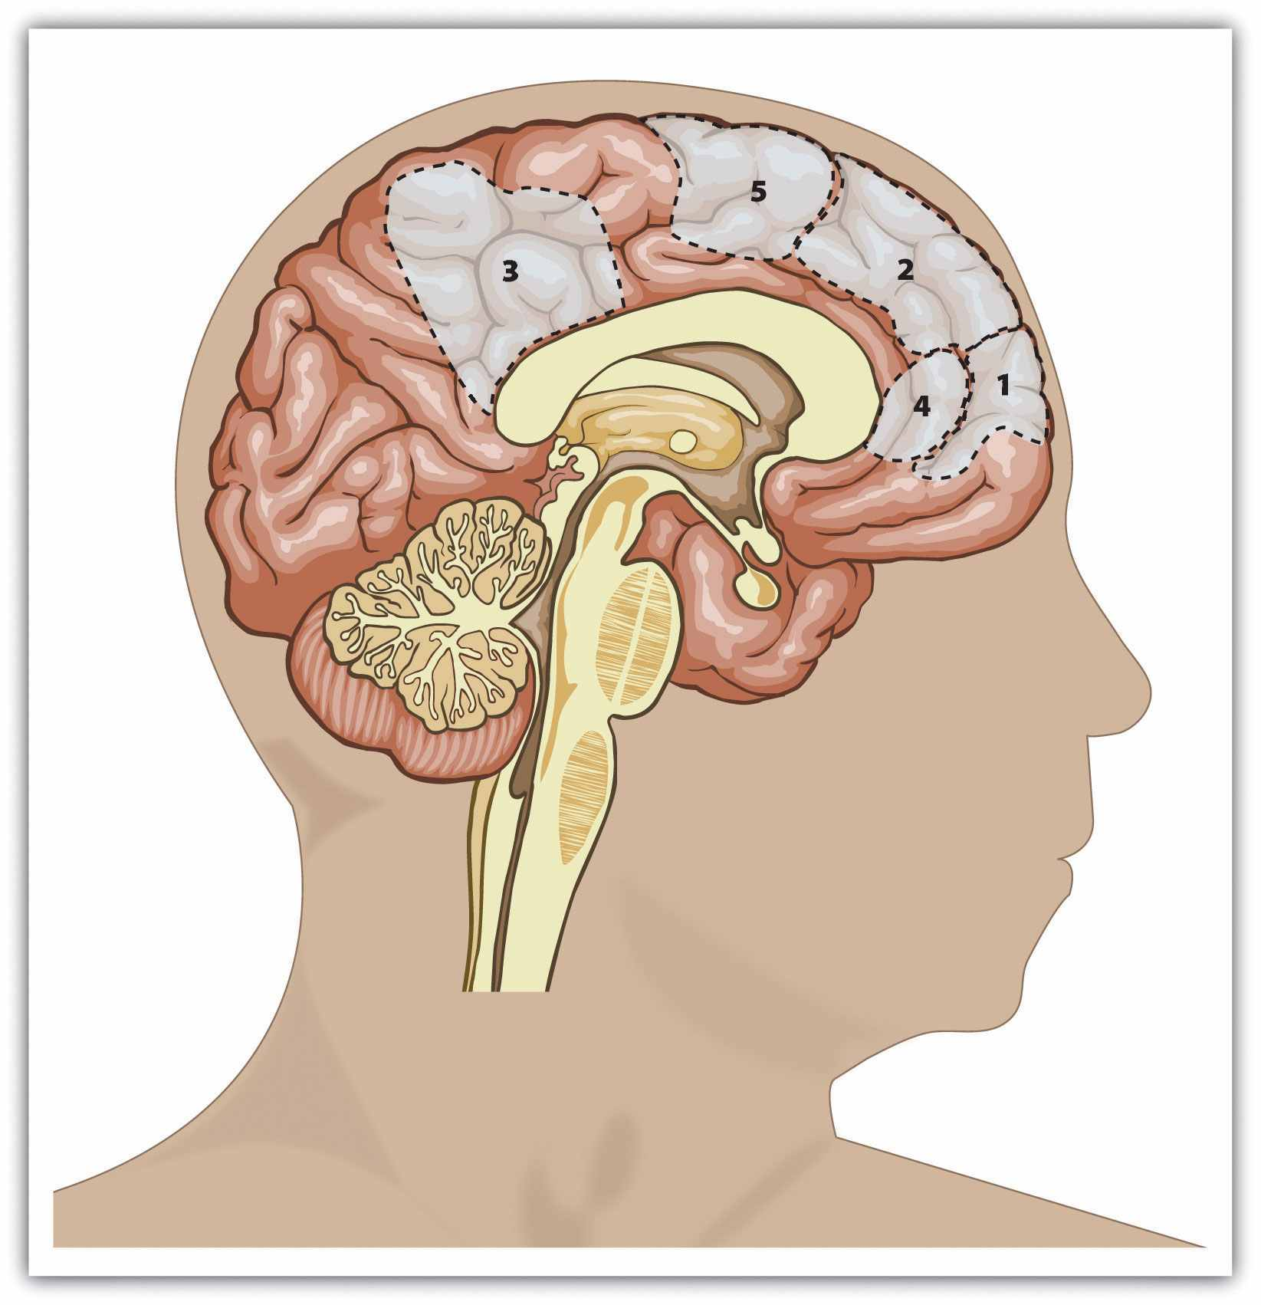
This figure shows the areas of the human brain that are known to be important in processing information about the self. They include primarily areas of the prefrontal cortex (areas 1, 2, 4, and 5). Data are from Lieberman (2010). ^{[18]}
Still another approach to studying the self is to investigate how we attend to and remember things that relate to the self. Indeed, because the self-concept is the most important of all our schemas, it has extraordinary influence on our thoughts, feelings, and behavior. Have you ever been at a party where there was a lot of noise and bustle, and yet you were surprised to discover that you could easily hear your own name being mentioned in the background? Because our own name is such an important part of our self-concept, and because we value it highly, it is highly accessible. We are very alert for, and react quickly to, the mention of our own name.
Other research has found that information that is related to the self-schema is better remembered than information that is unrelated to it, and that information related to the self can also be processed very quickly (Lieberman, Jarcho, & Satpute, 2004). ^{[19]} In one classic study that demonstrated the importance of the self-schema, Rogers, Kuiper, and Kirker (1977) ^{[20]} conducted an experiment to assess how college students recalled information that they had learned under different processing conditions. All the participants were presented with the same list of 40 adjectives to process, but through the use of random assignment, the participants were given one of four different sets of instructions about how to process the adjectives.
Participants assigned to the structural task condition were asked to judge whether the word was printed in uppercase or lowercase letters. Participants in the phonemic task condition were asked whether or not the word rhymed with another given word. In thesemantic task condition, the participants were asked if the word was a synonym of another word. And in the self-reference task condition, participants indicated whether or not the given adjective was or was not true of themselves. After completing the specified task, each participant was asked to recall as many adjectives as he or she could remember.

Figure 4.2 The Self-Reference Effect
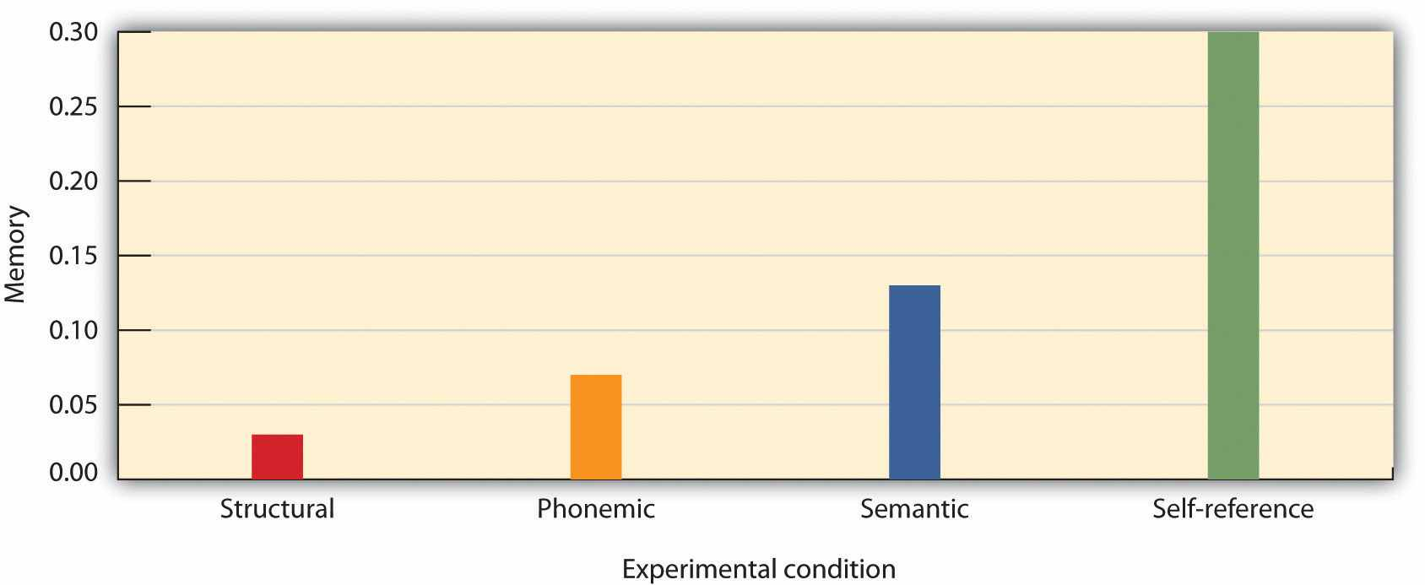
The chart shows the proportion of adjectives that students were able to recall under each of four learning conditions. The same words were recalled significantly better when they were processed in relation to the self than when they were processed in other ways. Data from Rogers et al. (1977). ^{[21]}
Rogers and his colleagues hypothesized that different types of processing would have different effects on memory. As you can see in Figure 4.2 "The Self-Reference Effect", the students in the self-reference task condition recalled significantly more adjectives than did students in any other condition. The finding that information that is processed in relationship to the self is particularly well remembered, known as theself-reference effect, is powerful evidence that the self-concept helps us organize and remember information. The next time you are studying for an exam, you might try relating the material to your own experiences—the self-reference effect suggests that doing so will help you better remember the information.

Self-Awareness
Like any other schema, the self-concept can vary in its current cognitive accessibility.Self-awareness refers to the extent to which we are currently fixing our attention on our own self-concept. When the self-concept becomes highly accessible because of our concerns about being observed and potentially judged by others, we experience the publicly induced self-awareness known as self-consciousness (Duval & Wicklund, 1972; Rochat, 2009). ^{[22]}
I am sure that you can remember times when your self-awareness was increased and you became self-conscious—for instance, when you were giving a class presentation and you were perhaps painfully aware that everyone was looking at you, or when you did something in public that embarrassed you. Emotions such as anxiety and embarrassment occur in large part because the self-concept becomes highly accessible, and they serve as a signal to monitor and perhaps change our behavior.
Not all aspects of our self-concepts are equally accessible at all times, and these long-term differences in the accessibility of the different self-schemas help create individual differences, for instance, in terms of our current concerns and interests. You may know some people for whom the physical appearance component of the self-concept is highly accessible. They check their hair every time they see a mirror, worry whether their clothes are making them look good, and do a lot of shopping—for themselves, of course. Other people are more focused on their social group memberships—they tend to think about things in terms of their role as Christians or as members of the tennis team. Think back for a moment to the opener of this chapter and consider Dancing Matt Harding. What do you think are his most highly accessible self-schemas?
In addition to variation in long-term accessibility, the self and its various components may also be made temporarily more accessible through priming. We become more self-aware when we are in front of a mirror, when a TV camera is focused on us, when we are speaking in front of an audience, or when we are listening to our own tape-recorded voice (Kernis & Grannemann, 1988). ^{[23]} When the knowledge contained in the self-schema becomes more accessible, it also becomes more likely to be used in information processing and more likely to influence our behavior.
Beaman, Klentz, Diener, and Svanum (1979) ^{[24]} conducted a field experiment to see if self-awareness would influence children’s honesty. The researchers expected that most children viewed stealing as wrong but that they would be more likely to act on this belief when they were more self-aware. They conducted this experiment on Halloween evening in homes within the city of Seattle. When children who were trick-or-treating came to particular houses, they were greeted by one of the experimenters, shown a large bowl of candy, and were told to take only one piece each. The researchers unobtrusively watched each child to see how many pieces he or she actually took.
Behind the candy bowl in some of the houses was a large mirror. In the other houses, there was no mirror. Out of the 363 children who were observed in the study, 19% disobeyed instructions and took more than one piece of candy. However, the children who were in front of a mirror were significantly less likely to steal (14.4%) than were those who did not see a mirror (28.5%). These results suggest that the mirror activated the children’s self-awareness, which reminded them of their belief about the importance of being honest. Other research has shown that being self-aware has a powerful influence on other behaviors as well. For instance, people are more likely to stay on their diets, eat better foods, and act more morally overall when they are self-aware (Baumeister, Zell, & Tice, 2007; Heatherton, Polivy, Herman, & Baumeister, 1993). ^{[25]} What this means is that when you are trying to stick to a diet, study harder, or engage in other difficult behaviors, you should try to focus on yourself and the importance of the goals you have set.
Social psychologists are interested in studying self-awareness because it has such an important influence on behavior. People lose their self-awareness and become more likely to violate acceptable social norms when, for example, they put on a Halloween mask or engage in other behaviors that hide their identities. The members of the militant White supremacist organization the Ku Klux Klan wear white robes and hats when they meet and when they engage in their racist behavior. And when people are in large crowds, such as in a mass demonstration or a riot, they may become so much a part of the group that they lose their individual self-awareness and experiencedeindividuation—the loss of self-awareness and individual accountability in groups (Festinger, Pepitone, & Newcomb, 1952; Zimbardo, 1969). ^{[26]}
Two particular types of individual differences in self-awareness have been found to be important, and they relate to self-concern and other-concern, respectively (Fenigstein, Scheier, & Buss, 1975; Lalwani, Shrum, & Chiu, 2009). ^{[27]} Private self-consciousness refers to the tendency to introspect about our inner thoughts and feelings. People who are high in private self-consciousness tend to think about themselves a lot and agree with statements such as “I’m always trying to figure myself out” and “I am generally attentive to my inner feelings.” People who are high on private self-consciousness are likely to base their behavior on their own inner beliefs and values—they let their inner thoughts and feelings guide their actions—and they may be particularly likely to strive to succeed on dimensions that allow them to demonstrate their own personal accomplishments (Lalwani, Shrum & Chiu, 2009). ^{[28]}
Public self-consciousness, in contrast, refers to the tendency to focus on our outer public image and to be particularly aware of the extent to which we are meeting the standards set by others. Those high in public self-consciousness agree with statements such as “I’m concerned about what other people think of me,” “Before I leave my house, I check how I look,” and “I care a lot about how I present myself to others.” These are the people who check their hair in a mirror they pass and spend a lot of time getting ready in the morning; they are more likely to let the opinions of others (rather than their own opinions) guide their behaviors and are particularly concerned with making good impressions on others.
Research has found cultural differences in public self-consciousness, such that people from East Asian collectivistic cultures have higher public self-consciousness than do people from Western individualistic cultures. Steve Heine and his colleagues (Heine, Takemoto, Moskalenko, Lasaleta, & Henrich, 2008) ^{[29]} found that when college students from Canada (a Western culture) completed questionnaires in front of a large mirror, they subsequently became more self-critical and were less likely to cheat (much like the trick-or-treaters we discussed earlier) than were Canadian students who were not in front of a mirror. However, the presence of the mirror had no effect on college students from Japan. This person-situation interaction is consistent with the idea that people from East Asian cultures are normally already high in public self-consciousness, in comparison with people from Western cultures, and thus manipulations designed to increase public self-consciousness are less influential for them.

Overestimating How Others View Us
Although the self-concept is the most important of all our schemas, and although people (particularly those high in self-consciousness) are aware of their self and how they are seen by others, this does not mean that people are always thinking about themselves. In fact, people do not generally focus on their self-concept any more than they focus on the other things and other people in their environments (Csikszentmihalyi & Figurski, 1982). ^{[30]}
On the other hand, self-awareness is more powerful for the person experiencing it than it is for others who are looking on, and the fact that self-concept is so highly accessible frequently leads people to overestimate the extent to which other people are focusing on them (Gilovich & Savitsky, 1999). ^{[31]} Although you may be highly self-conscious about of something you’ve done in a particular situation, that does not mean that others are necessarily paying all that much attention to you. Research by Thomas Gilovich and his colleagues (Gilovich, Medvec, & Savitsky, 2000) ^{[32]} found that people who were interacting with others thought that other people were paying much more attention to them than those other people reported actually doing.
Teenagers are particularly likely to be highly self-conscious, often believing that others are constantly watching them (Goossens, Beyers, Emmen, & van Aken, 2002). ^{[33]}Because teens think so much about themselves, they are particularly likely to believe that others must be thinking about them, too (Rycek, Stuhr, McDermott, Benker, & Swartz, 1998). ^{[34]} It is no wonder that everything a teen’s parents do suddenly feels embarrassing to them when they are in public.
People also often mistakenly believe that their internal states show to others more than they really do. Gilovich, Savitsky, and Medvec (1998) ^{[35]} asked groups of five students to work together on a “lie detection” task. One at a time, each student stood up in front of the others and answered a question that the researcher had written on a card (e.g., “I have met David Letterman”). On each round, one person’s card indicated that they were to give a false answer, whereas the other four were told to tell the truth.

Figure 4.3 The Illusion of Transparency
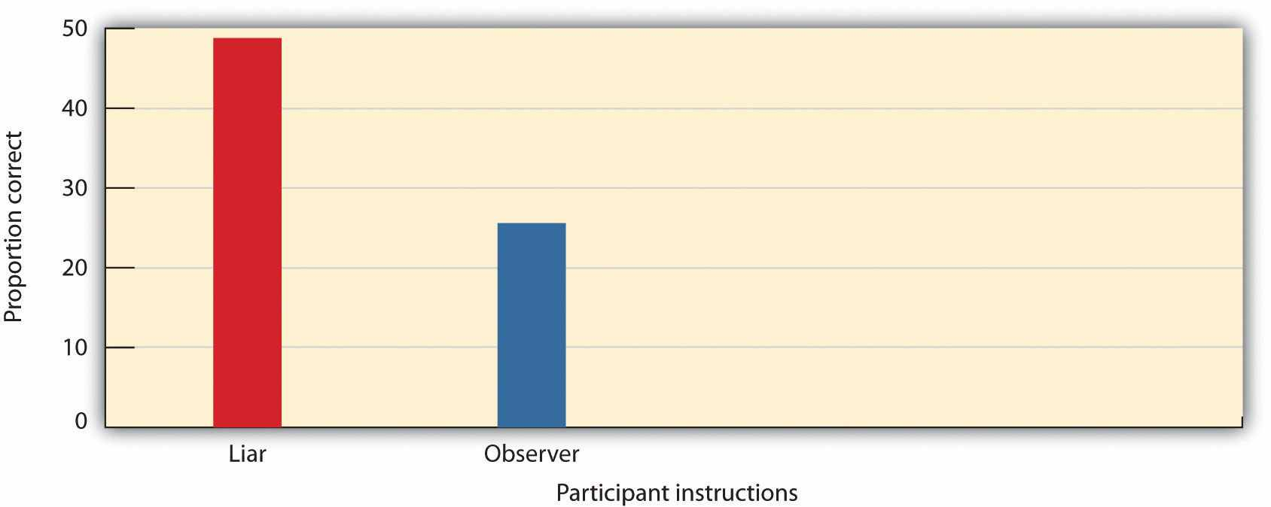
After each round, the students who had not been asked to lie indicated which of the students they thought had actually lied in that round, and the liar was asked to estimate the number of other students who would correctly guess who had been the liar. As you can see in Figure 4.3 "The Illusion of Transparency", the liars overestimated the detectability of their lies: On average, they predicted that over 44% of their fellow players had known that they were the liar, but in fact only about 25% were able to accurately identify them. Gilovitch and his colleagues called this effect the “illusion of transparency.”

KEY TAKEAWAYS
- The self-concept is a schema that contains knowledge about us. It is primarily made up of physical characteristics, group memberships, and traits.
- Because the self-concept is so complex, it has extraordinary influence on our thoughts, feelings, and behavior, and we can remember information that is related to it well.
- Self-complexity, the extent to which individuals have many different and relatively independent ways of thinking about themselves, helps people respond more positively to events that they experience.
- Self-awareness refers to the extent to which we are currently fixing our attention on our own self-concept. Differences in the accessibility of different self-schemas help create individual differences, for instance, in terms of our current concerns and interests.
- When people lose their self-awareness, they experience deindividuation, and this may lead them to act in violation of their personal norms.
- Private self-consciousness refers to the tendency to introspect about our inner thoughts and feelings; public self-consciousness refers to the tendency to focus on our outer public image and the standards set by others.
- There are cultural differences in self-consciousness, such that public self-consciousness may normally be higher in Eastern than in Western cultures.
- People frequently overestimate the extent to which others are paying attention to them and accurately understand their true intentions in public situations.

EXERCISES AND CRITICAL THINKING
- What are the most important aspects of your self-concept, and how do they influence your behavior?
- Consider people you know in terms of their self-complexity. What effects do these differences seem to have on their feelings and behavior?
- Can you think of ways that you have been influenced by your private and public self-consciousness?
- Do you think you have ever overestimated the extent to which people are paying attention to you in public?

[1] Boysen, S. T., & Himes, G. T. (1999). Current issues and emerging theories in animal cognition. Annual Review of Psychology, 50, 683–705.
[2] Gallup, G. G., Jr. (1970). Chimpanzees: self-recognition. Science, 167, 86–87.
[3] Asendorpf, J. B., Warkentin, V., & Baudonnière, P-M. (1996). Self-awareness and other-awareness. II: Mirror self-recognition, social contingency awareness, and synchronic imitation.Developmental Psychology, 32(2), 313–321; Povinelli, D. J., Landau, K. R., & Perilloux, H. K. (1996). Self-recognition in young children using delayed versus live feedback: Evidence of a developmental asynchrony. Child Development, 67(4), 1540–1554.
[4] Harter, S. (1998). The development of self-representations. In W. Damon & N. Eisenberg (Eds.), Handbook of child psychology: Social, emotional, & personality development (5th ed., Vol. 3, pp. 553–618). New York, NY: John Wiley & Sons.
[5] Doherty, M. J. (2009). Theory of mind: How children understand others’ thoughts and feelings. New York, NY: Psychology Press.
[6] Harter, S. (1999). The construction of the self: A developmental perspective. New York, NY: Guilford Press.
[7] Rees, A., & Nicholson, N. (1994). The Twenty Statements Test. In C. Cassell & G. Symon (Eds.), Qualitative methods in organizational research: A practical guide (pp. 37–54). Thousand Oaks, CA: Sage Publications.
[8] McGuire, W. J., McGuire, C. V., Child, P., & Fujioka, T. (1978). Salience of ethnicity in the spontaneous self-concept as a function of one’s ethnic distinctiveness in the social enviornment. Journal of Personality and Social Psychology, 36, 511–520.
[9] Oyserman, D., Bybee, D., Terry, K., & Hart-Johnson, T. (2004). Possible selves as roadmaps.Journal of Research in Personality, 38(2), 130–149.
[10] Linville, P. W. (1987). Self-complexity as a cognitive buffer against stress-related illness and depression. Journal of Personality and Social Psychology, 52(4), 663–676; Roccas, S., & Brewer, M. (2002). Social identity complexity. Personality and Social Psychology Review, 6(2), 88–106.
[11] Kalthoff, R. A., & Neimeyer, R. A. (1993). Self-complexity and psychological distress: A test of the buffering model. International Journal of Personal Construct Psychology, 6(4), 327–349.
[12] Gramzow, R. H., Sedikides, C., Panter, A. T., & Insko, C. A. (2000). Aspects of self-regulation and self-structure as predictors of perceived emotional distress. Personality and Social Psychology Bulletin, 26, 188–205.
[13] Niedenthal, P. M., Setterlund, M. B., & Wherry, M. B. (1992). Possible self-complexity and affective reactions to goal-relevant evaluation. Journal of Personality and Social Psychology, 63(1), 5–16.
[14] Rafaeli-Mor, E., & Steinberg, J. (2002). Self-complexity and well-being: A review and research synthesis. Personality and Social Psychology Review, 6, 31–58.
[15] Koch, E. J., & Shepperd, J. A. (2004). Is self-complexity linked to better coping? A review of the literature. Journal of Personality, 72(4), 727–760.
[16] McConnell, A. R., Renaud, J. M., Dean, K. K., Green, S. P., Lamoreaux, M. J., Hall, C. E.,…Rydel, R. J. (2005). Whose self is it anyway? Self-aspect control moderates the relation between self-complexity and well-being. Journal of Experimental Social Psychology, 41(1), 1–18. doi: 10.1016/j.jesp.2004.02.004
[17] Barrios, V., Kwan, V. S. Y., Ganis, G., Gorman, J., Romanowski, J., & Keenan, J. P. (2008). Elucidating the neural correlates of egoistic and moralistic self-enhancement. Consciousness and Cognition: An International Journal, 17(2), 451–456.
[18] Lieberman, M. D. (2010). Social cognitive neuroscience. In S. T. Fiske, D. T. Gilbert, & G. Lindzey (Eds.), Handbook of social psychology (5th ed., Vol. 1, pp. 143–193). Hoboken, NJ: John Wiley & Sons.
[19] Lieberman, M. D., Jarcho, J. M., & Satpute, A. B. (2004). Evidence-based and intuition-based self-knowledge: An fMRI study. Journal of Personality and Social Psychology, 87(4), 421–435.
[20] Rogers, T. B., Kuiper, N. A., & Kirker, W. S. (1977). Self-reference and the encoding of personal information. Journal of Personality and Social Psychology, 35(9), 677–688.
[21] Rogers, T. B., Kuiper, N. A., & Kirker, W. S. (1977). Self-reference and the encoding of personal information. Journal of Personality and Social Psychology, 35(9), 677–688.
[22] Duval, S., & Wicklund, R. A. (1972). A theory of objective self-awareness. New York, NY: Academic Press; Rochat, P. (2009). Others in mind: Social origins of self-consciousness. New York, NY: Cambridge University Press.
[23] Kernis, M. H., & Grannemann, B. D. (1988). Private self-consciousness and perceptions of self-consistency. Personality and Individual Differences, 9(5), 897–902.
[24] Beaman, A. L., Klentz, B., Diener, E., & Svanum, S. (1979). Self-awareness and transgression in children: Two field studies. Journal of Personality and Social Psychology, 37(10), 1835–1846.
[25] Baumeister, R. F., Zell, A. L., & Tice, D. M. (2007). How emotions facilitate and impair self-regulation. In J. J. Gross & J. J. E. Gross (Eds.), Handbook of emotion regulation (pp. 408–426). New York, NY: Guilford Press; Heatherton, T. F., Polivy, J., Herman, C. P., & Baumeister, R. F. (1993). Self-awareness, task failure, and disinhibition: How attentional focus affects eating.Journal of Personality, 61, 138–143.
[26] Festinger, L., Pepitone, A., & Newcomb, B. (1952). Some consequences of deindividuation in a group. Journal of Abnormal and Social Psychology, 47, 382–389; Zimbardo, P. (1969). The human choice: Individuation, reason and order versus deindividuation impulse and chaos. In W. J. Arnold & D. Levine (Eds.), Nebraska Symposium of Motivation (Vol. 17). Lincoln, NE: University of Nebraska Press.
[27] Fenigstein, A., Scheier, M. F., & Buss, A. H. (1975). Public and private self-consciousness: Assessment and theory. Journal of Consulting and Clinical Psychology, 43, 522–527; Lalwani, A. K., Shrum, L. J., & Chiu, C.-Y. (2009). Motivated response styles: The role of cultural values, regulatory focus, and self-consciousness in socially desirable responding. Journal of Personality and Social Psychology, 96, 870–882.
[28] Lalwani, A. K., Shrum, L. J., & Chiu, C-Y. (2009). Motivated response styles: The role of cultural values, regulatory focus, and self-consciousness in socially desirable responding.Journal of Personality and Social Psychology, 96, 870–882.
[29] Heine, S. J., Takemoto, T., Moskalenko, S., Lasaleta, J., & Henrich, J. (2008). Mirrors in the head: Cultural variation in objective self-awareness. Personality and Social Psychology Bulletin, 34(7), 879–887.
[30] Csikszentmihalyi, M., & Figurski, T. J. (1982). Self-awareness and aversive experience in everyday life. Journal of Personality, 50(1), 15–28.
[31] Gilovich, T., & Savitsky, K. (1999). The spotlight effect and the illusion of transparency: Egocentric assessments of how we are seen by others. Current Directions in Psychological Science, 8(6), 165–168.
[32] Gilovich, T., Medvec, V. H., & Savitsky, K. (2000). The spotlight effect in social judgment: An egocentric bias in estimates of the salience of one’s own actions and appearance. Journal of Personality and Social Psychology, 78(2), 211–222.
[33] Goossens, L., Beyers, W., Emmen, M., & van Aken, M. (2002). The imaginary audience and personal fable: Factor analyses and concurrent validity of the “new look” measures. Journal of Research on Adolescence, 12(2), 193–215.
[34] Rycek, R. F., Stuhr, S. L., McDermott, J., Benker, J., & Swartz, M. D. (1998). Adolescent egocentrism and cognitive functioning during late adolescence. Adolescence, 33, 746–750.
[35] Gilovich, T., Savitsky, K., & Medvec, V. H. (1998). The illusion of transparency: Biased assessments of others’ ability to read one’s emotional states. Journal of Personality and Social Psychology, 75(2), 332–346.

4.2 The Feeling Self: Self-Esteem

LEARNING OBJECTIVES
- Define self-esteem, and explain how it is measured by social psychologists.
- Provide examples of ways that people attempt to increase and maintain their self-esteem.
- Outline the benefits of having high self-esteem.
- Define self-monitoring and self-presentation, and explain how we may use the social situation to increase our status and self-esteem.
- Review the limits of self-esteem, with a focus on the negative aspects of narcissism.
Although the self is partly determined by our thoughts about ourselves, we are also the product of our emotions. I am certain that Matt Harding dances, at least in part, because he likes dancing and because dancing makes him feel good. In fact, we all want to feel positively about ourselves, and we work hard to be able to do so.

Self-Esteem Is Our Positive or Negative Attitude Toward Ourselves
Self-esteem refers to the positive (high self-esteem) or negative (low self-esteem) feelings that we have about ourselves. We experience the positive feelings of high self-esteem when we believe that we are good and worthy and that others view us positively. We experience the negative feelings of low self-esteem when we believe that we are inadequate and less worthy than others.
Our self-esteem is determined by many factors, including how well we view our own performance, our own appearance, and how satisfied we are with our relationships with other people (Tafarodi & Swann, 1995). ^{[1]} Self-esteem is in part a trait that is stable over time, such that some people have relatively high self-esteem and others have lower self-esteem. But our self-esteem is also a state that varies day to day and even hour to hour. When we have succeeded at an important task, when we have done something that we think is useful or important, or when we feel that we are accepted and valued by others, our self-concept will contain many positive thoughts and we will therefore have high self-esteem. When we have failed, done something harmful, or feel that we have been ignored or criticized, the negative aspects of the self-concept are more accessible and we experience low self-esteem.
Self-esteem can be measured using both explicit and implicit measures, and both approaches find that people tend to view themselves positively. One common self-report measure of self-esteem is the Rosenberg Self-Esteem Scale. Higher numbers on the scale indicate higher self-esteem, and the average score for college students who complete the scale is about 3 on a 1 to 4 scale, demonstrating that by and large, people have high self-esteem.

The Rosenberg Self-Esteem Scale
Please rate yourself on the following items by writing a number in the blank before each statement, where you
1 = Strongly Disagree 2 = Disagree 3 = Agree 4 = Strongly Agree
- _____I feel that I'm a person of worth, at least on any equal base with others.
- _____I feel that I have a number of good qualities.
- _____All in all, I am inclined to think that I am a failure (R).
- _____I am able to do things as well as other people.
- _____I feel I do not have much to be proud of. (R)
- _____I take a positive attitude towards myself.
- _____On the whole, I am satisfied with myself.
- _____I wish I could have more respect for myself. (R)
- _____I certainly feel useless at times. (R)
- _____At times I think I am no good at all. (R)
Note. (R) denotes an item that should be reverse scored. Subtract your response on these items from 5 before calculating the total. Data are from Rosenberg (1965).^{[2]}
One problem with measures such as the Rosenberg scale is that they can be influenced by the desire to portray the self positively. The observed scores on the Rosenberg scale are likely inflated because people naturally try to make themselves look as if they have very high self-esteem—maybe they fib a bit to make themselves look better than they really are to the experimenters and perhaps also to make themselves feel better.
More indirect measures of self-esteem have been created—measures that may provide a more accurate picture of the self-concept because they are less influenced by the desire to make a positive impression. Anthony Greenwald and Shelly Farnham (2000) ^{[3]}used the Implicit Association Test to study the self-concept indirectly. Participants worked at a computer and were presented with a series of words, each of which they were to categorize in one of two ways. One categorization decision involved whether the words were related to the self (e.g., me, myself, mine) or to another person (other, them, their). A second categorization decision involved determining whether words were pleasant (joy, smile, pleasant) or unpleasant (pain, death, tragedy).
On some trials, the self words were paired with the pleasant items, and the other words with the unpleasant items. On other trials, the self words were paired with the unpleasant items, and the other words with the pleasant items. Greenwald and Farnham found that on average, participants were significantly faster at categorizing positive words that were presented with self words than they were at categorizing negative words that were presented with self words, suggesting, again, that people did have positive self-esteem. Furthermore, there were also meaningful differences among people in the speed of responding, suggesting that the measure captured individual variation in self-esteem.
Brett Pelham and his colleagues (Jones, Pelham, Mirenberg, & Hetts, 2002; Koole & Pelham, 2003; Pelham, Carvallo, & Jones, 2005) ^{[4]} have taken still another approach to assessing self-esteem indirectly, by measuring a concept that they call implicit egoism. In their research, they have found that people prefer things that are associated with their own names to things that are not associated with their own names. More specifically, people prefer their own initials to the initials of other people, and prefer other people who share their initials to those who don’t. And Brendl, Chattopadhyay, Pelham, and Carvallo (2005) ^{[5]} found similar results for brand names, such that people are more likely to choose a brand when the brand name starts with letters from their names than when the brand name does not. Thus these indirect measures also came to the same conclusion that the direct measures do—most people have positive self-esteem in the sense that they regard themselves, and things associated with themselves, positively.

Maintaining and Enhancing Self-Esteem
Because it is so important to have self-esteem, we naturally try to get and maintain it. One way is to be successful at what we do. When we get a good grade on a test, perform well in a sports match, or get a date with someone that we really like, our self-esteem naturally rises. One reason that most people have positive self-esteem is because we are generally successful at creating positive lives. When we fail in one domain, we tend to move on until we find something that we are good at. Most of us realize that we cannot hang out with the most attractive person on campus, and so we generally don’t set ourselves up for failure by trying to. We don’t always expect to get the best grade on every test or to be the best player on the team. Therefore, we are not surprised or that hurt when those things don’t happen. In short, we feel good about ourselves because we do a pretty good job at creating decent lives.

Research Focus
Processing Information to Enhance the Self
Although we are all quite good at creating positive self-esteem by doing positive things, it turns out that we do not stop there. The desire to see ourselves positively is strong enough that it leads us to seek out, process, and remember information in a way that allows us to see ourselves even more positively.
Sanitioso, Kunda, and Fong (1990) ^{[6]} had students from Princeton University read about a study that they were told had been conducted by psychologists at Stanford University (the study was actually fictitious). The students were randomly assigned to two groups, such that one group read that the results of the research had showed that extroverts did better than introverts in academic or professional settings after graduating from college, while the other group read that introverts did better than extroverts on the same dimensions. The students then wrote explanations for why this might be true.
The experimenter then thanked the participants and led them to another room, where a second study was to be conducted (you will have guessed already that although the participants did not think so, the two experiments were really part of the same experiment). In the “second” experiment, participants were given a questionnaire that supposedly was investigating what different personality dimensions meant to people in terms of their own experience and behavior. The students were asked to list behaviors that they had performed in the past that related to the dimension of “shy” versus “outgoing”—a dimension that is very close in meaning to the introversion-extroversion dimension that they had read about in the first experiment.
The following figure shows the number of students in each condition who listed an extroverted behavior first, and the number who listed an introverted behavior first. You can see that the first memory listed by participants in both conditions tended to reflect the dimension that they had read was related to success according to the research presented in the first experiment. In fact, 62% of the students who had just learned that extroversion was related to success listed a memory about an extroverted behavior first, whereas only 38% of the students who had just learned that introversion was related to success listed an extroverted behavior first.

Figure 4.4Enhancing the Self
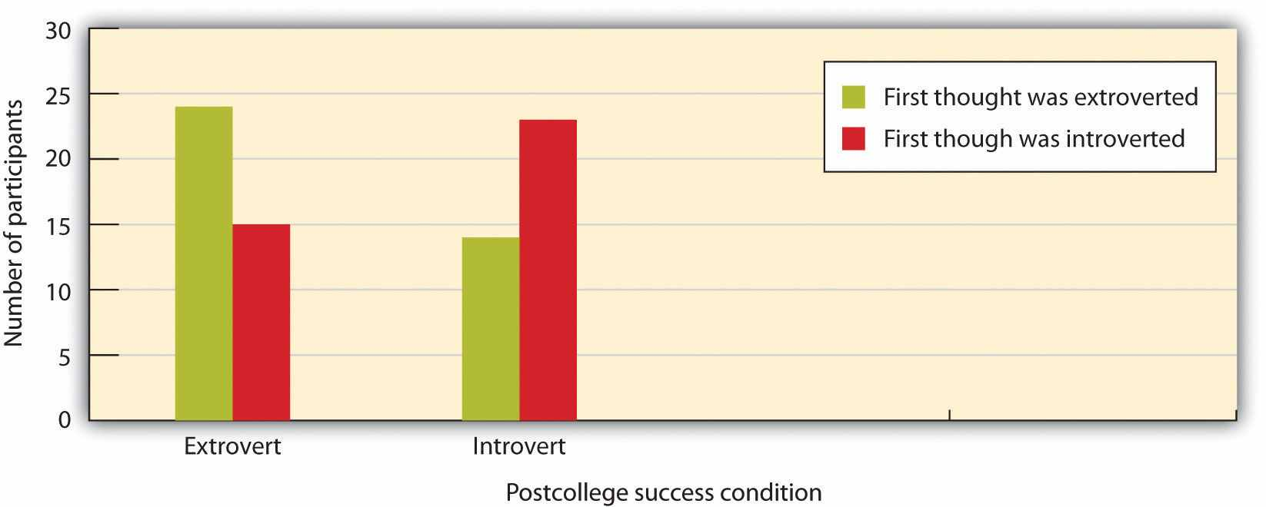
Sanitioso, Kunda, and Fong (1990) ^{[7]} found that students who had learned that extroverts did better than introverts after graduating from college tended to list extroverted memories about themselves, whereas those who learned that introverts did better than extroverts tended to list introverted memories.
It appears that the participants drew from their memories those instances of their own behavior that reflected the trait that had the most positive implications for their self-esteem—either introversion or extroversion, depending on experimental condition. The desire for positive self-esteem made events that were consistent with a positive self-perception more accessible, and thus they were listed first on the questionnaire.
Other research has confirmed this general principle—people attempt to create positive self-esteem whenever possible, even it if may involve distorting reality. We take credit for our successes, and we blame our failures on others. We remember our positive experiences, and we tend to forget the negative ones. We judge our likelihood of success and happiness as greater than our likelihood of failure and unhappiness. We think that our sense of humor and our honesty are above average, and that we are better drivers and less prejudiced than others. We also distort (in a positive way, of course) our memories of our grades, our performances on exams, and our romantic experiences. And we believe that we can control the events that we will experience to a greater extent than we really can (Crocker & Park, 2004). ^{[8]}

We Use Self-Presentation to Increase Our Status and Self-Esteem
Although self-esteem comes in part from our personal accomplishments, it is also influenced by the social situation. Positive self-esteem occurs not only when we do well in our own eyes but also when we feel that we are positively perceived by the other people we care about. Think about Dancing Matt as an example—he may love to dance for himself, but he also seems to enjoy sharing his dancing with others. Perhaps Matt feels good about himself in part because he knows that other people like to watch him.Social status refers to the extent to which we are viewed positively and are esteemed by others.
Because it is so important to be seen as competent and productive members of society, people naturally attempt to present themselves as positively as they can to others. We attempt to convince others that we are good and worthy people by appearing attractive, strong, intelligent, and likable and by saying positive things to others (Jones & Pittman, 1982; Leary, 1995; Schlenker, 2003). ^{[9]} The tendency to present a positive self-image to others, with the goal of increasing our social status, is known as self-presentation, and it is a basic and natural part of everyday life. Again, the dynamic interplay between the person and the situation is apparent—our individual self-esteem is influenced in large part by how we think others perceive us.
One way to self-present is to display our positive physical characteristics. The reason that so many of us spend money on teeth whiteners, hair dye, face-lifts, and fashion accessories of every sort is in part the result of the desire to self-present—we want to look good to others so that they will like us. We can also earn status by collecting expensive possessions such as fancy cars and big houses and by trying to associate with high-status others. And we may also gain status by attempting to dominate or intimidate others in social interaction. People who talk more and louder and those who initiate more social interactions are afforded higher status. A businessman who greets others with a strong handshake and a smile and people who speak out strongly for their opinions in group discussions may be attempting to do so as well. In some cases, people may even resort to aggressive behavior, such as bullying, in attempts to improve their status (Baumeister, Smart, & Boden, 1996). ^{[10]}
You might not be surprised to hear that men and women use different approaches to self-presentation. Men are more likely to present themselves in an assertive way, by speaking and interrupting others, by visually focusing on the other person when they are speaking, and by leaning their bodies into the conversation. Women, on the other hand, are more likely to be modest—they tend to create status by laughing and smiling, and by reacting more positively to the statements of others (Dovidio, Brown, Heltman, Ellyson, & Keation, 1988). ^{[11]}
These gender differences are probably in large part socially determined as a result of the different reinforcements that men and women receive for using self-presentational strategies. Speaking out and acting assertively is more effective for men than it is for women because our stereotypes about the appropriate behavior for women do not include assertive behavior. Women who act assertively may be seen negatively because they violate our expectations about appropriate behavior. In fact, because self-presenting in an assertive way is not as effective for women, it can be difficult for women to gain power in organizations (Carli, 2001). ^{[12]} But the observed gender differences in self-presentation are also due in part to the presence of testosterone, which is higher in men. Both women and men with more testosterone are more assertive (Baker, Pearcey, & Dabbs, 2002; Dabbs, Hargrove, & Heusel, 1996). ^{[13]}
Different self-presentation strategies may be used to create different emotions in other people, and the use of these strategies may be evolutionarily selected because they are successful (Kessler & Cohrs, 2008). ^{[14]} Edward Jones and Thane Pittman (1982) ^{[15]}described five self-presentation strategies, each of which is expected to create a resulting emotion in the other person.
- The goal of ingratiation is to create liking by using flattery or charm.
- The goal of intimidation is to create fear by showing that you can be aggressive.
- The goal of exemplification is to create guilt by showing that you are a better person than the other.
- The goal of supplication is to create pity by indicating to others that you are helpless and needy.
- The goal of self-promotion is to create respect by persuading others that you are competent.
No matter who is using it, self-presentation can easily be overdone, and when it is, it backfires. People who overuse the ingratiation technique and who are seen as obviously and strategically trying to impress or get others to like them are not liked. Nor are people who exemplify or self-promote by boasting or bragging, particularly if that boasting does not appear to reflect their true characteristics (Wosinska, Dabul, Whetstone-Dion, & Cialdini, 1996). ^{[16]} And using intimidation is also likely to backfire—acting more modestly may often be more effective. Again, the point is clear—we may want to self-promote with the goal of getting others to like us, but we must also be careful to take into consideration the point of view of the other person as well.

Figure 4.5
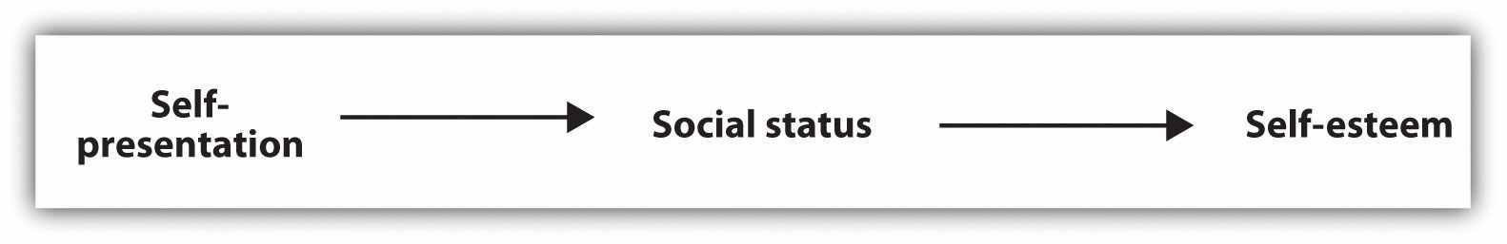
We use self-presentation to try to convince others that we are good and worthy people. When we are successful in our self-presentation and other people view us positively, we have high social status. When we perceive that we have high social status, we experience positive self-esteem.
In summary, although the variables of self-esteem, social status, and self-presentation are separate concepts with different meanings, they all are related, as you can see inFigure 4.5. We feel good about ourselves (we have high self-esteem) when we have high social status. And we can gain status by convincing other people that we are good people (self-presentation). Because these concepts are important parts of everyday life, we will return to them frequently throughout this book.

Self-Monitoring and Self-Presentation
Although the desire to present the self favorably is a natural part of everyday life, both person and situation factors influence the extent to which we do it. For one, we are more likely to self-present in some situations than in others. When we are applying for a job or meeting with others whom we need to impress, we naturally become more attuned to the social aspects of the self, and our self-presentation increases.
And there are also individual differences. Some people are naturally better at self-presentation—they enjoy doing it and are good at it—whereas others find self-presentation less desirable or more difficult. An important individual-difference variable known as self-monitoring has been shown, in hundreds of studies, to have a major impact on self-presentation. Self-monitoring refers to the tendency to be both motivated and capable of regulating our behavior to meet the demands of social situations (Gangestad & Snyder, 2000). ^{[17]} High self-monitors are particularly good at reading the emotions of others and therefore are better at fitting into social situations—they agree with statements such as “In different situations and with different people, I often act like very different persons” and “I guess I put on a show to impress or entertain people.” Low self-monitors, on the other hand, generally act on their own attitudes, even when the social situation suggests that they should behave otherwise. Low self-monitors are more likely to agree with statements such as “At parties and social gatherings, I do not attempt to do or say things that others will like” and “I can only argue for ideas that I already believe.” In short, high self-monitors try to get other people to like them by behaving in ways that the others find desirable (they are good self-presenters), whereas low self-monitors do not.
In one experiment that showed the importance of self-monitoring, Cheng and Chartrand (2003) ^{[18]} had college students interact individually with another student (actually an experimental confederate) whom they thought they would be working with on an upcoming task. While they were interacting, the confederate subtly touched her own face several times, and the researchers recorded the extent to which the student participant mimicked the confederate by also touching his or her own face.
The situational variable was the status of the confederate. Before the meeting began, and according to random assignment to conditions, the students were told either that they would be the leader and that the other person would be the worker on the upcoming task, or vice versa. The person variable was self-monitoring, and each participant was classified as either high or low on self-monitoring on the basis of his or her responses to the self-monitoring scale.

Figure 4.6
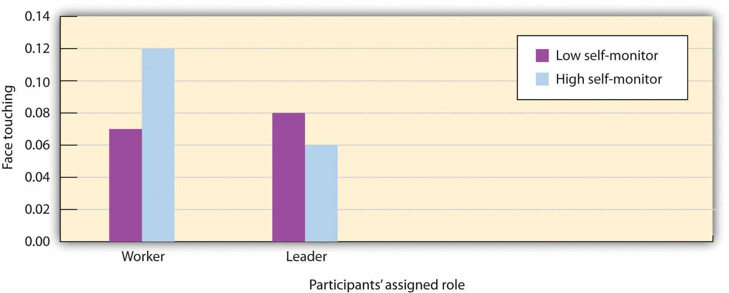
High self-monitors imitated more when the person they were interacting with was of higher (versus lower) status. Low self-monitors were not sensitive to the status of the other. Data are from Cheng and Chartrand (2003). ^{[19]}
As you can see in Figure 4.6, Cheng and Chartrand found an interaction effect: The students who had been classified as high self-monitors were more likely to mimic the behavior of the confederate when she was described as being the leader than when she was described as being the worker, indicating that they were “tuned in” to the social situation and modified their behavior to appear more positively. Although the low self-monitors did mimic the other person, they did not mimic her more when the other was high, versus low, status. This finding is quite consistent with the idea that the high self-monitors were particularly aware of the other person’s status and attempted to self-present more positively to the high-status leader. The low self-monitors, on the other hand—because they feel less need to impress overall—did not pay much attention to the other person’s status.

Narcissism and the Limits of Self-Enhancement
Our discussion to this point suggests that people will generally try to view themselves in the most positive possible light and to present themselves to others as favorably as they can. We emphasize our positive characteristics, and we may even in some cases distort information—all to help us maintain positive self-esteem.
There is a negative aspect to having too much self-esteem, however, at least when the esteem is unrealistic and undeserved. Narcissism is a personality trait characterized by overly high self-esteem, self-admiration, and self-centeredness. Narcissists agree with statements such as the following:
- “I know that I am good because everybody keeps telling me so.”
- “I can usually talk my way out of anything.”
- “I like to be the center of attention.”
- “I have a natural talent for influencing people.”
People do not normally like narcissists because they are unrealistic and think only of themselves. Narcissists make bad romantic partners—they behave selfishly and are always ready to look for someone else who they think will be a better mate, and they are likely to be unfaithful (Campbell & Foster, 2002; Campbell, Rudich, & Sedikides, 2002). ^{[20]} Narcissists may also be obnoxious, continually interrupting and bullying others, and they may respond very negatively to criticism. Although they make positive first impressions, people eventually see narcissists less positively than narcissists see themselves, in part because they are perceived as arrogant. Perhaps surprisingly, narcissists seem to understand these things about themselves, although they engage in the behaviors anyway (Carlson, Vazire, & Oltmanns, 2011). ^{[21]}

Social Psychology in the Public Interest
Does High Self-Esteem Cause Happiness or Other Positive Outcomes?
Teachers, parents, school counselors, and people in general frequently assume that high self-esteem causes many positive outcomes for people who have it and therefore that we should try to increase it in ourselves and others. Perhaps you agree with the idea that if you could increase your self-esteem, you would feel better about yourself and therefore be able to study harder, get better grades, or attract a more desirable mate. If you do believe that, you would not be alone. In 1986, the state of California funded a task force under the premise that raising self-esteem would help solve many of the state’s problems, including crime, teen pregnancy, drug abuse, school underachievement, and pollution.
Roy Baumeister and his colleagues (Baumeister, Campbell, Krueger, & Vohs, 2003) ^{[22]} recently conducted an extensive review of the research literature to determine whether having high self-esteem was as helpful as many people seem to think it is. They began by assessing which variables were correlated with high self-esteem and then considered the extent to which high self-esteem caused these outcomes.
Baumeister and his colleagues found that high self-esteem does correlate with many positive outcomes. People with high self-esteem get better grades, are less depressed, feel less stress, and may even live longer than those who view themselves more negatively. The researchers also found that high self-esteem was correlated with greater initiative and activity, such that high self-esteem people just did more things. People with high self-esteem are more likely to be bullies, but they are also more likely to defend victims against bullies, compared with people with low self-esteem. People with high self-esteem are more likely to initiate interactions and relationships. They are more likely to speak up in groups and to experiment with alcohol, drugs, and sex. High self-esteem people also work harder in response to initial failure and are more willing to switch to a new line of endeavor if the present one seems unpromising. Thus having high self-esteem seems to be a valuable resource—people with high self-esteem are happier, more active, and in many ways better able to deal with their environment.
On the other hand, Baumeister and his colleagues also found that people with high self-esteem may sometimes delude themselves. High self-esteem people believe that they are more likable and attractive, have better relationships, and make better impressions on others than people with low self-esteem. But objective measures show that these beliefs are often distortions rather than facts. Furthermore, people with overly high self-esteem, particularly when it is accompanied by narcissism, defensiveness, conceit, and the unwillingness to critically assess one’s potential negative qualities, have been found to engage in a variety of negative behaviors (Baumeister, Smart, & Boden, 1996). ^{[23]}
Todd Heatherton and Kathleen Vohs (2000) ^{[24]} found that when people with extremely high self-esteem were forced to fail on a difficult task in front of a partner, they responded by acting more unfriendly, rudely, and arrogantly than did students with lower self-esteem. And research has found that children who inflate their social self-worth—those who think that they are more popular than they really are and who thus have unrealistically high self-esteem—are also more aggressive than the children who do not show such narcissistic tendencies (Sandstrom & Herlan, 2007; Thomaes, Bushman, Stegge, & Olthof, 2008). ^{[25]} If you are thinking like a social psychologist, these findings may not surprise you—narcissists are all about self-concern, with little concern for others, and we have seen many times that other-concern is a necessity for satisfactory social relations.
Despite the many positive variables that relate to high self-esteem, when Baumeister and his colleagues looked at the causal role of self-esteem is they found little evidence that high self-esteem caused these positive outcomes. For instance, although high self-esteem is correlated with academic achievement, it is more the result than the cause of this achievement. Programs designed to boost the self-esteem of pupils have not been shown to improve academic performance, and laboratory studies have generally failed to find that manipulations of self-esteem cause better task performance.
In the end then, Baumeister and his colleagues concluded that programs designed to boost self-esteem should be used only in a limited way and should not be the only approach taken. Raising self-esteem will not make young people do better in school, obey the law, stay out of trouble, get along better with other people, or respect the rights of others. And these programs may even backfire, if the increased self-esteem creates narcissism or conceit. Baumeister and his colleagues suggested that attempts to boost self-esteem should only be carried out as a reward for good behavior and worthy achievements, and not simply to try to make children feel better about themselves.
Although we naturally desire to have social status and high self-esteem, we cannot always promote ourselves without any regard to the accuracy of our self-characterizations. If we consistently distort our capabilities, and particularly if we do this over a long period of time, we will just end up fooling ourselves and perhaps engaging in behaviors that are not actually beneficial to us. One of my colleagues has a son in high school who loves to think that he is an incredible golfer who could compete on the professional golf tour with the best golfers in the world. The problem, however, is that he’s actually only a pretty average golfer. His parents are worried about him because although they realize that his high self-esteem might propel him to work harder at this sport, and although he certainly enjoys thinking positively about himself, he may also be setting himself up for long-term failure. How long can he continue to consider himself in this overly positive way before the reality comes crashing down on him that perhaps he really is not cut out for a life on the professional golf circuit and that he should consider doing something else? The hope is that it will not be too late to take up a more reasonable career when he does.
When we promote ourselves too much, although we may feel good about it in the short term, in the longer term the outcomes for the self may not be that positive. The goal of creating and maintaining positive self-esteem (an affective goal) must be tempered by the cognitive goal of having an accurate self-view (Kirkpatrick & Ellis, 2001; Swann, Chang-Schneider, & Angulo, 2007). ^{[26]} Although we may prefer to hold highly favorable views of ourselves, more accurate views would almost certainly be more useful because accurate information is likely to lead to better decision making. Indeed, research suggests that people do not only self-enhance; they also desire to be known for who they believe they are, even if what they are is not all good. When people enter into relationships with others who verify their self-views, for example, they feel more intimate with the other person and more are satisfied with the interaction than they do with partners who are always positive toward them (Swann, De La Ronde, & Hixon, 1994; Swann & Pelham, 2002). ^{[27]} The desire for self-verifying feedback is so powerful that people who have negative self-esteem may in some cases work to verify those negative views by avoiding positive feedback in favor of negative, but self-verifying, feedback (Swann, Rentfrow, & Guinn, 2002). ^{[28]}
In some cases, the cognitive goal of obtaining an accurate picture of ourselves and our social world and the affective goal of gaining positive self-esteem work hand in hand. Getting the best grade in the class on an important exam produces accurate knowledge about our skills in the domain as well as giving us some positive self-esteem. In other cases, the two goals are incompatible. Doing more poorly on an exam than we had hoped produces conflicting, contradictory outcomes. The poor score provides accurate information about the self—namely, that we have not mastered the subject—but at the same time makes us feel bad. It is in these cases that we must learn to reconcile our self-concept with our self-esteem. We must be able to accept our negative aspects and to work to overcome them. The ability to balance the cognitive and the affective features of the self helps us create efficient and effective behavior.
Jennifer Crocker and Lora Park (2004) ^{[29]} have noted still another cost of our attempts to inflate our self-esteem: We may spend so much time trying to enhance our self-esteem in the eyes of others—by focusing on the clothes we are wearing, impressing others, and so forth—that we have little time left to really improve ourselves in more meaningful ways. And in some extreme cases, people experience such strong needs to improve their self-esteem and social status that they act in assertive or dominant ways in order to gain it. As in many other domains, then, having positive self-esteem is a good thing, but we must be careful to temper it with a healthy realism and a concern for others.

KEY TAKEAWAYS
- Self-esteem refers to the positive (high self-esteem) or negative (low self-esteem) feelings that we have about ourselves.
- Self-esteem is determined both by our own achievements and accomplishments and by how we think others are judging us.
- Self-esteem can be measured using both direct and indirect measures, and both approaches find that people tend to view themselves positively.
- Because it is so important to have self-esteem, we may seek out, process, and remember information in a way that allows us to see ourselves even more positively.
- The tendency to present a positive self-image to others, with the goal of increasing our social status, is known as self-presentation, and it is a basic and natural part of everyday life. Different self-presentation strategies may be used to create different emotions in other people.
- The individual-difference variable of self-monitoring relates to the ability and desire to self-present.
- High self-esteem is correlated with, but does not cause, a variety of positive outcomes.
- Although high self-esteem does correlate with many positive outcomes in life, overly high self-esteem creates narcissism, which can lead to unfriendly, rude, and ultimately dysfunctional behaviors.

EXERCISES AND CRITICAL THINKING
- In what ways do you attempt to boost your own self-esteem?
- Describe some people you know who use some of the self-presentation strategies that were listed in this section. Do they seem to be effective or not?
- Consider your own level of self-monitoring. Are you a high or a low self-monitor, and what makes you think so?
- Do you know people who have appropriately high self-esteem? What about people who are narcissists? How do these individual differences influence their social behavior in positive and negative ways?

[1] Tafarodi, R. W., & Swann, W. B., Jr. (1995). Self-liking and self-competence as dimensions of global self-esteem: Initial validation of a measure. Journal of Personality Assessment, 65(2), 322–342.
[2] Rosenberg, M. (1965). Society and the adolescent self-image. Princeton, NJ: Princeton University Press.
[3] Greenwald, A. G., & Farnham, S. D. (2000). Using the Implicit Association Test to measure self-esteem and self-concept. Journal of Personality and Social Psychology, 79(6), 1022–1038.
[4] Jones, J. T., Pelham, B. W., Mirenberg, M. C., & Hetts, J. J. (2002). Name letter preferences are not merely mere exposure: Implicit egotism as self-regulation. Journal of Experimental Social Psychology, 38(2), 170–177; Koole, S. L., & Pelham, B. W. (Eds.). (2003). On the nature of implicit self-esteem: The case of the name letter effect. Mahwah, NJ: Lawrence Erlbaum Associates; Pelham, B. W., Carvallo, M., & Jones, J. T. (2005). Implicit egotism. Current Directions in Psychological Science, 14, 106–110.
[5] Brendl, C. M., Chattopadhyay, A., Pelham, B. W., & Carvallo, M. (2005). Name letter branding: Valence transfers when product specific needs are active. Journal of Consumer Research, 32, 405–416.
[6] Sanitioso, R., Kunda, Z., & Fong, G. T. (1990). Motivated recruitment of autobiographical memories. Journal of Personality and Social Psychology, 59(2), 229–241.
[7] Sanitioso, R., Kunda, Z., & Fong, G. T. (1990). Motivated recruitment of autobiographical memories. Journal of Personality and Social Psychology, 59(2), 229–241.
[8] Crocker, J., & Park, L. E. (2004). The costly pursuit of self-esteem. Psychological Bulletin, 130, 392–414.
[9] Jones, E. E., & Pittman, T. S. (1982). Toward a general theory of strategic self-presentation. In J. Suls (Ed.), Psychological perspectives on the self (Vol 1, pp. 231–262). Hillsdale, NJ: Erlbaum; Leary, M. R. (1995). Self-presentation: Impression management and interpersonal behavior. Madison, WI: Brown & Benchmark Publishers; Schlenker, B. R. (2003). Self-presentation. In M. R. Leary, J. P. Tangney, M. R. E. Leary, & J. P. E. Tangney (Eds.), Handbook of self and identity (pp. 492–518). New York, NY: Guilford Press.
[10] Baumeister, R. F., Smart, L., & Boden, J. M. (1996). Relation of threatened egotism to violence and aggression: The dark side of high self-esteem. Psychological Review, 103(1), 5–34.
[11] Dovidio, J. F., Brown, C. E., Heltman, K., Ellyson, S. L., & Keation, C. F. (1988). Power displays between women and men in discussions of gender linked tasks: A multichannel study.Journal of Personality and Social Psychology, 55, 580–587.
[12] Carli, L. L. (2001). Gender and social influence. Journal of Social Issues, 57(4), 725–741.
[13] Baker, L. A., Pearcey, S. M., & Dabbs, J. M., Jr. (2002). Testosterone, alcohol, and civil and rough conflict resolution strategies in lesbian couples. Journal of Homosexuality, 42(4), 77–88; Dabbs, J. M., Jr., Hargrove, M. F., & Heusel, C. (1996). Testosterone differences among college fraternities: Well-behaved vs. rambunctious. Personality and Individual Differences, 20(2), 157–161.
[14] Kessler, T., & Cohrs, J. C. (2008). The evolution of authoritarian processes: Fostering cooperation in large-scale groups. Group Dynamics: Theory, Research, and Practice, 12, 73–84.
[15] Jones, E. E., & Pittman, T. S. (1982). Toward a general theory of strategic self-presentation. In J. Suls (Ed.), Psychological perspectives on the self (Vol 1, pp. 231–262). Hillsdale, NJ: Erlbaum.
[16] Wosinska, W., Dabul, A. J., Whetstone-Dion, R., & Cialdini, R. B. (1996). Self-presentational responses to success in the organization: The costs and benefits of modesty.Basic and Applied Social Psychology, 18(2), 229–242.
[17] Gangestad, S. W., & Snyder, M. (2000). Self-monitoring: Appraisal and reappraisal.Psychological Bulletin, 126(4), 530–555.
[18] Cheng, C. M., & Chartrand, T. L. (2003). Self-monitoring without awareness: Using mimicry as a nonconscious affiliation strategy. Journal of Personality and Social Psychology, 85(6), 1170–1179.
[19] Cheng, C. M., & Chartrand, T. L. (2003). Self-monitoring without awareness: Using mimicry as a nonconscious affiliation strategy. Journal of Personality and Social Psychology, 85(6), 1170–1179.
[20] Campbell, W. K., & Foster, C. A. (2002). Narcissism and commitment in romantic relationships: An investment model analysis. Personality and Social Psychology Bulletin, 28, 484–495; Campbell, W. K., Rudich, E., & Sedikides, C. (2002). Narcissism, self-esteem, and the positivity of self-views: Two portraits of self-love. Personality and Social Psychology Bulletin, 28, 358–368.
[21] Carlson, E. N., Vazire, S., & Oltmanns, T. F. (2011). You probably think this paper’s about you: Narcissists’ perceptions of their personality and reputation. Journal of Personality and Social Psychology, 101(1), 185–201.
[22] Baumeister, R. F., Campbell, J. D., Krueger, J. I., & Vohs, K. D. (2003). Does high self-esteem cause better performance, interpersonal success, happiness, or healthier lifestyles?Psychological Science in the Public Interest, 4(1), 1–44.
[23] Baumeister, R. F., Smart, L., & Boden, J. M. (1996). Relation of threatened egotism to violence and aggression: The dark side of high self-esteem. Psychological Review, 103(1), 5–34.
[24] Heatherton, T. F., & Vohs, K. D. (2000). Interpersonal evaluations following threats to self: Role of self-esteem. Journal of Personality and Social Psychology, 78, 725–736.
[25] Sandstrom, M. J., & Herlan, R. D. (2007). Threatened egotism or confirmed inadequacy? How children’s perceptions of social status influence aggressive behavior toward peers.Journal of Social and Clinical Psychology, 26(2), 240–267; Thomaes, S., Bushman, B. J., Stegge, H., & Olthof, T. (2008). Trumping shame by blasts of noise: Narcissism, self-esteem, shame, and aggression in young adolescents. Child Development, 79(6), 1792–1801.
[26] Kirkpatick, L. A., & Ellis, B. J. (2001). Evolutionary perspectives on self-evaluation and self-esteem. In M. Clark & G. Fletcher (Eds.), The Blackwell Handbook of Social Psychology, Vol. 2: Interpersonal processes (pp. 411–436). Oxford, UK: Blackwell; Swann, W. B., Jr., Chang-Schneider, C., & Angulo, S. (2007). Self-verification in relationships as an adaptive process. In J. Wood, A. Tesser, & J. Holmes (Eds.), Self and relationships. New York, NY: Psychology Press.
[27] Swann, W. B., Jr., De La Ronde, C., & Hixon, J. G. (1994). Authenticity and positivity strivings in marriage and courtship. Journal of Personality and Social Psychology, 66, 857–869; Swann, W. B., Jr., & Pelham, B. W. (2002). Who wants out when the going gets good? Psychological investment and preference for self-verifying college roommates. Journal of Self and Identity, 1, 219–233.
[28] Swann, W. B., Jr., Rentfrow, P. J., & Guinn, J. (2002). Self-verification: The search for coherence. In M. Leary & J. Tangney (Eds.), Handbook of self and identity. New York: Guilford Press.
[29] Crocker, J., & Park, L. E. (2004). The costly pursuit of self-esteem. Psychological Bulletin, 130, 392–414.

4.3 The Social Self: The Role of the Social Situation

LEARNING OBJECTIVES
- Define social comparison, and summarize how people use it to define their self-concepts and self-esteem.
- Give examples of the use of upward and downward social comparison and their influences on social cognition and affect.
- Explain the concept of social identity and why it is important to human behavior.
- Summarize the research evidence regarding cultural differences in self-concept and self-esteem.
To this point, we have argued that human beings have complex and well-developed self-concepts and that they generally attempt to come to view themselves as positively as they can. In this section, we will consider in more detail the social aspects of the self by considering the many ways that the social situation determines our self-concept. Our selves are not created in isolation; we are not born with perceptions of ourselves as shy, interested in jazz, or charitable to others. Rather, these beliefs are determined by our observations of and interactions with others. Are you rich or poor? Beautiful or ugly? Smart or not? Good or poor at video games? And how do you know? These questions can be answered only by comparing ourselves with those around us. The self has meaning only within the social context, and it is not wrong to say that the social situation defines our self-concept and our self-esteem. We rely on others to provide a “social reality”—to help us determine what to think, feel, and do (Hardin & Higgins, 1996). ^{[1]}

Social Comparison Helps Create the Self-Concept
The self-concept and self-esteem are determined in large part through the process ofsocial comparison (Buunk & Gibbons, 2007; Van Lange, 2008). ^{[2]}Social comparison occurs when we learn about our abilities and skills, about the appropriateness and validity of our opinions, and about our relative social status by comparing our own attitudes, beliefs, and behaviors with those of others. These comparisons can be with people that we know and interact with, with those that we read about or see on TV, or with anyone else that we view as important.
Social comparison occurs primarily on dimensions upon which there is no objectively correct answer and thus on which we can rely only on the beliefs of others for information. Answers to questions such as “What should I wear to the formal?” or “What kind of music should I have at my wedding?” are frequently determined at least in part by using the behavior of others as a basis of comparison. We also use social comparison to help us determine our skills or abilities—how good we are at performing a task or doing a job, for example. When a student looks at another student’s paper to see what grade he or she got, or when we join a tennis club to compare our performance and progress with those of others, we are using social comparison to evaluate our abilities.

Research Focus
Affiliation and Social Comparison
The extent to which individuals use social comparison to determine their evaluations of events was demonstrated in a set of classic research studies conducted by Stanley Schachter (1959). ^{[3]} Schachter’s experiments tested the hypothesis that people who were feeling anxious would prefer to affiliate with others rather than be alone because having others around would reduce their anxiety. Female college students at the University of Minnesota volunteered to participate in one of his experiments for extra credit in their introductory psychology class. They arrived at the experimental room to find a scientist dressed in a white lab coat, standing in front of a large array of electrical machinery. The scientist introduced himself as Dr. Zilstein of the Department of Neurology and Psychiatry, and he told the women that they would be serving as participants in an experiment concerning the effects of electrical shock. Dr. Zilstein stressed how important it was to learn about the effects of shocks, since electroshock therapy was being used more and more commonly and because the number of accidents due to electricity was also increasing!
At this point, the experimental manipulation occurred. One half of the participants (those in the high-anxiety condition) were told that the shocks would be “painful” and “intense,” although they were assured that they could do no permanent damage. The other half of the participants (those in the low-anxiety condition) were also told that they would be receiving shocks but that they would in no way be painful—rather, the shocks were said to be mild and to resemble a “tickle” or a “tingle.” Of course, the respondents were randomly assigned to conditions to assure that the women in the two conditions were, on average, equivalent except for the experimental manipulation.
Each of the women was then told that before the experiment could continue, the experimenter would have to prepare the equipment and that they would have to wait for a while until he was finished. He asked them if they would prefer to wait alone or to wait with others. The outcome of Schachter’s research was clear—while only 33% of the women who were expecting mild shocks preferred to wait with others, 63% of the women expecting to get painful shocks wanted to wait with others. This was a statistically significant difference, and Schachter concluded that the women chose to affiliate with each other in order to reduce their anxiety about the upcoming shocks.
In further studies, Schachter found that the research participants who were under stress did not want to wait with just any other people. They preferred to wait with other people who were expecting to undergo the same severe shocks that they were rather than with people who were supposedly just waiting to see their professor. Schachter concluded that this was not just because being around other people might reduce our anxiety but because we also use others who are in the same situation as we are to help us determine how to feel about things. As Schachter (1959) put it, “Misery doesn’t just love any kind of company, it loves only miserable company” (p. 24). In this case, the participants were expecting to determine from the other participants how afraid they should be of the upcoming shocks.
In short, and as predicted by the idea of social comparison, the women in Schachter’s studies relied on each other to help them understand what was happening to them and to find out how they should feel and respond to their social situations. Again, the power of the social situation—in this case, in determining our beliefs and attitudes—is apparent.
Although Schachter’s studies were conducted in relatively artificial lab settings, similar effects have been found in field studies in more naturally occurring settings. For instance, Kulik, Mahler, and Moore (1996) ^{[4]} found that hospital patients who were awaiting surgery preferred to talk to other individuals who were expecting to have similar procedures rather than to patients who were having different procedures, so that they could share information about what they might expect to experience. Furthermore, Kulik and his colleagues found that sharing information was helpful—people who were able to share more information had shorter hospital stays.

Upward and Downward Comparisons Influence Our Self-Esteem
Although we use social comparison in part to develop our self-concept—that is, to form accurate conclusions about our attitudes, abilities, and opinions—social comparison has perhaps an even bigger impact on our self-esteem. When we are able to compare ourselves favorably with others, we feel good about ourselves, but when the outcome of comparison suggests that others are better or better off than we are, then our self-esteem is likely to suffer. This is why good students who attend high schools in which the other students are only average may suddenly find their self-esteem threatened when they move on to more selective colleges in which they are no longer better than the other students (Marsh, Kong, & Hau, 2000). ^{[5]} I’m sure you’ve had the experience yourself of the changes in self-esteem that occur when you have moved into a new grade in school, got a new job, or changed your circle of friends. In these cases, you may have felt much better about yourself or much worse, depending on the nature of the change. You can see that in these cases the actual characteristics of the individual person has not changed at all; only the social situation and the comparison others have changed. And yet the social situation can make a big difference in one’s self-esteem.
Because we naturally want to have positive self-esteem, we frequently attempt to compare ourselves positively with others. Downward social comparison occurswhen we attempt to create a positive image of ourselves through favorable comparisons with others who are worse off than we are. Morse and Gergen (1970)^{[6]} had students apply for a job, and they also presented the students with another individual who was supposedly applying for the same job. When the other candidate was made to appear to be less qualified for the job than they were, the downward comparison with the less qualified applicant made the students feel better about their own qualifications. As a result, the students reported higher self-esteem than they did when the other applicant was seen as a highly competent job candidate. Research has also found that people who are suffering from serious diseases prefer to compare their condition with other individuals whose current condition and likely prognosis is worse than their own (Buunk, Gibbons, & Visser, 2002). ^{[7]} These comparisons make them feel better about their own possible outcomes.
Although downward comparison provides us with positive feelings,upward social comparison, which occurs when we compare ourselves with others who are better off than we are, is also possible (Blanton, Buunk, Gibbons, & Kuyper, 1999; Vrugt & Koenis, 2002). ^{[8]} Although upward comparison may lower our self-esteem by reminding us that we are not as well off as others, it is useful because it can provide information that can help us do better, help us imagine ourselves as part of the group of successful people that we want to be like (Collins, 2000), ^{[9]} and give us hope (Snyder, Cheavens, & Sympson, 1997). ^{[10]}
The outcomes of upward and downward social comparisons can have a substantial impact on our feelings, on our attempts to do better, and even on whether or not we want to continue performing an activity. When we compare positively with others and we feel that we are meeting our goals and living up to the expectations set by ourselves and others, we feel good about ourselves, enjoy the activity, and work harder at it. When we compare negatively with others, however, we are more likely to feel poorly about ourselves and enjoy the activity less, and we may even stop performing it entirely. When social comparisons come up poorly for us, we experience depression or anxiety, and these discrepancies are important determinants of our self-esteem (Higgins, Loeb, & Moretti, 1995; Strauman & Higgins, 1988). ^{[11]}

Social Groups Provide Social Identity
Still another way that we use other people to create positive self-esteem is through our group memberships. We use the social situation to gain self-esteem by perceiving ourselves as members of important and valued groups that make us feel good about ourselves. Social identity refers to the positive emotions that we experience as a member of an important social group (Hogg, 2003; Oakes, Haslam, & Turner, 1994; Tajfel, 1981). ^{[12]}
Normally, our group memberships result in positive feelings, which occur because we perceive our own groups and thus ourselves in a positive light. If you are a “Midwesterner at heart,” or if you live in the “best fraternity house on campus,” your membership in the group becomes part of what you are, and the membership makes you feel good about yourself. The list that follows presents a measure of the strength of social identity with a group of university students, which might give you a good idea of the variable. If you complete the measure for your own university or college, I would imagine that you would agree mostly with the statements that indicate that you do identify with the group.

A Measure of Social Identity
This 10-item scale is used to measure identification with students at the University of Maryland, but it could be modified to assess identification with any group. The items marked with an “R” are reversed (such that low numbers become high numbers and vice versa) before the average of the scale is computed. The scale was originally reported by Luhtanen and Crocker (1992). ^{[13]}
For each of the following items, please indicate your response on a scale from 1 (strongly disagree) to 7 (strongly agree) by writing a number in the blank next to the question.
- ___ I identify with the group of University of Maryland students.
- ___ I am glad to belong to the group of University of Maryland students.
- ___ I make excuses for belonging to the group of University of Maryland students.
- ___ I consider the group of University of Maryland students to be important.
- ___ I feel held back by the group of University of Maryland students.
- ___ I criticize the group of University of Maryland students.
- ___ I see myself as belonging to the group of University of Maryland students.
- ___ I try to hide belonging to the group of University of Maryland students.
- ___ I feel strong ties with the group of University of Maryland students.
- ___ I am annoyed to say that I am a member of the group of University of Maryland students.
Kay Deaux and her colleagues (Deaux, Reid, Mizrahi, & Ethier, 1995) ^{[14]} asked college students to list the groups that they identified with. As you can see in Table 4.1 "Varieties of Social Identities", the students reported belonging to a wide variety of groups and claimed that many of these groups provided them with social identities. The categories that they listed included ethnic and religious groups (e.g., Asian, Jewish), political affiliations (conservative, Democratic), occupations and hobbies (gardener, tennis player), personal relationships (husband, girlfriend), and stigmatized groups (gay, homeless). You can see that these identities were likely to provide a lot of positive feelings for the individuals.

Table 4.1 Varieties of Social Identities
Relationships | Vocation/avocation | Political affiliation | Stigma | Ethnicity/religion
Widow | Intellectual | Feminist | Welfare recipient | Jewish
Divorced person | Bookworm | Political independent | Unemployed person | Christian
Woman | Military veteran | Democrat | Homeless person | Catholic
Man | Student | Republican | Retired person | Southerner
Lover | Collector |  | Old person | New Yorker
Friend | Musician |  | Fat person | American
Girlfriend | Gardener |  | Deaf person | Hispanic
Boyfriend | Teacher |  | Person with AIDS | Asian-American
Homemaker | Supervisor |  | Lesbian | African-American
Head of household | Secretary |  | Gay
Teenager | Scientist |  | Smoker
Child | Psychologist |  | Alcoholic
Wife | Salesperson
Husband | Business person
Son | Athlete
Daughter
Sister
Brother
Grandmother
Grandfather
Uncle
Aunt
Mother Father
This table represents some of the many social identities reported by a sample of college students. Data are from Deaux et al. (1995). ^{[15]}
Which of our many category identities is most accessible for us will vary from day to day as a function of the particular situation we are in. Seeing a U.S. flag outside a post office may remind of us our national identity, whereas walking across campus and seeing the football stadium may remind us of our identification with our college. Identity can also be heightened when our identity is threatened by conflict with another group—such as during an important sports game with another university. Each individual has multiple potential social identities, including school and religious memberships, preferred sports and hobbies, and many other social groups, each of which is a potential source of social identity. As a result, which of the many group memberships a person emphasizes at a given time will depend on the situation as well as the person’s goals in that situation.
Robert Cialdini and his colleagues (Cialdini et al., 1976)^{[16]} studied the idea that we can sometimes enhance our self-esteem by “basking in the reflected glory” of our ingroups or of other people that we know. They called this basking process BIRGing. To test this idea, they observed the clothes and clothing accessories that students at different U.S. universities wore to classes on Mondays. They found that when the university’s football team had won its game on Saturday, students were likely to emphasize their university memberships by wearing clothing, such as sweatshirts and hats, with the symbols of their university on them. However, they were significantly less likely to wear university clothing on the Mondays that followed a football loss. Furthermore, in a study in which students from a university were asked to describe a victory by their university team, they frequently used the term “we,” whereas when asked to describe a game in which their school lost, they used the term “we” significantly less frequently. Emphasizing that “we’re a good school” and “we beat them” evidently provided a social identity for these students, allowing them to feel good about themselves.
It is not always possible to bask in the glory of others, however, because in some cases the other person’s successes may create a comparison standard that leads to upward comparison and thus more negative emotions. Basking can only occur when the performance is on a dimension that is not relevant to our own self-concept because being outperformed by someone on a task that is personally important leads to upward social comparison, resulting in decreased self-esteem (Tesser, 1988). ^{[17]}
To take an example from my own experience, I have found that although I can bask in my good friend Tom’s accomplishments in his career as a lawyer, it is more difficult for me to bask in my colleague Thane’s success in his career as a social psychologist. When the successes are on a dimension that I don’t care about very much (such as when Tom recently won a prize from the American Bar Association), I’m happy to accept and enjoy the positive news, but it was much harder for me to bask when I found that Thane had won an important social psychology prize that I might have liked to win myself. When we are outperformed by others on a dimension that we care about, we attempt to save our self-esteem, for instance, by downplaying the importance of the task or by attributing the success to the other person’s luck or other external factors (Tesser, 1988). ^{[18]}

Different Cultures Create Different Selves
Because our culture is a powerful social situation, it naturally has a profound influence on our self-concept, and it influences how we think about and relate to others (Breakwell, 1993). ^{[19]} For instance, East Asian students, who come from a collectivistic culture, are more likely to describe themselves in terms of group identities (“I am a member of a church,” “I am a student at my university”) and to make references to other people (“I try to make other people happy,” “I cook dinner with my sister”) than are European and American students, who come from an individualistic culture (Trafimow, Triandis, & Goto, 1991). ^{[20]} And Europeans and Americans make more positive statements about themselves (“I am an excellent cook,” “I am intelligent”), whereas East Asians are more likely to make positive statements about others (Markus, Kitayama, & Heiman, 1996; Smith & Bond, 1999). ^{[21]}
One simple yet powerful demonstration of how the culture influences our self-concept is a study that was conducted by Kim and Markus (1999). ^{[22]} In this study, participants were contacted in the waiting area of the San Francisco airport and asked to fill out a short questionnaire for the researcher. The participants were selected according to their cultural background, such that about one half of them indicated they were European Americans whose parents were born in the United States, whereas the other half indicated they were Asian Americans whose parents were born in China and who spoke Chinese at home. After completing the questionnaires (which were not used in the data analysis except to determine the cultural backgrounds), participants were asked if they would like to take a pen with them as a token of appreciation. The experimenter extended his or her hand, which contained five pens. It was arranged such that the pens offered to the participants were either three or four of one color and either two or one of another color (the ink in the pens was always black). As shown inFigure 4.7 "Cultural Differences in Desire for Uniqueness", and consistent with the hypothesized preference for uniqueness in Western, but not Eastern, cultures, the European Americans preferred to take a pen with the more unusual color, whereas the Asian American participants preferred one with the more common color.

Figure 4.7 Cultural Differences in Desire for Uniqueness
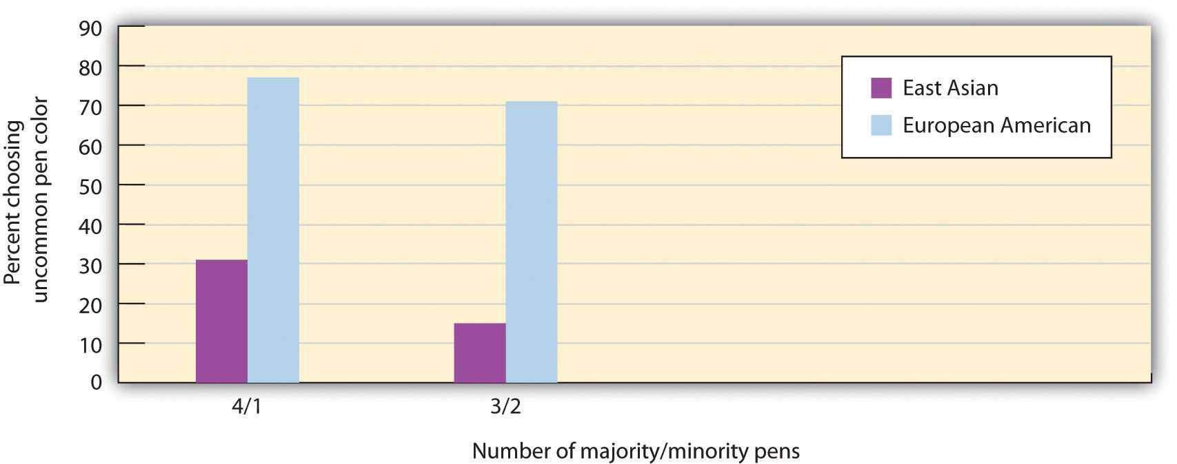
In this study, participants from European American and East Asian cultures were asked to choose a pen as a token of appreciation for completing a questionnaire. It was arranged such that there were either four pens of one color and one of another color or three pens of one color and two of another. European Americans were significantly more likely to choose the more uncommon pen color in both cases. Data are from Kim and Markus (1999, Experiment 3). ^{[23]}
Culture also influences behavior, through its influence on the self-concept. Western individualistic people generally use techniques of self-presentation to stand out and express themselves as better than others, whereas Eastern collectivistic individuals are more likely to gain status and self-esteem by trying to conform to the norms of the group and be good group members (Heine, 2005; Sedikides, Gaertner, & Toguchi, 2003). ^{[24]} Supporting the idea that people from Eastern cultures are less likely to need to self-enhance, Heine and Lehman (1999) ^{[25]} found that Japanese students were more critical of themselves and thus had larger discrepancies between their ideal selves and actual selves than did Canadian students, and yet at the same time, the Japanese students were less distressed by these discrepancies.

KEY TAKEAWAYS
- The self-concept and self-esteem are determined in large part through social comparison. We use social comparison to determine the accuracy and appropriateness of our thoughts, feelings, and behavior.
- When we are able to compare ourselves favorably with others through downward social comparison, we feel good about ourselves. Upward social comparison with others who are better or better off than we are leads to negative emotions.
- Social identity refers to the positive emotions that we experience as a member of an important social group.
- Normally, our group memberships result in positive feelings, which occur because we perceive our own groups, and thus ourselves, in a positive light.
- Which of our many category identities is most accessible for us will vary from day to day as a function of the particular situation we are in.
- We may enhance our self-esteem by “basking in the reflected glory” of our in-groups or of other people we know.
- Our culture has a profound influence on our self-concept, and it influences how we think about and relate to others.

EXERCISES AND CRITICAL THINKING
- Name some aspects of your self-concept that have been created through social comparison.
- Describe times when you have engaged in downward and upward social comparison and the effects these comparisons have had on your emotions.
- What are your social identities? How do they create positive feelings for you?

[1] Hardin, C., & Higgins, T. (1996). Shared reality: How social verification makes the subjective objective. In R. M. Sorrentino & E. T. Higgins (Eds.), Handbook of motivation and cognition: Foundations of social behavior (Vol. 3, pp. 28–84). New York, NY: Guilford Press.
[2] Buunk, A. P., & Gibbons, F. X. (2007). Social comparison: The end of a theory and the emergence of a field. Organizational Behavior and Human Decision Processes, 102(1), 3–21; Van Lange, P. A. M. (2008). Social comparison is basic to social psychology. American Journal of Psychology, 121(1), 169–172.
[3] Schachter, S. (1959). The psychology of affiliation. Stanford, CA: Stanford University Press.
[4] Kulik, J. A., Mahler, H. I. M., & Moore, P. J. (1996). Social comparison and affiliation under threat: Effects on recovery from major surgery. Journal of Personality and Social Psychology, 71(5), 967–979.
[5] Marsh, H. W., Kong, C.-K., & Hau, K-T. (2000). Longitudinal multilevel models of the big-fish-little-pond effect on academic self-concept: Counterbalancing contrast and reflected-glory effects in Hong Kong schools. Journal of Personality and Social Psychology, 78, 337–349.
[6] Morse, S., & Gergen, K. (1970). Social comparison, self-consistency, and the concept of self.Journal of Personality and Social Psychology, 16(1), 148–156.
[7] Buunk, A. P., Gibbons, F. X., & Visser, A. (2002). The relevance of social comparison processes for prevention and health care. Patient Education and Counseling, 47, 1–3.
[8] Blanton, H., Buunk, B. P., Gibbons, F. X., & Kuyper, H. (1999). When better-than-others compare upward: Choice of comparison and comparative evaluation as independent predictors of academic performance. Journal of Personality and Social Psychology, 76(3), 420–430; Vrugt, A., & Koenis, S. (2002). Perceived self-efficacy, personal goals, social comparison, and scientific productivity. Applied Psychology: An International Review, 51(4), 593–607.
[9] Collins, R. L. (2000). Among the better ones: Upward assimilation in social comparison. In J. Suls & L. Wheeler (Eds.), Handbook of social comparison (pp. 159–172). New York, NY: Kulwer Academic/Plenum.
[10] Snyder, C., Cheavens, J., & Sympson, S. (1997). Hope: An individual motive for social commerce. Group Dynamics: Theory, Research, and Practice, 1, 107–118.
[11] Higgins, E. T., Loeb, I., & Moretti, M. (Eds.). (1995). Self-discrepancies and developmental shifts in vulnerability: Life transitions in the regulatory significance of others. Rochester, NY: University of Rochester Press; Strauman, T. J., & Higgins, E. T. (1988). Self-discrepancies as predictors of vulnerability to distinct syndromes of chronic emotional distress. Journal of Personality, 56(4), 685–707.
[12] Hogg, M. A. (2003). Social identity. In M. R. Leary, J. P. Tangney, M. R. E. Leary, & J. P. E. Tangney (Eds.), Handbook of self and identity (pp. 462–479). New York, NY: Guilford Press; Oakes, P. J., Haslam, S. A., & Turner, J. C. (1994). Sterotyping and social reality. Oxford, England: Blackwell; Tajfel, H. (1981). Human groups and social categories: Studies in social psychology. Cambridge, England: Cambridge University Press.
[13] Luhtanen, R., & Crocker, J. (1992). A collective self-esteem scale: Self-evaluation of one’s social identity. Personality and Social Psychology Bulletin, 18, 302–318.
[14] Deaux, K., Reid, A., Mizrahi, K., & Ethier, K. A. (1995). Parameters of social identity.Journal of Personality and Social Psychology, 68(2), 280–291.
[15] Deaux, K., Reid, A., Mizrahi, K., & Ethier, K. A. (1995). Parameters of social identity.Journal of Personality and Social Psychology, 68(2), 280–291.
[16] Cialdini, R. B., Borden, R. J., Thorne, A., Walker, M. R., Freeman, S., & Sloan, L. R. (1976). Basking in reflected glory: Three (football) field studies. Journal of Personality and Social Psychology, 34, 366–374.
[17] Tesser, A. (1988). Toward a self-evaluation maintenance model of social behavior.Advances in Experimental Social Psychology, 21, 181–227.
[18] Tesser, A. (1988). Toward a self-evaluation maintenance model of social behavior.Advances in Experimental Social Psychology, 21, 181–227.
[19] Breakwell, G. M. (1993). Integrating paradigms, methodological implications. In G. M. Breakwell & D. V. Canter (Eds.), Empirical approaches to social representations (pp. 180–201). Oxford, England: Clarendon Press.
[20] Trafimow, D., Triandis, H. C., & Goto, S. G. (1991). Some tests of the distinction between the private self and the collective self. Journal of Personality and Social Psychology, 60(5), 649–655.
[21] Markus, H. R., Kitayama, S., & Heiman, R. J. (1996). Culture and “basic” psychological principles. In E. T. Higgins & A. W. Kruglanski (Eds.), Social psychology: Handbook of basic principles (pp. 857–913). New York, NY: Guilford Press; Smith, P. B., & Bond, M. H. (1999).Social psychology: Across cultures (2nd ed.). Needham Heights, MA: Allyn & Bacon.
[22] Kim, H., & Markus, H. (1999). Deviance or uniqueness, harmony or conformity: A cultural analysis. Journal of Personality and Social Psychology, 77, 785–800.
[23] Kim, H., & Markus, H. (1999). Deviance or uniqueness, harmony or conformity: A cultural analysis. Journal of Personality and Social Psychology, 77, 785–800.
[24] Heine, S. J. (2005). Where is the evidence for pancultural self-enhancement? A reply to Sedikides, Gaertner, and Toguchi (2003). Journal of Personality and Social Psychology, 89(4), 531–538; Sedikides, C., Gaertner, L., & Toguchi, Y. (2003). Pancultural self-enhancement.Journal of Personality and Social Psychology, 84(1), 60–79.
[25] Heine, S. J., & Lehman, D. R. (1999). Culture, self-discrepancies, and self-satisfaction.Personality and Social Psychology Bulletin, 25(8), 915–925.

4.4 Thinking Like a Social Psychologist About the Self
Social psychologists think about the self in the same way that they think about any other social phenomenon—in terms of affect, behavior, and cognition, and in terms of the person-situation interaction. Our focus in this chapter has been on the cognitive, affective, and behavioral aspects of the self and on the remarkable extent to which our selves are created by the social situation in which we find ourselves.
Take a moment and use this new knowledge about how social psychologists think about the self to consider your own self. Think carefully (and as fairly as you can) about how you think and feel about yourself. What constructs did you list when you tried the Twenty Statements Test in Section 4.1 "The Cognitive Self: The Self-Concept"? Which of your physical characteristics were most accessible for you? And what about your social identities and your traits? Do you now have a better insight into the characteristics that are most important to you?
Now consider the complexity of your-self-concept. Do you think it would be better if it were more complex? Do you think you should seek out more dimensions to round it out? Or perhaps you feel that you already have a healthy and complex self-concept. In any case, you might want to keep this concept in mind as you think about yourself in the future.
And what about your relations with the social groups you belong to? Do you derive a lot of your self-esteem from your group memberships? Which groups provide you with social identities, and are there group memberships that may potentially not provide you with high social identity?
Self-esteem is one of the most important aspects of the self. Do you have high or low self-esteem? What about other people whom you know—does their level of self-esteem influence how you relate to them? And how do the aspects of your own self help (or potentially harm) your relations with others?
Finally, take a moment and consider Matt Harding again. What do you think he thinks about when he dances, and what emotions is he feeling? Why do you think he continues to engage others as he does?
In sum, the self is the fundamental part of human psychology and will form the basis of all our analyses of social behavior.

4.5 Chapter Summary
The many and varied thoughts that we have about ourselves are stored in the variety of self-schemas that make up the cognitive part of the self—the self-concept. The self-concept is the most complex of all our schemas because it includes all of the images, desires, beliefs, feelings, and hopes that we have for and about ourselves.
The self-concept can be measured by simply asking people to list the things that come to mind when they think about themselves or by using other techniques such as asking people to remember information related to the self. Research has found that some people have more complex selves than others do and that having a variety of self-schemas is useful because the various aspects of the self help to improve our responses to the events that we experience.
The self-concept can vary in its current accessibility. When the self-concept is highly accessible and therefore becomes the focus of our attention, the outcome is known as self-awareness or self-consciousness. Private self-consciousness occurs when we introspect about our inner thoughts and feelings, whereas public self-consciousness occurs when we focus on our public image. It is important to be aware of variation in the accessibility of the various aspects of the self-concept because the changes in our thoughts about the self have an important influence on our behavior.
Self-esteem refers to the positive (high self-esteem) or negative (low self-esteem) evaluations that we make of ourselves. When we feel that we are viewed positively and held in esteem by others, we say that we have high social status. Having high social status creates positive self-esteem. The tendency to attempt to present a positive image to others and thereby attempt to increase our social status is known as self-presentation, and it is a basic and natural part of everyday life. Some people are high self-monitors, more able and willing to self-present than are other people.
The desire to see ourselves positively leads us to seek out, process, and remember information in a way that allows us to see ourselves even more positively. However, although the desire to self-enhance is a powerful motive, increases in self-esteem do not necessarily make us better or more effective people. An effective life involves an appropriate balance between the feeling and the cognitive parts of the self: We must always take into consideration not only the positivity of our self-views but also the accuracy of our self-characterizations and the strength of our relationships with others.
Although we learn about ourselves in part by examining our own behaviors, the self-concept and self-esteem are also determined through our interactions with others. Social comparison occurs when we learn about our abilities and skills, about the appropriateness and validity of our opinions, and about our relative social status by comparing our own attitudes, beliefs, and behaviors with those of others.
We use downward social comparison to create a positive image of ourselves through favorable comparisons with others who are worse off than we are. Through upward social comparison, we compare ourselves with others who are better off than we are. In some cases, we can bask in the reflected glory of others that we care about, but in other cases, upward comparison makes us feel inadequate. An important aspect of the self-concept that is derived from our social experiences is our social identity, which is derived from our membership in social groups and our attachments to those groups
There are cultural differences in the self. Individuals from Western cultures are more likely to make positive statements about themselves, whereas those from Eastern cultures are more likely to make positive statements about others.

Chapter 5

Attitudes, Behavior, and Persuasion

How the Obama Campaign Effectively Used Persuasion to Defeat John McCain
In ads and speeches, President Barack Obama’s 2008 presidential campaign used a variety of persuasion techniques, many based on principles of social psychology. The campaign’s outcome was that millions of voters joined Obama’s team and helped him defeat his opponent, Senator John McCain. Many of the “Obama for America” ads were online, in stark contrast to the more traditional media used by the McCain campaign.
Obama’s campaign used a range of techniques, including cognitive and emotional persuasive appeals and attitude inoculation. The campaign focused in part on self-interest, trying to reach voters who were feeling the pinch of high gas prices. In some of the online ads, Senator McCain was pictured next to a list of high gas station prices while a fuel pump moved across the ad. The idea was that Obama would be seen as a clean candidate promoting clean energy while McCain was labeled as accepting contributions from the oil industry.
Obama also tapped into the strong human desire for other-concern. In his speeches he talked about being part of an important group that would make a difference, thereby creating strong social identity and positive emotions. Examples were his use of slogans such as “Yes We Can,” “We Believe,” and “Join Us.”
Obama also made use of attitude inoculation, a technique in which he warned his supporters that an ad attacking him would be coming, at the same time reminding them of ways to counterargue the ad. Obama argued, for instance, “What they're going to try to do is make you scared of me. They’ll say ‘He's not patriotic enough, he's got a funny name…he’s young and inexperienced.” Obama hoped that people would be motivated to discount these messages when they came from McCain.
The techniques that were used by the Obama team are not unique—they are used by most contemporary advertisers, and also by attorneys, negotiators, corporate executives, and anyone else who wants to be an effective persuader—but they were masterfully employed by “Obama for America.”
Sources: Whitman, D. E. (2010). Cashvertising. Career Press; Kaye, Kate (2008).Obama targets Pennsylvania voters with pure persuasion ads. Personal Democracy Forum. Retrieved from http://techpresident.com/blog-entry/obama-targets-pennsylvania-voters-pure-persuasion-ads.
One of the most central concepts in social psychology is that of attitudes (Banaji & Heiphetz, 2010). ^{[1]} In this chapter we will focus on attitude formation, attitude change, and the influence of attitudes on behavior. We will see that attitudes are an essential component of our lives because they play a vital role in helping us effectively interact with our environment. Our attitudes allow us to make judgments about events (“I hate waiting in traffic”), people (“I really like Barack Obama”), social groups (“I love the University of Maryland”), and many other things.
We will begin our discussion by looking at how attitudes are defined by the ABCs of social psychology—affect, behavior, and cognition—noting that some attitudes are more affective in nature, some more cognitive in nature, and some more behavioral in nature. We will see that attitudes vary in terms of their strength such that some attitudes are stronger and some are weaker. And we will see that the strength of our attitudes is one of the determinants of when our attitudes successfully predict our behaviors.
Then we will explore how attitudes can be created and changed—the basic stuff of persuasion, advertising, and marketing. We will look at which types ofcommunicators can deliver the most effective messages to which types of message recipients. And we will see that the same message can be more effective for different people in different social situations. We will see that persuasive messages may be processed either spontaneously (that is, in a rather cursory or superficial way) orthoughtfully (with more cognitive elaboration of the message) and that the amount and persistence of persuasion will vary on the processing route that we use. Most generally, we will see that persuasion is effective when the communication resonates with the message recipient’s motivations, desires, and goals (Kruglanski & Stroebe, 2005). ^{[2]}
Because the ABCs of social psychology tend to be consistent, persuasive appeals that change our thoughts and feelings will be effective in changing our behavior as well. This attitude consistency means that if I make you think and feel more positively about my product, then you will be more likely to buy it. And if I can make you think and feel more positively about my political candidate, then you will be more likely to vote for him or her.
But attitude consistency works in the other direction too, such that when our behaviors change, our thoughts and beliefs about the attitude object may also change. Once we vote for a candidate or buy a product, we will find even more things to like about them, and our attitudes toward them will become even more positive. Although this possibility is less intuitive and therefore may seem more surprising, it also follows from the basic consistencies among affect, cognition, and behavior. We will discuss two theories—self-perception theory and cognitive dissonance theory—each of which makes this prediction but for different reasons.

[1] Banaji, M. R., & Heiphetz, L. (2010). Attitudes. In S. T. Fiske, D. T. Gilbert, & G. Lindzey (Eds.), Handbook of social psychology (5th ed., Vol. 1, pp. 353–393). Hoboken, NJ: John Wiley & Sons.
[2] Kruglanski, A. W., & Stroebe, W. (2005). The influence of beliefs and goals on attitudes: Issues of structure, function, and dynamics. In D. Albarracín, B. T. Johnson, & M. P. Zanna (Eds.), The handbook of attitudes (pp. 323–368). Mahwah, NJ: Lawrence Erlbaum.

5.1 Exploring Attitudes

LEARNING OBJECTIVES
- Define the concept of attitude and explain why it is of such interest to social psychologists.
- Review the variables that determine attitude strength.
- Outline the factors affect the strength of the attitude-behavior relationship.
Although we might use the term in a different way in our everyday life (“Hey, he's really got an attitude!”), social psychologists reserve the term attitude to refer to ourrelatively enduring evaluation of something, where the something is called theattitude object. The attitude object might be a person, a product, or a social group (Albarracín, Johnson, & Zanna, 2005; Wood, 2000). ^{[1]} In this section we will consider the nature and strength of attitudes and the conditions under which attitudes best predict our behaviors.

Attitudes Are Evaluations
When we say that attitudes are evaluations, we mean that they involve a preference for or against the attitude object, as commonly expressed in such terms as prefer, like,dislike, hate, and love. When we express our attitudes—for instance, when we say, “I love Cheerios,” “I hate snakes,” “I'm crazy about Bill,” or “I like Italians”—we are expressing the relationship (either positive or negative) between the self and an attitude object. Statements such as these make it clear that attitudes are an important part of the self-concept—attitudes tie the self-concept to the attitude object, and so our attitudes are an essential part of “us.”
Every human being holds thousands of attitudes, including those about family and friends, political parties and political figures, abortion rights and terrorism, preferences for music, and much more. Each of our attitudes has its own unique characteristics, and no two attitudes come to us or influence us in quite the same way. Research has found that some of our attitudes are inherited, at least in part, via genetic transmission from our parents (Olson, Vernon, Harris, & Jang, 2001). ^{[2]} Other attitudes are learned mostly through direct and indirect experiences with the attitude objects (De Houwer, Thomas, & Baeyens, 2001). ^{[3]} We may like to ride roller coasters in part because our genetic code has given us a thrill-loving personality and in part because we’ve had some really great times on roller coasters in the past. Still other attitudes are learned via the media (Hargreaves & Tiggemann, 2003; Levina, Waldo, & Fitzgerald, 2000) ^{[4]} or through our interactions with friends (Poteat, 2007). ^{[5]} Some of our attitudes are shared by others (most of us like sugar, fear snakes, and are disgusted by cockroaches), whereas other attitudes—such as our preferences for different styles of music or art—are more individualized.
Table 5.1 "Heritability of Some Attitudes" shows some of the attitudes that have been found to be the most highly heritable (i.e. most strongly determined by genetic variation among people). These attitudes form earlier and are stronger and more resistant to change than others (Bourgeois, 2002), ^{[6]} although it is not yet known why some attitudes are more genetically determined than are others.

Table 5.1 Heritability of Some Attitudes
Attitude | Heritability
Abortion on demand | 0.54
Roller coaster rides | 0.52
Death penalty for murder | 0.5
Open-door immigration | 0.46
Organized religion | 0.45
Doing athletic activities | 0.44
Voluntary euthanasia | 0.44
Capitalism | 0.39
Playing chess | 0.38
Reading books | 0.37
Exercising | 0.36
Education | 0.32
Big parties | 0.32
Smoking | 0.31
Being the center of attention | 0.28
Getting along well with other people | 0.28
Wearing clothes that draw attention | 0.24
Sweets | 0.22
Public speaking | 0.2
Castration as punishment for sex crimes | 0.17
Loud music | 0.11
Looking my best at all times | 0.1
Doing crossword puzzles | 0.02
Separate roles for men and women | 0
Making racial discrimination illegal | 0
Playing organized sports | 0
Playing bingo | 0
Easy access to birth control | 0
Being the leader of groups | 0
Being assertive | 0
Ranked from most heritable to least heritable. Data are from Olson, Vernon, Harris, and Jang (2001). ^{[7]}
Our attitudes are made up of cognitive, affective, and behavioral components. Consider my own attitude toward chocolate ice cream, which is very positive and always has been, as far as I can remember.
In terms of affect:
I LOVE it!

In terms of behavior:
I frequently eat chocolate ice cream.

In terms of cognitions:
Chocolate ice cream has a smooth texture and a rich, strong taste.
My attitude toward chocolate ice cream is composed of affect, behavior, and cognition.
Although most attitudes are determined by cognition, affect, and behavior, there is nevertheless variability in this regard across people and across attitudes. Some attitudes are more likely to be based on beliefs, some more likely to be based on feelings, and some more likely to be based on behaviors. I would say that my attitude toward chocolate ice cream is in large part determined by affect—although I can describe its taste, mostly I just like it. My attitudes toward my Toyota Corolla and my home air conditioner, on the other hand, are more cognitive. I don't really like them so much as I admire their positive features (the Toyota gets good gas mileage and the air conditioner keeps me cool on hot summer days). Still other of my attitudes are based more on behavior—I feel like I’ve learned to like my neighbors because I’ve done favors for them over the years (which they have returned) and these helpful behaviors on my part have, at least in part, led me to develop a positive attitude toward them.
Different people may hold attitudes toward the same attitude object for different reasons. Some people voted for Barack Obama in the 2008 elections because they like his policies (“he's working for the middle class”; “he wants to increase automobile fuel efficiency”), whereas others voted for (or against) him because they just liked (or disliked) him. Although you might think that cognition would be more important in this regard, political scientists have shown that many voting decisions are made primarily on the basis of affect. Indeed, it is fair to say that the affective component of attitudes is generally the strongest and most important (Abelson, Kinder, Peters, & Fiske, 1981; Stangor, Sullivan, & Ford, 1991). ^{[8]}
Human beings hold attitudes because they are useful. Particularly, our attitudes enable us to determine, often very quickly and effortlessly, which behaviors to engage in, which people to approach or avoid, and even which products to buy (Duckworth, Bargh, Garcia, & Chaiken, 2002; Maio & Olson, 2000). ^{[9]} You can imagine that making quick decisions about what to avoid
snake = bad ⟶ run away
or to approach
blueberries = good ⟶ eat
has had substantial value in our evolutionary experience.
Because attitudes are evaluations, they can be assessed using any of the normal measuring techniques used by social psychologists (Banaji & Heiphetz, 2010). ^{[10]}Attitudes are frequently assessed using self-report measures, but they can also be assessed more indirectly using measures of arousal and facial expressions (Mendes, 2008) ^{[11]} as well as implicit measures of cognition, such as the Implicit Association Test (IAT). Attitudes can also be seen in the brain by using neuroimaging techniques. This research has found that our attitudes, like most of our social knowledge, are stored primarily in the prefrontal cortex but that the amygdala is important in emotional attitudes, particularly those associated with fear (Cunningham, Raye, & Johnson, 2004; Cunningham & Zelazo, 2007; van den Bos, McClure, Harris, Fiske, & Cohen, 2007). ^{[12]} Attitudes can be activated extremely quickly—often within one fifth of a second after we see an attitude object (Handy, Smilek, Geiger, Liu, & Schooler, 2010). ^{[13]}

Some Attitudes Are Stronger Than Others
Some attitudes are more important than others, because they are more useful to us and thus have more impact on our daily lives. The importance of an attitude, as assessed by how quickly it comes to mind, is known as attitude strength (Fazio, 1990; Fazio, 1995; Krosnick & Petty, 1995). ^{[14]} Some of our attitudes are strong attitudes, in the sense that we find them important, hold them with confidence, do not change them very much, and use them frequently to guide our actions. These strong attitudes may guide our actions completely out of our awareness (Ferguson, Bargh, & Nayak, 2005).^{[15]}
Other attitudes are weaker and have little influence on our actions. For instance, John Bargh and his colleagues (Bargh, Chaiken, Raymond, & Hymes, 1996) ^{[16]} found that people could express attitudes toward nonsense words such as juvalamu (which people liked) and chakaka (which they did not like). The researchers also found that these attitudes were very weak. On the other hand, the heavy voter turnout for Barack Obama in the 2008 elections was probably because many of his supporters had strong positive attitudes about him.
Strong attitudes are attitudes that are more cognitively accessible—they come to mind quickly, regularly, and easily. We can easily measure attitude strength by assessing how quickly our attitudes are activated when we are exposed to the attitude object. If we can state our attitude quickly, without much thought, then it is a strong one. If we are unsure about our attitude and need to think about it for a while before stating our opinion, the attitude is weak.
Attitudes become stronger when we have direct positive or negative experiences with the attitude object, and particularly if those experiences have been in strong positive or negative contexts. Russell Fazio and his colleagues (Fazio, Powell, & Herr, 1983) ^{[17]}had people either work on some puzzles or watch other people work on the same puzzles. Although the people who watched ended up either liking or disliking the puzzles as much as the people who actually worked on them, Fazio found that attitudes, as assessed by reaction time measures, were stronger (in the sense of being expressed quickly) for the people who had directly experienced the puzzles.
Because attitude strength is determined by cognitive accessibility, it is possible to make attitudes stronger by increasing the accessibility of the attitude. This can be done directly by having people think about, express, or discuss their attitudes with others. After people think about their attitudes, talk about them, or just say them out loud, the attitudes they have expressed become stronger (Downing, Judd, & Brauer, 1992; Tesser, Martin, & Mendolia, 1995). ^{[18]} Because attitudes are linked to the self-concept, they also become stronger when they are activated along with the self-concept. When we are looking into a mirror or sitting in front of a TV camera, our attitudes are activated and we are then more likely to act on them (Beaman, Klentz, Diener, & Svanum, 1979). ^{[19]}
Attitudes are also stronger when the ABCs of affect, behavior, and cognition all line up. As an example, many people’s attitude toward their own nation is universally positive. They have strong positive feelings about their country, many positive thoughts about it, and tend to engage in behaviors that support it. Other attitudes are less strong because the affective, cognitive, and behavioral components are each somewhat different (Thompson, Zanna, & Griffin, 1995). ^{[20]} My affect toward chocolate ice cream is positive—I like it a lot. On the other hand, my cognitions are more negative—I know that eating too much ice cream can make me fat and that it is bad for my coronary arteries. And even though I love chocolate ice cream, I don’t eat some every time I get a chance. These inconsistencies among the components of my attitude make it less strong than it would be if all the components lined up together.

When Do Our Attitudes Guide Our Behavior?
Social psychologists (as well as advertisers, marketers, and politicians) are particularly interested in the behavioral aspect of attitudes. Because it is normal that the ABCs of our attitudes are at least somewhat consistent, our behavior tends to follow from our affect and cognition. If I determine that you have more positive cognitions about and more positive affect toward Cheerios than Frosted Flakes, then I will naturally predict (and probably be correct when I do so) that you’ll be more likely to buy Cheerios than Frosted Flakes when you go to the market. Furthermore, if I can do something to make your thoughts or feelings toward Frosted Flakes more positive, then your likelihood of buying that cereal instead of the other will also increase.
The principle of attitude consistency (that for any given attitude object, the ABCs of affect, behavior, and cognition are normally in line with each other) thus predicts that our attitudes (for instance, as measured via a self-report measure) are likely toguide behavior. Supporting this idea, meta-analyses have found that there is a significant and substantial positive correlation among the different components of attitudes, and that attitudes expressed on self-report measures do predict behavior (Glasman & Albarracín, 2006). ^{[21]}
Although there is generally consistency between attitudes and behavior, the relationship is stronger in certain situations, for certain people, and for certain attitudes (Wicker, 1969). ^{[22]} The theory of planned behavior, developed by Martin Fishbein and Izek Ajzen (Ajzen, 1991; Fishbein & Ajzen, 1975), ^{[23]} outlined many of the important variables that affected the attitude-behavior relationship, and some of these factors are summarized in the list that follows this paragraph. It may not surprise you to hear that attitudes that are strong, in the sense that they are expressed quickly and confidently, predict our behavior better than do weak attitudes (Fazio, Powell, & Williams, 1989; Glasman & Albarracín, 2006). ^{[24]} For example, Farc and Sagarin (2009) ^{[25]} found that people who could more quickly complete questionnaires about their attitudes toward the politicians George Bush and John Kerry were also more likely to vote for the candidate that they had more positive attitudes toward in the 2004 presidential elections. The relationship between the responses on the questionnaires and voting behavior was weaker for those who completed the items more slowly.
- When attitudes are strong, rather than weak
- When we have a strong intention to perform the behavior
- When the attitude and the behavior both occur in similar social situations
- When the same components of the attitude (either affect or cognition) are accessible when the attitude is assessed and when the behavior is performed
- When the attitudes are measured at a specific, rather than a general, level
- For low self-monitors (rather than for high self-monitors)
Attitudes only predict behaviors well under certain conditions and for some people. The preceding list summarizes the factors that create a strong attitude-behavior relationship.
People who have strong attitudes toward an attitude object are also likely to have strong intentions to act on their attitudes, and the intention to engage in an activity is a strong predictor of behavior (Fishbein & Ajzen, 1975). ^{[26]} Imagine for a moment that your friend Sharina is trying to decide whether to recycle her used laptop batteries or just throw them away. We know that her attitude toward recycling is positive—she thinks she should do it—but we also know that recycling takes work. It’s much easier to just throw the batteries away. Only if Sharina has a strong attitude toward recycling will she then have the necessary strong intentions to engage in the behavior that will make her recycle her batteries even when it is difficult to do.
The match between the social situations in which the attitudes are expressed and the behaviors are engaged in also matters, such that there is a greater attitude-behavior correlation when the social situations match. Imagine for a minute the case of Magritte, a 16-year-old high school student. Magritte tells her parents that she hates the idea of smoking cigarettes. Magritte’s negative attitude toward smoking seems to be a strong one because she’s thought a lot about it—she believes that cigarettes are dirty, expensive, and unhealthy. But how sure are you that Magritte’s attitude will predict her behavior? Would you be willing to bet that she’d never try smoking when she’s out with her friends?
You can see that the problem here is that Magritte’s attitude is being expressed in one social situation (when she is with her parents) whereas the behavior (trying a cigarette) is going to occur in a very different social situation (when she is out with her friends). The relevant social norms are of course much different in the two situations. Magritte’s friends might be able to convince her to try smoking, despite her initial negative attitude, when they entice her with peer pressure. Behaviors are more likely to be consistent with attitudes when the social situation in which the behavior occurs is similar to the situation in which the attitude is expressed (Ajzen, 1991; LaPiere, 1936).^{[27]}

Research Focus
Attitude-Behavior Consistency
Another variable that has an important influence on attitude-behavior consistency is the current cognitive accessibility of the underlying affective and cognitive components of the attitude. For example, if we assess the attitude in a situation in which people are thinking primarily about the attitude object in cognitive terms, and yet the behavior is performed in a situation in which the affective components of the attitude are more accessible, then the attitude-behavior relationship will be weak. Wilson and Schooler (1991) ^{[28]} showed a similar type of effect by first choosing attitudes that they expected would be primarily determined by affect—attitudes toward five different types of strawberry jam. Then they asked a sample of college students to taste each of the jams. While they were tasting, one-half of the participants were instructed to think about the cognitive aspects of their attitudes to these jams—that is, to focus on the reasons they held their attitudes, whereas the other half of the participants were not given these instructions. Then all the students completed measures of their attitudes toward each of the jams.
Wilson and his colleagues then assessed the extent to which the attitudes expressed by the students correlated with taste ratings of the five jams as indicated by experts at Consumer Reports. They found that the attitudes expressed by the students correlated significantly higher with the expert ratings for the participants who had not listed their cognitions first. Wilson and his colleagues argued that this occurred because our liking of jams is primarily affectively determined—we either like them or we don’t. And the students who simply rated the jams used their feelings to make their judgments. On the other hand, the students who were asked to list their thoughts about the jams had some extra information to use in making their judgments, but it was information that was not actually useful. Therefore, when these students used their thoughts about the jam to make the judgments, their judgments were less valid.
MacDonald, Zanna, and Fong (1996) ^{[29]} showed male college students a video of two other college students, Mike and Rebecca, who were out on a date. However, according to random assignment to conditions, half of the men were shown the video while sober and the other half viewed the video after they had had several alcoholic drinks. In the video, Mike and Rebecca go to the campus bar and drink and dance. They then go to Rebecca’s room, where they end up kissing passionately. Mike says that he doesn’t have any condoms, but Rebecca says that she is on the pill.
At this point the film clip ends, and the male participants are asked about their likely behaviors if they had been Mike. Although all men indicated that having unprotected sex in this situation was foolish and irresponsible, the men who had been drinking alcohol were more likely to indicate that they would engage in sexual intercourse with Rebecca even without a condom. One interpretation of this study is that sexual behavior is determined by both cognitive factors (“I know that it is important to practice safe sex and so I should use a condom”) and affective factors (“sex is enjoyable, I don’t want to wait”). When the students were intoxicated at the time the behavior was to be performed, it seems likely the affective component of the attitude was a more important determinant of behavior than was the cognitive component.
One other type of “match” that has an important influence on the attitude-behavior relationship concerns how we measure the attitude and behavior. Attitudes predict behavior better when the attitude is measured at a level that is similar to the behavior to be predicted. Normally, the behavior is specific, so it is better to measure the attitude at a specific level too. For instance, if we measure cognitions at a very general level (“do you think it is important to use condoms?”; “are you a religious person?”) we will not be as successful at predicting actual behaviors as we will be if we ask the question more specifically, at the level of behavior we are interested in predicting (“do you think you will use a condom the next time you have sex?”; “how frequently do you expect to attend church in the next month?”). In general, more specific questions are better predictors of specific behaviors, and thus if we wish to accurately predict behaviors, we should remember to attempt to measure specific attitudes. One example of this principle is shown in Figure 5.1 "Predicting Behavior From Specific and Nonspecific Attitude Measures". Davidson and Jaccard (1979) ^{[30]} found that they were much better able to predict whether women actually used birth control when they assessed the attitude at a more specific level.

Figure 5.1 Predicting Behavior From Specific and Nonspecific Attitude Measures
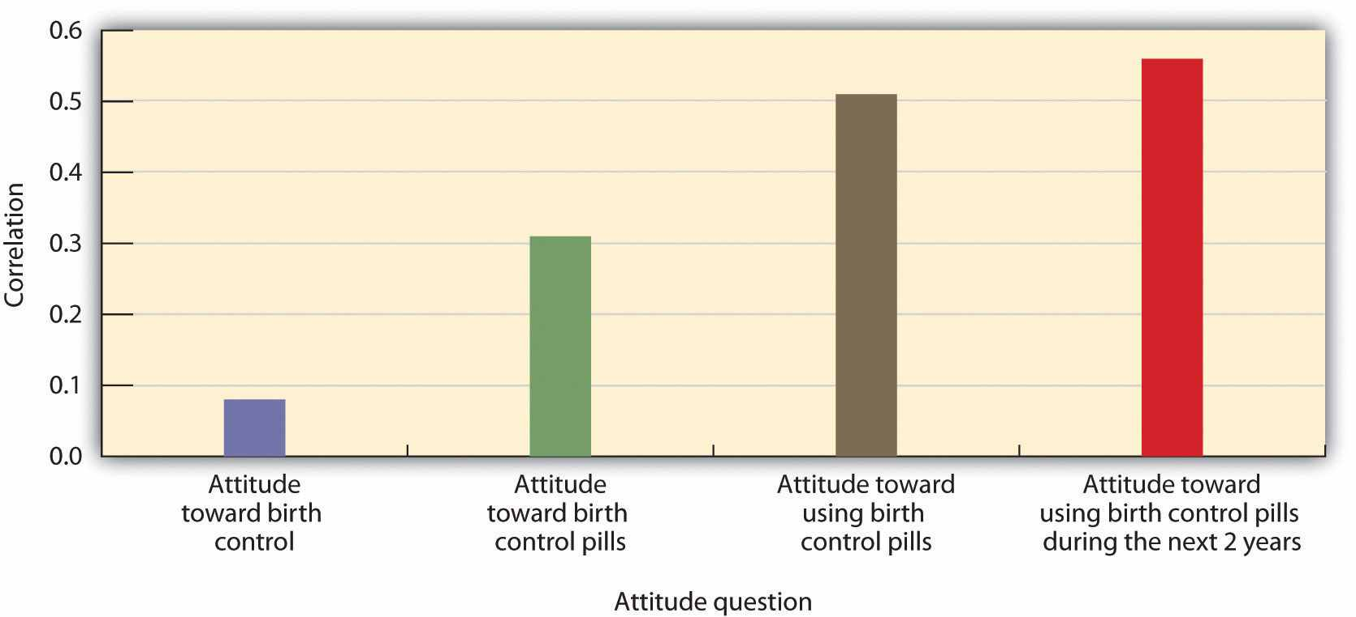
Attitudes that are measured using more specific questions are more highly correlated with behavior than are attitudes measured using less specific questions. Data are from Davidson and Jaccard (1979). ^{[31]}
Attitudes also predict behavior better for some people than for others. Self-monitoringrefers to individual differences in the tendency to attend to social cues and to adjust one’s behavior to one’s social environment. To return to our example of Magritte, you might wonder whether she is the type of person who is likely to be persuaded by peer pressure because she is particularly concerned with being liked by others. If she is, then she’s probably more likely to want to fit in with whatever her friends are doing, and she might try a cigarette if her friends offer her one. On the other hand, if Magritte is not particularly concerned about following the social norms of her friends, then she’ll more likely be able to resist the persuasion. High self-monitors are those who tend to attempt to blend into the social situation in order to be liked; low self-monitorsare those who are less likely to do so. You can see that, because they allow the social situation to influence their behaviors, the relationship between attitudes and behavior will be weaker for high self-monitors than it is for low self-monitors (Kraus, 1995).^{[32]}

KEY TAKEAWAYS
- The term attitude refers to our relatively enduring evaluation of an attitude object.
- Our attitudes are inherited and also learned through direct and indirect experiences with the attitude objects.
- Some attitudes are more likely to be based on beliefs, some more likely to be based on feelings, and some more likely to be based on behaviors.
- Strong attitudes are important in the sense that we hold them with confidence, we do not change them very much, and we use them frequently to guide our actions.
- Although there is a general consistency between attitudes and behavior, the relationship is stronger in some situations than in others, for some measurements than for others, and for some people than for others.

EXERCISES AND CRITICAL THINKING
- Consider some of your attitudes toward people, products, or other attitude objects. Are your attitudes strong or weak? Are they determined more by affect or by cognition? How do the attitudes influence your behavior?
- Consider a time when you acted on your own attitudes and a time when you did not act on your own attitudes. What factors do you think determined the difference?

[1] Albarracín, D., Johnson, B. T., & Zanna, M. P. (Eds.). (2005). The handbook of attitudes(pp. 223–271). Mahwah, NJ: Lawrence Erlbaum; Wood, W. (2000). Attitude change: Persuasion and social influence. Annual Review of Psychology, 539–570.
[2] Olson, J. M., Vernon, P. A., Harris, J. A., & Jang, K. L. (2001). The heritability of attitudes: A study of twins. Journal of Personality and Social Psychology, 80(6), 845–860.
[3] De Houwer, J., Thomas, S., & Baeyens, F. (2001). Association learning of likes and dislikes: A review of 25 years of research on human evaluative conditioning. Psychological Bulletin, 127(6), 853–869.
[4] Levina, M., Waldo, C. R., & Fitzgerald, L. F. (2000). We’re here, we’re queer, we’re on TV: The effects of visual media on heterosexuals’ attitudes toward gay men and lesbians. Journal of Applied Social Psychology, 30(4), 738–758; Hargreaves, D. A., & Tiggemann, M. (2003). Female “thin ideal” media images and boys’ attitudes toward girls. Sex Roles, 49(9–10), 539–544.
[5] Poteat, V. P. (2007). Peer group socialization of homophobic attitudes and behavior during adolescence. Child Development, 78(6), 1830–1842.
[6] Bourgeois, M. J. (2002). Heritability of attitudes constrains dynamic social impact.Personality and Social Psychology Bulletin, 28(8), 1063–1072.
[7] Olson, J. M., Vernon, P. A., Harris, J. A., & Jang, K. L. (2001). The heritability of attitudes: A study of twins. Journal of Personality and Social Psychology, 80(6), 845–860.
[8] Abelson, R. P., Kinder, D. R., Peters, M. D., & Fiske, S. T. (1981). Affective and semantic components in political person perception. Journal of Personality and Social Psychology, 42, 619–630; Stangor, C., Sullivan, L. A., & Ford, T. E. (1991). Affective and cognitive determinants of prejudice. Social Cognition, 9(4), 359–380.
[9] Duckworth, K. L., Bargh, J. A., Garcia, M., & Chaiken, S. (2002). The automatic evaluation of novel stimuli. Psychological Science, 13(6), 513–519; Maio, G. R., & Olson, J. M. (Eds.). (2000).Why we evaluate: Functions of attitudes. Mahwah, NJ: Lawrence Erlbaum.
[10] Banaji, M. R., & Heiphetz, L. (2010). Attitudes. In S. T. Fiske, D. T. Gilbert, & G. Lindzey (Eds.), Handbook of social psychology (5th ed., Vol. 1, pp. 353–393). Hoboken, NJ: John Wiley & Sons.
[11] Mendes, W. B. (2008). Assessing autonomic nervous system reactivity. In E. Harmon-Jones & J. Beer (Eds.), Methods in the neurobiology of social and personality psychology (pp. 118–147). New York, NY: Guilford Press.
[12] Cunningham, W. A., Raye, C. L., & Johnson, M. K. (2004). Implicit and explicit evaluation: fMRI correlates of valence, emotional intensity, and control in the processing of attitudes.Journal of Cognitive Neuroscience, 16(10), 1717–1729; Cunningham, W. A., & Zelazo, P. D. (2007). Attitudes and evaluations: A social cognitive neuroscience perspective. Trends in Cognitive Sciences, 11(3), 97–104; van den Bos, W., McClure, S. M., Harris, L. T., Fiske, S. T., & Cohen, J. D. (2007). Dissociating affective evaluation and social cognitive processes in the ventral medial prefrontal cortex. Cognitive, Affective & Behavioral Neuroscience, 7(4), 337–346.
[13] Handy, T. C., Smilek, D., Geiger, L., Liu, C., & Schooler, J. W. (2010). ERP evidence for rapid hedonic evaluation of logos. Journal of Cognitive Neuroscience, 22(1), 124–138. doi: 10.1162/jocn.2008.21180
[14] Fazio, R. H. (1990). The MODE model as an integrative framework. Advances in Experimental Social Psychology, 23, 75–109; Fazio, R. H. (1995). Attitudes as object-evaluation associations: Determinants, consequences, and correlates of attitude accessibility. In Attitude strength: Antecedents and consequences (pp. 247–282). Hillsdale, NJ: Lawrence Erlbaum; Krosnick, J. A., & Petty, R. E. (1995). Attitude strength: An overview. In Attitude strength: Antecedents and consequences (pp. 1–24). Hillsdale, NJ: Lawrence Erlbaum.
[15] Ferguson, M. J., Bargh, J. A., & Nayak, D. A. (2005). After-affects: How automatic evaluations influence the interpretation of subsequent, unrelated stimuli. Journal of Experimental Social Psychology, 41(2), 182–191. doi: 10.1016/j.jesp.2004.05.008
[16] Bargh, J. A., Chaiken, S., Raymond, P., & Hymes, C. (1996). The automatic evaluation effect: Unconditional automatic attitude activation with a pronunciation task. Journal of Experimental Social Psychology, 32(1), 104–128.
[17] Fazio, R. H., Powell, M. C., & Herr, P. M. (1983). Toward a process model of the attitude-behavior relation: Accessing one’s attitude upon mere observation of the attitude object.Journal of Personality and Social Psychology, 44(4), 723–735.
[18] Downing, J. W., Judd, C. M., & Brauer, M. (1992). Effects of repeated expressions on attitude extremity. Journal of Personality and Social Psychology, 63(1), 17–29; Tesser, A., Martin, L., & Mendolia, M. (Eds.). (1995). The impact of thought on attitude extremity and attitude-behavior consistency. Hillsdale, NJ: Lawrence Erlbaum.
[19] Beaman, A. L., Klentz, B., Diener, E., & Svanum, S. (1979). Self-awareness and transgression in children: Two field studies. Journal of Personality and Social Psychology, 37(10), 1835–1846.
[20] Thompson, M. M., Zanna, M. P., & Griffin, D. W. (1995). Let’s not be indifferent about (attitudinal) ambivalence. In Attitude strength: Antecedents and consequences (pp. 361–386). Hillsdale, NJ: Lawrence Erlbaum.
[21] Glasman, L. R., & Albarracín, D. (2006). Forming attitudes that predict future behavior: A meta-analysis of the attitude-behavior relation. Psychological Bulletin, 132(5), 778–822.
[22] Wicker, A. W. (1969). Attitudes versus actions: The relationship of verbal and overt behavioral responses to attitude objects. Journal of Social Issues, 25(4), 41–78.
[23] Ajzen, I. (1991). The theory of planned behavior. Organizational Behavior and Human Decision Processes, 50(2), 179–211; Fishbein, M., & Ajzen, I. (1975). Belief, attitude, intention and behavior: An introduction to theory and research. Reading, MA: Addison-Wesley.
[24] Fazio, R. H., Powell, M. C., & Williams, C. J. (1989). The role of attitude accessibility in the attitude-to-behavior process. Journal of Consumer Research, 16(3), 280–288; Glasman, L. R., & Albarracín, D. (2006). Forming attitudes that predict future behavior: A meta-analysis of the attitude-behavior relation. Psychological Bulletin, 132(5), 778–822.
[25] Farc, M.-M., & Sagarin, B. J. (2009). Using attitude strength to predict registration and voting behavior in the 2004 U.S. presidential elections. Basic and Applied Social Psychology, 31(2), 160–173. doi: 10.1080/01973530902880498
[26] Fishbein, M., & Ajzen, I. (1975). Belief, attitude, intention and behavior: An introduction to theory and research. Reading, MA: Addison-Wesley.
[27] Ajzen, I. (1991). The theory of planned behavior. Organizational Behavior and Human Decision Processes, 50(2), 179–211; LaPiere, R. T. (1936). Type rationalization of group antipathy. Social Forces, 15, 232–237.
[28] Wilson, T. D., & Schooler, J. W. (1991). Thinking too much: Introspection can reduce the quality of preferences and decisions. Journal of Personality and Social Psychology, 60(2), 181–192.
[29] MacDonald, T. K., Zanna, M. P., & Fong, G. T. (1996). Why common sense goes out the window: Effects of alcohol on intentions to use condoms. Personality and Social Psychology Bulletin, 22(8), 763–775.
[30] Davidson, A. R., & Jaccard, J. J. (1979). Variables that moderate the attitude-behavior relation: Results of a longitudinal survey. Journal of Personality and Social Psychology, 37(8), 1364–1376.
[31] Davidson, A. R., & Jaccard, J. J. (1979). Variables that moderate the attitude-behavior relation: Results of a longitudinal survey. Journal of Personality and Social Psychology, 37(8), 1364–1376.
[32] Kraus, S. J. (1995). Attitudes and the prediction of behavior: A meta-analysis of the empirical literature. Personality and Social Psychology Bulletin, 21(1), 58–75.

5.2 Changing Attitudes Through Persuasion

LEARNING OBJECTIVES
- Outline how persuasion is determined by the choice of effective communicators and effective messages.
- Review the conditions under which attitudes are best changed using spontaneous versus thoughtful strategies.
- Summarize the variables that make us more or less resistant to persuasive appeals.
Every day we are bombarded by advertisements of every sort. The goal of these ads is to sell us cars, computers, video games, clothes, and even political candidates. The ads appear on billboards, website popup ads, TV infomercials, and…well, you name it! It’s been estimated that the average American child views over 40,000 TV commercials every year and that over $400 billion is spent annually on advertising worldwide (Strasburger, 2001). ^{[1]}
There is substantial evidence that advertising is effective in changing attitudes. After the R. J. Reynolds Company started airing its Joe Camel ads for cigarettes on TV in the 1980s, Camel cigarettes’ share of sales among children increased dramatically. But persuasion can also have more positive outcomes. Persuasion is used to encourage people to donate to charitable causes, to volunteer to give blood, and to engage in healthy behaviors. The dramatic decrease in cigarette smoking (from about half of the U.S. population who smoked in 1970 to only about a quarter who smoke today) is due in large part to effective advertising campaigns.
Section 3.2 "Emotions, Stress, and Well-Being" considers how we can change people’s attitudes. If you are interested in learning how to persuade others, you may well get some ideas in this regard. If you think that advertisers and marketers have too much influence, then this section will help you understand how to resist such attempts at persuasion. Following the approach used by some of the earliest social psychologists and that still forms the basis of thinking about the power of communication, we will consider which communicators can deliver the most effective messages to which types of message recipients (Hovland, Lumsdaine, & Sheffield (1949). ^{[2]}

Choosing Effective Communicators
In order to be effective persuaders, we must first get people’s attention, then send an effective message to them, and then ensure that they process the message in the way we would like them to. Furthermore, to accomplish these goals, persuaders must take into consideration the cognitive, affective, and behavioral aspects of their methods. Persuaders also must understand how the communication they are presenting relates to the message recipient—his or her motivations, desires, and goals.
Research has demonstrated that the same message will be more effective if is delivered by a more persuasive communicator. In general we can say that communicators are more effective when they help their recipients feel good about themselves—that is, by appealing to self-concern. For instance, attractive communicators are frequently more effective persuaders than are unattractive communicators. Attractive communicators create a positive association with the product they are trying to sell and put us in a good mood, which makes us more likely to accept their messages. And as the many marketers who include free gifts, such as mailing labels or small toys, in their requests for charitable donations well know, we are more likely to respond to communicators who offer us something personally beneficial.
We’re also more persuaded by people who are similar to us in terms of opinions and values than by those whom we perceive as being different. This is of course why advertisements targeted at teenagers frequently use teenagers to present the message, and why advertisements targeted at the elderly use older communicators.
When communicators are perceived as attractive and similar to us, we tend to like them. And we also tend to trust the people that we like. The success of Tupperware parties, in which friends get together to buy products from other friends, may be due more to the fact that people like the “salesperson” than to the nature of the product. People such as the newscaster Walter Cronkite and the film stars Tom Hanks and Reese Witherspoon have been used as communicators for products in part because we see them as trustworthy and thus likely to present an unbiased message. Trustworthy communicators are effective because they allow us to feel good about ourselves when we accept their message, often without critically evaluating its content (Priester & Petty, 2003). ^{[3]}
Expert communicators may sometimes be perceived as trustworthy because they know a lot about the product they are selling. When a doctor recommends that we take a particular drug, we are likely to be influenced because we know that he or she has expertise about the effectiveness of drugs. It is no surprise that advertisers use race car drivers to sell cars and basketball players to sell athletic shoes.
Although expertise comes in part from having knowledge, it can also be communicated by how one presents a message. Communicators who speak confidently, quickly, and in a straightforward way are seen as more expert than those who speak in a more hesitating and slower manner. Taking regular speech and speeding it up by deleting very small segments of it, so that it sounds the same but actually goes faster, makes the same communication more persuasive (MacLachlan & Siegel, 1980; Moore, Hausknecht, & Thamodaran, 1986). ^{[4]} This is probably in part because faster speech makes the communicator seem more like an expert but also because faster speech reduces the listener’s ability to come up with counterarguments as he or she listens to the message (Megehee, Dobie, & Grant, 2003). ^{[5]}Effective speakers frequently use this technique, and some of the best persuaders are those who speak quickly.
Although expert communicators are expected to know a lot about the product they are endorsing, they may not be seen as trustworthy if their statements seem to be influenced by external causes. People who are seen to be arguing in their own self-interest (for instance, an expert witness who is paid by the lawyers in a case or a celebrity who is paid for her endorsement of a product) may be ineffective because we may discount their communications (Eagly, Wood, & Chaiken, 1978; Wood & Eagly, 1981). ^{[6]} On the other hand, when a person presents a message that goes againstexternal causes, for instance by arguing in favor of an opinion to a person who is known to disagree with it, we see the internal states (that the individual really believes in the message he or she is expressing) as even more powerful.
Communicators also may be seen as biased if they present only one side of an issue while completely ignoring the potential problems or counterarguments to the message. In these cases people who are informed about both sides of the topic may see the communicator as attempting to unfairly influence them.
Although we are generally very aware of the potential that communicators may deliver messages that are inaccurate or designed to influence us, and we are able to discount messages that come from sources that we do not view as trustworthy, there is one interesting situation in which we may be fooled by communicators. This occurs when a message is presented by someone that we perceive as untrustworthy. When we first hear that person’s communication we appropriately discount it and it therefore has little influence on our opinions. However, over time there is a tendency to remember the content of a communication to a greater extent than we remember the source of the communication. As a result, we may forget over time to discount the remembered message. This attitude change that occurs over time is known as the sleeper effect(Kumkale & Albarracín, 2004). ^{[7]}

Figure 5.2 The Sleeper Effect
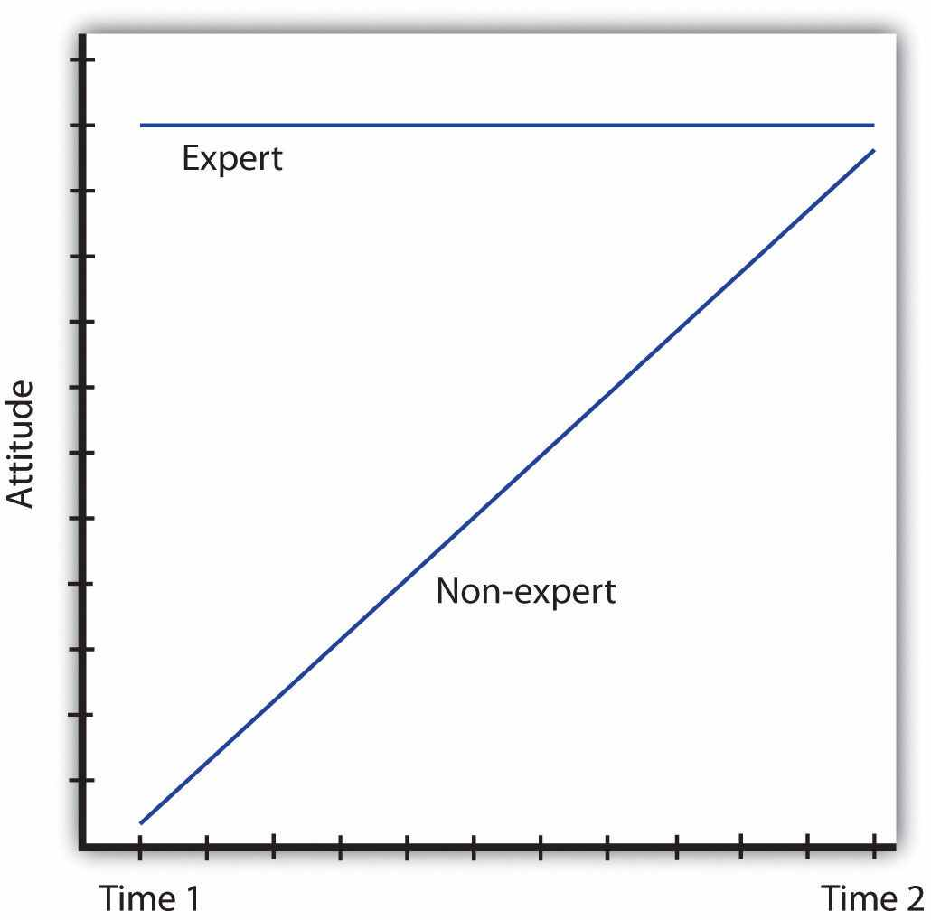
The sleeper effect occurs when we initially discount the message given by an untrustworthy or nonexpert communicator but, over time, we remember the content of the message and forget its source. The result is attitude change in the direction of the initially discounted message.
Perhaps you’ve experienced the sleeper effect. Once, I told my friends a story that I had read about one of my favorite movie stars. Only later did I remember that I had read the story while I was waiting in the supermarket checkout line, and that I had read it in the National Enquirer! I knew that the story was probably false because the newspaper is considered unreliable, but I had initially forgotten to discount that fact because I did not remember the source of the information. The sleeper effect is diagrammed in Figure 5.2 "The Sleeper Effect".

Creating Effective Communications
Once we have chosen a communicator, the next step is to determine what type of message we should have him or her deliver. Neither social psychologists nor advertisers are so naïve as to think that simply presenting a strong message is sufficient. No matter how good the message is, it will not be effective unless people pay attention to it, understand it, accept it, and incorporate it into their self-concept. This is why we attempt to choose good communicators to present our ads in the first place, and why we tailor our communications to get people to process them the way we want them to.

Figure 5.3
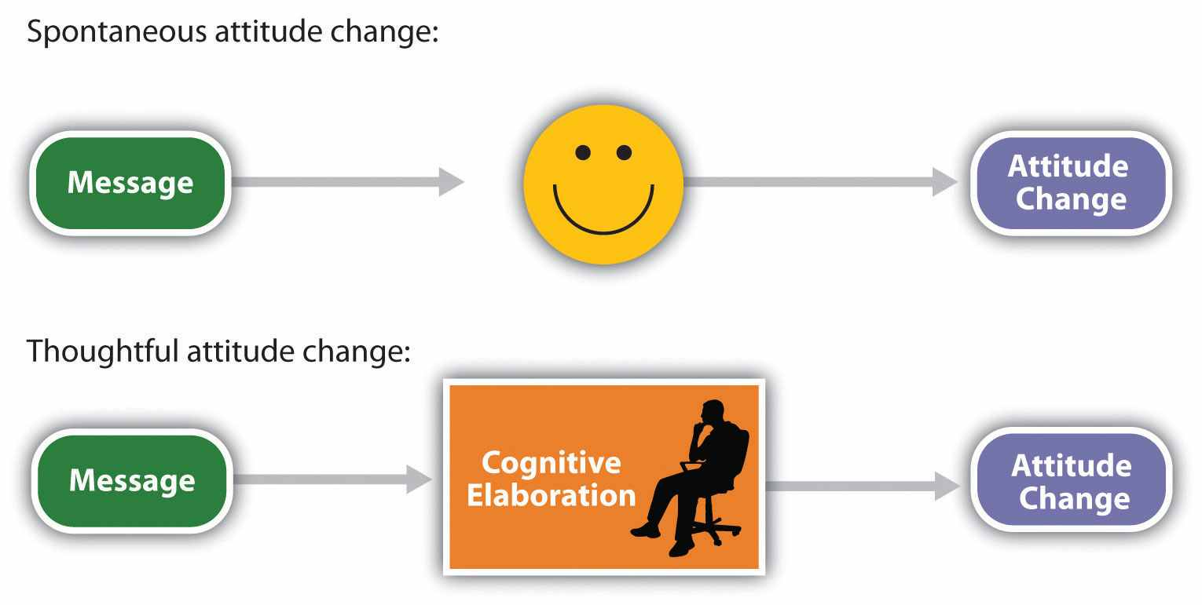
Spontaneous attitude change occurs as a direct or affective response to the message, whereas thoughtful attitude change is based on our cognitive elaboration of the message.
The messages that we deliver may be processed either spontaneously (other terms for this include peripherally or heuristically—Chen & Chaiken, 1999; Petty & Wegener, 1999) ^{[8]} or thoughtfully (other terms for this include centrally or systematically). Spontaneous processing is direct, quick, and often involves affective responses to the message. Thoughtful processing, on the other hand, is more controlled and involves a more careful cognitive elaboration of the meaning of the message (Figure 5.3). The route that we take when we process a communication is important in determining whether or not a particular message changes attitudes.

Spontaneous Message Processing
Because we are bombarded with so many persuasive messages—and because we do not have the time, resources, or interest to process every message fully—we frequently process messages spontaneously. In these cases, if we are influenced by the communication at all, it is likely that it is the relatively unimportant characteristics of the advertisement, such as the likeability or attractiveness of the communicator or the music playing in the ad, that will influence us.
If we find the communicator cute, if the music in the ad puts us in a good mood, or if it appears that other people around us like the ad, then we may simply accept the message without thinking about it very much (Giner-Sorolla & Chaiken, 1997). ^{[9]} In these cases, we engage in spontaneous message processing, in which we accept a persuasion attempt because we focus on whatever is most obvious or enjoyable, without much attention to the message itself. Shelley Chaiken (1980) ^{[10]} found that students who were not highly involved in a topic, because it did not affect them personally, were more persuaded by a likeable communicator than by an unlikeable one, regardless of whether the communicator presented a good argument for the topic or a poor one. On the other hand, students who were more involved in the decision were more persuaded by the better than by the poorer message, regardless of whether the communicator was likeable or not—they were not fooled by the likeability of the communicator.
You might be able to think of some advertisements that are likely to be successful because they create spontaneous processing of the message by basing their persuasive attempts around creating emotional responses in the listeners. In these cases the advertisers use associational learning to associate the positive features of the ad with the product. Television commercials are often humorous, and automobile ads frequently feature beautiful people having fun driving beautiful cars. The slogans “The joy of cola!” “Coke adds life!” and “Be a Pepper!” are good ads in part because they successfully create positive affect in the listener.
In some cases emotional ads may be effective because they lead us to watch or listen to the ad rather than simply change the channel or doing something else. The clever and funny TV ads that are shown during the Super Bowl broadcast every year are likely to be effective because we watch them, remember them, and talk about them with others. In this case the positive affect makes the ads more salient, causing them to grab our attention. But emotional ads also take advantage of the role of affect in information processing. We tend to like things more when we are in good moods, and—because positive affect indicates that things are OK—we process information less carefully when we are in good moods. Thus the spontaneous approach to persuasion is particularly effective when people are happy (Sinclair, Mark, & Clore, 1994), ^{[11]} and advertisers try to take advantage of this fact.
Another type of ad that is based on emotional responses is the one that uses fear appeals, such as ads that show pictures of deadly automobile accidents to encourage seatbelt use or images of lung cancer surgery to decrease smoking. By and large, fearful messages are persuasive (Das, de Wit, & Stroebe, 2003; Perloff, 2003; Witte & Allen, 2000). ^{[12]} Again, this is due in part to the fact that the emotional aspects of the ads make them salient and lead us to attend to and remember them. And fearful ads may also be framed in a way that leads us to focus on the salient negative outcomes that have occurred for one particular individual. When we see an image of a person who is jailed for drug use, we may be able to empathize with that person and imagine how we would feel if it happened to us. Thus this ad may be more effective than more “statistical” ads stating the base rates of the number of people who are jailed for drug use every year.
Fearful ads also focus on self-concern, and advertisements that are framed in a way that suggests that a behavior will harm the self are more effective than the same messages that are framed more positively. Banks, Salovey, Greener, and Rothman (1995) ^{[13]} found that a message that emphasized the negative aspects of not getting a breast cancer screening mammogram (“not getting a mammogram can cost you your life”) was more effective than a similar message that emphasized the positive aspects (“getting a mammogram can save your life”) in getting women to have a mammogram over the next year. These findings are consistent with the general idea that the brain responds more strongly to negative affect than it does to positive affect (Ito, Larsen, Smith, & Cacioppo, 1998). ^{[14]}
Although laboratory studies generally find that fearful messages are effective in persuasion, they have some problems that may make them less useful in real-world advertising campaigns (Hastings, Stead, & webb, 2004). ^{[15]} Fearful messages may create a lot of anxiety and therefore turn people off to the message (Shehryar & Hunt, 2005). ^{[16]} For instance, people who know that smoking cigarettes is dangerous but who cannot seem to quit may experience particular anxiety about their smoking behaviors. Fear messages are more effective when people feel that they know how to rectify the problem, have the ability to actually do so, and take responsibility for the change. Without some feelings of self-efficacy, people do not know how to respond to the fear (Aspinwall, Kemeny, Taylor, & Schneider, 1991). ^{[17]} Thus if you want to scare people into changing their behavior, it may be helpful if you also give them some ideas about how to do so, so that they feel like they have the ability to take action to make the changes (Passyn & Sujan, 2006). ^{[18]}

Thoughtful Message Processing
When we process messages only spontaneously, our feelings are more likely to be important, but when we process messages thoughtfully, cognition prevails. When we care about the topic, find it relevant, and have plenty of time to spend thinking about the communication, we are likely to process the message more deliberatively, carefully, and thoughtfully (Petty & Briñol, 2008). ^{[19]} In this case we elaborate on the communication by considering the pros and cons of the message and questioning the validity of the communicator and the message. Thoughtful message processingoccurs when we think about how the message relates to our own beliefs and goals and involves our careful consideration of whether the persuasion attempt is valid or invalid.
When an advertiser presents a message that he or she hopes will be processed thoughtfully, the goal is to create positive cognitions about the attitude object in the listener. The communicator mentions positive features and characteristics of the product and at the same time attempts to downplay the negative characteristics. When people are asked to list their thoughts about a product while they are listening to, or right after they hear, a message, those who list more positive thoughts also express more positive attitudes toward the product than do those who list more negative thoughts (Petty & Briñol, 2008). ^{[20]} Because the thoughtful processing of the message bolsters the attitude, thoughtful processing helps us develop strong attitudes, which are therefore resistant to counterpersuasion (Petty, Cacioppo, & Goldman, 1981). ^{[21]}

Which Route Do We Take: Thoughtful or Spontaneous?
Both thoughtful and spontaneous messages can be effective, but it is important to know which is likely to be better in which situation and for which people. When we can motivate people to process our message carefully and thoughtfully, then we are going to be able to present our strong and persuasive arguments with the expectation that our audience will attend to them. If we can get the listener to process these strong arguments thoughtfully, then the attitude change will likely be strong and long lasting. On the other hand, when we expect our listeners to process only spontaneously—for instance, if they don’t care too much about our message or if they are busy doing other things—then we do not need to worry so much about the content of the message itself; even a weak (but interesting) message can be effective in this case. Successful advertisers tailor their messages to fit the expected characteristics of their audiences.
In addition to being motivated to process the message, we must also have the ability to do so. If the message is too complex to understand, we may rely on spontaneous cues, such as the perceived trustworthiness or expertise of the communicator (Hafer, Reynolds, & Obertynski, 1996), ^{[22]} and ignore the content of the message. When experts are used to attempt to persuade people—for instance, in complex jury trials—the messages that these experts give may be very difficult to understand. In these cases the jury members may rely on the perceived expertise of the communicator rather than his or her message, being persuaded in a relatively spontaneous way. In other cases we may not be able to process the information thoughtfully because we are distracted or tired—in these cases even weak messages can be effective, again because we process them spontaneously (Petty, Wells & Brock, 1976). ^{[23]}
Petty, Cacioppo, and Goldman (1981) ^{[24]} showed how different motivations may lead to either spontaneous or thoughtful processing. In their research, college students heard a message suggesting that the administration at their college was proposing to institute a new comprehensive exam that all students would need to pass in order to graduate and then rated the degree to which they were favorable toward the idea. The researchers manipulated three independent variables:
- Message strength. The message contained either strong arguments (persuasive data and statistics about the positive effects of the exams at other universities) orweak arguments (relying only on individual quotations and personal opinions).
- Source expertise. The message was supposedly prepared either by an expert source (the Carnegie Commission on Higher Education, which was chaired by a professor of education at Princeton University) or by a nonexpert source (a class at a local high school).
- Personal relevance. The students were told either that the new exam would begin before they graduated (high personal relevance) or that it would not begin until after they had already graduated (low personal relevance).
As you can see in Figure 5.4, Petty and his colleagues found two interaction effects. The top panel of the figure shows that the students in the high personal relevance condition (left side) were not particularly influenced by the expertise of the source, whereas the students in the low personal relevance condition (right side) were. On the other hand, as you can see in the bottom panel, the students who were in the high personal relevance condition (left side) were strongly influenced by the quality of the argument, but the low personal involvement students (right side) were not.
These findings fit with the idea that when the issue was important, the students engaged in thoughtful processing of the message itself. When the message was largely irrelevant, they simply used the expertise of the source without bothering to think about the message.

Figure 5.4
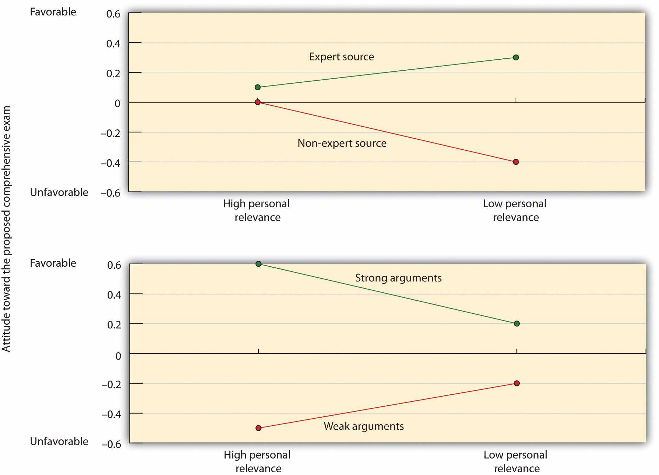
Petty, Cacioppo, and Goldman (1981) ^{[25]} found that students for whom an argument was not personally relevant based their judgments on the expertise of the source (spontaneous processing), whereas students for whom the decision was more relevant were more influenced by the quality of the message (thoughtful processing).
Because both thoughtful and spontaneous approaches can be successful, advertising campaigns, such as those used by the Obama presidential campaign, carefully make use of both spontaneous and thoughtful messages. In some cases, the messages showed Obama smiling, shaking hands with people around him, and kissing babies; in other ads Obama was shown presenting his plans for energy efficiency and climate change in more detail.

Preventing Persuasion
To this point we have focused on techniques designed to change attitudes. But it is also useful to develop techniques that prevent attitude change. If you are hoping that Magritte will never puff that first cigarette, then you might be interested in knowing what her parents might be able to do to prevent it from happening.
One approach to improving an individual’s ability to resist persuasion is to help the person create a strong attitude. Strong attitudes are more difficult to change than are weak attitudes, and we are more likely to act on our strong attitudes. This suggests that Magritte’s parents might want help Magritte consider all the reasons that she should not smoke and develop strong negative affect about smoking. As Magritte’s negative thoughts and feelings about smoking become more well-defined and more integrated into the self-concept, they should have a bigger influence on her behavior.
One method of increasing attitude strength involves forewarning: giving people a chance to develop a resistance to persuasion by reminding them that they might someday receive a persuasive message, and allowing them to practice how they will respond to influence attempts (Sagarin & Wood, 2007). ^{[26]} Magritte’s parents might want to try the forewarning approach. After the forewarning, when Magritte hears the smoking message from her peers, she may be less influenced by it because she was aware ahead of time that the persuasion would likely occur and had already considered how to resist it.
Forewarning seems to be particularly effective when the message that is expected to follow attacks an attitude that we care a lot about. In these cases the forewarning prepares us for action—we bring up our defenses to maintain our existing beliefs. When we don’t care much about the topic, on the other hand, we may simply change our belief before the appeal actually comes (Wood & Quinn, 2003). ^{[27]}

Video Clip 1
Forewarning can be effective in helping people respond to persuasive messages that they will receive later.
A similar approach is to help build up the cognitive component of the attitude by presenting a weak attack on the existing attitude with the goal of helping the person create counterarguments about a persuasion attempt that is expected to come in the future. Just as an inoculation against the flu gives us a small dose of the influenza virus that helps prevent a bigger attack later, giving Magritte a weak argument to persuade her to smoke cigarettes can help her develop ways to resist the real attempts when they come in the future. This procedure—known as inoculation—involves building up defenses against persuasion by mildly attacking the attitude position(Compton & Pfau, 2005; McGuire, 1961). ^{[28]} We would begin by telling Magritte the reasons that her friends might think that she should smoke (for instance, because everyone is doing it and it makes people look “cool”), therefore allowing her to create some new defenses against persuasion. Thinking about the potential arguments that she might receive and preparing the corresponding counterarguments will make the attitude stronger and more resistant to subsequent change attempts.
One difficulty with forewarning and inoculation attempts is that they may boomerang. If we feel that another person—for instance, a person who holds power over us—is attempting to take away our freedom to make our own decisions, we may respond with strong emotion, completely ignore the persuasion attempt, and perhaps even engage in the opposite behavior. Perhaps you can remember a time when you felt like your parents or someone else who had some power over you put too much pressure on you, and you rebelled against them.
The strong emotional response that we experience when we feel that our freedom of choice is being taken away when we expect that we should have choice is known aspsychological reactance (Brehm, 1966; Miron & Brehm, 2006). ^{[29]} If Magritte’s parents are too directive in their admonitions about not smoking, she may feel that they do not trust her to make her own decisions and are attempting to make them for her. In this case she may experience reactance and become more likely to start smoking. Erceg-Hurn and Steed (2011) ^{[30]} found that the graphic warning images that are placed on cigarette packs could create reactance in people who viewed them, potentially reducing the warnings’ effectiveness in convincing people to stop smoking.
Given the extent to which our judgments and behaviors are frequently determined by processes that occur outside of our conscious awareness, you might wonder whether it is possible to persuade people to change their attitudes or to get people to buy products or engage in other behaviors using subliminal advertising. Subliminal advertisingoccurs when a message, such as an advertisement or another image of a brand, is presented to the consumer without the person being aware that a message has been presented—for instance, by flashing messages quickly in a TV show, an advertisement, or a movie (Theus, 1994). ^{[31]}

Social Psychology in the Public Interest
Does Subliminal Advertising Work?
If it were effective, subliminal advertising would have some major advantages for advertisers because it would allow them to promote their product without directly interrupting the consumer’s activity and without the consumer knowing that he or she is being persuaded (Trappey, 1996). ^{[32]} People cannot counterargue with, or attempt to avoid being influenced by, messages that they do not know they have received and this may make subliminal advertising particularly effective. Due to fears that people may be influenced to buy products out of their awareness, subliminal advertising has been legally banned in many countries, including Australia, Great Britain, and the United States.
Some research has suggested that subliminal advertising may be effective. Karremans, Stroebe, and Claus (2006) ^{[33]} had Dutch college students view a series of computer trials in which a string of letters such as BBBBBBBBB orBBBbBBBBB was presented on the screen and the students were asked to pay attention to whether or not the strings contained a small b. However, immediately before each of the letter strings, the researchers presented either the name of a drink that is popular in Holland (“Lipton Ice”) or a control string containing the same letters as Lipton Ice (“Npeic Tol”). The priming words were presented so quickly (for only about 1/50th of a second) that the participants could not see them.
Then the students were asked to indicate their intention to drink Lipton Ice by answering questions such as “If you would sit on a terrace now, how likely is it that you would order Lipton Ice?” and also to indicate how thirsty they were at this moment. The researchers found that the students who had been exposed to the Lipton Ice primes were significantly more likely to say that they would drink Lipton Ice than were those who had been exposed to the control words, but that this was only true for the participants who said that they were currently thirsty.
On the other hand, other research has not supported the effectiveness of subliminal advertising. Charles Trappey (1996) conducted a meta-analysis in which he combined 23 research studies that had tested the influence of subliminal advertising on consumer choice. The results of his meta-analysis showed that subliminal advertising had a “negligible effect on consumer choice.” Saegert (1987) ^{[34]} concluded that “marketing should quit giving subliminal advertising the benefit of the doubt” (p. 107), arguing that the influences of subliminal stimuli are usually so weak that they are normally overshadowed by the person’s own decision making about the behavior.
Even if a subliminal or subtle advertisement is perceived, previous experience with the product or similar products—or even unrelated, more salient stimuli at the moment—may easily overshadow any effect the subliminal message would have had (Moore, 1988). ^{[35]} That is, even if we do perceive the “hidden” message, our prior attitudes or our current situation will likely have a stronger influence on our choices, potentially nullifying any effect the subliminal message would have had.
Taken together, the evidence for the effectiveness of subliminal advertising is weak and its effects may be limited to only some people and only some conditions. You probably don’t have to worry too much about being subliminally persuaded in your everyday life even if subliminal ads are allowed in your country. Of course, although subliminal advertising is not that effective, there are plenty of other indirect advertising techniques that are. Many ads for automobiles and alcoholic beverages have sexual connotations, which indirectly (even if not subliminally) associate these positive features with their products. And there are the ever more frequent “product placement” techniques, where images of brands (cars, sodas, electronics, and so forth) are placed on websites and in popular TV shows and movies.

KEY TAKEAWAYS
- Advertising is effective in changing attitudes, and principles of social psychology can help us understand when and how advertising works.
- Social psychologists study which communicators can deliver the most effective messages to which types of message recipients.
- Communicators are more effective when they help their recipients feel good about themselves. Attractive, similar, trustworthy, and expert communicators are examples of effective communicators.
- Attitude change that occurs over time, particularly when we no longer discount the impact of a low-credibility communicator, is known as the sleeper effect.
- The messages that we deliver may be processed either spontaneously or thoughtfully. When we are processing messages only spontaneously, our feelings are more likely to be important, but when we process the message thoughtfully, cognition prevails.
- Both thoughtful and spontaneous messages can be effective, in different situations and for different people.
- One approach to improving an individual’s ability to resist persuasion is to help the person create a strong attitude. Procedures such as forewarning and inoculation can help increase attitude strength and thus reduce subsequent persuasion.
- Taken together, the evidence for the effectiveness of subliminal advertising is weak, and its effects may be limited to only some people and only some conditions.

EXERCISES AND CRITICAL THINKING
- Reconsider the effectiveness of the Obama presidential campaign in terms of the principles of persuasion that we have discussed.
- Find and discuss examples of web or TV ads that make use of the principles discussed in this section.
- Visit the Joe Chemo site (http://www.joechemo.org/about.htm), designed to highlight and counterargue the negative effects of the Joe Camel cigarette ads. Create a presentation that summarizes the influence of cigarette ads on children.
- Based on our discussion of resistance to persuasion, what techniques would you use to help a child resist the pressure to start smoking or using recreational drugs?

[1] Strasburger, V. C. (2001). Children and TV advertising: Nowhere to run, nowhere to hide.Journal of Developmental and Behavioral Pediatrics, 22(3), 185–187.
[2] Hovland, C. I., Lumsdaine, A. A., & Sheffield, F. D. (1949). Experiments on mass communication. Princeton, NJ: Princeton University Press.
[3] Priester, J. R., & Petty, R. E. (2003). The influence of spokesperson trustworthiness on message elaboration, attitude strength, and advertising effectiveness. Journal of Consumer Psychology, 13(4), 408–421.
[4] MacLachlan, J. H., & Siegel, M. H. (1980). Reducing the costs of TV commercials by use of time compressions. Journal of Marketing Research, 17(1), 52–57; Moore, D. L., Hausknecht, D., & Thamodaran, K. (1986). Time compression, response opportunity, and persuasion.Journal of Consumer Research, 13(1), 85–99.
[5] Megehee, C. M., Dobie, K., & Grant, J. (2003). Time versus pause manipulation in communications directed to the young adult population: Does it matter? Journal of Advertising Research, 43(3), 281–292.
[6] Eagly, A. H., Wood, W., & Chaiken, S. (1978). Causal inferences about communicators and their effect on opinion change. Journal of Personality and Social Psychology, 36(4), 424–435; Wood, W., & Eagly, A. (1981). Stages in the analysis of persuasive messages: The role of causal attributions and message comprehension. Journal of Personality and Social Psychology, 40(2), 246–259.
[7] Kumkale, G. T., & Albarracín, D. (2004). The sleeper effect in persuasion: A meta-analytic review. Psychological Bulletin, 130(1), 143–172. doi: 10.1037/0033-2909.130.1.143
[8] Chen, S., & Chaiken, S. (1999). The heuristic-systematic model in its broader context. InDual-process theories in social psychology (pp. 73–96). New York, NY: Guilford Press; Petty, R. E., & Wegener, D. T. (1999). The elaboration likelihood model: Current status and controversies. In Dual-process theories in social psychology (pp. 37–72). New York, NY: Guilford Press.
[9] Giner-Sorolla, R., & Chaiken, S. (1997). Selective use of heuristic and systematic processing under defense motivation. Personality and Social Psychology Bulletin, 23(1), 84–97.
[10] Chaiken, S. (1980). Heuristic versus systematic information processing and the use of source versus message cues in persuasion. Journal of Personality and Social Psychology, 39(5), 752–766.
[11] Sinclair, R. C., Mark, M. M., & Clore, G. L. (1994). Mood-related persuasion depends on (mis)attributions. Social Cognition, 12(4), 309–326.
[12] Das, E. H. H. J., de Wit, J. B. F., & Stroebe, W. (2003). Fear appeals motivate acceptance of action recommendations: Evidence for a positive bias in the processing of persuasive messages. Personality and Social Psychology Bulletin, 29(5), 650–664; Perloff, R. M. (2003).The dynamics of persuasion: Communication and attitudes in the 21st century (2nd ed.). Mahwah, NJ: Lawrence Erlbaum; Witte, K., & Allen, M. (2000). A meta-analysis of fear appeals: Implications for effective public health campaigns. Health Education & Behavior, 27(5), 591–615.
[13] Banks, S. M., Salovey, P., Greener, S., & Rothman, A. J. (1995). The effects of message framing on mammography utilization. Health Psychology, 14(2), 178–184.
[14] Ito, T. A., Larsen, J. T., Smith, N. K., & Cacioppo, J. T. (1998). Negative information weighs more heavily on the brain: The negativity bias in evaluative categorizations. Journal of Personality and Social Psychology, 75(4), 887–900.
[15] Hastings, G., Stead, M., & webb, J. (2004). Fear appeals in social marketing: Strategic and ethical reasons for concern. Psychology and Marketing, 21(11), 961–986. doi: 10.1002/mar.20043
[16] Shehryar, O., & Hunt, D. M. (2005). A terror management perspective on the persuasiveness of fear appeals. Journal of Consumer Psychology, 15(4), 275–287. doi: 10.1207/s15327663jcp1504_2
[17] Aspinwall, L. G., Kemeny, M. E., Taylor, S. E., & Schneider, S. G. (1991). Psychosocial predictors of gay men’s AIDS risk-reduction behavior. Health Psychology, 10(6), 432–444.
[18] Passyn, K., & Sujan, M. (2006). Self-accountability emotions and fear appeals: Motivating behavior. Journal of Consumer Research, 32(4), 583–589. doi: 10.1086/500488
[19] Petty, R. E., & Briñol, P. (2008). Persuasion: From single to multiple to metacognitive processes. Perspectives on Psychological Science, 3(2), 137–147. doi: 10.1111/j.1745-6916.2008.00071.x
[20] Petty, R. E., & Briñol, P. (2008). Persuasion: From single to multiple to metacognitive processes. Perspectives on Psychological Science, 3(2), 137–147. doi: 10.1111/j.1745-6916.2008.00071.x
[21] Petty, R. E., Cacioppo, J. T., & Goldman, R. (1981). Personal involvement as a determinant of argument-based persuasion. Journal of Personality and Social Psychology, 41(5), 847–855.
[22] Hafer, C. L., Reynolds, K. L., & Obertynski, M. A. (1996). Message comprehensibility and persuasion: Effects of complex language in counterattitudinal appeals to laypeople. Social Cognition, 14, 317–337.
[23] Petty, R. E., Wells, G. L., & Brock, T. C. (1976). Distraction can enhance or reduce yielding to propaganda: Thought disruption versus effort justification. Journal of Personality and Social Psychology, 34(5), 874–884.
[24] Petty, R. E., Cacioppo, J. T., & Goldman, R. (1981). Personal involvement as a determinant of argument-based persuasion. Journal of Personality and Social Psychology, 41(5), 847–855.
[25] Petty, R. E., Cacioppo, J. T., & Goldman, R. (1981). Personal involvement as a determinant of argument-based persuasion. Journal of Personality and Social Psychology, 41(5), 847–855.
[26] Sagarin, B. J., & Wood, S. E. (2007). Resistance to influence. In A. R. Pratkanis (Ed.), The science of social influence: Advances and future progress (pp. 321–340). New York, NY: Psychology Press.
[27] Wood, W., & Quinn, J. M. (2003). Forewarned and forearmed? Two meta-analysis syntheses of forewarnings of influence appeals. Psychological Bulletin, 129(1), 119–138.
[28] Compton, J. A., & Pfau, M. (2005). Inoculation theory of resistance to influence at maturity: Recent progress in theory development and application and suggestions for future research. Communication Yearbook, 29, 97–145; McGuire, W. J. (1961). The effectiveness of supportive and refutational defenses in immunizing defenses. Sociometry, 24, 184–197.
[29] Brehm, J. (1966). A theory of psychological reactance. New York, NY: Academic Press; Miron, A. M., & Brehm, J. W. (2006). Reaktanz theorie—40 Jahre spärer. Zeitschrift fur Sozialpsychologie, 37(1), 9–18. doi: 10.1024/0044-3514.37.1.9
[30] Erceg-Hurn, D. M., & Steed, L. G. (2011). Does exposure to cigarette health warnings elicit psychological reactance in smokers? Journal of Applied Social Psychology, 41(1), 219–237.
[31] Theus, K. T. (1994). Subliminal advertising and the psychology of processing unconscious stimuli: A review of research. Psychology and Marketing, 11(3), 271–291.
[32] Trappey, C. (1996). A meta-analysis of consumer choice and subliminal advertising.Psychology and Marketing, 13(5), 517–531.
[33] Karremans, J. C., Stroebe, W., & Claus, J. (2006). Beyond Vicary’s fantasies: The impact of subliminal priming and brand choice. Journal of Experimental Social Psychology, 42(6), 792–798.
[34] Saegert, J. (1987). Why marketing should quit giving subliminal advertising the benefit of the doubt. Psychology and Marketing, 4(2), 107–121.
[35] Moore, T. E. (1988). The case against subliminal manipulation. Psychology and Marketing, 5(4), 297–316.

5.3 Changing Attitudes by Changing Behavior

LEARNING OBJECTIVES
- Outline the principles of self-perception and explain how they can account for the influences of behavior on attitude.
- Outline the principles of cognitive dissonance and explain how they can account for the influences of behavior on attitude.
Although it might not have surprised you to hear that we can often predict people’s behaviors if we know their thoughts and their feelings about the attitude object, you might be more surprised to find that our actions also have an influence on our thoughts and feelings. It makes sense that if I like Cheerios, I’ll buy them, because my thoughts and feelings about a product influence my behavior. But will my attitudes toward Frosted Flakes become more positive if I decide—for whatever reason—to buy them instead of Cheerios?
It turns out that if we engage in a behavior, and particularly one that we had not expected that we would have, our thoughts and feelings toward that behavior are likely to change. This might not seem intuitive, but it represents another example of how the principles of social psychology—in this case the principle of attitude consistency—lead us to make predictions that wouldn’t otherwise be that obvious.
Imagine that one Tuesday evening in the middle of the semester you see your friend Joachim. He’s just finished his dinner and tells you that he’s planning to head home to study and work on a term paper. When you see him the next day, however, he seems a bit shaken. It turns out that instead of going home to study, Joachim spent the entire evening listening to music at a rock club in town. He says that he had a great time, stayed up late to watch the last set, and didn’t get home until the crack of dawn. And he woke up so late this morning that he missed his first two classes.
You might imagine that Joachim might be feeling some uncertainty and perhaps some regret about his unexpected behavior the night before. Although he knows that it is important to study and to get to his classes on time, he nevertheless realizes that, at least in this case, he neglected his schoolwork in favor of another activity. Joachim seems to be wondering why he, who knows how important school is, engaged in this behavior after he promised himself that he was going home to study. Let’s see if we can use the principles of attitude consistency to help us understand how Joachim might respond to his unexpected behavior and how his attitudes toward listening to music and studying might follow from it.

Self-Perception Involves Inferring Our Beliefs From Our Behaviors
People have an avid interest in understanding the causes of behavior, both theirs and others, and doing so helps us meet the important goals of other-concern and self-concern. If we can better understand how and why the other people around us act the way they do, then we will have a better chance of avoiding harm from others and a better chance of getting those other people to cooperate with and like us. And if we have a better idea of understanding the causes of our own behavior, we can better work to keep that behavior in line with our preferred plans and goals.
In some cases people may be somewhat unsure about their attitudes toward different attitude objects. For instance, perhaps Joachim is a bit unsure about his attitude toward schoolwork versus listening to music (and this uncertainty certainly seems to be increasing in light of his recent behavior). Might Joachim look at his own behavior to help him determine his thoughts and feelings, just as he might look at the behavior of others to understand why they act the way that they do? Self-perception occurswhen we use our own behavior as a guide to help us determine our own thoughts and feelings (Bem, 1972; Olson & Stone, 2005). ^{[1]}

Research Focus
Looking at Our Own Behavior to Determine Our Attitudes
Eliot Aronson and J. Merrill Carlsmith (1963) ^{[2]} conducted an experiment to determine whether young children might look at their own behavior to help determine their attitudes toward toys. In their research, they first had the children rate the attractiveness of several toys. They then chose a toy that a child had just indicated he or she really wanted to play with and—this was rather mean—told that child he or she could not play with that toy. Furthermore, and according to random assignment to conditions, half of the children were threatened with mild punishment if they disobeyed and the other half were threatened with severe punishment. In the mild threat condition the experimenter said, “I don't want you to play with the toy. If you played with it, I would be annoyed,” whereas in the harsh threat condition the experimenter said, “I don't want you to play with the toy. If you played with it, I would be very angry. I would have to take all of my toys and go home and never come back again.” The experimenter then left the room for a few minutes to give the children the time and opportunity to play with the other toys and to resist the temptation of playing with the forbidden toy, while watching the children through a one-way mirror.
It turned out that both the harsh and the mild threat were sufficient to prevent the children from playing with the forbidden toy—none of the children actually did so. Nevertheless, when the experimenter returned to the room and asked each child to again rate how much he or she liked the forbidden toy, the children who had received the harsh threat rated the toy significantly more positively than the children who had received the mild threat. Furthermore, the children who had only received the mild threat actually rated the forbidden toy less positively than they had at the beginning of the experiment. And this change was long lasting. Even when tested several weeks later, children still showed these changes (Freedman, 1965). ^{[3]}
The results of this study indicate that the children’s self-perceptions of their behaviors influenced their attitudes toward the toys. Assume for a moment that the children were a bit unsure about how much they liked the toy that they did not play with and that they needed some information to determine their beliefs. The children in the harsh threat condition had a strong external reason for not having played with the toy—they were going to get into really big trouble if they did. Because these children likely saw the social situation as the cause of their behavior, they found it easy to believe that they still liked the toy a lot. For the children in the mild threat condition, however, the external reasons for their behavior were not so apparent—they had only been asked not to play with the toy. These children were more likely to come to the conclusion that their behavior was caused by internal, person factors—that they did not play with the toy simply because they did not like it that much.
We can use the principles of self-perception to help understand how Joachim is interpreting his behavior of staying out all night at the club rather than studying. When Joachim looks at this behavior, he may start to wonder why he engaged in it. One answer is that the social situation caused the behavior—he might decide that the band he heard last night was so fantastic that he simply had to go hear them and could not possibly have left the club early. Blaming the situation for the behavior allows him to avoid blaming himself for it and to avoid facing the fact that he found listening to music more important than his schoolwork. But the fact that Joachim is a bit worried about his unusual behavior suggests that he, at least in part, might be starting to wonder about his own motivations.
Perhaps you have experienced the effects of self-perception. Have you ever found yourself becoming more convinced about an argument you were making as you heard yourself making it? Or did you ever realize how thirsty you must have been as you quickly drank a big glass of water? Research has shown that self-perception occurs regularly and in many different domains. For instance, Gary Wells and Richard Petty (1980) ^{[4]} found that people who were asked to shake their heads up and down rather than sideways while reading arguments favoring or opposing tuition increases at their school ended up agreeing with the arguments more, and Daryl Bem (1965) ^{[5]} found that when people were told by the experimenter to say that certain cartoons were funny, they ended up actually finding those cartoons funnier. It appears in these cases that people looked at their own behavior: If they moved their head up and down or said that the cartoons were funny, they figured that they must agree with the arguments and like the cartoon.

Creating Insufficient and Oversufficient Justification
You may recall that one common finding in social psychology is that people frequently do not realize the extent to which behavior is influenced by the social situation. Although this is particularly true for the behavior of others, in some cases it may apply to understanding our own behavior as well. This means that, at least in some cases, we may believe that we have chosen to engage in a behavior for personal reasons, even though external, situational factors have actually led us to it. Consider again the children who did not play with the forbidden toy in the Aronson and Carlsmith study, even though they were given only a mild reason for not doing so. Although these children were actually led to avoid the toy by the power of the situation (they certainly would have played with it if the experimenter hadn’t told them not to), they frequently concluded that the decision was a personal choice and ended up believing that the toy was not that fun after all. When the social situation actually causes our behavior, but we do not realize that the social situation was the cause, we call the phenomenoninsufficient justification. Insufficient justification occurs when the threat or reward is actually sufficient to get the person to engage in or to avoid a behavior, but the threat or reward is insufficient to allow the person to conclude that the situation caused the behavior.
Although insufficient justification leads people to like something less because they (incorrectly) infer that they did not engage in a behavior due to internal reasons, it is also possible that the opposite may occur. People may in some cases come to like a task less when they perceive that they did engage in it for external reasons.Overjustification occurs when we view our behavior as caused by the situation, leading us to discount the extent to which our behavior was actually caused by our own interest in it (Deci, Koestner, & Ryan, 1999; Lepper & Greene, 1978). ^{[6]}
Mark Lepper and his colleagues (Lepper, Greene, & Nisbett, 1973) ^{[7]} studied the overjustification phenomenon by leading some children to think that they engaged in an activity for a reward rather than because they simply enjoyed it. First, they placed some fun felt-tipped markers into the classroom of the children they were studying. The children loved the markers and played with them right away. Then, the markers were taken out of the classroom and the children were given a chance to play with the markers individually at an experimental session with the researcher. At the research session, the children were randomly assigned to one of three experimental groups. One group of children (the expected reward condition) was told that if they played with the markers they would receive a good drawing award. A second group (theunexpected reward condition) also played with the markers and got the award—but they were not told ahead of time that they would be receiving the award (it came as a surprise after the session). The third group (the no reward condition) played with the markers too but got no award.
Then, the researchers placed the markers back in the classroom and observed how much the children in each of the three groups played with them. The results are shown in Figure 5.5 "Undermining Initial Interest in an Activity". The fascinating result was that the children who had been led to expect a reward for playing with the markers during the experimental session played with the markers less at the second session than they had at the first session. Expecting to receive the award at the session had undermined their initial interest in the markers.

Figure 5.5 Undermining Initial Interest in an Activity
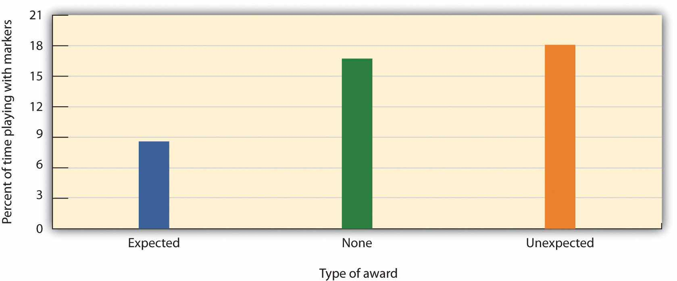
Children who had been expecting to receive a reward when they played with the fun markers played less with them in their free play period than did children who received no reward or an unexpected reward—their initial interest had been undermined by the expected reward. Data are from Lepper, Greene, and Nisbett (1973). ^{[8]}
Although this might not seem logical at first, it is exactly what is expected on the basis of the principle of overjustification. When the children had to choose whether or not to play with the markers when the markers reappeared in the classroom, they based their decision on their own prior behavior. The children in the no reward condition group and the children in the unexpected reward condition group realized that they played with the markers because they liked them. Children in the expected award condition group, however, remembered that they were promised a reward for the activity before they played with the markers the last time. These children were more likely to draw the inference that they play with the markers mostly for the external reward, and because they did not expect to get any reward for playing with the markers in the classroom they discounted the possibility that they enjoyed playing the markers because they liked them. As a result, they played less frequently with the markers in comparison to the children in the other groups.
This research suggests that, although giving rewards may in many cases lead us to perform an activity more frequently or with more effort, reward may not always increase our liking for the activity. In some cases reward may actually make us like an activity less than we did before we were rewarded for it. And this outcome is particularly likely when the reward is perceived as an obvious attempt on the part of others to get us to do something. When children are given money by their parents to get good grades in school, they may improve their school performance to gain the reward. But at the same time their liking for school may decrease. On the other hand, rewards that are seen as more internal to the activity, such as rewards that praise us, remind us of our achievements in the domain, and make us feel good about ourselves as a result of our accomplishments, are more likely to be effective in increasing not only the performance of, but also the liking of, the activity (Deci & Ryan, 2002; Hulleman, Durik, Schweigert, & Harackiewicz, 2008). ^{[9]}
In short, when we use harsh punishments we may prevent a behavior from occurring. However, because the person sees that it is the punishment that is controlling the behavior, the person’s attitudes may not change. Parents who wish to encourage their children to share their toys or to practice the piano therefore would be wise to provide “just enough” external incentive. Perhaps a consistent reminder of the appropriateness of the activity would be enough to engage the activity, making a stronger reprimand or other punishment unnecessary. Similarly, when we use extremely positive rewards, we may increase the behavior but at the same time undermine the person’s interest in the activity.
The problem, of course, is finding the right balance between reinforcement and overreinforcement. If we want our child to avoid playing in the street, and if we provide harsh punishment for disobeying, we may prevent the behavior but not change the attitude. The child may not play in the street while we are watching but do so when we leave. Providing less punishment is more likely to lead the child to actually change his or her beliefs about the appropriateness of the behavior, but the punishment must be enough to prevent the undesired behavior in the first place. The moral is clear: If we want someone to develop a strong attitude, we should use the smallest reward or punishment that is effective in producing the desired behavior.

The Experience of Cognitive Dissonance Can Create Attitude Change
Let’s return once more to our friend Joachim and imagine that we now discover that over the next two weeks he has spent virtually every night at clubs listening to music rather than studying. And these behaviors are starting to have some severe consequences: He just found out that he’s failed his biology midterm. How will he ever explain that to his parents? What were at first relatively small discrepancies between self-concept and behavior are starting to snowball, and they are starting to have more affective consequences. Joachim is realizing that he’s in big trouble—the inconsistencies between his prior attitudes about the importance of schoolwork and his behavior are creating some significant threats to his positive self-esteem. The discomfort that occurs when we behave in ways that we see as inappropriate, such as when we fail to live up to our own expectations, is called cognitive dissonance(Cooper, 2007; Festinger, 1957; Harmon-Jones & Mills, 1999). ^{[10]} The discomfort of cognitive dissonance is experienced as pain, showing up in a part of the brain that is particularly sensitive to pain—the anterior cingulate cortex (van Veen, Krug, Schooler, & Carter, 2009). ^{[11]}
Leon Festinger and J. Merrill Carlsmith (1959) ^{[12]} conducted an important study designed to demonstrate the extent to which behaviors that are discrepant from our initial beliefs can create cognitive dissonance and can influence attitudes. College students participated in an experiment in which they were asked to work on a task that was incredibly boring and lasted for a full hour. After they had finished the task, the experimenter explained that the assistant who normally helped convince people to participate in the study was unavailable and that he could use some help persuading the next person that the task was going to be interesting and enjoyable. The experimenter explained that it would be much more convincing if a fellow student rather than the experimenter delivered this message and asked the participant if he would be willing do to it. Thus with his request the experimenter induced the participants to lie about the task to another student, and all the participants agreed to do so.
The experimental manipulation involved the amount of money the students were paid to tell the lie. Half of the students were offered a large payment ($20) for telling the lie, whereas the other half were offered only a small payment ($1) for telling the lie. After the participants had told the lie, an interviewer asked each of them how much they had enjoyed the task they had performed earlier in the experiment. As you can see in Figure 5.6 "Festinger and Carlsmith", Festinger and Carlsmith found that the students who had been paid $20 for saying the tasks had been enjoyable rated the task as very boring, which indeed it was. In contrast, the students who were paid only $1 for telling the lie changed their attitude toward the task and rated it as significantly more interesting.
Festinger explained the results of this study in terms of consistency and inconsistency among cognitions. He hypothesized that some thoughts might be dissonant, in the sense that they made us feel uncomfortable, while other thoughts were moreconsonant, in the sense that they made us feel good. He argued that people may feel an uncomfortable state (which he called cognitive dissonance) when they have many dissonant thoughts—for instance, between the idea that (a) they are smart and decent people and (b) they nevertheless told a lie to another student for only a small payment.
Festinger argued that the people in his experiment who had been induced to lie for only $1 experienced more cognitive dissonance than the people who were paid $20 because the latter people had a strong external justification for having done it whereas the former did not. The people in the $1 condition, Festinger argued, needed to convince themselves that that the task was actually interesting to reduce the dissonance they were experiencing.

Figure 5.6 Festinger and Carlsmith
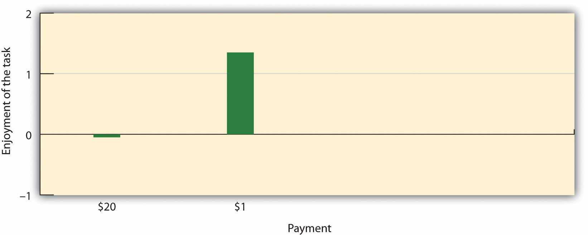
Participants who had engaged in a boring task and then told another student it was interesting experienced cognitive dissonance, leading them to rate the task more positively in comparison to those who were paid $20 to do the same. Data are from Festinger and Carlsmith (1959). ^{[13]}
Although originally considered in terms of the inconsistency among different cognitions, Festinger’s theory has also been applied to the negative feelings that we experience when there is inconsistency between our attitudes and our behavior, and particularly when the behavior threatens our perceptions of ourselves as good people (Aronson, 1969). ^{[14]} Thus Joachim is likely feeling cognitive dissonance because he has acted against his better judgment and these behaviors are having some real consequences for him. The dissonant thoughts involve (a) his perception of himself as a hardworking student, compared to (b) his recent behaviors that do not support that idea. Our expectation is that Joachim will not enjoy these negative feelings and will attempt to get rid of them.

We Reduce Dissonance by Decreasing Dissonant or by Increasing Consonant Cognitions
Because Joachim’s perception of himself as a hardworking student is now in jeopardy, he is feeling cognitive dissonance and will naturally try to reduce these negative emotions. He can do so in a number of ways. One possibility is that Joachim could simply change his behavior by starting to study more and go out less. If he is successful in doing this, his dissonance will clearly be reduced and he can again feel good about himself. But it seems that he has not been very successful in this regard—over the past weeks he has continually put off studying for listening to music. A second option is to attempt to reduce his dissonant cognitions—those that threaten his self-esteem. Perhaps he might try to convince himself that he has only failed one test and that he didn’t expect to do very well in biology anyway. If he can make the negative behaviors seem less important, dissonance will be reduced.
One of Festinger’s most powerful insights into social psychology was that, even if Joachim cannot change his behavior and even if he knows that what he’s doing has negative consequences, he still has a third option: He can create new consonant cognitions to counteract the dissonant cognitions. For instance, Joachim might try to convince himself that he is going to become an important record producer some day and that it is therefore essential that he attend many concerts. When Joachim takes this route he changes his beliefs to be more in line with his behavior, and the outcome is that he has now restored attitude consistency. His behaviors no longer seem as discrepant from his attitudes as they were before, and when consistency is restored, dissonance is reduced. What the principles of cognitive dissonance suggest, then, is that we may frequently spend more energy convincing ourselves that we are good people than we do thinking of ourselves accurately. Of course we do this because viewing ourselves negatively is painful.

Cognitive Dissonance in Everyday Life
Cognitive dissonance is an important social psychological principle that can explain how attitudes follow behavior in many domains of our everyday life. For instance, people who try but fail to quit smoking cigarettes naturally suffer lowered self-esteem (Gibbons, Eggleston, & Benthin, 1997). ^{[15]} But rather than accepting this negative feeling, they frequently attempt to engage in behaviors that reduce dissonance. They may try to convince themselves that smoking is not that bad: “My grandmother smoked but lived to be 93 years old!” “I’m going to quit next year!” Or they may try to add new consonant cognitions: “Smoking is fun; it relaxes me.” You can see that these processes, although making us feel better about ourselves at least in the short run, may nevertheless have some long-term negative outcomes.
Elliot Aronson and Judson Mills (1959) ^{[16]} studied whether the cognitive dissonance created by an initiation process could explain how much commitment students felt to a group they were part of. In their experiment, female college students volunteered to join a group that would be meeting regularly to discuss various aspects of the psychology of sex. According to random assignment, some of the women were told that they would be required to perform an embarrassing procedure (they were asked to read some obscene words and some sexually oriented passages from a novel in public) before they could join the group, whereas other women did not have to go through this initiation. Then all the women got a chance to listen to the group’s conversation, which turned out to be very boring.
Aronson and Mills found that the women who had gone through the embarrassing experience subsequently reported more liking for the group than those who had not, and Gerard and Matthewson (1966) ^{[17]} found that having to take some electrical shocks as part of an initiation process had the same effect. Aronson and Mills argued that the more effort an individual expends to become a member of the group (for instance, a severe initiation), the more he will become committed to the group in order to justify the effort he has put in during the initiation. The idea is that the effort creates dissonant cognitions (“I did all this work to join the group”), which are then justified by creating more consonant ones (“OK, this group is really pretty fun”). The women who spent little effort to get into the group were able to see the group as the dull and boring conversation that it was. The women who went through the more severe initiation, however, succeeded in convincing themselves that the same discussion was a worthwhile experience. When we put in effort for something—an initiation, a big purchase price, or even some of our precious time—we will likely end up liking the activity more than we would have if the effort had been less. Even the effort of having to fill out a purchase agreement for a product, rather than having the salesperson do it for you, creates commitment to the purchase and a greater likelihood of staying in the deal (Cialdini, 1988). ^{[18]}
Another time you may have experienced the negative affective state of cognitive dissonance is after you have made an important and irrevocable decision. Imagine that you are about to buy a new car and you have narrowed your search to a small new car and a larger (but much cheaper) used car. The problem is that you can see advantages and disadvantages to each. For instance, the smaller car would get better gas mileage, but the larger car—because it is used—is cheaper. Imagine, however, that you finally decide to buy the larger car because you feel that you really don’t have enough money for the new car.
That night, you’re lying in bed and wondering about your decision. Although you’ve enjoyed driving the big car that you have just purchased, you’re worried about rising gas costs, the negative impact of the big car on the environment, and the possibility that the car might need a lot of repairs. Have you made the right decision? This “buyer’s remorse” can be interpreted in terms of postdecisional dissonance—the feeling of regret that may occur after we make an important decision (Brehm, 1956).^{[19]} However, the principles of dissonance predict that once you make the decision—and regardless of which car you choose—you will convince yourself that you made the right choice. I would predict that since you have chosen the larger car you will begin to think more about the positive aspects of the choice that you have made (what you are going to be able to do with the money you saved, rather than how much more it is going to cost to fill up the gas tank) and at the same time you will likely downplay the values of the smaller car.
Jack Brehm (1956) ^{[20]} posed as a representative of a consumer testing service and asked women to rate the attractiveness and desirability of several kinds of appliances, such as toasters and electric coffee makers. Each woman was told that as a reward for having participated in the survey, she could have one of the appliances as a gift. She was given a choice between two of the products she had rated as being about equally attractive. After she made her decision, her appliance was wrapped up and given to her. Then, 20 minutes later, each woman was asked to rerate all the products. As you can see in Figure 5.7 "Postdecisional Dissonance", Brehm found that the women rated the appliance that they had chosen and been given as a gift higher than they had the first time. And the women also lowered their rating of the appliance they might have chosen but decided to reject. These results are of course consistent with the principles of cognitive dissonance—post-decisional dissonance is reduced by focusing on the positive aspects of the chosen product and the negative aspects of the rejected product.

Figure 5.7 Postdecisional Dissonance
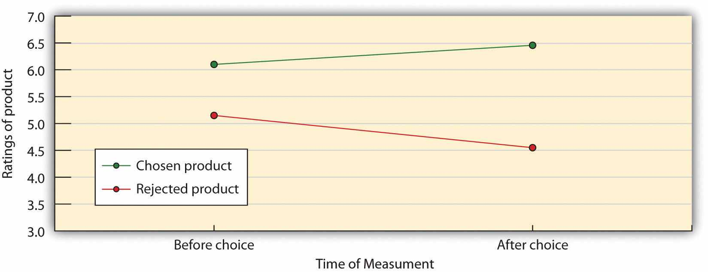
As predicted by the desire to reduce postdecisional dissonance, participants increased the perceived desirability of a product they had chosen and decreased the perceived desirability of a product they did not choose. Data are from Brehm (1956).^{[21]}
What research on cognitive dissonance suggests, then, is that people who are experiencing dissonance will generally try to reduce it. If we fail to lose the weight we wanted to lose, we decide that we look good anyway. If we cheat on an exam, we decide that cheating is OK. If we hurt someone else’s feelings, we may even decide that they are bad people who deserve our negative behavior. To escape from feeling poorly about ourselves, people will engage in quite extraordinary rationalizing. No wonder that most of us believe that “If I had it all to do over again, I would not change anything important.”
Of course, the tendency to justify our past behavior has positive outcomes for our affect. If we are able to convince ourselves that we can do no wrong, we will be happier—at least for today. But the desire to create positive self-esteem can lead to a succession of self-justifications that ultimately result in a chain of irrational actions. The irony is that to avoid thinking of ourselves as bad or immoral, we may set ourselves up for more immoral acts. Once Joachim has convinced himself that his schoolwork is not important, it may be hard to pick it up again. Once a smoker has decided it is OK to smoke, she may just keep smoking. If we spend too much time thinking positively about ourselves we will not learn from our mistakes, nor grow or change. In order to learn from our behavior, it would be helpful to learn to tolerate dissonance long enough to examine the situation critically and dispassionately. We then stand a chance of breaking out of the cycle of action followed by justification, followed by more action.
There is still another potential negative outcome of dissonance: When we have to make choices we may feel that we have made poor ones. Barry Schwartz (2004) ^{[22]}has argued that having too many choices can create dissonance and thus the opportunity for regret. When we go to the store and have to pick only one out of 30 different types of chocolates, we have more opportunities for postdecisional dissonance. Although it seems like being allowed to choose would be a good thing, people report being happier when they are given a free gift than when they are given a choice between two similar gifts and have to reject one of them (Hsee & Hastie, 2006).^{[23]}

Positive Self-Esteem Reduces Dissonance
We have seen that the experience of cognitive dissonance can influence our thoughts and feelings about an attitude object by making us feel uncomfortable about our own behaviors. The discrepant behavior causes our sense of self-worth to be lowered, which then causes us to change our attitudes to feel better about ourselves.
discrepant behavior ⟶ lowered self-worth ⟶ changes in thoughts and feelings
Imagine that immediately after you did something dishonest, but before you had a chance to try to reduce the dissonance you were experiencing, you were able to remind yourself of the fact that you had recently done something else very positive—perhaps you had recently spent some time volunteering at a homeless shelter or gotten a really high score on an important exam. Would the possibility of boosting your self-esteem in this other, but unrelated, domain make it unnecessary for you to engage in dissonance reduction? Could you not say, “Well, it’s true that I cheated, but I’m really a fine, intelligent, and generous person.” Research has demonstrated that this is the case. If we can affirm our self-worth, even on dimensions that are not related to the source of the original dissonance, the negative feelings we experience are reduced and so is the tendency to justify our attitudes (Steele, 1988). ^{[24]}
Just as finding ways to affirm our self-esteem should reduce cognitive dissonance, threats to our self-esteem should increase it. Because cognitive dissonance poses a threat to one’s self-esteem, people who are more motivated by self-concern should show bigger changes in their thoughts and feelings after they engage in a discrepant behavior than should those who are less motivated by self-concern.
Following the research of Brehm, Steve Heine and Darren Lehman (1997) ^{[25]}conducted an experiment to determine if threats to self-esteem would increase the magnitude of the dissonance-reduction effect, and if dissonance reduction would also occur for Japanese students as they had previously been found in students from Western samples. They expected that there would be less need for dissonance reduction in the Japanese than in Western students because the Japanese (and other Easterners) were less motivated overall to maintain a positive self-image.
In their study, 71 Canadian and 71 Japanese participants were first asked to take a personality test. According to random assignment to conditions, one third of the sample in each country were led to believe that they had scored much higher on the test than did the other participants and thus that they had “positive” personalities (thepositive feedback condition). Another third of the sample (the negative feedbackcondition) were led to believe that they had scored more poorly on the test than average, and a final third (the control condition) were not given any feedback on their personality test scores.
Then all participants rated the desirability of 10 compact discs (the discs were known to be popular in both Canada and Japan) and were asked to choose between their fifth and sixth rated CDs as compensation for their participation. Finally, after choosing one of the CDs, the participants were asked to again rate their liking for the CDs. The change in the ratings from before choice to after choice, which would have occurred if the participants increased their liking of the CD they had chosen or decreased their liking of the CD they had rejected, was the dependent measure in the study.
As you can see in Figure 5.8 "Spread of Alternatives by Culture and Feedback Condition", the researchers found a significant interaction between culture and personality feedback. The pattern of means showed that the feedback mattered for the Canadian participants—the difference in the ratings of the chosen versus the rejected CD (the “spread of alternatives”) increased from the positive to the control to the negative feedback conditions. However, there was no significant simple effect of feedback for the Japanese students, nor did they show a significant spread of alternatives in any feedback condition.

Figure 5.8 Spread of Alternatives by Culture and Feedback Condition
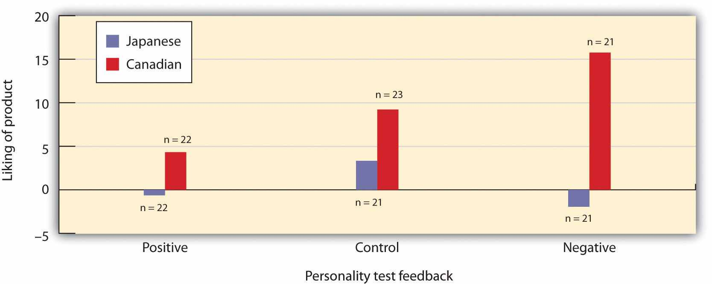
The Canadian participants showed a greater spread of alternatives when their self-esteem was threatened, but Japanese participants did not. Data are from Heine and Lehman (1997). ^{[26]}
However, other researchers have found that individuals from collectivist cultures do show dissonance effects when they are focused on their relationships with others. For instance, Kitayama, Snibbe, Markus, and Suzuki (2004) ^{[27]} found that East Asian participants experienced dissonance particularly when they were asked to think about a close friend who had made a dissonance-creating decision. Such a result would be expected because behaviors that involve more other-oriented, collectivistic outcomes should be more important for these people. Indeed, research has found that advertisements that are framed in terms of personal benefits (“Use this breath mint!”) are more persuasive in individualistic cultures, whereas ads that emphasize family or ingroup benefits (“Share this breath mint with your friends!”) are more persuasive in collectivistic cultures (Han & Shavitt, 1994). ^{[28]}
Although dissonance is most likely when our behavior violates our positive self-concept, attitude change can occur whenever our thoughts and behaviors are inconsistent, even if the self-concept is not involved. For instance, Harmon-Jones and his colleagues (Harmon-Jones, Brehm, Greenberg, Simon, & Nelson, 1996) ^{[29]} had people drink an unpleasant-tasting beverage (Kool-Aid made with vinegar instead of sugar) and then write down on a small slip of paper, which they then immediately crumpled up and threw away, a statement saying that they really liked the drink. Harmon-Jones and his colleagues found that even though the lie could not possibly harm anyone, the act of lying nevertheless made the participants express more positive attitudes toward the drink. It appears that even lying to oneself about something relatively unimportant can produce dissonance and change attitudes (Prislin & Pool, 1996; Stone, 1999). ^{[30]}
Salespeople make use of psychological principles, including self-perception and cognitive dissonance, to encourage people to buy their products, often in ways that seem less than completely open and ethical. Informed consumers are aware of such techniques, including the foot-in-the-door technique, the low-ball technique, and the bait-and-switch technique. Let’s consider in the next section how these strategies might work.

Social Psychology in the Public Interest
How Salespeople Use Principles of Persuasion
The research that we have discussed in this chapter suggests some of the many ways that we can persuade people to buy our products, to vote for our candidates, and to engage in other behaviors that we would like them to engage in. We have seen that we will be more successful if we use the right communicators and if we present the right messages under the right conditions. But it must also be kept in mind that a full understanding of the techniques used by persuaders may also be useful to help us avoid being persuaded by others.
Salespeople sometimes make use of the Behavior ⟶ Attitude relationship to attempt to persuade others. Regardless of whether the change is due to the cognitive principles of self-perception or the more affective principles of dissonance reduction, the attitude change that follows behavior can be strong and long lasting. This fact creates some very interesting opportunities for changing attitudes.
One approach based on this idea is to get people to move slowly in the desired direction, such that they commit to a smaller act first. The idea is that it will be relatively easy to get people to engage in a small behavior after which their perceptions of this initial behavior will change their attitudes, making it more likely for them to engage in a more costly behavior later. The foot-in-the-door technique refers to a persuasion attempt in which we first get the target to accept a rather minor request, and then we ask for a larger request. Freedman and Fraser (1966) ^{[31]} asked homeowners if they would be willing to place a small sticker in the window of their house that said “Be a safe driver.” Many of the homeowners agreed to this small request. Then several weeks later, the researchers came back and asked these same homeowners to put a big, ugly “DRIVE CAREFULLY” sign on their lawns. Almost 80% of the homeowners who had agreed to put the sticker in their window later agreed to put the sign up, in comparison to only about 20% who agreed when they were asked about the sign without having been asked about the sticker first. In a more recent study, Nicolas Guéguen (2002) ^{[32]} found that students in a computer discussion group were more likely to volunteer to complete a 40-question survey on their food habits (which required 15 to 20 minutes of their time) if they had already, a few minutes earlier, agreed to help the same requestor with a simple computer-related question (about how to convert a file type) than if they had not first been given the smaller opportunity to help.
You can see that the foot-in-the-door technique is a classic case of self-perception and commitment—once people label themselves as the kind of person who conforms to the requests of others in the relevant domain (“I volunteer to help safe driving campaigns,” “I help people in my discussion group”), it is easier to get them to conform later. Similarly, imagine a restaurant owner who has problems with people who make table reservations but then don’t call to cancel when they can’t come at the appointed time. The restaurant owner could try to reduce the problem by first getting a small commitment. Instead of having the people who take the reservations say, “Please call if you change your plans,” they could instead ask, “Will you call us if you change your plans?” and then wait for the person to say yes. The act of saying yes to a simple request creates commitment to the behavior, and not following through on the promise would be likely to create cognitive dissonance. Since people don’t want to feel that they have violated their commitment, this should reduce the no-show rate.
Another approach based on the attitudes-follow-behavior idea, and which can be used by unscrupulous salespeople, is known as the low-ball technique. In this case the salesperson promises the customer something desirable, such as a low price on a car, with the intention of getting the person to imagine themselves engaging in the desired behavior (in this case, purchasing the car). After the customer has committed to purchasing the car at a low price, the salesperson then indicates that he or she cannot actually sell the car at that price. In this case people are more likely to buy the car at the higher price than they would have been if the car had first been offered at the higher price. Backing out on a commitment seems wrong and may threaten self-esteem, even if the commitment was obtained in an unethical way.
In research testing the low-ball effect, Guéguen, Pascual, and Dagot (2002) ^{[33]}asked people to watch a dog for them while they visited someone in the hospital. Some participants were told that they would need to watch the dog for 30 minutes. Other participants were first asked simply to commit to watching the dog, and then only later informed that they would have to watch it for 30 minutes. The latter group had been low-balled, and they complied more often with the request.
A close alternative to low-balling is known as the bait-and-switch technique,which occurs when someone advertises a product at a very low price. When you visit to the store to buy the product, however, you learn that the product you wanted at the low price has been sold out. An example is a car dealership that advertises a low-priced car in a newspaper ad but doesn’t have that car available when you visit the dealership to purchase it. Again, people are more likely to buy an alternative higher-priced product after they have committed themselves to the purchase than they would have been without the original information. Once you imagine yourself owning the car, your attitude toward the car becomes more positive, making the idea of giving it up more costly and also making it more likely that you will buy it.

KEY TAKEAWAYS
- As predicted by the principle of attitude consistency, if we engage in an unexpected or unusual behavior, our thoughts and feelings toward that behavior are likely to change.
- Self-perception occurs when we use our own behavior as a guide to help us determine our thoughts and feelings.
- Self-perception can lead to either insufficient justification—the perception that there was not enough external threat to avoid engaging in a behavior—or overjustification—the perception that our behavior was caused primarily by external factors.
- Principles of self-perception suggest that to create true attitude change we should avoid using too much punishment or too much reward.
- Cognitive dissonance refers to the discomfort that occurs when we behave in ways that we see as inappropriate, such as when we fail to live up to our own expectations
- Dissonance is reduced by changing behavior, by reducing dissonant cognitions, or by creating new consonant cognitions to counteract the dissonant cognitions.
- Dissonance is observed in many everyday experiences, including initiation and the experience of postdecisional dissonance.
- Engaging in dissonance reduction has many positive outcomes for our affect but may lead to harmful self-justifications and irrational actions.
- Because dissonance involves self-concern, it is stronger when we do not feel very positively about ourselves and may be stronger in Western than in Eastern cultures.
- Marketers use the principles of dissonance in their attempts at persuasion. Examples are the foot-in-the-door technique, low-balling, and the bait-and-switch technique.

EXERCISES AND CRITICAL THINKING
- Describe a time when your attitudes changed on the basis of your observation of your behaviors.
- Describe a time when you behaved in a way that was inconsistent with your self-concept and which led you to experience cognitive dissonance. How did you reduce the dissonance?
- Benjamin Franklin once asked one of his rivals in Congress to lend him a scarce and valuable book. The opponent accepted the request, and Franklin found, as he had predicted, that the opponent began to like him more after doing it. Explain this “Benjamin Franklin effect” in terms of self-perception and cognitive dissonance.
- Did you ever buy a product or engage in an activity as the result of the foot-in-the-door technique, low-balling, or the bait-and-switch technique? If so, describe your experience.

[1] Bem, D. J. (1965). An experimental analysis of self-persuasion. Journal of Experimental Social Psychology, 1(3), 199–218; Olson, J. M., & Stone, J. (2005). The influence of behavior on attitudes. In D. Albarracín, B. T. Johnson, & M. P. Zanna (Eds.), The handbook of attitudes(pp. 223–271). Mahwah, NJ: Lawrence Erlbaum.
[2] Aronson, E., & Carlsmith, J. M. (1963). Effect of the severity of threat on the devaluation of forbidden behavior. Journal of Abnormal and Social Psychology, 66(6), 584–588.
[3] Freedman, J. L. (1965). Long-term behavioral effects of cognitive dissonance. Journal of Experimental Social Psychology, 1(2), 145–155.
[4] Wells, G. L., & Petty, R. E. (1980). The effects of overt head movements on persuasion: Compatibility and incompatibility of responses. Basic and Applied Social Psychology, 1(3), 219–230.
[5] Bem, D. J. (1965). An experimental analysis of self-persuasion. Journal of Experimental Social Psychology, 1(3), 199–218.
[6] Deci, E. L., Koestner, R., & Ryan, R. M. (1999). A meta-analytic review of experiments examining the effects of extrinsic rewards on intrinsic motivation. Psychological Bulletin, 125(6), 627–668; Lepper, M. R., & Greene, D. (1978). The hidden costs of reward: New perspectives on the psychology of human motivation. Hillsdale, NJ: Lawrence Erlbaum.
[7] Lepper, M. R., Greene, D., & Nisbett, R. E. (1973). Undermining children’s intrinsic interest with extrinsic reward: A test of the “overjustification” hypothesis. Journal of Personality and Social Psychology, 28, 129–137.
[8] Lepper, M. R., Greene, D., & Nisbett, R. E. (1973). Undermining children’s intrinsic interest with extrinsic reward: A test of the “overjustification” hypothesis. Journal of Personality and Social Psychology, 28, 129–137.
[9] Deci, E. L., & Ryan, R. M. (2002). Self-determination research: Reflections and future directions. In E. L. Deci & R. M. Ryan (Eds.), Handbook of self-determination research (pp. 431–441). Rochester, NY: University of Rochester Press; Hulleman, C. S., Durik, A. M., Schweigert, S. B., & Harackiewicz, J. M. (2008). Task values, achievement goals, and interest: An integrative analysis. Journal of Educational Psychology, 100(2), 398–416. doi: 10.1037/0022-0663.100.2.398
[10] Cooper, J. M. (2007). Cognitive dissonance: 50 years of a classical theory. Thousand Oaks, CA: Sage; Festinger, L. (1957). A theory of cognitive dissonance. Evanston, IL: Row, Peterson; Harmon-Jones, E., & Mills, J. (1999). Cognitive dissonance: Progress on a pivotal theory in social psychology. Washington, DC: American Psychological Association.
[11] van Veen, V., Krug, M. K., Schooler, J. W., & Carter, C. S. (2009). Neural activity predicts attitude change in cognitive dissonance. Nature Neuroscience, 12(11), 1469–1474.
[12] Festinger, L., & Carlsmith, J. M. (1959). Cognitive consequences of forced compliance.Journal of Abnormal and Social Psychology, 58, 203–210.
[13] Festinger, L., & Carlsmith, J. M. (1959). Cognitive consequences of forced compliance.Journal of Abnormal and Social Psychology, 58, 203–210.
[14] Aronson, E. (1969). The theory of cognitive dissonance: A current perspective. In L. Berkowitz (Ed.). Advances in experimental social psychology (Vol. 4, pp. 1–34). New York, NY: Academic Press.
[15] Gibbons, F. X., Eggleston, T. J., & Benthin, A. C. (1997). Cognitive reactions to smoking relapse: The reciprocal relation between dissonance and self-esteem. Journal of Personality and Social Psychology, 72(1), 184–195.
[16] Aronson, E., & Mills, J. (1959). The effect of severity of initiation on liking for a group.Journal of Abnormal and Social Psychology, 59, 171–181.
[17] Gerard, H. B., & Matthewson, G. C. (1966). The effects of severity of initiation on liking for a group: A replication. Journal of Experimental Social Psychology, 2, 278–287.
[18] Cialdini, R. (1988). Influence: Science and practice. Glenview, IL: Scott Foresman.
[19] Brehm, J. W. (1956). Postdecision changes in the desirability of alternatives. Journal of Abnormal and Social Psychology, 52(3), 384–389.
[20] Brehm, J. W. (1956). Postdecision changes in the desirability of alternatives. Journal of Abnormal and Social Psychology, 52(3), 384–389.
[21] Brehm, J. W. (1956). Postdecision changes in the desirability of alternatives. Journal of Abnormal and Social Psychology, 52(3), 384–389.
[22] Schwartz, B. (2004). The paradox of choice: Why more is less. New York, NY: HarperCollins Publishers.
[23] Hsee, C. K., & Hastie, R. (2006). Decision and experience: Why don’t we choose what makes us happy? Trends in Cognitive Sciences, 10(1), 31–37.
[24] Steele, C. M. (1988). The psychology of self-affirmation: Sustaining the integrity of the self. Advances in Experimental Social Psychology, 21, 261–302.
[25] Heine, S. J., & Lehman, D. R. (1997). Culture, dissonance, and self-affirmation. Personality and Social Psychology Bulletin, 23, 389-400. doi:10.1177/0146167297234005.
[26] Heine, S. J., & Lehman, D. R. (1997). Culture, dissonance, and self-affirmation. Personality and Social Psychology Bulletin, 23, 389-400. doi:10.1177/0146167297234005.
[27] Kitayama, S., Snibbe, A. C., Markus, H. R., & Suzuki, T. (2004). Is there any “free” choice?: Self and dissonance in two cultures. Psychological Science, 15(8), 527–535.
[28] Han, S., & Shavitt, S. (1994). Persuasion and culture: Advertising appeals in individualistic and collectivistic societies. Journal of Experimental Social Psychology, 30(4), 326–350.
[29] Harmon-Jones, E., Brehm, J. W., Greenberg, J., Simon, L., & Nelson, D. E. (1996). Evidence that the production of aversive consequences is not necessary to create cognitive dissonance.Journal of Personality and Social Psychology, 70(1), 5–16.
[30] Prislin, R., & Pool, G. J. (1996). Behavior, consequences, and the self: Is all well that ends well? Personality and Social Psychology Bulletin, 22(9), 933–948; Stone, J. (Ed.). (1999).What exactly have I done? The role of self-attribute accessibility in dissonance. Washington, DC: American Psychological Association.
[31] Freedman, J. L., & Fraser, S. C. (1966). Compliance without pressure: The foot-in-the-door technique. Journal of Personality and Social Psychology, 4(2), 195–202.
[32] Guéguen, N. (2002). Foot-in-the-door technique and computer-mediated communication.Computers in Human Behavior, 18(1), 11–15. doi: 10.1016/s0747-5632(01)00033-4
[33] Guéguen, N., Pascual, A., & Dagot, L. (2002). Low-ball and compliance to a request: An application in a field setting. Psychological Reports, 91(1), 81–84. doi: 10.2466/pr0.91.5.81-84

5.4 Thinking Like a Social Psychologist About Attitudes, Behavior, and Persuasion
Now that we have discussed the concept of attitudes more fully, I hope you can better understand how they fit into the bigger picture of social psychology. Attitudes are central because they provide an organizing principle that helps us understand when and how our beliefs, feelings, and behaviors work together. I hope you can now see some of the many ways that your attitudes toward people, social groups, products, and many other objects help you make sense of your environment and react quickly to it.
Hopefully this chapter has also given you more insight into the many techniques that advertisers use to persuade people, and perhaps given you ideas about how to prevent that persuasion from occurring. You may now have a better understanding of the remarkable success of the Obama presidential campaign as well as the techniques used in other advertising campaigns. Can you see how the characteristics of Obama himself (his attractiveness, trustworthiness, and speaking style) had such an impact on the voters? Can you see that his campaign message created very strong attitudes on the part of the Obama supporters, which made them likely to act on these attitudes? Perhaps you might see how the processes of self-perception and cognitive dissonance were important in making and keeping the momentum of the campaign. Perhaps, once people started to act as part of the “Obama for America” team, their perceptions of their own behavior drove their attitudes to be even more positive.
Think about some of the other ads that you have seen recently and consider the principles of persuasion that they used. Were the ads effective in matching the communicator, the message, and the message recipient?
You may also want to consider the principles of self-perception and cognitive dissonance as you analyze your own behavior. Can you remember times when your behavior influenced your attitudes? Were the attitudes changed as a result of self-perception or cognitive dissonance? Do you remember feeling the negative emotions associated with dissonance? Perhaps you realize that the rationalizations that you make to relieve your dissonance might not always have such positive outcomes in the long term.

5.5 Chapter Summary
Attitudes are our positive or negative evaluations of an attitude object. Our attitudes are based on the ABCs of affect, behavior, and cognition. Some attitudes are more important than others because they are more useful to us and thus have more impact on our daily lives. The importance of an attitude, as assessed by how quickly it comes to mind, is known as attitude strength.
The affective, behavioral, and cognitive components of attitudes normally line up or match—this is the idea of attitude consistency. Because of this consistency, our attitudes (as assessed on self-report measures) normally predict our behavior.
We may be able to change attitudes by using persuasive communicators who deliver persuasive messages to message recipients. In general, persuasion will be greater when the communicator appeals to our self-interest. Thus attractive, trustworthy, and expert communicators, who present their messages confidently and fairly and who do not appear to be influenced by situational forces, are most effective.
Persuasive messages may be processed either spontaneously or thoughtfully. In some cases the spontaneous and emotional processing of messages may be effective because the positive or negative affect makes the message more salient, causing it to grab our attention. We are more willing and able to process information thoughtfully when the information allows us to meet underlying goals—for instance, when the message is personally relevant to us. We also process more thoughtfully when we have the ability and motivation to do so.
We may be able to help people develop a resistance to persuasion by reminding them that a persuasive message will be coming and having them practice how they will respond to influence attempts. These techniques are called forewarning and inoculation, respectively. Persuasion attempts may sometimes create reactance and thus be ineffective.
Self-perception occurs when individuals use their own behavior to help them determine their attitudes toward an attitude object. That is, we may use our own behavior as a guide to help us determine our own thoughts and feelings, based on the assumption that our thoughts and feelings should be consistent with our behaviors.
When the social situation actually causes a behavior but the individual does not realize that the social situation was the cause, we call the phenomenon insufficient justification. Overjustification occurs when we view our behavior as caused by the situation, leading us to discount the extent to which our behavior was actually caused by our own interest in it.
The discomfort that occurs when we behave in ways that we see as inappropriate, such as when we fail to live up to our own expectations, is called cognitive dissonance. Dissonance can be reduced by changing behavior, by convincing ourselves that the behavior was not so negative, or by creating new consonant cognitions.
Persuaders may use principles of attitude-behavior consistency to create attitude change, for instance through techniques such as the foot-in-the-door technique, the low-ball technique, and the bait-and-switch technique.

Chapter 6

Perceiving Others

Detecting Deception: Can Observers at U.S. Airports Detect Terrorist Intent?
Although the U.S. Transportation Security Administration (TSA) makes use of thorough luggage searches and full-body scanners at airport checkpoints, you might wonder why the agency does not attempt to observe the behaviors of waiting passengers as the corresponding agency in Israel does.
The rationale behind profiling the behavior of passengers is that it is better to detect terrorists who are planning to attack than to attempt to detect the weapons themselves (remember that the 9/11 hijackers were armed only with box cutters.)
The U.S. Screening Passengers by Observation Techniques (SPOT) program was designed to do just that. The program has deployed about 3,000 behavior detection officers in 161 U.S. airports to look for people displaying suspicious behavior.
The officers normally work in pairs, observing passengers’ behavior as they wait in the security line. On average, the officers have less than a minute to assess whether a passenger in line could have malicious intent.
One major flaw of the program is the difficulty of quickly determining who is likely to be a terrorist. From late May 2004 through August 2008, the agents observed about two billion passengers. Out of the two billion, 151,943 people were sent to secondary screening because of a SPOT referral; from those, 14,104 were chosen for more intense scrutiny. In the end, law enforcement officers arrested only 1,083 referred passengers.
Furthermore, according to a recent report, during that same time period at least 16 alleged terrorists were said to have traveled out of a SPOT airport on at least 23 different occasions without being pulled out of line for inspection.
Source: Harwood, M. (2010, December 23). $385 million TSA Program fails to detect terrorists: Behavioral profiling program is pseudoscience. BanderasNews. Retrieved from http://www.banderasnews.com/1012/edat-tsa23.htm.
Although most of us do not need to attempt to detect who is or is not likely to be a terrorist, we all see and meet new people every day, and we make countless decisions about how to react to them. Some of these people are not particularly significant to us—the unknown pedestrians we pass on the sidewalk or the checkout clerk at the grocery, for instance. In these cases, our interactions might be on a fairly superficial level—we might just engage in a quick transaction, nod our head in passing, exchange pleasantries, or accomplish some relatively limited tasks with the person before we move on. Interactions like these are going to involve mostly spontaneous processing on our part, and therefore they may be subject to some errors and biases.
On the other hand, there are people whom we cannot or do not wish to ignore—our family, friends, bosses, and teachers, for example. We might wonder whether the attractive person at the movies has a current partner or whether our new social psychology professor is going to be an easy or hard grader. We might suspect that our boss or best friend is angry at us and wonder if we did something wrong and how we might rectify the situation. In these cases, we are more thoughtful—these individuals have meaning for us because they are essential in helping us meet the important goals of protecting the self and relating to others. We think carefully about how our boss is feeling toward us and our work because we really want and need to know whether we are doing a good enough job.
In this chapter, we will consider how we make sense of other people, including the initial and often intuitive impressions that we rely on so heavily, the all-important nonverbal cues, and the more telling personality traits. Then we will turn to the process of causal attribution, with the goal of understanding how we infer what other people are really like by observing their behaviors. Finally, we will consider how accurate we are in making our determinations about others and will examine the differences among people in their person-perception styles. When we are finished, you will have a better idea of how we make our judgments about other people, and this insight may enable you to perceive others more accurately.

6.1 Initial Impression Formation

LEARNING OBJECTIVES
- Describe how people use behaviors and traits to form initial perceptions of others.
- Summarize the role of nonverbal behaviors in person perception.
People are very skilled at person perception—the process of learning about other people—and our brains are designed to help us judge others efficiently (Haselton & Funder, 2006; Macrae, 2010). ^{[1]} Infants prefer to look at faces of people more than they do other visual patterns, and children quickly learn to identify people and their emotional expressions (Turati, Cassia, Simion, & Leo, 2006). ^{[2]} As adults, we are able to identify and remember an unlimited number of people as we navigate our social environments (Haxby, Hoffman, & Gobbini, 2000), ^{[3]} and we form impressions of those others quickly and without much effort (Carlston & Skowronski, 2005; Fletcher-Watson, Findlay, Leekam, & Benson, 2008). ^{[4]} Furthermore, our first impressions are, at least in some cases, remarkably accurate (Ambady, Bernieri, & Richeson, 2000). ^{[5]}
Recent research is beginning to uncover the areas in our brain where person perception occurs. In one relevant study, Mason and Macrae (2004) ^{[6]} used functional magnetic resonance imaging (fMRI) scans to test whether people stored information about other people in a different location in the brain than where they stored information about animals, and they found that this was the case. The areas of the prefrontal cortex that were more active when people made judgments about people rather than dogs are shown in red in Figure 6.1.

Figure 6.1
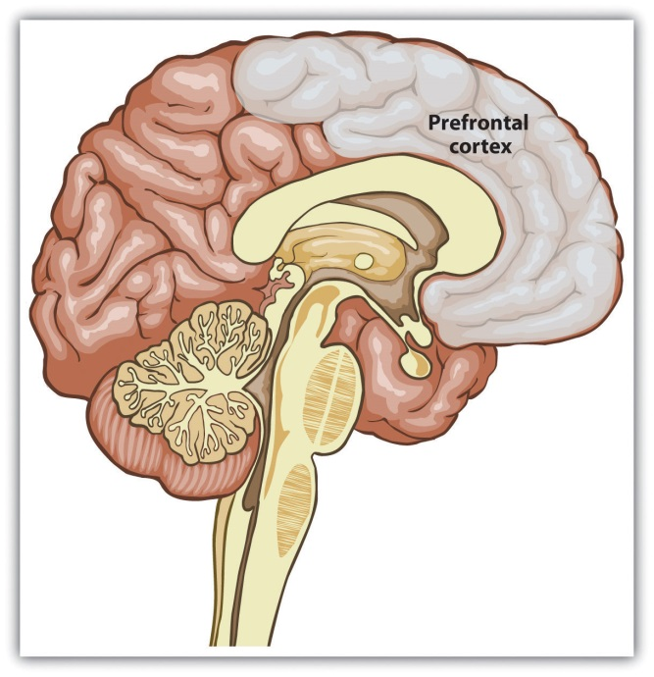
Recent advances in neuroimaging techniques have provided information about the brain structures that are involved in person perception. The prefrontal cortex shows strong activation when we are thinking about another person. Data are from Mason, Banfield, and Macrae (2004). ^{[7]}
Learning about people is a lot like learning about any other object in our environment, with one major exception. With an object, there is no interaction: We learn about the characteristics of a car or a cell phone, for example, without any concern that the car or the phone is learning about us. It is a one-way process. With people, in contrast, there is a two-way social process: Just as we are learning about another person, that person is learning about us, or potentially attempting to keep us from accurately perceiving him or her. For instance, research has found that when other people are looking directly at us, we process their features more fully and faster, and we remember them better, than when the same people are not looking at us (Hood & Macrae, 2007; Mason, Hood, & Macrae, 2004). ^{[8]}
In the social dynamic with others, then, we have two goals: First, we need to learn about them, and second, we want them to learn about (and, we hope, like and respect) us. Our focus here is on the former process—how we make sense of other people. But remember that just as you are judging them, they are judging you.
We have seen in Chapter 4 "The Self" that when people are asked to describe themselves, they generally do so in terms of their physical features (“I am really tall”), social category memberships (“I am a woman”), and traits (“I am friendly”). These characteristics well reflect the dimensions we use when we try to form impressions of others. In this section, we will review how we initially use the physical features and social category memberships of others (e.g., male or female, race, and ethnicity) to form judgments and then will focus on the role of personality traits in person perception.

Research Focus
Forming Impressions From Thin Slices
Although it might seem surprising, social psychological research has demonstrated that at least in some limited situations, people can draw remarkably accurate conclusions about others on the basis of very little data and that they can do this very quickly. (Rule & Ambady, 2010; Rule, Ambady, Adams, & Macrae, 2008; Rule, Ambady, & Hallett, 2009). ^{[9]}
Ambady and Rosenthal (1993) ^{[10]} made videotapes of six female and seven male graduate students while they were teaching an undergraduate course. The courses covered diverse areas of the college curriculum, including humanities, social sciences, and natural sciences. For each instructor, three 10-second video clips were taken—10 seconds from the first 10 minutes of the class, 10 seconds from the middle of the class, and 10 seconds from the last 10 minutes of the class.
Nine female undergraduates were asked to rate the 39 clips of the instructors individually on 15 dimensions, including optimistic, confident, active, enthusiastic, dominant, likable, warm, competent, and supportive. Ambady and her colleagues then compared the ratings of the instructors made by the participants who had seen the instructors for only 30 seconds with the ratings of the same instructors that had been made by actual students who had spent a whole semester with the instructors and who had rated them at the end of the semester on dimensions such as “the quality of the course section” and “the section leader’s performance.” The researchers used the Pearson correlation coefficient to make the comparison (remember that correlations nearer +1.0 or –1.0 are stronger correlations). As you can see in the following table, the ratings of the participants and the ratings of the students were highly positively correlated.

Table 6.1 Forming Accurate Impressions in Only 30 Seconds
Correlations of Molar Nonverbal Behaviors With College Teacher Effectiveness Ratings (Student Ratings)
Variable | r
Accepting | .50
Active | .77**
Attentive | .48
Competent | .56*
Confident | .82***
Dominant | .79**
Empathic | .45
Enthusiastic | .76**
Honest | .32
Likable | .73**
(Not) Anxious | .26
Optimistic | .84***
Professional | .53
Supportive | .55*
Warm | .67*
Global Variable | .76**
*p<.05. **p<.01. ***p<.001. Data are from Ambady and Rosenthal (1993).^{[11]}
If the finding that we can make accurate judgments about other people in only 30 seconds surprises you, then perhaps you will be even more surprised to learn that we do not even need that much time. Willis and Todorov (2006) ^{[12]} found that even a tenth of a second was enough to make judgments that correlated highly with the same judgments made by other people who were given several minutes to make the judgments. Other research has found that we can make accurate judgments in seconds or even milliseconds about, for instance, the personalities of salespersons (Ambady, Krabbenhoft, & Hogan, 2006) ^{[13]} and even whether or not a person is prejudiced (Richeson & Shelton, 2005). ^{[14]}
Todorov, Mandisodza, Goren, and Hall (2005) ^{[15]} reported a demonstration of just how important such initial impressions can be. These researchers showed participants pairs of political candidates who had run against each other in previous elections for the U.S. Senate and House of Representatives. Participants saw only the faces of the candidates, and they saw them in some cases for only one second. Their task was to judge which person in of each pair was the most competent. Todorov et al. (2005) ^{[16]} found that these judgments predicted the actual result of the election, such that 68% of the time the person judged to have the most competent face won.
Rule and Ambady (2010) ^{[17]} showed that perceivers were also able to accurately distinguish whether people were Democrats or Republicans based only on photos of their faces. Republicans were perceived as more powerful than Democrats, and Democrats were perceived as warmer than Republicans. And Rule, Ambady, Adams, and Macrae (2008) ^{[18]} found that people could accurately determine the sexual orientation of faces presented in photos (gay or straight) based on their judgments of what they thought “most people” would say.
Taken together, these data confirm that we can form a wide variety of initial impressions of others quickly and, at least in some cases, quite accurately. Of course, in these situations (unlike those faced by airport security guards), the people who were being observed were not trying to hide their personalities from the observers.

Nonverbal Behavior
One way that the participants in the studies we just described may have been able to form such accurate impressions of instructors on the basis of such little information was by viewing their nonverbal behavior. Nonverbal behavior is any type of communication that does not involve speaking, including facial expressions, body language, touching, voice patterns, and interpersonal distance. Nonverbal behaviors are used to reinforce spoken words (Hostetter, 2011) ^{[19]} but also include such things as interpersonal distance (how far away from you the other person stands), tone of voice, eye gaze, and hand gestures and body positions (DePaulo et al., 2003). ^{[20]}
The ability to decode nonverbal behavior is learned early, even before the development of language (Walker-Andrews, 2008). ^{[21]} We tend to like people who have pleasant tones of voice and open postures, who stand an appropriate distance away from us, and who look at and touch us for the “right” amount of time—not too much or too little. And of course behavior matters—people who walk faster are perceived as happier and more powerful than those who walk more slowly (Montepare & Zebrowitz-McArthur, 1988). ^{[22]}
The importance of body movement has been demonstrated in studies in which people are viewed in point-light displays in dark rooms with only small lights at their joints. Research has found that observers are able to accurately recognize others’ behaviors from these minimal displays (Clarke, Bradshaw, Field, Hampson, & Rose, 2005; Johnson, Gill, Reichman, & Tassinary, 2007; Heberlein, Adolphs, Tranel, & Damasio, 2004; See Figure 6.2 "Point-Light Displays"). ^{[23]} And people can also determine personality by tone of voice provided by degraded and incomprehensible speech (Ambady, Krabbenhoft, & Hogan, 2006). ^{[24]}
Although they may be pretty good at it in some cases, people are often not aware of their ability to make accurate judgments. Rule, Ambady, Adams, and Macrae (2008)^{[25]} found that even though the participants in their research were quite accurate in their perceptions, they could not articulate how they made their judgments. They claimed that they were “just guessing” and could hardly believe that they were getting the judgments right. These results suggest that they were made without any conscious awareness on the part of the judgers. Furthermore, the participants’ judgments of their own accuracy were not generally correlated with their actual accurate judgments.
The particular nonverbal behaviors that we use, as well as their meanings, are determined by social norms, and these norms may vary across cultures. For example, people who live in warm climates nearer the equator use more nonverbal communication (e.g., talking with their hands or showing strong facial expressions) and are more likely to touch each other during conversations than people who live in colder climates nearer Earth’s poles (Manstead, 1991; Pennebaker, Rime, & Blankenship, 1996). ^{[26]} And the appropriate amount of personal space to keep between ourselves and others also varies across cultures. In some cultures—for instance, South American countries—it is appropriate to stand very close to another person while talking to him or her; in other cultures—for example, the United States and Europe—more interpersonal space is the norm (Knapp & Hall, 2006). ^{[27]} The appropriate amount of eye contact with others is also determined by culture. In Latin America, it is appropriate to lock eyes with another person, whereas in Japan, people generally try to avoid eye contact.
Although nonverbal behaviors can be informative during the initial stages of person perception, they are limited in what they can convey. In general, they communicate our own status or dominance (self-concern) as well as our interest in or liking of another (other-concern). If we notice that someone is smiling and making eye contact with us while leaning toward us in conversation, we can be pretty sure that he or she likes us. On the other hand, if someone frowns at us, touches us inappropriately, or moves away when we get close, we may naturally conclude that they do not like us.
We may also use nonverbal behaviors to try out new situations: If we move a little closer and look at someone a bit longer, we communicate our interest. If these responses are reciprocated by the other person, that can indicate that he or she likes us, and we can move on to share other types of information. If the initial nonverbal behaviors are not reciprocated, then we may conclude that the relationship may not work out and we can withdraw before we go “too far.” When we use nonverbal communication, we do not have to come right out and say “I like you.” That’s dangerous!
Nonverbal behavior provides different information than verbal behavior because people frequently say one thing and do another. Perhaps you remember being really angry at someone but not wanting to let on that you were mad, so you tried to hide your emotions by not saying anything. But perhaps your nonverbal behavior eventually gave you away to the other person: Although you were trying as hard as you could not to, you just looked angry. I remember well a student I had in my social psychology class a few years ago. He would come up to me after class every few lectures to tell me how much he liked my class, what a great teacher I was, and so forth. But I noticed a strange discrepancy: When I watched him during class, he never seemed to be paying much attention. He was either doing a crossword puzzle or fiddling with his cell phone or even sleeping! What kind of impression do you think I formed of this student? Did I base it more on his verbal comments after class, or more on his nonverbal behavior that I observed when he didn’t realize I was watching him?
If you guessed that I believed my student’s nonverbal behavior, you are correct. We frequently rely more on nonverbal than on verbal behavior when their messages are contradictory. It is relatively easy to monitor our verbal behavior but harder to monitor the nonverbal. However, we expect that people who need to deceive others—for instance, good poker players—are able to monitor their nonverbal behavior better than most people, making it difficult to get a good read on them.
Because we use them so frequently in our social interactions, we are fluent readers of nonverbal behaviors. And we realize that we can better communicate with others when we use them. Indeed, it is difficult to communicate accurately when we cannot express ourselves nonverbally (Krauss, Chen, & Chawla, 1996). ^{[28]} You probably have noticed this yourself. If you e-mail or text a message to your friend, for instance, you need to be careful about using sarcasm because he or she might misinterpret your meaning. Because nonverbal information is so important, we quickly learned to incorporate it, in the form of emoticons, in our text messages (Figure 6.3).

Detecting Danger by Focusing on Negative Information
One thing that you might have noticed when you first looked at the images presented earlier in the chapter is that you tended to like some of the people and to dislike others. It is not surprising that you had these emotions—these initial affective reactions are an essential and highly adaptive part of person perception. One of the things that we need to determine when we are first perceiving someone is whether the person poses any threat to our well-being. We may dislike or experience negative emotions about people because we feel that they are likely to be sick or to harm us, just as we may like and feel positively about them if we feel that they can help us (Rozin & Royzman, 2001). ^{[29]} Research has found that the threat and the trustworthiness of others are particularly quickly perceived, at least by people who are not trying to hide their intentions (Bar, Neta, & Linz, 2006; Todorov, Said, Engel, & Oosterhof, 2008). ^{[30]}
Most people with whom we interact are not dangerous, nor do they create problems for us. In fact, when we are asked to rate how much we like complete strangers, we generally rate them positively (Sears, 1986). ^{[31]} Because we expect people to be positive, people who are negative or threatening are salient, likely to create strong emotional responses, and relatively easy to spot.
Compared with positive information, negative information about a person tends to elicit more physiological arousal, draw greater attention, and exert greater impact on our judgments and impressions of the person. Hansen and Hansen (1988) ^{[32]} had undergraduate students complete a series of trials in which they were shown, for very brief time periods, “crowds” of nine faces (Figure 6.4 "Faces"). On some of the trials, all the faces were happy ones or all the faces were angry. On other trials, the “crowd” was made up of eight happy faces and one angry face, or eight angry faces and one happy face. For each trial, the participants were instructed to say, as quickly as possible, whether the crowd contained a discrepant face or not. Hansen and Hansen found that the students were significantly faster at identifying the single angry face among the eight happy ones than they were at identifying the single happy face among the eight angry ones and that they also made significantly fewer errors doing so. The researchers’ conclusion was that angry, and thus threatening, faces quickly popped out from the crowd. Similarly, Ackerman et al. (2006) ^{[33]} found that people were better at recognizing the faces of other people when those faces had angry, rather than neutral, expressions, and Dijksterhuis and Aarts (2003) ^{[34]} found that people could more quickly and more accurately recognize negative, rather than positive, words.

Figure 6.4 Faces
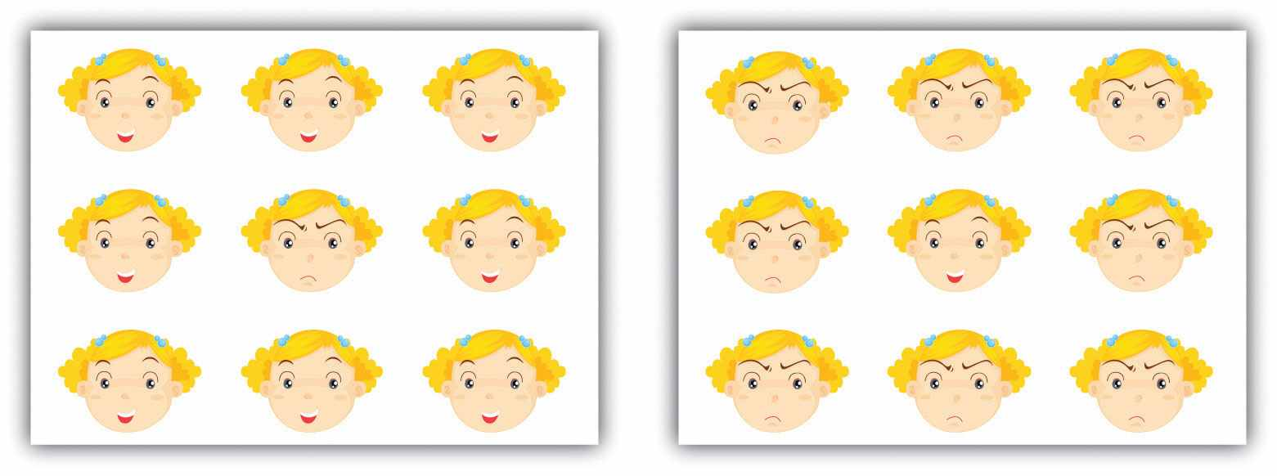
Because negative faces are more salient and therefore more likely to grab our attention than are positive faces, people are faster at locating a single negative face in a display of positive faces than they are to locate a single positive face in a display of negative faces.
Our brains seem to be hardwired to detect negative behaviors (Adams, Gordon, Baird, Ambady, & Kleck, 2003), ^{[35]} and at an evolutionary level this makes sense. It is important to tell the “good guys” from the “bad guys” and to try to avoid interacting with the latter. In one study, Tiffany Ito and her colleagues (Ito, Larsen, Smith, & Cacioppo, 1998) ^{[36]} showed college students a series of positive, negative, and neutral images while their event-related brain potentials were collected. The researchers found that different parts of the brain reacted to positive and negative images and that the response to negative images was greater overall. They concluded that “negative information weighs more heavily on the brain” (p. 887). In sum, the results of research in person perception are clear: When we are perceiving people, negative information is simply more important than positive information (Pratto & John, 1991).^{[37]}

Social Psychology in the Public Interest
Detecting Deception
One important person-perception task that we must all engage in sometimes is to try to determine whether other people are lying to us. We might wonder whether our poker opponent is bluffing, whether our partner is being honest when she tells us she loves us, or whether our boss is really planning to give us the promotion she has promised. This task is particularly important for members of courtroom juries, who are asked determine the truth or falsehood of the testimony given by witnesses. American jurors are instructed to judge the person’s truthfulness by considering his or her “demeanor upon the witness stand” and “manner of testifying” (Judicial Committee on Model Jury Instructions for the Eighth Circuit, 2002, p. 53). ^{[38]} And detecting deception is perhaps even more important for those whose job is to provide public security. How good are professionals, such as airport security officers, police detectives, and members of the CIA, FBI, and U.S. Secret Service, at determining whether or not someone is telling the truth?
It turns out that the average person is only moderately good at detecting deception and that experts do not seem to be much better. In a recent meta-analysis, researchers looked at over 200 studies that had tested the ability of almost 25,000 people to detect deception (Bond & DePaulo, 2006). ^{[39]} The researchers found that people were better than chance at doing so but were not really that great. The participants in the studies were able to correctly identify lies and truths about 54% of the time (chance performance is 50%). This is not a big advantage, but it is one that could have at least some practical consequences and that suggests that we can at least detect some deception. However, the meta-analysis also found that experts—including police officers, detectives, judges, interrogators, criminals, customs officials, mental health professionals, polygraph examiners, job interviewers, federal agents, and auditors—were not significantly better at detecting deception than were nonexperts. These findings seem consistent with the failure of the agents discussed in the chapter opener who attempted to spot potential hijackers at U.S. airports.
Why is it so difficult for us to detect liars? One reason is that people do not expect to be lied to. Most people are good and honest folks, we expect them to tell the truth, and we tend to give them the benefit of the doubt (Buller, Stiff, & Burgoon, 1996; Gilbert, Krull, & Malone, 1990). ^{[40]} In fact, people are more likely to expect deception when they view someone on a videotape than when they are having an interpersonal interaction with the person. It’s as if we expect the people who are right around us to be truthful (Bond & DePaulo, 2006). ^{[41]}
A second reason is that most people are pretty good liars. The cues that liars give off are quite faint, particularly when the lies that they are telling are not all that important.
Bella DePaulo and her colleagues (DePaulo et al., 2003) ^{[42]} found that in most cases, it was very difficult to tell if someone was lying, although it was easier when the liar was trying to cover up something important (e.g., a sexual transgression) than when he or she was lying about something less important. De Paulo and her colleagues did find, however, that there were some reliable cues to deception.
Compared with truth tellers, liars
- made more negative statements overall,
- appeared more tense,
- provided fewer details in their stories,
- gave accounts that were more indirect and less personal,
- took longer to respond to questions and exhibited more silent pauses when they were not able to prepare their responses,
- gave responses that were briefer and spoken in a higher pitch.
A third reason it is difficult for us to detect liars is that we tend to think we are better at catching lies than we actually are. This overconfidence may prevent us from working as hard as we should to try to uncover the truth.
Finally, most of us do not really have a very good idea of how to detect deception—we tend to pay attention to the wrong things. Many people think that a person who is lying will avert his or her gaze or will not smile or that perhaps he or she will smile too much. But it turns out that faces are not that revealing. The problem is that liars can more easily control their facial expressions than they can control other parts of their bodies. In fact, Ekman and Friesen (1974) ^{[43]} found that people were better able to detect other people’s true emotions when they could see their bodies but not their faces than when they could see their faces but not their bodies. Although we may think that deceivers do not smile when they are lying, it is actually common for them to mask their statements with false smiles—smiles that look very similar to the more natural smile that we make when we are really happy (Ekman & Davidson, 1993; Frank & Ekman, 1993). ^{[44]}
Recently, new advances in technology have begun to provide new ways to assess deception. Some new software analyzes the language of truth tellers, other software analyzes facial microexpressions that are linked with lying (Newman, Pennebaker, Berry, & Richards, 2003), ^{[45]} and still other software uses neuroimaging techniques to try to catch liars (Langleben et al., 2005). ^{[46]}Whether these techniques will be successful, however, remains to be seen.

Judging People by Their Traits
Although we can learn some things about others by observing their physical characteristics and their nonverbal behaviors, to really understand them we will eventually need to know their personality traits. Traits are important because they are the basic language by which we understand and communicate about people. When we talk about other people, we describe them using trait terms. Our friends are “fun,” “creative,” and “crazy in a good way,” or “quiet,” “serious,” and “controlling.” The language of traits is a powerful one—indeed, there are over 18,000 trait terms in the English language.

Combining Traits: Information Integration
Let’s consider for a moment how people might use trait terms to form an overall evaluation of another person. Imagine that you have to describe two friends of yours, William and Frank, to another person, Rianna, who might be interested in dating one of them. You’ll probably describe the two men in terms of their physical features first, but then you’ll want to say something about their personalities. Let’s say that you want to make both William and Frank sound as good as possible to Rianna, but you also want to be honest and not influence her one way or the other. How would you do that? You would probably start by mentioning their positive traits—William is “intelligent” and “serious,” Frank is “fun” and “exciting.” But to be fair, you would also need to mention their negative traits—William sometimes seems “depressed,” and Frank can be “inconsiderate” (sometimes he doesn’t show up on time).
You might figure that Rianna will just combine whatever information you give her, perhaps in a mathematical way. For instance, she might listen to all the traits that you mention, decide how positive or negative each one is, and then add the traits together or average them. Research has found that people do exactly that, both for strangers and for people that they know very well (Anderson, 1974; Falconi & Mullet, 2003). ^{[47]}Consider what might happen if you gave Rianna the following information:
- William is smart, serious, kind, and sad.
- Frank is fun, happy, selfish, and inconsiderate.
Rianna might decide to score each trait on a scale of +5 (very positive) to –5 (very negative). Once she has these numbers, she could then either add them together or average them to get an overall judgment.
William | Smart | +5
 | Serious | +1
 | Kind | +4
 | Sad | –4
Sum |  | +6.0
Average |  | +1.5
Frank | Fun | +3
 | Happy | +2
 | Selfish | –4
 | Inconsiderate | –5
Sum |  | –4.0
Average |  | –1.0
Based on this scoring, Rianna would probably decide that she likes William more than Frank. Of course, different people might weight the traits in somewhat different ways, and this would lead different people to draw different impressions about William and Frank. But there is pretty good agreement among most people about the meaning of traits, at least in terms of the overall positivity or negativity of each trait, and thus most people would be likely to draw similar conclusions.
Now imagine that you later thought of some other new, moderately positive characteristics about William—that he was also “careful” and “helpful.” Whether you told her about them or not might depend on how you thought they would affect her overall impression of William. Perhaps these new traits would make Rianna like William more (after all, they do add new positive information about him). But perhaps they might make her like him less (if the new, moderately positive information diluted the existing positive impression she has already formed about him).
One way to think about this is to consider whether Rianna might be adding the traits together or averaging them. In our first example, it didn’t matter because the outcome was the same. But now it might—if she’s adding the traits together, then Rianna will probably like William more after she hears the new information, because new positive traits have been added to the existing sum score. If she is averaging the traits together, however, then Rianna will probably like him less than she did before, because the new, more moderate information tends to dilute the initial impressions.
It turns out that in most cases, our judgments are better predicted by mental averaging than by mental adding (Mills, 2007). ^{[48]} What this means is that when you are telling someone about another person and you are trying to get them to like the person, say the most positive things that you know but leave out the more moderate (although also positive) information. The moderate information is more likely to dilute, rather than enhance, the more extreme information.

The Importance of the Central Traits Warm and Cold
Although the averaging model is quite good at predicting final impressions, it is not perfect. This is because some traits are simply weighted more heavily than others. For one, negative information is more heavily weighted than is positive information (Rozin & Royzman, 2001). ^{[49]} In addition to the heavy weight that we give to negative traits, we give a particular emphasis to the traits “warm” and “cold.” Imagine two men, Brad and Phil, who were described with these two sets of characteristics:
- Brad is industrious, critical, warm, practical, and determined.
- Phil is industrious, critical, cold, practical, and determined.
As you can see, the descriptions are identical except for the presence of “warm” and “cold.” Solomon Asch (1946) ^{[50]} found that people described with these two sets of traits were perceived very differently—the “warm” person very positively and the “cold” person very negatively.
To test whether or not these differences would influence real behavior, Harold Kelley (1950) ^{[51]} had students read about a professor who was described either as “rather cold” or as “very warm.” Then the professor came into the classroom and led a 20-minute discussion group with the students. Although the professor behaved in the same way for both groups, the students nevertheless reacted very differently to him. The students who were expecting the “warm” instructor were more likely to participate in the discussion, in comparison with those who were expecting him to be “cold.” And at the end of the discussion, the students also rated the professor who had been described as “warm” as being significantly more humorous, sociable, popular, and better natured than the “cold” professor. Moreover, the effects of warmth and coolness seem to be wired into our bodily responses. Research has found that even holding a cup of hot, versus iced, coffee or making judgments in warm, versus cold, rooms leads people to judge others more positively (Ijzerman & Semin, 2009; Williams & Bargh, 2008). ^{[52]}
In short, the particular dimension warm versus cold makes a big difference in how we perceive people—much bigger than do other traits. As a result, the traits of warm and cold are known as central traits (Asch, 1946). ^{[53]} The powerful influence of central traits is due to two things. For one, they lead us to make inferences about other traits that might not have been mentioned. The students who heard that the professor was “warm” might also have assumed that he had other positive traits (maybe “nice” and “funny”), in comparison with those who heard that he was “cold.” Second, the important central traits also color our perceptions of the other traits that surround them. When a person is described as “warm” and “intelligent,” the meaning of “intelligent” seems a lot better than does the term “intelligent” in the context of a person who is also “cold.” Overall, the message is clear: If you want to get someone to like you, try to act in a warm manner toward them. Be friendly, nice, and interested in what they say. This attention you pay to the other will be more powerful than any other characteristics that you might try to display to them.

First Impressions Matter: The Primacy Effect
It has frequently been said that “first impressions matter.” Social psychological research supports this idea. Information that we learn first is weighted more heavily than is information that comes later. This is known as the primacy effect. One demonstration of the primacy effect was conducted by Solomon Asch (1946). ^{[54]} In his research, participants learned some traits about a person and then made judgments about him. One half of the participants saw this list of traits:
- intelligent, industrious, impulsive, critical, stubborn, envious
The other half of the participants saw this list:
- envious, stubborn, critical, impulsive, industrious, intelligent
You may have noticed something interesting about these two lists—they contain exactly the same traits but in reverse order.
Asch discovered something interesting in his study: Because the traits were the same, we might have expected that both groups would form the same impression of the person, but this was not at all the case. Rather, Asch found that the participants who heard the first list, in which the positive traits came first, formed much more favorable impressions than did those who heard the second list, in which the negative traits came first. Similar findings were found by Edward Jones (1968), ^{[55]} who had participants watch one of two videotapes of a woman taking an intelligence test. In each video, the woman correctly answered the same number of questions and got the same number wrong. However, when the woman got most of her correct answers in the beginning of the test but got more wrong near the end, she was seen as more intelligent than when she got the same number correct but got more correct at the end of the test.
Primacy effects also show up in other domains, even in those that seem really important. For instance, Koppell and Steen (2004) ^{[56]} found that in elections in New York City, the candidate who was listed first on the ballot was elected more than 70% of the time, and Miller and Krosnick (1998) ^{[57]} found similar effects for candidate preferences in laboratory studies.
This is not to say that it is always good to be first. In some cases, the information that comes last can be most influential. Recency effects, in which information that comes later is given more weight, although much less common than primacy effects, may sometimes occur. For example, Bruine de Bruin (2005) ^{[58]} found that in competitions such as the Eurovision Song Contest and ice skating, higher marks were given to competitors who performed last.
Considering the primacy effect in terms of the cognitive processes central to human information processing leads us to understand why it can be so powerful. For one, humans are cognitive misers. Because we desire to conserve our energy, we are more likely to pay more attention to the information that comes first and less likely to attend to information that comes later. In fact, when people read a series of statements about a person, the amount of time they spend reading the items declines with each new piece of information (Belmore & Hubbard, 1987). ^{[59]} Not surprisingly, then, we are more likely to show the primacy effect when we are tired than when we are wide awake and when we are distracted than when we are paying attention (webster, Richter, & Kruglanski, 1996). ^{[60]}
Another reason for the primacy effect is that the early traits lead us to form an initial expectancy about the person, and once that expectancy is formed, we tend to process information in ways that keep that expectancy intact. This of course is a classic case of assimilation—once we have developed a schema, it becomes difficult to change it. If we learn that a person is “intelligent” and “industrious,” those traits become cognitively accessible, which leads us to develop an expectancy about the person. When the information about the negative features comes later, these negatives will be assimilated into the existing knowledge more than the existing knowledge is accommodated to fit the new information. Once we have formed a positive impression, the new negative information just doesn’t seem as bad as it might have been had we learned it first. On the other hand, if we learn the negatives first, the opposite happens—the positives don’t seem so positive when we get to them.
You can be sure that it would be good to take advantage of the primacy effect if you are trying to get someone to like you. Begin with your positive characteristics, and only bring the negatives up later. This will create a much better outcome than beginning with the negatives. And if your instructor is going to write a recommendation letter for you, she’ll likely do the same thing—she’ll put your good qualities first and save the poorer ones (if you have any!) for the second page of the letter.

KEY TAKEAWAYS
- Every day we must size up the people we interact with. The process of doing this is known as person perception.
- We can form a wide variety of initial impressions of others quickly and often quite accurately.
- Nonverbal behavior is communication that does not involve speaking, including facial expressions, body language, touching, voice patterns, and interpersonal distance. We rely on nonverbal behavior in our initial judgments of others.
- The particular nonverbal behaviors that we use, as well as their meanings, are determined by social norms, and these may vary across cultures.
- In comparison with positive information about people, negative information tends to elicit more physiological arousal, draw greater attention, and exert greater impact on our judgments and impressions of the people.
- People are only moderately good at detecting deception, and experts are not usually much better than the average person.
- We integrate traits to form judgments of people primarily by averaging them.
- Negative and central traits have a large effect on our impressions of others.
- The primacy effect occurs because we pay more attention to information that comes first and also because initial information colors how we perceive information that comes later.

EXERCISES AND CRITICAL THINKING
- Consider a case where you formed an impression of someone quickly and on only a little information. Do you think your judgment was accurate? Why or why not?
- Consider some of the nonverbal behaviors that you and your friends use when you communicate. What information are you usually trying to communicate by using them?
- Give an example of a situation in which you have noticed the effects of central traits or the primacy effect or in which you averaged or added information to make a judgment about someone.

[1] Haselton, M. G., & Funder, D. C. (2006). The evolution of accuracy and bias in social judgment. In M. Schaller, J. A. Simpson, & D. T. Kenrick (Eds.), Evolution and social psychology(pp. 15–37). Madison, CT: Psychosocial Press; Macrae, C. N., & Quadflieg, S. (2010). Perceiving people. In S. T. Fiske, D. T. Gilbert, & G. Lindzey (Eds.), Handbook of social psychology (5th ed., Vol. 1, pp. 428–463). Hoboken, NJ: John Wiley & Sons.
[2] Turati, C., Cassia, V. M., Simion, F., & Leo, I. (2006). Newborns’ face recognition: Role of inner and outer facial features. Child Development, 77(2), 297–311.
[3] Haxby, J. V., Hoffman, E. A., & Gobbini, M. I. (2000). The distributed human neural system for face perception. Trends in Cognitive Sciences, 4(6), 223–233.
[4] Carlston, D. E., & Skowronski, J. J. (2005). Linking versus thinking: Evidence for the different associative and attributional bases of spontaneous trait transference and spontaneous trait inference. Journal of Personality and Social Psychology, 89(6), 884–898; Fletcher-Watson, S., Findlay, J. M., Leekam, S. R., & Benson, V. (2008). Rapid detection of person information in a naturalistic scene. Perception, 37(4), 571–583.
[5] Ambady, N., Bernieri, F. J., & Richeson, J. A. (2000). Toward a histology of social behavior: Judgmental accuracy from thin slices of the behavioral stream. In M. P. Zanna (Ed.), Advances in experimental social psychology (Vol. 32, pp. 201–271). San Diego, CA: Academic Press.
[6] Mason, M. F., & Macrae, C. N. (2004). Categorizing and individuating others: The neural substrates of person perception. Journal of Cognitive Neuroscience, 16(10), 1785–1795. doi: 10.1162/0898929042947801
[7] Mason, M. F., & Macrae, C. N. (2004). Categorizing and individuating others: The neural substrates of person perception. Journal of Cognitive Neuroscience, 16(10), 1785–1795. doi: 10.1162/0898929042947801
[8] Hood, B. M., & Macrae, C. N. (2007). Look into my eyes: The effect of direct gaze on face processing in children and adults. In R. Flom, K. Lee, & D. Muir (Eds.), Gaze-following: Its development and significance (pp. 283–296). Mahwah, NJ: Lawrence Erlbaum; Mason, M. F., Hood, B. M., & Macrae, C. N. (2004). Look into my eyes: Gaze direction and person memory.Memory, 12(5), 637–643.
[9] Rule, N. O., & Ambady, N. (2010). Democrats and Republicans can be differentiated from their faces. PLoS ONE, 5(1), e8733; Rule, N. O., Ambady, N., Adams, R. B., Jr., & Macrae, C. N. (2008). Accuracy and awareness in the perception and categorization of male sexual orientation. Journal of Personality and Social Psychology, 95(5), 1019–1028; Rule, N. O., Ambady, N., & Hallett, K. C. (2009). Female sexual orientation is perceived accurately, rapidly, and automatically from the face and its features. Journal of Experimental Social Psychology, 45(6), 1245–1251.
[10] Ambady, N., & Rosenthal, R. (1993). Half a minute: Predicting teacher evaluations from thin slices of nonverbal behavior and physical attractiveness. Journal of Personality and Social Psychology, 64(3), 431–441.
[11] Ambady, N., & Rosenthal, R. (1993). Half a minute: Predicting teacher evaluations from thin slices of nonverbal behavior and physical attractiveness. Journal of Personality and Social Psychology, 64(3), 431–441.
[12] Willis, J., & Todorov, A. (2006). First impressions: Making up your mind after a 100ms exposure to a face. Psychological Science, 17(7), 592–598.
[13] Ambady, N., Krabbenhoft, M. A., & Hogan, D. (2006). The 30-sec sale: Using thin-slice judgments to evaluate sales effectiveness. Journal of Consumer Psychology, 16(1), 4–13. doi: 10.1207/s15327663jcp1601_2
[14] Richeson, J. A., & Shelton, J. N. (2005). Brief report: Thin slices of racial bias. Journal of Nonverbal Behavior, 29(1), 75–86.
[15] Todorov, A., Mandisodza, A. N., Goren, A., & Hall, C. C. (2005). Inferences of competence from faces predict election outcomes. Science, 308(5728), 1623–1626.
[16] Todorov, A., Mandisodza, A. N., Goren, A., & Hall, C. C. (2005). Inferences of competence from faces predict election outcomes. Science, 308(5728), 1623–1626.
[17] Rule, N. O., & Ambady, N. (2010). Democrats and Republicans can be differentiated from their faces. PLoS ONE, 5(1), e8733.
[18] Rule, N. O., Ambady, N., Adams, R. B., Jr., & Macrae, C. N. (2008). Accuracy and awareness in the perception and categorization of male sexual orientation. Journal of Personality and Social Psychology, 95(5), 1019–1028. doi: 10.1037/a0013194
[19] Hostetter, A. B. (2011). When do gestures communicate? A meta-analysis. Psychological Bulletin, 137 (2), 297–315.
[20] DePaulo, B. M., Lindsay, J. J., Malone, B. E., Muhlenbruck, L., Charlton, K., & Cooper, H. (2003). Cues to deception. Psychological Bulletin, 129(1), 74–118.
[21] Walker-Andrews, A. S. (2008). Intermodal emotional processes in infancy. In M. Lewis, J. M. Haviland-Jones, & L. F. Barrett (Eds.), Handbook of emotions (3rd ed., pp. 364–375). New York, NY: Guilford Press.
[22] Montepare, J. M., & Zebrowitz-McArthur, L. (1988). Impressions of people created by age-related qualities of their gaits. Journal of Personality and Social Psychology, 55(4), 547–556.
[23] Clarke, T. J., Bradshaw, M. F., Field, D. T., Hampson, S. E., & Rose, D. (2005). The perception of emotion from body movement in point-light displays of interpersonal dialogue.Perception, 34(10), 1171–1180; Johnson, K. L., Gill, S., Reichman, V., & Tassinary, L. G. (2007). Swagger, sway, and sexuality: Judging sexual orientation from body motion and morphology.Journal of Personality and Social Psychology, 93(3), 321–334; Heberlein, A. S., Adolphs, R., Tranel, D., & Damasio, H. (2004). Cortical regions for judgments of emotions and personality traits from point-light walkers. Journal of Cognitive Neuroscience, 16(7), 1143–1158.
[24] Ambady, N., Krabbenhoft, M. A., & Hogan, D. (2006). The 30-sec sale: Using thin-slice judgments to evaluate sales effectiveness. Journal of Consumer Psychology, 16(1), 4–13. doi: 10.1207/s15327663jcp1601_2
[25] Rule, N. O., Ambady, N., Adams, R. B., Jr., & Macrae, C. N. (2008). Accuracy and awareness in the perception and categorization of male sexual orientation. Journal of Personality and Social Psychology, 95(5), 1019–1028. doi: 10.1037/a0013194
[26] Manstead, A. S. R. (Ed.). (1991). Expressiveness as an individual difference. New York, NY: Cambridge University Press; Pennebaker, J. W., Rime, B., & Blankenship, V. E. (1996). Stereotypes of emotional expressiveness of Northerners and Southerners: A cross-cultural test of Montesquieu’s hypotheses. Journal of Personality and Social Psychology, 70(2), 372–380.
[27] Knapp, M. L., & Hall, J. A. (2006). Nonverbal communication in human interaction (6th ed.). Belmont, CA: Thomson Wadsworth.
[28] Krauss, R. M., Chen, Y., & Chawla, P. (Eds.). (1996). Nonverbal behavior and nonverbal communication: What do conversational hand gestures tell us? San Diego, CA: Academic Press.
[29] Rozin, P., & Royzman, E. B. (2001). Negativity bias, negativity dominance, and contagion.Personality and Social Psychology Review, 5(4), 296–320.
[30] Bar, M., Neta, M., & Linz, H. (2006). Very first impressions. Emotion, 6(2), 269–278. doi: 10.1037/1528–3542.6.2.269; Todorov, A., Said, C. P., Engel, A. D., & Oosterhof, N. N. (2008). Understanding evaluation of faces on social dimensions. Trends in Cognitive Sciences, 12(12), 455–460. doi: 10.1016/j.tics.2008.10.001
[31] Sears, D. O. (1986). College sophomores in the laboratory: Influences of a narrow data base on social psychology’s view of human nature. Journal of Personality and Social Psychology, 51(3), 515–530.
[32] Hansen, C. H., & Hansen, R. D. (1988). Finding the face in the crowd: An anger superiority effect. Journal of Personality and Social Psychology, 54(6), 917–924.
[33] Ackerman, J. M., Shapiro, J. R., Neuberg, S. L., Kenrick, D. T., Becker, D. V., Griskevicius, V.,…Schaller, M. (2006). They all look the same to me (unless they’re angry): From out-group homogeneity to out-group heterogeneity. Psychological Science, 17(10), 836–840.
[34] Dijksterhuis, A., & Aarts, H. (2003). On wildebeests and humans: The preferential detection of negative stimuli. Psychological Science, 14(1), 14–18.
[35] Adams, R. B., Jr., Gordon, H. L., Baird, A. A., Ambady, N., & Kleck, R. E. (2003). Effects of gaze on amygdala sensitivity to anger and fear faces. Science, 300(5625), 1536.
[36] Ito, T. A., Larsen, J. T., Smith, N. K., & Cacioppo, J. T. (1998). Negative information weighs more heavily on the brain: The negativity bias in evaluative categorizations. Journal of Personality and Social Psychology, 75(4), 887–900.
[37] Pratto, F., & John, O. P. (1991). Automatic vigilance: The attention-grabbing power of negative social information. Journal of Personality and Social Psychology, 61(3), 380–391.
[38] Federal Evidence Review. Federal jury instructions resource page. Retrieved fromhttp://federalevidence.com/evidence-resources/federal-jury-instructions
[39] Bond, C. F., Jr., & DePaulo, B. M. (2006). Accuracy of deception judgments. Personality and Social Psychology Review, 10(3), 214–234.
[40] Buller, D. B., Stiff, J. B., & Burgoon, J. K. (1996). Behavioral adaptation in deceptive transactions: Fact or fiction: Reply to Levine and McCornack. Human Communication Research, 22(4), 589–603; Gilbert, D. T., Krull, D. S., & Malone, P. S. (1990). Unbelieving the unbelievable: Some problems in the rejection of false information. Journal of Personality and Social Psychology, 59(4), 601–613.
[41] Bond, C. F., Jr., & DePaulo, B. M. (2006). Accuracy of deception judgments. Personality and Social Psychology Review, 10(3), 214–234.
[42] DePaulo, B. M., Lindsay, J. J., Malone, B. E., Muhlenbruck, L., Charlton, K., & Cooper, H. (2003). Cues to deception. Psychological Bulletin, 129(1), 74–118.
[43] Ekman, P., & Friesen, W. V. (1974). Detecting deception from the body or face. Journal of Personality and Social Psychology, 29(3), 288–298. doi: 10.1037/h0036006
[44] Ekman, P., & Davidson, R. J. (1993). Voluntary smiling changes regional brain activity.Psychological Science, 4(5), 342–345; Frank, M. G., & Ekman, P. (1993). Not all smiles are created equal: The differences between enjoyment and nonenjoyment smiles. Humor: International Journal of Humor Research, 6(1), 9–26.
[45] Newman, M. L., Pennebaker, J. W., Berry, D. S., & Richards, J. M. (2003). Lying words: Predicting deception from linguistic styles. Personality and Social Psychology Bulletin, 29(5), 665–675.
[46] Langleben, D. D., Loughead, J. W., Bilker, W. B., Ruparel, K., Childress, A. R., Busch, S. I., & Gur, R. C. (2005). Telling truth from lie in individual subjects with fast event-related fMRI.Human Brain Mapping, 26(4), 262–272.
[47] Anderson, N. H. (1974). Cognitive algebra: Integration theory applied to social attribution. In L. Berkowitz (Ed.), Advances in experimental social psychology (Vol. 7, pp. 1–101). New York, NY: Academic Press; Falconi, A., & Mullet, E. (2003). Cognitive algebra of love through the adult life. International Journal of Aging and Human Development, 57(3), 275–290.
[48] Mills, J. (2007). Evidence forming attitudes from combining beliefs about positive attributes of activities follows averaging (Unpublished manuscript). University of Maryland, College Park.
[49] Rozin, P., & Royzman, E. B. (2001). Negativity bias, negativity dominance, and contagion.Personality and Social Psychology Review, 5(4), 296–320.
[50] Asch, S. E. (1946). Forming impressions of personality. Journal of Abnormal and Social Psychology, 41, 258–290.
[51] Kelley, H. H. (1950). The warm-cold variable in first impressions of persons. Journal of Personality,18(4), 431–439.
[52] Ijzerman, H., & Semin, G. R. (2009). The thermometer of social relations: Mapping social proximity on temperature. Psychological Science, 20(10), 1214–1220; Williams, L. E., & Bargh, J. A. (2008). Experiencing physical warmth promotes interpersonal warmth. Science, 322(5901), 606–607.
[53] Asch, S. E. (1946). Forming impressions of personality. Journal of Abnormal and Social Psychology, 41, 258–290.
[54] Asch, S. E. (1946). Forming impressions of personality. Journal of Abnormal and Social Psychology, 41, 258–290.
[55] Jones, E. E. (1968). Pattern of performance and ability attribution: An unexpected primacy effect. Journal of Personality and Social Psychology, 10(4), 317–340.
[56] Koppell, J. G. S., & Steen, J. A. (2004). The effects of ballot position on election outcomes.Journal of Politics, 66(1), 267–281.
[57] Miller, J. M., & Krosnick, J. A. (1998). The impact of candidate name order on election outcomes. Public Opinion Quarterly, 62(3), 291–330.
[58] de Bruin, W. B. (2005). Save the last dance for me: Unwanted serial position effects in jury evaluations. Acta Psychologica, 118(3), 245–260. doi: 10.1016/j.actpsy.2004.08.005
[59] Belmore, S. M., & Hubbard, M. L. (1987). The role of advance expectancies in person memory. Journal of Personality and Social Psychology, 53(1), 61–70.
[60] webster, D. M., Richter, L., & Kruglanski, A. W. (1996). On leaping to conclusions when feeling tired: Mental fatigue effects on impressional primacy. Journal of Experimental Social Psychology, 32(2), 181–195.

6.2 Inferring Dispositions Using Causal Attribution

LEARNING OBJECTIVES
- Review the fundamental principles of causal attribution.
- Compare and contrast the tendency to make person attributions for unusual events, the covariation principle, and Weiner’s model of success and failure.
- Describe some of the factors that lead to inaccuracy in causal attribution.
We have seen that we use personality traits to help us understand and communicate about the people we know. But how do we know what traits people have? People don’t walk around with labels saying “I am generous” or “I am aggressive” on their foreheads. In some cases, we may learn about a person indirectly, for instance, through the comments that other people make about that person. We also use the techniques of person perception to help us learn about people and their traits by observing them and interpreting their behaviors. If Frank hits Joe, we might conclude that Frank is aggressive. If Leslie leaves a big tip for the waitress, we might conclude that Leslie is generous. It seems natural and reasonable to make such inferences because we can assume (often, but not always, correctly) that behavior is caused by personality. It is Frank’s aggressiveness that causes him to hit, and it is Leslie’s generosity that led to her big tip.
Although we can sometimes infer personality by observing behavior, this is not always the case. Remember that behavior is influenced by both our personal characteristics and the social context in which we find ourselves. What this means is that the behavior we observe other people engaging in might not always be that reflective of their personality—the behavior might have been caused by the situation rather than by underlying person characteristics. Perhaps Frank hit Joe not because he is really an aggressive person but because Joe insulted or provoked him first. And perhaps Leslie left a big tip in order to impress her friends rather than because she is truly generous.
Because behavior is determined by both the person and the situation, we must attempt to determine which of these two causes actually determined the behavior. The process of trying to determine the causes of people’s behavior is known ascausal attribution (Heider, 1958). ^{[1]} Because we cannot see personality, we must work to infer it. When a couple we know breaks up, despite what seemed to be a match made in heaven, we are naturally curious. What could have caused the breakup? Was it something one of them said or did? Or perhaps stress from financial hardship was the culprit?
Making a causal attribution is a bit like conducting a social psychology experiment. We carefully observe the people we are interested in, and we note how they behave in different social situations. After we have made our observations, we draw our conclusions. We make a personal (or internal or dispositional) attributionwhen we decide that the behavior was caused primarily by the person. A personal attribution might be something like “I think they broke up because Sarah was not committed to the relationship.” At other times, we may determine that the behavior was caused primarily by the situation—we call this making asituational (or external) attribution. A situational attribution might be something like “I think they broke up because they were under such financial stress.” At yet other times, we may decide that the behavior was caused by both the person and the situation.

Making Inferences About Personality
It is easier to make personal attributions in some cases than in others. When a behavior is unusual or unexpected, we can more easily make a personal attribution for it. Imagine that you go to a party and you are introduced to Tess. Tess shakes your hand and says, “Nice to meet you!” Can you readily conclude, on the basis of this behavior, that Tess is a friendly person? Probably not. Because the social context demands that people act in a friendly way (by shaking your hand and saying “Nice to meet you”), it is difficult to know whether Tess acted friendly because of the situation or because she is really friendly. Imagine, however, that instead of shaking your hand, Tess sticks her tongue out at you and walks away. I think you would agree that it is easier in this case to infer that Tess is unfriendly because her behavior is so contrary to what one would expect.
To test this idea, Edward Jones and his colleagues (Jones, Davis, & Gergen, 1961) ^{[2]}conducted an experiment in which participants viewed one of four different videotapes of a man who was applying for a job. For half the participants, the video they viewed indicated that the man was interviewing for a job as a submariner, a position that required close contact with many people over a long period of time. It was clear to the man being interviewed, as well as to the research participants, that to be a good submariner you should be extroverted (i.e., you should enjoy being around others). The other half of the participants saw a video in which the man was interviewing for a job as an astronaut, which involved (remember, this study was conducted in 1961) being in a small capsule, alone, for days on end. In this case, it was clear to everyone that in order to be good astronaut, you should have an introverted personality.
During the videotape of the interview, a second variable was also manipulated. One half of the participants saw the man indicate that he was actually an introvert (he said things such as “I like to work on my own,” “I don’t go out much”), and the other half saw the man say that he was actually an extrovert (he said things such as “I would like to be a salesman,” “I always get ideas from others”). After viewing one of the four videotapes, participants were asked to indicate how introverted or extroverted they thought the applicant really was.
As you can see in Table 6.2 "Attributions to Expected and Unexpected Behaviors", when the applicant gave responses that better matched what was required by the job (i.e., for the submariner job, the applicant said he was an extrovert, and for the astronaut job, he said he was an introvert), the participants did not think his statements were as indicative of his underlying personality as they did when the applicant said the opposite of what was expected by the job (i.e., when the job required that he be extroverted but he said he was introverted, or vice versa).

Table 6.2 Attributions to Expected and Unexpected Behaviors
The Job Applied For | Extraverted | Introverted
Astronaut | 91 | 71
Submariner | 71 | 45
We are more likely to draw personal attributions when a behavior is unexpected. The numbers represent the percentage of extraverted responses that participants believed the job applicant would actually endorse if he were telling the complete truth. Participants were more likely to believe that the applicant was more extraverted (91%) and more introverted (45%) when he said that he didnot have the personality traits required by the job than when he said that he didhave the personality traits required by the job. Data are from Jones, Davis, and Gergen (1961). ^{[3]}
The idea here is that the statements that were unusual or unexpected (on the basis of the job requirements) just seemed like they could not possibly have been caused by the situation, so the participants really thought that the interviewee was telling the truth. On the other hand, when the interviewees made statements that were consistent with what was required by the situation, it was more difficult to be sure that he was telling the truth (perhaps he was just saying these things because he wanted to get the job), and the participants made weaker personal attributions for his behavior.
We can also make personal attributions more easily when we know that the person had a choice in the behavior. If a person chooses to be friendly, even in situations in which he might not be, this probably means that he is friendly. But if we can determine that he’s been forced to be friendly, it’s more difficult to know. I’m sure you would agree that if you saw a man pointing a gun at another person, and then you saw that person give his watch and wallet to the gunman, you would not infer that the person was generous!
Jones and Harris (1967) ^{[4]} had student participants in a study read essays that had been written by other students. Half of the participants thought that the students had chosen the essay topics, whereas the other half thought that the students had been assigned the topics by their professor. The participants were more likely to make a personal attribution that the students really believed in the essay they were writing when they had chosen the topics rather than been assigned topics.
Sometimes a person may try to lead others to make personal attributions for their behavior to make themselves seem more believable to those others. For example, when a politician makes statements supporting a cause in front of an audience that does not agree with her position, the politician will be seen as more committed to her beliefs, and may be more persuasive, than if she gave the same argument in front of an audience known to support her views. Again, the idea is based on principles of attribution—if there is an obvious situational reason for making a statement (the audience supports the politician’s views), then the personal attribution (that the politician really believes what she is saying) is harder to make.

Detecting the Covariation Between Personality and Behavior
So far, we have considered how we make personal attributions when we have only limited information, that is, behavior observed at only a single point in time—a woman leaving a big tip at a restaurant, a man answering questions at a job interview, or a politician giving a speech. But the process of making attributions also occurs when we are able to observe a person’s behavior in more than one situation. Certainly, we can learn more about Leslie’s generosity if she gives a big tip in many different restaurants with many different people, and we can learn more about a politician’s beliefs by observing the kinds of speeches she gives to different audiences over time.
When people have multiple sources of information about the behavior of a person, they can make attributions by assessing the relationship between a person’s behavior and the social context in which it occurs. One way of doing so is to use thecovariation principle, which states that a given behavior is more likely to have been caused by the situation if that behavior covaries (or changes) across situations.Our job, then, is to study the patterns of a person’s behavior across different situations in order to help us to draw inferences about the causes of that behavior (Jones et al., 1987; Kelley, 1967). ^{[5]}
Research has found that people focus on three kinds of covariation information when they are observing the behavior of others (Cheng & Novick, 1990). ^{[6]}
- Consistency information. A situation seems to be the cause of a behavior if the situation always produces the behavior. For instance, if I always start to cry at weddings, then it seems as if the wedding is the cause of my crying.
- Distinctiveness information. A situation seems to be the cause of a behavior if the behavior occurs when the situation is present but not when it is not present. For instance, if I only cry at weddings but not at any other time, then it seems as if the wedding is the cause of my crying.
- Consensus information. A situation seems to be the cause of a behavior if the situation creates the same behavior in most people. For instance, if many people cry at weddings, then it seems as if the wedding is the cause of my (and the other people’s) crying.
Imagine that your friend Jane likes to go out with a lot of different guys, and you have observed her behavior with each of these guys over time. One night she goes to a party with Jimmy, where you observe something unusual. Although Jane has come to the party with Jimmy, she completely ignores him all night. She dances with some other guys, and in the end she leaves the party with someone else. This is the kind of situation that might make you wonder about the cause of Jane’s behavior (is she a rude person, or is this behavior caused more by Jimmy?) and for which you might use the covariation principle to attempt to draw some conclusions.
According to the covariation principle, you should be able to determine the cause of Jane’s behavior by considering the three types of covariation information: consistency, distinctiveness, and consensus. One question you might ask is whether Jane always treats Jimmy this way when she goes out with him. If the answer is yes, then you have some consistency information—the situation (Jimmy’s presence) always produces the same behavior in Jane. If you have noticed that Jane ignores Jimmy more than she ignores the other men she dates, then you also have distinctiveness information—the behavior is occurring only (or at least more often or more strongly) when the social situation (Jimmy) is present. Finally, you might look for consensus informationtoo—if the other women Jimmy goes out with also treat him this way, then it seems, again, as if it’s Jimmy who is causing the behavior.
Consider one more example. Imagine that a friend of yours tells you that he has just seen a new movie and that it is the greatest movie he’s ever seen. As you wonder whether you should make an attribution to the situation (the movie), you will naturally ask about consensus—do other people like the movie too? If they do, then you have positive consensus information about how good the movie is. But you probably also have some information about your friend’s experiences with movies over time. If you are like me, you probably have friends who love every movie they see; if this is the case for this friend, you probably won’t yet be that convinced that it’s a great movie—in this case, your friend’s reactions would not be distinctive. On the other hand, if your friend does not like of most movies he sees but loves this one, then distinctiveness is strong (the behavior is occurring only in this particular situation). If this is the case, then you can be more certain it’s something about the movie that has caused your friend’s enthusiasm. Your next thought may be, “I’m going to see that movie tonight.” You can see still another example of the use of covariation information in Table 6.3 "Using Covariation Information".

Table 6.3 Using Covariation Information
Attribution | Consensus | Distinctiveness | Consistency
An external attribution (to the situation, in this case the TV show) is more likely if… | All my friends laugh at this TV show | Bill laughs more at this TV show | Bill always laughs more at this TV show than other TV shows
An internal attribution (to the person, in this case Bill) is more likely if… | Very few of my friends laugh at this TV show | Bill laughs at this TV show as much as he laughs at other TV shows | Bill only sometimes laughs at this TV show
According to the covariation principle, we use three sources of information to help us determine whether we should make an attribution to the situation or to the person. In this example, the attribution is either personal (to my friend Bill) or situational (to a TV show we are watching).

Attributions for Success and Failure
Still another time when we may use our powers of causal attribution to help us determine the causes of events is when we attempt to determine why we or others have succeeded or failed at a task. Think back for a moment to a test that you took, or perhaps about another task that you performed, and consider why you did either well or poorly on it. Then see if your thoughts reflect what Bernard Weiner (1985) ^{[7]}considered to be the important factors in this regard.
Weiner was interested in how we determine the causes of success or failure because he felt that this information was particularly important for us: Accurately determining why we have succeeded or failed will help us see which tasks we are at good at already and which we need to work on in order to improve. Weiner also proposed that we make these determinations by engaging in causal attribution and that the outcomes of our decision-making process were made either to the person (“I succeeded/failed because of my own person characteristics”) or to the situation (“I succeeded/failed because of something about the situation”).
Weiner’s analysis is shown in Figure 6.5 "Attributions for Success and Failure". According to Weiner, success or failure can be seen as coming from personal causes (ability or motivation) or from situational causes (luck or task difficulty). However, he also argued that those personal and situational causes could be either stable (less likely to change over time) or unstable (more likely to change over time).

Figure 6.5 Attributions for Success and Failure
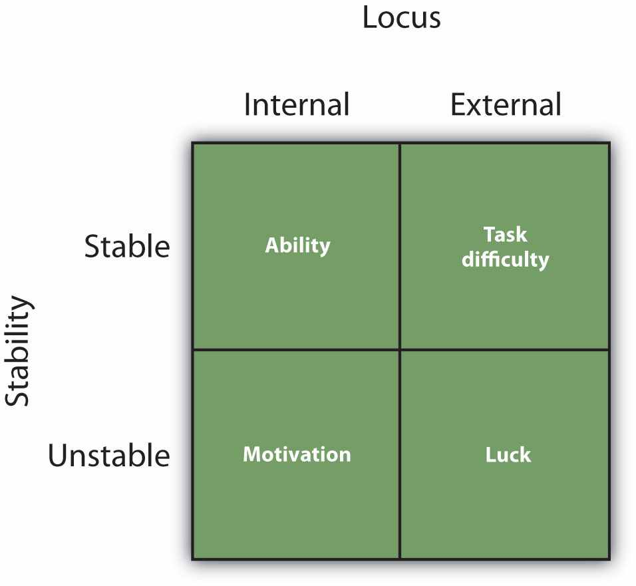
This figure shows the potential attributions that we can make for our, or for other people’s, success or failure. Locus considers whether the attributions are to the person or to the situation, and stability considers whether or not the situation is likely to remain the same over time.
If you did well on a test because you are really smart, then this is a personal and stable attribution of ability. It’s clearly something that is caused by you personally, and it is also a stable cause—you are smart today, and you’ll probably be smart in the future. However, if you succeeded more because you studied hard, then this is a success due tomotivation. It is again personal (you studied), but it is also unstable (although you studied really hard for this test, you might not work so hard for the next one). Weiner considered task difficulty to be a situational cause—you may have succeeded on the test because it was easy, and he assumed that the next test would probably be easy for you too (i.e., that the task, whatever it is, is always either hard or easy). Finally, Weiner considered success due to luck (you just guessed a lot of the answers correctly) to be a situational cause, but one that was more unstable than task difficulty.
It turns out that although Weiner’s attributions do not always fit perfectly (e.g., task difficulty may sometimes change over time and thus be at least somewhat unstable), the four types of information pretty well capture the types of attributions that people make for success and failure.

Are Our Attributions Accurate?
We have seen that person perception is useful in helping us successfully interact with others. If we can figure out why our roommate is angry at us, we can respond appropriately to resolve the problem; and if we can determine why we did so poorly on the last psychology test, we can try to prepare differently so we do better on the next test. Because successful navigation of the social world is based on being accurate, we can expect that our attributional skills will be pretty good. However, although people are reasonably accurate in their attributions—we could say, perhaps, that they are “good enough” (Fiske, 2003) ^{[8]}—they are far from perfect. In fact (and I doubt this is going to surprise you), causal attributions are subject to the same types of biases that any other types of social judgments are. Let’s consider some of the ways that our attributions may go awry.

Overemphasizing the Role of the Person
One way that our attributions are biased is that we are often too quick to attribute the behavior of other people to something personal about them rather than to something about their situation. This is a classic example of the general human tendency of underestimating how important the social situation really is in determining behavior. This bias occurs in two ways. First, we are too likely to make strong personal attributions to account for the behavior that we observe others engaging in. That is, we are more likely to say “Leslie left a big tip, so she must be generous” than “Leslie left a big tip, but perhaps that was because she was trying to impress her friends.” Second, we also tend to make more personal attributions about the behavior of others (we tend to say “Leslie is a generous person”) than we do for ourselves (we tend to say “I am generous in some situations but not in others”). Let’s consider each of these biases (thefundamental attribution error and the actor-observer difference) in turn.
When we explain the behavior of others, we tend to overestimate the role of person factors and overlook the impact of situations. In fact, the tendency to do so is so common that it is known as thefundamental attribution error (correspondence bias).
In one demonstration of the fundamental attribution error, Linda Skitka and her colleagues (Skitka, Mullen, Griffin, Hutchinson, & Chamberlin, 2002) ^{[9]} had participants read a brief story about a professor who had selected two student volunteers to come up in front of a class to participate in a trivia game. The students were described as having been randomly assigned to the role of a quizmaster or of a contestant by drawing straws. The quizmaster was asked to generate five questions from his idiosyncratic knowledge, with the stipulation that he knew the correct answer to all five questions.
Joe (the quizmaster) subsequently posed his questions to the other student (Stan, the contestant). For example, Joe asked, “What cowboy movie actor’s sidekick is Smiley Burnette?” Stan looked puzzled and finally replied, “I really don’t know. The only movie cowboy that pops to mind for me is John Wayne.” Joe asked four additional questions, and Stan was described as answering only one of the five questions correctly. After reading the story, the students were asked to indicate their impression of both Stan’s and Joe’s intelligence.
If you think about the setup here, you’ll notice that the professor has created a situation that can have a big influence on the outcomes. Joe, the quizmaster, has a huge advantage because he got to choose the questions. As a result, the questions are hard for the contestant to answer. But did the participants realize that the situation was the cause of the outcomes? They did not. Rather, the students rated Joe as significantly more intelligent than Stan. You can imagine that Joe just seemed to be really smart to the students; after all, he knew all the answers, whereas Stan knew only one of the five. But of course this is a mistake. The difference was not at all due to person factors but completely to the situation—Joe got to use his own personal store of esoteric knowledge to create the most difficult questions he could think of. The observers committed the fundamental attribution error and did not sufficiently take the quizmaster’s situational advantage into account.
The fundamental attribution error involves a bias in how easily and frequently we make personal versus situational attributions to others. Another, similar way that we overemphasize the power of the person is that we tend to make more personal attributions for the behavior of others than we do for ourselves and to make more situational attributions for our own behavior than for the behavior of others. This is known as the actor-observer difference (Nisbett, Caputo, Legant, & Marecek, 1973; Pronin, Lin, & Ross, 2002). ^{[10]} When we are asked about the behavior of other people, we tend to quickly make trait attributions (“Oh, Sarah, she’s really shy”). On the other hand, when we think of ourselves, we are more likely to take the situation into account—we tend to say, “Well, I’m shy in my psychology discussion class, but with my baseball friends I’m not at all shy.” When our friend behaves in a helpful way, we naturally believe that she is a friendly person; when we behave in the same way, on the other hand, we realize that there may be a lot of other reasons why we did what we did.
You might be able to get a feel for the actor-observer difference by taking the following short quiz. First, think about a person you know—your mom, your roommate, or someone from one of your classes. Then, for each row, circle which of the three choices best describes his or her personality (for instance, is the person’s personality more energetic, relaxed, or does it depend on the situation?). Then answer the questions again, but this time about yourself.
1. | Energetic | Relaxed | Depends on the situation
2. | Skeptical | Trusting | Depends on the situation
3. | Quiet | Talkative | Depends on the situation
4. | Intense | Calm | Depends on the situation
Richard Nisbett and his colleagues (Nisbett, Caputo, Legant, & Marecek, 1973) ^{[11]}had college students complete exactly this task—they did it for themselves, for their best friend, for their father, and for the newscaster Walter Cronkite. As you can see inTable 6.4 "The Actor-Observer Difference", the participants checked one of the two trait terms more often for other people than they did for themselves and checked off “depends on the situation” more frequently for themselves than they did for the other person—this is the actor-observer difference.

Table 6.4 The Actor-Observer Difference
 | Trait Term | Depends on the Situation
Self | 11.92 | 8.08
Best Friend | 14.21 | 5.79
Father | 13.42 | 6.58
Walter Cronkite | 15.08 | 4.92
This table shows the average number of times (out of 20) that participants checked off a trait term (such as “energetic” or “talkative”) rather than “depends on the situation” when asked to describe the personalities of themselves and various other people. You can see the actor-observer difference. Participants were significantly more likely to check off “depends on the situation” for themselves than for others. Data are from Nisbett, Caputo, Legant, and Marecek (1973). ^{[12]}
Like the fundamental attribution error, the actor-observer difference reflects our tendency to overweight the personal explanations of the behavior of other people. However, a recent meta-analysis (Malle, 2006) ^{[13]} has suggested that the actor-observer difference might not be as strong as the fundamental attribution error is and may only be likely to occur for some people.
The tendency to overemphasize personal attributions seems to occur for several reasons. One reason is simply because other people are so salient in our social environments. When I look at you, I see you as my focus, and so I am likely to make personal attributions about you. It’s just easy because I am looking right at you. When I look at Leslie giving that big tip, I see her—and so I decide that it is she who caused the action. When I think of my own behavior, however, I do not see myself but am instead more focused on my situation. I realize that it is not only me but also the different situations that I am in that determine my behavior. I can remember the other times that I didn’t give a big tip, and so I conclude that my behavior is caused more by the situation than by my underlying personality. In fact, research has shown that we tend to make more personal attributions for the people we are directly observing in our environments than for other people who are part of the situation but who we are not directly watching (Taylor & Fiske, 1975). ^{[14]}
A second reason for the tendency to make so many personal attributions is that they are simply easier to make than situational attributions. In fact, personal attributions seem to be made spontaneously, without any effort on our part, and even on the basis of only very limited behavior (Newman & Uleman, 1989; Uleman, Blader, & Todorov, 2005). ^{[15]} Personal attributions just pop into mind before situational attributions do.
Third, personal attributions also dominate because we need to make them in order to understand a situation. That is, we cannot make either a personal attribution (e.g., “Leslie is generous”) or a situational attribution (“Leslie is trying to impress her friends”) until we have first identified the behavior as being a generous behavior (“Leaving that big tip was a generous thing to do”). So we end up starting with the personal attribution (“generous”) and only later try to correct or adjust our judgment (“Oh,” we think, “perhaps it really was the situation that caused her to do that”).
Adjusting our judgments generally takes more effort than making the original judgment does, and the adjustment is frequently not sufficient. We are more likely to commit the fundamental attribution error—quickly jumping to the conclusion that behavior is caused by underlying personality—when we are tired, distracted, or busy doing other things (Geeraert, Yzerbyt, Corneille, & Wigboldus, 2004; Gilbert, 1989; Trope & Alfieri, 1997). ^{[16]}
I hope you might have noticed that there is an important moral about perceiving others that applies here: We should not be too quick to judge other people! It is easy to think that poor people are lazy, that people who harm someone else are mean, and that people who say something harsh are rude or unfriendly. But these attributions may frequently overemphasize the role of the person. This can sometimes result in overly harsh evaluations of people who don’t really deserve them—we tend to blame the victim, even for events that they can’t really control (Lerner, 1980). ^{[17]} Sometimes people are lazy, mean, or rude, but they may also be the victims of situations. When you find yourself making strong personal attribution for the behaviors of others, your experience as a social psychologist should lead you to stop and think more carefully: Would you want other people to make personal attributions for your behavior in the same situation, or would you prefer that they more fully consider the situation surrounding your behavior? Are you perhaps making the fundamental attribution error?

Self-Serving Attributions
You may recall that the process of making causal attributions is supposed to proceed in a careful, rational, and even scientific manner. But this assumption turns out to be, at least in part, untrue. Our attributions are sometimes biased by affect—particularly the fundamental desire to enhance the self. Although we would like to think that we are always rational and accurate in our attributions, we often tend to distort them to make us feel better. Self-serving attributions are attributions that help us meet our desires to see ourselves positively (Mezulis, Abramson, Hyde, & Hankin, 2004). ^{[18]}
I have noticed that I sometimes make self-enhancing attributions. If my students do well on one of my exams, I make a personal attribution for their successes (“I am, after all, a great teacher!”). On the other hand, when my students do poorly on an exam, I tend to make a situational attribution—I blame them for their failure (“Why didn’t you guys study harder?”). You can see that this process is clearly not the type of scientific, rational, and careful process that attribution theory suggests I should be following. It’s unfair, although it does make me feel better about myself. If I were really acting like a scientist, however, I would determine ahead of time what causes good or poor exam scores and make the appropriate attribution regardless of the outcome.
You might have noticed yourself making self-serving attributions too. Perhaps you have blamed another driver for an accident that you were in or blamed your partner rather than yourself for a breakup. Or perhaps you have taken credit (internal) for your successes but blamed your failures on external causes. If these judgments were somewhat less than accurate, even though they did benefit you, then they are indeed self-serving.

KEY TAKEAWAYS
- Causal attribution is the process of trying to determine the causes of people’s behavior.
- Attributions are made to personal or situational causes.
- It is easier to make personal attributions when a behavior is unusual or unexpected and when people are perceived to have chosen to engage in it.
- The covariation principle proposes that we use consistency information, distinctiveness information, and consensus information to draw inferences about the causes of behaviors.
- According to Bernard Weiner, success or failure can be seen as coming from either personal causes (ability and motivation) or situational causes (luck and task difficulty).
- Our attributional skills are “good enough” but not perfect. Examples of errors in causal attribution are the fundamental attribution error, the actor-observer difference, and the tendency to make self-serving attributions.

EXERCISES AND CRITICAL THINKING
- Describe a time when you used causal attribution to make an inference about another person’s personality. What was the outcome of the attributional process? Do you think the attribution was accurate?
- Consider a time when you made an attribution about your own success or failure. How did your analysis of the situation relate to Weiner’s ideas about these processes?
- Describe a time when you or someone you know engaged in the fundamental attribution error, the actor-observer difference, or a self-serving attribution. What was the outcome of the error for yourself or for the other person?

[1] Heider, F. (1958). The psychology of interpersonal relations. Hillsdale, NJ: Lawrence Erlbaum.
[2] Jones, E. E., Davis, K. E., & Gergen, K. J. (1961). Role playing variations and their informational value for person perception. Journal of Abnormal and Social Psychology, 63(2), 302–310.
[3] Jones, E. E., Davis, K. E., & Gergen, K. J. (1961). Role playing variations and their informational value for person perception. Journal of Abnormal and Social Psychology, 63(2), 302–310.
[4] Jones, E. E., & Harris, V. A. (1967). The attribution of attitudes. Journal of Experimental Social Psychology, 3(1), 1–24.
[5] Jones, E. E., Kanouse, D. E., Kelley, H. H., Nisbett, R. E., Valins, S., & Weiner, B. (Eds.). (1987).Attribution: Perceiving the causes of behavior. Hillsdale, NJ: Lawrence Erlbaum; Kelley, H. H. (1967). Attribution theory in social psychology. In D. Levine (Ed.), Nebraska symposium on motivation (Vol. 15, pp. 192–240). Lincoln, NE: University of Nebraska Press.
[6] Cheng, P. W., & Novick, L. R. (1990). A probabilistic contrast model of causal induction.Journal of Personality and Social Psychology, 58(4), 545–567.
[7] Weiner, B. (1985). Attributional theory of achievement motivation and emotion.Psychological Review, 92, 548–573.
[8] Fiske, S. T. (2003). Social beings. Hoboken, NJ: John Wiley & Sons.
[9] Skitka, L. J., Mullen, E., Griffin, T., Hutchinson, S., & Chamberlin, B. (2002). Dispositions, scripts, or motivated correction? Understanding ideological differences in explanations for social problems. Journal of Personality and Social Psychology, 83(2), 470–487.
[10] Nisbett, R. E., Caputo, C., Legant, P., & Marecek, J. (1973). Behavior as seen by the actor and as seen by the observer. Journal of Personality and Social Psychology, 27(2), 154–164; Pronin, E., Lin, D. Y., & Ross, L. (2002). The bias blind spot: Perceptions of bias in self versus others. Personality and Social Psychology Bulletin, 28(3), 369–381.
[11] Nisbett, R. E., Caputo, C., Legant, P., & Marecek, J. (1973). Behavior as seen by the actor and as seen by the observer. Journal of Personality and Social Psychology, 27(2), 154–164.
[12] Nisbett, R. E., Caputo, C., Legant, P., & Marecek, J. (1973). Behavior as seen by the actor and as seen by the observer. Journal of Personality and Social Psychology, 27(2), 154–164.
[13] Malle, B. F. (2006). The actor-observer asymmetry in attribution: A (surprising) meta-analysis. Psychological Bulletin, 132(6), 895–919.
[14] Taylor, S. E., & Fiske, S. T. (1975). Point of view and perceptions of causality. Journal of Personality and Social Psychology, 32(3), 439–445.
[15] Newman, L. S., & Uleman, J. S. (1989). Spontaneous trait inference. In J. S. Uleman & J. A. Bargh (Eds.), Unintended thought (pp. 155–188). New York, NY: Guilford Press; Uleman, J. S., Blader, S. L., & Todorov, A. (Eds.). (2005). Implicit impressions. New York, NY: Oxford University Press.
[16] Geeraert, N., Yzerbyt, V. Y., Corneille, O., & Wigboldus, D. (2004). The return of dispositionalism: On the linguistic consequences of dispositional suppression. Journal of Experimental Social Psychology, 40(2), 264–272; Gilbert, D. T. (Ed.). (1989). Thinking lightly about others: Automatic components of the social inference process. New York, NY: Guilford Press; Trope, Y., & Alfieri, T. (1997). Effortfulness and flexibility of dispositional judgment processes. Journal of Personality and Social Psychology, 73(4), 662–674.
[17] Lerner, M. J. (1980). The belief in a just world: A fundamental delusion. New York, NY: Plenum.
[18] Mezulis, A. H., Abramson, L. Y., Hyde, J. S., & Hankin, B. L. (2004). Is there a universal positivity bias in attributions? A meta-analytic review of individual, developmental, and cultural differences in the self-serving attributional bias. Psychological Bulletin, 130(5), 711–747.

6.3 Individual and Cultural Differences in Person Perception

LEARNING OBJECTIVES
- Outline the characteristics of perceivers and of cultures that influence their causal attributions.
- Explain the ways that our attributions can influence our mental health and the ways that our mental health affects our attributions.
To this point, we have focused on how the appearance, behaviors, and traits of the people we encounter influence our understanding of them. It makes sense that this would be our focus because of the emphasis within social psychology on the social situation—in this case, the people we are judging. But the person is also important, so let’s consider some of the person variables that influence how we judge other people.

Perceiver Characteristics
So far, we have assumed that different perceivers will all form pretty much the same impression of the same person. For instance, if you and I are both thinking about our friend Janetta, or describing her to someone else, we should each think about or describe her in pretty much the same way—after all, Janetta is Janetta, and she should have a personality that you and I can both see. But this is not always the case—you and I may form different impressions of Janetta, and for a variety of reasons. For one, my experiences with Janetta are somewhat different than yours. I see her in different places and talk to her about different things than you do, and thus I will have a different sample of behavior on which to base my impressions.
But you and I might even form different impressions of Janetta if we see her performing exactly the same behavior. To every experience, each of us brings our own schemas, attitudes, and expectations. In fact, the process of interpretation guarantees that we will not all form exactly the same impression of the people that we see. This, of course, reflects a basic principle that we have discussed throughout this book—our prior experiences color our current perceptions.
One perceiver factor that influences how we perceive others is the current cognitive accessibility of a given person characteristic—that is, the extent to which a person characteristic quickly and easily comes to mind for the perceiver. Differences in accessibility will lead different people to attend to different aspects of the other person. Some people first notice how attractive someone is because they care a lot about physical appearance—for them, appearance is a highly accessible characteristic. Others pay more attention to a person’s race or religion, and still others attend to a person’s height or weight. If you are interested in style and fashion, you would probably first notice a person’s clothes, whereas another person might be more likely to notice one’s athletic skills.
You can see that these differences in accessibility will influence the kinds of impressions that we form about others because they influence what we focus on and how we think about them. In fact, when people are asked to describe others, there is often more overlap in the descriptions provided by the same perceiver about differentpeople than there is in those provided by different perceivers about the same target person (Dornbusch, Hastorf, Richardson, Muzzy, & Vreeland, 1965; Park, 1986). ^{[1]} If you care a lot about fashion, you will describe all your friends on that dimension, whereas if I care about athletic skills, I will tend to describe all my friends on the basis of their athletic qualities. These differences reflect the differing emphasis that we as observers place on the characteristics of others rather than the real differences between those people.
People also differ in terms of how carefully they process information about others. Some people have a strong need to think about and understand others. I’m sure you know people like this—they want to know why something went wrong or right, or just to know more about anyone with whom they interact. Need for cognition refers tothe tendency to think carefully and fully about social situations (Cacioppo & Petty, 1982). ^{[2]} People with a strong need for cognition tend to process information more thoughtfully and therefore may make more causal attributions overall. In contrast, people without a strong need for cognition tend to be more impulsive and impatient and may make attributions more quickly and spontaneously (Sargent, 2004). ^{[3]}Although the need for cognition refers to a tendency to think carefully and fully about any topic, there are also individual differences in the tendency to be interested in people more specifically. For instance, Fletcher, Danilovics, Fernandez, Peterson, and Reeder (1986) ^{[4]} found that psychology majors were more curious about people than were natural science majors.
Individual differences exist not only in the depth of our attributions but also in the types of attributions we tend to make about both ourselves and others (Plaks, Levy, & Dweck, 2009). ^{[5]} Some people tend to believe that people’s traits are fundamentally stable and incapable of change. We call these people entity theorists. Entity theorists tend to focus on the traits of other people and tend to make a lot of personal attributions. On the other hand, incremental theorists are those who believe that personalities change a lot over time and who therefore are more likely to make situational attributions for events. Incremental theorists are more focused on the dynamic psychological processes that arise from individuals’ changing mental states in different situations.
In one relevant study, Molden, Plaks, and Dweck (2006) ^{[6]} found that when forced to make judgments quickly, people who had been classified as entity theorists were nevertheless still able to make personal attributions about others but were not able to easily encode the situational causes of a behavior. On the other hand, when forced to make judgments quickly, the people who were classified as incremental theorists were better able to make use of the situational aspects of the scene than the personalities of the actors.
Individual differences in attributional styles can also influence our own behavior. Entity theorists are more likely to have difficulty when they move on to new tasks because they don’t think that they will be able to adapt to the new challenges. Incremental theorists, on the other hand, are more optimistic and do better in such challenging environments because they believe that their personality can adapt to the new situation. You can see that these differences in how people make attributions can help us understand both how we think about ourselves and others and how we respond to our own social contexts (Malle, Knobe, O’Laughlin, Pearce, & Nelson, 2000). ^{[7]}

Research Focus
How Our Attributions Can Influence Our School Performance
Carol Dweck and her colleagues (Blackwell, Trzesniewski, & Dweck, 2007) ^{[8]}tested whether the type of attributions students make about their own characteristics might influence their school performance. They assessed the attributional tendencies and the math performance of 373 junior high school students at a public school in New York City. When they first entered seventh grade, the students all completed a measure of attributional styles. Those who tended to agree with statements such as “You have a certain amount of intelligence, and you really can’t do much to change it” were classified as entity theorists, whereas those who agreed more with statements such as “You can always greatly change how intelligent you are” were classified as incremental theorists. Then the researchers measured the students’ math grades at the end of the fall and spring terms in seventh and eighth grades.
As you can see in int the following figure, the researchers found that the students who were classified as incremental theorists improved their math scores significantly more than did the entity students. It seems that the incremental theorists really believed that they could improve their skills and were then actually able to do it. These findings confirm that how we think about traits can have a substantial impact on our own behavior.

Figure 6.6
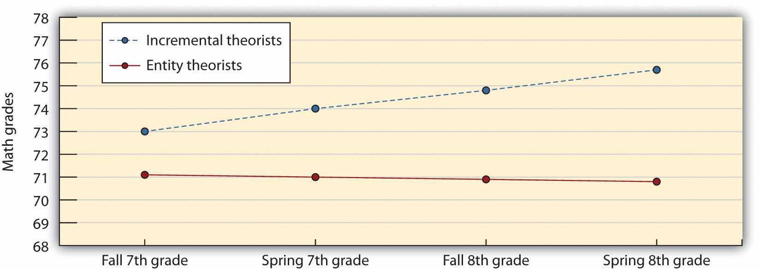
Students who believed that their intelligence was more malleable (incremental styles) were more likely to improve their math skills than were students who believed that intelligence was difficult to change (entity styles). Data are from Blackwell et al. (2007). ^{[9]}

Cultural Differences in Person Perception
As we have seen in many places in this book, the culture that we live in has a significant impact on the way we think about and perceive the world. And thus it is not surprising that people in different cultures would tend to think about people at least somewhat differently. One difference is between people from Western cultures (e.g., the United States, Canada, and Australia) and people from East Asian cultures (e.g., Japan, China, Taiwan, Korea, and India). People from Western cultures tend to be primarily oriented toward individualism, tending to think about themselves as different from (and often better than) the other people in their environment and believing that other people make their own decisions and are responsible for their own actions. In contrast, people in many East Asian cultures take a more collectivistic view of people that emphasizes not so much the individual but rather the relationship between individuals and the other people and things that surround them. The outcome of these differences is that on average, people from individualistic cultures tend to focus more on the individual person, whereas, again on average, people from collectivistic cultures tend to focus more on the situation (Ji, Peng, & Nisbett, 2000; Lewis, Goto, & Kong, 2008; Maddux & Yuki, 2006). ^{[10]}
In one study demonstrating this difference, Miller (1984) ^{[11]} asked children and adults in both India (a collectivist culture) and the United States (an individualist culture) to indicate the causes of negative actions by other people. Although the youngest children (ages 8 and 11) did not differ, the older children (age 15) and the adults did—Americans made more personal attributions, whereas Indians made more situational attributions for the same behavior.
Masuda and Nisbett (2001) ^{[12]} asked American and Japanese students to describe what they saw in images like the one shown in Figure 6.7 "Cultural Differences in Perception". They found that while both groups talked about the most salient objects (the fish, which were brightly colored and swimming around), the Japanese students also tended to talk and remember more about the images in the background—they remembered the frog and the plants as well as the fish.

Figure 6.7 Cultural Differences in Perception
Michael Morris and his colleagues (Hong, Morris, Chiu, & Benet-Martínez, 2000) ^{[13]} investigated the role of culture on person perception in a different way, by focusing on people who are bicultural (i.e., who have knowledge about two different cultures). In their research, they used high school students living in Hong Kong. Although traditional Chinese values are emphasized in Hong Kong, because Hong Kong was a British-administrated territory for more than a century, the students there are also acculturated with Western social beliefs and values.
Morris and his colleagues first randomly assigned the students to one of three priming conditions. Participants in the American culture priming condition saw pictures of American icons (such as the U.S. Capitol building and the American flag) and then wrote 10 sentences about American culture. Participants in the Chinese culturepriming condition saw eight Chinese icons (such as a Chinese dragon and the Great Wall of China) and then wrote 10 sentences about Chinese culture. Finally, participants in the control condition saw pictures of natural landscapes and wrote 10 sentences about the landscapes.
Then participants in all conditions read a story about an overweight boy who was advised by a physician not to eat food with high sugar content. One day, he and his friends went to a buffet dinner where a delicious-looking cake was offered. Despite its high sugar content, he ate it. After reading the story, the participants were asked to indicate the extent to which the boy’s weight problem was caused by his personality (personal attribution) or by the situation (situational attribution). The students who had been primed with symbols about American culture gave relatively less weight to situational (rather than personal) factors in comparison with students who had been primed with symbols of Chinese culture.
In still another test of cultural differences in person perception, Kim and Markus (1999) ^{[14]} analyzed the statements made by athletes and by the news media regarding the winners of medals in the 2000 and 2002 Olympic Games. They found that athletes in China described themselves more in terms of the situation (they talked about the importance of their coaches, their managers, and the spectators in helping them to do well), whereas American athletes (can you guess?) focused on themselves, emphasizing their own strength, determination, and focus.
Taken together then, we can see that cultural and individual differences play a similar role in person perception as they do in other social psychological areas. Although most people tend to use the same basic person-perception processes, and although we can understand these processes by observing the communalities among people, the outcomes of person perception will also be determined—at least in part—by the characteristics of the person himself or herself. And these differences are often created by the culture in which the person lives.

Attributional Styles and Mental Health
As we have seen in this chapter, how we make attributions about other people has a big influence on our reactions to them. But we also make attributions for our own behaviors. Social psychologists have discovered that there are important individual differences in the attributions that people make to the negative events that they experience and that these attributions can have a big influence on how they respond to them. The same negative event can create anxiety and depression in one individual but have virtually no effect on someone else. And still another person may see the negative event as a challenge to try even harder to overcome the difficulty (Blascovich & Mendes, 2000). ^{[15]}
A major determinant of how we react to perceived threats is the attributions that we make to them. Attributional style refers to the type of attributions that we tend to make for the events that occur to us. These attributions can be to our own characteristics (internal) or to the situation (external), but attributions can also be made on other dimensions, including stable versus unstable, and global versusspecific. Stable attributions are those that we think will be relatively permanent, whereas unstable attributions are expected to change over time. Global attributionsare those that we feel apply broadly, whereas specific attributions are those causes that we see as more unique to specific events.
You may know some people who tend to make negative or pessimistic attributions to negative events that they experience—we say that these people have a negative attributional style. These people explain negative events by referring to their own internal, stable, and global qualities. People with negative attributional styles say things such as the following:
- “I failed because I am no good” (an internal attribution).
- “I always fail” (a stable attribution).
- “I fail in everything” (a global attribution).
You might well imagine that the result of these negative attributional styles is a sense of hopelessness and despair (Metalsky, Joiner, Hardin, & Abramson, 1993). ^{[16]}Indeed, Alloy, Abramson, and Francis (1999) ^{[17]} found that college students who indicated that they had negative attributional styles when they first came to college were more likely than those who had a more positive style to experience an episode of depression within the next few months.
People who have extremely negative attributional styles, in which they continually make external, stable, and global attributions for their behavior, are said to be experiencing learned helplessness (Abramson, Seligman, & Teasdale, 1978; Seligman, 1975). ^{[18]} Learned helplessness was first demonstrated in research that found that some dogs that were strapped into a harness and exposed to painful electric shocks became passive and gave up trying to escape from the shock, even in new situations in which the harness had been removed and escape was therefore possible. Similarly, some people who were exposed to bursts of noise later failed to stop the noise when they were actually able to do so. In short, learned helplessness is the tendency to make external, rather than internal, attributions for our behaviors. Those who experience learned helplessness do not feel that they have any control over their own outcomes and are more likely to have a variety of negative health outcomes (Henry, 2005; Peterson & Seligman, 1984). ^{[19]}
Another type of attributional technique that people sometimes use to help them feel better about themselves is known as self-handicapping. Self-handicapping occurs when we make statements or engage in behaviors that help us create a convenient external attribution for potential failure. For instance, in research by Berglas and Jones (1978), ^{[20]} participants first performed an intelligence test on which they did very well. It was then explained to them that the researchers were testing the effects of different drugs on performance and that they would be asked to take a similar but potentially more difficult intelligence test while they were under the influence of one of two different drugs.
The participants were then given a choice—they could take a pill that was supposed to facilitate performance on the intelligence task (making it easier for them to perform) or a pill that was supposed to inhibit performance on the intelligence task, thereby making the task harder to perform (no drugs were actually administered). Berglas found that men—but not women—engaged in self-handicapping: They preferred to take the performance-inhibiting rather than the performance-enhancing drug, choosing the drug that provided a convenient external attribution for potential failure.
Although women may also self-handicap, particularly by indicating that they are unable to perform well due to stress or time constraints (Hirt, Deppe, & Gordon, 1991),^{[21]} men seem to do it more frequently. This is consistent with the general gender differences we have talked about in many places in this book—on average, men are more concerned about maintaining their self-esteem and social status in the eyes of themselves and others than are women.
You can see that there are some benefits (but also, of course, some costs) of self-handicapping. If we fail after we self-handicap, we simply blame the failure on the external factor. But if we succeed despite the handicap that we have created for ourselves, we can make clear internal attributions for our success. But engaging in behaviors that create self-handicapping can be costly because they make it harder for us to succeed. In fact, research has found that people who report that they self-handicap regularly show lower life satisfaction, less competence, poorer moods, less interest in their jobs, and even more substance abuse (Zuckerman & Tsai, 2005). ^{[22]}Although self-handicapping would seem to be useful for insulating our feelings from failure, it is not a good tack to take in the long run.
Fortunately, not all people have such negative attributional styles. In fact, most people tend to have more positive ones—styles that are related to high positive self-esteem and a tendency to explain the negative events they experience by referring to external, unstable, and specific qualities. Thus people with positive attributional styles are likely to say things such as the following:
- “I failed because the task is very difficult” (an external attribution).
- “I will do better next time” (an unstable attribution).
- “I failed in this domain, but I’m good in other things” (a specific attribution).
In sum, we can say that people who make more positive attributions toward the negative events that they experience will persist longer at tasks and that this persistence can help them. But there are limits to the effectiveness of these strategies. We cannot control everything, and trying to do so can be stressful. We can change some things but not others; thus sometimes the important thing is to know when it’s better to give up, stop worrying, and just let things happen. Having a positive outlook is healthy, but we cannot be unrealistic about what we can and cannot do.Unrealistic optimism is the tendency to be overly positive about the likelihood that negative things will occur to us and that we will be able to effectively cope with them if they do. When we are too optimistic, we may set ourselves up for failure and depression when things do not work out as we had hoped (Weinstein & Klein, 1996).^{[23]} We may think that we are immune to the potential negative outcomes of driving while intoxicated or practicing unsafe sex, but these optimistic beliefs are not healthy. Fortunately, most people have a reasonable balance between optimism and realism (Taylor & Armor, 1996). ^{[24]} They tend to set goals that they believe they can attain, and they regularly make some progress toward reaching them. Research has found that setting reasonable goals and feeling that we are moving toward them makes us happy, even if we may not in fact attain the goals themselves (Lawrence, Carver, & Scheier, 2002). ^{[25]}

KEY TAKEAWAYS
- Because we each use our own expectations in judgment, people may form different impressions of the same person performing the same behavior.
- Individual differences in the cognitive accessibility of a given personal characteristic may lead to more overlap in the descriptions provided by the same perceiver about different people than there is in those provided by different perceivers about the same target person.
- People with a strong need for cognition make more causal attributions overall. Entity theorists tend to focus on the traits of other people and tend to make a lot of personal attributions, whereas incremental theorists tend to believe that personalities change a lot over time and therefore are more likely to make situational attributions for events.
- People from Western cultures tend to make more personal attributions, whereas people from collectivistic cultures tend to focus more on the situational explanations of behavior.
- Individual differences in attributional styles can influence how we respond to the negative events that we experience.
- People who have extremely negative attributional styles, in which they continually make external, stable, and global attributions for their behavior, are said to be experiencing learned helplessness
- Self-handicapping is an attributional technique that prevents us from making ability attributions for our own failures.
- Having a positive outlook is healthy, but it must be tempered. We cannot be unrealistic about what we can and cannot do.

EXERCISES AND CRITICAL THINKING
- Can you think of a time when your own expectations influenced your attributions about another person?
- Which constructs are more cognitively accessible for you? Do these constructs influence how you judge other people?
- Consider a time when you or someone you knew engaged in self-handicapping. What was the outcome of doing so?
- Do you think that you have a more positive or a more negative attributional style? How do you think this style influences your judgments about your own successes and failures?

[1] Dornbusch, S. M., Hastorf, A. H., Richardson, S. A., Muzzy, R. E., & Vreeland, R. S. (1965). The perceiver and the perceived: Their relative influence on the categories of interpersonal cognition. Journal of Personality and Social Psychology, 1(5), 434–440; Park, B. (1986). A method for studying the development of impressions of real people. Journal of Personality and Social Psychology, 51(5), 907–917.
[2] Cacioppo, J. T., & Petty, R. E. (1982). The need for cognition. Journal of Personality and Social Psychology, 42, 116–131.
[3] Sargent, M. (2004). Less thought, more punishment: Need for cognition predicts support for punitive responses to crime. Personality and Social Psychology Bulletin, 30(11), 1485–1493. doi: 10.1177/0146167204264481
[4] Fletcher, G. J. O., Danilovics, P., Fernandez, G., Peterson, D., & Reeder, G. D. (1986). Attributional complexity: An individual differences measure. Journal of Personality and Social Psychology, 51(4), 875–884.
[5] Plaks, J. E., Levy, S. R., & Dweck, C. S. (2009). Lay theories of personality: Cornerstones of meaning in social cognition. Social and Personality Psychology Compass, 3(6), 1069–1081. doi: 10.1111/j.1751–9004.2009.00222.x
[6] Molden, D. C., Plaks, J. E., & Dweck, C. S. (2006). “Meaningful” social inferences: Effects of implicit theories on inferential processes. Journal of Experimental Social Psychology, 42(6), 738–752.
[7] Malle, B. F., Knobe, J., O’Laughlin, M. J., Pearce, G. E., & Nelson, S. E. (2000). Conceptual structure and social functions of behavior explanations: Beyond person-situation attributions.Journal of Personality and Social Psychology, 79(3), 309–326.
[8] Blackwell, L. S., Trzesniewski, K. H., & Dweck, C. S. (2007). Implicit theories of intelligence predict achievement across an adolescent transition: A longitudinal study and an intervention.Child Development, 78(1), 246–263.
[9] Blackwell, L. S., Trzesniewski, K. H., & Dweck, C. S. (2007). Implicit theories of intelligence predict achievement across an adolescent transition: A longitudinal study and an intervention.Child Development, 78(1), 246–263.
[10] Ji, L.-J., Peng, K., & Nisbett, R. E. (2000). Culture, control, and perception of relationships in the environment. Journal of Personality and Social Psychology, 78(5), 943–955; Lewis, R. S., Goto, S. G., & Kong, L. L. (2008). Culture and context: East Asian American and European American differences in P3 event-related potentials and self-construal. Personality and Social Psychology Bulletin, 34(5), 623–634; Maddux, W. W., & Yuki, M. (2006). The “ripple effect”: Cultural differences in perceptions of the consequences of events. Personality and Social Psychology Bulletin, 32(5), 669–683.
[11] Miller, J. G. (1984). Culture and the development of everyday social explanation. Journal of Personality and Social Psychology, 46(5), 961–978.
[12] Masuda, T., & Nisbett, R. E. (2001). Attending holistically versus analytically: Comparing the context sensitivity of Japanese and Americans. Journal of Personality and Social Psychology, 81(5), 922–934.
[13] Hong, Y.-Y., Morris, M. W., Chiu, C.-Y., & Benet-Martínez, V. (2000). Multicultural minds: A dynamic constructivist approach to culture and cognition. American Psychologist, 55(7), 709–720.
[14] Kim, H., & Markus, H. R. (1999). Deviance or uniqueness, harmony or conformity? A cultural analysis. Journal of Personality and Social Psychology, 77(4), 785–800.
[15] Blascovich, J., & Mendes, W. B. (2000). Challenge and threat appraisals: The role of affective cues. In J. P. Forgas (Ed.), Feeling and thinking: The role of affect in social cognition(pp. 59–82). New York, NY: Cambridge University Press.
[16] Metalsky, G. I., Joiner, T. E., Hardin, T. S., & Abramson, L. Y. (1993). Depressive reactions to failure in a naturalistic setting: A test of the hopelessness and self-esteem theories of depression. Journal of Abnormal Psychology, 102(1), 101–109.
[17] Alloy, L. B., Abramson, L. Y., & Francis, E. L. (1999). Do negative cognitive styles confer vulnerability to depression? Current Directions in Psychological Science, 8(4), 128–132.
[18] Abramson, L. Y., Seligman, M. E., & Teasdale, J. D. (1978). Learned helplessness in humans: Critique and reformulation. Journal of Abnormal Psychology, 87(1), 49–74; Seligman, M. E. (1975). Helplessness: On depression, development, and death. San Francisco, CA: W. H. Freeman.
[19] Henry, P. C. (2005). Life stress, explanatory style, hopelessness, and occupational stress.International Journal of Stress Management, 12, 241–256; Peterson, C., & Seligman, M. E. P. (1984). Causal explanations as a risk factor for depression: Theory and evidence.Psychological Review, 91, 347–374.
[20] Berglas, S., & Jones, E. E. (1978). Drug choice as a self-handicapping strategy in response to noncontingent success. Journal of Personality and Social Psychology, 36(4), 405–417.
[21] Hirt, E. R., Deppe, R. K., & Gordon, L. J. (1991). Self-reported versus behavioral self-handicapping: Empirical evidence for a theoretical distinction. Journal of Personality and Social Psychology, 61(6), 981–991.
[22] Zuckerman, M., & Tsai, F.-F. (2005). Costs of self-handicapping. Journal of Personality, 73(2), 411–442.
[23] Weinstein, N. D., & Klein, W. M. (1996). Unrealistic optimism: Present and future. Journal of Social and Clinical Psychology, 15(1), 1–8.
[24] Taylor, S. E., & Armor, D. A. (1996). Positive illusions and coping with adversity. Journal of Personality, 64, 873–898.
[25] Lawrence, J. W., Carver, C. S., & Scheier, M. F. (2002). Velocity toward goal attainment in immediate experience as a determinant of affect. Journal of Applied Social Psychology, 32(4), 788–802. doi: 10.1111/j.1559–1816.2002.tb00242.x

6.4 Thinking Like a Social Psychologist About Person Perception
Understanding other people is one of the most important tasks facing us in our everyday lives. Now that you are familiar with the processes we use during person perception, perhaps you will use this information to be more aware of—and perhaps even improve—your own person-perception skills. Are you now more aware of how quickly you are forming impressions of other people and of how quickly they are forming impressions of you? Does this knowledge make you think differently about those snap judgments you make about others? Might it make you more careful about how you behave in front of others?
You may find that you are now better able to use your person-perception powers to accurately determine how others are responding to you. Do you find yourself more attuned to the nonverbal information that you are sending to others and that they are sending to you? Are you more aware of the role that traits (and particularly central traits) are playing in your everyday interactions? Can you now better see the important role that traits (and particularly central traits) play in our everyday lives? And are you now more (or perhaps less?) sure about your skills at detecting deception in others?
Your broader understanding about the processes of causal attribution—and the potential errors that may accompany it—may also help you improve your relationships with others. Do you sometimes blame other people for their misfortunes that they could not really have caused themselves? If so, and you stop to think about it, you know that you may well be falling into the trap of the fundamental attribution error. Do you sometimes take more credit for your contribution to a group project than you should? This would, of course, be expected if you, like most people, tend to make self-serving attributions. But because you are thinking like a social psychologist, you will more likely be aware of these potential pitfalls and try to prevent or correct for them.
With your new knowledge of person perception in hand, you may also think about your own style of person perception. Do you do this more thoughtfully or more spontaneously? Could you be more accurate if you took more time to judge others? And how do you think that the culture that you live in influences your person perception? Do you think that Americans are simply too focused on individuals and unlikely to consider situational factors?
Finally, consider again the many ways that the processes of causal attribution guide your perceptions of yourself and influence your own behaviors and even your mental and physical health. Now that you can see how important your own thinking styles are, you might want to try to improve them.

6.5 Chapter Summary
Person perception helps us make accurate and informed judgments about how other people are likely to respond to us. At the same time we are exercising our person-perception skills on other people, those same people are also using their powers of person perception to form impressions of us.
Our initial impressions of other people can be formed quite accurately in a very short time—sometimes in a matter of seconds. These initial judgments are made on the basis of the other person’s social category memberships—such as race, gender, and age—and their physical appearance.
Another source of information in initial perception is nonverbal behavior. We use a wide variety of nonverbal cues to help us form impressions of others. These behaviors are also useful in helping us determine whether or not people are being honest with us. Although our ability to detect deception is often not very good, there are nevertheless some reliable cues that we can use to do so.
Once we learn more about a person, we begin to think about them in terms of their personality traits. Often we average traits together to form an overall impression of the person. Some traits have more weight than others—for instance, negative traits, the central traits of warm and cold, and those traits that we learn first.
An important task of person perception is to attempt to draw inferences about a person’s personality by observing their behavior. This is the process of causal attribution. When we make attributions, we make either personal attributions, situational attributions, or both.
We can make stronger personal attributions when behavior is unusual or unexpected and when it is freely chosen. When we have information about behavior over time, we can analyze the consistency, distinctiveness, and consensus of that behavior to make attributions. In some cases, we may use the process of causal attribution to draw conclusions about the causes of success and failure.
Our attributions are generally accurate, but they are subject to some biases. We tend to make too strong personal attributions for the behavior of others (the fundamental attribution error), and we make more personal attributions for others than we do for ourselves (the actor-observer effect). In some cases, this may lead us to blame others for events that they might not have been responsible for. Furthermore, we tend to make self-serving attributions, which are frequently inaccurate but which do help us to meet our needs for self-enhancement.
Different individuals make different judgments about others, in part because they see those people in different circumstances and in part because they use their own attitudes and schemas when they judge them. This can lead people to make more similar judgments about different people than different people make about the same person.
Individual difference variables such as need for cognition and entity versus incremental thinking can influence our person perception.
There are also cultural differences in person perception. People from individualistic cultures, or people for whom an individualistic culture is currently highly accessible, tend to make stronger personal attributions and weaker situational attributions, in comparison with people from collectivist cultures.
Causal attributions for our own behaviors have an important outcome on our mental and physical health. Important concepts in this regard are attributional styles, learned helplessness, self-handicapping, and unrealistic optimism.

Chapter 7

Influencing and Conforming

Death by Alcohol
Sam Spady had it all. During her high school years she was not only homecoming queen but also an honor student, as well as class president. As a 19-year-old college student at Colorado State University, Spady had many dreams for her future, all of which never materialized, as she died on September 5, 2004, after hours of binge drinking.
Spady, who was celebrating with friends at the school’s biggest social event, consumed over 30 alcoholic beverages over a period of 11 hours and was then left at a fraternity house to sleep it off. Another student and fraternity member later discovered her body while showing his mother the house.
An estimated 1,400 college students between the ages of 18 and 24 die from alcohol-related incidents each year, according to the National Institute of Alcohol Abuse and Alcoholism.
Unfortunately, things have not changed since Spady’s death. People still feel as though they’re invincible and bars are enticing students to drink by offering alcohol at inexpensive prices.
Sources: http://www.usatoday.com/news/health/2006-06-26-spady-binge-drinking_x.htm; http://www.samspadyfoundation.org/press.html.
Have you ever decided what courses to take by asking for advice from your friends or by observing what courses they were choosing? Have you picked the clothes to wear to a party based on what your friends were wearing? Can you think of a time when you changed your beliefs or behaviors because a person in authority, such as a teacher or a religious or political leader, gave you ideas about new ways to think or new things to do? Or perhaps you started smoking cigarettes or drinking alcohol, even though you didn’t really want to, because some of your friends were doing it.
Your answers to at least some of these questions will be yes because you, like all people, are influenced by those around you. When you find yourself in situations like these, you are experiencing what is perhaps the most basic of all social psychological processes—social influence, defined as the influence of other people on our everyday thoughts, feelings, and behavior (Hogg, 2010). ^{[1]}
This chapter focuses on the social influence that leads individuals, sometimes against their will, to adopt and adhere to the opinions and behaviors of others. The outcome of this social influence, known as conformity, refers to the change in beliefs, opinions, and behaviors as a result of our perceptions about what other people believe or do. We conform to social influence in part to meet cognitive goals of forming accurate knowledge about the world around us, for instance, by using the opinions and recommendations of others to help us make better decisions. But conformity also involves affective processes. Because we want to be liked and accepted by others, we may sometimes behave in ways that we might not really have wanted to if we had thought about them more carefully. As an example, we may we engage in unhealthy behaviors, such as smoking or alcohol abuse, simply because our friends are engaging in them.
There are many types of conformity, ranging from the simple and unconscious imitation of the other people around us to the obedience created by powerful people who have direct control over us. In this chapter we will consider both conformity andleadership, which is the ability to direct or inspire others to achieve goals. We’ll look at the potential benefits of conforming to others but also consider the costs of doing so. And we will also consider which people are most likely to conform.
Although conformity sounds like it might be a negative thing (and in some cases it is), overall the tendency to be influenced by the actions of others is an important human adaptation. Just as birds conform to the movements of those around them when they fly together in a flock, social influence among humans probably increases our fitness by helping us live and work well together (Coultas, 2004; Fincher, Thornhill, Murray, & Schaller, 2008; Henrich & Boyd, 1998; Kessler & Cohrs, 2008). ^{[2]} Conformity is determined by the person-situation interaction, and although the situation is extremely powerful, different people are more or less likely to conform.
As you read this chapter, keep in mind that conformity is another example of the ongoing interactive dynamic among people. Just as you are conforming to the influence that others have on you, your behavior is also influencing those others to conform to your beliefs and opinions. You may be surprised by how often these influences are occurring around you.

[1] Hogg, M. A. (2010). Influence and leadership. In S. F. Fiske, D. T. Gilbert, & G. Lindzey (Eds.), Handbook of social psychology (Vol. 2, pp. 1166–1207). New York, NY: Wiley.
[2] Coultas, J. (2004). When in Rome…An evolutionary perspective on conformity. Group Processes and Intergroup Relations, 7, 317–331; Fincher, C. L., Thornhill, R., Murray, D. R., & Schaller, M. (2008). Pathogen prevalence predicts human cross-cultural variability in individualism/collectivism. Proceedings of the Royal Society B, 275, 1279–1285; Henrich, J., & Boyd, R. (1998). The evolution of conformist transmission and the emergence of between-group differences. Evolution and Human Behavior, 19, 215–242; Kessler, T., & Cohrs, J. C. (2008). The evolution of authoritarian processes: Fostering cooperation in large-scale groups.Group Dynamics: Theory, Research, and Practice, 12, 73–84.

7.1 The Many Varieties of Conformity

LEARNING OBJECTIVES
- Describe some of the active and passive ways that conformity occurs in our everyday lives.
- Compare and contrast informational conformity and normative conformity.
- Summarize the variables that create majority and minority social influence.
- Outline the situational variables that influence the extent to which we conform.
The typical outcome of social influence is that our beliefs and behaviors become more similar to those of others around us. At times this change occurs in a spontaneous and automatic sense, without any obvious intent of one person to change the other. Perhaps you learned to like jazz or rap music because your roommate was playing a lot of it. You didn’t really want to like the music, and your roommate didn’t force it on you—your preferences changed in passive way. Robert Cialdini and his colleagues (Cialdini, Reno, & Kallgren, 1990) ^{[1]} found that college students were more likely to throw litter on the ground when they had just seen another person throw some paper on the ground and were least likely to litter when they had just seen another person pick up and throw paper into a trash can. The researchers interpreted this as a kind of spontaneous conformity—a tendency to follow the behavior of others, often entirely out of our awareness. Even our emotional states become more similar to those we spend more time with (Anderson, Keltner, & John, 2003). ^{[2]}

Research Focus
Imitation as Subtle Conformity
Perhaps you have noticed in your own behavior a type of very subtle conformity—the tendency to imitate other people who are around you. Have you ever found yourself talking, smiling, or frowning in the same way that a friend does? Tanya Chartrand and John Bargh (1999) ^{[3]} investigated whether the tendency to imitate others would occur even for strangers, and even in very short periods of time.
In their first experiment, students worked on a task with another student, who was actually an experimental confederate. The two worked together to discuss photographs taken from current magazines. While they were working together, the confederate engaged in some unusual behaviors to see if the research participant would mimic them. Specifically, the confederate either rubbed his or her face or shook his or her foot. It turned out that the students did mimic the behavior of the confederate, by themselves either rubbing their own faces or shaking their own feet. And when the experimenters asked the participants if they had noticed anything unusual about the behavior of the other person during the experiment, none of them indicated awareness of any face rubbing or foot shaking.
It is said that imitation is a form of flattery, and we might therefore expect that we would like people who imitate us. Indeed, in a second experiment, Chartrand and Bargh found exactly this. Rather than creating the behavior to be mimicked, in this study the confederate imitated the behaviors of the participant. While the participant and the confederate discussed the magazine photos, the confederate mirrored the posture, movements, and mannerisms displayed by the participant.
As you can see in the following figure, the participants who had been mimicked liked the other person more and indicated that they thought the interaction had gone more smoothly, in comparison with the participants who had not been imitated.

Figure 7.1
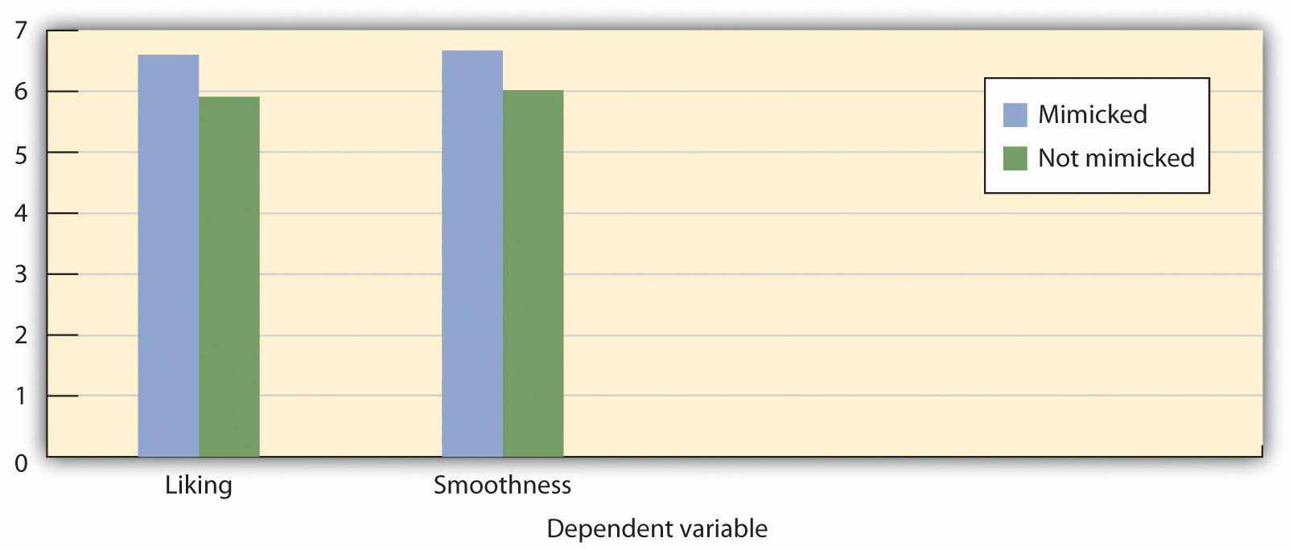
Participants who had been mimicked indicated that they liked the person who had imitated them more and that the interaction with that person had gone more smoothly, in comparison with participants who had not been mimicked. Data are from Chartrand and Bargh (1999). ^{[4]}
Imitation is an important part of social interaction. We easily and frequently mimic others without being aware that we are doing so. We may communicate to others that we agree with their viewpoints by mimicking their behaviors, and we tend to get along better with people with whom we are well “coordinated.” We even expect people to mimic us in social interactions, and we become distressed when they do not (Dalton, Chartrand, & Finkel, 2010). ^{[5]} This unconscious conformity may help explain why we hit it off immediately with some people and never get it together with others (Chartrand & Dalton, 2009; Tickle-Degnen & Rosenthal, 1990, 1992). ^{[6]}

Informational Conformity: Conforming to Be Accurate
Although mimicry represents the more subtle side, conformity also occurs in a more active and thoughtful sense, for instance, when we actively look to our friends’ opinions to determine appropriate behavior, when a car salesperson attempts to make a sale, or even when a powerful dictator uses physical aggression to force the people in his country to engage in the behaviors that he desires. In these cases, the influence is obvious. We know we are being influenced and we may attempt—sometimes successfully, and sometimes less so—to counteract the pressure.
Influence sometimes occurs because we believe that other people have valid knowledge about an opinion or issue, and we use that information to help us make good decisions. When we take our winter coat to school because the weatherman says it’s going to be cold, this is because we think that the weatherman has some good information that we can use. Informational conformity is the change in opinions or behavior that occurs when we conform to people whom we believe have accurate information. We base our beliefs on those presented to us by reporters, scientists, doctors, and lawyers because we believe they have more expertise in certain fields than we have. But we also use our friends and colleagues for information; when we choose a prom gown on the basis of our friends’ advice about what looks good on us, we are using informational conformity—we believe that our friends have good judgment about the things that matter to us.
Informational conformity is often the end result of social comparison, the process of comparing our opinions with those of others to gain an accurate appraisal of the validity of an opinion or behavior (Festinger, Schachter, & Back, 1950; Hardin & Higgins, 1996; Turner, 1991). ^{[7]} Informational conformity lead to real, long-lasting, changes in beliefs. The result of informational influence is normallyprivate acceptance: real change in opinions on the part of the individual. We believe that taking the winter coat was the right thing to do and that the prom gown really looks good on us.

Normative Conformity: Conforming to Be Liked and to Avoid Rejection
In other cases we conform not because we want to have valid knowledge but rather to meet the goal of belonging to and being accepted by a group that we care about (Deutsch & Gerard, 1955). ^{[8]} When we start smoking cigarettes or buy shoes that we cannot really afford in order to impress others, we do these things not so much because we think they are the right things to do but rather because we want to be liked.
Normative conformity occurs when we express opinions or behave in ways that help us to be accepted or that keep us from being isolated or rejected by others. When we engage in normative conformity we conform to social norms—socially accepted beliefs about what we do or should do in particular social contexts (Cialdini, 1993; Sherif, 1936; Sumner, 1906). ^{[9]}
In contrast to informational conformity, in which the attitudes or opinions of the individual change to match that of the influencers, the outcome of normative conformity often represents public conformity rather than private acceptance.Public conformity is a superficial change in behavior (including the public expression of opinions) that is not accompanied by an actual change in one’s private opinion. Conformity may appear in our public behavior even though we may believe something completely different in private. We may obey the speed limit or wear a uniform to our job (behavior) to conform to social norms and requirements, even though we may not necessarily believe that it is appropriate to do so (opinion). We may use drugs with our friends without really wanting to, and without believing it is really right, because our friends are all using drugs. However, behaviors that are originally performed out of a desire to be accepted (normative conformity) may frequently produce changes in beliefs to match them, and the result becomes private acceptance. Perhaps you know someone who started smoking to please his friends but soon convinced himself that it was an acceptable thing to do.
Although in some cases conformity may be purely informational or purely normative, in most cases the goals of being accurate and being accepted go hand-in-hand, and therefore informational and normative conformity often occur at the same time. When soldiers obey their commanding officers, they probably do it both because others are doing it (normative conformity) and because they think it is the right thing to do (informational conformity). It has been argued that the distinction between informational and normative conformity is more apparent than real and that it may not be possible to fully differentiate them (Turner, 1991). ^{[10]}

Majority Influence: Conforming to the Group
Although conformity occurs whenever group members change their opinions or behaviors as a result of their perceptions of others, we can divide such influence into two types. Majority influence occurs when the beliefs held by the larger number of individuals in the current social group prevail. In contrast, minority influenceoccurs when the beliefs held by the smaller number of individuals in the current social group prevail. Not surprisingly, majority influence is more common, and we will consider it first.
In a series of important studies on conformity, Muzafer Sherif (1936) ^{[11]} used a perceptual phenomenon known as the autokinetic effect to study the outcomes of conformity on the development of group norms. The autokinetic effect is caused by the rapid, small movements of our eyes that occur as we view objects and that allow us to focus on stimuli in our environment. However, when individuals are placed in a dark room that contains only a single, small, stationary pinpoint of light, these eye movements produce an unusual effect for the perceiver—they make the point of light appear to move.
Sherif took advantage of this effect to study how group norms develop in ambiguous situations. In his studies, college students were placed in a dark room with the point of light and were asked to indicate, each time the light was turned on, how much it appeared to move. Some participants first made their judgments alone. Sherif found that although each participant who was tested alone made estimates that were within a relatively narrow range (as if they had their own “individual” norm), there were wide variations in the size of these judgments among the different participants he studied.
Sherif also found that when individuals who initially had made very different estimates were then placed in groups along with one or two other individuals, and in which all the group members gave their responses on each trial aloud (each time in a different random order), the initial differences in judgments among the participants began to disappear, such that the group members eventually made very similar judgments. You can see that this pattern of change, which is shown in Figure 7.2 "Outcomes of Sherif’s Study", illustrates the fundamental principle of social influence—over time, people come more and more to share their beliefs with each other. Sherif’s study is thus a powerful example of the development of group norms.

Figure 7.2 Outcomes of Sherif’s Study
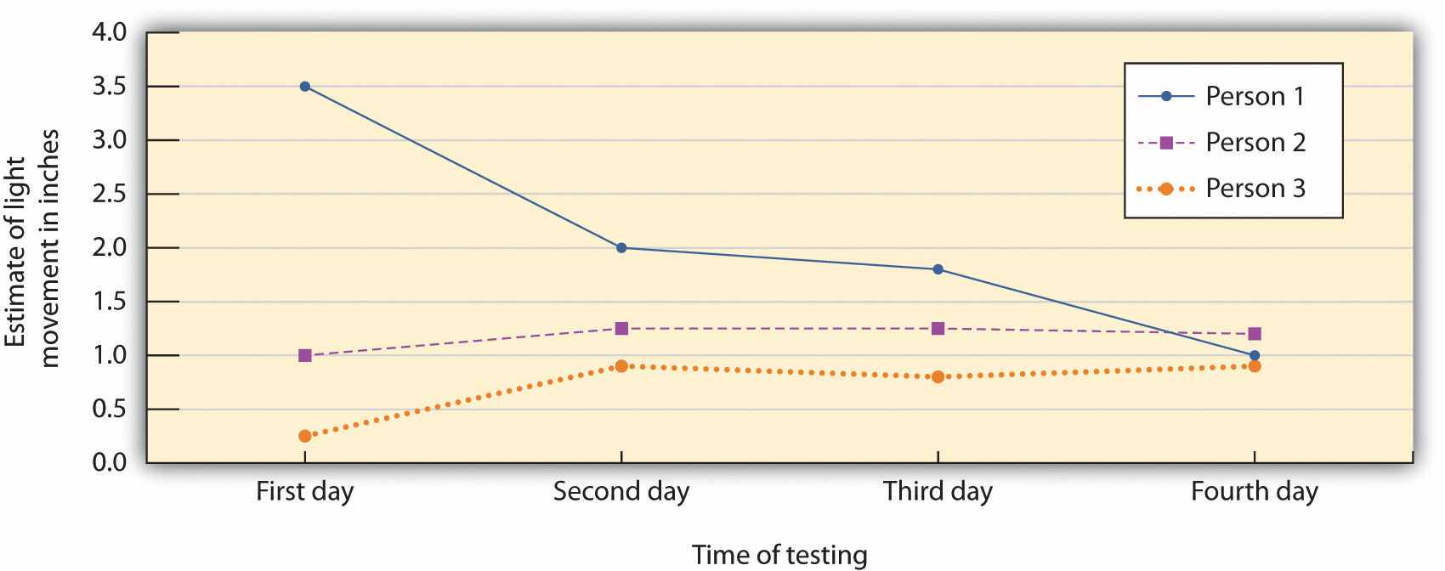
The participants in the studies by Muzafer Sherif (1936) ^{[12]} initially had different beliefs about the degree to which a point of light appeared to be moving. (You can see these differences as expressed on Day 1.) However, as they shared their beliefs with other group members over several days, a common group norm developed. Shown here are the estimates made by a group of three participants who met together on four different days.
Furthermore, and indicating that Sherif had created private acceptance, the new group norms continued to influence judgments when the individuals were again tested alone. The participants did not revert back to their initial opinions, even though they were quite free to do so; rather, they stayed with the new group norms. And these conformity effects appear to have occurred entirely out of the awareness of most participants. Sherif (1936, p. 108) ^{[13]} reported that the majority of the participants indicated after the experiment was over that their judgments had not been influenced by the judgments made by the other group members.
Sherif also found that the norms that were developed in groups could continue over time. When the original research participants were moved into groups with new people, their opinions subsequently influenced the judgments of the new group members (Jacobs & Campbell, 1961). ^{[14]} The norms persisted through several “generations” (MacNeil & Sherif, 1976) ^{[15]} and could influence individual judgments up to a year after the individual was last tested (Rohrer, Baron, Hoffman, & Swander, 1954). ^{[16]}
When Solomon Asch (Asch, 1952, 1955) ^{[17]} heard about Sherif’s studies, he responded in perhaps the same way that you might have: “Well of course people conformed in this situation, because after all the right answer was very unclear,” you might have thought. Since the study participants didn’t know the right answer (or indeed the “right” answer was no movement at all), it is perhaps not that surprising that people conformed to the beliefs of others.
Asch conducted studies in which, in complete contrast to the autokinetic effect experiments of Sherif, the correct answers to the judgments were entirely unambiguous. In these studies, the research participants were male college students who were told that they were to be participating in a test of visual abilities. The men were seated in a small semicircle in front of a board that displayed the visual stimuli that they were going to judge. The men were told that there would be 18 trials during the experiment, and on each trial they would see two cards. The standard card had a single line that was to be judged. And the test card had three lines that varied in length between about 2 and 10 inches:
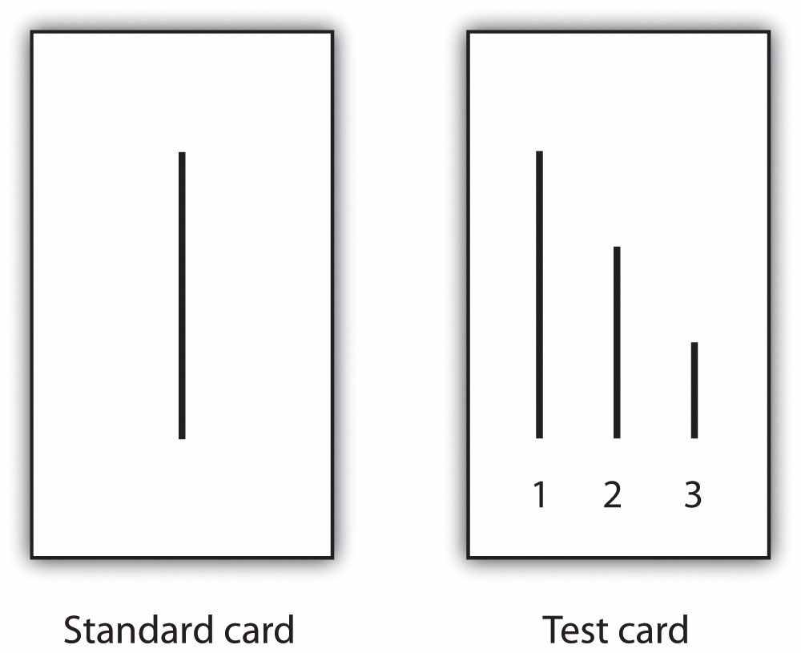
The men’s task was simply to indicate which line on the test card was the same length as the line on the standard card. As you can see from the Asch card sample above, there is no question that correct answer is line 1. In fact, Asch found that people made virtually no errors on the task when they made their judgments alone.
On each trial, the each person answered out loud, beginning with one end of the semicircle and moving to the other end. Although the participant did not know it, the other group members were not true participants but experimental confederates who gave predetermined answers on each trial. Because the participant was seated next to last in the row, he always made his judgment after most of the other group members made theirs. Although on the first two trials the confederates each gave the correct answer, on the third trial, and on 11 of the subsequent trials, they all had been instructed to give the same incorrect answer. For instance, even though the correct answer was Line 1, they would all say it was Line 2. Thus when it became the participant’s turn to answer, he could either give the clearly correct answer or conform to the incorrect responses of the confederates.

Asch found that about 76% of the 123 men who were tested gave at least one incorrect response when it was their turn, and 37% of the responses, overall, were conforming. This is indeed evidence for the power of conformity because the research participants were giving clearly incorrect answers out loud. However, conformity was not absolute—in addition to the 24% of the men who never conformed, only 5% of the men conformed on all 12 of the critical trials.

You might think that Asch’s study shows primarily normative conformity, in the sense that the participants gave the wrong answer not because they thought it was correct but because they wanted to avoid being seen as different. But is it not possible that the participants were also a bit unsure of the correct answer? When I look at the picture of one of the participants in Asch’s studies (see Figure 7.3 "Participants in the Asch Line-Judging Experiment"), it looks to me like he is really unsure about what he is seeing. Perhaps, then, even in Asch’s study some informational influence is occurring. Maybe the participants became unsure of their responses and used the opinions of others to help them determine what was correct. Normative and informational conformity often operate together.

Minority Influence: Resisting Group Pressure
The research that we have discussed to this point involves conformity in which the opinions and behaviors of individuals become more similar to the opinions and behaviors of the majority of the people in the group—majority influence. But we do not always blindly conform to the beliefs of the majority. Although more unusual, there are nevertheless cases in which a smaller number of individuals are able to influence the opinions or behaviors of the group—this is minority influence.
It is a good thing that minorities can be influential; otherwise, the world would be pretty boring. When we look back on history we find that it is the unusual, divergent, innovative minority groups or individuals, who—although frequently ridiculed at the time for their unusual ideas—end up being respected for producing positive changes. The work of scientists, religious leaders, philosophers, writers, musicians, and artists who go against group norms by expressing new and unusual ideas frequently is not liked at first. These novel thinkers may be punished—in some cases even killed—for their beliefs. In the end, however, if the ideas are interesting and important, the majority may conform to these new ideas, producing social change. In short, although conformity to majority opinions is essential to provide a smoothly working society, if individuals only conformed to others there would be few new ideas and little social change.
The French social psychologist Serge Moscovici was particularly interested in the situations under which minority influence might occur. In fact, he argued that all members of all groups are able, at least in some degree, to influence others, regardless of whether they are in the majority or the minority. To test whether minority group members could indeed produce influence, he and his colleagues (Moscovici, Lage, & Naffrechoux, 1969) ^{[18]} created the opposite of Asch’s line perception study, such that there was now a minority of confederates in the group (two) and a majority of experimental participants (four). All six individuals viewed a series of slides depicting colors, supposedly as a study of color perception, and as in Asch’s research, each voiced out loud an opinion about the color of the slide.
Although the color of the slides varied in brightness, they were all clearly blue. Moreover, demonstrating that the slides were unambiguous, just as the line judgments of Asch had been, participants who were asked to make their judgments alone called the slides a different color than blue less than 1% of the time. (When it happened, they called the slides green.)
In the experiment, the two confederates had been instructed to give one of two patterns of answers that were different from the normal responses. In the consistent-minoritycondition, the two confederates gave the unusual response (green) on every trial. In theinconsistent-minority condition the confederates called the slides “green” on two thirds of their responses and called them blue on the other third.
The minority of two was able to change the beliefs of the majority of four, but only when they were unanimous in their judgments. As shown in Figure 7.4 "The Power of Consistent Minorities", Moscovici found that the presence of a minority who gave consistently unusual responses influenced the judgments made by the experimental participants. When the minority was consistent, 32% of the majority group participants said green at least once and 18% of the responses of the majority group were green. However, as you can see in Figure 7.4 "The Power of Consistent Minorities", the inconsistent minority had virtually no influence on the judgments of the majority.

Figure 7.4 The Power of Consistent Minorities
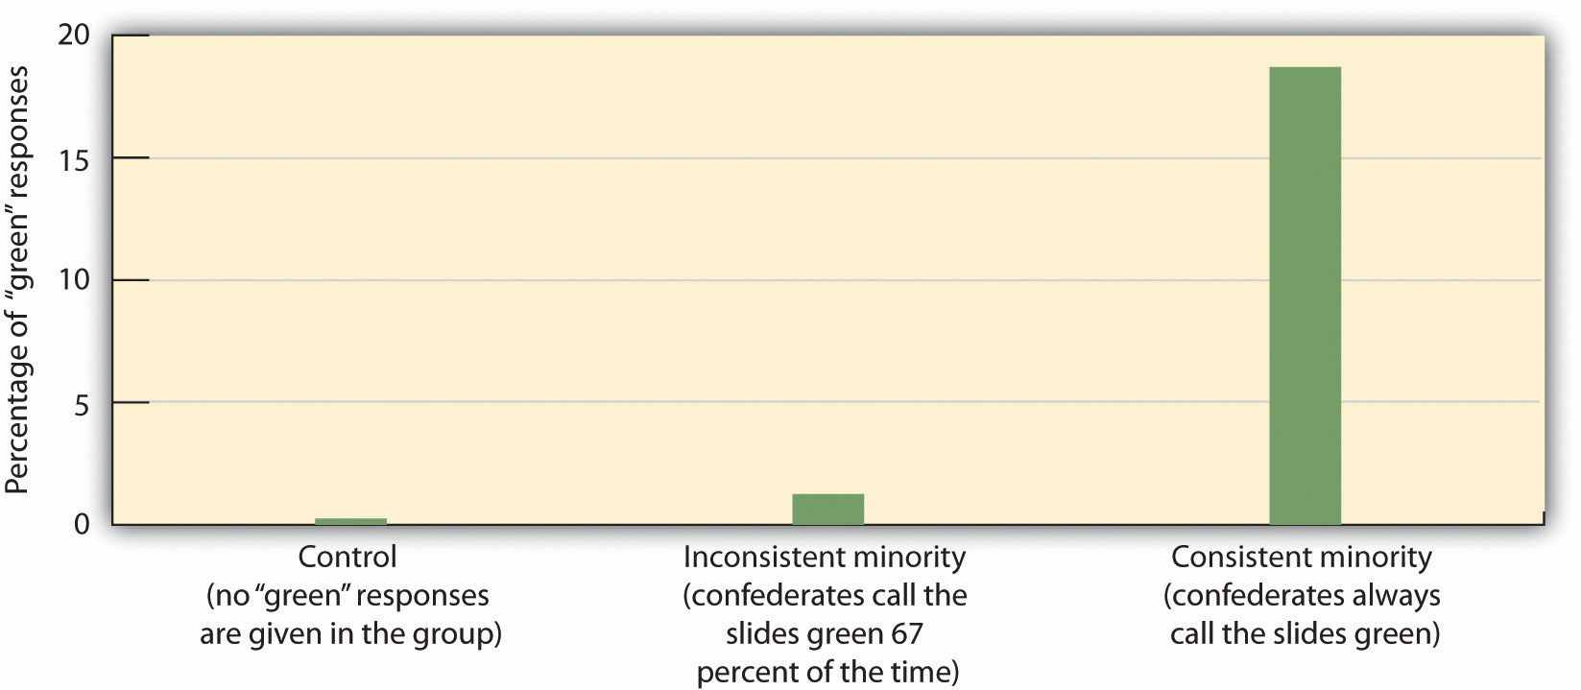
In the studies of minority influence by Serge Moscovici, only a consistent minority (in which each individual gave the same incorrect response) was able to produce conformity in the majority participants. Data are from Moscovici, Lage, and Naffrechoux (1969). ^{[19]}
On the basis of this research, Moscovici argued that minorities could have influence over majorities, provided they gave consistent, unanimous responses. Subsequent research has found that minorities are most effective when they express consistent opinions over time and with each other, when they show that they are invested in their position by making significant personal and material sacrifices, and when they seem to be acting out of principle rather than from ulterior motives (Hogg, 2010). ^{[20]}Although they may want to adopt a relatively open-minded and reasonable negotiating style on issues that are less critical to the attitudes they are trying to change, successful minorities must be absolutely consistent with regard to their core arguments (Mugny & Papastamou, 1981). ^{[21]}
When minorities are successful at producing influence, they are able to produce strong and lasting attitude change—true private acceptance—rather than simply public conformity. People conform to minorities because they think that they are right, and not because they think it is socially acceptable. Minorities have another, potentially even more important, outcome on the opinions of majority group members—the presence of minority groups can lead majorities to engage in fuller, as well as more divergent, innovative and creative thinking about the topics being discussed (Martin & Hewstone, 2003; Martin, Martin, Smith, & Hewstone, 2007). ^{[22]}
Nemeth and Kwan (1987) ^{[23]} had participants work in groups of four on a creativity task in which they were presented with letter strings such as tdogto and asked to indicate which word came to their mind first as they looked at the letters. The judgments were made privately, which allowed the experimenters to provide false feedback about the responses of the other group members. All participants indicated the most obvious word (in this case, dog) as their response on each of the initial trials. However, the participants were told (according to experimental condition) either that three of the other group members had also reported seeing dog and that one had reported seeing god or that three out of the four had reported seeing god whereas only one had reported dog. Participants then completed other similar word strings on their own, and their responses were studied.
Results showed that when the participants thought that the unusual response (for instance, god rather than dog) was given by a minority of one individual in the group rather than by a majority of three individuals, they subsequently answered more of the new word strings using novel solutions, such as finding words made backward or using a random order of the letters. On the other hand, the individuals who thought that the majority of the group had given the novel response did not develop more creative ideas. The idea is when the participants thought that the novel response came from a group minority (one person), they thought about the responses more carefully, in comparison with the same behaviors performed by majority group members, and this led them to adopt new and creative ways to think about the problems. This result, along with other research showing similar findings, suggests that messages that come from minority groups lead us to think more fully about the decision, which can produce innovative, creative thinking in majority group members (Crano & Chen, 1998). ^{[24]}
In summary, we can conclude that minority influence, although not as likely as majority influence, does sometimes occur. The few are able to influence the many when they are consistent and confident in their judgments but are less able to have influence when they are inconsistent or act in a less confident manner. Furthermore, although minority influence is difficult to achieve, if it does occur it is powerful. When majorities are influenced by minorities they really change their beliefs—the outcome is deeper thinking about the message, private acceptance of the message, and in some cases even more creative thinking.

Situational Determinants of Conformity
The studies of Asch, Sherif, and Moscovici demonstrate the extent to which individuals—both majorities and minorities—can create conformity in others. Furthermore, these studies provide information about the characteristics of the social situation that are important in determining the extent to which we conform to others. Let’s consider some of those variables.

The Size of the Majority
As the number of people in the majority increases, relative to the number of persons in the minority, pressure on the minority to conform also increases (Latané, 1981; Mullen, 1983). ^{[25]} Asch conducted replications of his original line-judging study in which he varied the number of confederates (the majority subgroup members) who gave initial incorrect responses from 1 to 16 people, while holding the number in the minority subgroup constant at 1 (the single research participant). You may not be surprised to hear the results of this research: When the size of the majorities got bigger, the lone participant was more likely to give the incorrect answer.
Increases in the size of the majority increase conformity, regardless of whether the conformity is informational or normative. In terms of informational conformity, if more people express an opinion, their opinions seem more valid. Thus bigger majorities should result in more informational conformity. But larger majorities will also produce more normative conformity because being different will be harder when the majority is bigger. As the majority gets bigger, the individual giving the different opinion becomes more aware of being different, and this produces a greater need to conform to the prevailing norm.
Although increasing the size of the majority does increase conformity, this is only true up to a point. The increase in the amount of conformity that is produced by adding new members to the majority group (known as the social impact of each group member) is greater for initial majority members than it is for later members (Latané, 1981). ^{[26]} This pattern is shown in Figure 7.5 "Social Impact", which presents data from a well-known experiment by Stanley Milgram and his colleagues (Milgram, Bickman, & Berkowitz, 1969) ^{[27]} that studied how people are influenced by the behavior of others on the streets of New York City.
Milgram had confederates gather in groups on 42nd street in New York City, in front of the Graduate Center of the City University of New York, each looking up at a window on the sixth floor of the building. The confederates were formed into groups ranging from one to 15 people. A video camera in a room on the sixth floor above recorded the behavior of 1,424 pedestrians who passed along the sidewalk next to the groups.
As you can see in Figure 7.5 "Social Impact", larger groups of confederates increased the number of people who also stopped and looked up, but the influence of each additional confederate was generally weaker as size increased. Groups of three confederates produced more conformity than did a single person, and groups of five produced more conformity than groups of three. But after the group reached about six people, it didn’t really matter very much. Just as turning on the first light in an initially dark room makes more difference in the brightness of the room than turning on the second, third, and fourth lights does, adding more people to the majority tends to produce diminishing returns—less effect on conformity.

Figure 7.5 Social Impact
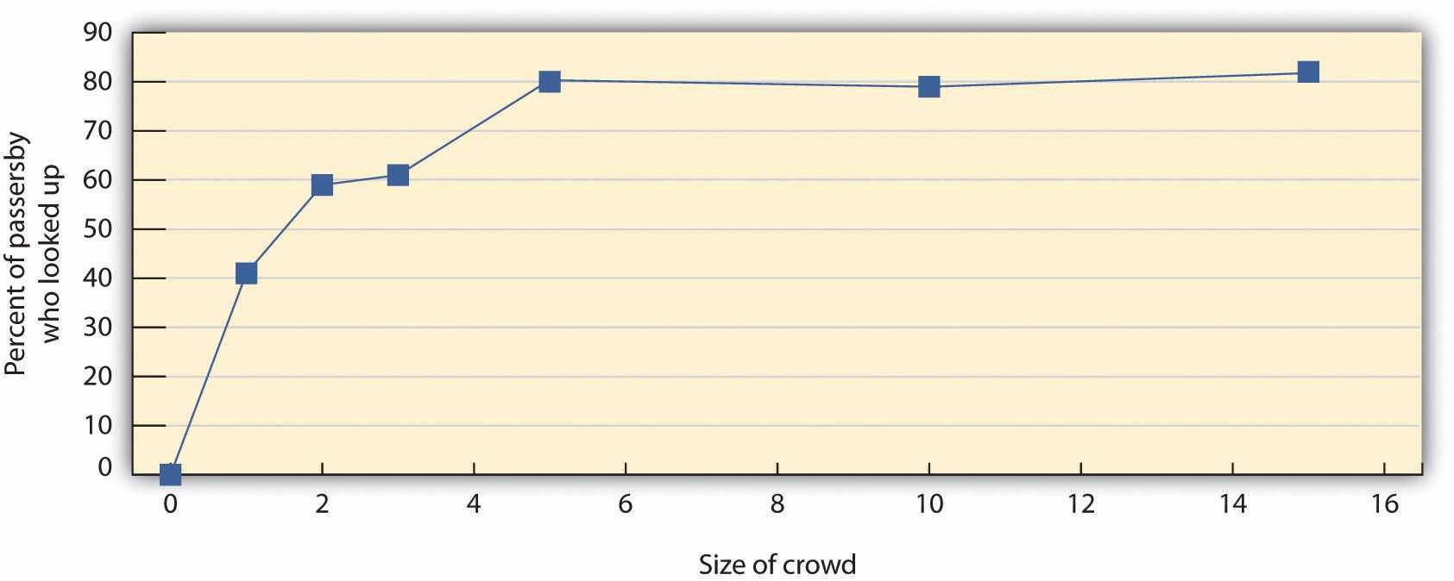
This figure shows the percentage of participants who looked up as a function of the size of the crowd on the street in Milgram’s (1969) ^{[28]} study on the streets of New York. You can see that the amount of conformity increases dramatically until there are five participants, after which it levels off. Similar patterns have been found in many other studies of conformity.
Group size is an important variable that influences a wide variety of behaviors of the individuals in groups. People leave proportionally smaller tips in restaurants as the number in their party increases, and people are less likely to help as the number of bystanders to an incident increases (Latané, 1981). ^{[29]} The number of group members also has an important influence on group performance: As the size of a working group gets larger, the contributions of each individual member to the group effort become smaller. In each case, the influence of group size on behavior is found to be similar to that shown in Figure 7.5 "Social Impact".
As you can see in Figure 7.5 "Social Impact", the effect of adding new individuals to the group eventually levels off entirely, such that adding more people to the majority after that point makes no meaningful difference in the amount of conformity. This peak usually occurs when the majority has about four or five persons. One reason that the impact of new group members decreases so rapidly is because as the number in the group increases, the individuals in the majority are soon seen more as a group rather than as separate individuals. When there are only a couple of individuals expressing opinions, each person is likely to be seen as an individual, holding his or her own unique opinions, and each new individual adds to the impact. As a result, two people are more influential than one, and three more influential than two. However, as the number of individuals grows, and particularly when those individuals are perceived as being able to communicate with each other, the individuals are more likely to be seen as a group rather than as individuals. At this point, adding new members does not change the perception; regardless of whether there are four, five, six, or more members, the group is still just a group. As a result, the expressed opinions or behaviors of the group members no longer seem to reflect their own characteristics, so much as they do that of the group as a whole, and thus increasing the number of group members is less effective in increasing influence (Wilder, 1977). ^{[30]}

The Unanimity of the Majority
Although the number of people in the group is an important determinant of conformity, it cannot be the only thing—if it were, minority influence would be impossible. It turns out that the consistency or unanimity of the group members is even more important. In Asch’s study, as an example, conformity occurred not so much because many confederates gave a wrong answer but rather because each of the confederates gave the same wrong answer. In one follow-up study that he conducted, Asch increased the number of confederates to 16 but had just one of those confederates give the correct answer. He found that in this case, even though there were 15 incorrect and only one correct answer given by the confederates, conformity was nevertheless sharply reduced—to only about 5% of the participants’ responses. And you will recall that in the minority influence research of Moscovici, the same thing occurred; conformity was only observed when the minority group members were completely consistent in their expressed opinions.
Although you might not be surprised to hear that conformity decreases when one of the group members gives the right answer, you may be more surprised to hear that conformity is reduced even when the dissenting confederate gives a different wronganswer. For example, conformity is reduced dramatically in Asch’s line-judging situation, such that virtually all participants give the correct answer (assume it is line 3 in this case) even when the majority of the confederates have indicated that line 2 is the correct answer and a single confederate indicates that line 1 is correct. In short, conformity is reduced when there is any inconsistency among the members of the majority group—even when one member of the majority gives an answer that is even more incorrect than that given by the other majority group members (Allen & Levine, 1968). ^{[31]}
Why should unanimity be such an important determinant of conformity? For one, when there is complete agreement among the majority members, the individual who is the target of influence stands completely alone and must be the first to break ranks by giving a different opinion. Being the only person who is different is potentially embarrassing, and people who wish to make a good impression on, or be liked by, others may naturally want to avoid this. If you can convince your friend to wear blue jeans rather than a coat and tie to a wedding, then you’re naturally going to feel a lot less conspicuous when you wear jeans too.
Second, when there is complete agreement—remember the consistent minority in the studies by Moscovici—the participant may become less sure of his or her own perceptions. Because everyone else is holding the exact same opinion, it seems that they must be correctly responding to the external reality. When such doubt occurs, the individual may be likely to conform due to informational conformity. Finally, when one or more of the other group members gives a different answer than the rest of the group (so that the unanimity of the majority group is broken), that person is no longer part of the group that is doing the influencing and becomes (along with the participant) part of the group being influenced. You can see that another way of describing the effect of unanimity is to say that as soon as the individual has someone who agrees with him or her that the others may not be correct (a supporter or ally), then the pressure to conform is reduced. Having one or more supporters who challenge the status quo validates one’s own opinion and makes disagreeing with the majority more likely (Allen, 1975; Boyanowsky & Allen, 1973). ^{[32]}

The Importance of the Task
Still another determinant of conformity is the perceived importance of the decision. The studies of Sherif, Asch, and Moscovici may be criticized because the decisions that the participants made—for instance, judging the length of lines or the colors of objects—seem rather trivial. But what would happen when people were asked to make an important decision? Although you might think that conformity would be less when the task becomes more important (perhaps because people would feel uncomfortable relying on the judgments of others and want to take more responsibility for their own decisions), the influence of task importance actually turns out to be more complicated than that.

Research Focus
How Task Importance and Confidence Influence Conformity
The joint influence of an individual’s confidence in his or her beliefs and the importance of the task was demonstrated in an experiment conducted by Baron, Vandello, and Brunsman (1996) ^{[33]} that used a slight modification of the Asch procedure to assess conformity. Participants completed the experiment along with two other students, who were actually experimental confederates. The participants worked on several different types of trials, but there were 26 that were relevant to the conformity predictions. On these trials a photo of a single individual was presented first, followed immediately by a “lineup” photo of four individuals, one of whom had been viewed in the initial slide (but who might have been dressed differently):
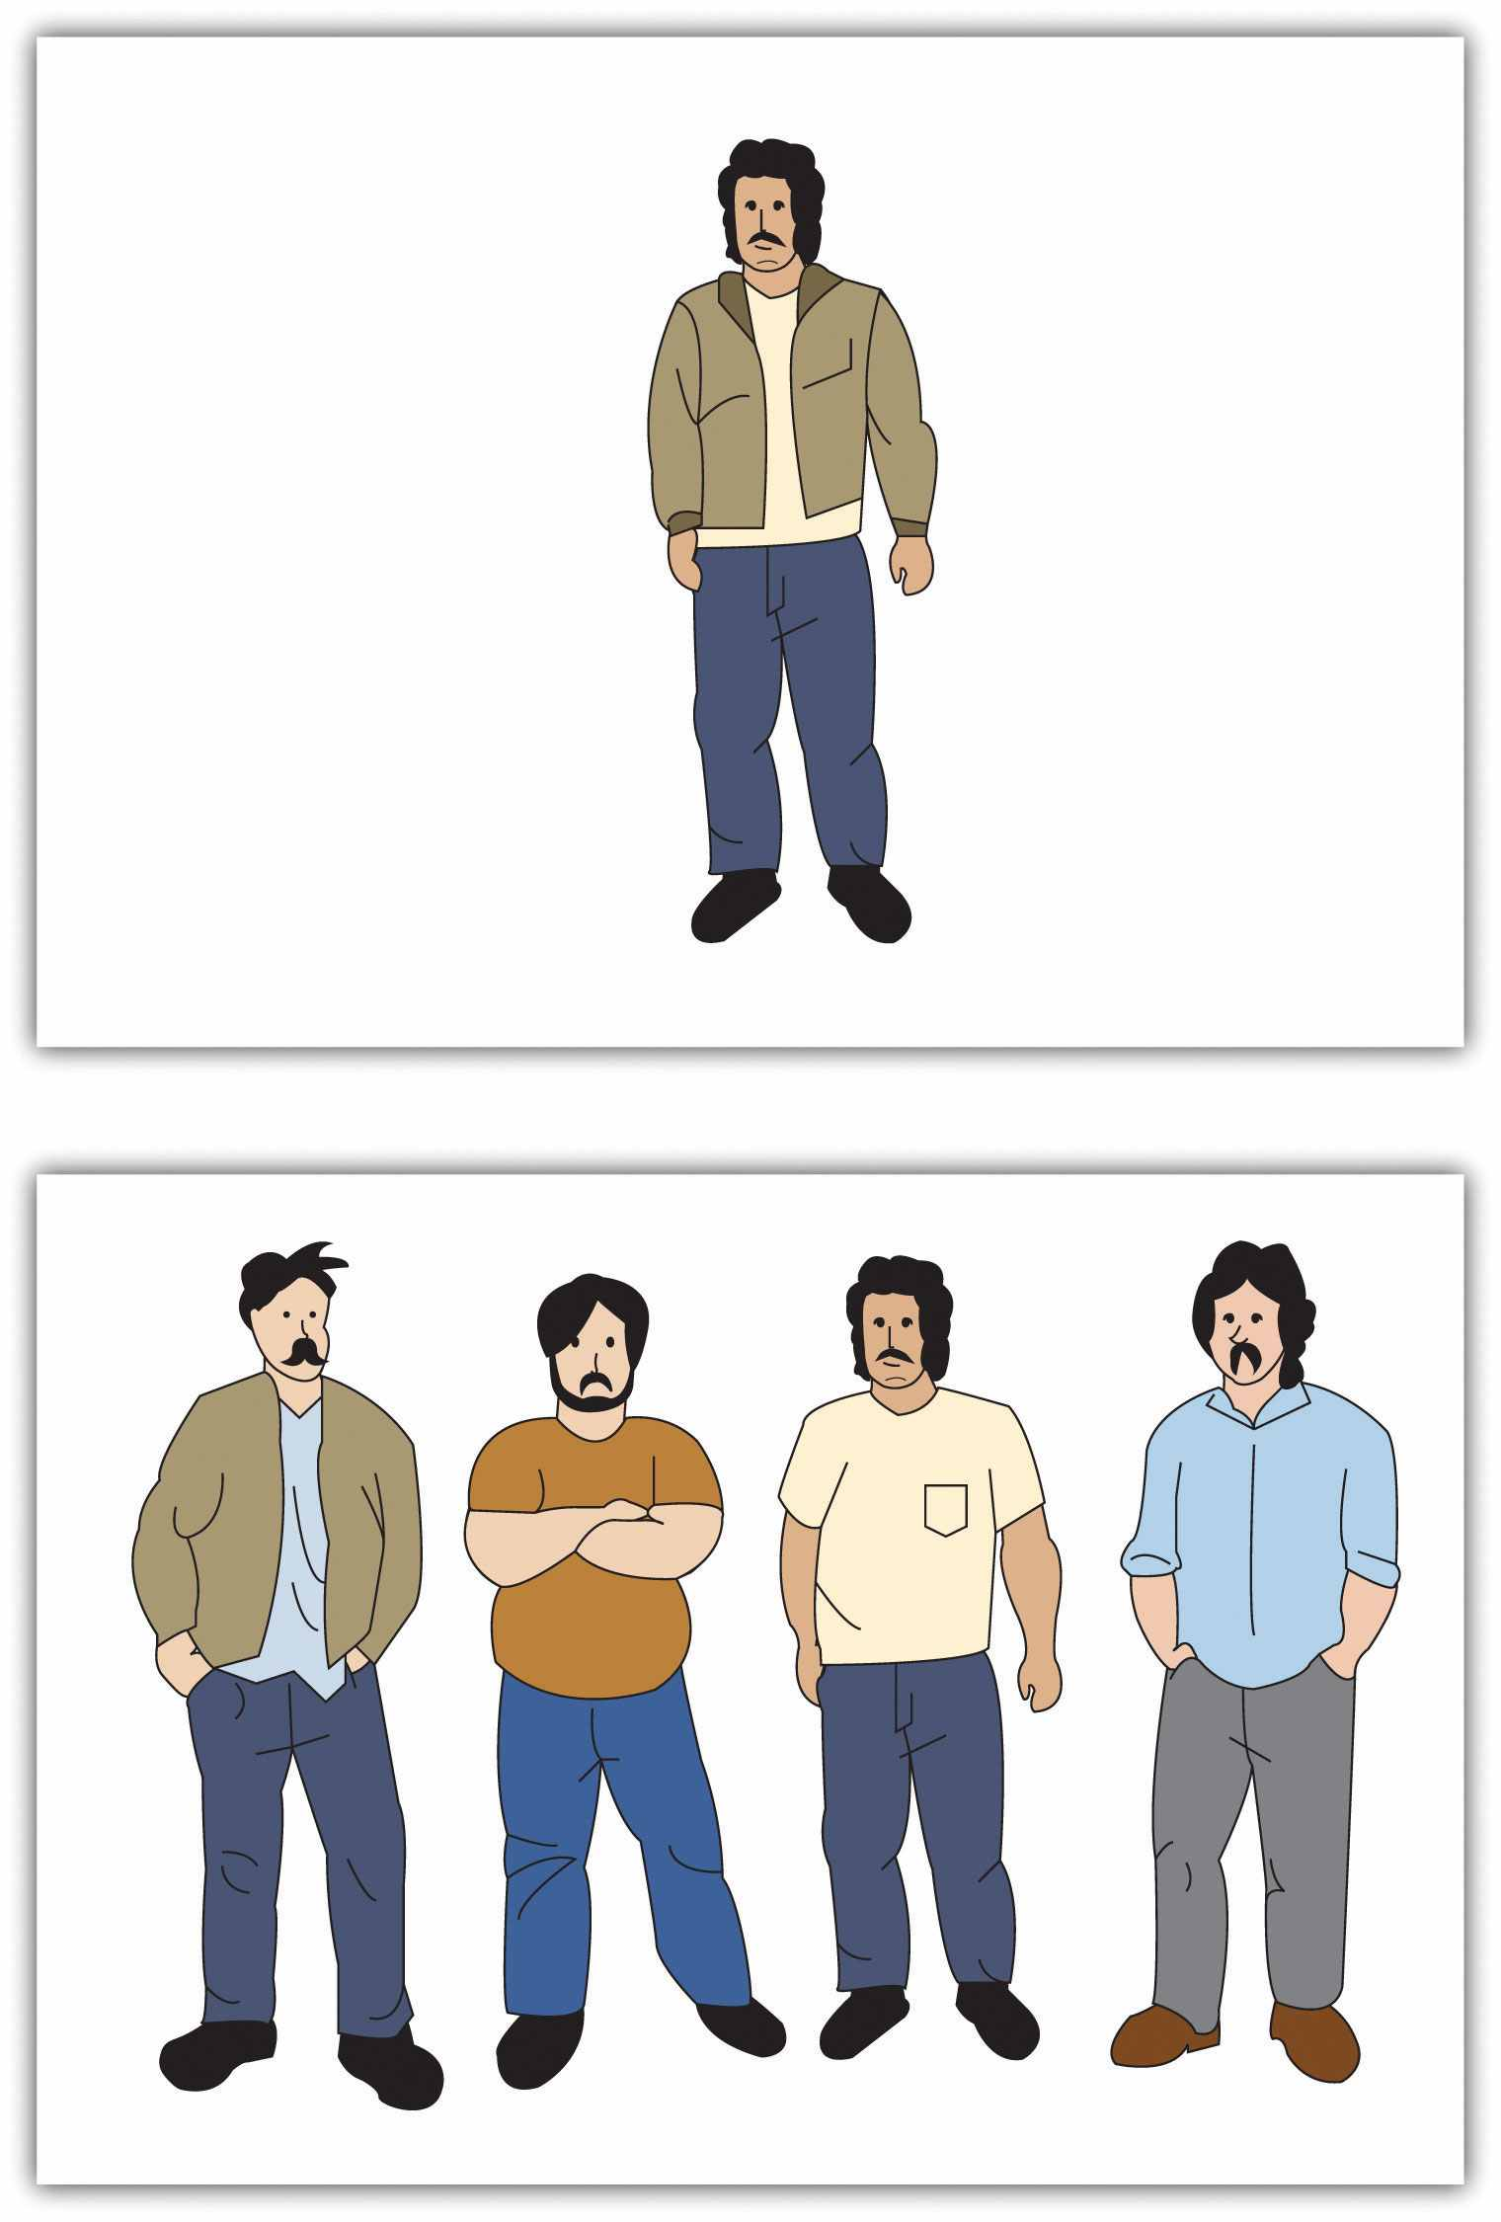
The participants’ task was to call out which person in the lineup was the same as the original individual using a number between 1 (the person on the left) and 4 (the person on the right). In each of the critical trials the two confederates went before the participant and they each gave the same wrong response.
Two experimental manipulations were used. First, the researchers manipulated task importance by telling some participants (the high importance condition) that their performance on the task was an important measure of eyewitness ability and that the participants who performed most accurately would receive $20 at the end of the data collection. (A lottery using all the participants was actually held at the end of the semester, and some participants were paid the $20.) Participants in thelow-importance condition, on the other hand, were told that the test procedure was part of a pilot study and that the decisions were not that important. Second, task difficulty was varied by showing the test and the lineup photos for 5 and 10 seconds, respectively (easy condition) or for only ½ and 1 second, respectively (difficult condition). The conformity score was defined as the number of trials in which the participant offered the same (incorrect) response as the confederates.

Figure 7.6
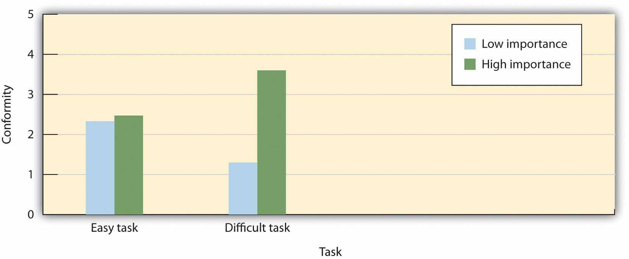
On easy tasks, participants conformed less when they thought that the decision was of high (versus low) importance, whereas on difficult tasks, participants conformed more when they thought the decision was of high importance. Data are from Baron et al. (1996). ^{[34]}
As you can see in the preceding figure, an interaction between task difficulty and task importance was observed. On easy tasks, participants conformed less to the incorrect judgments of others when the decision had more important consequences for them. In these cases, they seemed to rely more on their own opinions (which they were convinced were correct) when it really mattered, but were more likely to go along with the opinions of the others when things were not that critical (probably normative conformity).
On the difficult tasks, however, results were the opposite. In this case participants conformed more when they thought the decision was of high, rather than low, importance. In these cases in which they were more unsure of their opinions and yet they really wanted to be correct, they used the judgments of others to inform their own views (informational conformity).

KEY TAKEAWAYS
- Social influence creates conformity.
- Influence may occur in more passive or more active ways.
- We conform both to gain accurate knowledge (informational conformity) and to avoid being rejected by others (normative conformity).
- Both majorities and minorities may create social influence, but they do so in different ways.
- The characteristics of the social situation, including the number of people in the majority and the unanimity of the majority, have a strong influence on conformity.

EXERCISES AND CRITICAL THINKING
- Describe a time when you conformed to the opinions or behaviors of others. Interpret the conformity in terms of the concepts discussed in this section.
- Imagine you were serving on a jury trial in which you found yourself the only person who believed that the defendant was innocent. What strategies might you use to convince the majority?

[1] Cialdini, R. B., Reno, R. R., & Kallgren, C. A. (1990). A focus theory of normative conduct: Recycling the concept of norms to reduce littering in public places. Journal of Personality and Social Psychology, 58, 1015–1026.
[2] Anderson, C., Keltner, D., & John, O. P. (2003). Emotional convergence between people over time. Journal of Personality and Social Psychology, 84(5), 1054–1068.
[3] Chartrand, T. L., & Bargh, J. A. (1999). The chameleon effect: The perception-behavior link and social interaction. Journal of Personality and Social Psychology, 76(6), 893–910.
[4] Chartrand, T. L., & Bargh, J. A. (1999). The chameleon effect: The perception-behavior link and social interaction. Journal of Personality and Social Psychology, 76(6), 893–910.
[5] Dalton, A. N., Chartrand, T. L., & Finkel, E. J. (2010). The schema-driven chameleon: How mimicry affects executive and self-regulatory resources. Journal of Personality and Social Psychology, 98(4), 605–617.
[6] Chartrand, T. L., & Dalton, A. N. (2009). Mimicry: Its ubiquity, importance, and functionality. In E. Morsella, J. A. Bargh, & P. M. Gollwitzer (Eds.), Oxford handbook of human action (pp. 458–483). New York, NY: Oxford University Press; Tickle-Degnen, L., & Rosenthal, R. (1990). The nature of rapport and its nonverbal correlates. Psychological Inquiry, 1(4), 285–293; Tickle-Degnen, L., & Rosenthal, R. (Eds.). (1992). Nonverbal aspects of therapeutic rapport. Hillsdale, NJ: Lawrence Erlbaum.
[7] Festinger, L., Schachter, S., & Back, K. (1950). Social pressures in informal groups. New York, NY: Harper; Hardin, C., & Higgins, T. (1996). Shared reality: How social verification makes the subjective objective. In R. M. Sorrentino & E. T. Higgins (Eds.), Handbook of motivation and cognition: Foundations of social behavior (Vol. 3, pp. 28–84). New York, NY: Guilford; Turner, J. C. (1991). Social influence. Pacific Grove, CA: Brooks Cole.
[8] Deutsch, M., & Gerard, H. B. (1955). A study of normative and informational social influences upon individual judgment. Journal of Abnormal and Social Psychology, 51, 629–636.
[9] Cialdini, R. B. (1993). Influence: Science and practice (3rd ed.). New York, NY: Harper Collins; Sherif, M. (1936). The psychology of social norms. New York, NY: Harper & Row; Sumner, W. G. (1906). Folkways. Boston, MA: Ginn.
[10] Turner, J. C. (1991). Social influence. Pacific Grove, CA: Brooks Cole.
[11] Sherif, M. (1936). The psychology of social norms. New York, NY: Harper & Row.
[12] Sherif, M. (1936). The psychology of social norms. New York, NY: Harper & Row.
[13] Sherif, M. (1936). The psychology of social norms. New York, NY: Harper & Row.
[14] Jacobs, R. C., & Campbell, D. T. (1961). The perpetuation of an arbitrary tradition through several generations of a laboratory microculture. Journal of Abnormal and Social Psychology, 62, 649–658.
[15] MacNeil, M. K., & Sherif, M. (1976). Norm change over subject generations as a function of arbitrariness of prescribed norms. Journal of Personality and Social Psychology, 34, 762–773.
[16] Rohrer, J. H., Baron, S. H., Hoffman, E. L., & Swander, D. V. (1954). The stability of autokinetic judgments. American Journal of Psychology, 67, 143–146.
[17] Asch, S. E. (1952). Social psychology. Englewood Cliffs, NJ: Prentice-Hall; Asch, S. E. (1955). Opinions and social pressure. Scientific American, 11, 32.
[18] Moscovici, S., Lage, E., & Naffrechoux, M. (1969). Influence of a consistent minority on the responses of a majority in a colour perception task. Sociometry, 32, 365–379.
[19] Moscovici, S., Lage, E., & Naffrechoux, M. (1969). Influence of a consistent minority on the responses of a majority in a colour perception task. Sociometry, 32, 365–379.
[20] Hogg, M. A. (2010). Influence and leadership. In S. F. Fiske, D. T. Gilbert, & G. Lindzey (Eds.), Handbook of social psychology (Vol. 2, pp. 1166–1207). New York, NY: Wiley.
[21] Mugny, G., & Papastamou, S. (1981). When rigidity does not fail: Individualization and psychologicalization as resistance to the diffusion of minority innovation. European Journal of Social Psychology, 10, 43–62.
[22] Martin, R., & Hewstone, M. (2003). Majority versus minority influence: When, not whether, source status instigates heuristic or systematic processing. European Journal of Social Psychology, 33(3), 313–330; Martin, R., Martin, P. Y., Smith, J. R., & Hewstone, M. (2007). Majority versus minority influence and prediction of behavioral intentions and behavior. Journal of Experimental Social Psychology, 43(5), 763–771.
[23] Nemeth, C. J., & Kwan, J. L. (1987). Minority influence, divergent thinking, and the detection of correct solutions. Journal of Applied Social Psychology, 17, 788–799.
[24] Crano, W. D., & Chen, X. (1998). The leniency contract and persistence of majority and minority influence. Journal of Personality and Social Psychology, 74, 1437–1450.
[25] Latané, B. (1981). The psychology of social impact. American Psychologist, 36, 343–356; Mullen, B. (1983). Operationalizing the effect of the group on the individual: A self-attention perspective. Journal of Experimental Social Psychology, 19, 295–322.
[26] Latané, B. (1981). The psychology of social impact. American Psychologist, 36, 343–356.
[27] Milgram, S., Bickman, L., & Berkowitz, L. (1969). Note on the drawing power of crowds of different size. Journal of Personality and Social Psychology, 13, 79–82.
[28] Milgram, S., Bickman, L., & Berkowitz, L. (1969). Note on the drawing power of crowds of different size. Journal of Personality and Social Psychology, 13, 79–82.
[29] Latané, B. (1981). The psychology of social impact. American Psychologist, 36, 343–356.
[30] Wilder, D. A. (1977). Perception of groups, size of opposition, and social influence.Journal of Experimental Social Psychology, 13(3), 253–268.
[31] Allen, V. L., & Levine, J. M. (1968). Social support, dissent and conformity. Sociometry, 31(2), 138–149.
[32] Allen, V. L. (1975). Social support for nonconformity. In L. Berkowitz (Ed.), Advances in experimental social psychology (Vol. 8). New York, NY: Academic Press; Boyanowsky, E. O., & Allen, V. L. (1973). Ingroup norms and self-identity as determinants of discriminatory behavior. Journal of Personality and Social Psychology, 25, 408–418.
[33] Baron, R. S., Vandello, J. A., & Brunsman, B. (1996). The forgotten variable in conformity research: Impact of task importance on social influence. Journal of Personality and Social Psychology, 71, 915–927.
[34] Baron, R. S., Vandello, J. A., & Brunsman, B. (1996). The forgotten variable in conformity research: Impact of task importance on social influence. Journal of Personality and Social Psychology, 71, 915–927.

7.2 Obedience, Power, and Leadership

LEARNING OBJECTIVES
- Describe and interpret the results of Stanley Milgram’s research on obedience.
- Compare the different types of power proposed by John French and Bertram Raven and explain how they produce conformity.
- Define leadership and explain how effective leaders are determined by the person, the situation, and the person-situation interaction.
One of the fundamental aspects of social interaction is that some individuals have more influence than others. Social power can be defined as the ability of a person to create conformity even when the people being influenced may attempt to resist those changes (Fiske, 1993; Keltner, Gruenfeld, & Anderson, 2003). ^{[1]} Bosses have power over their workers, parents have power over their children, and, more generally, we can say that those in authority have power over their subordinates. In short, power refers to the process of social influence itself—those who have power are those who are most able to influence others.

Milgram’s Studies on Obedience to Authority
The powerful ability of those in authority to control others was demonstrated in a remarkable set of studies performed by Stanley Milgram (1974). ^{[2]} Milgram was interested in understanding the factors that lead people to obey the orders given by people in authority. He designed a study in which he could observe the extent to which a person who presented himself as an authority would be able to produce obedience, even to the extent of leading people to cause harm to others.

Video Clip 1
Milgram’s Obedience to Authority Experiment
Like many other social psychologists, Milgram’s interest in conformity stemmed in part from his desire to understand how the presence of a powerful person—particularly the German dictator Adolph Hitler who ordered the killing of millions of people during World War II—could produce obedience. Under Hitler’s direction the German SS troops oversaw the execution of 6 million Jews as well as other “undesirables,” including political and religious dissidents, homosexuals, the mentally and physically disabled, and prisoners of war.
Milgram used newspaper ads to recruit men (and in one study, women) from a wide variety of backgrounds to participate in his research. When the research participant arrived at the lab, he or she was introduced to a man whom the participant believed was another research participant but who was actually an experimental confederate. The experimenter explained that the goal of the research was to study the effects of punishment on learning. After the participant and the confederate both consented to be in the study, the researcher explained that one of them would be the teacher and the other the learner. They were each given a slip of paper and asked to open it and to indicate what it said. In fact both papers read teacher, which allowed the confederate to pretend that he had been assigned to be the learner and thus to assure that the actual participant was always the teacher.
While the research participant (now the teacher) looked on, the learner was taken into the adjoining shock room and strapped to an electrode that was to deliver the punishment. The experimenter explained that the teacher’s job would be to sit in the control room and to read a list of word pairs to the learner. After the teacher read the list once, it would be the learner’s job to remember which words went together. For instance, if the word pair was blue-sofa, the teacher would say the word blue on the testing trials and the learner would have to indicate which of four possible words (house, sofa, cat, or carpet) was the correct answer by pressing one of four buttons in front of him.
After the experimenter gave the “teacher” a sample shock (which was said to be at 45 volts) to demonstrate that the shocks really were painful, the experiment began. The research participant first read the list of words to the learner and then began testing him on his learning. The shock panel, as shown in Figure 7.7 "The Shock Apparatus Used in Milgram’s Obedience Study", was presented in front of the teacher, and the learner was not visible in the shock room. The experimenter sat behind the teacher and explained to him that each time the learner made a mistake the teacher was to press one of the shock switches to administer the shock. Moreover, which switch was to be pressed increased by one level with each mistake, such that each mistake required a stronger shock.
Once the learner (who was, of course, actually an experimental confederate) was alone in the shock room, he unstrapped himself from the shock machine and brought out a tape recorder that he used to play a prerecorded series of responses that the teacher could hear through the wall of the room.
As you can see in Table 7.1 "The Confederate’s Schedule of Protest in the Milgram Experiments", the teacher heard the learner say “ugh!” after the first few shocks. After the next few mistakes, when the shock level reached 150 volts, the learner was heard to exclaim “Let me out of here. I have a heart trouble!” As the shock reached about 270 volts the learner’s protests became more vehement, and after 300 volts the learner proclaimed that he was not going to answer any more questions. From 330 volts and up the learner was silent. The experimenter responded to participants’ questions at this point, if they asked any, with a scripted response indicating that they should continue reading the questions and applying increasing shock when the learner did not respond.

Table 7.1 The Confederate’s Schedule of Protest in the Milgram Experiments
75 volts | Ugh!
90 volts | Ugh!
105 voles | Ugh! (louder)
120 volts | Ugh! Hey, this really hurts.
135 volts | Ugh!!
150 volts | Uh!! Experimenter! That’s all. Get me out of here. I told you I had heart trouble. My heart’s starting to bother me now. Get me out of here, please. My heart’s starting to bother me. I refuse to go on. Let me out!
165 volts | Ugh! Let me out! (shouting)
180 volts | Ugh! I can’t stand the pain. Let me out of here! (shouting)
195 volts | Ugh! Let me out of here! Let me out of here! My heart’s bothering me. Let me out of here! You have no right to keep me here! Let me out! Let me out of here! Let me out! Let me out of here! My heart’s bothering me. Let me out! Let me out!
210 volts | Ugh!! Experimenter! Get me out of here. I’ve had enough. I won’t be in the experiment any more.
225 volts | Ugh!
240 volts | Ugh!
255 volts | Ugh! Get me out of here.
270 volts | (agonized scream) Let me out of here. Let me out of here. Let me out of here. Let me out. Do you hear? Let me out of here.
285 volts | (agonized scream)
300 volts | (agonized scream) I absolutely refuse to answer any more. Get me out of here. You can’t hold me here. Get me out. Get me out of here.
315 volts | (intensely agonized scream) Let me out of here. Let me out of here. My heart’s bothering me. Let me out, I tell you. (hysterically) Let me out of here. Let me out of here. You have no right to hold me here. Let me out! Let me out! Let me out! Let me out of here! Let me out! Let me out!
The results of Milgram’s research were themselves quite shocking. Although all of the participants gave the initial mild levels of shock, responses varied after that. Some refused to continue after about 150 volts, despite the insistence of the experimenter to continue to increase the shock level. Still others, however, continued to present the questions, and to administer the shocks, under the pressure of the experimenter, who demanded that they continue. In the end, 65% of the participants continued giving the shock to the learner all the way up to the 450 volts maximum, even though that shock was marked as “danger: severe shock” and there had been no response heard from the participant for several trials. In sum, well over half of the men who participated had, as far as they knew, shocked another person to death, all as part of a supposed experiment on learning.
In case you are thinking that such high levels of obedience would not be observed in today’s modern culture, there is fact evidence that they would be. Studies similar to Milgram’s findings have been conducted all over the world (Blass, 1999) ^{[3]} and have found similar levels of conformity, with obedience rates ranging from a high of 90% in Spain and the Netherlands (Meeus & Raaijmakers, 1986) ^{[4]} to a low of 16% among Australian women (Kilham & Mann, 1974). ^{[5]}
Recently, Milgram’s results were almost exactly replicated, using men and women from a wide variety of ethnic groups, in a study conducted by Jerry Burger at Santa Clara University. In this replication of the Milgram experiment, 65% of the men and 73% of the women agreed to administer increasingly painful electric shocks when they were ordered to by an authority figure (Borge, 2010). ^{[6]} In the replication, however, the participants were not allowed to go beyond the 150 volt shock switch.
Although it might be tempting to conclude that Milgram’s experiments demonstrate that people are innately evil creatures who are ready to shock others to death, Milgram did not believe that this was the case. Rather, he felt that it was the social situation, and not the people themselves, that was responsible for the behavior. To demonstrate this, Milgram conducted research that explored a number of variations on his original procedure, each of which demonstrated that changes in the situation could dramatically influence the amount of conformity. These variations are summarized inFigure 7.8 "Authority and Obedience in Stanley Milgram’s Studies".

Figure 7.8 Authority and Obedience in Stanley Milgram’s Studies
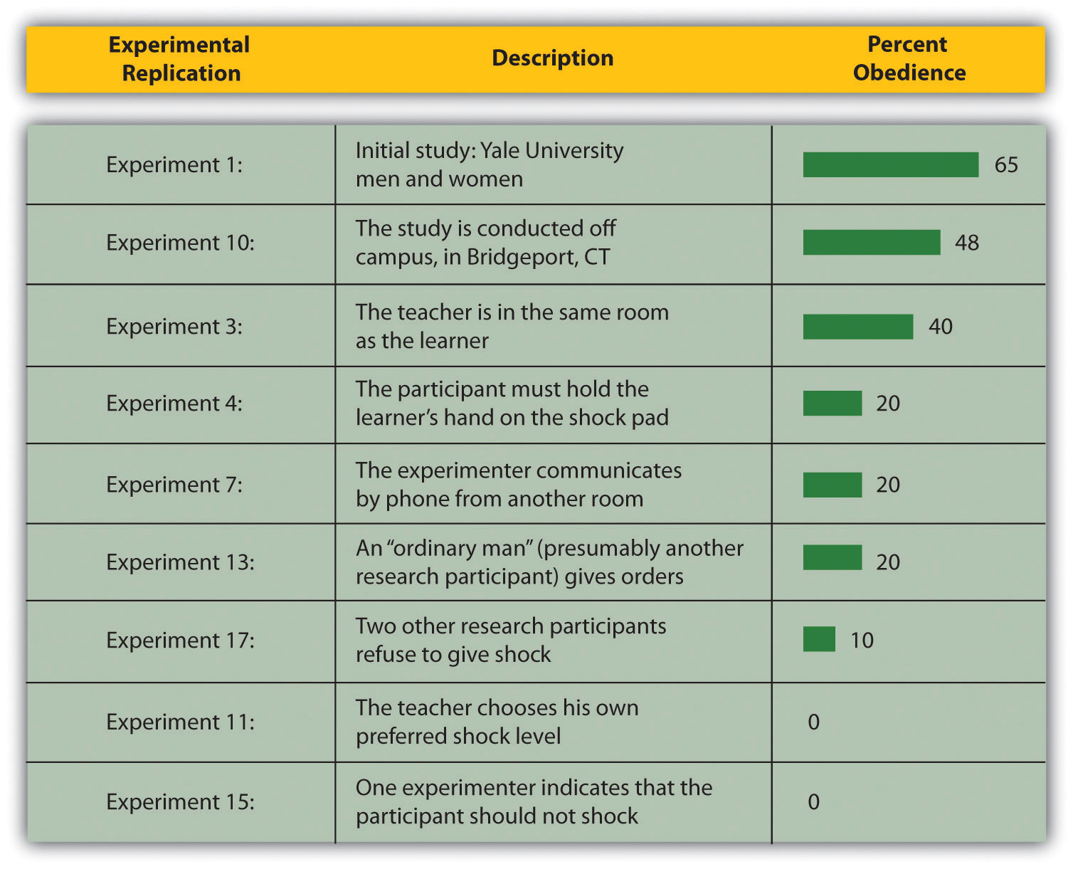
This figure presents the percentage of participants in Stanley Milgram’s (1974) studies on obedience who were maximally obedient (that is, who gave all 450 volts of shock) in some of the variations that he conducted.
In the initial study the authority’s status and power was maximized—the experimenter had been introduced as a respected scientist at a respected university. However, in replications of the study in which the experimenter’s authority was decreased, obedience also declined. In one replication the status of the experimenter was reduced by having the experiment take place in a building located in Bridgeport, Connecticut, rather than at the labs on the Yale University campus, and the research was ostensibly sponsored by a private commercial research firm instead of by the university. In this study less obedience was observed (only 48% of the participants delivered the maximum shock). Full obedience was also reduced (to 20%) when the experimenter’s ability to express his authority was limited by having him sit in an adjoining room and communicate to the teacher by telephone. And when the experimenter left the room and had another student (actually a confederate) give the instructions for him, conformity was also reduced to 20%.
In addition to the role of authority, Milgram’s studies also confirmed the role of unanimity in producing conformity. When another research participant (again an experimental confederate) began by giving the shocks but then later refused to continue and the participant was asked to take over, only 10% were obedient. And if two experimenters were present but only one proposed shocking while the other argued for stopping the shocks, all the research participants took the more benevolent advice and did not shock. Finally, in another condition the teacher sat next to the learner and was forced to wear an insulated glove and to hold the learner’s hand on the shock pad as he administered the shock. Again, obedience was reduced, this time to only 30%.
Perhaps most telling regarding the important role of the situation were the studies in which Milgram allowed the participants to choose their own shock levels or in which one of the experimenters suggested that they should not actually use the shock machine. In these situations, there was virtually no shocking. These conditions show that people do not like to harm others, and when given a choice they will not. On the other hand, the social situation can create powerful, and potentially deadly, social influence.

Social Psychology in the Public Interest
The Zimbardo Prison Studies and Abu Ghraib
In Milgram’s research we can see a provocative demonstration of how people who have power can control the behavior of others. Can our understanding of the social psychological factors that produce conformity and obedience help us explain the events that occurred in 2004 at Abu Ghraib, the Iraqi prison in which U.S. soldiers physically and psychologically tortured their Iraqi prisoners? The social psychologist Philip Zimbardo thinks so. He notes the parallels between the events that occurred at Abu Ghraib and the events that occurred in the “prison study” that he conducted in 1971. ^{[7]}
In that study, Zimbardo and his colleagues set up a mock prison. They selected 23 student volunteers and divided them into two groups. One group was chosen to be the “prisoners.” They were picked up at their homes by actual police officers, “arrested,” and brought to the prison to be guarded by the other group of students—the “guards.” The two groups were placed in a setting that was designed to look like a real prison, and the role-play began.
The Zimbardo Prison Study
The study was expected to run for two weeks. However, on the second day, the prisoners tried to rebel against the guards. The guards quickly moved to stop the rebellion by using both psychological punishment and physical abuse. In the ensuing days, the guards denied the prisoners food, water, and sleep; shot them with fire-extinguisher spray; threw their blankets into the dirt; and stripped them naked. On the fifth night the experimenters witnessed the guards putting bags over the prisoners’ heads, chaining their legs, and marching them around. At this point the researchers stopped the experiment early. The conclusions of Zimbardo’s research were clear: People may be so profoundly influenced by their social situation that they become coldhearted jail masters who torture their victims.
Zimbardo’s research can help us understand the events that occurred at Abu Ghraib. Zimbardo acted as an expert witness in the trial of Sergeant Chip Frederick, who was sentenced to eight years in prison for his role in the abuse at Abu Ghraib. Frederick was the Army reservist who was put in charge of the night shift at Tier 1A, where the detainees were abused. During this trial Frederick said, “What I did was wrong, and I don’t understand why I did it.” Zimbardo believes that Frederick acted exactly like the students in the prison study did. He worked in a prison that was overcrowded, filthy, and dangerous, and where he was expected to maintain control over the Iraqi prisoners—in short, the situation he found himself in was very similar to that of Zimbardo’s prison study.
In a recent interview, Zimbardo argued (you can tell that he is a social psychologist) that “human behavior is more influenced by things outside of us than inside.” He believes that, despite our moral and religious beliefs and despite the inherent goodness of people, there are times when external circumstances can overwhelm us and we do things we never thought we were capable of doing. He argued that “if you’re not aware that this can happen, you can be seduced by evil. We need inoculations against our own potential for evil. We have to acknowledge it. Then we can change it” (Driefus, 2007). ^{[8]}
You may wonder whether the extreme behavior of the guards and prisoners in Zimbardo’s prison study was unique to the particular social context that he created. Recent research by Stephen Reicher and Alex Haslam (2006) ^{[9]} suggests that this is indeed the case. In their research, they recreated Zimbardo’s prison experiment while making some small, but important, changes. For one, the prisoners were not “arrested” before the study began, and the setup of the jail was less realistic. Furthermore, the researchers in this experiment told the “guards” and the “prisoners” that the groups were arbitrary and could change over time (that is, that some prisoners might be able to be promoted to guards). The results of this study were entirely different than those found by Zimbardo. Although this study was also stopped early, this was more because the guards felt uncomfortable in their superior position than because the prisoners were being abused. This “prison” simply did not feel like a real prison to the participants, and as a result they did not take on the roles they were assigned. Again, the conclusions are clear—the specifics of the social situation, more than the people themselves, are often the most important determinants of behavior.

Types of Power
One of the most influential theories of power was developed by Bertram Raven and John French (French & Raven, 1959; Raven, 1992). ^{[10]} Raven identified five different types of power—reward power, coercive power, legitimate power, referent power, and expert power (shown in Table 7.2 "Types of Power"), arguing that each type of power involves a different type of social influence and that the different types vary in terms of whether their use will create public conformity or private acceptance. Understanding the types of power is important because it allows us to see more clearly the many ways that people can influence others. Let’s consider these five types of power, beginning with those that are most likely to produce public conformity only and moving on to those that are more likely to produce private acceptance.

Table 7.2 Types of Power
Reward power | The ability to distribute positive or negative rewards
Coercive power | The ability to dispense punishments
Legitimate power | Authority that comes from a belief on the part of those being influenced that the person has a legitimate right to demand conformity.
Referent power | Influence based on identification with, attraction to, or respect for the power-holder
Expert power | Power that comes from other’s beliefs that the power-holder possesses superior skills and abilities
Note. French and Raven proposed five types of power, which differ in their likelihood of producing public conformity or private acceptance.

Reward Power
Reward power occurs when one person is able to influence others by providing them with positive outcomes. Bosses have reward power over employees because they are able to increase employees’ salary and job benefits, and teachers have reward power over students because they can assign student high marks. The variety of rewards that can be used by the powerful is almost endless and includes verbal praise or approval, the awarding of status or prestige, and even direct financial payment.
The ability to wield reward power over those we want to influence is contingent on the needs of the person being influenced. Power is greater when the person being influenced has a strong desire to obtain the reward, and power is weaker when the individual does not need the reward. A boss will have more influence on an employee who has no other job prospects than on one who is being sought after by other corporations, and expensive presents will be more effective in persuading those who cannot buy the items with their own money. Because the change in behavior that results from reward power is driven by the reward itself, its use is usually more likely to produce public conformity than private acceptance.

Coercive Power
Coercive power is power that is based on the ability to create negative outcomes for others, for instance by bullying, intimidating, or otherwise punishing. Bosses have coercive power over employees if they are able (and willing) to punish employees by reducing their salary, demoting them to a lower position, embarrassing them, or firing them. And friends can coerce each other through teasing, humiliation, and ostracism. As with reward power, coercive power is effective only when the person being influenced is dependent upon the power-holder. Furthermore, coercion works only if the person being influenced does not leave the group entirely—people who are punished too much are likely to look for other situations that provide more positive outcomes.
In many cases power-holders use reward and coercive power at the same time—for instance, by both increasing salaries as a result of positive performance but also threatening to reduce them if the performance drops. Because the use of coercion has such negative consequences, authorities are generally more likely to use reward than coercive power (Molm, 1997). ^{[11]} Coercion is usually more difficult to use, since it often requires energy to keep the person from avoiding the punishment by leaving the situation altogether. And coercive power is less desirable for both the power-holder and the person being influenced because it creates an environment of negative feelings and distrust that is likely to make interactions difficult, undermine satisfaction, and lead to retaliation against the power-holder (Tepper et al., 2009). ^{[12]}
As with reward power, coercive power is more likely to produce public conformity than private acceptance. Furthermore, in both cases the effective use of the power requires that the power-holder continually monitor the behavior of the target to be sure that he or she is complying. This monitoring may itself lead to a sense of mistrust between the two individuals in the relationship. The power-holder feels (perhaps unjustly) that the target is only complying due to the monitoring, whereas the target feels (again perhaps unjustly) that the power-holder does not trust him or her.

Legitimate Power
Whereas reward and coercive power are likely to produce conformity, other types of power, which are not so highly focused around reward and punishment, are more likely to create changes in attitudes as well as behavior (private acceptance). In many ways, then, these sources of power are stronger because they produce real belief change. Legitimate power is power vested in those who are appointed or elected to positions of authority, such as teachers, politicians, policemen, and judges, and their power is successful because members of the group accept it as appropriate. We accept that governments can levy taxes and that judges can decide the outcomes of court cases because we see these groups and individuals as valid parts of our society. Individuals with legitimate power can exert substantial influence on their followers. Those with legitimate power may not only create changes in the behavior of others but also have the power to create and change the social norms of the group.
In some cases legitimate power is given to the authority figure as a result of laws or elections, or as part of the norms, traditions, and values of the society. The power that the experimenter had over the research participants in Milgram’s study on obedience seems to have been primarily the result of his legitimate power as a respected scientist at an important university. In other cases legitimate power comes more informally, as a result of being a respected group member. People who contribute to the group process and follow group norms gain status within the group and therefore earn legitimate power.
In some cases legitimate power can even be used successfully by those who do not seem to have much power. You may recall that after Hurricane Katrina hit the city of New Orleans in 2005, the people there demanded that the federal government help them rebuild the city. Although these people did not have much reward or coercive power, they were nevertheless perceived as good and respected citizens of the United States. Many U.S. citizens tend to believe that people who do not have as much as others (for instance, those who are very poor) should be treated fairly and that these people may legitimately demand resources from those who have more. This might not always work, but to the extent that it does it represents a type of legitimate power—power that comes from a belief in the appropriateness or obligation to respond to the requests of others with legitimate standing.

Referent Power
People with referent power have an ability to influence others because they can lead those others to identify with them. In this case, the person who provides the influence is (a) a member of an important reference group—someone we personally admire and attempt to emulate; (b) a charismatic, dynamic, and persuasive leader; or (c) a person who is particularly attractive or famous (Heath, McCarthy, & Mothersbaugh, 1994; Henrich & Gil-White, 2001; Kamins, 1989; Wilson & Sherrell, 1993). ^{[13]} A young child who mimics the opinions or behaviors of an older sibling or a famous baseball player, or a churchgoer who follows the advice of a respected church leader, is influenced by referent power. Referent power generally produces private acceptance rather than public conformity (Kelman, 1961). ^{[14]}
The influence brought on by referent power may occur in a passive sense because the person being emulated does not necessarily attempt to influence others, and the person who is being influenced may not even realize that the influence is occurring. In other cases, however, the person with referent power (such as the leader of a cult) may make full use of his or her status as the target of identification or respect to produce change. In either case, referent power is a particularly strong source of influence because it is likely to result in the acceptance of the opinions of the important other.

Expert Power
French and Raven’s final source of power is expert power. Experts have knowledge or information, and conforming to those whom we perceive to be experts is useful for making decisions about issues for which we have insufficient expertise. Expert power thus represents a type of informational influence based on the fundamental desire to obtain valid and accurate information, and where the outcome is likely to be private acceptance. Conformity to the beliefs or instructions of doctors, teachers, lawyers, and computer experts is an example of expert influence; we assume that these individuals have valid information about their areas of expertise, and we accept their opinions based on this perceived expertise (particularly if their advice seems to be successful in solving problems). Indeed, one method of increasing one’s power is to become an expert in a domain. Expert power is increased for those who possess more information about a relevant topic than others do because the others must turn to this individual to gain the information. You can see, then, that if you want to influence others, it can be useful to gain as much information about the topic as you can.

Research Focus
Does Power Corrupt?
Having power provides some benefits for those who have it. In comparison to those with less power, people who have more power over others are more confident and more attuned to potential opportunities in their environment (Anderson & Berdahl, 2002). ^{[15]} They are also more likely than are people with less power to take action to meet their goals (Anderson & Galinsky, 2006; Galinsky, Gruenfeld, & Magee, 2003). ^{[16]}
Despite these advantages of having power, a little power goes a long way and having too much can be dangerous, for both the targets of the power and the power-holder himself or herself. In an experiment by David Kipnis (1972), ^{[17]}college students played the role of “supervisors” who were supposedly working on a task with other students (the “workers”). According to random assignment to experimental conditions, one half of the supervisors were able to influence the workers through legitimate power only, by sending them messages attempting to persuade them to work harder. The other half of the supervisors were given increased power. In addition to being able to persuade the workers to increase their output through the messages, they were also given both reward power (the ability to give small monetary rewards) and coercive power (the ability to take away earlier rewards).
Although the workers (who were actually preprogrammed) performed equally well in both conditions, the participants who were given more power took advantage of it by more frequently contacting the workers and more frequently threatening them. The students in this condition relied almost exclusively on coercive power rather than attempting to use their legitimate power to develop positive relations with the subordinates.
Although it did not increase the workers’ performance, having the extra power had a negative effect on the power-holders’ images of the workers. At the end of the study, the supervisors who had been given extra power rated the workers more negatively, were less interested in meeting them, and felt that the only reason the workers did well was to obtain the rewards.
The conclusion of these researchers is clear: Having power may lead people to use it, even though it may not be necessary, which may then lead them to believe that their subordinates are performing only because of the threats. Although using excess power may be successful in the short run, power that is based exclusively on reward and coercion is not likely to produce a positive environment for either the power-holder or the subordinate. People with power may also be more likely to stereotype people with less power than they have (Depret & Fiske, 1999) ^{[18]} and may be less likely to help other people who are in need (van Kleef et al., 2008).^{[19]}
Although this research suggests that people may use power when it is available to them, other research has found that this is not equally true for all people—still another case of a person-situation interaction. Serena Chen and her colleagues (Chen, Lee-Chai, & Bargh, 2001) ^{[20]} found that students who had been classified as more self-oriented (in the sense that they considered relationships in terms of what they could and should get out of them for themselves) were more likely to misuse their power, whereas students who were classified as other-oriented were more likely to use their power to help others

Leaders and Leadership
One type of person who has power over others, in the sense that they are able to influence them, are leaders. Leaders are in a position in which they can exertleadership, which is the ability to direct or inspire others to achieve goals(Chemers, 2001; Hogg, 2010). ^{[21]} Leaders have many different influence techniques at their disposal: In some cases they may give commands and enforce them with reward or coercive power, resulting in public conformity with the commands. In other cases they may rely on well-reasoned technical arguments or inspirational appeals, making use of legitimate, referent, or expert power, with the goal of creating private acceptance and leading their followers to achieve.
Leadership is a classic example of the combined effects of the person and the social situation. Let’s consider first the person part of the equation and then turn to consider how the person and the social situation work together to create effective leadership.

Personality and Leadership
One approach to understanding leadership is to focus on person variables.Personality theories of leadership are explanations of leadership based on the idea that some people are simply “natural leaders” because they possess personality characteristics that make them effective (Zaccaro, 2007). ^{[22]}
One personality variable that is associated with effective leadership is intelligence. Being intelligent improves leadership, as long as the leader is able to communicate in a way that is easily understood by his or her followers (Simonton, 1994, 1995). ^{[23]}Other research has found that a leader’s social skills, such as the ability to accurately perceive the needs and goals of the group members, are also important to effective leadership. People who are more sociable, and therefore better able to communicate with others, tend to make good leaders (Kenny & Zaccaro, 1983; Sorrentino & Boutillier, 1975). ^{[24]} Other variables that relate to leadership effectiveness include verbal skills, creativity, self-confidence, emotional stability, conscientiousness, and agreeableness (Cronshaw & Lord, 1987; Judge, Bono, Ilies, & Gerhardt, 2002; Yukl, 2002). ^{[25]} And of course the individual’s skills at the task at hand are important. Leaders who have expertise in the area of their leadership will be more effective than those who do not.
Because so many characteristics seem to be related to leader skills, some researchers have attempted to account for leadership not in terms of individual traits but in terms of a package of traits that successful leaders seem to have. Some have considered this in terms of charisma (Beyer, 1999; Conger & Kanungo, 1998). ^{[26]}Charismatic leaders are leaders who are enthusiastic, committed, and self-confident; who tend to talk about the importance of group goals at a broad level; and who make personal sacrifices for the group. Charismatic leaders express views that support and validate existing group norms but that also contain a vision of what the group could or should be. Charismatic leaders use their referent power to motivate, uplift, and inspire others. And research has found a positive relationship between a leader’s charisma and effective leadership performance (Simonton, 1988). ^{[27]}
Another trait-based approach to leadership is based on the idea that leaders take eithertransactional or transformational leadership styles with their subordinates (Avolio &Yammarino, 2003; Podsakoff, MacKenzie, Moorman, & Fetter, 1990). ^{[28]}Transactional leaders are the more regular leaders who work with their subordinates to help them understand what is required of them and to get the job done.Transformational leaders, on the other hand, are more like charismatic leaders—they have a vision of where the group is going and attempt to stimulate and inspire their workers to move beyond their present status and to create a new and better future. Transformational leaders are those who can reconfigure or transform the group’s norms (Reicher & Hopkins, 2003). ^{[29]}

Leadership as an Interaction Between the Person and the Situation
Despite the fact that there appear to be at least some personality traits that relate to leadership ability, the most important approaches to understanding leadership take into consideration both the personality characteristics of the leader and the situation in which the leader is operating. In some cases the situation itself is important. For instance, you might remember that President George W. Bush’s ratings as a leader increased dramatically after the September 11, 2001, terrorist attacks on the World Trade Center. This is a classic example of how a situation can influence the perceptions of a leader’s skill. In other cases, however, both the situation and the person are critical.
One well-known person-situation approach to understanding leadership effectiveness was developed by Fred Fiedler and his colleagues (Ayman, Chemers, & Fiedler, 1995). ^{[30]} Thecontingency model of leadership effectiveness is a model of leadership effectiveness that focuses on both person variables and situational variables. Fielder conceptualized the leadership style of the individual as a relatively stable personality variable and measured it by having people consider all the people they had ever worked with and describe the person that they least liked to work with (their least preferred coworker). Those who indicated that they only somewhat disliked their least preferred coworker are relationship-oriented types of people, who are motivated to have close personal relationships with others. However, those who indicated that they did not like this coworker very much were classified as task-oriented types, who are motivated primarily by getting the job done.
In addition to classifying individuals according to their leadership styles, Fiedler also classified the situations in which groups had to perform their tasks, both on the basis of the task itself and on the basis of the leader’s relationship to the group members. Specifically, as shown in Figure 7.9 "The Contingency Model of Leadership Effectiveness", Fiedler thought that three aspects of the group situation were important:
- The degree to which the leader already has a good relationship with the group and the support of the group members (leader-member relations)
- The extent to which the task is structured and unambiguous (task structure)
- The leader’s level of power or support in the organization (position power)
Furthermore, Fielder believed that these factors were ordered in terms of their importance, such that leader-member relationships were more important than task structure, which was in turn more important than position power. As a result, he was able to create eight levels of the “situational favorableness” of the group situation, which roughly range from most favorable to least favorable for the leader. The most favorable relationship involves good relationships, a structured task, and strong power for the leader, whereas the least favorable relationship involves poor relationships, an unstructured task, and weak leader power.

Figure 7.9 The Contingency Model of Leadership Effectiveness
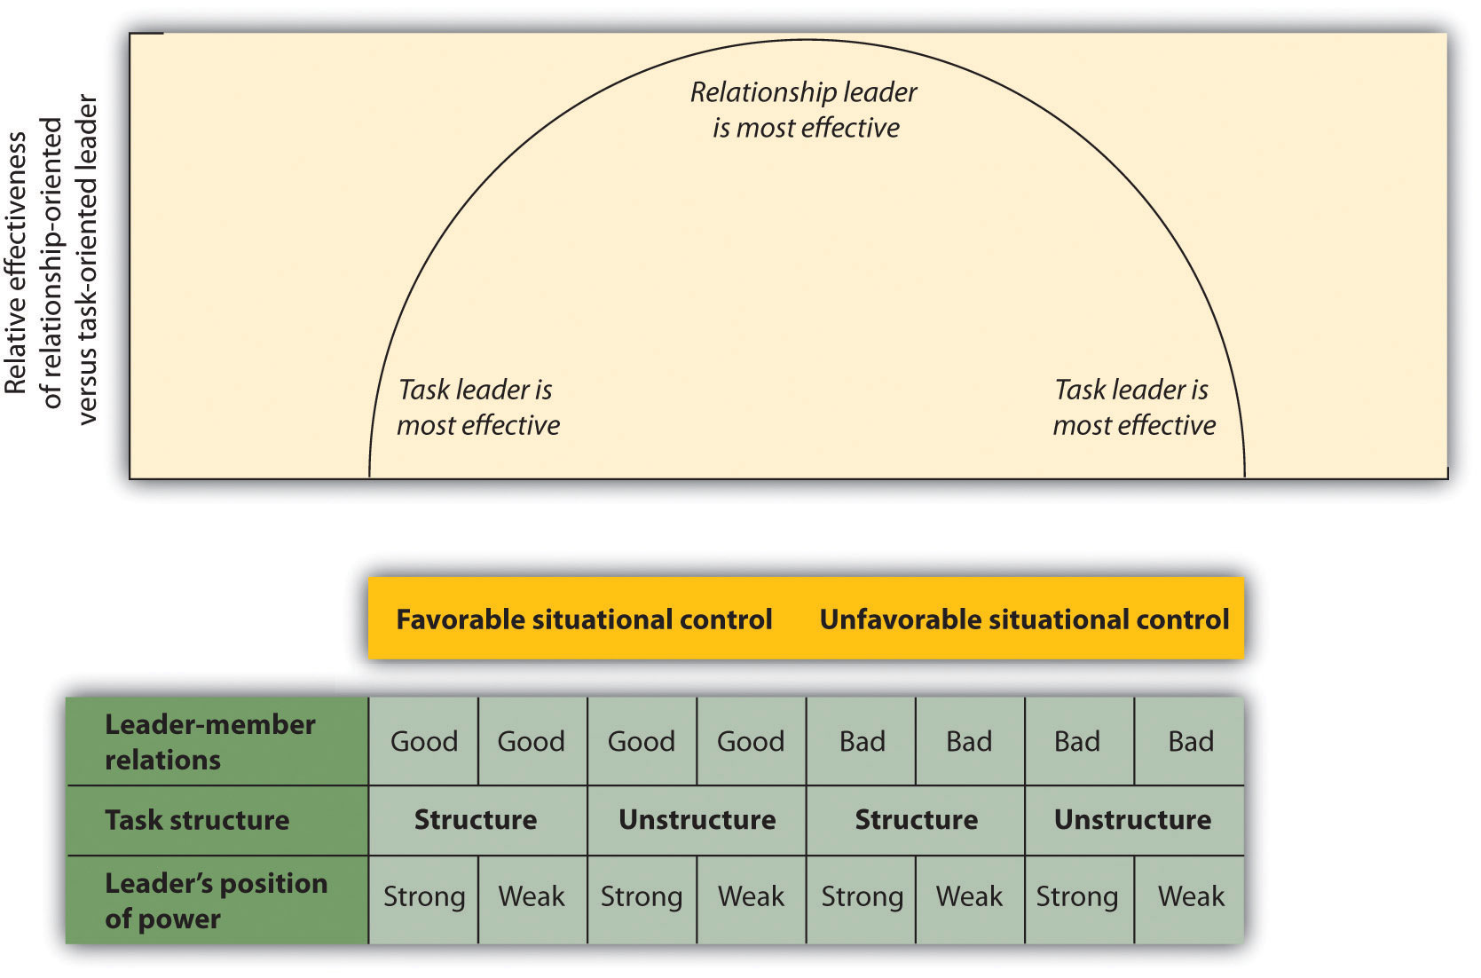
The contingency model is interactionist because it proposes that individuals with different leadership styles will differ in effectiveness in different group situations. Task-oriented leaders are expected to be most effective in situations in which the group situation is very favorable because this gives the leader the ability to move the group forward, or in situations in which the group situation is very unfavorable and in which the extreme problems of the situation require the leader to engage in decisive action. However, in the situations of moderate favorableness, which occur when there is a lack of support for the leader or when the problem to be solved is very difficult or unclear, the more relationship-oriented leader is expected to be more effective. In short, the contingency model predicts that task-oriented leaders will be most effective either when the group climate is very favorable and thus there is no need to be concerned about the group members’ feelings, or when the group climate is very unfavorable and the task-oriented leader needs to take firm control.
Still another approach to understanding leadership is based on the extent to which a group member embodies the norms of the group. The idea is that people who accept group norms and behave in accordance with them are likely to be seen as particularly good group members and therefore become leaders (Hogg, 2001; Hogg & Van Knippenberg, 2003). ^{[31]} Group members who follow group norms are seen as more trustworthy (Dirks & Ferrin, 2002) ^{[32]} and are likely to engage in group-oriented behaviors to strengthen their leadership credentials (Platow & van Knippenberg, 2001). ^{[33]}

KEY TAKEAWAYS
- Social power can be defined as the ability of a person to create conformity, even when the people being influenced may attempt to resist those changes.
- Milgram’s studies on obedience demonstrated the remarkable extent to which the social situation and people with authority have the power to create obedience.
- One of the most influential theories of power was developed by French and Raven, who identified five different types of power—reward power, coercive power, legitimate power, referent power, and expert power. The types vary in terms of whether their use is more likely to create public conformity or private acceptance.
- Although power can be abused by those who have it, having power also creates some positive outcomes for individuals.
- Leadership is determined by person variables, situational variables, and by the person-situation interaction. The contingency model of leadership effectiveness is an example of the latter.

EXERCISES AND CRITICAL THINKING
- Write a paragraph that expresses your opinions about the Holocaust or about another example of obedience to authority. Consider how social psychological research on obedience informs your interpretation of the event.
- Write a report on Dr. Philip Zimbardo’s book, The Lucifer Effect: Understanding How Good People Turn Evil, http://lucifereffect.com.
- Provide an example of someone who has each of the types of power discussed in this section.
- Consider a leader whom you have worked with in the past. What types of leadership did that person use? Were they effective?
- Choose a recent event that involved a very effective leader or one that involved a very poor one. Analyze the leadership in terms of the topics discussed in this chapter.

[1] Fiske, S. T. (1993). Controlling other people: The impact of power on stereotyping.American Psychologist, 48, 621–628; Keltner, D., Gruenfeld, D. H., & Anderson, C. (2003). Power, approach, and inhibition. Psychological Review, 110(2), 265–284.
[2] Milgram, S. (1974). Obedience to authority: An experimental view. New York, NY: Harper & Row.
[3] Blass, T. (1999). The Milgram paradigm after 35 years: Some things we now know about obedience to authority. Journal of Applied Social Psychology, 29, 955–978.
[4] Meeus, W. H., & Raaijmakers, Q. A. (1986). Administrative obedience: Carrying out orders to use psychological-administrative violence. European Journal of Social Psychology, 16, 311–324.
[5] Kilham, W., & Mann, L. (1974). Level of destructive obedience as a function of transmitter and executant roles in the Milgram obedience paradigm. Journal of Personality and Social Psychology, 29, 692–702.
[6] Borge, C. (2007). Basic instincts: The science of evil. Retrieved fromhttp://a.abcnews.com/Primetime/Story?id=2765416&page=1
[7] Stanford Prison Experiment. Retrieved from http://www.prisonexp.org/links.htm
[8] Driefus, C. (2007, April 3). Finding hope in knowing the universal capacity for evil. New York Times.
[9] Reicher, S., & Haslam, S. A. (2006). Rethinking the psychology of tyranny: The BBC prison study. British Journal of Social Psychology, 45(1), 1–40.
[10] French, J. R. P., & Raven, B. H. (1959). The bases of social power. In D. Cartwright (Ed.),Studies in social power (pp. 150–167). Ann Arbor, MI: Institute for Social Research; Raven, B. H. (1992). A power/interaction model of interpersonal influence: French and Raven thirty years later. Journal of Social Behavior and Personality, 7(2), 217–244.
[11] Molm, L. D. (1997). Coercive power in social exchange. New York, NY: Cambridge University Press.
[12] Tepper, B. J., Carr, J. C., Breaux, D. M., Geider, S., Hu, C., & Hua, W. (2009). Abusive supervision, intentions to quit, and employees’ workplace deviance: A power/dependence analysis. Organizational Behavior and Human Decision Processes, 109(2), 156–167.
[13] Heath, T. B., McCarthy, M. S., and Mothersbaugh, D. L. (1994). Spokesperson fame and vividness effects in the context of issue-relevant thinking: The moderating role of competitive setting. Journal of Consumer Research, 20, 520–534; Henrich, J., & Gil-White, F. (2001). The evolution of prestige: Freely conferred status as a mechanism for enhancing the benefits of cultural transmission. Evolution and Human Behavior, 22, 1–32; Kamins, A. M. (1989). Celebrity and non-celebrity in two-sided context. Journal of Advertising Research, 29, 34–42; Wilson, E. J., &. Sherrell, D. L. (1993). Source effects in communication and persuasion: A meta-analysis of effect size. Journal of the Academy of Marketing Science, 21, 101–112.
[14] Kelman, H. (1961). Processes of opinion change. Public Opinion Quarterly, 25, 57–78.
[15] Anderson, C., & Berdahl, J. L. (2002). The experience of power: Examining the effects of power on approach and inhibition tendencies. Journal of Personality and Social Psychology, 83, 1362–1377.
[16] Anderson, C., & Galinsky, A. D. (2006). Power, optimism, and risk-taking. European Journal of Social Psychology, 36, 511–536; Galinsky A. D., Gruenfeld, D. H, & Magee, J. C. (2003). From power to action. Journal of Personality and Social Psychology, 85, 453–466.
[17] Kipnis, D. (1972). Does power corrupt? Journal of Personality and Social Psychology, 24, 33–41.
[18] Depret, E., & Fiske, S. T. (1999). Perceiving the powerful: Intriguing individuals versus threatening groups. Journal of Experimental Social Psychology, 35(5), 461–480.
[19] van Kleef, G. A., Oveis, C., van der Löwe, I., LuoKogan, A., Goetz, J., & Keltner, D. (2008). Power, distress, and compassion: Turning a blind eye to the suffering of others. Psychological Science, 19(12), 1315–1322.
[20] Chen, S., Lee-Chai, A. Y., & Bargh, J. A. (2001). Relationship orientation as a moderator of the effects of social power. Journal of Personality and Social Psychology, 80(2), 173–187.
[21] Chemers, M. M. (2001). Leadership effectiveness: An integrative review. In M. A. Hogg & R. S. Tindale (Eds.), Blackwell handbook of social psychology: Group processes (pp. 376–399). Oxford, UK: Blackwell; Hogg, M. A. (2010). Influence and leadership. In S. F. Fiske, D. T. Gilbert, & G. Lindzey (Eds.), Handbook of social psychology (Vol. 2, pp. 1166–1207). New York, NY: Wiley.
[22] Zaccaro, S. J. (2007). Trait-based perspectives of leadership. American Psychologist, 62, 6–16.
[23] Simonton, D. K. (1994). Greatness: Who makes history and why. New York, NY: Guilford Press; Simonton, D. K. (1995). Personality and intellectual predictors of leadership. In D. H. Saklofske et al. (Eds.), International handbook of personality and intelligence. Perspectives on individual differences (pp. 739–757). New York, NY: Plenum.
[24] Kenny, D. A., & Zaccaro, S. J. (1983). An estimate of variance due to traits in leadership.Journal of Applied Psychology, 68, 678–685; Sorrentino, R. M., & Boutillier, R. G. (1975). The effect of quantity and quality of verbal interaction on ratings of leadership ability. Journal of Experimental Social Psychology, 11, 403–411.
[25] Cronshaw, S. F., & Lord, R. G. (1987). Effects of categorization, attribution, and encoding processes on leadership perceptions. Journal of Applied Psychology, 72, 97–106; Judge, T, Bono, J., Ilies, R., & Gerhardt, M. (2002). Personality and leadership: A qualitative and quantitative review, Journal of Applied Psychology, 87, 765–780; Yukl, G. A. (2002).Leadership in organizations. Upper Saddle River, NJ: Prentice Hall.
[26] Beyer, J. M. (1999). Taming and promoting charisma to change organizations. Leadership Quarterly, 10(2), 307–330; Conger, J. A., & Kanungo, R. N. (1998). Charismatic leadership in organizations. Thousand Oaks, CA: Sage.
[27] Simonton, D. K. (1988). Presidential style: Personality, biography and performance.Journal of Personality and Social Psychology, 55, 928–936.
[28] Avolio, B. J., & Yammarino, F. J. (2003). Transformational and charismatic leadership: The road ahead. Oxford, UK: Elsevier Press; Podsakoff, P. M., MacKenzie, S. B., Moorman, R. H., & Fetter, R. (1990). Transformational leader behaviors and their effects on followers’ trust in leader, satisfaction, and organizational citizenship behaviors. Leadership Quarterly, 1, 107–142.
[29] Reicher, S. D., & Hopkins, N. (2003). On the science of the art of leadership. In D. van Knippenberg and M. A. Hogg (Eds.), Leadership and power: Identity processes in groups and organizations (pp. 197–209). London, UK: Sage.
[30] Ayman, R., Chemers, M. M., & Fiedler, F. (1995). The contingency model of leadership effectiveness: Its level of analysis. Leadership Quarterly, 6(2), 147–167.
[31] Hogg, M. A. (2001). A social identity theory of leadership. Personality and Social Psychology Review, 5,184–200; Hogg, M. A., & van Knippenberg, D. (2003). Social identity and leadership processes in groups. Advances in Experimental Social Psychology, 35, 1–52.
[32] Dirks, K. T., & Ferrin, D. L. (2002). Trust in leadership: Meta-analytic findings and implications for research and practice. Journal of Applied Psychology, 87, 611–628.
[33] Platow, M. J., & van Knippenberg, D. (2001). A social identity analysis of leadership endorsement: The effects of leader in-group prototypicality and distributive intergroup fairness. Personality and Social Psychology Bulletin, 27, 1508–1519.

7.3 Person, Gender, and Cultural Differences in Conformity

LEARNING OBJECTIVES
- Summarize the social psychological literature concerning differences in conformity between men and women.
- Review research concerning the relationship between culture and conformity.
- Explain the concept of psychological reactance and describe how and when it might occur.
Although we have focused to this point on the situational determinants of conformity, such as the number of people in the majority and their unanimity and status, we have not yet considered the question of which people are likely to conform and which people are not. In this section we will consider how personality variables, gender, and culture influence conformity.

Person Differences
Even in cases in which the pressure to conform is strong and a large percentage of individuals do conform (such as in Solomon Asch’s line-judging research), not everyone does so. There are usually some people willing and able to go against the prevailing norm. In Asch’s study, for instance, despite the strong situational pressures, 24% of the participants never conformed on any of the trials.
People prefer to have an “optimal” balance between being similar to, and different from, others (Brewer, 2003). ^{[1]} When people are made to feel too similar to others, they tend to express their individuality, but when they are made to feel too different from others, they attempt to increase their acceptance by others. Supporting this idea, research has found that people who have lower self-esteem are more likely to conform in comparison with those who have higher self-esteem. This makes sense because self-esteem rises when we know we are being accepted by others, and people with lower self-esteem have a greater need to belong. And people who are dependent on and who have a strong need for approval from others are also more conforming (Bornstein, 1992). ^{[2]}
Age also matters, such that individuals who are either younger or older are more easily influenced than individuals who are in their 40s and 50s (Visser & Krosnick, 1998).^{[3]} People who highly identify with the group that is creating the conformity are also more likely to conform to group norms, in comparison to people who don’t really care very much (Jetten, Spears, & Manstead, 1997; Terry & Hogg, 1996). ^{[4]}
However, although there are some differences among people in terms of their tendency to conform (it has even been suggested that some people have a “need for uniqueness” that leads them to be particularly likely to resist conformity; Snyder & Fromkin, 1977),^{[5]} research has generally found that the impact of person variables on conformity is smaller than the influence of situational variables, such as the number and unanimity of the majority.

Gender Differences
Several reviews and meta-analyses of the existing research on conformity and leadership in men and women have now been conducted, and so it is possible to draw some strong conclusions in this regard. In terms of conformity, the overall conclusion from these studies is that that there are only small differences between men and women in the amount of conformity they exhibit, and these differences are influenced as much by the social situation in which the conformity occurs as by gender differences themselves. For instance, in Milgram’s studies he found no differences in conformity between men and women.
On average, men and women have different levels of self-concern and other-concern. Men are, on average, more concerned about appearing to have high status and may be able to demonstrate this status by acting independently from the opinions of others. On the other hand, and again although there are substantial individual differences among them, women are, on average, more concerned with connecting to others and maintaining group harmony. Taken together, this means that, at least when they are being observed by others, men are likely to hold their ground, act independently, and refuse to conform, whereas women are more likely to conform to the opinions of others in order to prevent social disagreement. These differences are less apparent when the conformity occurs in private (Eagly, 1978, 1983). ^{[6]}
The observed gender differences in conformity have social explanations—namely that women are socialized to be more caring about the desires of others—but there are also evolutionary explanations. Men may be more likely to resist conformity to demonstrate to women that they are good mates. Griskevicius, Goldstein, Mortensen, Cialdini, and Kenrick (2006) ^{[7]} found that men, but not women, who had been primed with thoughts about romantic and sexual attraction were less likely to conform to the opinions of others on a subsequent task than were men who had not been primed to think about romantic attraction.
In addition to the public versus private nature of the situation, the topic being discussed also is important, such that both men and women are less likely to conform on topics that they know a lot about, in comparison with topics on which they feel less knowledgeable (Eagly & Chravala, 1986). ^{[8]} When the topic is sports, women tend to conform to men, whereas the opposite is true when the topic is fashion. Thus it appears that the small observed differences between men and women in conformity are due, at least in part, to informational influence.
Because men have higher status in most societies, they are more likely to be perceived as effective leaders (Eagly, Makhijani, & Klonsky, 1992; Rojahn & Willemsen, 1994; Shackelford, Wood, & Worchel, 1996). ^{[9]} And men are more likely to be leaders in most cultures. For instance, in the current U.S. Senate, 83% of the members are men. The percentages also favor men in the U.S. House of Representatives (84%) and the Supreme Court (66%). Similar differences are found in the legislatures of almost all countries. There are also more men than women in leadership roles, and particularly in high-level administrative positions, in many different types of businesses and other organizations. Women are not promoted to positions of leadership as fast as men are in real working groups, even when actual performance is taken into consideration (Geis, Boston, & Hoffman, 1985; Heilman, Block, & Martell, 1995). ^{[10]}
Men are also more likely than women to emerge and act as leaders in small groups, even when other personality characteristics are accounted for (Bartol & Martin, 1986; Megargee, 1969; Porter, Geis, Cooper, & Newman, 1985). ^{[11]} In one experiment, Nyquist and Spence (1986) ^{[12]} had pairs of same- and mixed-sex students interact. In each pair there was one highly dominant and one low dominant individual, as assessed by previous personality measures. They found that in pairs in which there was one man and one woman, the dominant man became the leader 90% of the time, but the dominant woman became the leader only 35% of the time.
Keep in mind, however, that the fact that men are perceived as effective leaders, and are more likely to become leaders, does not necessarily mean that they are actually better, more effective leaders than women. Indeed, a meta-analysis studying theeffectiveness of male and female leaders did not find that there were any gender differences overall (Eagly, Karau, & Makhijani, 1995) ^{[13]} and even found that women excelled over men in some domains. Furthermore, the differences that were found tended to occur primarily when a group was first forming but dissipated over time as the group members got to know one another individually.
One difficulty for women as they attempt to lead is that traditional leadership behaviors, such as showing independence and exerting power over others, conflict with the expected social roles for women. The norms for what constitutes success in corporate life are usually defined in masculine terms, including assertiveness or aggressiveness, self-promotion, and perhaps even macho behavior. It is difficult for women to gain power because to do so they must conform to these masculine norms, and often this goes against their personal beliefs about appropriate behavior (Rudman & Glick, 1999). ^{[14]} And when women do take on male models of expressing power, it may backfire on them because they end up being disliked because they are acting nonstereotypically for their gender. In an important U.S. Supreme Court case, a female account executive argued that she was denied promotion (although she was a top performer) because she acted too “masculine,” even though the same behaviors were required for the success of the male coworkers (Fiske, Bersoff, Borgida, Deaux, & Heilman, 1991). ^{[15]}
One way that women can react to this “double-bind” in which they must take on masculine characteristics to succeed, but if they do they are not liked, is to adopt more feminine leadership styles, in which they use more interpersonally oriented behaviors such as agreeing with others, acting in a friendly manner, and encouraging subordinates to participate in the decision-making process (Eagly & Johnson, 1990; Eagly et al., 1992; Wood, 1987). ^{[16]} In short, women are more likely to take on a transformational leadership style than are men—doing so allows them to be effective leaders while not acting in an excessively masculine way (Eagly & Carli, 2007; Eagly, Johannesen-Schmidt, & van Egen, 2003). ^{[17]}
In sum, women may conform somewhat more than men, although these differences are small and limited to situations in which the responses are made publicly. In terms of leadership effectiveness, there is no evidence that men, overall, make better leaders than do women. However, men do better as leaders on tasks that are “masculine” in the sense that they require the ability to direct and control people. On the other hand, women do better on tasks that are more “feminine” in the sense that they involve creating harmonious relationships among the group members.

Cultural Differences
In addition to gender differences, there is also evidence that conformity is greater in some cultures than others. Your knowledge about the cultural differences between individualistic and collectivistic cultures might lead you to think that collectivists will be more conforming than individualists, and there is some support for this. Bond and Smith (1996) ^{[18]} analyzed results of 133 studies that had used Asch’s line-judging task in 17 different countries. They then categorized each of the countries in terms of the degree to which it could be considered collectivist versus individualist in orientation. They found a significant relationship, such that conformity was greater in more collectivist than in individualist countries.
Kim and Markus (1999) ^{[19]} analyzed advertisements from popular magazines in the United States and in Korea to see if they differentially emphasized conformity and uniqueness. As you can see in Figure 7.10 "Culture and Conformity", they found that while U.S. magazine ads tended to focus on uniqueness (“Choose your own view!” and “Individualize”) Korean ads tended to focus more on themes of conformity (“Seven out of 10 people use this product” and “Our company is working toward building a harmonious society”).

Figure 7.10 Culture and Conformity
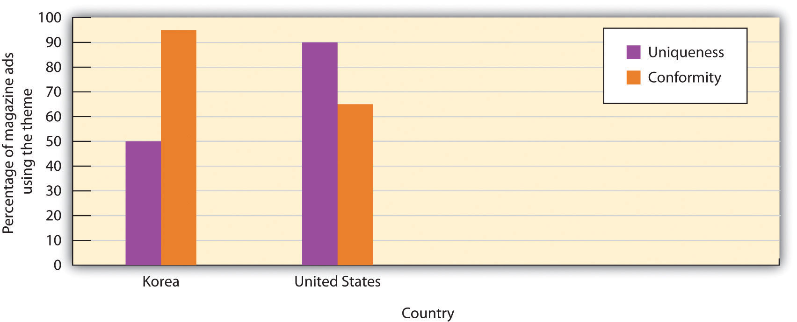
Kim and Markus (1999) found that U.S. magazine ads tended to focus on uniqueness whereas Korean ads tended to focus more on conformity.
In summary, although the effects of individual differences on conformity tend to be smaller than those of the social context, they do matter. And gender and cultural differences can also be important. Conformity, like most other social psychological processes, represents an interaction between the situation and the person.

Psychological Reactance
Conformity is usually quite adaptive overall, both for the individuals who conform and for the group as a whole. Conforming to the opinions of others can help us enhance and protect ourselves by providing us with important and accurate information and can help us better relate to others. Following the directives of effective leaders can help a group attain goals that would not be possible without them. And if only half of the people in your neighborhood thought it was appropriate to stop on red and go on green but the other half thought the opposite—and behaved accordingly—there would be problems indeed.
But social influence does not always produce conformity. If we feel that we have the choice to conform or not conform, we may well choose to do so in order to be accepted or to obtain valid knowledge. On the other hand, if we perceive that others are trying to force our conformity, the influence pressure may backfire, resulting in the opposite of what the influencer intends.
Consider an experiment conducted by Pennebaker and Sanders (1976), ^{[20]} who attempted to get people to stop writing graffiti on the walls of campus restrooms. In some restrooms they posted a sign that read “Do not write on these walls under any circumstances!” whereas in other restrooms they placed a sign that simply said “Please don’t write on these walls.” Two weeks later, the researchers returned to the restrooms to see if the signs had made a difference. They found that there was much less graffiti in the second restroom than in the first one. It seems as if people who were given strong pressures to not engage in the behavior were more likely to react against those directives than were people who were given a weaker message.
When individuals feel that their freedom is being threatened by influence attempts and yet they also have the ability to resist that persuasion, they may experiencepsychological reactance, a strong motivational state that prevents conformity(Brehm, 1966; Miron & Brehm, 2006). ^{[21]} Reactance is aroused when our ability to choose which behaviors to engage in is eliminated or threatened with elimination. The outcome of the experience of reactance is that people may not conform at all and may even move their opinions or behaviors away from the desires of the influencer.
Reactance represents a desire to restore freedom that is being threatened. A child who feels that his or her parents are forcing him to eat his asparagus may react quite vehemently with a strong refusal to touch the plate. And an adult who feels that she is being pressured by a car salesman might feel the same way and leave the showroom entirely, resulting in the opposite of the salesman’s intended outcome.
Of course, parents are sometimes aware of this potential, and even use “reverse psychology”—for example, telling a child that she cannot go outside when they really want her to, hoping that reactance will occur. In the Broadway musical The Fantasticks, neighboring fathers set up to make one’s daughter and the other’s son fall in love with each other by building a fence between their properties. The fence is seen by the children as an infringement on their freedom to see each other, and as predicted by the idea of reactance, they ultimately fall in love.
In addition to helping us understand the affective determinants of conformity and of failure to conform, reactance has been observed to have its ironic effects in a number of real-world contexts. For instance, Wolf and Montgomery (1977) ^{[22]} found that when judges give jury members instructions indicating that they absolutely must not pay any attention to particular information that had been presented in a courtroom trial (because it had been ruled as inadmissible), the jurors were more likely to use that information in their judgments. And Bushman and Stack (1996) ^{[23]} found that warning labels on violent films (for instance, “This film contains extreme violence—Viewer discretion advised”) created more reactance (and thus led participants to bemore interested in viewing the film) than did similar labels that simply provided information (“This film contains extreme violence”). In another relevant study, Kray, Reb, Galinsky, and Thompson (2004) ^{[24]} found that when women were told that they were poor negotiators and would be unable to succeed on a negotiation task, this information led them to work even harder and to be more successful at the task.
Finally, within clinical therapy, it has been argued that people sometimes are less likely to try to reduce the harmful behaviors that they engage in, such as smoking or drug abuse, when the people they care about try too hard to press them to do so (Shoham, Trost, & Rohrbaugh, 2004). ^{[25]} One patient was recorded as having reported that his wife kept telling him that he should quit drinking, saying, “If you loved me enough, you’d give up the booze.” However, he also reported that when she gave up on him and said instead, “I don’t care what you do anymore,” he then enrolled in a treatment program (Shoham et al., 2004, p. 177). ^{[26]}

KEY TAKEAWAYS
- Although some person variables predict conformity, overall situational variables are more important.
- There are some small gender differences in conformity. In public situations, men are somewhat more likely to hold their ground, act independently, and refuse to conform, whereas women are more likely to conform to the opinions of others in order to prevent social disagreement. These differences are less apparent when the conformity occurs in private.
- Conformity to social norms is more likely in Eastern, collectivist cultures than in Western, independent cultures.
- Psychological reactance occurs when people feel that their ability to choose which behaviors to engage in is eliminated or threatened with elimination. The outcome of the experience of reactance is that people may not conform at all and may even move their opinions or behaviors away from the desires of the influencer.

EXERCISE AND CRITICAL THINKING
- Following this paragraph are some examples of social influence and conformity. In each case, the person who is conforming has changed his or her behavior because of the expressed opinions or behaviors of another person. In some cases the influence of the others is more obvious; in other cases less so. Using the principles discussed in Chapter 1 "Introducing Social Psychology", first consider the likely role of the social situation versus the individual person. Did the person freely engage in the behavior, did the social situation force him to engage in the behavior, or was there some combination of both? Then consider the role of underlying human goals—concern for self and concern for others. Did the conformity occur primarily because the person wanted to feel good about himself or herself or because he or she cared for those around him or her? Then ask yourself about the role of cognition, affect, and behavior. Do you think the conformity was primarily behavioral, or did it involve a real change in the person’s thoughts and feelings?
  - Bill laughed at the movie, even though he didn’t think it was all that funny; he realized he was laughing just because all his friends were laughing.
  - Frank realized that he was starting to like jazz music, in part because his roommate liked it.
  - Jennifer went to the mall with her friends so that they could help her choose a gown for the upcoming prom.
  - Sally tried a cigarette at a party because all her friends urged her to.
  - Phil spent over $150 on a pair of sneakers, even though he couldn’t really afford them, because his best friend had a pair.

[1] Brewer, M. B. (2003). Optimal distinctiveness, social identity, and the self. In M. R. Leary & J. P. Tangney (Eds.), Handbook of self and identity (pp. 480–491). New York, NY: Guilford Press.
[2] Bornstein, R. F. (1992). The dependent personality: Developmental, social, and clinical perspectives. Psychological Bulletin, 112, 3–23.
[3] Visser, P. S., & Krosnick, J. A. (1998). The development of attitude strength over the life cycle: Surge and decline. Journal of Personality and Social Psychology, 75, 1389–1410.
[4] Jetten, J., Spears, R., & Manstead, A. S. R. (1997). Strength of identification and intergroup differentiation: The influence of group norms. European Journal of Social Psychology, 27, 603–609; Terry, D., & Hogg, M. (1996). Group norms and the attitude-behavior relationship: A role for group identification. Personality and Social Psychology Bulletin, 22, 776–793.
[5] Snyder, C. R., & Fromkin, H. L. (1977). Abnormality as a positive characteristic: The development and validation of a scale measuring need for uniqueness. Journal of Abnormal Psychology, 86(5), 518–527.
[6] Eagly, A. H. (1978). Sex differences in influenceability. Psychological Bulletin, 85, 86–116; Eagly, A. H. (1983). Gender and social influence: A social psychological analysis. American Psychologist, 38, 971–981.
[7] Griskevicius, V., Goldstein, N. J., Mortensen, C. R., Cialdini, R. B., & Kenrick, D. T. (2006). Going along versus going alone: When fundamental motives facilitate strategic (non)conformity. Journal of Personality and Social Psychology, 91, 281–294.
[8] Eagly, A. H., & Chravala, C. (1986). Sex differences in conformity: Status and gender-role interpretations. Psychology of Women Quarterly, 10, 203–220.
[9] Eagly, A. H., Makhijani, M. G., & Klonsky, B. G. (1992). Gender and evaluation of leaders: A meta-analysis. Psychological Bulletin, 111, 3–22; Rojahn, K., & Willemsen, T. M. (1994). The evaluation of effectiveness and likability of gender-role congruent and gender-role incongruent leaders. Sex Roles, 30, 109–119; Shackelford, S., Wood, W., & Worchel, S. (1996). Behavioral styles and the influence of women in mixed-sex groups. Social Psychology Quarterly, 59, 284–293.
[10] Geis, F. L., Boston, M. B., and Hoffman, N. (1985). Sex of authority role models and achievement by men and women: Leadership performance and recognition, Journal of Personality and Social Psychology, 49, 636–653; Heilman, M. E., Block, C. J., & Martell, R. (1995). Sex stereotypes: Do they influence perceptions of managers? Journal of Social Behavior and Personality, 10, 237–252.
[11] Bartol, K. M., & Martin, D. C. (1986). Women and men in task groups. In R. D. Ashmore & F. K. Del Boca (Eds.), The social psychology of female-male relations. New York, NY: Academic Press; Megargee, E. I. (1969). Influence of sex roles on the manifestation of leadership. Journal of Applied Psychology, 53, 377–382; Porter, N., Geis, F. L., Cooper, E., & Newman, E. (1985). Androgyny and leadership in mixed-sex groups. Journal of Personality and Social Psychology, 49, 808–823.
[12] Nyquist, L. V., & Spence, J. T. (1986). Effects of dispositional dominance and sex role expectations on leadership behaviors. Journal of Personality and Social Psychology, 50, 87–93.
[13] Eagly, A. H., Karau, S. J., & Makhijani, M. G. (1995). Gender and the effectiveness of leaders: A meta-analysis. Psychological Bulletin, 117, 125–145.
[14] Rudman, L. A., & Glick, P. (1999). Feminized management and backlash toward agentic women: The hidden costs to women of a kinder, gentler image of middle-managers. Journal of Personality and Social Psychology, 77, 1004–1010.
[15] Fiske, S. T., Bersoff, D. N., Borgida, E., Deaux, K., & Heilman, M. E. (1991). Social science research on trial. The use of sex stereotyping research in Price Waterhouse v. Hopkins.American Psychologist, 46, 1049–1060.
[16] Eagly, A. H., & Johnson, B. T. (1990). Gender and leadership style: A meta-analysis.Psychological Bulletin, 108, 233–256; Eagly, A. H., Makhijani, M. G., & Klonsky, B. G. (1992). Gender and evaluation of leaders: A meta-analysis. Psychological Bulletin, 111, 3–22; Wood, W. (1987). A meta-analytic review of sex differences in group performance. Psychological Bulletin, 102, 53–71.
[17] Eagly, A. H., & Carli, L. L. (2007). Through the labyrinth: The truth about how women become leaders. Boston, MA: Harvard Business School Press; Eagly, A. H., Johannesen-Schmidt, M. C., & van Engen, M. L. (2003). Transformational, transactional, and laissez-faire leadership styles: A meta-analysis comparing men and women. Psychological Bulletin, 129, 569–591.
[18] Bond, R., & Smith, P. B. (1996). Culture and conformity: A meta-analysis of studies using Asch’s (1952b, 1956) line judgment task. Psychological Bulletin, 119(1), 111–137.
[19] Kim, H., & Markus, H. R. (1999). Deviance or uniqueness, harmony or conformity? A cultural analysis. Journal of Personality and Social Psychology, 77, 785–800.
[20] Pennebaker, J. W., & Sanders, D. Y. (1976). American graffiti: Effects of authority and reactance arousal. Personality and Social Psychology Bulletin, 2, 264–267.
[21] Brehm, J. (1966). A theory of psychological reactance. New York, NY: Academic Press; Miron, A. M., & Brehm, J. W. (2006). Reaktanz theorie—40 Jahre spärer. Zeitschrift fur Sozialpsychologie, 37, 9–18. doi: 10.1024/0044-3514.37.1.9.
[22] Wolf, S., & Montgomery, D. A. (1977). Effects of inadmissible evidence and level of judicial admonishment to disregard on the judgments of mock jurors. Journal of Applied Social Psychology, 7, 205–219.
[23] Bushman, B. J., & Stack, A. D. (1996). Forbidden fruit versus tainted fruit: Effects of warning labels on attraction to television violence. Journal of Experimental Psychology: Applied, 2, 207–226.
[24] Kray, L. J., Reb, J., Galinsky, A. D., & Thompson, L. (2004). Stereotype reactance at the bargaining table: The effect of stereotype activation and power on claiming and creating value.Personality and Social Psychology Bulletin, 30, 399–411.
[25] Shoham, V., Trost, S. E., & Rohrbaugh, M. J. (Eds.). (2004). From state to trait and back again: Reactance theory goes clinical. Mahwah, NJ: Lawrence Erlbaum.
[26] Shoham, V., Trost, S. E., & Rohrbaugh, M. J. (Eds.). (2004). From state to trait and back again: Reactance theory goes clinical. Mahwah, NJ: Lawrence Erlbaum.

7.4 Thinking Like a Social Psychologist About Conformity
This chapter has concerned the many and varied ways that conformity influences our everyday lives. Perhaps you were surprised about the wide variety of phenomena—ranging from the unaware imitation of others to leadership to blind obedience to authority—that involve conformity. Yet because you are thinking like a social psychologist, you will realize why conformity occurs and why it is such an important part of our everyday life. We conform to better meet the basic goals of self-concern and other-concern. Conforming helps us do better by helping us make accurate, informed decisions. And conformity helps us be accepted by those we care about.
Because you are now more aware of these factors, you will naturally pay attention to the times when you conform to others and when you influence others to conform. You will see how important—indeed how amazing—the effects of conformity are. You will realize that almost everything we do involves conformity, or perhaps the desire to avoid being too conforming. Furthermore, you will realize (and hopefully use this knowledge to inform your everyday decisions) that conformity is sometimes an important part of societal functioning and that at other times conformity creates bad—indeed horrible—outcomes.
You can use your understanding of conformity to help understand your own behavior. Do you think you conform too much, or too little? Do you think about when you do or don’t conform? Are you more of a conformist or an independent thinker—and why do you prefer to be that way? Perhaps you will use your understanding of the power of conformity when you judge others. Do you have a new understanding of the behavior of the soldiers at Abu Ghraib? Do you perhaps now understand better how much they were influenced by the social situation?
Your understanding of the process of conformity may also help you develop more satisfying relations with others. Because you now understand the importance of conformity, you will also understand how to make use of these powers to influence others. If you are in a leadership position, you now have a better idea about the many influence techniques that are available to you and better understand their likely outcomes on others.

7.5 Chapter Summary
Conformity refers to the change in beliefs, opinions, and behaviors that occurs as the result of social influence. The typical outcome of conformity is that peoples’ beliefs and behaviors become more similar to those of others around them.
The change in opinions or behavior that occurs when we conform to people whom we believe have accurate information is known as informational conformity. Informational conformity usually results in private acceptance, which is real change in opinions on the part of the individual.
Normative conformity occurs when we express opinions or behave in ways that help us to be accepted or that keep us from being isolated or rejected by those we care about. The outcome of normative conformity is frequently public conformity—a change in behavior that is not accompanied by an actual change in one’s private opinion.
Majority influence occurs when the views or behaviors of a larger number of individuals in the current social group prevail. Majority influence may frequently produce public conformity. One powerful example of majority influence can be found in the line-judging studies of Solomon Asch.
Minority influence occurs when the views of a smaller number of individuals prevail. Although less frequent than majority influence, minority influence can occur if the minority expresses their views consistently and confidently. An example is Moscovici’s color-judgment study. Because minorities force group members to think more fully about a topic, they can produce more creative thinking.
The extent to which we conform is influenced by the size of the majority group. The increase in the amount of conformity that is produced by adding new members to the majority group, known as the social impact of each group member, is greater for initial majority members than it is for later members.
Conformity decreases sharply when there is any disagreement among the members of the group that is trying to create influence. Unanimity is powerful in part because being the only person who is different is potentially embarrassing, and because we want to be liked by others, we may naturally want to avoid this.
Milgram’s study on obedience is an example of the power of an authority to create obedience. Milgram found that, when an authority figure accepted responsibility for the behavior of the individuals, 65% of the participants followed his instructions and administered what they thought was severe and dangerous shock to another person.
The conformity observed in Milgram’s study was due in part to the authority of the experimenter. In a replication when the experimenter had lower status, obedience was reduced. Obedience was also reduced when the experimenter’s ability to express his authority was limited by having him sit in an adjoining room and communicate to the teacher by telephone. Milgram’s studies also confirmed the role of unanimity in producing conformity.
Social power is the ability of one individual to create behavioral or belief changes in another person. Five types of social power—reward, coercive, legitimate, referent, and expert power—vary in terms of whether they are more likely to create private acceptance or public conformity.
Leaders use many types of power to influence others. Some approaches to understanding the nature of leadership have focused on the personality of the leader, finding that variables such as intelligence and sociability are associated with good leaders. Other leadership styles, such as those exhibited by charismatic and transformational leaders, have also been studied. Other approaches, including the contingency model of leadership effectiveness, examine the conditions under which different types of leaders are most likely to be effective.
People with lower self-esteem are more likely to conform than are those with higher self-esteem, and people who are dependent on and who have a strong need for approval from others are also more conforming.
Men, on average, are more concerned about appearing to have high status by acting independently from the opinions of others; they are more likely to resist changing their beliefs in public than are women. In contrast, women, on average, are more concerned with connecting to others and maintaining group harmony; they are more likely to conform to the opinions of others in order to prevent social disagreement.
Men and women differ in their preferred leadership styles, such that women use more relationship-oriented approaches than men use. Although men are perceived to be better leaders than women, and often are more likely to become leaders, there is no evidence that either men or women are more effective leaders.
When individuals feel that their freedom is being threatened by influence attempts, and yet they also have the ability to resist that persuasion, they may develop psychological reactance and not conform at all. Reactance has been shown to occur in many real-world contexts.

Chapter 8

Liking and Loving

Britain’s Longest Married Couple Celebrate a Quiet 80th Anniversary
Frank and Anita Milford are in some ways your average couple: They met in 1926 at a YMCA dance, married in 1928, had two children, and lived together in the same a three-bedroom house their entire lives. But unlike many other couples, Frank and Anita’s marriage lasted—in fact, it really lasted. In May of 2008, the pair equaled the record for being Britain’s longest married couple—80 years of marriage.
To celebrate their 80th wedding anniversary, Frank (100 years old), and Anita (99 years old) spent a quiet weekend together—pretty typical of most of their days.
“At our age that’s all you need,” said Mr. Milford. “Just us together, no big fuss.”
Frank and Anita indicated that one of the secrets to a successful marriage was to “share a little kiss and cuddle every night before bed. It’s our golden rule.”
The Milfords believe that making time for one another is vital to keeping the relationship healthy. They claimed that respect and a process of “give and take” are great ways to sustain a relationship.
“We do everything together even after nearly 80 years.”
Like most couples who have been together for a number of years, there are still some cross words and everyday squabbles. Regardless, their relationship remains one that is loving and healthy.
Source: Miller, V. (2008, 24 May). Britain's longest married couple celebrate a quiet 80th anniversary. The Telegraph. Retrieved fromhttp://www.telegraph.co.uk/news/uknews/2020233/Britains-longest-married-couple-celebrate-a-quiet-80th-anniversary.html.
In prior chapters, we have considered the basic processes of person perception. In doing so, we have focused primarily on our perceptions of people we do not know very well and with whom we do not have many social connections. But people also desire and need to develop close relationships with others, particularly those others who help us engage in reproduction and child rearing and who provide social support—the approval, assistance, advice, and comfort that we receive from those with whom we have developed stable positive relationships (Taylor, 2007). ^{[1]}
Close relationships are relationships between people that are characterized by loving, caring, commitment, and intimacy—such as those between adult friends, dating partners, lovers, and married couples (Clark & LeMay, 2010; Hendrick & Hendrick, 2000). ^{[2]} These relationships are determined by biological, evolutionary, individual, and cultural factors. Successful close relationships involve the positive influence of cognitive variables, including perceptions of similarity with the other, interdependence, commitment, and the incorporation of other into the self-concept,as well as affective variables, including attachment, intimacy, and commitment. Our close relationships help us meet the goals of self-concern and other-concern.
In this chapter, we will consider the benefits that come from our close relationships, the principles that lead people to become attracted to others, and the variables that help create stable, healthy, and happy close relationships. In addition to being vitally important to us in an evolutionary sense (effective child rearing requires committed and effective parents), close relationships bring us health and happiness when we are able to create successful ones; they may produce a profound sense of loneliness and sadness when we are not.
People are well aware of the importance of having other people in their lives. When they are asked what makes them happy, people of all ages indicate that having friendships and good relationships with others is what they care about the most (Baumeister & Leary, 1995). ^{[3]}And our self-esteem is in large part determined by how much we feel that we are accepted by others (Leary, 2005). ^{[4]} Self-esteem rises when we feel accepted and valued by others and falls when we do not (Leary & Cox, 2008). ^{[5]} People who do not feel that they are able to develop the types and quality of social relationships that they would prefer to have are lonely—a highly unpleasant and potentially unhealthy state (Cacioppo & Patrick, 2008). ^{[6]}
Close relationships also keep us healthy. People who do not have adequate social support in the form of friends and family have more physical and mental health problems than do those with adequate social relationships (Cacioppo, Hawkley, & Bernston, 2003; Cacioppo et al., 2002). ^{[7]}
In summary, our close relationships make us happy and healthy, and the lack of them leaves us lonely and hurting. We experience higher self-efficacy, self-esteem, and positive mood when we believe that our friends and partners are responding to us supportively and with a concern for our needs and our own welfare. Our relationships with others help us buffer the negative effects of stress, avoid unhealthy behaviors, and cope with serious physical illness. And our close relationships allow us to express our fundamental desires to reach out and respond to other people.

[1] Taylor, S. E. (2007). Social support. In H. S. Friedman & R. C. Silver (Eds.), Foundations of health psychology (pp. 145–171). New York, NY: Oxford University Press.
[2] Clark, M. S., & Lemay, E. P., Jr. (2010). Close relationships. In S. T. Fiske, D. T. Gilbert, & G. Lindzey (Eds.), Handbook of social psychology (5th ed., Vol. 2, pp. 898–940). Hoboken, NJ: John Wiley & Sons; Hendrick, C., & Hendrick, S. S. (Eds.). (2000). Close relationships: A sourcebook. Thousand Oaks, CA: Sage.
[3] Baumeister, R., & Leary, M. (1995). The need to belong: Desire for interpersonal attachments as a fundamental human motivation. Psychological Bulletin, 117, 497–529.
[4] Leary, M. R. (2005). Sociometer theory and the pursuit of relational value: Getting to the root of self-esteem. European Review of Social Psychology, 16, 75–111.
[5] Leary, M. R., & Cox, C. B. (Eds.). (2008). Belongingness motivation: A mainspring of social action. New York, NY: Guilford Press.
[6] Cacioppo, J. T., & Patrick, W. (2008). Loneliness: Human nature and the need for social connection. New York, NY: W. W. Norton.
[7] Cacioppo, J. T., Hawkley, L. C., & Bernston, G. G. (2003). The anatomy of loneliness. Current Directions in Psychological Science, 12(3), 71–74; Cacioppo, J. T., Hawkley, L. C., Crawford, E., Ernst, J. M., Burleson, M. H., Kowalewski, R. B,…Berntson, G. G. (2002). Loneliness and health: Potential mechanisms. Psychosomatic Medicine, 64(3), 407–417.

8.1 Initial Attraction

LEARNING OBJECTIVES
- Summarize the variables that lead to initial attraction between people.
- Outline the variables that lead us to perceive someone as physically attractive, and explain why physical attractiveness is so important in liking.
- Describe the ways that similarity and complementarity influence our liking for others.
- Define the concept of mere exposure, and explain how proximity influences liking.
When we say that we like or love someone, we are experiencinginterpersonal attraction—the strength of our liking or loving for another person. Although interpersonal attraction occurs between friends, family members, and other people in general, and although our analysis can apply to these relationships as well, our primary focus in this chapter will be on romantic attraction—for instance, between boys and girls, between men and women, and between people in same-sex relationships. There is a large literature on the variables that lead us to like others in our initial interactions with them, and we’ll review the most important findings here (Sprecher, Wenzel, & Harvey, 2008). ^{[1]}

Physical Attractiveness
Although it may seem inappropriate or shallow to admit it, and although it is certainly not the only determinant of liking, people are strongly influenced, at least in initial encounters, by the physical attractiveness of their partners (Swami & Furnham, 2008).^{[2]} Elaine Walster and her colleagues (Walster, Aronson, Abrahams, & Rottman, 1966) ^{[3]} arranged a field study in which college boys and girls were randomly paired with one another at a “computer dance.” After the partners had danced and talked for a couple of hours, they were interviewed separately about their own preferences and characteristics as well as about their perceptions of their date. Walster and her colleagues found that the only important determinant of participants’ liking for their date was his or her physical attractiveness. None of the other characteristics—even the perceived intelligence of the partner—mattered.
Perhaps this finding doesn’t surprise you too much, given the importance of physical attractiveness in our culture. Movies and TV shows feature attractive people, TV ads use attractive people to promote their products, and we spend millions of dollars each year to make ourselves look more attractive. Even infants who are only a year old prefer to look at faces that adults consider attractive rather than at unattractive faces (Langlois, Ritter, Roggman, & Vaughn 1991). ^{[4]}
People who are attractive are also seen as having a variety of positive characteristics, and these traits are activated quickly and spontaneously when we see their faces (Olson & Marshuetz, 2005; van Leeuwen & Macrae, 2004). ^{[5]} Attractive people are seen as more sociable, altruistic, and intelligent than their unattractive counterparts (Griffin & Langlois, 2006). ^{[6]} Attractive people also have more choices of sex partners (Epstein, Klinkenberg, Scandell, Faulkner, & Claus, 2007), ^{[7]} are more likely to be offered jobs (Dubois & Pansu, 2004), ^{[8]} and may even live longer (Henderson & Anglin, 2003). ^{[9]}
Although it is sometimes said that “beauty is in the eyes of the beholder” (i.e., that each person has his or her own idea about what is beautiful), this is not completely true. There is good agreement among people, including children, and within and across cultures, about which people are most physically attractive (Berry, 2000; Ramsey, Langlois, Hoss, Rubenstein, & Griffin, 2004). ^{[10]} If your instructor asked the students in your class to rate each other on their attractiveness, there would be general agreement among them on which students are most and least attractive. This agreement is in part due to shared norms within cultures about what is attractive, but it is also due to evolutionary predispositions to attend to and be influenced by specific characteristics of others.
Leslie Zebrowitz and her colleagues have extensively studied the tendency for both men and women to prefer facial features that have youthful characteristics (Zebrowitz, 1996). ^{[11]} These features include large, round, and widely spaced eyes, a small nose and chin, prominent cheekbones, and a large forehead. Zebrowitz has found that individuals who have youthful-looking faces are more liked, are judged as warmer and more honest, and also receive other positive outcomes. Parents give baby-faced children fewer chores and punishments, and people with young-looking faces are also required to pay lower monetary awards in courtroom trials (Zebrowitz & McDonald, 1991). ^{[12]} On the other hand, baby-faced individuals are also seen as less competent than their more mature-looking counterparts (Zebrowitz & Montpare, 2005). ^{[13]}
The preference for youth is found in our perceptions of both men and women but is somewhat stronger for our perceptions of women (Wade, 2000). ^{[14]} This is because for men, although we do prefer youthful faces, we also prefer masculine faces—those with low, broad jaws and with pronounced bone ridges and cheekbones—and these men tend to look somewhat older (Rhodes, 2006). ^{[15]} We may like baby-faced people because they remind us of babies, or perhaps because we respond to baby-faced people positively, they may act more positively to us.
Some faces are more symmetrical than others. People are more attracted to faces that are more symmetrical in comparison with those that are less symmetrical. This may be in part because of the perception that people with symmetrical faces are more healthy and thus make better reproductive mates (Rhodes, 2006; Rhodes et al., 2001)^{[16]} and in part because symmetrical faces seem more familiar and thus less threatening to us (Winkielman & Cacioppo, 2001). ^{[17]} The attraction to symmetry is not limited to face perception. Body symmetry is also a likely indicator of good genes, and women favor more symmetrical men as sexual partners (Gangestad & Thornhill, 1997). ^{[18]} If you would like to see what your own face would look like if it were perfectly symmetrical, check this website:http://www.symmeter.com/symfacer.htm.
Although you might think that we would prefer faces that are unusual or unique, in fact the opposite is true (Langlois, Roggman, & Musselman, 1994). ^{[19]} Langlois and Rodman (1990) ^{[20]} showed college students the faces of men and women. The faces were composites made up of the average of 2, 4, 8, 16, or 32 faces. The researchers found that the more faces that were averaged into the stimulus, the more attractive it was judged (see Figure 8.2 "Facial Averageness"). As with the findings for facial symmetry, one possible explanation for our liking of average faces is that because they are more similar to the ones that we have frequently seen, they are thus more familiar to us (Grammer, Fink, Juette, Ronzal, & Thornhill, 2002). ^{[21]}
Other determinants of perceived attractiveness are healthy skin, good teeth, a smiling expression, and good grooming (Jones et al., 2004; Rhodes, 2006; Willis, Esqueda, & Schacht, 2008). ^{[22]} These features may also have evolutionary significance—people with these characteristics probably appear to be healthy.
Although the preferences for youth, symmetry, and averageness appear to be universal, at least some differences in perceived attractiveness are due to social factors. What is seen as attractive in one culture may not be seen as attractive in another, and what is attractive in a culture at one time may not be attractive at another time. To consider one example, in modern Western cultures, “thin is in,” and people prefer those who have little excess fat and who look physically fit (Crandall, Merman, & Hebl, 2009; Hönekopp, Rudolph, Beier, Liebert, & Müller, 2007; Weeden & Sabini, 2005). ^{[23]}
However, the norm of thinness has not always been in place. The preference for women with slender, masculine, and athletic looks has become stronger over the past 50 years in Western cultures, and this can be seen by comparing the figures of female movie stars from the 1940s and 1950s with those of today. In contrast to the relatively universal preferences for youth, symmetry, and averageness, other cultures do not show such a strong propensity for thinness (Anderson, Crawford, Nadeau, & Lindberg, 1992). ^{[24]}

Gender Differences in Perceived Attractiveness
You might wonder whether men and women find different mates attractive. The answer is yes, although as in most cases with gender differences, the differences are outweighed by overall similarities. Overall, both men and women value physical attractiveness, as well as certain personality characteristics, such as kindness, humor, dependability, intelligence, and sociability; this is true across many different cultures (Berry, 2000; Li, Bailey, Kenrick, & Linsenmeier, 2002). ^{[25]} For men, however, the physical attractiveness of women is most important; women, although also interested in the attractiveness of men, are relatively more interested in the social status of a potential partner. When they are forced to choose one or the other, women from many different cultures have been found to prioritize a man’s status over his physical attractiveness, whereas men prioritize a woman’s attractiveness over her status (Li, Bailey, Kenrick, & Linsenmeier, 2002). ^{[26]}
The differences between the preferences of men and women for opposite-sex romantic partners have been demonstrated in archival research that has analyzed the ads placed in the classifieds of U.S. newspapers. The personal ads that men place when they are searching for women tend to focus on the preferred physical appearance of the desired partner. Personal ads placed by women seeking men, on the other hand, are more likely to specify the preferred partner’s status and material resources (Harrison & Saeed, 1977; Wiederman, 1993). ^{[27]} Furthermore, women actually respond more to men who advertise their (high) income and educational levels, whereas men are less interested in this information in women’s ads (Baize & Schroeder, 1995). ^{[28]} These findings seem to be due to universal preferences of men and women, because similar patterns have been found across cultures, and even in ads seeking same-sex partners (Buss, 1989). ^{[29]}
Age also matters, such that the preference for youthful partners is more important for men than for women. Women have been found to be more likely to respond to personal ads placed by relatively older men, whereas men tend to respond to ads placed by younger women—men of all ages (even teenagers) are most attracted to women who are in their 20s. Younger people (and particularly younger women) are more fertile than older people, and research suggests that men may be evolutionarily predisposed to like them for this reason (Buunk, Dijstra, Kenrick, & Warntjes, 2001; Dunn, Brinton, & Clark, 2010; Kenrick & Li, 2000). ^{[30]}
Another research finding consistent with the idea that men are looking for cues to fertility in their partners is that across many cultures, men have a preference for women with a low waist-to-hip ratio (i.e., large hips and a small waist), a shape that is likely to indicate fertility. On the other hand, women prefer men with a more masculine-appearing waist to hip ratio (similar waist and hip size; Singh, 1995; Swami, 2006). ^{[31]} Recent research, however, has suggested that these preferences, too, may be in part due to a preference for averageness, rather than to a specific preference for a particular waist-to-hip ratio (Donohoe, von Hippel, & Brooks, 2009).^{[32]}
Men are much more willing to have casual sex than are women, and their standards for sex partners is lower (Petersen & Hyde, 2010; Saad, Eba, & Sejan, 2009). ^{[33]} And when asked about their regrets in life, men are more likely to wish they had had sex with more partners, whereas women wish they had tried harder to avoid getting involved with men who did not stay with them (Roese et al., 2006). ^{[34]} These differences may be due to differential evolutionary-based predispositions of men and women. Evolutionary arguments suggest that women should be more selective than men in their choices of sex partners because they must invest more time in bearing and nurturing their children than do men (most men do help out, of course, but women simply do more; Buss & Kenrick, 1998). ^{[35]} Because they do not need to invest a lot of time in child rearing, men may be evolutionarily predisposed to be more willing and desiring of having sex with many different partners and may be less selective in their choice of mates. Women on the other hand, because they must invest substantial effort in raising each child, should be more selective.
But gender differences in mate preferences may also be accounted for in terms of social norms and expectations. Overall, women have lower status than men, and as a result, they may find it important to attempt to raise their status by marrying men who have more of it. Men who, on average, already have higher status may be less concerned in this regard, allowing them to focus relatively more on physical attractiveness. Some studies show that women’s preference for men of high status, rather than for physically attractive men, is greatest in cultures in which women are less well educated, poorer, and have less control over conception and family size (Petersen & Hyde, 2010). ^{[36]}

Why Is Physical Attractiveness So Important?
You might find yourself wondering why people find physical attractiveness so important when it seems to say so little about what the person is really like as a person. If beauty is really only “skin deep,” as the proverb goes, why are we so concerned with it?
One reason that we like attractive people is because they are rewarding. We like being around attractive people because they are enjoyable to look at and because being with them makes us feel good about ourselves. Attractiveness implies high status, and we naturally like being around people who have it. Furthermore, the positive features of attractive people tend to “rub off” on those around them as a result of associational learning (Sigall & Landy, 1973). ^{[37]}
We may also like attractive people because they are seen as, and in fact may actually be, better friends and partners. The physical attractiveness stereotype refers tothe tendency to perceive attractive people as having positive characteristics, such as sociability and competence, and meta-analyses have found substantial support for it (Dion, Berscheid, & Walster, 1972). ^{[38]} Physically attractive people are seen as more dominant, sexually warm, mentally healthy, intelligent, and socially skilled than are physically unattractive people (Eagly, Ashmore, Makhijani, & Longo, 1991). ^{[39]} One outcome of the physical attractiveness stereotype is that attractive people receive many social benefits from others. Attractive people are given better grades on essay exams, are more successful on job interviews, and receive lighter sentences in court judgments in comparison with their less attractive counterparts (Hosoda, Stone-Romero, & Coats, 2003). ^{[40]} We are all of course aware of the physical attractiveness stereotype and make use of it when we can. We try to look our best on dates, at job interviews, and (not necessary, we hope!) for court appearances.
As with many stereotypes, there may be some truth to the physical attractiveness stereotype. Research has found at least some evidence for the idea that attractive people are actually more sociable, more popular, and less lonely in comparison with less attractive individuals (Diener, Wolsic, & Fujita, 1995; Langlois et al., 2000). ^{[41]}These results are probably the result of self-fulfilling prophecies. Because people expect attractive others to be friendly and warm, and because they want to be around them, they treat attractive people more positively than they do unattractive people. In the end, this may lead attractive people to develop these positive characteristics (Zebrowitz, Andreoletti, Collins, Lee, & Blumenthal, 1998). ^{[42]} However, as with most stereotypes, our expectations about the different characteristics of attractive and unattractive individuals are much stronger than the real differences between them.

Similarity: We Like Those Who Are Like Us
Although it is a very important variable, finding someone physically attractive is of course only the first stage in developing a close relationship with another person. If we find someone attractive, we may want to pursue the relationship. And if we are lucky, that person will also find us attractive and be interested in the possibility of developing a closer relationship. At this point, we will begin to communicate, sharing our values, beliefs, and interests, and begin to determine whether we are compatible in a way that leads to increased liking.
Relationships are more likely to develop and be maintained to the extent that the partners share values and beliefs. Research has found that people tend to like and associate with others who share their age, education, race, religion, level of intelligence, and socioeconomic status. It has even been found that taller people tend to like other tall people, that happy people tend to like other happy people, and that people particularly enjoy others who have the same birthday and a similar sense of humor (Jones, Pelham, Carvallo, & Mirenberg, 2004; Pinel, Long, Landau, Alexander, & Pyszczynski, 2006). ^{[43]} One classic study (Newcomb, 1961) ^{[44]}arranged for male undergraduates, all strangers, to live together in a house while they were going to school. The men whose attitudes were similar during the first week ended up being friends, whereas those who did not initially share attitudes were significantly less likely to become friends.

Why Does Similarity Matter?
Similarity leads to attraction for a variety of reasons. For one, similarity makes things easier. You can imagine that if you only liked to go to action movies but your girlfriend or boyfriend only liked to go to foreign films, this would create difficulties in choosing an evening activity. Things would be even more problematic if the dissimilarity involved something even more important, such as your attitudes toward the relationship itself. Perhaps you want to have sex but your partner doesn’t, or perhaps your partner wants to get married but you don’t. These dissimilarities are going to create real problems. Romantic relationships in which the partners hold different religious and political orientations or different attitudes toward important issues such as premarital sex, marriage, and child rearing are of course not impossible—but they are more complicated and take more effort to maintain.
In addition to being easier, relationships with those who are similar to us are also reinforcing. Imagine you are going to a movie with your very best friend. The movie begins, and you realize that you are starting to like it a lot. At this point, you might look over at your friend and wonder how she is reacting to it. One of the great benefits of sharing beliefs and values with others is that those others tend to react the same way to events as you do. Wouldn’t it be painful if every time you liked a movie, your best friend hated it, and every time she liked it, you hated it? But you probably don’t need to worry too much about this, because your friend is probably your friend in good part because she likes the same things you like. Odds are that if you like the movie, your friend will too, and because she does, you can feel good about yourself and about your opinions of what makes a good movie. Sharing our values with others and having others share their values with us help us validate the worthiness of our self-concepts. Finding similarities with another makes us feel good and makes us feel that the other person will reciprocate our liking for them (Singh, Yeo, Lin, & Tan, 2007). ^{[45]}

Status Similarity
We all naturally want to have friends and form relationships with people who have high status. We prefer to be with people who are healthy, attractive, wealthy, fun, and friendly. But our ability to attract such high-status partners is limited by the principles of social exchange. It is no accident that attractive people are more able to get dates with other attractive people, or that men with more money can attract more attractive women. The basic principles of social exchange and equity dictate that there will be general similarity in status among people in close relationships because attractiveness is a resource that allows people to attract other people with resources (Kalick & Hamilton, 1986; Lee, Loewenstein, Ariely, Hong, & Young, 2008). ^{[46]} You can do the test for yourself. Go to a movie or a concert, and watch the couples who are together. You’ll find that the attractive people are together, as are the less attractive ones. It seems surprising to us when one partner appears much more attractive than the other, and we may well assume that the less attractive partner is offering some type of (perhaps less visible) social status in return.
There is still one other type of similarity that is important in determining whether a relationship will grow and continue, and it is also based on the principles of social exchange and equity. The finding is rather simple—we tend to prefer people who seem to like us about as much as we like them. Imagine, for instance, that you have met someone and you are hoping to pursue a relationship with them. You begin to give yourself to the relationship by opening up to the other person, telling him or her about yourself and making it clear that you would like to pursue a closer relationship. You make yourself available to spend time with the person and contact him or her regularly. You naturally expect the same type of behaviors in return, and if the partner does not return the openness and giving, the relationship is not going to go very far.
Relationships in which one person likes the other much more than the other likes him or her are inherently unstable because they are not balanced or equitable. An unfortunate example of such an imbalanced relationship occurs when one individual continually attempts to contact and pursue a relationship with another person who is not interested in one. It is difficult for the suitor to give up the pursuit because he or she feels passionately in love with the other, and his or her self-esteem will be hurt if the other person is rejecting. But the situation is even worse for the person who is being pursued because they feel both guilty about rejecting the suitor and angry that the suitor continues the pursuit (Baumeister & Wotman, 1992). ^{[47]} Such situations are not uncommon and require that the individual who is being pursued make it completely clear that he or she is not interested in any further contact.
There is a clear moral to the importance of liking similarity, and it pays to remember it in everyday life. If we act toward others in a positive way, this expresses liking and respect for them, and the others will likely return the compliment. Being liked, praised, and even flattered by others is rewarding, and (unless it is too blatant and thus ingratiating) we can expect that others will enjoy it.
In sum, similarity is probably the most important single determinant of liking. Although we may sometimes prefer people who have different interests and skills from ours (Beach, Whitaker, Jones, & Tesser, 2001; Tiedens & Jimenez, 2003), ^{[48]} when it comes to personality traits, it is similarity that matters—complementarity (being different from the other) just does not have much influence on liking.

Proximity
If I were to ask you who you might end up marrying (assuming you are not married already), I would guess that you’d respond with a list of the preferred personality traits or an image of your desired mate. You’d probably say something about being attractive, rich, creative, fun, caring, and so forth. And there is no question that such individual characteristics matter. But social psychologists realize that there are other aspects that are perhaps even more important. Consider this:
You’ll never marry someone that you never meet!
Although that seems obvious, it’s also really important. There are about 7 billion people in the world, and you are only going to have the opportunity to meet a tiny fraction of those people before you marry. This also means that you are likely to marry someone who’s pretty similar to you because, unless you travel widely, most of the people you meet are going to share your cultural background and therefore have some of the values that you hold. In fact, the person you marry probably will live in the same city as you, attend the same college, take similar classes, and be pretty similar to you in most respects (Kubitschek & Hallinan, 1998). ^{[49]}
Although meeting someone is an essential first step, simply being around another person also increases liking. People tend to become better acquainted with, and more fond of, each other when the social situation brings them into repeated contact. This is the basic principle of proximity liking. For instance, research has found that students who sit next to each other in class are more likely to become friends, and this is true even when the seating is assigned by the instructor (Back, Schmukle, & Egloff, 2008).^{[50]} Festinger, Schachter, and Back (1950) ^{[51]} studied friendship formation in people who had recently moved into a large housing complex. They found not only that people became friends with those who lived near them but that people who lived nearer the mailboxes and at the foot of the stairway in the building (where they were more likely to come into contact with others) were able to make more friends than those who lived at the ends of the corridors in the building and thus had fewer social encounters with others.
Mere exposure refers to the tendency to prefer stimuli (including, but not limited to, people) that we have seen frequently. Consider the research findings presented inFigure 8.3 "Mere Exposure in the Classroom". In this study, Moreland and Beach (1992) ^{[52]} had female confederates attend a large lecture class of over 100 students 5, 10, or 15 times or not at all during a semester. At the end of the term, the students were shown pictures of the confederates and asked to indicate if they recognized them and also how much they liked them. The number of times the confederates had attended class didn’t influence the other students’ recognition of them, but it did influence their liking for them. As predicted by the mere-exposure hypothesis, students who had attended more often were liked more.

Figure 8.3 Mere Exposure in the Classroom
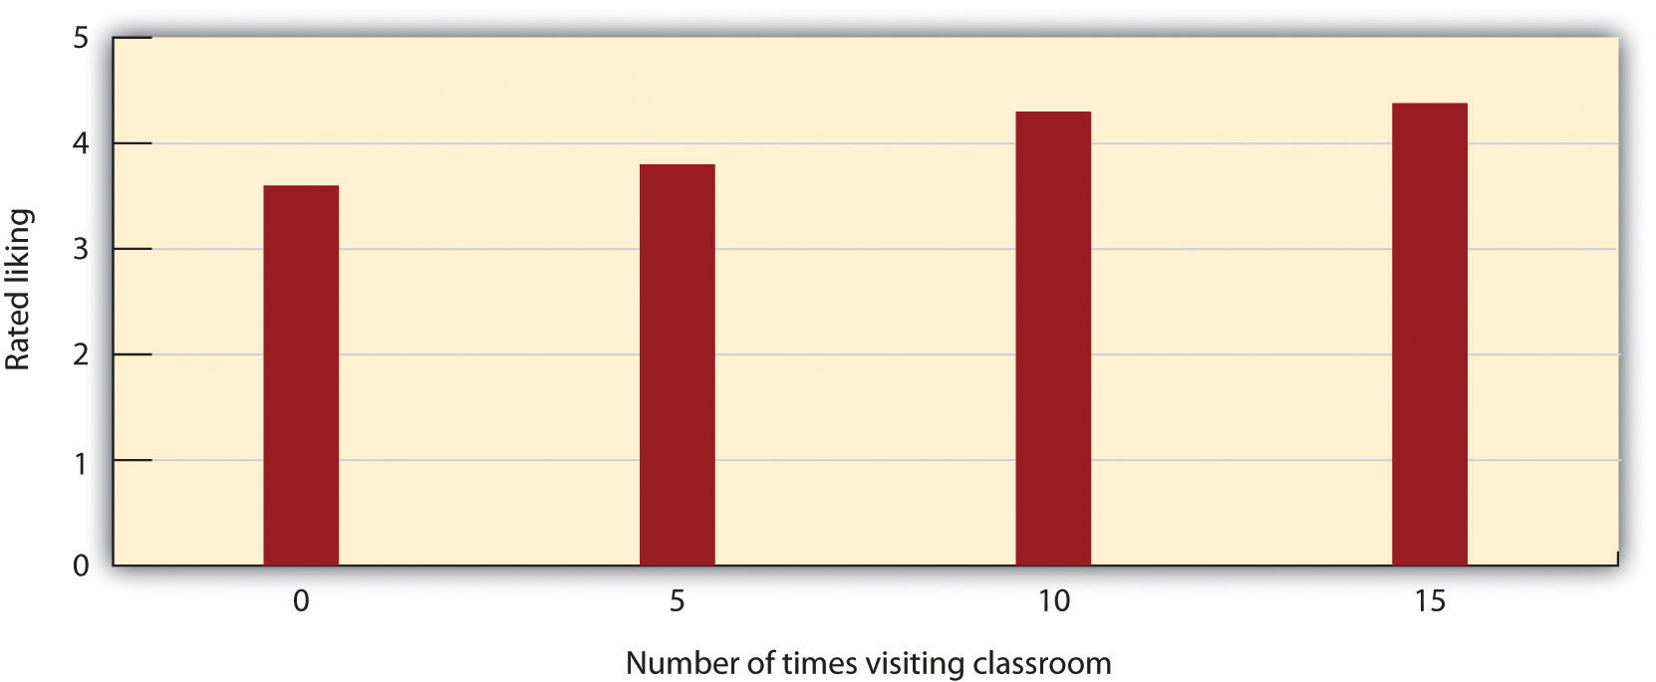
Richard Moreland and Scott Beach had female confederates visit a class 5, 10, or 15 times or not at all over the course of a semester. Then the students rated their liking of the confederates. The mere-exposure effect is clear. Data are from Moreland and Beach (1992). ^{[53]}
The effect of mere exposure is powerful and occurs in a wide variety of situations (Bornstein, 1989). ^{[54]} Infants tend to smile at a photograph of someone they have seen before more than they smile at someone they are seeing for the first time (Brooks-Gunn & Lewis, 1981). ^{[55]} And people have been found to prefer left-to-right reversed images of their own faces over their normal (nonreversed) face, whereas their friends prefer their regular face over the reversed one (Mita, Dermer, & Knight, 1977). ^{[56]}This also is expected on the basis of mere exposure, since people see their own faces primarily in mirrors and thus are exposed to the reversed face more often.
Mere exposure may well have an evolutionary basis. We have an initial and potentially protective fear of the unknown, but as things become more familiar, they produce more positive feelings and seem safer (Freitas, Azizian, Travers, & Berry, 2005; Harmon-Jones & Allen, 2001). ^{[57]} When the stimuli are people, there may well be an added effect—familiar people are more likely to be seen as part of the ingroup rather than the outgroup, and this may lead us to like them even more. Leslie Zebrowitz and her colleagues showed that we like people of our own race in part because they are perceived as familiar to us (Zebrowitz, Bronstad, & Lee, 2007). ^{[58]}
It should be kept in mind that mere exposure only applies to the change that occurs when one is completely unfamiliar with another person (or object) and subsequently becomes more familiar with him or her. Thus mere exposure applies only in the early stages of attraction. Later, when we are more familiar with someone, that person may become too familiar and thus boring. You may have experienced this effect when you first bought some new songs and began to listen to them. Perhaps you didn’t really like all the songs at first, but you found yourself liking them more and more as you played them more often. If this has happened to you, you have experienced mere exposure. But perhaps one day you discovered that you were really tired of the songs—they had become too familiar. You put the songs away for a while, only bringing them out later, when you found that liked them more again (they were now less familiar). People prefer things that have an optimal level of familiarity—neither too strange nor too well-known (Bornstein, 1989). ^{[59]}

Affect and Attraction
Because our relationships with others are based in large part on emotional responses, it will come as no surprise to you to hear that affect is particularly important in interpersonal relationships. The relationship between mood and liking is pretty straightforward. We tend to like people more when we are in good moods and to like them less when we are in bad moods. This prediction follows directly from the expectation that affective states provide us with information about the social context—in this case, the people around us. Positive affect signals that it is safe and desirable to approach the other person, whereas negative affect is more likely to indicate danger and to suggest avoidance.
Moods are particularly important and informative when they are created by the person we are interacting with. When we find someone attractive, for instance, we experience positive affect, and we end up liking the person even more. However, mood that is created by causes other than the other person can also influence liking. Alice Isen and her colleagues (Isen & Levin, 1972) ^{[60]} created a variety of situations designed to put people in good moods. They had participants unexpectedly find a coin in a phone booth, played them some soothing music, or provided them a snack of milk and cookies at an experimental session. In each of these cases, the participants who had been provided with the pleasant experience indicated more positive mood in comparison with other participants who had not received the positive experience—and they also expressed more liking for other things and other people. The moral of the story is clear—if you want to get someone to like you, put them in a good mood. Furthermore, it is pretty easy to do so—simply bringing flowers, looking your best, or telling a funny joke might well be enough to be effective.

Research Focus
Arousal and Attraction
Although the relationship between mood and liking is very simple, the relationship between our current state of physiological arousal and liking is more complex. Consider an experiment by Gregory White and his colleagues (White, Fishbein, & Rutsein, 1981) ^{[61]} in which the participants, male college students, were asked to complete a number of different tasks in a laboratory setting. In one part of the study, the men were asked to run in place for either a short time (15 seconds) or a longer time (120 seconds). Then the men viewed a videotape of either an attractive or an unattractive woman who was supposedly a sophomore at the college. In the video, she talked about her hobbies and career interests and indicated that she was interested in meeting people and did not have a boyfriend. The men, who thought that they would soon be meeting the woman, rated how romantically attracted they were to her.
Confirming that the experimental manipulation had created high and low levels of arousal, White and his colleagues found that the heart rate and other signs of physiological arousal were higher for the participants who had exercised longer. They did not find that the arousal created by running in place for 2 minutes increased or decreased liking directly, but they did find an interaction between arousal level and the attractiveness of the woman being judged. As you can see in the following figure, the men who had been aroused by running in place liked the attractive woman more and the unattractive woman less than the men who were less aroused.

Figure 8.4
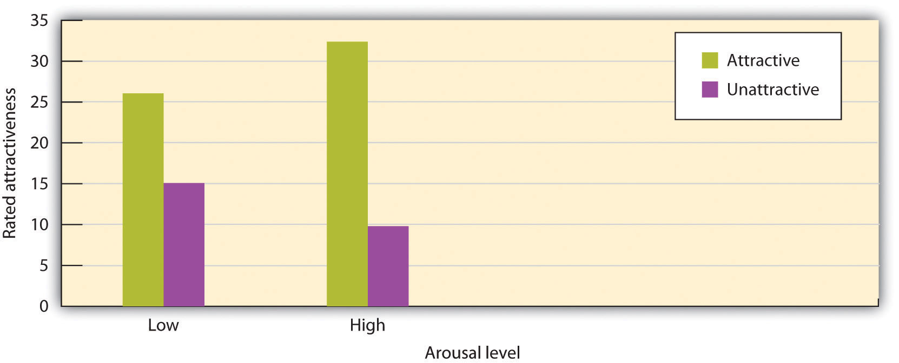
Arousal polarizes judgments. In this experiment, male college students rated an attractive or an unattractive woman after they had run in place for 15 seconds (low arousal) or for 120 seconds (high arousal). The judgments under arousal are polarized. Data are from White, Fishbein, and Rutstein (1981). ^{[62]}
In another interesting field study, Dutton and Aron (1974) ^{[63]} had an attractive young woman approach individual young men as they crossed a long, wobbly suspension bridge hanging over 200 feet above the Capilano River in British Columbia. The woman asked each man to help her fill out a questionnaire for a class project. When he had finished, she wrote her name and phone number on a piece of paper and invited him to call if he wanted to hear more about the project. Over half of the men who had been interviewed on the bridge later called her. In contrast, men who were approached on a low solid bridge by the same experimenter or who were interviewed on the suspension bridge by men called the woman significantly less frequently. One interpretation of this finding is that the men who were interviewed on the bridge were experiencing arousal as a result of being on the bridge but that they misattributed their arousal as liking the interviewer.
What these studies and many others like them demonstrate is that arousal polarizes liking (Foster, Witcher, Campbell, & Green, 1998). ^{[64]} When we are aroused, everything seems more extreme. This effect is not unexpected because the function of arousal in emotion is to increase the strength of an emotional response. Love that is accompanied by arousal (sexual or otherwise) is stronger love than love that has a lower level of arousal. And our feelings of anger, dislike, or disgust are also stronger when they are accompanied by high arousal.
As with mood states, arousal may sometimes come directly from the partner. Both very attractive and very unattractive people are likely to be more arousing than are people who are more average in attractiveness, and this arousal may create strong feelings of like or dislike. In other cases, the arousal may come from another source, such as from exercising, walking across a high bridge, or a roller-coaster ride.
The strong feelings that we experience toward another person that are accompanied by increases in arousal and sexual attraction are called passion, and the emotionally intense love that is based on passion is known as passionate love—the kind of love that we experience when we are first getting to know a romantic partner. Again, there is a clear take-home for you: If you like a person and think that the person likes you in return, and if you want to get that person to like you more, then it will be helpful to create some extra arousal in that person, perhaps by going to a scary movie, doing in-line skating, or even meeting for a workout at the gym. On the other hand, you need to be sure that the other person is initially positively inclined toward you. If not, arousing experiences could make matters even worse.

KEY TAKEAWAYS
- Particularly in initial encounters, people are strongly influenced by the physical attractiveness of the other person.
- We prefer people who are young, who have symmetrical facial features and bodies, and who appear average. These preferences may be because these features suggest to us that the person is healthy.
- Although men and women agree on many aspects of what they find attractive, women are relatively more focused on the social status of their romantic partners, whereas men are more focused on the youth and attractiveness of their partners.
- We tend to like people who share our values and beliefs, both because similarity makes things easier and because similarity reinforces our own values and beliefs.
- Proximity and the principle of mere exposure are two important determinants of interpersonal attraction.
- We tend to like people more when we are in good moods.
- Our current state of physiological arousal tends to polarize our liking.

EXERCISES AND CRITICAL THINKING
- Consider some people that you find most attractive. Do they match the characteristics that social psychologists have found to be important?
- Describe a time when you saw or knew a couple in which one person was much more attractive than the other. Do you think this was an exception to the rule of status similarity, or was there a reason for it?
- Consider some features that your culture finds attractive. Why do you think these features make people look attractive?
- Describe a time when you experienced the mere exposure effect or polarization of arousal.

[1] Sprecher, S., Wenzel, A., & Harvey, J. (2008). Handbook of relationship initiation. New York, NY: Psychology Press. Retrieved from http://search.ebscohost.com/login.aspx?direct=true&db=psyh&AN=2008-09972-000&loginpage=Login.asp&site= ehost-live
[2] Swami, V., & Furnham, A. (2008). The psychology of physical attraction. New York, NY: Routledge/Taylor & Francis Group.
[3] Walster, E., Aronson, V., Abrahams, D., & Rottmann, L. (1966). Importance of physical attractiveness in dating behavior. Journal of Personality and Social Psychology, 4(5), 508–516.
[4] Langlois, J. H., Ritter, J. M., Roggman, L. A., & Vaughn, L. S. (1991). Facial diversity and infant preferences for attractive faces. Developmental Psychology, 27, 79–84.
[5] Olson, I. R., & Marshuetz, C. (2005). Facial attractiveness is appraised in a glance. Emotion, 5(4), 498–502; van Leeuwen, M. L., & Macrae, C. N. (2004). Is beautiful always good? Implicit benefits of facial attractiveness. Social Cognition, 22(6), 637–649.
[6] Griffin, A. M., & Langlois, J. H. (2006). Stereotype directionality and attractiveness stereotyping: Is beauty good or is ugly bad? Social Cognition, 24(2), 187–206.
[7] Epstein, J., Klinkenberg, W. D., Scandell, D. J., Faulkner, K., & Claus, R. E. (2007). Perceived physical attactiveness, sexual history, and sexual intentions: An internet study. Sex Roles, 56(1–2), 23–31.
[8] Dubois, M., & Pansu, P. (2004). Facial attractiveness, applicants’ qualifications, and judges’ expertise about decisions in preselective recruitment. Psychological Reports, 95(3, Pt. 2), 1129–1134.
[9] Henderson, J. J. A., & Anglin, J. M. (2003). Facial attractiveness predicts longevity.Evolution and Human Behavior, 24(5), 351–356.
[10] Berry, D. S. (2000). Attractiveness, attraction, and sexual selection: Evolutionary perspectives on the form and function of physical attractiveness. Advances in Experimental Social Psychology, 32, 273–342; Ramsey, J. L., Langlois, J. H., Hoss, R. A., Rubenstein, A. J., & Griffin, A. M. (2004). Origins of a stereotype: Categorization of facial attractiveness by 6-month-old infants. Developmental Science, 7(2), 201–211.
[11] Zebrowitz, L. A. (1996). Physical appearance as a basis of stereotyping. In C. N. Macrae, C. Stangor, & M. Hewstone (Eds.), Stereotypes and stereotyping (pp. 79–120). New York, NY: Guilford Press.
[12] Zebrowitz, L. A., & McDonald, S. M. (1991). The impact of litigants’ baby-facedness and attractiveness on adjudications in small claims courts. Law and Human Behavior, 15(6), 603–623.
[13] Zebrowitz, L. A., & Montepare, J. M. (2005). Appearance does matter. Science, 308(5728), 1565–1566.
[14] Wade, T. J. (2000). Evolutionary theory and self-perception: Sex differences in body esteem predictors of self-perceived physical and sexual attractiveness and self-esteem.International Journal of Psychology, 35(1), 36–45.
[15] Rhodes, G. (2006). The evolutionary psychology of facial beauty. Annual Review of Psychology, 57, 199–226.
[16] Rhodes, G. (2006). The evolutionary psychology of facial beauty. Annual Review of Psychology, 57, 199–226; Rhodes, G., Zebrowitz, L. A., Clark, A., Kalick, S. M., Hightower, A., & McKay, R. (2001). Do facial averageness and symmetry signal health? Evolution and Human Behavior, 22(1), 31–46.
[17] Winkielman, P., & Cacioppo, J. T. (2001). Mind at ease puts a smile on the face: Psychophysiological evidence that processing facilitation elicits positive affect. Journal of Personality and Social Psychology, 81(6), 989–1000.
[18] Gangestad, S. W., & Thornhill, R. (1997). The evolutionary psychology of extra-pair sex: The role of fluctuating asymmetry. Evolution and Human Behavior, 18(2), 69–88.
[19] Langlois, J. H., Roggman, L. A., & Musselman, L. (1994). What is average and what is not average about attractive faces? Psychological Science, 5(4), 214–220.
[20] Langlois, J. H., & Roggman, L. A. (1990). Attractive faces are only average. Psychological Science, 1(2), 115–121.
[21] Grammer, K., Fink, B., Juette, A., Ronzal, G., & Thornhill, R. (2002). Female faces and bodies: N-dimensional feature space and attractiveness. In G. Rhodes & L. A. Zebrowitz (Eds.),Facial attractiveness: Evolutionary, cognitive, and social perspectives (pp. 91–125). Westport, CT: Ablex Publishing.
[22] Jones, B. C., Little, A. C., Feinberg, D. R., Penton-Voak, I. S., Tiddeman, B. P., & Perrett, D. I. (2004). The relationship between shape symmetry and perceived skin condition in male facial attractiveness. Evolution and Human Behavior, 25(1), 24–30; Rhodes, G. (2006). The evolutionary psychology of facial beauty. Annual Review of Psychology, 57, 199–226; Willis, M. S., Esqueda, C. W., & Schacht, R. N. (2008). Social perceptions of individuals missing upper front teeth. Perceptual and Motor Skills, 106(2), 423–435.
[23] Crandall, C. S., Merman, A., & Hebl, M. (2009). Anti-fat prejudice. In T. D. Nelson (Ed.),Handbook of prejudice, stereotyping, and discrimination (pp. 469–487). New York, NY: Psychology Press; Hönekopp, J., Rudolph, U., Beier, L., Liebert, A., & Müller, C. (2007). Physical attractiveness of face and body as indicators of physical fitness in men. Evolution and Human Behavior, 28(2), 106–111; Weeden, J., & Sabini, J. (2005). Physical attractiveness and health in Western societies: A review. Psychological Bulletin, 131(5), 635–653.
[24] Anderson, J. L., Crawford, C. B., Nadeau, J., & Lindberg, T. (1992). Was the Duchess of Windsor right? A cross-cultural review of the socioecology of ideals of female body shape.Ethology and Sociobiology, 13(3), 197–227.
[25] Berry, D. S. (2000). Attractiveness, attraction, and sexual selection: Evolutionary perspectives on the form and function of physical attractiveness. Advances in Experimental Social Psychology, 32, 273–342; Li, N. P., Bailey, J. M., Kenrick, D. T., & Linsenmeier, J. A. W. (2002). The necessities and luxuries of mate preferences: Testing the tradeoffs. Journal of Personality and Social Psychology, 82(6), 947–955.
[26] Li, N. P., Bailey, J. M., Kenrick, D. T., & Linsenmeier, J. A. W. (2002). The necessities and luxuries of mate preferences: Testing the tradeoffs. Journal of Personality and Social Psychology, 82(6), 947–955.
[27] Harrison, A. A., & Saeed, L. (1977). Let’s make a deal: An analysis of revelations and stipulation in lonely hearts advertisements. Journal of Personality and Social Psychology, 35, 257–264; Wiederman, M. W. (1993). Evolved gender differences in mate preferences: Evidence from personal advertisements. Ethology and Sociobiology, 14(5), 331–351.
[28] Baize, H. R., & Schroeder, J. E. (1995). Personality and mate selection in personal ads: Evolutionary preferences in a public mate selection process. Journal of Social Behavior and Personality, 10(3), 517–536.
[29] Buss, D. M. (1989). Sex differences in human mate preferences: Evolutionary hypotheses tested in 37 cultures. Behavioral and Brain Sciences, 12(1), 1–49.
[30] Buunk, B. P., Dijkstra, P., Kenrick, D. T., & Warntjes, A. (2001). Age preferences for mates as related to gender, own age, and involvement level. Evolution and Human Behavior, 22(4), 241–250; Dunn, M. J., Brinton, S., & Clark, L. (2010). Universal sex differences in online advertisers age preferences: Comparing data from 14 cultures and 2 religious groups.Evolution and Human Behavior, 31(6), 383–393; Kenrick, D. T., & Li, N. (2000). The Darwin is in the details. American Psychologist, 55(9), 1060–1061.
[31] Singh, D. (1995). Female judgment of male attractiveness and desirability for relationships: Role of waist-to-hip ratio and financial status. Journal of Personality and Social Psychology, 69(6), 1089–1101; Swami, V. (2006). The influence of body weight and shape in determining female and male physical attractiveness. In M. V. Kindes (Ed.), Body image: New research (pp. 35–61). Hauppauge, NY: Nova Science.
[32] Donohoe, M. L., von Hippel, W., & Brooks, R. C. (2009). Beyond waist-hip ratio: Experimental multivariate evidence that average women’s torsos are most attractive.Behavioral Ecology, 20(4), 716–721.
[33] Petersen, J. L., & Hyde, J. S. (2010). A meta-analytic review of research on gender differences in sexuality, 1993–2007. Psychological Bulletin, 136(1), 21–38; Saad, G., Eba, A., & Sejean, R. (2009). Sex differences when searching for a mate: A process-tracing approach.Journal of Behavioral Decision making, 22(2), 171–190.
[34] Roese, N. J., Pennington, G. L., Coleman, J., Janicki, M., Li, N. P., & Kenrick, D. T. (2006). Sex differences in regret: All for love or some for lust? Personality and Social Psychology Bulletin, 32(6), 770–780.
[35] Buss, D., & Kenrick, D. (1998). Evolutionary social psychology. In D. T. Gilbert, S. T. Fiske, & G. Lindzey (Eds.), Handbook of social psychology (4th ed., Vol. 2, pp. 982–1026). Boston, MA: McGraw-Hill.
[36] Petersen, J. L., & Hyde, J. S. (2010). A meta-analytic review of research on gender differences in sexuality, 1993–2007. Psychological Bulletin, 136(1), 21–38.
[37] Sigall, H., & Landy, D. (1973). Radiating beauty: Effects of having a physically attractive partner on person perception. Journal of Personality and Social Psychology, 28(2), 218–224.
[38] Dion, K., Berscheid, E., & Walster, E. (1972). What is beautiful is good. Journal of Personality and Social Psychology, 24(3), 285–290.
[39] Eagly, A. H., Ashmore, R. D., Makhijani, M. G., & Longo, L. C. (1991). What is beautiful is good, but…: A meta-analytic review of research on the physical attractiveness stereotype.Psychological Bulletin, 110(1), 109–128.
[40] Hosoda, M., Stone-Romero, E. F., & Coats, G. (2003). The effects of physical attractiveness on job-related outcomes: A meta-analysis of experimental studies. Personnel Psychology, 56(2), 431–462.
[41] Diener, E., Wolsic, B., & Fujita, F. (1995). Physical attractiveness and subjective well-being.Journal of Personality and Social Psychology, 69(1), 120–129; Langlois, J. H., Kalakanis, L., Rubenstein, A. J., Larson, A., Hallam, M., & Smoot, M. (2000). Maxims or myths of beauty? A meta-analytic and theoretical review. Psychological Bulletin, 126(3), 390–423.
[42] Zebrowitz, L. A., Andreoletti, C., Collins, M. A., Lee, S. Y., & Blumenthal, J. (1998). Bright, bad, baby-faced boys: Appearance stereotypes do not always yield self-fulfilling prophecy effects. Journal of Personality and Social Psychology, 75(5), 1300–1320.
[43] Jones, J. T., Pelham, B. W., Carvallo, M., & Mirenberg, M. C. (2004). How do I love thee? Let me count the Js: Implicit egotism and interpersonal attraction. Journal of Personality and Social Psychology, 87(5), 665–683; Pinel, E. C., Long, A. E., Landau, M. J., Alexander, K., & Pyszczynski, T. (2006). Seeing I to I: A pathway to interpersonal connectedness. Journal of Personality and Social Psychology, 90(2), 243–257.
[44] Newcomb, T. M. (1961). The acquaintance process. New York, NY: Holt, Rinehart & Winston.
[45] Singh, R., Yeo, S. E. L., Lin, P. K. F., & Tan, L. (2007). Multiple mediators of the attitude similarity-attraction relationship: Dominance of inferred attraction and subtlety of affect. Basic and Applied Social Psychology, 29(1), 61–74.
[46] Kalick, S. M., & Hamilton, T. E. (1986). The matching hypothesis reexamined. Journal of Personality and Social Psychology, 51(4), 673–682; Lee, L., Loewenstein, G., Ariely, D., Hong, J., & Young, J. (2008). If I’m not hot, are you hot or not? Physical-attractiveness evaluations and dating preferences as a function of one’s own attractiveness. Psychological Science, 19(7), 669–677.
[47] Baumeister, R. F., & Wotman, S. R. (1992). Breaking hearts: The two sides of unrequited love. New York, NY: Guilford Press
[48] Beach, S. R. H., Whitaker, D. J., Jones, D. J., & Tesser, A. (2001). When does performance feedback prompt complementarity in romantic relationships? Personal Relationships, 8(3), 231–248; Tiedens, L. Z., & Jimenez, M. C. (2003). Assimilation for affiliation and contrast for control: Complementary self-construals. Journal of Personality and Social Psychology, 85(6), 1049–1061.
[49] Kubitschek, W. N., & Hallinan, M. T. (1998). Tracking and students’ friendships. Social Psychology Quarterly, 61(1), 1–15.
[50] Back, M. D., Schmukle, S. C., & Egloff, B. (2008). Becoming friends by chance.Psychological Science, 19(5), 439–440.
[51] Festinger, L., Schachter, S., & Back, K. (1950). Social pressures in informal groups. New York, NY: Harper.
[52] Moreland, R. L., & Beach, S. R. (1992). Exposure effects in the classroom: The development of affinity among students. Journal of Experimental Social Psychology, 28(3), 255–276.
[53] Moreland, R. L., & Beach, S. R. (1992). Exposure effects in the classroom: The development of affinity among students. Journal of Experimental Social Psychology, 28(3), 255–276.
[54] Bornstein, R. F. (1989). Exposure and affect: Overview and meta-analysis of research, 1968–1987. Psychological Bulletin, 106(2), 265–289.
[55] Brooks-Gunn, J., & Lewis, M. (1981). Infant social perception: Responses to pictures of parents and strangers. Developmental Psychology, 17(5), 647–649.
[56] Mita, T. H., Dermer, M., & Knight, J. (1977). Reversed facial images and the mere-exposure hypothesis. Journal of Personality and Social Psychology, 35(8), 597–601.
[57] Freitas, A. L., Azizian, A., Travers, S., & Berry, S. A. (2005). The evaluative connotation of processing fluency: Inherently positive or moderated by motivational context? Journal of Experimental Social Psychology, 41(6), 636–644; Harmon-Jones, E., & Allen, J. J. B. (2001). The role of affect in the mere exposure effect: Evidence from psychophysiological and individual differences approaches. Personality and Social Psychology Bulletin, 27(7), 889–898.
[58] Zebrowitz, L. A., Bronstad, P. M., & Lee, H. K. (2007). The contribution of face familiarity to in-group favoritism and stereotyping. Social Cognition, 25(2), 306–338. doi: 10.1521/soco.2007.25.2.306
[59] Bornstein, R. F. (1989). Exposure and affect: Overview and meta-analysis of research, 1968–1987. Psychological Bulletin, 106(2), 265–289.
[60] Isen, A. M., & Levin, P. F. (1972). Effect of feeling good on helping: Cookies and kindness.Journal of Personality and Social Psychology, 21, 384–388.
[61] White, G. L., Fishbein, S., & Rutsein, J. (1981). Passionate love and the misattribution of arousal. Journal of Personality and Social Psychology, 41(1), 56–62.
[62] White, G. L., Fishbein, S., & Rutstein, J. (1981). Passionate love and the misattribution of arousal. Journal of Personality and Social Psychology, 41(1), 56–62.
[63] Dutton, D., & Aron, A. (1974). Some evidence for heightened sexual attraction under conditions of high anxiety. Journal of Personality and Social Psychology, 30, 510–517.
[64] Foster, C. A., Witcher, B. S., Campbell, W. K., & Green, J. D. (1998). Arousal and attraction: Evidence for automatic and controlled processes. Journal of Personality and Social Psychology, 74(1), 86–101.

8.2 Close Relationships: Liking and Loving Over the Long Term

LEARNING OBJECTIVES
- Outline the factors that define close relationships.
- Explain how people can best maintain their close relationships.
To this point in the chapter, we have focused upon the attraction that occurs between people who are initially getting to know one another. But the basic principles of social psychology can also be applied to help us understand relationships that last longer. When good friendships develop, when people get married and plan to spend the rest of their lives together, and when families grow closer over time, the relationships take on new dimensions and must be understood in somewhat different ways. Yet the principles of social psychology can still be applied to help us understand what makes these relationships last. Although humans seem to be the only animals that are able to develop close relationships in which partners stay sexually faithful to each other for a lifetime (Barash & Lipton, 2002), ^{[1]} these relationships do not come easily. About one half of contemporary marriages in the United States and Canada end in divorce (CDC, 2010). ^{[2]}
The factors that keep people liking each other in long-term relationships are at least in part the same as the factors that lead to initial attraction. For instance, regardless of how long they have been together, people remain interested in the physical attractiveness of their partners, although it is relatively less important than for initial encounters. And similarity remains essential. Relationships are also more satisfactory and more likely to continue when the individuals develop and maintain similar interests and continue to share their important values and beliefs over time (Davis & Rusbult, 2001). ^{[3]} Proximity also remains important—relationships that undergo the strain of the partners’ being apart from each other for very long are more at risk for breakup.
But what about passion? Does it still matter over time? Yes and no. People in long-term relationships who are most satisfied with their partners report that they still feel passion for their partners—they still want to be around them as much as possible, and they enjoy making love with them (Simpson, 1987; Sprecher, 2006). ^{[4]} And partners report that the more they love their partners, the more attractive they find them (Simpson, Gangestad, & Lerma, 1990). ^{[5]} On the other hand, the high levels of passionate love that are experienced in initial encounters are not likely to be maintained throughout the course of a long-term relationship (Acker & Davis, 1992).^{[6]} Over time, cognition becomes relatively more important than emotion, and close relationships are more likely to be based on companionate love, defined as love that is based on friendship, mutual attraction, common interests, mutual respect, and concern for each other’s welfare. This does not mean that enduring love is less strong—it just has a different underlying structure than initial love.

Closeness and Intimacy
Although it is safe to say that many of the variables that influence initial attraction remain important in longer-term relationships, other variables also come into play over time. One important change is that as a relationship progresses, the partners come to know each other more fully and care about each other to a greater degree. In successful relationships, the partners feel increasingly close to each other over time, whereas in unsuccessful relationships, closeness does not increase and may even decrease. The closeness experienced in these relationships is marked in part byreciprocal self-disclosure—the tendency to communicate frequently, without fear of reprisal, and in an accepting and empathetic manner.
When the partners in a relationship feel that they are close, and when they indicate that the relationship is based on caring, warmth, acceptance, and social support, we can say that the relationship is intimate (Sternberg, 1986). ^{[7]} Partners in intimate relationships are likely to think of the couple as “we” rather than as two separate individuals. People who have a sense of closeness with their partner are better able to maintain positive feelings about the relationship while at the same time being able to express negative feelings and to have accurate (although sometimes less than positive) judgments of the other (Neff & Karney, 2002). ^{[8]} People may also use their close partner’s positive characteristics to feel better about themselves (Lockwood, Dolderman, Sadler, & Gerchak, 2004). ^{[9]}
Arthur Aron and his colleagues (Aron, Aron, & Smollan, 1992) ^{[10]} have assessed the role of closeness in relationships directly, using the simple measure shown in Figure 8.6 "Measuring Relationship Closeness". You might try completing the measure yourself for some different people that you know—for instance, your family members, your friends, your spouse, or your girlfriend or boyfriend. The measure is simple to use and to interpret. If a person chooses a circle that represents the self and the other as more overlapping, this means that the relationship is close. But if they choose a circle that is less overlapping, then the relationship is less so.

Figure 8.6 Measuring Relationship Closeness
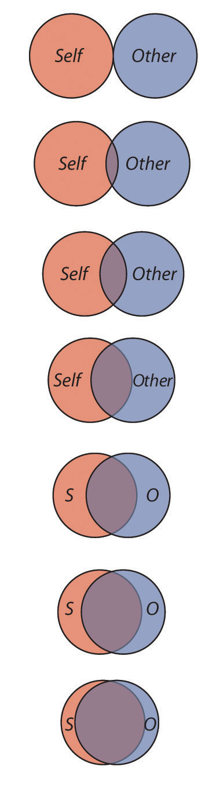
This measure is used to determine how close two partners feel to each other. The respondent simply circles which of the figures he or she feels characterizes the relationship. From Aron, Aron, and Smollan (1992). ^{[11]}
Although the closeness measure is simple, it has been found to be highly predictive of people’s satisfaction with their close relationships and of the tendency for couples to stay together. In fact, the perceived closeness between romantic partners can be a better predictor of how long a relationship will last than is the number of positive feelings that the partners indicate having for each other. In successful close relationships cognitive representations of the self and the other tend to merge together into one, and it is this tie—based on acceptance, caring, and social support—that is so important (Aron, Aron, Tudor, & Nelson, 1991). ^{[12]}
Aron and his colleagues (Aron, Melinat, Aron, & Vallone, 1997) ^{[13]} used an experimental design to test whether self-disclosure of intimate thoughts to others would increase closeness. In a laboratory, they paired college students with another student, one whom they did not know. Some of the students were asked to share some intimate thoughts with each other by asking and answering questions such as “When did you last cry in front of another person?” In comparison with control participants who only engaged in small talk with their partners (answering questions such as “What is your favorite holiday?”), the students who disclosed more intimate experiences reported feeling significantly closer to each other at the end of the conversation.

Communal and Exchange Relationships
In intimate close relationships, the partners can become highly attuned to each other’s needs, such that the desires and goals of the other become as important as, or more important than, one’s own needs. When people are attentive to the needs of others—for instance, parents’ attentiveness to the needs of their children or the attentiveness of partners in a romantic relationship—and when they help the other person meet his or her needs without explicitly keeping track of what they are giving or expecting to get in return, we say that the partners have a communal relationship.Communal relationships are close relationships in which partners suspend their need for equity and exchange, giving support to the partner in order to meet his or her needs, and without consideration of the costs to themselves. Communal relationships are contrasted with exchange relationships, relationships in which each of the partners keeps track of his or her contributions to the partnership.
Suggesting that communal relationships can be beneficial, research has found that happier couples are less likely to “keep score” of their respective contributions (Buunk, Van Yperen, Taylor, & Collins, 1991). ^{[14]} And when people are reminded of the external benefits that their partners provide them, they may experience decreased feelings of love for them (Seligman, Fazio, & Zanna, 1980). ^{[15]}
Although partners in long-term relationships are frequently willing and ready to help each other meet their needs, and although they will in some cases forgo the need for exchange and reciprocity, this does not mean that they always or continually give to the relationship without expecting anything in return. Partners do keep track of their contributions and received benefits. If one or both of the partners feel that they are unfairly contributing more than their fair share, and if this inequity continues over a period of time, the relationship will suffer. Partners who feel that they are contributing more will naturally become upset because they will feel that they are being taken advantage of. But the partners who feel that they are receiving more than they deserve might feel guilty about their lack of contribution to the partnership.
Members of long-term relationships focus to a large extent on maintaining equity, and marriages are happiest when both members perceive that they contribute relatively equally (Van Yperen & Buunk, 1990). ^{[16]} People stay in relationships longer when they feel that they are being rewarded by them (Margolin & Wampold, 1981). ^{[17]} In short, in relationships that last, the partners are aware of the needs of the other person and attempt to meet them equitably. But partners in the best relationships are also able to look beyond the rewards themselves and to think of the relationship in a communal way.

Interdependence and Commitment
Another factor that makes long-term relationships different from short-term ones is that they are more complex. When a couple begins to take care of a household together, has children, and perhaps has to care for elderly parents, the requirements of the relationship become correspondingly bigger. As a result of this complexity, the partners in close relationships increasingly turn to each other not only for social support but also for help in coordinating activities, remembering dates and appointments, and accomplishing tasks (Wegner, Erber, & Raymond, 1991). ^{[18]} The members of a close relationship are highly interdependent, relying to a great degree on each other to meet their goals.
It takes a long time for partners in a relationship to develop the ability to understand the other person’s needs and to form positive patterns of interdependence in which each person’s needs are adequately met. The social representation of a significant other is a rich, complex, and detailed one because we know and care so much about him or her and because we have spent so much time in his or her company (Andersen & Cole, 1990). ^{[19]} Because a lot of energy has been invested in creating the relationship, particularly when the relationship includes children, breaking off the partnership becomes more and more costly with time. After spending a long time with one person, it may also become more and more difficult to imagine ourselves with anyone else.
In relationships in which a positive rapport between the partners is developed and maintained over a period of time, the partners are naturally happy with the relationship and they become committed to it. Commitment refers to the feelings and actions that keep partners working together to maintain the relationship. In comparison to those who are less committed, partners who are more committed to the relationship see their mates as more attractive than others, are less able to imagine themselves with another partner, express less interest in other potential mates, are less aggressive toward each other, and are less likely to break up (Simpson, 1987; Slotter et al., 2011). ^{[20]}
Commitment may in some cases lead individuals to stay in relationships that they could leave, even though the costs of remaining in the relationship are very high. On the surface, this seems puzzling because people are expected to attempt to maximize their rewards in relationships and would be expected to leave them if they are not rewarding. But in addition to evaluating the outcomes that one gains from a given relationship, the individual also evaluates the potential costs of moving to another relationship or not having any relationship at all. We might stay in a romantic relationship, even if the benefits of that relationship are not high, because the costs of being in no relationship at all are perceived as even higher. In short, when considering whether to stay or leave, we must consider both the costs and benefits of the current relationship and the costs and benefits of the alternatives to it (Rusbult, Olsen, Davis, & Hannon, 2001). ^{[21]}
Although the good news about interdependence and commitment is clear—they help relationships last longer—they also have a potential downside. Breaking up, should it happen, is more difficult in relationships that are interdependent and committed. The closer and more committed a relationship has been, the more devastating a breakup will be.

What Is Love?
Although we have talked about it indirectly, we have not yet tried to define love itself—and yet it is obviously the case that close relationships are all about love. Social psychologists have studied the function and characteristics of romantic love, finding that it has cognitive, affective, and behavioral components and that it occurs cross-culturally. Romantic love is found in all cultures, although how it is experienced may vary.
Robert Sternberg and others (Arriaga & Agnew, 2001; Sternberg, 1986) ^{[22]} have proposed a triangular model of love, an approach that suggests that there are different types of love and that each is made up of different combinations of cognitive and affective variables, specified in terms of passion, intimacy, and commitment. The model, shown in Figure 8.7 "Triangular Model of Love", suggests that onlyconsummate love has all three of the components (and is probably experienced only in the very best romantic relationships), whereas the other types of love are made up of only one or two of the three components. For instance, people who are good friends may have liking (intimacy) only or may have known each other so long that they also share commitment to each other (companionate love). Similarly, partners who are initially dating might simply be infatuated with each other (passion only) or may be experiencing romantic love (both passion and liking but not commitment).

Figure 8.7 Triangular Model of Love
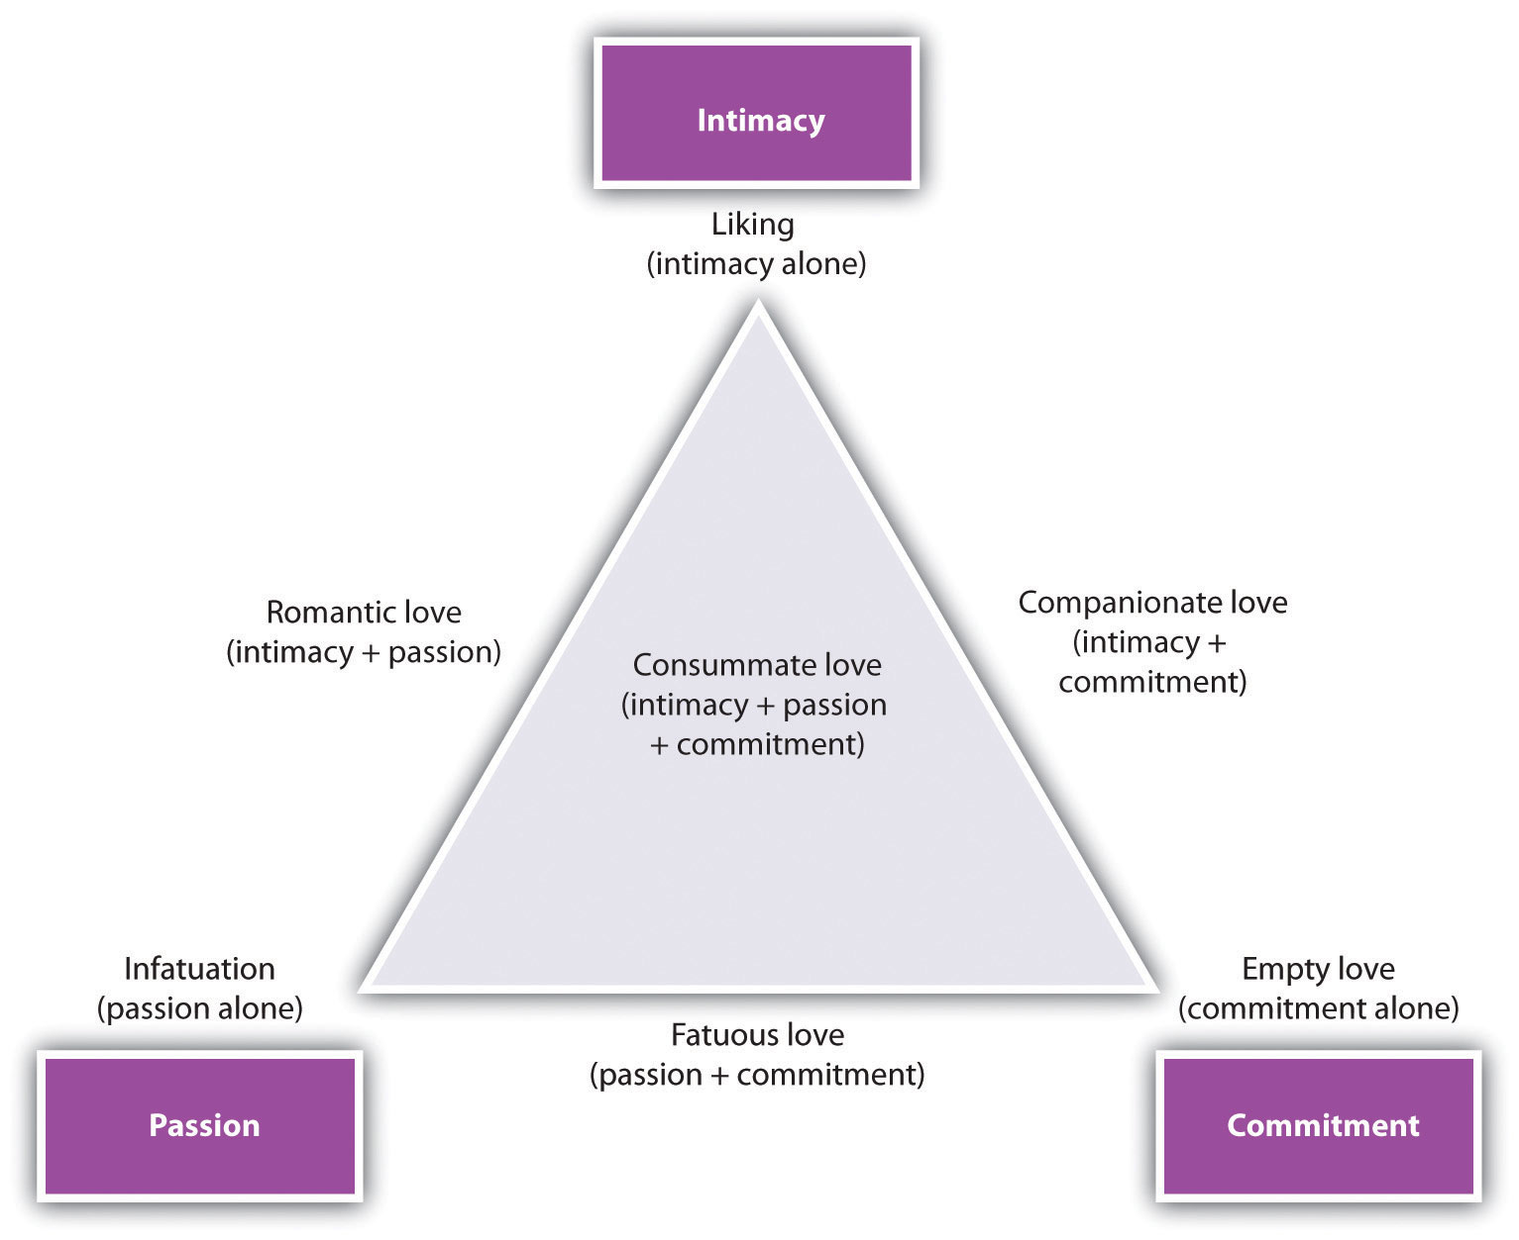
The triangular model of love, proposed by Robert Sternberg. Note that there are seven types of love, which are defined by the combinations of the underlying factors of intimacy, passion, and commitment. From Sternberg (1986). ^{[23]}

Research Focus
Romantic Love Reduces Our Attention to Attractive Others
Evolutionary psychologists have proposed that we experience romantic love to help increase our evolutionary fitness (Taylor & Gonzaga, 2006). ^{[24]} According to this idea, love helps couples work together to improve the relationship by coordinating and planning activities and by increasing commitment to the partnership. If love acts as a “commitment device,” it may do so in part by helping people avoid being attracted to other people who may pose a threat to the stability of the relationship (Gonzaga, Haselton, Smurda, Davies, & Poore, 2008; Sabini & Silver, 2005). ^{[25]}
Jon Maner and his colleagues (Maner, Rouby, & Gonzaga, 2008) ^{[26]} tested this idea by selecting a sample of participants who were currently in a committed relationship and manipulating the extent to which the participants were currently experiencing romantic love for their partners. They predicted that the romantic love manipulation would decrease attention to faces of attractive opposite-sex people.
One half of the participants (the romantic love condition) were assigned to write a brief essay about a time in which they experienced strong feelings of love for their current partner. Participants assigned to the control condition wrote a brief essay about a time in which they felt extremely happy. After completing the essay, participants completed a procedure in which they were shown a series of attractive and unattractive male and female faces. The procedure assessed how quickly the participants could shift their attention away from the photo they were looking at to a different photo. The dependent variable was the reaction time (in milliseconds) with which participants could shift their attention.

Figure 8.8Romantic Love and Attention to Faces
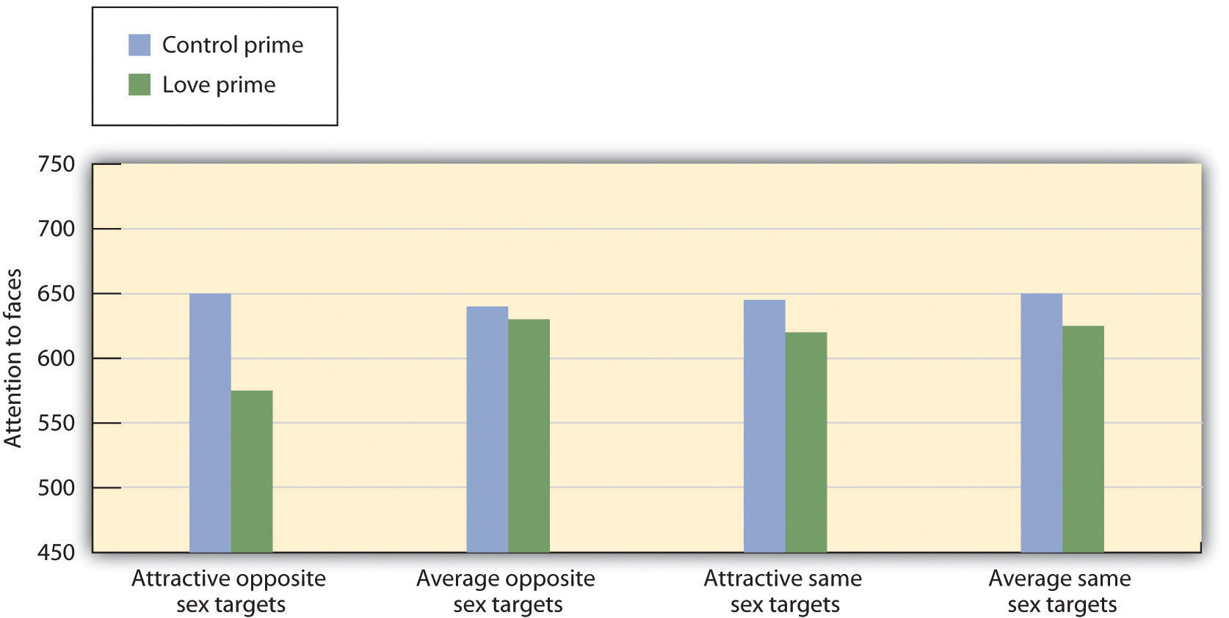
Activating thoughts and feelings of romantic love reduced attention to faces of attractive alternatives. Attention to other social targets remained unaffected. Data are from Maner et al. (2008). ^{[27]}
As you can see in the preceding figure, the participants who had been asked to think about their thoughts and feelings of love for their partner were faster at moving their attention from the attractive opposite-sex photos than were participants in any of the other conditions. When experiencing feelings of romantic love, participants’ attention seemed repelled, rather than captured, by highly attractive members of the opposite sex. These findings suggest that romantic love may inhibit the perceptual processing of physical attractiveness cues—the very same cues that often pose a high degree of threat to the relationship.

Individual Differences in Loving: Attachment Styles
One of the important determinants of the quality of close relationships is the way that the partners relate to each other. These approaches can be described in terms ofattachment style—individual differences in how people relate to others in close relationships. We display our attachment styles when we interact with our parents, our friends, and our romantic partners (Eastwick & Finkel, 2008). ^{[28]}
Attachment styles are learned in childhood, as children develop either a healthy or an unhealthy attachment style with their parents (Ainsworth, Blehar, Waters, & Wall, 1978; Cassidy & Shaver, 1999). ^{[29]} Most children develop healthy or secure attachment styles. These children perceive their parents as safe, available, and responsive caregivers and are able to relate easily to them. For these children, the parents successfully create appropriate feelings of affiliation and provide a secure base from which the child feels free to explore and then to return to. However, for children with unhealthy attachment styles, the family does not provide these needs. Some children develop an anxious/ambivalent attachment style, becoming overly dependent upon the parents and continually seeking more affection from them than they can give. These children are anxious about whether the parents will reciprocate closeness. Still other children become unable to relate to the parents at all, becoming distant, fearful, and cold (the avoidant attachment style).
The attachment styles that we develop in childhood remain to a large extent stable into adulthood (Caspi, 2000; Collins, Cooper, Albino, & Allard, 2002; Rholes, Simpson, Tran, Martin, & Friedman, 2007). ^{[30]} Fraley (2002) ^{[31]}conducted a meta-analysis of 27 studies that had looked at the relationship between attachment behavior in infants and in adults over 17 years of age and found a significant correlation between the two measures.
The consistency of attachment styles over the life span means that children who develop secure attachments with their parents as infants are better able to create stable, healthy interpersonal relationships with other individuals, including romantic partners, as adults (Hazan & Diamond, 2000). ^{[32]} They stay in relationships longer and are less likely to feel jealousy about their partners. But the relationships of anxious and avoidant partners are more problematic. Anxious men and women tend to be less warm with their partners, are more likely to get angry at them, and have more difficulty expressing their feelings (Collins & Feeney, 2000). ^{[33]} Anxious types also tend to worry about their partner’s love and commitment for them, and they interpret their partner’s behaviors more negatively (Collins & Feeney, 2004; Pierce & Lydon, 2001).^{[34]} Anxious partners also see more conflict in their relationships and experience the conflicts more negatively (Campbell, Simpson, Boldry, & Kashy, 2005). ^{[35]}
On the other hand, people with avoidant personality types simply have trouble creating close relationships at all (Gabriel, Carvallo, Dean, Tippin, & Renaud, 2005). ^{[36]} They have difficulty expressing emotions, and experience more negative affect in their interactions (Tidwell, Reis, & Shaver, 1996). ^{[37]} They also have trouble understanding other’s emotions (Fraley, Garner, & Shaver, 2000) ^{[38]} and show a relative lack of interest in learning about their romantic partner’s thoughts and feelings (Rholes, Simpson, Tran, Martin, & Friedman, 2007). ^{[39]}
One way to think about attachment styles, shown in Table 8.1 "Attachment as Self-Concern and Other-Concern", is in terms of the extent to which the individual is able to successfully meet the important goals of self-concern and other-concern in his or her close relationships. People with a secure attachment style have positive feelings about themselves and also about others. People with anxious/ambivalent attachment styles feel good about themselves (the goal of self-concern is being met), but they do not have particularly good relations with others. People with avoidant attachment styles are primarily other-concerned. They want desperately to be liked, but they do not have a very positive opinion of themselves; this lack of self-esteem hurts their ability to form good relationships. The fourth cell in the table, lower right, represents people who are not meeting goals of either self-concern or other-concern. We can call this attachment style fearful-avoidant.
This way of thinking about attachment shows, again, the importance of both self-concern and other-concern in successful social interaction. People who cannot connect with others do not make good partners. But people who do not feel good about themselves also are not good partners—self-concern goals must be met before we can successfully meet the goals of other-concern.

Table 8.1 Attachment as Self-Concern and Other-Concern
 | Other-concern
Self-concern | Goals are met | Goals are not met
Goals are met | Secure attachment  (Healthy feelings about the self and about important others) | Avoidant attachment  (Healthy feelings about the self but fears about connecting with others)
Goals are not met | Anxious/ambivalent attachment  (Desires to reach out to others but also anxious about the self) | Fearful attachment  (Relationships with others are poor but so is the self-concept)
Because attachment styles have such an important influence on relationships, you should think carefully about your potential partner’s interactions with the other people in his or her life. The quality of the relationships that people have with their parents and close friends will predict the quality of their romantic relationships. But although they are very important, attachment styles do not predict everything. People have many experiences as adults, and these interactions can influence, both positively and negatively, their ability to develop close relationships (Baldwin & Fehr, 1995; Scharfe & Bartholomew, 1994). ^{[40]}

Social Psychology in the Public Interest
Internet Relationships
Most of us are spending more time connecting with others electronically, and online close relationships are becoming more popular. But you might wonder whether meeting and interacting with others online can create the same sense of closeness and caring that we experience through face-to-face encounters. And you might wonder whether people who spend more time on Facebook, Twitter, and the Internet might end up finding less time to engage in activities with the friends and loved ones who are physically close by (Kraut et al., 1998). ^{[41]}
Despite these potential concerns, research shows that using the Internet actually has a positive influence on our close relationships (Bargh, 2002; Bargh & McKenna, 2004). ^{[42]} In one study, Kraut et al. (2002) ^{[43]} found that people who reported using the Internet more frequently also reported spending more time with their family and friends and indicated having better psychological health.
The Internet also seems to be useful for helping people develop new relationships, and the quality of those relationships is as good as or better than those formed face-to-face (Parks & Floyd, 1996). ^{[44]} McKenna, Green, and Gleason (2002)^{[45]} found that many people who participated in news and users groups online reported having formed a close relationship with someone they had originally met on the Internet. Over half of the participants said that they had developed a real-life relationship with people they had first met online, and almost a quarter reported that they had married, had become engaged to, or were living with someone they initially met on the Internet.
McKenna, Green, and Gleason (2002) ^{[46]} studied how relationships developed online using laboratory studies. In their research, a previously unacquainted male and female college student met each other for the first time either in what they thought was an Internet chat room or face-to-face. Those who met first on the Internet reported liking each other more than those who met first face-to-face—even when it was the same partner that they had met both times. People also report being better able to express their own emotions and experiences to their partners online than in face-to-face meetings (Bargh, McKenna, & Fitzsimons, 2002). ^{[47]}
There are probably a number of reasons why Internet relationships can be so successful. For one, relationships grow to the extent that the partners self-disclose by sharing personal information with each other, and the relative anonymity of Internet interactions may allow people to self-disclose more readily. Another characteristic of Internet relationships is the relative lack of physical cues to a person’s attractiveness. When physical attractiveness is taken out of the picture, people may be more likely to form relationships on the basis of other more important characteristics, such as similarity in values and beliefs. Another advantage of the Internet is that it allows people to stay in touch with friends and family who are not nearby and to maintain better long-distance relationships (Wellman, Quan Haase, Witte, & Hampton, 2001). ^{[48]} The Internet also may be helpful in finding others with shared interests and values. Finally, the major purpose of many Internet activities is to make new friends. In contrast, most face-to-face interactions are less conducive to starting new conversations and friendships.
Overall, then, the evidence suggests that rather than being an isolating activity, interacting with others over the Internet helps us maintain close ties with our family and friends and in many cases helps us form intimate and rewarding relationships.

Hormones and Close Relationships
Because liking and loving are so central to human experience, they are determined in large part by fundamental human biological mechanisms. And one important determinant of our responses to others is the release of hormones. The one that is most directly involved in interpersonal attraction is oxytocin, a hormone that is important in female reproduction and that also influences social behaviors, including the development of long-term romantic attachments. Levels of oxytocin increase when mothers nurse their infants, and its presence helps mothers and infants bond (Feldman, Weller, Zagoory-Sharon, & Levine, 2007; Penton-Voak et al., 2003; Pedersen, 2006). ^{[49]} But oxytocin also binds us to others in adult close relationships (Floyd, 2006). ^{[50]} Oxytocin leads us to trust and cooperate with others (Kirsch et al., 2005; Kosfeld, Heinriches, Zak, Fischbacker, & Fehr, 2005) ^{[51]} and, particularly, to respond positively to others who are members of our ingroups. The experience of romantic love is also associated with the release of oxytocin (Gonzaga, Turner, Keltner, Campos, & Altemus, 2006). ^{[52]}
The hormones that are released during the female menstrual cycle influence women’s attraction to men. Women become more attracted to men, especially to those with symmetrical and particularly masculine characteristics, during the times in their menstrual cycles when they are most likely to become pregnant (Gangestad, Thornhill, & Garver-Apgar, 2005; Pillsworth & Haselton, 2006). ^{[53]} It is likely that these preferences were selected evolutionarily because the men who have these characteristics are also more genetically fit (Johnston, Hagel, Franklin, Fink, & Grammer, 2001; Pawlowski & Jasienska, 2005). ^{[54]}
The male sex hormone testosterone also relates to liking, but particularly for passionate love. Testosterone is related to an increased sex drive in both men and women. However, over the long term, testosterone does not help people stay together. In comparison with men who are in short-term sexual relationships, those in long-term relationships have relatively lower levels of testosterone, and people who are married have lower levels of testosterone in comparison with people who are single (Dabbs & Dabbs, 2000; Gray et al., 2004). ^{[55]}

Making Relationships Last
Now that you have a better idea of the variables that lead to interpersonal attraction and that are important in close relationships, you should be getting a pretty good idea of the things that partners need to do to help them stay together. It is true that many marriages end in divorce, and this number is higher in individualistic cultures, where the focus is on the individual, than it is in collectivistic cultures, where the focus is on maintaining group togetherness. But even in the West, the number of divorces is falling, at least for the most educated segments of U.S. society (Marriage Project, 2011). ^{[56]} Successful relationships take work, but the work is worth it. People who are happily married are also happier overall and have better psychological and physical health. And at least for men, marriage leads to a longer life (Kiecolt-Glaser & Newton, 2002).
In part, the ideas of Britain’s long-married couple Frank and Anita Milford about what made their relationship so successful are probably correct. Let’s look at some of the things that they seem to have done and compare them with what we might expect on the basis of social psychological research.
- Be prepared for squabbles. Every relationship has conflict. This is not unexpected or always bad. Working through minor conflicts can help you and your partner improve your social skills and make the relationship stronger (Pickett & Gardner, 2005). ^{[57]}
- Don’t be negative. Negative cognitions and emotions have an extremely harmful influence on relationships (Gottman, 1994). ^{[58]} Don’t let a spiral of negative thinking and negative behaviors get started. Do whatever you can to think positively.
- Be fair in how you evaluate behaviors. People in close relationships, as do most people in their everyday lives, tend to inflate their own self-worth. They rate their own positive behaviors as better than their partner’s, and rate their partner’s negative behaviors as worse than their own. Try to give your partner the benefit of the doubt—remember that you are not perfect either.
- Don’t do something dumb. Relationships break up when one or both of the partners betray the relationship. Of course sexual infidelities create a major strain, but women are also concerned about emotional infidelity in their partners. (Men: Stop flirting; it will make your partner jealous!) Marriages are happier when the partners focus on each other and not on other potential mates (Maner et al., 2009). ^{[59]}
- Do things that please your partner. The principles of social exchange make it clear that being nice to others leads them to be nice in return.
- Have fun. Relationships in which the partners have positive moods and in which the partners are not bored tend to last longer (Tsapelas, Aron, & Orbuch, 2009).^{[60]}
- Stop fighting. Conflict in relationships leads to divorce (Birditt, Brown, Orbuch, & McIlvane, 2010). ^{[61]} Learn to talk with your partner in positive, rather than negative, ways.
Partners who are able to remain similar in their values and other beliefs are going to be more successful. This seems to have been the case for Frank and Anita—they continued to share activities and interests. Partners must also display positive affect toward each other. Happy couples are in positive moods when they are around each other—they laugh together, and they express approval rather than criticism of each other’s behaviors. Partners are happier when they view the other person in a positive or even “idealized” sense rather than in a more realistic and perhaps more negative one (Murray, Holmes, & Griffin, 1996). ^{[62]} Anita and Frank talked in their interview about how their time together was characterized by positive feelings and romance, and perhaps that helped them stay together.
Next, the partners must share, in the sense that they are willing to express their thoughts about each other. Successful relationships involve self-disclosure of one’s own needs and desires, which allows the partner to become aware of the needs of the other and attempt to meet them if possible. If the partners are not able to express their concerns, then the relationship cannot become more intimate. Successful relationships have successful communication patterns.
Finally, but not least important, are social behaviors. Many people think (based in part on what they see on TV and read about) that extramarital affairs are a common part of close relationships. But research suggests that this is not the case. A survey by the Chicago Social Health and Life Survey (Chicago Health and Social Life Survey, 2011)^{[63]} found not only that 87% of married partners believe that extramarital sex is wrong but that the partners also seemed to act in accordance with these values. In answering the survey, 75% of the men and 90% of the women claimed to have been completely faithful to their partner over their entire marriage. And extramarital affairs, when they do occur, are likely to be one-time events.
These data confirm that partners must refrain from engaging in behaviors that are harmful to the relationship, such as cheating on a partner, because these are naturally disruptive to a happy relationship. Partners do not expect or tolerate cheating. “Open marriages” do not work; infidelity in relationships is strongly associated with divorce (Wiederman, 1997). ^{[64]}
Even if a person does not actually cheat by having sex with someone else, his or her partner may still be jealous, and jealously can harm relationships. Jealousy is a powerful emotion that has been evolutionarily selected to help maintain close relationships. Both men and women experience jealousy, although they experience it to different extents and in different ways. Men are more jealous than women overall. And men are more concerned than women about sexual infidelities of their partners, whereas women are relatively more concerned about emotional infidelities of their partners (Buss, Larsen, Westen, & Semmelroth, 1992). ^{[65]} Men’s concern with sexual cheating is probably due in large part to evolutionary factors related to kin selection: Men need to be particularly sure that their partners are sexually faithful to them to ensure that the time they spend raising children is spent on raising their own children, not those of others. And women’s concern with emotional fidelity fits with a focus on maintaining the relationship intact. Flirting suggests that the man is not really committed to the relationship and may leave it.

When Relationships End
Inevitably, some relationships do break up, and these separations may cause substantial pain. When the partners have been together for a long time, particularly in a relationship characterized by interdependence and commitment, the pain is even greater (Simpson, 1987). ^{[66]} The pain of a breakup is in part due to the loneliness that results from it. People who lose someone they care about also lose a substantial amount of social support, and it takes time to recover and develop new social connections. Lonely people sleep more poorly, take longer to recover from stress, and show poorer health overall (Cacioppo et al., 2002). ^{[67]}
The pain of a loss may be magnified when people feel that they have been rejected by the other. The experience of rejection makes people sad, angry, more likely to break social norms, and more focused on self-concern. The ability to effectively self-regulate is lowered, and people are more likely to act on their impulses (Baumeister, DeWall, Ciarocco, & Twenge, 2005). ^{[68]} But people who have been rejected are also more motivated by other-concern; they are particularly likely to try to make new friends to help make up for the rejection (Gardner, Pickett, & Brewer, 2000). ^{[69]} Although people who have been rejected are particularly hurt, people who have rejected others may feel guilty about it.
Breaking up is painful, but people do recover from it, and they usually move on to find new relationships. Margaret Stroebe and her colleagues (Stroebe, Hansson, Schut, & Stroebe, 2008) ^{[70]} found that people adjusted to the loss of a partner, even one with whom they had been together for a long time, although many did have increased psychological difficulties, at least in the short term.

KEY TAKEAWAYS
- The factors that keep people liking each other in long-term relationships are at least in part the same as the factors that lead to initial attraction.
- Over time, cognition becomes relatively more important than passion, and close relationships are more likely to be based on companionate love than on passionate love.
- In successful relationships, the partners begin to feel close to each other and become attuned to each other’s needs.
- Partners in close relationships become interdependent and develop a commitment to the relationship.
- Attachment styles, formed in infancy, predict how people relate to others in close relationships as adults.
- Close relationships are influenced by fundamental human biological mechanisms, particularly the release of hormones, such as oxytocin.

EXERCISES AND CRITICAL THINKING
- Imagine that you are in a romantic relationship with someone you really care about and that you would really like the relationship to last. List three strategies that you might use to help keep the relationship happy and harmonious.
- Analyze a well-known Hollywood romance that has lasted (or that has not lasted). Do the variables that we have considered in this chapter seem to help explain the outcome of the relationship?

[1] Barash, D. P., & Lipton, J. E. (2002). Gender gap: The biology of male-female differences. Piscataway, NJ: Transaction Publishers. Retrieved fromhttp://search.ebscohost.com/login.aspx?direct=true&db=psyh&AN=2002-17744-000&site=ehost-live
[2] Centers for Disease Control and Prevention. Marriage and divorce. Retrieved fromhttp://www.cdc.gov/nchs/fastats/divorce.htm
[3] Davis, J. L., & Rusbult, C. E. (2001). Attitude alignment in close relationships. Journal of Personality and Social Psychology, 81(1), 65–84.
[4] Simpson, J. A. (1987). The dissolution of romantic relationships: Factors involved in relationship stability and emotional distress. Journal of Personality and Social Psychology, 53(4), 683–692; Sprecher, S. (2006). Sexuality in close relationships. In P. Noller & J. A. Feeney (Eds.), Close relationships: Functions, forms and processes (pp. 267–284). Hove, England: Psychology Press/Taylor & Francis (UK).
[5] Simpson, J. A., Gangestad, S. W., & Lerma, M. (1990). Perception of physical attractiveness: Mechanisms involved in the maintenance of romantic relationships. Journal of Personality and Social Psychology, 59(6), 1192–1201.
[6] Acker, M., & Davis, M. H. (1992). Intimacy, passion and commitment in adult romantic relationships: A test of the triangular theory of love. Journal of Social and Personal Relationships, 9(1), 21–50.
[7] Sternberg, R. (1986). A triangular theory of love. Psychological Review, 93, 119–135.
[8] Neff, L. A., & Karney, B. R. (2002). Self-evaluation motives in close relationships: A model of global enhancement and specific verification. In P. Noller & J. A. Feeney (Eds.),Understanding marriage: Developments in the study of couple interaction (pp. 32–58). New York, NY: Cambridge University Press.
[9] Lockwood, P., Dolderman, D., Sadler, P., & Gerchak, E. (2004). Feeling better about doing worse: Social comparisons within romantic relationships. Journal of Personality and Social Psychology, 87(1), 80–95.
[10] Aron, A., Aron, E. N., & Smollan, D. (1992). Inclusion of other in the self scale and the structure of interpersonal closeness. Journal of Personality and Social Psychology, 63(4), 596–612.
[11] Aron, A., Aron, E. N., & Smollan, D. (1992). Inclusion of other in the self scale and the structure of interpersonal closeness. Journal of Personality and Social Psychology, 63(4), 596–612.
[12] Aron, A., Aron, E. N., Tudor, M., & Nelson, G. (1991). Close relationships as including other in the self. Journal of Personality and Social Psychology, 60(2), 241–253.
[13] Aron, A., Melinat, E., Aron, E. N., & Vallone, R. D. (1997). The experimental generation of interpersonal closeness: A procedure and some preliminary findings. Personality and Social Psychology Bulletin, 23(4), 363–377.
[14] Buunk, B. P., Van Yperen, N. W., Taylor, S. E., & Collins, R. L. (1991). Social comparison and the drive upward revisited: Affiliation as a response to marital stress. European Journal of Social Psychology, 21(6), 529–546.
[15] Seligman, C., Fazio, R. H., & Zanna, M. P. (1980). Effects of salience of extrinsic rewards on liking and loving. Journal of Personality and Social Psychology, 38(3), 453–460.
[16] Van Yperen, N. W., & Buunk, B. P. (1990). A longitudinal study of equity and satisfaction in intimate relationships. European Journal of Social Psychology, 20(4), 287–309.
[17] Margolin, G., & Wampold, B. E. (1981). Sequential analysis of conflict and accord in distressed and nondistressed marital partners. Journal of Consulting and Clinical Psychology, 49(4), 554–567.
[18] Wegner, D. M., Erber, R., & Raymond, P. (1991). Transactive memory in close relationships. Journal of Personality and Social Psychology, 61(6), 923–929.
[19] Andersen, S. M., & Cole, S. W. (1990). “Do I know you?” The role of significant others in general social perception. Journal of Personality and Social Psychology, 59(3), 384–399.
[20] Slotter, B., Finkel, E. J., DeWall, C. N., Pond, R. S., Jr., Lambert, N. M., Bodenhausen, G. V., & Fincham, F. D. (2011, August 8). Putting the brakes on aggression toward a romantic partner: The inhibitory influence of relationship commitment. Journal of Personality and Social Psychology (in press); Simpson, J. A. (1987). The dissolution of romantic relationships: Factors involved in relationship stability and emotional distress. Journal of Personality and Social Psychology, 53(4), 683–692.
[21] Rusbult, C. E., Olsen, N., Davis, J. L., & Hannon, P. A. (2001). Commitment and relationship maintenance mechanisms. In J. Harvey & A. Wenzel (Eds.), Close romantic relationships: Maintenance and enhancement (pp. 87–113). Mahwah, NJ: Lawrence Erlbaum.
[22] Arriaga, X. B., & Agnew, C. R. (2001). Being committed: Affective, cognitive, and conative components of relationship commitment. Personality and Social Psychology Bulletin, 27(9), 1190–1203; Sternberg, R. (1986). A triangular theory of love. Psychological Review, 93, 119–135.
[23] Sternberg, R. (1986). A triangular theory of love. Psychological Review, 93, 119–135.
[24] Taylor, S. E., & Gonzaga, G. C. (2006). Evolution, relationships, and health: The social shaping hypothesis. In M. Schaller, J. A. Simpson, & D. T. Kenrick (Eds.), Evolution and social psychology (pp. 211–236). Madison, CT: Psychosocial Press.
[25] Gonzaga, G. C., Haselton, M. G., Smurda, J., Davies, M. S., & Poore, J. C. (2008). Love, desire, and the suppression of thoughts of romantic alternatives. Evolution and Human Behavior, 29(2), 119–126; Sabini, J., & Silver, M. (2005). Gender and jealousy: Stories of infidelity. Cognition and Emotion, 19(5), 713–727.
[26] Maner, J. K., Rouby, D. A., & Gonzaga, G. C. (2008). Automatic inattention to attractive alternatives: The evolved psychology of relationship maintenance. Evolution and Human Behavior, 29(5), 343–349.
[27] Maner, J. K., Rouby, D. A., & Gonzaga, G. C. (2008). Automatic inattention to attractive alternatives: The evolved psychology of relationship maintenance. Evolution and Human Behavior, 29(5), 343–349.
[28] Eastwick, P. W., & Finkel, E. J. (2008). The attachment system in fledgling relationships: An activating role for attachment anxiety. Journal of Personality and Social Psychology, 95(3), 628–647.
[29] Ainsworth, M. S., Blehar, M. C., Waters, E., & Wall, S. (1978). Patterns of attachment: A psychological study of the strange situation. Oxford, England: Lawrence Erlbaum; Cassidy, J. E., & Shaver, P. R. E. (1999). Handbook of attachment: Theory, research, and clinical applications. New York, NY: Guilford Press.
[30] Caspi, A. (2000). The child is father of the man: Personality continuities from childhood to adulthood. Journal of Personality and Social Psychology, 78(1), 158–172; Collins, N. L., Cooper, M. L., Albino, A., & Allard, L. (2002). Psychosocial vulnerability from adolescence to adulthood: A prospective study of attachment style differences in relationship functioning and partner choice. Journal of Personality, 70, 965–1008; Rholes, W. S., Simpson, J. A., Tran, S., Martin, A. M., III, & Friedman, M. (2007). Attachment and information seeking in romantic relationships. Personality and Social Psychology Bulletin, 33(3), 422–438.
[31] Fraley, R. C. (2002). Attachment stability from infancy to adulthood: Meta-analysis and dynamic modeling of developmental mechanisms. Personality and Social Psychology Review, 6(2), 123–151.
[32] Hazan, C., & Diamond, L. M. (2000). The place of attachment in human mating. Review of General Psychology, 4(2), 186–204.
[33] Collins, N. L., & Feeney, B. C. (2000). A safe haven: An attachment theory perspective on support seeking and caregiving in intimate relationships. Journal of Personality and Social Psychology, 78(6), 1053–1073.
[34] Collins, N. L., & Feeney, B. C. (2004). Working models of attachment shape perceptions of social support: Evidence from experimental and observational studies. Journal of Personality and Social Psychology, 87(3), 363–383; Pierce, T., & Lydon, J. E. (2001). Global and specific relational models in the experience of social interactions. Journal of Personality and Social Psychology, 80(4), 613–631.
[35] Campbell, L., Simpson, J. A., Boldry, J., & Kashy, D. A. (2005). Perceptions of conflict and support in romantic relationships: The role of attachment anxiety. Journal of Personality and Social Psychology, 88(3), 510–531.
[36] Gabriel, S., Carvallo, M., Dean, K. K., Tippin, B., & Renaud, J. (2005). How I see me depends on how I see we: The role of attachment style in social comparison. Personality and Social Psychology Bulletin, 31(11), 1561–1572.
[37] Tidwell, M.-C. O., Reis, H. T., & Shaver, P. R. (1996). Attachment, attractiveness, and social interaction: A diary study. Journal of Personality and Social Psychology, 71(4), 729–745.
[38] Fraley, R. C., Garner, J. P., & Shaver, P. R. (2000). Adult attachment and the defensive regulation of attention and memory: Examining the role of preemptive and postemptive defensive processes. Journal of Personality and Social Psychology, 79(5), 816–826.
[39] Rholes, W. S., Simpson, J. A., Tran, S., Martin, A. M., III, & Friedman, M. (2007). Attachment and information seeking in romantic relationships. Personality and Social Psychology Bulletin, 33(3), 422–438.
[40] Baldwin, M. W., & Fehr, B. (1995). On the instability of attachment style ratings. Personal Relationships, 2(3), 247–261; Scharfe, E., & Bartholomew, K. (1994). Reliability and stability of adult attachment patterns. Personal Relationships, 1(1), 23–43.
[41] Kraut, R., Patterson, M., Lundmark, V., Kiesler, S., Mukophadhyay, T., & Scherlis, W. (1998). Internet paradox: A social technology that reduces social involvement and psychological well-being? American Psychologist, 53(9), 1017–1031.
[42] Bargh, J. A. (2002). Beyond simple truths: The human-Internet interaction. Journal of Social Issues, 58(1), 1–8; Bargh, J. A., & McKenna, K. Y. A. (2004). The Internet and social life.Annual Review of Psychology, 55, 573–590.
[43] Kraut, R., Kiesler, S., Boneva, B., Cummings, J., Helgeson, V., & Crawford, A. (2002). Internet paradox revisited. Journal of Social Issues, 58(1), 49–74.
[44] Parks, M. R., & Floyd, K. (1996). Making friends in cyberspace. Journal of Communication, 46(1), 80–97.
[45] McKenna, K. Y. A., Green, A. S., Gleason, M. J. (2002). Relationship formation on the Internet: What’s the big attraction? Journal of Social Issues, 58(1), 9–31.
[46] McKenna, K. Y. A., Green, A. S., Gleason, M. J. (2002). Relationship formation on the Internet: What’s the big attraction? Journal of Social Issues, 58(1), 9–31.
[47] Bargh, J. A., McKenna, K. Y. A., & Fitzsimons, G. M. (2002). Can you see the real me? Activation and expression of the “true self” on the Internet. Journal of Social Issues, 58(1), 33–48.
[48] Wellman, B., Quan Haase, A., Witte, J., & Hampton, K. (2001). Does the Internet increase, decrease, or supplement social capital? Social networks, participation, and community commitment. American Behavioral Scientist, 45(3), 436–455.
[49] Feldman, R., Weller, A., Zagoory-Sharon, O., & Levine, A. (2007). Evidence for a neuroendocrinological foundation of human affiliation: Plasma oxytocin levels across pregnancy and the postpartum period predict mother-infant bonding. Psychological Science, 18, 965–970; Penton-Voak, I. S., Little, A. C., Jones, B. C., Burt, D. M., Tiddeman, B. P., & Perrett, D. I. (2003). Female condition influences preferences for sexual dimorphism in faces of male humans (Homo sapiens). Journal of Comparative Psychology, 117(3), 264–271; Pedersen, C. A. (2006). Biological aspects of social bonding and the roots of human violence.Annals of the New York Academy of Sciences, 1036, 106–127.
[50] Floyd, K. (2006). Communicating affection: Interpersonal behavior and social context. New York, NY: Cambridge University Press.
[51] Kirsch, P., Esslinger, C., Chen, Q., Mier, D., Lis, S., Siddhanti, S.,…Meyer-Lindenberg, A. (2005). Oxytocin modulates neural circuitry for social cognition and fear in humans. Journal of Neuroscience, 25, 11489–11489; Kosfeld, M., Heinriches, M., Zak, P. J., Fischbacker, U., & Fehr, E. (2005). Oxytocin increases trust in humans. Nature, 435, 673–676.
[52] Gonzaga, G. C., Turner, R. A., Keltner, D., Campos, B., & Altemus, M. (2006). Romantic love and sexual desire in close relationships. Emotion, 6(2), 163–179.
[53] Gangestad, S. W., Thornhill, R., & Garver-Apgar, C. E. (2005). Adaptations to ovulation: Implications for sexual and social behavior. Current Directions in Psychological Science, 14(6), 312–316; Pillsworth, E. G., & Haselton, M. G. (2006). Male sexual attractiveness predicts differential ovulatory shifts in female extra-pair attraction and male mate retention. Evolution and Human Behavior, 27(4), 247–258.
[54] Johnston, V. S., Hagel, R., Franklin, M., Fink, B., & Grammer, K. (2001). Male facial attractiveness: Evidence for hormone-mediated adaptive design. Evolution and Human Behavior, 22(4), 251–267; Pawlowski, B., & Jasienska, G. (2005). Women’s preferences for sexual dimorphism in height depend on menstrual cycle phase and expected duration of relationship. Biological Psychology, 70(1), 38–43.
[55] Dabbs, J. M., & Dabbs, M. G. (2000). Heroes, rogues, and lovers: Testosterone and behavior. New York, NY: McGraw-Hill; Gray, P. B., Chapman, J. F., Burnham, T. C., McIntyre, M. H., Lipson, S. F., & Ellison, P. T. (2004). Human male pair bonding and testosterone. Human Nature, 15(2), 119–131.
[56] University of Virginia. The National Marriage Project. Retrieved fromhttp://www.virginia.edu/marriageproject
[57] Pickett, C. L., & Gardner, W. L. (2005). The social monitoring system: Enhanced sensitivity to social cues as an adaptive response to social exclusion. In K. D. Williams, J. P. Forgas, & W. von Hippel (Eds.), The social outcast: Ostracism, social exclusion, rejection, and bullying (pp. 213–226). New York, NY: Psychology Press.
[58] Gottman, J. M. (1994). What predicts divorce? Hillsdale, NJ: Lawrence Erlbaum.
[59] Maner, J. K., Miller, S. L., Rouby, D. A., & Gailliot, M. T. (2009). Intrasexual vigilance: The implicit cognition of romantic rivalry. Journal of Personality and Social Psychology, 97(1), 74–87.
[60] Tsapelas, I., Aron, A., & Orbuch, T. (2009). Marital boredom now predicts less satisfaction 9 years later. Psychological Science, 20(5), 543–545. doi: 10.1111/j.1467–9280.2009.02332.x
[61] Birditt, K. S., Brown, E., Orbuch, T. L., & McIlvane, J. M. (2010). Marital conflict behaviors and implications for divorce over 16 years. Journal of Marriage and Family, 72(5), 1188–1204. doi: 10.1111/j.1741–3737.2010.00758.x
[62] Murray, S. L., Holmes, J. G., & Griffin, D. W. (1996). The benefits of positive illusions: Idealization and the construction of satisfaction in close relationships. Journal of Personality and Social Psychology, 70(1), 79–98.
[63] University of Chicago. Chicago health and social life survey. Retrieved fromhttp://popcenter.uchicago.edu/data/chsls.shtml
[64] Wiederman, M. W. (1997). Extramarital sex: Prevalence and correlates in a national survey. Journal of Sex Research, 34(2), 167–174.
[65] Buss, D. M., Larsen, R. J., Westen, D., & Semmelroth, J. (1992). Sex differences in jealousy: Evolution, physiology, and psychology. Psychological Science, 3(4), 251–255.
[66] Simpson, J. A. (1987). The dissolution of romantic relationships: Factors involved in relationship stability and emotional distress. Journal of Personality and Social Psychology, 53(4), 683–692.
[67] Cacioppo, J. T., Hawkley, L. C., Crawford, E., Ernst, J. M., Burleson, M. H., Kowalewski, R. B.,…Berntson, G. G. (2002). Loneliness and health: Potential mechanisms. Psychosomatic Medicine, 64(3), 407–417.
[68] Baumeister, R. F., DeWall, C. N., Ciarocco, N. J., & Twenge, J. M. (2005). Social exclusion impairs self-regulation. Journal of Personality and Social Psychology, 88(4), 589–604.
[69] Gardner, W. L., Pickett, C. L., & Brewer, M. B. (2000). Social exclusion and selective memory: How the need to belong influences memory for social events. Personality and Social Psychology Bulletin, 26(4), 486–496.
[70] Stroebe, M. S., Hansson, R. O., Schut, H., & Stroebe, W. (2008). Bereavement research: Contemporary perspectives. In M. S. Stroebe, R. O. Hansson, H. Schut, W. Stroebe, & E. Van den Blink (Eds.), Handbook of bereavement research and practice: Advances in theory and intervention (pp. 3–25). Washington, DC: American Psychological Association.

8.3 Thinking Like a Social Psychologist About Liking and Loving
There is no part of human experience that is more important to our survival than our close relationships with others. Without close relationships, we could not successfully reproduce, and without the social support provided by others who care about us, our lives would be less meaningful and we would be less mentally and physically healthy. I hope this chapter has reminded you of the importance of your relationships with others or perhaps taught you to think differently about those relationships.
Perhaps you are already in a happy close relationship, and this chapter may have given you some ideas about how keep that relationship happy and healthy. Perhaps you are thinking more now about your commitment to the relationship, the benefits and costs you receive from the relationship, the equity between you and your partner, and the costs or benefits you and your partner gain from the relationship. Is your relationship a communal relationship or is it more of an exchange relationship? What can you do to help ensure that you and your partner remain together as one interrelated pair?
Or perhaps you are not currently in a relationship and are hoping to develop a new close relationship. In this case, this chapter may have provided you with some ideas about how to get someone to like you and to see you as an appropriate partner. Maybe you will think more about the important role of physical attractiveness in initial liking, the influence of similarity and reciprocal disclosure on liking, and the role of proximity in attraction. I hope that you have learned some new ideas about how to be more attractive to others that you are interested in.
In any case, I hope you can now see that even close relationships can be considered in terms of the basic principles of social psychology, the ABCs of affect, behavior, and cognition, and the goals of self-concern and other-concern. Close relationships are particularly interesting in terms of the latter because they are one of the ways that we can feel good about ourselves by connecting with others.

8.4 Chapter Summary
Relationships between or among people that are characterized by loving, caring, commitment, and intimacy, such as those between adult friends, dating partners, lovers and married couples, are known as close relationships.
Our close relationships make us happy and healthy. We experience higher self-efficacy, self-esteem, and positive mood when we believe that our friends and partners are responding to us supportively and with a concern for our needs and our welfare.
When we say that we like or love someone, we are experiencing interpersonal attraction. People are strongly influenced by the physical attractiveness of their partners in initial encounters. On average, we find younger people more attractive than older people, we are more attracted to faces that are more symmetrical in comparison with those that are less symmetrical, and we prefer faces that are more, rather than less, average. Although the preferences for youth, symmetry, and averageness appear to be universal, there is evidence that at least some differences in perceived attractiveness are due to social and cultural factors.
Overall, both men and women value physical attractiveness. However, for men, the physical attractiveness of women is more important than it is for women judging men, whereas women are relatively more interested in the social status of men. These gender differences may have evolutionary origins.
The tendency to perceive attractive people as having positive characteristics, such as sociability and competence, is known as the physical attractiveness stereotype.
Relationships are more likely to develop and be maintained to the extent that the partners share values and beliefs. The basic principles of social exchange and equity dictate that there will be general similarity in status among people in close relationships. And we tend to prefer people who seem to like us about as much as we like them.
Simply being around another person also increases our liking for them. The tendency to prefer stimuli (including, but not limited to, people) that we have seen more frequently is known as mere exposure.
We tend to like people more when we are in good moods and to like them less when we are in bad moods. And it has been found that arousal polarizes our liking of others. The strong feelings that we experience toward another person that are accompanied by increases in arousal are called passion, and the emotionally intense love that is based on arousal and sexual attraction is known as passionate love.
As partners stay together over time, cognition becomes relatively more important than passion, and close relationships are more likely to be based on companionate love than on passionate love. As a relationship progresses, the partners in the relationship come to know each other more fully and care about each other to a greater degree—they become closer to each other. Intimacy is marked in large part by reciprocal self-disclosure—that is, the tendency to communicate frequently and openly.
The partners in close relationships increasingly turn to each other for social support and for other needs. The members of a close relationship are highly interdependent and rely to a great degree on effective social exchange. When partners are attentive to the needs of the other person, and when they help the other meet his or her needs without explicitly keeping track of what they are giving or expecting to get in return, we say that the partners have a communal relationship.
In relationships in which a positive rapport between the partners is developed and maintained over a period of time, the partners are naturally happy with the relationship and they become committed to it.
The triangular model of love proposes that there are different types of love, each made up of different combinations of the basic components of passion, intimacy, and commitment.
Children have been found to develop either a healthy or an unhealthy attachment style with their parents, and individual differences in these styles remain to a large extent stable into adulthood. People with secure attachment styles may make better partners.

Chapter 9

Helping and Altruism

Brad Pitt Helping in New Orleans
The film actor Brad Pitt has been personally involved in helping rebuild the city of New Orleans after it was devastated by Hurricane Katrina in 2005. As one who has always been interested in architecture, Pitt created a rebuilding project and donated $5 million of his own money to get it started. With the help of some architectural firms, he produced a wide variety of ecologically friendly homes and flood-proof designs. The website (http://www.makeitrightnola.org) asks businesses, religious groups, and individuals to provide grants and donations for house projects.
Pitt says the primary goal of his work is to replace homes, although many officials and politicians wonder whether it is a good idea to rebuild these houses in area that is likely to be flooded again.
To publicize his cause, Pitt had 150 huge pink Monopoly-shaped houses built around the Lower Ninth Ward. The pink blocks, which he described as a work of art, emphasize the needs of the ward and his ideas for redesign.
Pitt said at the time that rebuilding the Lower Ninth Ward was a bigger priority than his movie career, a project he was going to see through to the end.
Source: http://www.guardian.co.uk/world/2007/dec/04/film.usa.
I’m sure you remember when Hurricane Katrina hit the southern coast of the United States in the fall of 2005. The hurricane created billions of dollars in damage, destroyed a good part of the city of New Orleans and other Southern towns, and caused the dislocation of thousands of people from their homes. The hurricane made news across the world, and the disaster was not ignored. Hundreds of thousands of people made financial contributions to help rebuild the cities and repair the lives that were devastated by the storm. During the first few months after the storm, thousands more people came from across the country, and even from around the world, to help clean up the mess and repair the damage that the storm had caused. Many of these volunteers had been to New Orleans, and some had families and friends there. Others came simply because they had heard about the disaster and wanted to help the people who were so profoundly affected by it.
When you hear about this type of behavior, you may wonder about its meaning for human nature. Why would people sacrifice so much of themselves for others who cannot help them in return? Is helping part of the normal human experience, or are these acts unusual, unexpected, and rare? Who is most likely to help, who are we most likely to help, and under what social circumstances do we help or not help? And what biological, personal, social, and cultural factors influence helping?
On the other hand, perhaps you are skeptical about altruism. You may have noticed the many cases in which people seem oblivious to the needs of others. We allow tens of millions of people in our country to live in poverty, we do little to help fellow citizens who do not receive adequate health care, and often we seem to be more concerned with ourselves that we are with others. You might wonder whether people ever perform behaviors that are not designed—at least in some way—to benefit themselves. Perhaps at least some of the Katrina volunteers, and even Brad Pitt himself, were really helping—at least in part—for themselves. The money and time that they volunteered might have been motivated by the desire to avoid being seen as selfish, or by the fear of feeling guilty if they did not help. Perhaps our seemingly altruistic behaviors are actually motivated not by the desire to increase another’s welfare but by the desire to enhance the self.
Human nature has created a general tendency for people to enjoy the company of others and to trust, care for, and respect other people. This idea leads us to expect that we will, in most cases, be helpful and cooperative, and perhaps even altruistic. There is evidence to support this idea. According to a survey given by an established coalition that studies and encourages volunteering (http://www.independentsector.org), in the year 2001 over 83 million American adults reported that they helped others by volunteering and did so an average of 3.6 hours per week. The survey estimated that the value of the volunteer time that was given was over 239 billion dollars. It seems that many people are helpful to others. Indeed, although few of us are likely to have the opportunity to engage in an act of helpful heroism, we are all likely to have the opportunity to help somebody sometime, and it is likely that—if the costs are not too great—we will do so.
If you are thinking like a social psychologist, you will realize that whether we help or don’t help is not likely to be determined completely by random factors. Rather, these decisions are influenced by the underlying human motivations of protecting the self and reaching out to others. Some of our altruistic behavior is part of our genetic endowment—we help because we are human beings, and human beings (as are many other species) are helpful. In other cases our helping is more selfish, designed to make ourselves feel better or even to gain rewards such as praise, status, or money. Although we may not completely understand the characteristics of altruism and we cannot always predict who will or will not help others, social psychologists nevertheless have learned a great deal about these determinants.
Because we spend so much time in the presence of others, we have the opportunity to react to them in either positive or negative ways. To some people we are friendly, caring, and helpful; to others we are wary, unfriendly, or even mean and aggressive. The goal of Chapter 9 "Helping and Altruism" and Chapter 10 "Aggression" is to understand when and why people engage in either prosocial or antisocial behaviors. Let’s begin by focusing on the positive side of the equation—what makes us help others. Chapter 10 "Aggression" will discuss the flip side—the causes of human aggression.

9.1 Understanding Altruism: Self and Other Concerns

LEARNING OBJECTIVES
- Understand the differences between altruism and helping and explain how social psychologists try to differentiate the two.
- Review the roles of reciprocity and social exchange in helping.
- Describe the evolutionary factors that influence helping.
- Summarize how the perceptions of rewards and costs influence helping.
- Outline the social norms that influence helping.
Altruism refers to any behavior that is designed to increase another person’s welfare, and particularly those actions that do not seem to provide a direct reward to the person who performs them (Batson, 2011; Dovidio, Piliavin, Schroeder, & Penner, 2006; Penner, Dovidio, Piliavin, & Schroeder, 2005). ^{[1]} Altruism occurs when we go out of our way to help people who have lost their homes as a result of a natural disaster such as a hurricane, when we stop to help a stranger who has been stranded on the highway, when we volunteer at a homeless shelter or donate to a charity, or when we get involved to prevent a crime from occurring. Every day there are numerous acts of helping that occur all around us. As we will see, some of these represent true altruism, whereas other represent helping that is motivated more by self-concern. And of course, there are also times when we do not help at all, seeming to not care about the needs of others.

Figure 9.1
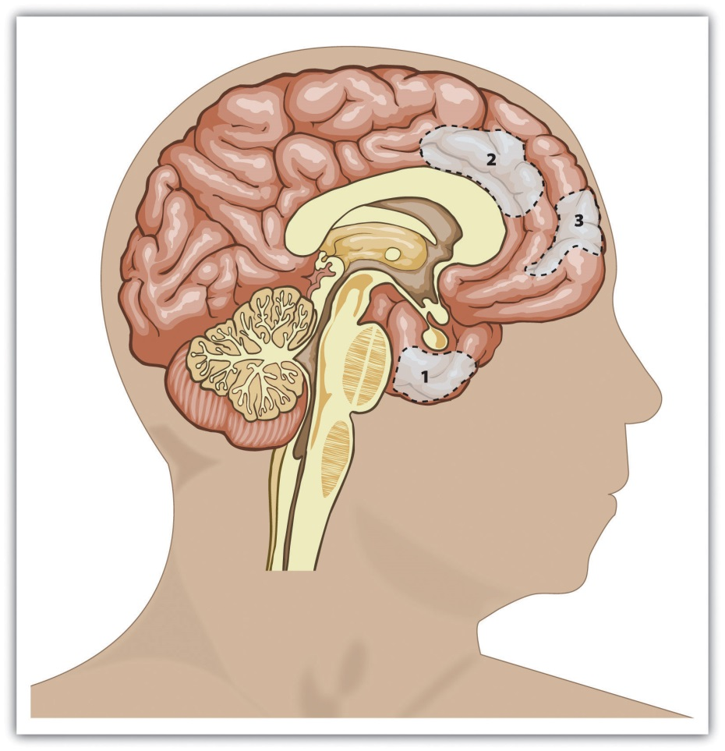
This figure shows the areas of the human brain that are known to be important in empathy and helping. They include the amygdala (area 1) and sections of the prefrontal cortex (areas 2 and 3). From Lieberman (2010). ^{[2]}
.
Helping is strongly influenced by affective variables. Indeed, the parts of the brain that are most involved in empathy, altruism, and helping are the amygdala and the prefrontal cortex, areas that are responsible for emotion and emotion regulation (Figure 9.1).

Kinship
Is the tendency to help others, at least in part, a basic feature of human nature? Evolutionary psychologists believe so. They argue that although helping others can be costly to us as individuals, altruism does have a clear benefit for the group as a whole. Remember that in an evolutionary sense the survival of the individual is less important than the survival of the individual’s genes (McAndrew, 2002). ^{[3]} Therefore, if a given behavior such as altruism enhances our reproductive success by helping the species as a whole survive and prosper, then that behavior is likely to increase fitness, be passed on to subsequent generations, and become part of human nature.
If we are altruistic in part to help us pass on our genes, then we should be particularly likely try to care for and to help our relatives. Research has found that we are indeed particularly helpful to our kin (Madsen et al., 2007; Stewart-Williams, 2007). ^{[4]}Burnstein, Crandall, and Kitayama (1994) ^{[5]} asked students in the United States and Japan to report how they would respond to a variety of situations in which someone needed help. The students indicated that in cases in which a person’s life was at stake and the helping involved a lot of effort, time, and danger, they would be more likely to help a person who was closely related to them (for instance, a sibling, parent, or child) than they would be to help a person who was more distantly related (for example, a niece, nephew, uncle, or grandmother). People are more likely to donate kidneys to relatives than to strangers (Borgida, Conner, & Manteufel, 1992), ^{[6]} and even children indicate that they are more likely to help their siblings than they are to help a friend (Tisak & Tisak, 1996). ^{[7]}
Table 9.1 "Percentage of Genetic Material Shared by the Members of Each Category"shows the average extent to which we share genes with some of the people we are genetically related to. According to evolutionary principles, this degree of genetic closeness should be positively correlated with the likelihood that we will help each of those people. Do you think that your own likelihood of helping each of the people listed corresponds to the degree to which you are genetically related to that person?

Table 9.1 Percentage of Genetic Material Shared by the Members of Each Category
Identical monozygotic twins | 100%
Parents, children, siblings, and fraternal (dizygotic) twins | 50%
Half-sibling, grandparent, and grandchild | 25%
Cousins, great-grandchildren, great-grandparents, great-aunts, great-uncles | 12.5%
Unrelated persons, such as a marital partner, brother-in-law or sister-in-law, adopted or step-sibling, friend, or acquaintance | 0%
*Source: Neyer and Lang (2003). ^{[8]}
Our reactions to others are influenced not only by our genetic relationship to them but also by their perceived similarity to us. We help friends more than we help strangers, we help members of our ingroups more than we help members of outgroups, and we help people who are more similar to us more generally (Dovidio et al., 1997; Krupp, DeBruine, & Barclay, 2008; Sturmer, Snyder, Kropp, & Siem, 2006). ^{[9]} It is quite possible that similarity is an important determinant of helping because we use it as a marker—although not a perfect one—that people share genes with us (Park & Schaller, 2005; Van Vugt & Van Lange, 2006). ^{[10]} Cialdini, Brown, Lewis, Luce, and Neuberg (1997) ^{[11]} have proposed that it is the sense of perceived similarity—the sense of ‘‘oneness’’ between the helper and the individual in need—that motivates most helping.

Reciprocity and Social Exchange
Although it seems logical that we would help people we are related to or those we perceive as similar to us, why would we ever help people to whom we are not related? One explanation for such behavior is based on the principle of reciprocal altruism (Trivers, 1971). ^{[12]} Reciprocal altruism is the idea that, if we help other people now, they will return the favor should we need their help in the future. By helping others, we both increase our chances of survival and reproductive success and help others increase their chances of survival too. Over the course of evolution, those who engage in reciprocal altruism should be able to reproduce more often than those who do not, thus enabling this kind of altruism to continue. Reciprocal altruism means that people even may help total strangers, based on the assumption that doing so is useful because it may lead others to help them in the future.
One fact that might help convince you that altruism is in fact evolutionarily adaptive is that many animals also engage in reciprocal altruism. Birds emit an alarm to nearby birds to warn them of a predator even at a potential cost to themselves. Dolphins may support sick or injured animals by swimming under them and pushing them to the surface so they can breathe. Male baboons threaten predators and guard the rear of the troop as it retreats. And even bats have a buddy system in which a bat that has had a successful night of feeding will regurgitate food for its less fortunate companion (Wilkinson, 1990). ^{[13]}
Altruism can even be found in low-level organisms, such as the cellular slime molds (Figure 9.2). Slime molds are groups of cells that live as individuals until they are threatened by a lack of food, at which point they come together and form a multicellular organism in which some of the cells sacrifice themselves to promote the survival of other cells in the organism. Altruism, then, is truly all around us.

Figure 9.2
Reciprocal altruism is one example of the general principle of social exchange. We frequently use each other to gain rewards and to help protect ourselves from harm, and helping is one type of benefit that we can provide to others. In some cases this exchange reflects overt cooperation, such as when two students take notes for each other in classes that they miss or when neighbors care for each other’s pets while one of them is away. In other cases the exchange may be more subtle and indirect, for instance, when we help someone we don’t really know, with the expectation that someone else may help us in return someday.

Social Reinforcement and Altruism: The Role of Rewards and Costs
Although there continues to be a lively debate within the social psychological literature about the relative contributions of each factor, it is clear that helping is both part of our basic human biological nature and also in part learned through our social experiences with other people (Batson, 2011). ^{[14]}
The principles of social learning suggest that people will be more likely to help when they receive rewards for doing so. Parents certainly realize this—children who share their toys with others are praised, whereas those who act more selfishly are reprimanded. And research has found that we are more likely to help attractive rather than unattractive people of the other sex (Farrelly, Lazarus, & Roberts, 2007) ^{[15]}—again probably because it is rewarding to do so.
Darley and Batson (1973) ^{[16]} demonstrated the effect of the costs of helping in a particularly striking way. They asked students in a religious seminary to prepare a speech for presentation to other students. According to random assignment to conditions, one half of the seminarians prepared a talk on the parable of the altruistic Good Samaritan; the other half prepared a talk on the jobs that seminary students like best. The expectation was that preparing a talk on the Good Samaritan would prime the concept of being helpful for these students.
After they had prepared their talks, the religion students were then asked to walk to a nearby building where the speech would be recorded. However, and again according to random assignment, the students were told that they had plenty of time to get to the recording session, that they were right on time, or that should hurry because they were already running late. On the way to the other building, the students all passed a person in apparent distress (actually research confederate) who was slumped in a doorway, coughing and groaning, and clearly in need of help. The dependent variable in the research was the degree of helping that each of the students gave to the person who was in need (Figure 9.3 "The Costs of Helping").
Darley and Batson found that the topic of the upcoming speech did not have a significant impact on helping. The students who had just prepared a speech about the importance of helping did not help significantly more than those who had not. Time pressure, however, made a difference. Of those who thought they had plenty of time, 63% offered help, compared to 45% of those who believed they were on time and only 10% of those who thought they were late. You can see that this is exactly what would be expected on the basis of the principles of social reinforcement—when we have more time to help, then helping is less costly and we are more likely to do it.

Figure 9.3 The Costs of Helping
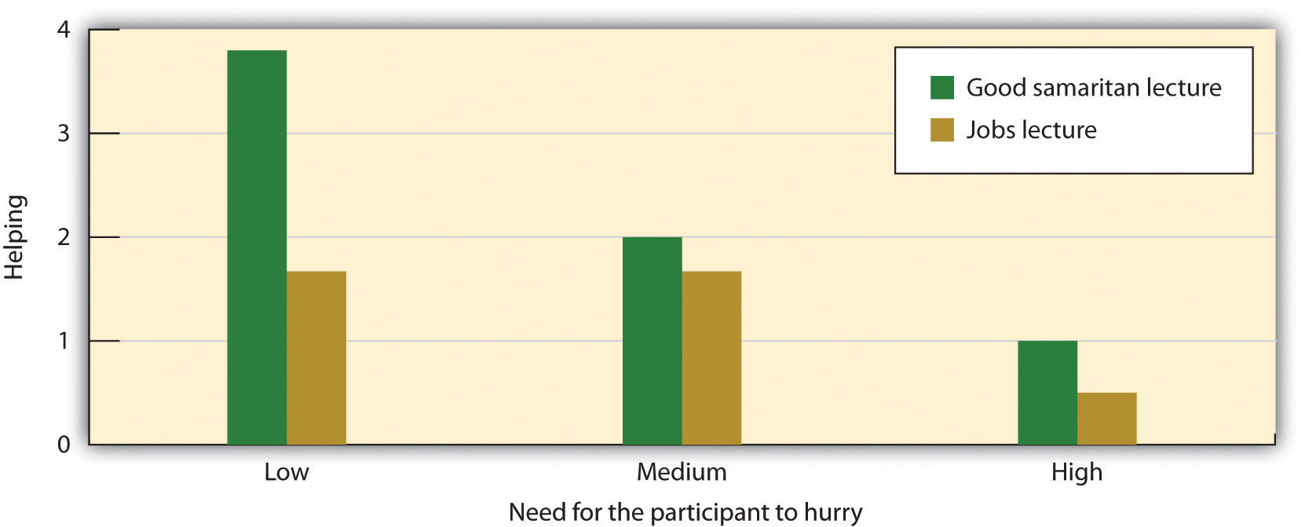
The seminary students in the research by Darley and Batson (1973) ^{[17]} were less likely to help a person in need when they were in a hurry than when they had more time, even when they were actively preparing a talk on the Good Samaritan. The dependent measure is a 5-point scale of helping, ranging from “failed to notice the victim at all” to “after stopping, refused to leave the victim or took him for help.”
Of course, not all helping is equally costly. The costs of helping are especially high when the situation is potentially dangerous or when the helping involves a long-term commitment to the person in need, such as when we decide to take care of a very ill person. Because helping strangers is particularly costly, some European countries have enacted Good Samaritan laws that increase the costs of not helping others. These laws require people, with the threat of a fine or other punishment if they do not, to provide or call for aid in an emergency if they can do so without endangering themselves in the process. Many countries and states also have passed “Angel of Mercy” laws that decrease the costs of helping and encourage people to intervene in emergencies by offering them protection from the law if their actions turn out not to be not helpful or even harmful. For instance, the current law in California states,
No person who in good faith, and not for compensation, renders emergency care at the scene of an emergency shall be liable for any civil damages resulting from any act or omission. The scene of an emergency shall not include emergency departments and other places where medical care is usually offered.
These policies are particularly applied to doctors and other medical professionals who are encouraged, or even required, to volunteer medical care when they happen upon emergencies.
In addition to learning through reinforcement, we are also likely to help more often when we model the helpful behavior of others (Bryan & Test, 1967). ^{[18]} In fact, although people frequently worry about the negative impact of the violence that is seen on TV, there is also a great deal of helping behavior shown on TV. Smith et al. (2006)^{[19]} found that 73% of TV shows had some altruism and that about three altruistic behaviors were shown every hour. Furthermore, the prevalence of altruism was particularly high in children’s shows.
Viewing positive role models provides ideas about ways to be helpful to others and gives us information about appropriate helping behaviors. Research has found a strong correlation between viewing helpful behavior on TV and helping. Hearold (1980) ^{[20]} concluded on the basis of a meta-analysis that watching altruism on TV had a larger effect on helping than viewing TV violence had on aggressive behavior. She encouraged public officials and parents to demand more TV shows with prosocial themes and positive role models. But just as viewing altruism can increase helping, modeling of behavior that is not altruistic can decrease altruism. Anderson and Bushman (2001) ^{[21]} found that playing violent video games led to a decrease in helping.
There are still other types of rewards that we gain from helping others. One is the status we gain as a result of helping. Altruistic behaviors serve as a type of signal about the altruist’s personal qualities. If good people are also helpful people, then helping implies something good about the helper. When we act altruistically, we gain a reputation as a person with high status who is able and willing to help others, and this status makes us better and more desirable in the eyes of others. Hardy and Van Vugt (2006) ^{[22]} found that both men and women were more likely to make cooperative rather than competitive choices in games that they played with others when their responses were public rather than private. Furthermore, when the participants made their cooperative choices in public, the participants who had been more cooperative were also judged by the other players as having higher social status than were the participants who had been less cooperative.
Finally, helpers are healthy! Research has found that people who help are happier and even live longer than those who are less helpful (Brown, Nesse, Vinokur, & Smith, 2003). ^{[23]}

Social Norms for Helping
The outcome of reinforcement for and modeling of helping is the development of social norms of morality—standards of behavior that we see as appropriate and desirable regarding helping (Eisenberg & Fabes, 1998). ^{[24]} One norm that we all are aware of and that we attempt to teach our children is based on the principles of equity and exchange. The reciprocity norm is a social norm reminding us that we should follow the principles of reciprocal altruism—if someone helps us, then we should help them in the future, and we should help people now with the expectation that they will help us later if we need it. The reciprocity norm is found in everyday adages like “Scratch my back and I’ll scratch yours” and in religious and philosophical teachings such as the golden rule: “Do unto others as you would have them do unto you.” The reciprocity norm forms the basis of human cooperation and is found in every culture. For instance, you can see a list of variations of the golden rule, as expressed in 21 different religions, at http://www.religioustolerance.org/reciproc.htm. Because the rule is normally followed, people generally do help others who have helped them (Whatley, webster, Smith, & Rhodes, 1999). ^{[25]}
Because helping following the reciprocity norm is based on the return of earlier help and the expectation of a future return from others, it might not seem so much like true altruism to you. But we might also hope that our children internalize another relevant social norm that seems more altruistic—the social responsibility norm. The social responsibility norm tells us that we should try to help others who need assistance, even without any expectation of future paybacks. The social responsibility norm involves a sense of duty and obligation, in which people are expected to respond to others by giving help to those in need. The teachings of many religions are based on the social responsibility norm that we should, as good human beings, reach out and help other people whenever we can.

Research Focus
Moral Hypocrisy
We have seen that the reciprocity norm teaches us that we should help others, with the expectation of a future return, and that the social responsibility norm teaches us that we should do the right thing by helping other people whenever we can, without the expectation of a payback. And most of us believe that we should be helpful to others. The problem is that these goals may not always be easy for us to follow because they represent a classic case in which one of the basic human motives (other-concern) conflicts with another basic human motive (self-concern). Trying to do the best thing for ourselves in the short term may lead us to take the selfish road—taking advantage of the benefits that others provide us without returning the favor. Furthermore, we may be particularly likely to act selfishly when we can get away with it. Perhaps you can remember a time when you did exactly that—you acted in a selfish way but attempted nevertheless to appear to others not to have done so.
Daniel Batson and his colleagues (Batson, Thompson, Seuferling, Whitney, & Strongman, 1999) ^{[26]} created a simple moral dilemma in the laboratory that pitted the desires of individual student research participants against the interests of other students. They compared what the students said they should do with what they actually did.
Each participant was told that there were two tasks being used in the research: In the positive task the participants would engage in an interesting task and have an opportunity to compete for a $30 prize, but in the neutral task the task was described as boring and there was no opportunity to win anything. The moral dilemma was created when the experimenter informed the student participants that there was another student who had supposedly come to the experiment at the same time, and that each student had to be assigned to one of the two tasks. Furthermore, it was the job of the student participant to determine who should get which task.
The students were told that they could make the decision however they wanted and that the other student would never know who had made the decision. And they were also given a coin that they could use to help them make the decision if they wanted to use it. The coin was clearly marked—on one side it said “SELF to POSITIVE” and on the other side it said “OTHER to POSITIVE.” The participants were then left alone in a room and asked to determine who should get the positive task and then to indicate what they thought the right decision should be.
In terms of what they thought they should do, Batson and his colleagues found that of the 40 students who participated in the experiment, 31 said that flipping the coin was the most morally right thing to do, 5 said assigning the other participant to the positive consequences task was the most morally right decision, and 4 said that there was no morally right way to assign the tasks. These results show that the students believed that being generous, or at least fair, was appropriate. This would suggest that most students would have flipped the coin and chosen whatever side came up.
It turned out that 12 of the participants decided not to flip the coin at all. Of these 12, 10 assigned themselves to the positive task and 2 gave the positive task to others. These students were clearly putting self-concern ahead of other-concern. But what about the 28 students who chose to flip the coin? They were clearly trying to do the “right” thing by being fair. By chance, we would have expected that about 14 of these 28 students would have assigned the other person to the positive task, because the coin would have come up “OTHER TO POSITIVE” about half of the time. But in fact only 4 actually did so; the other 24 took the positive task themselves, a significant difference from what would have been expected by chance if the participants had fairly used the actual results of the coin flip.
It appears that the students who flipped the coin wanted to be fair—they flipped the coin to see who would get the positive task. But in the end, they did not act on the principles of fairness when doing so conflicted with their self-interest. Rather, they tended to accept the results of the coin toss when it favored them but rejected it when it did not. Batson’s research makes clear the trade-offs that exist between helping ourselves and helping others. We know that helping is the right thing to do, but it hurts!

KEY TAKEAWAYS
- Altruism refers to any behavior that is designed to increase another person’s welfare, and particularly those actions that do not seem to provide a direct reward to the person who performs them.
- The tendency to help others is at least in part an evolutionary adaptation. We are particularly helpful to our kin and to people we perceive as being similar to us. We also help people who are not related or similar as the result of reciprocal altruism. By cooperating with others, we increase our and others’ chances of survival and reproductive success.
- We are more likely to help when we are rewarded and less likely when the perceived costs of helping are high.
- Social norms for helping include the reciprocity norm, which reminds us that we should follow the principles of reciprocal altruism, and the social responsibility norm, which tells us that we should try to help others who need assistance, even without any expectation of future payback.
- Helping frequently involves a trade-off between self-concern and other-concern. We want to help, but self-interest often keeps us from doing so.

EXERCISES AND CRITICAL THINKING
- Determine whether the following behaviors are, or are not, altruism. Consider your answer in terms of your ideas about altruism, but also consider the role of the person and the situation as well as the underlying human motivations of self-concern and other-concern.
  - Jill donates a pint of blood in exchange for 10 dollars.
  - Bill stops to help an attractive woman on the highway change a flat tire.
  - In 2007, the UK band Radiohead decided to buck the recording industry system and offer its new album “In Rainbows” directly to fans at whatever price they felt like paying. Although they could have downloaded the songs for free, thousands of people paid something anyway.
  - When Sherry renews her driver’s license, she checks off the box that indicates that she is willing to donate her organs to others when she dies.
  - Kim volunteers once a week at a local soup kitchen.
  - George is a Buddhist and believes that true self-understanding comes only from selflessly helping others.

[1] Batson, C. D. (2011). Altruism in humans. New York, NY: Oxford University Press; Dovidio, J. F., Piliavin, J. A., Schroeder, D. A., & Penner, L. (2006). The social psychology of prosocial behavior. Mahwah, NJ: Lawrence Erlbaum; Penner, L. A., Dovidio, J. F., Piliavin, J. A., & Schroeder, D. A. (2005). Prosocial behavior: Multilevel perspectives. Annual Review of Psychology, 56, 365–392.
[2] Lieberman, M. D. (2010). Social cognitive neuroscience. In S. T. Fiske, D. T. Gilbert, & G. Lindzey (Eds.), Handbook of social psychology (5th ed., Vol. 1, pp. 143–193). Hoboken, NJ: John Wiley & Sons.
[3] McAndrew, F. T. (2002). New evolutionary perspectives on altruism: Multilevel-selection and costly-signaling theories. Current Directions in Psychological Science, 11(2), 79–82.
[4] Madsen, E. A., Tunney, R. J., Fieldman, G., Plotkin, H. C., Dunbar, R. I. M., Richardson, J.-M., & McFarland, D. (2007). Kinship and altruism: A cross-cultural experimental study. British Journal of Psychology, 98(2), 339–359; Stewart-Williams, S. (2007). Altruism among kin vs. nonkin: Effects of cost of help and reciprocal exchange. Evolution and Human Behavior, 28(3), 193–198.
[5] Burnstein, E., Crandall, C., & Kitayama, S. (1994). Some neo-Darwinian decision rules for altruism: Weighing cues for inclusive fitness as a function of the biological importance of the decision. Journal of Personality and Social Psychology, 67(5), 773–789.
[6] Borgida, E., Conner, C., & Manteufel, L. (Eds.). (1992). Understanding living kidney donation: A behavioral decision-making perspective. Thousand Oaks, CA: Sage.
[7] Tisak, M. S., & Tisak, J. (1996). My sibling’s but not my friend’s keeper: Reasoning about responses to aggressive acts. Journal of Early Adolescence, 16(3), 324–339.
[8] Neyer, F. J., & Lang, F. R. (2003). Blood is thicker than water: Kinship orientation across adulthood. Journal of Personality and Social Psychology, 84(2), 310–321.
[9] Dovidio, J. F., Gaertner, S. L., Validzic, A., Matoka, K., Johnson, B., & Frazier, S. (1997). Extending the benefits of recategorization: Evaluations, self-disclosure, and helping. Journal of Experimental Social Psychology, 33(4), 401–420; Krupp, D. B., Debruine, L. M., & Barclay, P. (2008). A cue of kinship promotes cooperation for the public good. Evolution and Human Behavior, 29(1), 49–55; Sturmer, S., Snyder, M., Kropp, A., & Siem, B. (2006). Empathy-motivated helping: The moderating role of group membership. Personality and Social Psychology Bulletin, 32(7), 943–956.
[10] Park, J. H., & Schaller, M. (2005). Does attitude similarity serve as a heuristic cue for kinship? Evidence of an implicit cognitive association. Evolution and Human Behavior, 26(2), 158–170; Van Vugt, M., & Van Lange, P. A. M. (2006). Psychological adaptations for prosocial behavior: The altruism puzzle. In M. Schaller, J. Simpson, & D. Kenrick (Eds.), Evolution and social psychology (pp. 237–262). New York, NY: Psychology Press.
[11] Cialdini, R. B., Brown, S. L., Lewis, B. P., Luce, C., & Neuberg, S. L. (1997). Reinterpreting the empathy-altruism relationship: When one into one equals oneness. Journal of Personality and Social Psychology, 73(3), 481–494.
[12] Trivers, R. L. (1971). The evolution of reciprocal altruism. Quarterly Review of Biology, 46, 35–57.
[13] Wilkinson, G. S. (1990, February). Food sharing in vampire bats. Scientific American, 262, 76–82.
[14] Batson, C. D., Ahmad, N., & Stocks, E. L. (2011). Four forms of prosocial motivation: Egoism, altruism, collectivism, and principalism. In D. Dunning (Ed.), Social motivation. (pp. 103–126). New York, NY: Psychology Press.
[15] Farrelly, D., Lazarus, J., & Roberts, G. (2007). Altruists attract. Evolutionary Psychology, 5(2), 313–329.
[16] Darley, J. M., & Batson, C. D. (1973). “From Jerusalem to Jericho”: A study of situational and dispositional variables in helping behavior. Journal of Personality and Social Psychology, 27(1), 100–108.
[17] Darley, J. M., & Batson, C. D. (1973). “From Jerusalem to Jericho”: A study of situational and dispositional variables in helping behavior. Journal of Personality and Social Psychology, 27(1), 100–108.
[18] Bryan, J. H., & Test, M. A. (1967). Models and helping: Naturalistic studies in aiding behavior. Journal of Personality and Social Psychology, 6(4, Pt.1), 400–407.
[19] Smith, S. W., Smith, S. L., Pieper, K. M., Yoo, J. H., Ferris, A. L., Downs, E., & Bowden, B. (2006). Altruism on American television: Examining the amount of, and context surrounding, acts of helping and sharing. Journal of Communication, 56(4), 707–727.
[20] Hearold, S. L. (1980). Meta-analysis of the effects of television on social behavior.Dissertation Abstracts International, 40(8-B), 3902–3903.
[21] Anderson, C. A., & Bushman, B. J. (2001). Effects of violent video games on aggressive behavior, aggressive cognition, aggressive affect, physiological arousal, and prosocial behavior: A meta-analytic review of the scientific literature. Psychological Science, 12(5), 353–359.
[22] Hardy, C. L., & Van Vugt, M. (2006). Nice guys finish first: The competitive altruism hypothesis. Personality and Social Psychology Bulletin, 32(10), 1402–1413.
[23] Brown, S. L., Nesse, R. M., Vinokur, A. D., & Smith, D. M. (2003). Providing social support may be more beneficial than receiving it: Results from a prospective study of mortality.Psychological Science, 14(4), 320–327.
[24] Eisenberg, N., & Fabes, R. A. (Eds.). (1998). Prosocial development. Hoboken, NJ: John Wiley & Sons.
[25] Whatley, M. A., webster, J. M., Smith, R. H., & Rhodes, A. (1999). The effect of a favor on public and private compliance: How internalized is the norm of reciprocity? Basic and Applied Social Psychology, 21(3), 251–259.
[26] Batson, C. D., Thompson, E. R., Seuferling, G., Whitney, H., & Strongman, J. A. (1999). Moral hypocrisy: Appearing moral to oneself without being so. Journal of Personality and Social Psychology, 77(3), 525–537.

9.2 The Role of Affect: Moods and Emotions

LEARNING OBJECTIVES
- Summarize the effects of positive and negative moods on helping.
- Explain how the affective states of guilt, empathy, and personal distress influence helping.
Because our ability to successfully interact with other people is so important to our survival, these skills have become part of human nature. We determine whether to help in large part on the basis of how other people make us feel, and how we think we will feel if we help or do not help them.

Positive Moods Increase Helping
I do not need to tell you that people help more when they are in good mood. We ask our parents to use their car, and we ask our boss for a raise, when we think they are in a positive mood rather than a negative one. Positive moods have been shown to increase many types of helping behavior, including contributing to charity, donating blood, and helping coworkers (Isen, 1999). ^{[1]} It is also relatively easy to put people in a good mood. You might not be surprised to hear that people are more likely to help after they’ve done well on a test or just received a big bonus in their paycheck. But research has found that even more trivial things, such as finding a coin in a phone booth, listening to a comedy recording, having someone smile at you, or even smelling the pleasant scent of perfume is enough to put people in a good mood and to cause them to be helpful (Baron & Thomley, 1994; Gueguen & De Gail, 2003; Isen & Levin, 1972). ^{[2]}
In another study, van Baaren, Holland, Kawakami, and van Knippenberg (2004) ^{[3]}had students interact with an experimenter who either mimicked them by subtly copying their behaviors out of their awareness or did not mimic them. The researchers found that people who had been mimicked were more likely to help, by picking up pens that had fallen on the floor and by donating to a charity. It seems quite possible that this effect is due to the influence of positive moods on helping—we like people we see as similar to us and that puts us in a good mood, making us more likely to help. In sum, the influence of mood on helping is substantial (Carlson, Charlin, & Miller, 1988), ^{[4]} so if you’re looking for help, ask on a nice day, subtly mimic the person’s behaviors, or prepare some good jokes.
But why does being in a good mood make us helpful? There are probably several reasons. For one, positive mood indicates that the environment is not dangerous and therefore that we can safely help others. Second, we like other people more when we are in good moods, and that may lead us to help them. Finally, and perhaps most important, is the possibility the helping makes us feel good about ourselves, thereby maintaining our positive mood. In fact, people who are in good moods are particularly likely to help when the help that they are going to give seems likely to maintain their positive mood. But if they think that the helping is going spoil their good mood, even people in good moods are likely to refuse to help (Erber & Markunas, 2006). ^{[5]}

Relieving Negative Emotions: Guilt Increases Helping
Although positive moods can increase helping, negative emotions can do so too. The idea is that if helping can reduce negative feelings we are experiencing, then we may help in order to get rid of those bad feelings (Cialdini, Darby, & Vincent, 1973). ^{[6]} One emotion that is particularly important in this regard is guilt. We feel guilt when we think that we (or others we feel close to) may have caused harm to another person (Tangney, 2003). ^{[7]} The experience of guilt increases our desire to create positive relationships with other people. Because we hate to feel guilty, we will go out of our way to reduce any feelings of guilt that we may be experiencing. And one way to relieve our guilt is by helping. Put simply, feelings of guilt lead us to try to make up for our transgressions in any way possible, including by helping others.
In research by Dennis Regan and his colleagues (Regan, Williams, & Sparling, 1972),^{[8]} students were led to believe that they had broken another person’s camera, which in turn made them feel guilty. Then another person presented a need for help. The students who were feeling guilty were more likely to help the second person than were those who were not feeling guilty. Thus participants who unintentionally harmed one person ended up being more helpful to another person who had nothing to do with the original source of the guilt. This situation illustrates the function of guilt: We feel guilty when we think we have harmed our relationships with others, and the guilt reminds us that we need to work to repair these transgressions (Baumeister, Stillwell, & Heatherton, 1994). ^{[9]}
Advertisers may try to invoke guilt to get people to contribute to charitable causes. This approach is particularly effective when people feel that they are able to engage in the necessary helping (Basil, Ridgway, & Basil, 2008). ^{[10]}
But what about other emotions, such as sadness, anger, and fear? It turns out that we also may be more likely to help when we are fearful or sad—again to make ourselves feel better. Jonas, Schimel, Greenberg, and Pyszczynski (2002) ^{[11]} found that people who were induced to think about their own death—for instance, when they were interviewed in front of a funeral home—became more altruistic.

Personal Distress and Empathy as Determinants of Helping
Imagine that you arrive upon the scene of a car accident that has just occurred. The driver of the car has been thrown out on the highway and is seriously injured. He is bleeding, has many broken bones, and may be near death. Other cars are just driving by the scene, but you could easily pull over to help. Would you be likely to just drive by, or would you stop to help?
The negative emotions that we may experience when we are perceiving another person’s distress have a big influence on our helping. In some cases people feel rather sickened or disgusted by the victim of an emergency—for instance, when the person is seriously injured and bleeding. Personal distress refers to the negative emotions that we may experience when we view another person’s suffering. Because we feel so uncomfortable, when we feel personal distress we may simply leave the scene rather than stopping.
In other cases we may not feel so many negative emotions upon viewing another person in need but rather more positive feelings of a close connection with the person who is suffering. When we really experience the pain and the needs of the other person, we say that we are feeling empathy for the other. Empathy refers to an affective response in which a person understands, and even feels, another person’s distress and experiences events the way the other person does. Empathy seems to be a biological aspect of human nature—an emotion that is an integral part of being human—and that is designed to help us help. Empathy allows us to quickly and automatically perceive and understand the emotional states of others and to regulate our behavior toward others in coordinated and cooperative ways (de Waal, 2008). ^{[12]}Empathy may also create other emotions, such as sympathy, compassion, and tenderness. You can well imagine that we are more likely to help someone when we are feeling empathy for them—in this case we want to comfort and help the victim of the car accident.

Research Focus
Personal Distress Versus Empathy as Determinants of Helping
We have seen that people may feel either positive or negative emotions when they see someone who needs help. They may help others in part for selfish reasons—for instance, to relieve their own negative feelings about the suffering of the other—and in part for truly altruistic reasons—because they are experiencing empathy for the distress of the other person. But which type of emotion leads us to help in which situations? Daniel Batson and his colleagues (Batson, O’Quin, Fultz, Varnderplas, & Isen, 1983, Study 2) ^{[13]} attempted answer this question by finding out if the ability to easily leave the scene of the suffering might matter.
In the study, male and female college students watched another person of the same sex who they thought was working on series of tasks in the next room (the person was actually on a prerecorded videotape, although the participants did not know that). The women were told the person was named Elaine, and the men were told the person was named Charlie. During the time the students were watching, and as part of the experiment, the other person also supposedly received some mild electric shocks.
The students who were observing were randomly assigned to one of two experimental conditions. The students who were in the easy-escape condition were told that although the other person would be completing 10 shock trials, they only needed to watch the first two, after which they could leave. The students in the difficult-escape condition, however, were told that they would need to watch all 10 of the shock trials.
During the second trial, the person in other room began to look as if he or she was experiencing some discomfort. As the participants looked on, the assistant administering the shocks to the person asked whether he or she was all right, and the person hesitantly said yes but also asked for a glass of water before going on.
During this break, the experimenter entered the observation room and gave the research participant a questionnaire. The questionnaire asked the participant to indicate the feelings he or she was experiencing at the moment, and the responses to these questions allowed the experimenters to determine whether the person was feeling more personal distress (if they indicated that they were primarily feeling alarmed, grieved, upset, worried, disturbed, distressed, troubled, or perturbed) or more empathy (if they indicated that they were primarily feeling sympathetic, moved, compassionate, warm, softhearted, or tender).
Then, the experimenter pointed out to the research participant that the other person was feeling uncomfortable and asked if he or she might be willing to change places with that person. The dependent measure in the research was the average number of trials that the participant agreed to take for Elaine or Charlie.
As you can see in the following figure, Batson and the team found a person-situation interaction effect, such that when the participants knew that they could leave relatively quickly (the easy-escape condition), then the people who were feeling empathy helped, whereas those who were feeling distress did not. This makes sense because empathy involves a real concern for other person—a concern that could not be reduced even by leaving the scene. On other hand, when the participants knew that they were going to have to view all the trials (the difficult-escape condition), the participants who felt distress were more likely to help than were those who were feeling empathy. Batson and his colleagues interpreted this to mean that these people helped to avoid having to feel the negative emotion of personal distress which they were certain to experience as they continued to watch the other person suffer the shocks.

Figure 9.4
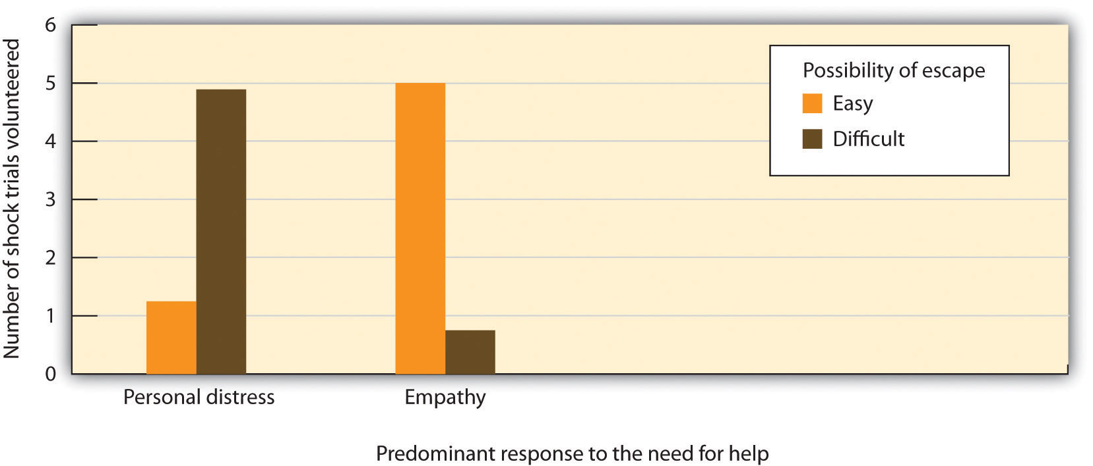
This figure shows the mean number of shock trials participants in each condition agreed to take for Elaine or Charlie. Data are from Batson et al. (1983), Study 2.
In subsequent research, Batson and his colleagues have tested this same hypothesis in other ways, such as by having the experimenter or the person in need of help appeal to the participants either to remain objective and “not get caught up” in what the person in need is experiencing (low empathy) or to try to imagine what the person in need is feeling (high empathy). In many experiments, they have found that when empathy is high, most people help regardless of whether or not they can easily escape the situation. On other hand, people who feel primarily distress tend to help only if they cannot avoid the negative affect they are experiencing by leaving the scene of the person in need.
Although help that occurs as a result of experiencing empathy for the other seems to be truly altruistic, it is difficult even in this case to be to be sure. There is ample evidence that we do help to make those that we help feel better, but there is just as much evidence that we help in order to feel good about ourselves. Even when we are feeling empathy, we may help in part because we know that we will feel sad or guilty if we do not help (Schaller & Cialdini, 1988). ^{[14]} Thus the distinction between an egoistic, self-concerned motive and an altruistic, other-concerned motive is not always completely clear; we help for both reasons.
In the end, we cannot completely rule out the possibility that people help in large part for selfish reasons. But does it really matter? If we give money to the needy because we will feel badly about ourselves if we do not, or if we give money to the needy because we want them to feel good, we have nevertheless made the contribution in both cases.

KEY TAKEAWAYS
- We react to people in large part on the basis of how they make us feel and how we think we will feel if we help them.
- Positive mood states increase helping, and negative affective states, particularly guilt, reduce it.
- Personal distress refers to the negative feelings and emotions that we may experience when we view another person’s distress.
- Empathy refers to an affective response in which the person understands, and even feels, the other person’s emotional distress, and when he or she experiences events the way the other person does.

EXERCISES AND CRITICAL THINKING
- Think about the times that you have considered helping other people or were actually helping them. What emotions did you feel while you were helping?
- Consider a time when you helped out of guilt, out of personal distress, or out of empathy.

[1] Isen, A. M. (Ed.). (1999). Positive affect. New York, NY: John Wiley & Sons.
[2] Baron, R. A., & Thomley, J. (1994). A whiff of reality: Positive affect as a potential mediator of the effects of pleasant fragrances on task performance and helping. Environment and Behavior, 26(6), 766–784; Gueguen, N., & De Gail, M.-A. (2003). The effect of smiling on helping behavior: Smiling and Good Samaritan behavior. Communication Reports, 16(2), 133–140; Isen, A. M., & Levin, P. F. (1972). Effect of feeling good on helping: Cookies and kindness.Journal of Personality and Social Psychology, 21, 384–388.
[3] van Baaren, R. B., Holland, R. W., Kawakami, K., & van Knippenberg, A. (2004). Mimicry and prosocial behavior. Psychological Science, 15(1), 71–74.
[4] Carlson, M., Charlin, V., & Miller, N. (1988). Positive mood and helping behavior: A test of six hypotheses. Journal of Personality and Social Psychology, 55(2), 211–229.
[5] Erber, R., & Markunas, S. (Eds.). (2006). Managing affective states. New York, NY: Psychology Press.
[6] Cialdini, R. B., Darby, B. L., & Vincent, J. E. (1973). Transgression and altruism: A case for hedonism. Journal of Experimental Social Psychology, 9(6), 502–516.
[7] Tangney, J. P. (Ed.). (2003). Self-relevant emotions. New York, NY: Guilford Press.
[8] Regan, D. T., Williams, M., & Sparling, S. (1972). Voluntary expiation of guilt: A field experiment. Journal of Personality and Social Psychology, 24(1), 42–45.
[9] Baumeister, R. F., Stillwell, A. M., & Heatherton, T. F. (1994). Guilt: An interpersonal approach. Psychological Bulletin, 115(2), 243–267.
[10] Basil, D. Z., Ridgway, N. M., & Basil, M. D. (2008). Guilt and giving: A process model of empathy and efficacy. Psychology and Marketing, 25(1), 1–23.
[11] Jonas, E., Schimel, J., Greenberg, J., & Pyszczynski, T. (2002). The Scrooge effect: Evidence that mortality salience increases prosocial attitudes and behavior. Personality and Social Psychology Bulletin, 28(10), 1342–1353.
[12] de Waal, F. B. M. (2008). Putting the altruism back into altruism: The evolution of empathy. Annual Review of Psychology, 59, 279–300.
[13] Batson, C. D., O’Quin, K., Fultz, J., Varnderplas, M., & Isen, A. M. (1983). Influence of self-reported distress and empathy on egoistic versus altruistic motivation to help. Journal of Personality and Social Psychology, 45(3), 706–718.
[14] Schaller, M., & Cialdini, R. B. (1988). The economics of empathic helping: Support for a mood management motive. Journal of Experimental Social Psychology, 24(2), 163–181.

9.3 How the Social Context Influences Helping

LEARNING OBJECTIVE
- Review Bibb Latané and John Darley’s model of helping behavior and indicate the social psychological variables that influence each stage.
Although emotional responses such as guilt, personal distress, and empathy are important determinants of altruism, it is the social situation itself—the people around us when we are deciding whether or not to help—that has perhaps the most important influence on whether and when we help.
Consider the unusual case of the killing of 28-year-old Katherine “Kitty” Genovese in New York City at about 3:00 a.m. on March 13, 1964. Her attacker, Winston Moseley, stabbed and sexually assaulted her within a few yards of her apartment building in the borough of Queens. During the struggle with her assailant, Kitty screamed, “Oh my God! He stabbed me! Please help me!” But no one responded. The struggle continued; Kitty broke free from Moseley, but he caught her again, stabbed her several more times, and eventually killed her.
The murder of Kitty Genovese shocked the nation, in large part because of the (often inaccurate) reporting of it. Stories about the killing, in the New York Times and other papers, indicated that as many as 38 people had overheard the struggle and killing, that none of them had bothered to intervene, and that only one person had even called the police, long after Genovese was dead.
Although these stories about the lack of concern by people in New York City proved to be false (Manning, Levine, & Collins, 2007), ^{[1]} they nevertheless led many people to think about the variables that might lead people to help or, alternatively, to be insensitive to the needs of others. Was this an instance of the uncaring and selfish nature of human beings? Or was there something about this particular social situation that was critical? It turns out, contrary to your expectations I would imagine, that having many people around during an emergency can in fact be the opposite of helpful—it can reduce the likelihood that anyone at all will help.

Latané and Darley’s Model of Helping
Two social psychologists, Bibb Latané and John Darley, found themselves particularly interested in, and concerned about, the Kitty Genovese case. As they thought about the stories that they had read about it, they considered the nature of emergency situations, such as this one. They realized that emergencies are unusual and that people frequently do not really know what to do when they encounter one. Furthermore, emergencies are potentially dangerous to the helper, and it is therefore probably pretty amazing that anyone helps at all.

Figure 9.5 Latané and Darley’s Stages of Helping
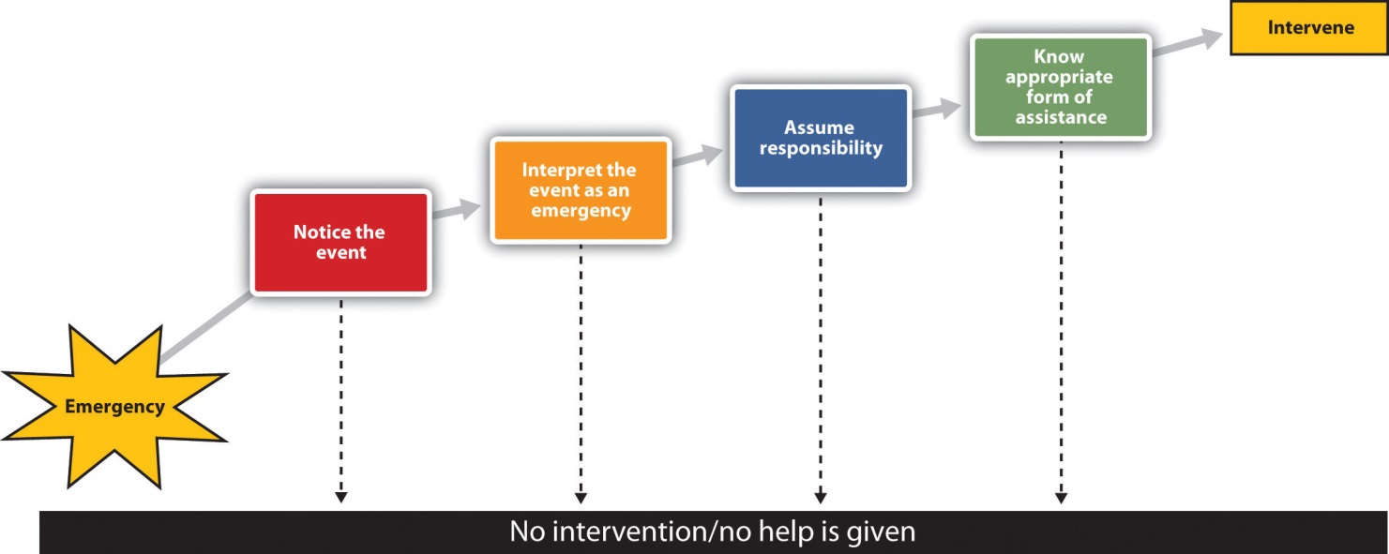
To better understand the processes of helping in an emergency, Latané and Darley developed a model of helping that took into consideration the important role of the social situation. Their model, which is shown in , has been extensively tested in many studies, and there is substantial support for it.

Noticing
Latané and Darley thought that the first thing that had to happen in order for people to help is that they had to notice the emergency. This seems pretty obvious, but it turns out that the social situation has a big impact on noticing an emergency. Consider, for instance, people who live in a large city such as New York City, Bangkok, or Beijing. These cities are big, noisy, and crowded—it seems like there are a million things going at once. How could people living in such a city even notice, let alone respond to, the needs of all the people around them? They are simply too overloaded by the stimuli in the city (Milgram, 1970). ^{[2]}
Many studies have found that people who live in smaller and less dense rural towns are more likely to help than those who live in large, crowded, urban cities (Amato, 1983; Levine, Martinez, Brase, & Sorenson, 1994). ^{[3]} Although there are a lot of reasons for such differences, just noticing the emergency is critical. When there are more people around, it is less likely that the people notice the needs of others.
You may have had an experience that demonstrates the influence of the social situation on noticing. Imagine that you have lived with a family or a roommate for a while, but one night you find yourself alone in your house or apartment because your housemates are staying somewhere else that night. If you are like me, I bet you found yourself hearing sounds that you never heard before—and they might have made you pretty nervous. Of course the sounds were always there, but when other people were around you, you were simply less alert to them. The presence of others can divert our attention from the environment—it’s as if we are unconsciously, and probably quite mistakenly, counting on the others to take care of things for us.
Latané and Darley (1968) ^{[4]} wondered if they could examine this phenomenon experimentally. To do so, they simply asked their research participants to complete a questionnaire in a small room. Some of the participants completed the questionnaire alone, while others completed the questionnaire in small groups in which two other participants were also working on questionnaires.
A few minutes after the participants had begun the questionnaires, the experimenters started to release some white smoke into the room through a vent in the wall while they watched through a one-way mirror. The smoke got thicker as time went on, until it filled the room. The experimenters timed how long it took before the first person in the room looked up and noticed the smoke. The people who were working alone noticed the smoke in about 5 seconds, and within 4 minutes most of the participants who were working alone had taken some action. But what about the participants working in groups of three? Although we would certainly expect that having more people around would increase the likelihood that someone would notice the smoke, on average, the first person in the group conditions did not notice the smoke until over 20 seconds had elapsed. And although 75% of the participants who were working alone reported the smoke within 4 minutes, the smoke was reported in only 12% of the three-person groups by that time. In fact, in only three of the eight three-person groups did anyone report the smoke at all, even after it had entirely filled the room!

Interpreting
Even if we notice an emergency, we might not interpret it as one. The problem is that events are frequently ambiguous, and we must interpret them to understand what they really mean. Furthermore, we often don’t see the whole event unfolding, so it is difficult to get a good handle on it. Is a man holding an iPod and running away from a group of pursuers a criminal who needs to be apprehended, or is this just a harmless prank? Were the cries of Kitty Genovese really calls for help, or were they simply an argument with a boyfriend? It’s hard for us to tell when we haven’t seen the whole event (Piliavin, Piliavin, & Broll, 1976). ^{[5]} Moreover, because emergencies are rare and because we generally tend to assume that events are benign, we may be likely to treat ambiguous cases as not being emergencies.
The problem is compounded when others are present because when we are unsure how to interpret events we normally look to others to help us understand them (this is informational social influence). However, the people we are looking toward for understanding are themselves unsure how to interpret the situation, and they are looking to us for information at the same time we are looking to them.
When we look to others for information we may assume that they know something that we do not know. This is often a mistake, because all the people in the situation are doing the same thing. None of us really know what to think, but at the same time we assume that the others do know. Pluralistic ignorance occurs when people think that others in their environment have information that they do not have and when they base their judgments on what they think the others are thinking.
Pluralistic ignorance seems to have been occurring in Latané and Darley’s studies, because even when the smoke became really heavy in the room, many people in the group conditions did not react to it. Rather, they looked at each other, and because nobody else in the room seemed very concerned, they each assumed that the others thought that everything was all right. You can see the problem—each bystander thinks that other people aren’t acting because they don’t see an emergency. Of course, everyone is confused, but believing that the others know something that they don’t, each observer concludes that help is not required.
Pluralistic ignorance is not restricted to emergency situations (Miller, Turnbull, & McFarland, 1988; Suls & Green, 2003). ^{[6]} Maybe you have had the following experience: You are in one of your classes and the instructor has just finished a complicated explanation. He is unsure whether the students are up to speed and asks, “Are there any questions?” All the class members are of course completely confused, but when they look at each other, nobody raises a hand in response. So everybody in the class (including the instructor) assumes that everyone understands the topic perfectly. This is pluralistic ignorance at its worst—we are all assuming that others know something that we don’t, and so we don’t act. The moral to instructors in this situation is clear: Wait until at least one student asks a question. The moral for students is also clear: Ask your question! Don’t think that you will look stupid for doing so—the other students will probably thank you.

Taking Responsibility
Even if we have noticed the emergency and interpret it as being one, this does not necessarily mean that we will come to the rescue of the other person. We still need to decide that it is our responsibility to do something. The problem is that when we see others around, it is easy to assume that they are going to do something and that we don’t need to do anything. Diffusion of responsibility occurs when we assume that others will take action and therefore we do not take action ourselves. The irony of course is that people are more likely to help when they are the only ones in the situation than they are when there are others around.
Darley and Latané (1968) ^{[7]} had study participants work on a communication task in which they were sharing ideas about how to best adjust to college life with other people in different rooms using an intercom. According to random assignment to conditions, each participant believed that he or she was communicating with either one, two, or five other people, who were in either one, two, or five other rooms. Each participant had an initial chance to give his opinions over the intercom, and on the first round one of the other people (actually a confederate of the experimenter) indicated that he had an “epileptic-like” condition that had made the adjustment process very difficult for him. After a few minutes, the subject heard the experimental confederate say,
I-er-um-I think I-I need-er-if-if could-er-er-somebody er-er-er-er-er-er-er give me a liltle-er-give me a little help here because-er-I-er-I’m-er-er having a-a-a real problcm-er-right now and I-er-if somebody could help me out it would-it would-er-er s-s-sure be-sure be good…because there-er-er-a cause I-er-I-uh-I’ve got a-a one of the-er-sei er-er-things coming on and-and-and I could really-er-use some help so if somebody would-er-give me a little h-help-uh-er-er-er-er-er c-could somebody-er-er-help-er-uh-uh-uh (choking sounds).…I’m gonna die-er-er-I’m…gonna die-er-help-er-er-seizure-er- (chokes, then quiet). (Darley & Latané, 1968, p. 379) ^{[8]}
As you can see in , the participants who thought that they were the only ones who knew about the emergency (because they were only working with one other person) left the room quickly to try to get help. In the larger groups, however, participants were less likely to intervene and slower to respond when they did. Only 31% of the participants in the largest groups responded by the end of the 6-minute session.
You can see that the social situation has a powerful influence on helping. We simply don’t help as much when other people are with us.

Table 9.2 Effects of Group Size on Likelihood and Speed of Helping
Group size | Average helping (%) | Average time to help (in seconds)
2 (Participant and victim) | 85 | 52
3 (Participant, victim, and 1 other) | 62 | 93
6 (Participant, victim, and 4 others) | 31 | 166
*Source: Darley and Latané (1968). ^{[9]}
Perhaps you have noticed diffusion of responsibility if you have participated in an Internet users group where people asked questions of the other users. Did you find that it was easier to get help if you directed your request to a smaller set of users than when you directed it to a larger number of people? Consider the following: In 1998, Larry Froistad, a 29-year-old computer programmer, sent the following message to the members of an Internet self-help group that had about 200 members. “Amanda I murdered because her mother stood between us…when she was asleep, I got wickedly drunk, set the house on fire, went to bed, listened to her scream twice, climbed out the window and set about putting on a show of shock and surprise.” Despite this clear online confession to a murder, only three of the 200 newsgroup members reported the confession to the authorities (Markey, 2000). ^{[10]}
To study the possibility that this lack of response was due to the presence of others, the researchers (Markey, 2000) ^{[11]} conducted a field study in which they observed about 5,000 participants in about 400 different chat groups. The experimenters sent a message to the group, from either a male (JakeHarmen) or female (SuzyHarmen) screen name. Help was sought by either asking all the participants in the chat group, “Can anyone tell me how to look at someone’s profile?” or by randomly selecting one participant and asking “[name of selected participant], can you tell me how to look at someone’s profile?” The experimenters recorded the number of people present in the chat room, which ranged from 2 to 19, and then waited to see how long it took before a response was given.
It turned out that the gender of the person requesting help made no difference, but that addressing to a single person did. Assistance was received more quickly when help was asked for by specifying a participant’s name (in only about 37 seconds) than when no name was specified (51 seconds). Furthermore, a correlational analysis found that when help was requested without specifying a participant’s name, there was a significant negative correlation between the number of people currently logged on in the group and the time it took to respond to the request.
Garcia, Weaver, Moskowitz, and Darley (2002) ^{[12]} found that the presence of others can promote diffusion of responsibility even if those other people are only imagined. In these studies the researchers had participants read one of three possible scenarios that manipulated whether participants thought about dining out with 10 friends at a restaurant (group condition) or whether they thought about dining at a restaurant with only one other friend (one-person condition). Participants in the group condition were asked to “Imagine you won a dinner for yourself and 10 of your friends at your favorite restaurant.” Participants in the one-person condition were asked to “Imagine you won a dinner for yourself and a friend at your favorite restaurant.”
After reading one of the scenarios, the participants were then asked to help with another experiment supposedly being conducted in another room. Specifically, they were asked: “How much time are you willing to spend on this other experiment?” At this point, participants checked off one of the following minute intervals: 0 minutes, 2 minutes, 5 minutes, 10 minutes, 15 minutes, 20 minutes, 25 minutes, and 30 minutes.

Figure 9.6 Helping as a Function of Imagined Social Context
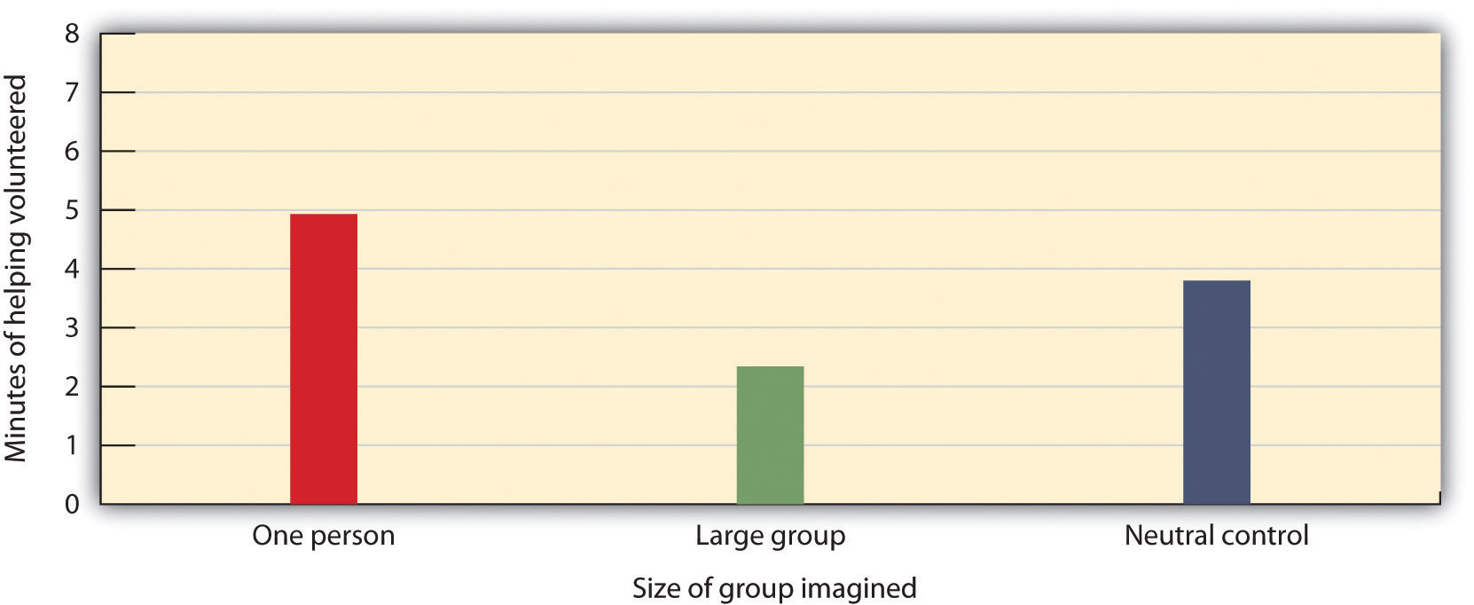
Garcia et al. (2002) ^{[13]} found that the presence of others reduced helping, even when those others were only imagined.
As you can see in , simply imagining that they were in a group or alone had a significant effect on helping, such that those who imagined being with only one other person volunteered to help for more minutes than did those who imagined being in a larger group.

Implementing Action
The fourth step in the helping model is knowing how to help. Of course, for many of us the ways to best help another person in an emergency are not that clear; we are not professionals and we have little training in how to help in emergencies. People who do have training in how to act in emergencies are more likely to help, whereas the rest of us just don’t know what to do and therefore may simply walk by. On the other hand, today most people have cell phones, and we can do a lot with a quick call. In fact, a phone call made in time might have saved Kitty Genovese’s life. The moral: You might not know exactly what to do, but you may well be able to contact someone else who does.
Latané and Darley’s decision model of bystander intervention has represented an important theoretical framework for helping us understand the role of situational variables on helping. Whether or not we help depends on the outcomes of a series of decisions that involve noticing the event, interpreting the situation as one requiring assistance, deciding to take personal responsibility, and deciding how to help.
Fischer et al. (2011) ^{[14]} recently analyzed data from over 105 studies using over 7,500 participants who had been observed helping (or not helping) in situations in which they were alone or with others. They found significant support for the idea that people helped more when fewer others were present. And supporting the important role of interpretation, they also found that the differences were smaller when the need for helping was clear and dangerous and thus required little interpretation. They also found that there were at least some situations (such as when bystanders were able to help provide needed physical assistance) in which having other people around increased helping.
Although the Latané and Darley model was initially developed to understand how people respond in emergencies requiring immediate assistance, aspects of the model have been successfully applied to many other situations, ranging from preventing someone from driving drunk to making a decision about whether to donate a kidney to a relative (Schroeder, Penner, Dovidio, & Piliavin, 1995). ^{[15]}

KEY TAKEAWAYS
- The social situation has an important influence on whether or not we help.
- Latané and Darley’s decision model of bystander intervention has represented an important theoretical framework for helping us understand the role of situational variables on helping. According to the model, whether or not we help depends on the outcomes of a series of decisions that involve noticing the event, interpreting the situation as one requiring assistance, deciding to take personal responsibility, and implementing action.
- Latané and Darley’s model has received substantial empirical support and has been applied not only to helping in emergencies but to other helping situations as well.

EXERCISES AND CRITICAL THINKING
- Analyze the Kitty Genovese incident in terms of the Latané and Darley model of helping. Which factors do you think were most important in preventing helping?
- Recount a situation in which you did or did not help, and consider how that decision might have been influenced by the variables specified in Latané and Darley’s model.

[1] Manning, R., Levine, M., & Collins, A. (2007). The Kitty Genovese murder and the social psychology of helping: The parable of the 38 witnesses. American Psychologist, 62(6), 555–562.
[2] Milgram, S. (1970). The experience of living in cities. Science, 167(3924), 1461–1468.
[3] Amato, P. R. (1983). The helpfulness of urbanites and small town dwellers: A test between two broad theoretical positions. Australian Journal of Psychology, 35(2), 233–243; Levine, R. V., Martinez, T. S., Brase, G., & Sorenson, K. (1994). Helping in 36 U.S. cities. Journal of Personality and Social Psychology, 67(1), 69–82.
[4] Latané, B., & Darley, J. M. (1968). Group inhibition of bystander intervention in emergencies. Journal of Personality and Social Psychology, 10(3), 215–221.
[5] Piliavin, J. A., Piliavin, I. M., & Broll, L. (1976). Time of arrival at an emergency and likelihood of helping. Personality and Social Psychology Bulletin, 2(3), 273–276.
[6] Miller, D. T., Turnbull, W., & McFarland, C. (1988). Particularistic and universalistic evaluation in the social comparison process. Journal of Personality and Social Psychology, 55, 908–917; Suls, J., & Green, P. (2003). Pluralistic ignorance and college student perceptions of gender-specific alcohol norms. Health Psychology, 22(5), 479–486.
[7] Darley, J. M., & Latané, B. (1968). Bystander intervention in emergencies: Diffusion of responsibility. Journal of Personality and Social Psychology, 8(4, Pt.1), 377–383.
[8] Darley, J. M., & Latané, B. (1968). Bystander intervention in emergencies: Diffusion of responsibility. Journal of Personality and Social Psychology, 8(4, Pt.1), 377–383.
[9] Darley, J. M., & Latané, B. (1968). Bystander intervention in emergencies: Diffusion of responsibility. Journal of Personality and Social Psychology, 8(4, Pt.1), 377–383.
[10] Markey, P. M. (2000). Bystander intervention in computer-mediated communication.Computers in Human Behavior, 16(2), 183–188.
[11] Markey, P. M. (2000). Bystander intervention in computer-mediated communication.Computers in Human Behavior, 16(2), 183–188.
[12] Garcia, S. M., Weaver, K., Moskowitz, G. B., & Darley, J. M. (2002). Crowded minds: The implicit bystander effect. Journal of Personality and Social Psychology, 83(4), 843–853.
[13] Garcia, S. M., Weaver, K., Moskowitz, G. B., & Darley, J. M. (2002). Crowded minds: The implicit bystander effect. Journal of Personality and Social Psychology, 83(4), 843–853.
[14] Fischer, P., Krueger, J. I., Greitemeyer, T., Vogrincic, C., Kastenmüller, A., Frey, D.,…Kainbacher, M. (2011). The bystander-effect: A meta-analytic review on bystander intervention in dangerous and non-dangerous emergencies. Psychological Bulletin, 137(4), 517–537.
[15] Schroeder, D. A., Penner, L. A., Dovidio, J. F., & Piliavin, J. A. (1995). The psychology of helping and altruism: Problems and puzzles. New York, NY: McGraw-Hill.

9.4 Other Determinants of Helping

LEARNING OBJECTIVES
- Review the person, gender, and cultural variables that relate to altruism.
- Explain how the reactions of the person being helped may influence the benefits of helping.
- Outline the ways that we might be able to increase helping.
Although we have discussed many of the most important factors, there are still other variables that determine our willingness to help others. These include characteristics of the people who are potentially providing help as well as the ways that others respond to the help they may receive. Let us consider them now.

Some People Are More Helpful Than Others: The Altruistic Personality
We have seen that the social situation is a very strong determinant of whether or not we help. But although the effects of personality may not generally be as strong as those of the social context, person variables do matter. Some people are indeed more helpful than others across a variety of situations, and we say that these people have analtruistic or prosocial personality (Penner, Fritzsche, Craiger, & Freifeld, 1995).^{[1]} Try answering the questions posed in Figure 9.7 "Measuring the Altruistic Personality" to see how you stand on this variable.

Figure 9.7 Measuring the Altruistic Personality
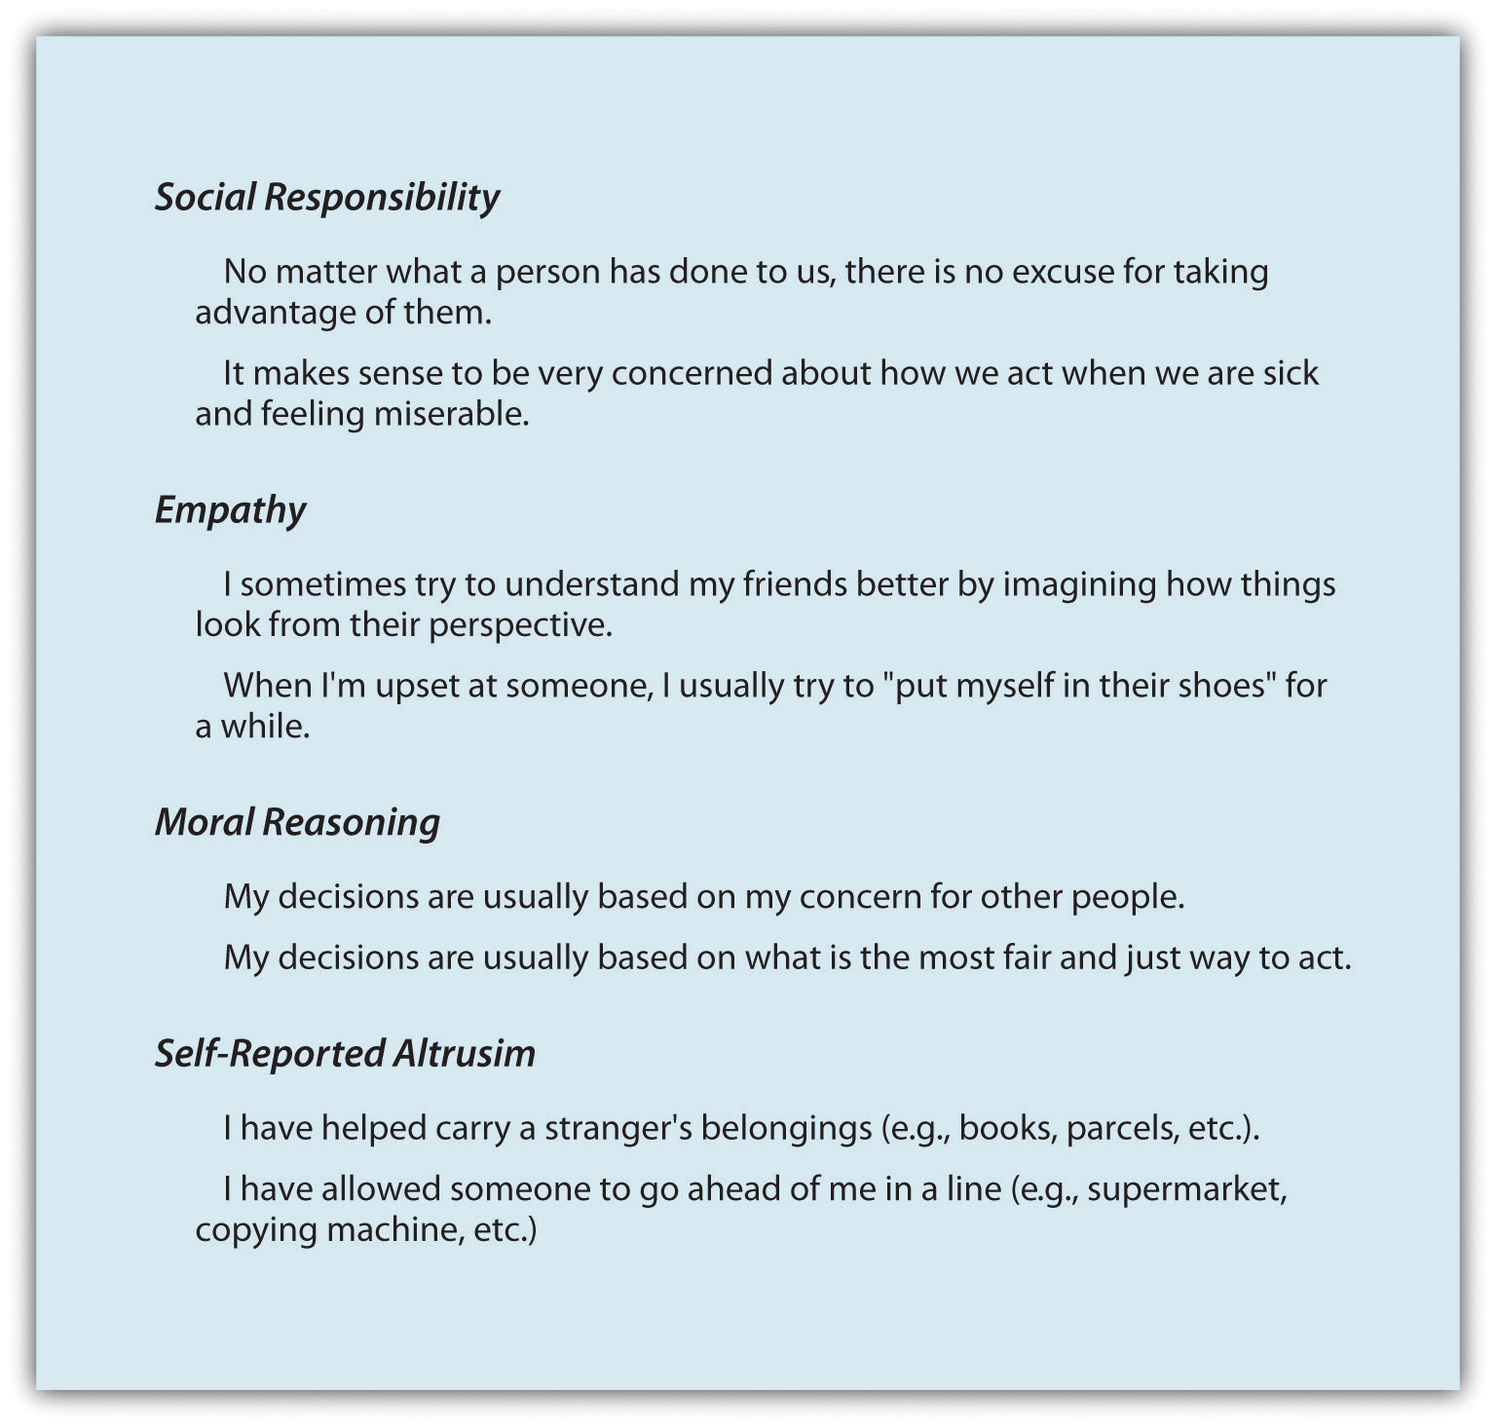
This scale measures individual differences in willingness to provide help—the prosocial personality. The scale includes questions on four dimensions of altruism. Adapted from Penner, Fritzsche, Craiger, and Freifeld (1995). ^{[2]}
The altruistic personality involves both the cognitive and the emotional responses that we experience around others. People with altruistic personalities tend to show empathy and sympathy for others and feel that it is appropriate and right to follow the norm of social responsibility. These people help more people in a wider variety of areas, including providing help to coworkers, donating organs, and volunteering, and also have been found to help more quickly than do people who score lower on these measures (Borman, Penner, Allen, & Motowidlo, 2001; Penner, 2002). ^{[3]} A longitudinal study conducted by Nancy Eisenberg and her colleagues (Eisenberg et al., 1999) ^{[4]} found that children who were the most helpful when they were measured in their preschool classes also were the most helpful later in childhood and in early adulthood, suggesting that they really were helpful people. People with altruistic personalities seem to be people who have a strong other-concern—they like to be with, to relate to, and to help others.
The altruistic personality is in part heritable. Research has found that identical twins are more similar to each other in both their helping-related emotions (such as empathy) and their actual helping than are fraternal twins, who share only a portion of their genetic makeup (Davis, Luce, & Kraus, 1994). ^{[5]}

Gender Differences in Helping
You may have already asked yourself an important question about helping: Do men or women help more? And perhaps you have answered this question. For instance, you might have decided that women would be more helpful because they are by and large more attuned to the needs of others. Or perhaps you decided that men would be more helpful because helping involves demonstrating bravery and heroicism and men are more likely to desire to be heroes, or at least to look heroic in the eyes of other people.
In fact, on average there are no big differences between men and women in terms of their helping. For instance, in the survey of altruism we discussed earlier in the chapter (http://www.independentsector.org), the percentage of women volunteering (46%) was not significantly different than the percentage of men (42%). Rather, there appears to be a person-by-situation interaction, such that gender differences show up more strongly in some situations than in others. The differences depend not only upon the opportunity to help but also on the type of helping that is required (Becker & Eagly, 2004). ^{[6]} In general, men are more likely to help in situations that involve physical strength. If you remember photos and videos taken immediately after the World Trade Center attack in 2001, you’ll probably recall the many images of firefighters and police officers, who were primarily men, engaged in heroic acts of helping.
This does not mean that women are any less helpful—in fact thousands of women helped during and after the World Trade Center attack by tending to the wounded in hospitals, donating blood, raising money for the families of the victims, and helping with the cleanup of the disaster sites. Because women are, on average, more focused on other-concern, they are more likely than men to help in situations that involve long-term nurturance and caring, particularly within close relationships. Women are also more likely than men to engage in community behaviors, such as volunteering in the community or helping families (Becker & Eagly, 2004; Eagly & Becker, 2005). ^{[7]}Helping within the family is done in large part by mothers, sisters, wives, and female friends. (You might ask yourself when you last received a thank-you note from a man!)
Although this type of helping might be less likely to be rewarded with newspaper stories and medals, providing social support and helping connect people serves to help us meet the important goal of relating to others and thus helps improve the quality of our lives. And women are not afraid to help in situations that are dangerous. In fact, women have been found to be as likely as men are to engage in dangerous behaviors such as donating a kidney to others (Becker & Eagly, 2004). ^{[8]}

Social Psychology in the Public Interest
Are the Religious More Altruistic?
Do you think that religious people are more helpful than are people who are less religious? There are plenty of reasons to think that this might be so. After all, every major religion preaches the importance of compassion and helpfulness, and many faith-based organizations help the poor and disadvantaged every year. Religious organizations help provide education, food, clothes, financial support, and other essentials to the needy across the globe.
There is support, based on surveys and questionnaires, that religious people do indeed report being more helpful than the less religious (Penner, 2002). ^{[9]} For instance, Morgan (1983) ^{[10]} found that people who reported that they prayed more often also said that they were more good, friendly, and cooperative toward others. Furrow, King, and White (2004) ^{[11]} found a significant positive relationship between religiousness and prosocial concerns such as empathy, moral reasoning, and responsibility in urban high school students. And Benson, Donahue, and Erickson (1989) ^{[12]} found that adolescents who said that they were more religious were also more likely to have been involved in a volunteer service project in the last year.
Batson and his colleagues (1989) ^{[13]} wondered if religious people were actually more likely to help or if they simply indicated that they would be on questionnaires. To test this question, they recruited college students and first asked them to report on their religious beliefs. On the basis of these responses, Batson categorized the students into one of four groups:
- The nonreligious students were those who did not indicate much interest in religion.
- The externally religious students were those who primarily indicated that they used religion for self-concern, such as for feeling more comfortable and being comforted by others, for gaining social status, and for finding support for one’s chosen way of life. The externally religious tended to agree with such statements as “The church is most important as a place to formulate good social relationships” and “What religion offers me most is comfort when sorrows and misfortune strike.”
- The internally religious were those who indicated that they had accepted religion and that it was part of their inner experiences. The internally religious agreed with statements such as “I try hard to carry my religion over into all my other dealings in life” and “Quite often I have been keenly aware of the presence of God or the Divine Being.”
- Finally, people who agreed with such statements as “It might be said that I value my religious doubts and uncertainties” and “Questions are far more central to my religious experience than are answers” were considered to bequest-oriented. These students see religion as a lifelong commitment to getting answers to important moral and religious questions.
Then Batson and his colleagues asked the participants whether or not they would be willing to volunteer their time by helping a woman in need or by walking in a walkathon for a charity. However, in each case Batson also gave one half of the participants a possible excuse for not helping, by informing them that a number of other students had already volunteered to help the woman or that they would have to complete a difficult physical exam before they could be in the walkathon.
The researchers found that the externally religious were not more likely to help overall and were actually less likely to help when there was an easy excuse not to. It seems that the externally religious were not really altruistic at all. The internally religious participants seemed somewhat more altruistic—they helped more when the helping was easy, but they did not continue to help when the task got difficult. However, Batson and his team found that the quest-oriented students were the true altruists—they volunteered to help even when doing so required engaging in some difficult exercise and continued to help even when there was an easy excuse not to.
Although most studies investigating the role of religion on altruism have been correlational, there is also some experimental research showing that that activating symbols relating to religion causes increased altruism. Shariff and Norenzayan (2007) ^{[14]} showed their research participants religious words such as divine, God, sacred, and prophet and then later asked them to contribute some money to a charity. The participants who had seen the religious words were more likely to donate money to an anonymous recipient than were a control group of people who had been exposed to nonreligious control words. However, religion was not the only concept that increased helping. Similar increases in altruism were found when people were shown words related to civil duty, such as civic,jury, court, police, and contract.
In summary, when surveyed, religious people say that they are more helpful than are the nonreligious, but whether they really help when helping conflicts with self-interest seems to depend on what type of religious person they are. People who are religious for personal reasons related to self-concern generally are not more helpful. On the other hand, those who are more quest-oriented—those who really believe that helping is an important part of religious experience—are likely to help even when doing so requires effort. Furthermore, religion is not the only thing that makes us helpful. Being reminded of other social norms, such as our civil responsibility to others, also makes us more helpful.

Who Do We Help? Attributions and Helping
We do not help everyone equally—some people just seem to be more worthy of help than others. Our cognitions about people in need matter as do our emotions toward them. For one, our perception of the amount of the need is important. Bickman and Kamzan (1973) ^{[15]} found that people were considerably more reluctant to help someone requesting money in a grocery store to buy some cookie dough (a relative luxury item) than they were to help someone requesting money to buy milk (which seems more necessary).
In addition to attempting to determine whether the help is really needed, we also tend to determine whether people are deserving of the help. We tend to provide less help to people who seem to have brought on their problems themselves or who don’t seem to be working very hard to solve them on their own than we do to people who need help as a result of events that seem to be out of their control. Imagine, for instance, that a student in your class asks to borrow your class notes to prepare for an exam. And then imagine if the student said, “I just can’t take good notes—I attend every class, and I really try, but I just can’t do it.” I’m guessing that you might be willing to help this student. On the other hand, imagine that the student said, “Well, I miss class a lot because I don’t feel like coming, and even when I’m here I don’t bother to take notes every day.” I bet you’d be less likely to help this person, who doesn’t seem to be trying very hard.
Supporting this idea, Dooley (1995) ^{[16]} had students read scenarios about a person who had been diagnosed with AIDS. Participants who learned that the person had contracted the disease through a blood transfusion felt more empathy and pity for the person, and also expressed a greater desire to help them, than did participants who believed that the disease was caused by unprotected sex or by illicit drug use. One reason we may be particularly likely to help victims of hurricanes and other natural disasters, then, is that we see that these people did not cause their own problems. Those who do argue against helping these victims may well take the opposite position because they believe that the individuals deserved what they got (“they should have known better than to live there.”)
It has been argued that a fundamental difference between individuals who hold politically conservative views and those who hold politically liberal views is how they perceive the necessity or moral responsibility of helping others, and that this relates to how they perceive the causes of people’s outcomes. Consider people who appear to need help because they have inadequate food, shelter, or health care, for example. Liberals tend to attribute these outcomes more externally, blaming them on unjust social practices and societal structures that create inequalities. Because they are likely to believe that the people do not deserve their unfortunate situation, they are likely to favor spending on social programs designed to help these people. Conservatives, on the other hand, are more likely to hold just world beliefs—beliefs that people get what they deserve in life (Lerner, 1980). ^{[17]} Conservatives make more internal attributions for negative outcomes, believing that the needs are caused by the lack of effort or ability on the part of the individual. They are therefore less likely than liberals to favor government spending on welfare and other social programs designed to help people (Kluegel & Smith, 1986; Skitka, 1999). ^{[18]}

Reactions to Receiving Help
To this point in the chapter we have proceeded as if helping is always a good thing—that people need to receive help and that they are appreciative of and thankful to the people who help them. But perhaps this is not always true. We haven’t yet considered the cognitive and affective reactions of the people who are receivingthe help. Can you remember a time when somebody tried to help you make a decision or perform a task, but you didn’t really want the help? How did that make you think and feel about yourself? Maybe there are costs involved in receiving help, just as there are in giving it.
Although people who receive help often really need the help and may indeed feel appreciative and grateful to those who help them, receiving help may also have some negative consequences. When we help another person, it indicates that we have enough resources that we can afford to give some of them to the recipient; it also indicates that the recipient is dependent on our goodwill. Thus helping creates a status disparity in the sense that the helper is seen as having higher status than the person being helped. This inequality makes giving help an indication of high status and power, and receiving help a potentially self-threatening experience for the recipient (Nadler, 2002; Nadler & Halabi, 2006). ^{[19]}There are a variety of emotions that help recipients might feel in these cases, including embarrassment and worry that they are, or are seen as, incompetent or dependent (DePaulo, Brown, Ishii, & Fisher, 1981; Nadler, Fisher, & Itzhak, 1983). ^{[20]} Research has found that people frequently respond negatively when they receive help and may in some cases even prefer to endure hardships rather than to seek out help (Nadler, 1991). ^{[21]} Receiving help, then, can be a potential blow to our self-esteem.
The negative feelings that we experience when receiving help are likely to be particularly strong when the recipient feels that the implication of the helping is that they are unable to care for themselves. In these cases the help is perceived as beingdependency oriented (Nadler et al., 1983). ^{[22]} When the helper takes control of the situation and solves the problem facing the individual, leaving little left for the individual to accomplish on his or her own, the behavior may be seen as indicating that the individual cannot help herself. The potential recipients of help are likely to reject offers of dependency-oriented help, refrain from seeking it, and react negatively when it is offered.
Another situation in which people may not appreciate the help they are receiving is when that help comes on the basis of one’s presumed need. For instance Blaine, Crocker, and Major (1995) ^{[23]} found that people who imagined that they had been hired for a job because they were disabled experienced lower self-esteem and felt that they were less likely to work hard on the job than those who imagined that they were hired on the basis of their job qualifications. You can see that government programs, such as those based on affirmative action, although likely to be helpful for the people who receive them, may also lead those people to feel dependent on others.
In contrast to dependency-oriented help, autonomy-oriented help is partial and temporary and provides information to the other, for instance, by giving instructions or guidance or providing ideas about how to help oneself. Autonomy-oriented help reflects the helper’s view that, given the appropriate tools, recipients can help themselves (Brickman, 1982). ^{[24]} Autonomy-oriented help allows help recipients to retain their independence despite their reliance on the more resourceful helper. This type of help is less likely to clash with help recipients’ view of themselves as capable people who can help themselves.
There are also observed gender differences in the willingness to seek help. Boys and men are less likely to ask for help overall, perhaps in part because they feel that asking for help indicates to others that they are less capable of handling their own affairs or that they have low status (Addis & Mahalik, 2003; Mansfield, Addis, & Mahalik, 2003). ^{[25]}
In short, when we help others we must be careful that we do it in a way that allows them to maintain their independence and that reminds them that they are still able to help themselves. This type of help will be more easily accepted and more beneficial in the long run.

Cultural Issues in Helping
Although almost every culture has a social responsibility norm, the strength of those norms varies across cultures. And these differences relate well to what we know about individualism and collectivism. In one study, Miller, Bersoff, and Harwood (1990) ^{[26]}found that children and adults in the United States (a Western and therefore individualistic culture) were less likely than children and adults in India (an Eastern and therefore collectivistic culture) to believe that people have an obligation to provide assistance to others. The Indian respondents believed that there was an absolute requirement to help, whereas the Americans offered their helping more selectively, even to their friends. Similarly, Baron and Miller (2000) ^{[27]} found that Indian students were more likely than U.S. students to view donating bone marrow to save someone’s life as morally required, whereas U.S. students were more likely than Indian students to say that donating was a decision that the potential donor had to make himself or herself.
Perlow and Weeks (2002) ^{[28]} found that there were substantial cultural differences in the behavior of software engineers working at similar companies and doing the same type of work in the United States and in India. Engineers at the American site were more focused on exchange and reciprocity—they tended to provide help to others only if they thought those people could be helpful to them in the future. The engineers at the Indian company, on the other hand, were more willing to help anyone who seemed to need help, regardless of the potential for a return. Perlow and Weeks interpreted these differences in terms of different ways of meeting the goal of self-interest. Among the Americans, helping was seen as an unwanted interruption on the time of the individual, and thus helping was not personally beneficial. At the Indian company, however, helping was seen more as an opportunity for improving one’s skills by helping. These results suggest that helping, at least in Western contexts such as the United States, can be increased if it is framed to be perceived as important toward achieving one’s goals.
One important difference between Eastern and Western cultures is that the importance of self-concern (versus other-concern) is higher in the latter. In fact, the strong individualistic norms in cultures such as the United States make it sometimes inappropriate to try to help in cases where we do not have a personal interest. Rebecca Ratner and Dale Miller (2001) ^{[29]} had participants read a scenario in which a governmental funding agency was planning to reduce funding for research regarding a disease. The disease was said to affect only women or only men. Then the participants were asked to indicate both whether they were opposed to the reduction in funding and how comfortable they would be in attending a meeting to protest the funding changes.
In terms of their attitudes toward the reduction in funding, there were no significant gender differences. Men thought that the funding should be maintained even when the disease only affected women, and vice versa. However, as you can see in Figure 9.8 "Effects of Standing on Feelings of Comfort in Taking Action", when asked how comfortable they would feel attending a meeting protesting the funding decreases, significant differences occurred. The men predicted that they would feel less comfortable attending a meeting to protest the funding reductions when the disease only affected women, and the women predicted that they would feel less comfortable attending a meeting to protest the funding reductions when the disease only affected men.

Figure 9.8 Effects of Standing on Feelings of Comfort in Taking Action
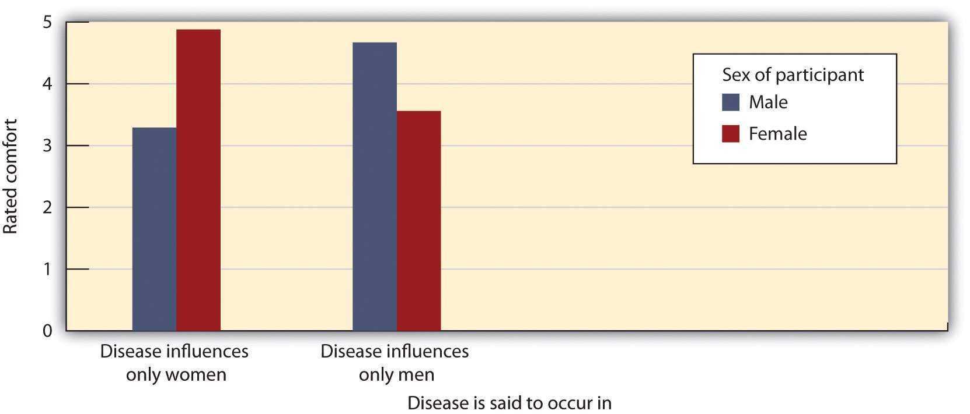
This figure represents participants’ ratings of how comfortable they would be attending a meeting supporting the attempt to prevent funding reductions for a disease. Suggesting that a norm of self-interest is necessary to get involved, both men and women were less likely to feel comfortable arguing for a position that does not influence them personally. Data from Ratner and Miller (2001, Experiment 3).^{[30]}
Ratner and Miller argued that in Western cultures there is a norm of self-interest that influences whether or not we feel that we can be involved in actions designed to help others. In short, people are not expected to volunteer for, or to be involved in, causes that do not affect them personally. It is simply inappropriate to lend help to others unless the person is personally involved in the issue and thus stands to benefit. Indeed, participants in another study by Ratner and Miller reacted more negatively to an individual’s altruistic behaviors when they did not appear consistent with his or her self-interest.
There is still another example of the subtle role of self-interest in helping. Did you ever notice that many people who are looking for contributions to a cause do not ask directly but rather ask that you purchase something from them, allowing them to keep the profit from the sale? Bake sales, car washes, and address sticker and magazine subscription charity campaigns are all examples of this. Of course, it would be more profitable for the charity if people simply gave the same amount of money rather than taking the gift—and perhaps the people who are making the purchases would prefer not to have to buy the product anyway.
Is it possible that people are simply more comfortable making donations in exchange for a product than they are simply giving money to a charity? Research by John Holmes and his colleagues (Holmes, Miller, & Lerner, 2002) ^{[31]} has supported this idea, finding that people are more likely to help when they can pretend that they are acting in their own self-interest. In one study, Holmes and his team found that students were more likely to donate money to a needy charity when they were offered a small candle in return for their donation than when they were not offered the candle. However, and suggesting that they didn’t really care about the candle that much, when the request was to contribute to a charity that did not seem that needy, contributions were smaller overall but were not greater when the candle was offered than when it was not. Again, it seems that people feel more comfortable being altruistic when they can pretend that they are really helping themselves—not violating the norm of self-interest.

Increasing Helping
Now that we have a fundamental understanding of the variables that influence the likelihood that we will help others, let’s spend some time considering how we might use this information in our everyday life to try to become more helpful ourselves and to encourage those around us to do the same. In doing so we will make use of many of the principles of altruism that we have discussed in this chapter.
First, we need to remember that not all helping is based on other-concern—self-concern is important. People help in part because it makes them feel good, and therefore anything that we can do to increase the benefits of helping and to decrease the costs of helping would be useful. Consider, for instance, the research of Mark Snyder, who has extensively studied the people who volunteer to help other people who are suffering from AIDS (Snyder & Omoto, 2004; Snyder, Omoto, & Lindsay, 2004).^{[32]} To help understand which volunteers were most likely to continue to volunteer over time, Snyder and his colleagues (Omoto & Snyder, 1995) ^{[33]} asked the AIDS volunteers to indicate why they volunteered. As you can see in Figure 9.9 "Reasons for Volunteering to Help AIDS Victims", the researchers found that the people indicated that they volunteered for many different reasons, and these reasons fit well with our assumptions about human nature—they involve both self-concern as well as other-concern.

Figure 9.9 Reasons for Volunteering to Help AIDS Victims
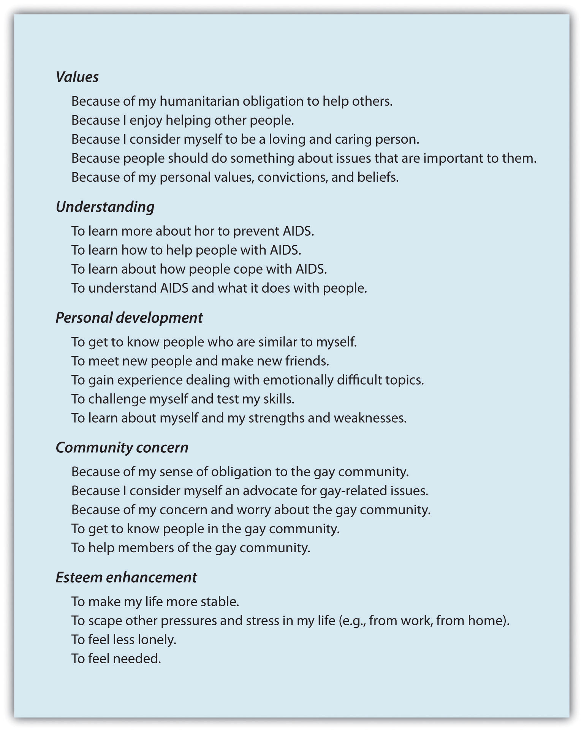
From Omoto and Snyder (1995). ^{[34]}
Omoto and Snyder (1995) ^{[35]} found that the volunteers were more likely to continue their volunteer work if their reasons for volunteering involved self-related activities, such as understanding, personal development, or esteem enhancement. The volunteers who felt that they were getting something back from their work were likely to stay involved. In addition, Snyder and his colleagues found that that people were more likely to continue volunteering when their existing social support networks were weak. This result suggests that some volunteers were using the volunteer opportunity to help them create better social connections (Omoto & Snyder, 1995). ^{[36]} On the other hand, the volunteers who reported experiencing negative reactions about their helping from their friends and family members, which made them feel embarrassed, uncomfortable, and stigmatized for helping, were also less likely to continue working as volunteers (Snyder, Omoto, & Crain, 1999). ^{[37]}
These results again show that people will help more if they see it as rewarding. So if you want to get people to help, try to increase the rewards of doing so, for instance by enhancing their mood or by offering incentives. Simple things, such as noticing, praising, and even labeling helpful behavior can be enough. When children are told that they are “kind and helpful children,” they contribute more of their prizes to other children (Grusec, Kuczynski, Rushton, & Simutis, 1978). ^{[38]} Rewards work for adults too: People were more likely to donate to charity several weeks after they were described by another person as being “generous” and “charitable” people (Kraut, 1973).^{[39]} In short, once we start to think of ourselves as helpful people, self-perception takes over and we continue to help.
The nations and states that have passed Good Samaritan laws realize the importance of self-interest: If people must pay fines or face jail sentences if they don’t help, then they are naturally more likely to help. And the programs in many schools, businesses, and other institutions that encourage students and workers to volunteer by rewarding them for doing so are also effective in increasing volunteering (Clary et al., 1998; Clary, Snyder, & Stukas, 1998). ^{[40]}
Helping also occurs in part because of other-concern. We are more likely to help people we like and care about, we feel similar to, and with whom we experience positive emotions. Therefore, anything that we can do to increase our connections with others will likely increase helping. We must work to encourage ourselves, our friends, and our children to interact with others—to help them meet and accept new people and to instill a sense of community and caring in them. These social connections will make us feel closer to others and increase the likelihood we will help them. We must also work to install the appropriate norms in our children. Kids must be taught not to be selfish and to value the norms of sharing and altruism.
One way to increase our connection with others is to make those people highly salient and personal. Charities and other organizations that seek to promote helping understand this and do the best they can to individualize the people they are asking us to help. When we see a single person suffering, we naturally feel strong emotional responses to that person. And, as we have seen, the emotions that we feel when others are in need are powerful determinants of helping. In fact, Paul Slovic (2007) ^{[41]} found that people are simply unable to identify with statistical and abstract descriptions of need because they do not feel emotions for these victims in the same way they do for individuals. They argued that when people seem completely oblivious or numb to the needs of millions of people who are victims of genocide, hurricanes, and other atrocities, it is because the victims are presented as statistics rather than as individual cases. As Joseph Stalin, the Russian dictator who executed millions of Russians, put it, “A single death is a tragedy, a million deaths is a statistic.”
We can also use what we have learned about helping in emergency situations to increase the likelihood of responding. Most importantly, we must remember how strongly pluralistic ignorance can influence the interpretation of events and how quickly responsibility can be diffused among the people present at an emergency. Therefore, in emergency situations we must attempt to counteract pluralistic ignorance and diffusion of responsibility by remembering that others do not necessarily know more than we do. Depend on your own interpretation—don’t simply rely on your assumptions about what others are thinking and don’t just assume that others will do the helping.
We must be sure to follow the steps in Latané and Darley’s model, attempting to increase helping at each stage. We must make the emergency noticeable and clearly an emergency, for instance, by yelling out: “This is an emergency! Please call the police! I need help!” And we must attempt to avoid the diffusion of responsibility, for instance, by designating one individual to help: “You over there in the red shirt, please call 911 now!”

KEY TAKEAWAYS
- Some people—for instance, those with altruistic personalities—are more helpful than others.
- Gender differences in helping depend on the type of helping that is required. Men are more likely to help in situations that involve physical strength, whereas women are more likely to help in situations that involve long-term nurturance and caring, particularly within close relationships.
- Our perception of the amount of the need is important. We tend to provide less help to people who seem to have brought on their own problems or who don’t seem to be working very hard to solve them on their own.
- In some cases helping can create negative consequences. Dependency-oriented help may make the helped feel negative emotions, such as embarrassment and worry that they are seen as incompetent or dependent. Autonomy-oriented help is more easily accepted and will be more beneficial in the long run.
- Norms about helping vary across cultures, for instance, between Eastern and Western cultures.
- We can increase helping by using our theoretical knowledge about the factors that produce it. Our strategies can be based on using both self-concern and other-concern.

EXERCISES AND CRITICAL THINKING
- Consider your own personality and compare it to that of some other people you know. Do you have an altruistic personality? Do you know people who seem to have one?
- Imagine that you knew someone who was ill and needed help. How would you frame your help to make him or her willing to accept it?
- Assume for a moment that you were in charge of creating an advertising campaign designed to increase people’s altruism. On the basis of your reading, what approaches might you take?

[1] Penner, L. A., Fritzsche, B. A., Craiger, J. P., & Freifeld, T. S. (1995). Measuring the prosocial personality. In J. Butcher & C. Speigelberger (Eds.), Advances in personality assessment (Vol. 10, pp. 147–163). Hillsdale, NJ: Lawrence Erlbaum.
[2] Penner, L. A., Fritzsche, B. A., Craiger, J. P., & Freifeld, T. S. (1995). Measuring the prosocial personality. In J. Butcher & C. Speigelberger (Eds.), Advances in personality assessment (Vol. 10, pp. 147–163). Hillsdale, NJ: Lawrence Erlbaum.
[3] Borman, W. C., Penner, L. A., Allen, T. D., & Motowidlo, S. J. (2001). Personality predictors of citizenship performance. International Journal of Selection and Assessment, 9(1–2), 52–69; Penner, L. A. (2002). Dispositional and organizational influences on sustained volunteerism: An interactionist perspective. Journal of Social Issues, 58(3), 447–467.
[4] Eisenberg, N., Guthrie, I. K., Murphy, B. C., Shepard, S. A., Cumberland, A., & Carlo, G. (1999). Consistency and development of prosocial dispositions: A longitudinal study. Child Development, 70(6), 1360–1372.
[5] Davis, M. H., Luce, C., & Kraus, S. J. (1994). The heritability of characteristics associated with dispositional empathy. Journal of Personality, 62(3), 369–391.
[6] Becker, S. W., & Eagly, A. H. (2004). The heroism of women and men. American Psychologist, 59(3), 163–178.
[7] Becker, S. W., & Eagly, A. H. (2004). The heroism of women and men. American Psychologist, 59(3), 163–178; Eagly, A. H., & Becker, S. W. (2005). Comparing the heroism of women and men. American Psychologist, 60(4), 343–344.
[8] Becker, S. W., & Eagly, A. H. (2004). The heroism of women and men. American Psychologist, 59(3), 163–178.
[9] Penner, L. A. (2002). Dispositional and organizational influences on sustained volunteerism: An interactionist perspective. Journal of Social Issues, 58(3), 447–467.
[10] Morgan, S. P. (1983). A research note on religion and morality: Are religious people nice people? Social Forces, 61(3), 683–692.
[11] Furrow, J. L., King, P. E., & White, K. (2004). Religion and positive youth development: Identity, meaning, and prosocial concerns. Applied Developmental Science, 8(1), 17–26.
[12] Benson, P. L., Donahue, M. J., & Erickson, J. A. (Eds.). (1989). Adolescence and religion: A review of the literature from 1970 to 1986. Research in the Social Scientific Study of Religion, 1, 153–181.
[13] Batson, C. D., Oleson, K. C., Weeks, J. L., Healy, S. P., Reeves, P. J., Jennings, P., & Brown, T. (1989). Religious prosocial motivation: Is it altruistic or egoistic? Journal of Personality and Social Psychology, 57(5), 873–884.
[14] Shariff, A. F., & Norenzayan, A. (2007). God is watching you: Priming God concepts increases prosocial behavior in an anonymous economic game. Psychological Science, 18(9), 803–809.
[15] Bickman, L., & Kamzan, M. (1973). The effect of race and need on helping behavior.Journal of Social Psychology, 89(1), 73–77.
[16] Dooley, P. A. (1995). Perceptions of the onset controllability of AIDS and helping judgments: An attributional analysis. Journal of Applied Social Psychology, 25(10), 858–869.
[17] Lerner, M. (1980). The belief in a just world: A fundamental delusion. New York, NY: Plenum.
[18] Kluegel, J. R., & Smith, E. R. (1986). Beliefs about inequality: Americans’ views of what is and what ought to be. Hawthorne, NY: Aldine de Gruyter; Skitka, L. J. (1999). Ideological and attributional boundaries on public compassion: Reactions to individuals and communities affected by a natural disaster. Personality and Social Psychology Bulletin, 25(7), 793–808.
[19] Nadler, A. (2002). Inter-group helping relations as power relations: Maintaining or challenging social dominance between groups through helping. Journal of Social Issues, 58(3), 487–502; Nadler, A., & Halabi, S. (2006). Intergroup helping as status relations: Effects of status stability, identification, and type of help on receptivity to high-status group’s help.Journal of Personality and Social Psychology, 91(1), 97–110.
[20] DePaulo, B. M., Brown, P. L., Ishii, S., & Fisher, J. D. (1981). Help that works: The effects of aid on subsequent task performance. Journal of Personality and Social Psychology, 41(3), 478–487; Nadler, A., Fisher, J. D., & Itzhak, S. B. (1983). With a little help from my friend: Effect of single or multiple act aid as a function of donor and task characteristics. Journal of Personality and Social Psychology, 44(2), 310–321.
[21] Nadler, A. (Ed.). (1991). Help-seeking behavior: Psychological costs and instrumental benefits. Thousand Oaks, CA: Sage.
[22] Nadler, A., Fisher, J. D., & Itzhak, S. B. (1983). With a little help from my friend: Effect of single or multiple act aid as a function of donor and task characteristics. Journal of Personality and Social Psychology, 44(2), 310–321.
[23] Blaine, B., Crocker, J., & Major, B. (1995). The unintended negative consequences of sympathy for the stigmatized. Journal of Applied Social Psychology, 25(10), 889–905.
[24] Brickman, P. (1982). Models of helping and coping. American Psychologist, 37(4), 368–384.
[25] Addis, M. E., & Mahalik, J. R. (2003). Men, masculinity, and the contexts of help seeking.American Psychologist, 58(1), 5–14; Mansfield, A. K., Addis, M. E., & Mahalik, J. R. (2003). “Why won’t he go to the doctor?”: The psychology of men’s help seeking. International Journal of Men’s Health, 2(2), 93–109.
[26] Miller, J. G., Bersoff, D. M., & Harwood, R. L. (1990). Perceptions of social responsibilities in India and in the United States: Moral imperatives or personal decisions? Journal of Personality and Social Psychology, 58(1), 33–47.
[27] Baron, J., & Miller, J. G. (2000). Limiting the scope of moral obligations to help: A cross-cultural investigation. Journal of Cross-Cultural Psychology, 31(6), 703–725.
[28] Perlow, L., & Weeks, J. (2002). Who’s helping whom? Layers of culture and workplace behavior. Journal of Organizational Behavior, 23(Spec. Issue), 345–361.
[29] Ratner, R. K., & Miller, D. T. (2001). The norm of self-interest and its effects on social action. Journal of Personality and Social Psychology, 81(1), 5–16.
[30] Ratner, R. K., & Miller, D. T. (2001). The norm of self-interest and its effects on social action. Journal of Personality and Social Psychology, 81(1), 5–16.
[31] Holmes, J. G., Miller, D. T., & Lerner, M. J. (2002). Committing altruism under the cloak of self-interest: The exchange fiction. Journal of Experimental Social Psychology, 38(2), 144–151.
[32] Snyder, M., & Omoto, A. M. (Eds.). (2004). Volunteers and volunteer organizations: Theoretical perspectives and practical concerns. San Francisco, CA: Jossey-Bass; Snyder, M., Omoto, A. M., & Lindsay, J. J. (Eds.). (2004). Sacrificing time and effort for the good of others: The benefits and costs of volunteerism. New York, NY: Guilford Press.
[33] Omoto, A. M., & Snyder, M. (1995). Sustained helping without obligation: Motivation, longevity of service, and perceived attitude change among AIDS volunteers. Journal of Personality and Social Psychology, 68(4), 671–686.
[34] Omoto, A. M., & Snyder, M. (1995). Sustained helping without obligation: Motivation, longevity of service, and perceived attitude change among AIDS volunteers. Journal of Personality and Social Psychology, 68(4), 671–686.
[35] Omoto, A. M., & Snyder, M. (1995). Sustained helping without obligation: Motivation, longevity of service, and perceived attitude change among AIDS volunteers. Journal of Personality and Social Psychology, 68(4), 671–686.
[36] Omoto, A. M., & Snyder, M. (1995). Sustained helping without obligation: Motivation, longevity of service, and perceived attitude change among AIDS volunteers. Journal of Personality and Social Psychology, 68(4), 671–686.
[37] Snyder, M., Omoto, A. M., & Crain, A. L. (1999). Punished for their good deeds: Stigmatization of AIDS volunteers. American Behavioral Scientist, 42(7), 1175–1192.
[38] Grusec, J. E., Kuczynski, L., Rushton, J. P., & Simutis, Z. M. (1978). Modeling, direct instruction, and attributions: Effects on altruism. Developmental Psychology, 14(1), 51–57.
[39] Kraut, R. E. (1973). Effects of social labeling on giving to charity. Journal of Experimental Social Psychology, 9(6), 551–562.
[40] Clary, E. G., Snyder, M., Ridge, R. D., Copeland, J., Stukas, A. A., Haugen, J., & Miene, P. (1998). Understanding and assessing the motivations of volunteers: A functional approach.Journal of Personality and Social Psychology, 74(6), 1516–1530; Clary, E. G., Snyder, M., & Stukas, A. (1998). Service-learning and psychology: Lessons from the psychology of volunteers’ motivations. Washington, DC: American Psychological Association.
[41] Slovic, P. (2007). “If I look at the mass I will never act”: Psychic numbing and genocide.Judgment and Decision Making, 2(2), 79–95.

9.5 Thinking Like a Social Psychologist About Altruism
This chapter has concerned the many varieties of helping. We have seen that helping and altruism may occur in a variety of ways and toward a variety of people. Were you surprised to learn how important helping is in our social lives, and in how many different ways it occurs? Can you now see—perhaps in a way that you did not before—that helping allows us to lead more effective lives?
Because you are thinking like a social psychologist, you will realize that we help partly as a result of other-concern. We help because we care about others, we feel bad when they feel bad, and we really want to help. We help more when we see those others as similar to us and when we feel empathy for them. But we also help out of self-concern, to relieve our personal distress, to escape public shame for not helping, and to feel good about our helpful actions. Helping others is beneficial to others but also to us—we often enjoy being helpful, and helping can make us feel good and be healthy.
Perhaps your new knowledge about the causes of helping may lead you to be less surprised about the extent to which people are willing, in many cases at substantial cost to themselves, to help others. Or perhaps you are now thinking more fully about whether altruism truly exists. Do people ever help only out of other-concern, or is all helping at least partly the result of self-concern? Does your knowledge about altruism lead you to reevaluate your decisions about Brad Pitt’s helping in New Orleans?
Perhaps you will be able to use your new understanding of the situational factors involved in helping to make sure that you and others are not led to ignore the needs of others as a result of pluralistic ignorance or diffusion of responsibility. If you find yourself in an emergency situation, you may now have a better idea of how to make sure someone helps. Remember to use this information if the need arises.
And perhaps your new understanding about helping has given you new insights into your own behavior. Are you now more willing to help others? Do you think it is important to help? Can you see how you might feel better about yourself if you do? Will you try to increase your own altruistic behavior? I hope that this chapter has encouraged you to do so.

9.6 Chapter Summary
Altruism refers to any behavior that is designed to increase another person’s welfare, and particularly those actions that do not seem to provide a direct reward to the person who performs them. Every day numerous acts of altruism occur all around us. People give up substantial time and energy to help others.
The tendency to help others is at least in part a basic feature of human nature, designed to help us help ourselves. Altruism enhances our reproductive success by helping the species as a whole survive and prosper. We are particularly helpful to our kin and to people we perceive as being similar to us. We also help people who are not related or similar as the result of reciprocal altruism. By cooperating with others, we increase our and others’ chances of survival and reproductive success.
We are more likely to help when we are rewarded and less likely when the perceived costs of helping are high. When we act altruistically, we may gain a reputation as a person with high status who is able and willing to help others. Some countries have enacted Good Samaritan laws that require people to provide or call for aid in an emergency if they can do so. We also learn to help by modeling the helpful behavior of others.
Social norms for helping include the reciprocity norm, which reminds us that we should follow the principles of reciprocal altruism, and the social responsibility norm, which tells us that we should try to help others who need assistance, even without any expectation of future payback.
We react to people in large part on the basis of how they make us feel and how we think we will feel if we help them. Positive mood states increase helping, and negative affective states, particularly guilt, do also. Personal distress refers to the negative feelings and emotions that we may experience when we view another person’s distress. Empathy refers to an affective response in which a person understands, and even feels, another person’s emotional distress and when he or she experiences events the way the other person does.
Latané and Darley’s decision model of bystander intervention has represented an important theoretical framework for helping us understand the role of situational variables on helping. According to the model, whether or not we help depends on the outcomes of a series of decisions that involve noticing the event, interpreting the situation as one requiring assistance, deciding to take personal responsibility, and implementing action.
Some people—for instance, those with altruistic personalities—are more helpful than others. And we help some people more than we help others; our perception of the amount of the need is important. We tend to provide less help to people who seem to have brought on their own problems or who don’t seem to be working very hard to solve them on their own. Gender differences in helping depend on the type of helping that is required. Men are more likely to help in situations that involve physical strength, whereas women are more likely than men to help in situations that involve long-term nurturance and caring, particularly within close relationships.
In some cases helping can create negative consequences. Dependency-oriented help may make the helped feel negative emotions, such as embarrassment and worry that they are seen as incompetent or dependent. Autonomy-oriented help is more easily accepted and will be more beneficial in the long run.
Norms about helping vary across cultures, for instance, between Eastern and Western cultures. The strong individualistic norms in cultures such as the United States make it seem inappropriate to help in cases where we do not have a personal interest. People may feel more comfortable helping when they feel that they are acting, at least in part, in their own self-interest.
We can increase helping by using our theoretical knowledge about the factors that produce it. Our strategies can be based on using both self-concern and other-concern. In terms of self-concern, if helping is seen as something positive for the self, people will help more. In terms of other-concern, we may try to increase our social connections with others, thereby increasing the likelihood we will help them. And we must also work to instill the appropriate norms about helping in our children. In emergency situations, we must be must be sure to disambiguate the emergency to others rather than assuming that those others will notice and interpret the event as one requiring help, and to help individuals experience that they have a personal responsibility to intervene.
In sum, altruism is an important and frequent part of human lives. We couldn’t live without the help we receive from others, and we are generally willing in many cases to return that help. Helping others is beneficial to them, but helping is also beneficial to us—we often enjoy being helpful, and helping can make us feel good and be healthy.

Chapter 10

Aggression

Dad Kills Another Dad at a Youth Hockey Game
In 2002, a jury of nine women and three men found Thomas Junta, 44, guilty of involuntary manslaughter in the beating death of Michael Costin, 40. The deadly fight between the two fathers occurred after a hockey practice that their two sons attended in Reading, Massachusetts, on July 5, 2000.
The two men started fighting after arguing over rough play during hockey drills in which their sons participated. There were many witnesses to the incident, including Junta’s son as well as Costin’s three sons.
Junta’s 12-year-old son said he saw Costin jump on his father’s back, but he also said that Junta was kneeling over Costin and beating him and that he had screamed for his father to stop.
As reported by the medical examiner, Costin’s body suffered a lot of trauma, including extensive bleeding in the brain.
Prosecutor Sheila Calkins described the fight, saying
“He was on top of him, straddling him…and pounding him on the left side of his head.”
Junta had a hard time keeping his composure on the witness stand, telling the court that he acted out of self-defense and was unaware of how badly he had injured Costin. Costin’s own father and several of his other family members said they forgave Junta, noting that they want to put the incident behind them.
Source: http://archives.cnn.com/2002/LAW/01/11/hockey.dads.trial.
If you go to the movies tonight, you may choose to see one of the more violent ones, in which you will view depictions of assaults, kidnappings, murders, rapes, wars, or executions. If you turn on the TV or surf the Internet you’ll likely see news reports of the real thing—more assaults, kidnappings, murders, rapes, wars, and executions. Indeed, there seems to be more and more violence every day, and we all live with the constant fear of terrorism by weapons of mass destruction. We also suffer more directly from aggression in our everyday life. When we get in our cars we may become the victim of aggressive driving by other drivers, or we may play violent video games that involve—well, more murder and killing. Even relaxing by watching sports on TV will lead us to see violence, as baseball players purposely bean each other with fastballs and hockey players start violent fistfights.
Indeed, the statistics on violence are sobering at many levels (Dutton, Boyanowsky, & Bond, 2005; Staub, 1989). ^{[1]} In terms of wars, genocides, and mass killings, the 20th century was the most violent of any century in human existence, and the 21st century is shaping up to be just as brutal. There were over 15,000 homicides, 100,000 rapes, and a million assaults in the United States alone in the year 2006. Child abuse is common—it is estimated that over a million children are physically abused and over 150,000 are sexually abused each year in the United States. Sexual violence is also a serious problem. In the United States, over 20% of female college students report having experienced either an attempted or actual rape (Koss, Gidycz, & Wisniewski, 1987). ^{[2]}A majority of college women and about a third of college men say they have experienced coercive sexual contact (Struckman-Johnson & Struckman-Johnson, 1998). ^{[3]} And aggression even shows up in children, who routinely fight and bully other children in school.
Although we have argued that people are generally caring toward others—that they have a basic desire to accept, care for, and help them—the violent events that surround us present a problem for this assumption. If people are generally good and care about others so much, then how could anyone possibly kill another human being, let alone participate in a suicide bombing or even genocide? Do aggressive events mean that people are naturally aggressive, violent, and hostile—or are they unusual events, shaped more by particularly extreme social situations that do not reflect the normal character of human beings?
We will answer these questions by considering the underlying principles of aggression—in terms of affect, cognition, and behavior, and in terms of the general goals of protecting the self and reaching out to others. (In this case, however, it is the former goal that prevails.) Aggression is wired into the deepest and oldest parts of our brain and yet is stimulated and controlled by social, situational, and cultural variables. In this chapter we will study the causes of aggression and make some suggestions for how we might be able to reduce it. Most importantly, we will see that—consistent with our analysis of human behavior more generally—aggression is not so much about the goal of harming others as it is about the goal of protecting the self.

[1] Dutton, D. G., Boyanowsky, E. O., & Bond, M. H. (2005). Extreme mass homicide: From military massacre to genocide. Aggression and Violent Behavior, 10(4), 437–473; Staub, E. (1989). The roots of evil: The origins of genocide and other group violence. New York, NY: Cambridge University Press.
[2] Koss, M. P., Gidycz, C. A., & Wisniewski, N. (1987). The scope of rape: Incidence and prevalence of sexual aggression and victimization in a national sample of higher education students. Journal of Consulting and Clinical Psychology, 55(2), 162–170.
[3] Struckman-Johnson, C., & Struckman-Johnson, D. (Eds.). (1998). The dynamics and impact of sexual coercion of men by women. New York, NY: Guilford Press.

10.1 Defining Aggression

LEARNING OBJECTIVES
- Define aggression and violence as social psychologists do.
- Differentiate emotional from instrumental aggression.
Aggression is a word that we use every day to characterize the behavior of others and perhaps even of ourselves. We say that people are aggressive if they yell at or hit each other, if they cut off other cars in traffic, or even when they smash their fists on the table in frustration. But other harmful acts, such as the injuries that sports players receive during a rough game or the killing of enemy soldiers in a war might not be viewed by everyone as aggression. Because aggression is so difficult to define, social psychologists (as well as many other people, including lawyers) judges and politicians, have spent a great deal of time trying to determine what should and should not be considered aggression. Doing so forces us to make use of the processes of causal attribution to help us determine the reasons for the behavior of others.
Social psychologists define aggression as behavior that is intended to harm another individual who does not wish to be harmed (Baron & Richardson, 1994). ^{[1]} Because it involves the perception of intent, what looks like aggression from one point of view may not look that way from another, and the same harmful behavior may or may not be aggressive depending on its intent.
You can see that this definition rules out some behaviors that we might normally think are aggressive. For instance, a football linebacker who accidentally breaks the arm of another player or a driver who accidentally hits a pedestrian would not by our definition be displaying aggression because although harm was done, there was no intent to harm. A salesperson who attempts to make a sale through repeated phone calls is not aggressive because he is not intending any harm. (We should say this behavior is “assertive” rather than aggressive.) And not all intentional behaviors that hurt others are aggressive behaviors. A dentist might intentionally give a patient a painful injection of a painkiller, but the goal is to prevent further pain during the procedure.
Because our definition requires us to determine the intent of the perpetrator, there is going to be some interpretation of these intents and there may well be disagreement among the parties involved. The U.S. government perceives the development of a nuclear weapon by North Korea as aggressive because the government believes that the weapon is intended to harm others, but North Korea may see the program as promoting self-defense. Although the player whose arm is broken in a football game may attribute hostile intent, the other player may claim that the injury was not intended. Within the legal system, juries and judges are frequently asked to determine whether harm was done intentionally.
Social psychologists use the term violence to refer to aggression that has extreme physical harm, such as injury or death, as its goal. Thus violence is a subset of aggression. All violent acts are aggressive, but only acts that are intended to cause extreme physical damage, such as murder, assault, rape, and robbery, are violent. Slapping someone really hard across the face might be violent, but calling people names would only be aggressive.
The type or level of intent that underlies an aggressive behavior creates the distinction between two fundamental types of aggression, which are caused by very different psychological processes. Emotional or impulsive aggression refers to aggression that occurs with only a small amount of forethought or intent and that is determined primarily by impulsive emotions. Emotional aggression is the result of the extreme negative emotions we’re experiencing at the time that we aggress and is not really intended to create any positive outcomes. When Sarah yells at her boyfriend, this is probably emotional aggression—it is impulsive and carried out in the heat of the moment. Other examples are the jealous lover who strikes out in rage or the sports fans at my university who, after our basketball team won the national NCAA championship, lit fires and destroyed cars around the stadium.
Instrumental or cognitive aggression, on other hand, is aggression that is intentional and planned. Instrumental aggression is more cognitive than affective and may be completely cold and calculating. Instrumental aggression is aimed at hurting someone to gain something—attention, monetary reward, or political power, for instance. If the aggressor believes that there is an easier way to obtain the goal, the aggression would probably not occur. A bully who hits a child and steals her toys, a terrorist who kills civilians to gain political exposure, and a hired assassin are all good examples of instrumental aggression.
Sometimes it is hard to distinguish between instrumental and emotional aggression, and yet it is important to try to do so. Emotional aggression is usually treated as second-degree homicide in the U.S. legal system, to differentiate it from cognitive, instrumental aggression (first-degree homicide). However, it may well be the case that all aggression is at least in part instrumental because it serves some need for the perpetrator. Therefore, it is probably best to consider emotional and instrumental aggression not as distinct categories but rather as endpoints on a continuum (Bushman & Anderson, 2001). ^{[2]}
Social psychologists agree that aggression can be verbal as well as physical. Therefore, slinging insults at a boyfriend is definitely, according to our definition, aggressive, just as hitting someone is. Physical aggression is aggression that involves harming others physically—for instance hitting, kicking, stabbing, or shooting them. Nonphysical aggression is aggression that does not involve physical harm. Nonphysical aggression includes verbal aggression (yelling, screaming, swearing, and name calling) and relational or social aggression, which is defined as intentionally harming another person’s social relationships, for instance by gossiping about another person, excluding others from our friendship, or giving others the “silent treatment” (Crick & Grotpeter, 1995). ^{[3]} Nonverbal aggression also occurs in the form of sexual, racial, and homophobic jokes and epithets, which are designed to cause harm to individuals.
The list that follows this paragraph (adapted from Archer & Coyne, 2005) ^{[4]} presents some examples of the types of nonphysical aggression that have been observed in children and adults. One reason that people may use nonphysical rather than physical aggression is that it is more subtle. When we use these techniques we may be able to better get away with it—we can be aggressive without appearing to others to be aggressing.
- Gossiping
- Spreading rumors
- Criticizing other people behind their backs
- Bullying
- Leaving others out of a group or otherwise ostracizing them
- Turning people against each other
- Dismissing the opinions of others
- “Stealing” a boyfriend or girlfriend
- Threatening to break up with partner if the partner does not comply
- Flirting with another person to make a partner jealous
Although the negative outcomes of physical aggression are perhaps more obvious, nonphysical aggression also has costs to the victim. Craig (1998) ^{[5]} found that children who were victims of bullying showed more depression, loneliness, peer rejection, and anxiety in comparison to other children. In Great Britain, 20% of adolescents report being bullied by someone spreading hurtful rumors about them (Sharp, 1995). ^{[6]} Girls who are victims of nonphysical aggression have been found to be more likely to engage in harmful behaviors such as smoking or considering suicide (Olafsen & Viemero, 2000). ^{[7]} And Paquette and Underwood (1999) ^{[8]} found that both boys and girls rated social aggression as making them feel more “sad” and “bad” than did physical aggression.
Recently, there has been an increase in school bullying through cyberbullying—aggression inflicted through the use of computers, cell phones, and other electronic devices (Hinduja & Patchin, 2009). ^{[9]} Perhaps the most notable recent example was the suicide of 18-year-old Rutgers University student Tyler Clementi on September 22, 2010. Tyler’s last words before he died were shared through an update to his Facebook status:
“jumping off the gw bridge sorry”
Clementi’s suicide occurred after his roommate, Dharun Ravi, and Ravi’s friend Molly Wei secretly enabled a remote webcam in a room where Tyler and a male friend were sharing a sexual encounter and then broadcasted the streaming video footage across the Internet.
Cyberbullying can be directed at anyone, but lesbian, gay, bisexual, and transgendered (LGBT) students are most likely to be the targets (Potok, 2010). ^{[10]} Blumenfeld and Cooper (2010) ^{[11]} found that 54% of LGBT youth reported being cyberbullied within the past three months.
Hinduja and Patchin (2009) ^{[12]} found that youth who report being victims of cyberbullying experience a variety of stresses from it, including psychological disorders, alcohol use, and in extreme cases, suicide. In addition to its emotional toll, cyberbullying also negatively affects students’ participation in, and success at, school.

Social Psychology in the Public Interest
Terrorism as Instrumental Aggression
There is perhaps no clearer example of the prevalence of violence in our everyday lives than the increase in terrorism that has been observed in the past decades. These terrorist attacks have occurred in many countries across the world, in both Eastern as well as Western cultures. Even affluent Western democracies such as Denmark, Italy, Spain, France, Canada, and the United States have experienced terrorism, which has killed thousands of people, primarily innocent civilians. Terrorists use tactics such as killing civilians to create publicity for their causes and to lead the governments of the countries that are attacked to overrespond to the threats (McCauley, 2004). ^{[13]}
How can we understand the motives and goals of terrorists? Are they naturally evil people whose primary desire is hurt others? Or are they more motivated to gain something for themselves, their families, or their countries? What are the thoughts and feelings that terrorists experience that drive them to their extreme behaviors? And what person and situational variables cause terrorism?
Prior research has attempted to determine if there are particular personality characteristics that describe terrorists (Horgan, 2005). ^{[14]} Perhaps terrorists are individuals with some kind of deep psychological disturbance. However, the research conducted on various terrorist organizations does not reveal anything distinctive about the psychological makeup of individual terrorists.
Empirical data has also found little evidence for some of the situational variables that might have been expected to be important. There is little evidence for a relation between poverty or lack of education and terrorism. Furthermore, terrorist groups seem to be quite different from each other in terms of their size, organizational structure, and sources of support.
Arie Kruglanski and Shira Fishman (2006) ^{[15]} have argued that it is best to understand terrorism not from the point of view of either particular personality traits or particular situational causes but rather as a type of instrumental aggression—a means to an end. In their view, terrorism is simply a “tool,” a tactic of warfare that anyone from any nation, military group, or even a lone perpetrator could use.
Kruglanski and his colleagues argue that terrorists believe that they can gain something through their terrorist acts that they could not gain through other methods. The terrorist makes a cognitive, deliberate, and instrumental decision that his or her action will gain particular objectives. Furthermore, the goal of the terrorist is not to harm others but rather to gain something personally or for one’s religion, beliefs, or country. Even suicide terrorists believe that they are dying for personal gain—for instance, the promise of heavenly paradise, the opportunity to meet Allah and the prophet Muhammad, and rewards for members of one’s family (Berko & Erez, 2007). ^{[16]} Thus, for the terrorist, willingness to die in an act of suicidal terrorism may be motivated not so much by the desire to harm others but rather by self-concern—the desire to live forever.
One recent example of the use of terrorism to promote one’s beliefs can be seen in the actions of Anders Behring Breivik, 32, who killed over 90 people in July 2011 through a bomb attack in downtown Olso, Norway, and a shooting spree at a children’s campground. Breivik planned his attacks for years, believing that his actions would help spread his conservative beliefs about immigration and alert the Norwegian government to the threats posed by multiculturalism (and particularly the inclusion of Muslims in Norwegian society). This violent act of instrumental aggression is typical of terrorists.

KEY TAKEAWAYS
- Aggression refers to behavior that is intended to harm another individual.
- Violence is aggression that creates extreme physical harm.
- Emotional or impulsive aggression refers to aggression that occurs with only a small amount of forethought or intent.
- Instrumental or cognitive aggression is intentional and planned.
- Aggression may be physical or nonphysical.

EXERCISES AND CRITICAL THINKING
- Consider how social psychologists would analyze each of the following behaviors. What do you think might have caused each one? Consider your answer in terms of the ABCs of social psychology, as well as the two underlying motivations of enhancing the self and connecting with others.
  - A football linebacker tackles an opponent and breaks his arm.
  - A salesperson repeatedly calls a customer to try to convince her to buy a product, even though the customer would rather he did not.
  - Malik loses all the changes he made on his term paper and slams his laptop computer on the floor.
  - Marty finds her boyfriend kissing another girl and beats him with her purse.
  - Sally spreads false rumors about Michele.
  - Jamie knows that Bill is going to hit Frank when he next sees him, but she doesn’t warn him about it.
  - The U.S. Army attacks terrorists in Iraq but kills Iraqi civilians, including children, as well.
  - A suicide bomber kills himself and 30 other people in a crowded bus in Jerusalem.
  - North Korea develops a nuclear weapon that it claims it will use to defend itself from potential attack by other countries but that the United States sees as a threat to world peace.

[1] Baron, R. A., & Richardson, D. R. (1994). Human aggression (2nd ed.). New York, NY: Plenum Press.
[2] Bushman, B. J., & Anderson, C. A. (2001). Is it time to pull the plug on hostile versus instrumental aggression dichotomy? Psychological Review, 108(1), 273–279.
[3] Crick, N. R., & Grotpeter, J. K. (1995). Relational aggression, gender, and social-psychological adjustment. Child Development, 66(3), 710–722.
[4]
[5] Craig, W. M. (1998). The relationship among bullying, victimization, depression, anxiety, and aggression in elementary school children. Personality and Individual Differences, 24(1), 123–130.
[6] Sharp, S. (1995). How much does bullying hurt? The effects of bullying on the personal well-being and educational progress of secondary aged students. Educational and Child Psychology, 12(2), 81–88.
[7] Olafsen, R. N., & Viemero, V. (2000). Bully/victim problems and coping with stress in school among 10- to 12-year-old pupils in Aland, Finland. Aggressive Behavior, 26(1), 57–65.
[8] Paquette, J. A., & Underwood, M. K. (1999). Gender differences in young adolescents’ experiences of peer victimization: Social and physical aggression. Merrill-Palmer Quarterly, 45(2), 242–266.
[9] Hinduja, S., & Patchin J. W. (2009). Bullying beyond the schoolyard: Preventing and responding to cyberbullying. Thousand Oaks, CA: Corwin Press.
[10] Potok M. (2010). Gays remain minority most targeted by hate crimes. Intelligence Report, 140. Retrieved from http://www.splcenter.org/get-informed/intelligence-report/browse-all-issues/2010/winter/under-attack-gays-remain-minority-mos
[11] Blumenfeld, W. J., & Cooper, R. M. (2010). LGBT and allied youth responses to cyberbullying: Policy implications. International Journal of Critical Pedagogy, 3(1), 114–133.
[12] Hinduja S., & Patchin, J. W. (2009). Bullying beyond the schoolyard: Preventing and responding to cyberbullying. Thousand Oaks, CA: Corwin Press.
[13] McCauley, C. (Ed.). (2004). Psychological issues in understanding terrorism and the response to terrorism. Westport, CT: Praeger Publishers/Greenwood Publishing Group.
[14] Horgan, J. (2005). The psychology of terrorism. New York, NY: Routledge.
[15] Kruglanski, A. W., & Fishman, S. (2006). Terrorism between “syndrome” and “tool.”Current Directions in Psychological Science, 15(1), 45–48.
[16] Berko, A., & Erez, E. (2007). Gender, Palestinian women, and terrorism: Women’s liberation or oppression? Studies in Conflict & Terrorism, 30(6), 493–519.

10.2 The Biological and Emotional Causes of Aggression

LEARNING OBJECTIVES
- Explain how aggression might be evolutionarily adaptive.
- Describe how different parts of the brain influence aggression.
- Summarize the effects of testosterone and serotonin on aggression.
When we see so much violence around us every day, we might conclude that people have an innate tendency, or even an instinct, to be aggressive. Some well-known philosophers and psychologists have argued that this is the case. For instance, the philosopher Thomas Hobbes (1588–1679) took this view, arguing that humans are naturally evil and that only society could constrain their aggressive tendencies. On the other hand, the philosopher Jean-Jacques Rousseau (1712–1778) was more positive. He believed that humans are naturally gentle creatures who are aggressive only because we are taught to be so by our society. The psychologist Sigmund Freud, who lived through the disaster of World War I in which millions of his fellow human beings were massacred, argued that although people do have a “life instinct,” they also have a “death instinct”—an impulse toward destruction of themselves and others.

Is Aggression Evolutionarily Adaptive?
A belief in the innate aggressive tendencies of human beings—that the ability to be aggressive to others, at least under some circumstances, is part of our fundamental human makeup—is consistent with the principles of evolutionary psychology. After all, the goal of maintaining and enhancing the self will in some cases require that we prevent others from harming us and those we care about. We may aggress against others because it allows us to gain access to valuable resources such as food and desirable mates or to protect ourselves from direct attack by others. And we may aggress when we feel that our social status is threatened. Therefore, if aggression helps in either our individual survival or in the survival of our genes, then the process of natural selection may well cause humans, as it would any other animal, to be aggressive. Human beings need to be able to aggress, and nature has provided us with these skills (Buss & Duntley, 2006). ^{[1]} Under the right situation, almost all of us will aggress.
However, just because we can aggress does not mean that we will. It is not necessarily evolutionarily adaptive to aggress in all situations. For one, aggressing can be costly if the other person aggresses back. Therefore neither people nor animals are always aggressive. Rather, they use aggression only when they feel that they absolutely need to (Berkowitz, 1993). ^{[2]} In animals, the fight-or-flight response to threat leads them sometimes to attack and sometimes to flee the situation. Human beings have an even wider variety of potential responses to threat, only one of which is aggression. Again, the social situation is critical. We may react violently in situations in which we are uncomfortable or fearful or when another person has provoked us, but we may react more calmly in other settings. And there are cultural differences, such that violence is more common in some cultures than in others.
There is no doubt that aggression is in part genetically determined. Animals can be bred to be aggressive by breeding the most aggressive offspring with each other (Lagerspetz & Lagerspetz, 1971). ^{[3]} Children who are aggressive as infants also are aggressive when they are adults (Coie & Dodge, 1998; Dubow, Huesmann, & Boxer, 2003; Raine, 1993), ^{[4]} and identical twins are more similar than fraternal twins in their aggressive tendencies and criminal records. Behavioral genetics studies have found that criminal and aggressive behavior is correlated at about .7 for identical twins but only at about .4 for fraternal twins (Tellegen et al., 1988). ^{[5]}
Avsalom Caspi and his colleagues (2002) ^{[6]} found evidence for the person x situation interaction in determining aggression. They focused on the the influence of a particular genetic factor, the monoamine oxidase (MAOA) gene, located on the X chromosome, that produces an enzyme that influences the production of serotonin, a neurotransmitter that influences mood, appetite, and sleep and that reduces aggression. Supporting the role of genetics in aggression, they found that individuals who had lower levels of activity of this gene were more at risk to show a variety of aggressive behaviors as adults. However, they also found that the genetic factor was only important for children who had also been severely mistreated. This person-by-situation interaction effect is shown in Figure 10.1. Although much more research is needed, it appears that aggressive behavior, like most other behaviors, is affected by an interaction between genetic and environmental variations.

Figure 10.1
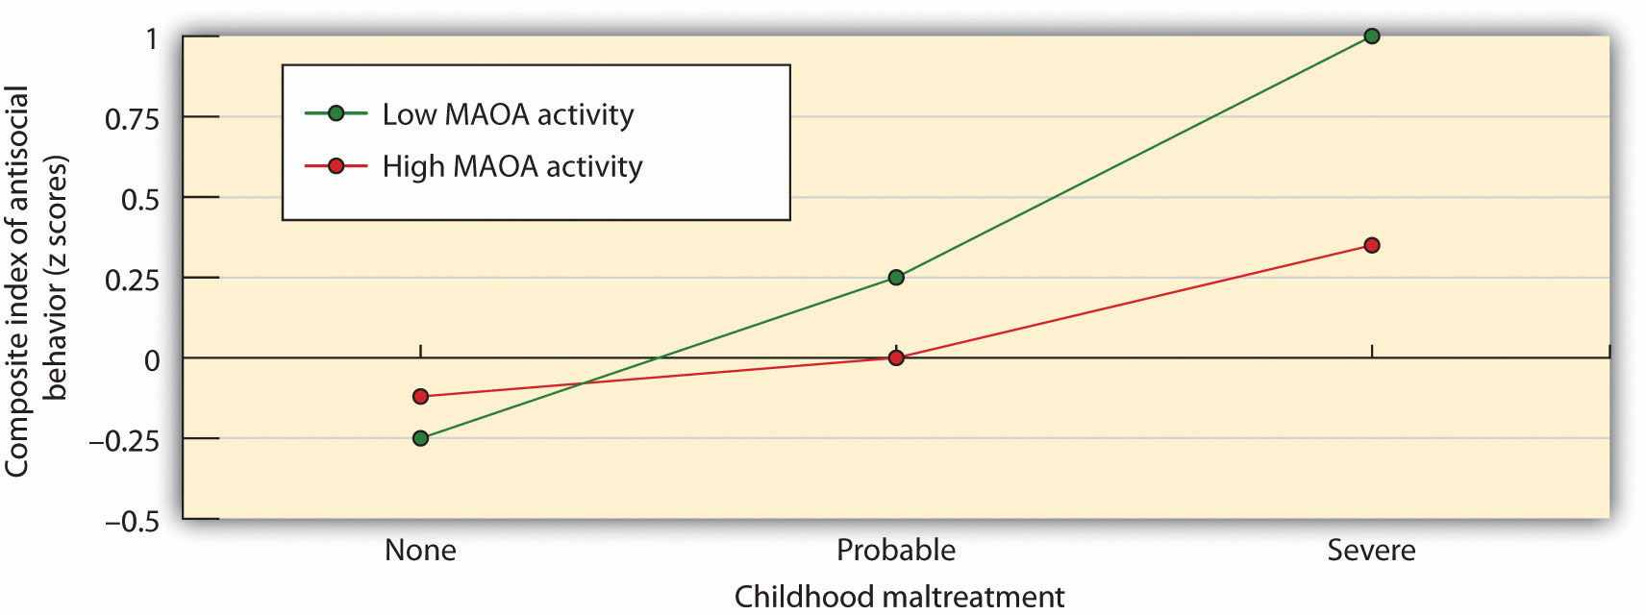
Caspi and his colleagues (2002) ^{[7]} found evidence for a person-by-situation interaction regarding the role of genetics and parental treatment in aggression. Antisocial behavior and aggression were greater for children who had been severely maltreated, but this effect was even stronger for children with a gene variation that reduced the production of serotonin.
Evolutionary principles suggest that we should be less likely to harm those who are genetically related to us than we are to harm others who are different. And research has supported this finding—for instance, biological parents are much less likely to abuse or murder their own children than stepparents are to harm their stepchildren (Daly & Wilson, 1998, 1999). ^{[8]} In fact, these researchers found that preschool children living with a stepparent or foster parent were many times more likely to be murdered by their parent than were children who lived with both biological parents.

The Role of Biology in Aggression
Aggression is controlled in large part by the area in the older part of the brain known as the amygdala (Figure 10.2 "Key Brain Structures Involved in Regulating and Inhibiting Aggression"). The amygdala is a brain region responsible for regulating our perceptions of, and reactions to, aggression and fear. The amygdala has connections with other body systems related to fear, including the sympathetic nervous system, facial responses, the processing of smells, and the release of neurotransmitters related to stress and aggression.
In addition to helping us experience fear, the amygdala also helps us learn from situations that create fear. The amygdala is activated in response to positive outcomes but also to negative ones, and particularly to stimuli that we see as threatening and fear arousing. When we experience events that are dangerous, the amygdala stimulates the brain to remember the details of the situation so that we learn to avoid it in the future. The amygdala is activated when we look at facial expressions of other people experiencing fear or when we are exposed to members of racial outgroups (Morris, Frith, Perrett, & Rowland, 1996; Phelps et al., 2000). ^{[9]}
Although the amygdala helps us perceive and respond to danger, and this may lead us to aggress, other parts of the brain serve to control and inhibit our aggressive tendencies. One mechanism that helps us control our negative emotions and aggression is a neural connection between the amygdala and regions of the prefrontal cortex (Gibson, 2002). ^{[10]}
The prefrontal cortex is in effect a control center for aggression: When it is more highly activated, we are more able to control our aggressive impulses. Research has found that the cerebral cortex is less active in murderers and death row inmates, suggesting that violent crime may be caused at least in part by a failure or reduced ability to regulate emotions (Davidson, Jackson, & Kalin, 2000; Davidson, Putnam, & Larson, 2000). ^{[11]}

Figure 10.2 Key Brain Structures Involved in Regulating and Inhibiting Aggression
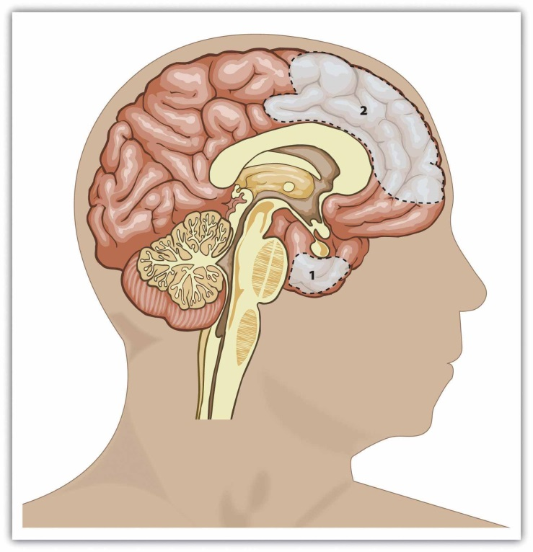
Brain regions that influence aggression include the amygdala (area 1) and the prefrontal cortex (area 2). Individual differences in one or more of these regions or in the interconnections among them can increase the propensity for impulsive aggression.

Hormones Influence Aggression: Testosterone and Serotonin
Hormones are also important in creating aggression. Most important in this regard is the male sex hormonetestosterone, which is associated with increased aggression in both animals and in humans. Research conducted on a variety of animals has found a strong correlation between levels of testosterone and aggression. This relationship seems to be weaker among humans than among animals, yet it is still significant (Dabbs, Hargrove, & Heusel, 1996). ^{[12]}
In one study showing the relationship between testosterone and behavior, James Dabbs and his colleagues (Dabbs, Hargrove, & Heusel, 1996) ^{[13]}measured the testosterone levels of 240 men who were members of 12 fraternities at two universities. They also obtained descriptions of the fraternities from university officials, fraternity officers, yearbook and chapter house photographs, and researcher field notes. The researchers correlated the testosterone levels and the descriptions of each of the fraternities. They found that the fraternities that had the highest average testosterone levels were also more wild and unruly, and in one case were known across campus for the crudeness of their behavior. The fraternities with the lowest average testosterone levels, on the other hand, were more well-behaved, friendly, academically successful, and socially responsible. Another study found that juvenile delinquents and prisoners who have high levels of testosterone also acted more violently (Banks & Dabbs, 1996).^{[14]} Testosterone affects aggression by influencing the development of various areas of the brain that control aggressive behaviors. The hormone also affects physical development such as muscle strength, body mass, and height that influence our ability to successfully aggress.
Although testosterone levels are much higher in men than in women, the relationship between testosterone and aggression is not limited to males. Studies have also shown a positive relationship between testosterone and aggression and related behaviors (such as competitiveness) in women (Cashdan, 2003). ^{[15]} Although women have lower levels of testosterone overall, they are more influenced by smaller changes in these levels than are men.
It must be kept in mind that the observed relationships between testosterone levels and aggressive behavior that have been found in these studies cannot prove that testosterone causes aggression—the relationships are only correlational. In fact, the effect of aggression on testosterone is probably stronger than the effect of testosterone on aggression. Engaging in aggression causes temporary increases in testosterone. People who feel that they have been insulted show both more aggression as well as more testosterone (Cohen, Nisbett, Bosdle, & Schwarz, 1996), ^{[16]} and the experience of stress is also associated with higher levels of testosterone and also with aggression. Even playing an aggressive game, such as tennis or chess, increases the testosterone levels of the winners and decreases the testosterone levels of the losers (Gladue, Boechler, & McCaul, 1989; Mazur, Booth, & Dabbs, 1992). ^{[17]} Perhaps this is why the fans at my university rioted after our team won the basketball championship.
Testosterone is not the only biological factor linked to human aggression. Recent research has found that serotonin is also important, as serotonin tends to inhibit aggression. Low levels of serotonin have been found to predict future aggression (Kruesi, Hibbs, Zahn, & Keysor, 1992; Virkkunen, de Jong, Bartko, & Linnoila, 1989).^{[18]} Violent criminals have lower levels of serotonin than do nonviolent criminals, and criminals convicted of impulsive violent crimes have lower serotonin levels than criminals convicted of premeditated crimes (Virkkunen, Nuutila, Goodwin, & Linnoila, 1987). ^{[19]}
In one experiment assessing the influence of serotonin on aggression, Berman, McCloskey, Fanning, Schumacher, and Coccaro (2009) ^{[20]} first chose two groups of participants, one of which indicated that they had frequently engaged in aggression (temper outbursts, physical fighting, verbal aggression, assaults, and aggression toward objects) in the past, and a second group that reported that they had not engaged in aggressive behaviors.
In a laboratory setting, participants from both groups were then randomly assigned to receive either a drug that raises serotonin levels or a placebo. Then the participants completed a competitive task with what they thought was another person in another room. (The opponent’s responses were actually controlled by computer.) During the task, the person who won each trial could punish the loser of the trial by administering electric shocks to the finger. Over the course of the game, the “opponent” kept administering more intense shocks to the participants.
As you can see in Figure 10.3, the participants who had a history of aggression were significantly more likely to retaliate by administering severe shocks to their opponent than were the less aggressive participants. The aggressive participants who had been given serotonin, however, showed significantly reduced aggression levels during the game. Increased levels of serotonin appear to help people and animals inhibit impulsive responses to unpleasant events (Soubrié, 1986). ^{[21]}

Figure 10.3
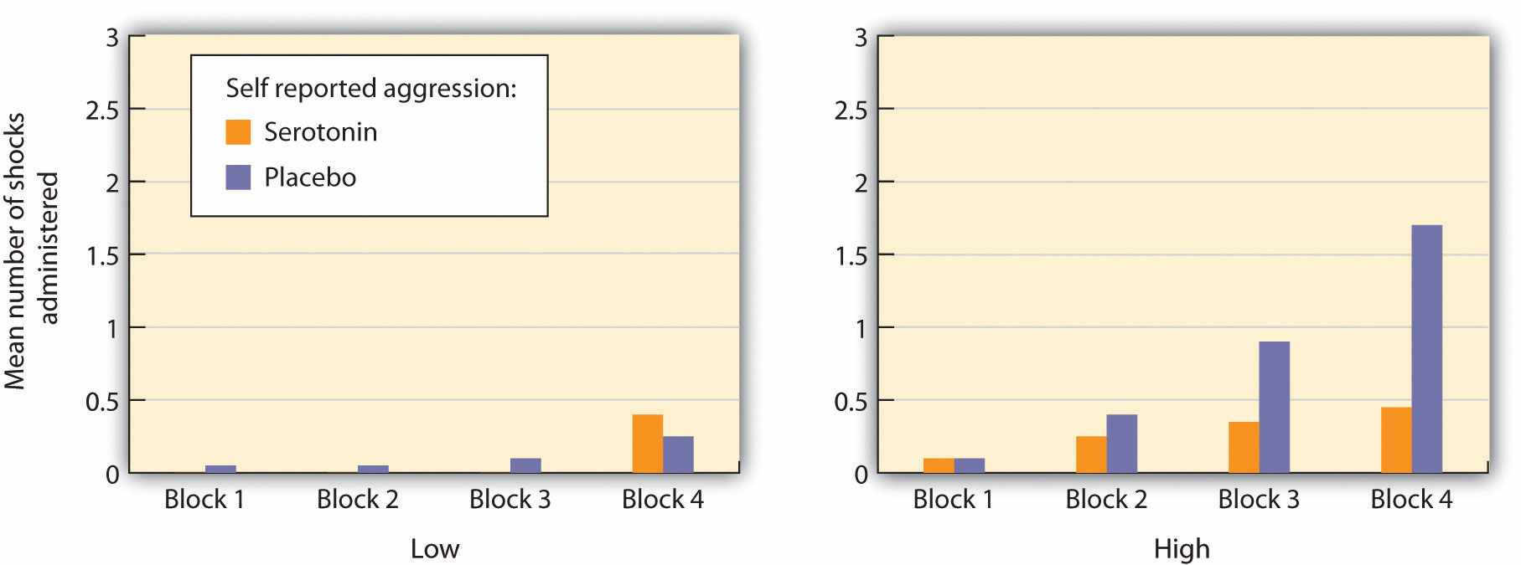
Participants who reported having engaged in a lot of aggressive behaviors (right panel) showed more aggressive responses in a competitive game than did those who reported being less aggressive (left panel). The aggression levels for the more aggressive participants increased over the course of the experiment for those who did not take a dosage of serotonin but aggression did not significantly increase for those who had taken serotonin. Data are from Berman et al. (2009). ^{[22]}

Drinking Alcohol Increases Aggression
Perhaps not surprisingly, research has found that the consumption of alcohol increases aggression. In fact, excessive alcohol consumption is involved in a majority of violent crimes, including rape and murder (Abbey, Ross, McDuffie, & McAuslan, 1996). ^{[23]} The evidence is very clear, both from correlational research designs and from experiments in which participants are randomly assigned either to ingest or not ingest alcohol, that alcohol increases the likelihood that people will respond aggressively to provocations (Bushman, 1997; Ito, Miller, & Pollock, 1996; Graham, Osgood, Wells, & Stockwell, 2006). ^{[24]} Even people who are not normally aggressive may react with aggression when they are intoxicated (Bushman & Cooper, 1990). ^{[25]}
Alcohol increases aggression for a couple of reasons. For one, alcohol disrupts executive functions, which are the cognitive abilities that help us plan, organize, reason, achieve goals, control emotions, and inhibit behavioral tendencies (Séguin & Zelazo, 2005). ^{[26]} Executive functioning occurs in the prefrontal cortex, which is the area that allows us to control aggression. Alcohol therefore reduces the ability of the person who has consumed it to inhibit his or her aggression (Steele & Southwick, 1985). ^{[27]} Acute alcohol consumption is more likely to facilitate aggression in people with low, rather than high, executive functioning abilities.
Secondly, when people are intoxicated, they become more self-focused and less aware of the social situation, a state that is known as alcohol myopia. As a result, they are less likely to notice the social constraints that normally prevent them from engaging aggressively and are less likely to use those social constraints to guide them. We might normally notice the presence of a police officer or other people around us, which would remind us that being aggressive is not appropriate, but when we are drunk we are less likely to be so aware. The narrowing of attention that occurs when we are intoxicated also prevents us from being aware of the negative outcomes of our aggression. When we are sober, we realize that being aggressive may produce retaliation as well as cause a host of other problems, but we are less likely to be aware of these potential consequences when we have been drinking (Bushman & Cooper, 1990). ^{[28]}
Alcohol also influences aggression through expectations. If we expect that alcohol will make us more aggressive, then we tend to become more aggressive when we drink. The sight of a bottle of alcohol or an alcohol advertisement increases aggressive thoughts and hostile attributions about others (Bartholow & Heinz, 2006), ^{[29]} and the belief that we have consumed alcohol increases aggression (Bègue et al., 2009). ^{[30]}

Negative Emotions Cause Aggression
If I were to ask you about the times that you have been aggressive, you probably would tell me that many of them occurred when you were angry, in a bad mood, tired, in pain, sick, or frustrated. And you would be right—we are much more likely to aggress when we are experiencing negative emotions. When we are feeling ill, when we get a poor grade on an exam, or when our car doesn’t start—in short, when we are angry and frustrated in general—we are likely to have many unpleasant thoughts and feelings, and these are likely to lead to violent behavior. Aggression is caused in large part by the negative emotions that we experience as a result of the aversive events that occur to us and by our negative thoughts that accompany them (Berkowitz & Heimer, 1989).^{[31]}
One kind of negative affect that increases arousal when we are experiencing it isfrustration (Berkowitz, 1989; Dollard, Doob, Miller, Mowrer, & Sears, 1939). ^{[32]}Frustration occurs when we feel that we are not obtaining the important goals that we have set for ourselves. We get frustrated when our computer crashes while we are writing an important paper, when we feel that our social relationships are not going well, or when our schoolwork is going poorly. How frustrated we feel is also determined in large part through social comparison. If we can make downward comparisons with important others, in which we see ourselves as doing as well or better than they are, then we are less likely to feel frustrated. But when we are forced to make upward comparisons with others, we may feel frustration. When we receive a poorer grade than our classmates received or when we are paid less than our coworkers, this can be frustrating to us.
Although frustration is one cause of the negative affect that can lead to aggression, there are other sources as well. In fact, anything that leads to discomfort or negative emotions can increase aggression. For instance, working in extremely high temperatures is known to increase aggression—when we are hot, we are more aggressive. Griffit and Veitch (1971) ^{[33]} had students complete questionnaires either in rooms in which the heat was at a normal temperature or in rooms in which the temperature was over 90 degrees Fahrenheit. The students in the latter conditions expressed significantly more hostility.
Hotter temperatures are associated with higher levels of aggression and violence (Anderson, Anderson, Dorr, DeNeve, & Flanagan, 2000). ^{[34]} Hotter regions generally have higher violent crime rates than cooler regions, and violent crime is greater on hot days than it is on cooler days, and during hotter years than during cooler years (Bushman, Wang, & Anderson, 2005). ^{[35]} Even the number of baseball batters hit by pitches is higher when the temperature at the game is higher (Reifman, Larrick, & Fein, 1991). ^{[36]} Researchers who study the relationship between heat and aggression have proposed that global warming is likely to produce even more violence (Anderson & Delisi, 2011). ^{[37]} Pain also increases aggression. Berkowitz (1993) ^{[38]}reported a study in which participants were made to feel pain by placing their hands in a bucket of ice-cold water, and it was found that this source of pain also increased subsequent aggression.

Research Focus
The Effects of Provocation and Fear of Death on Aggression
McGregor et al. (1998) ^{[39]} demonstrated that people who have been provoked by others may be particularly aggressive if they are also experiencing negative emotions about the fear of their own death. The participants in the study had been selected, on the basis of prior reporting, to have either politically liberal or politically conservative views. When they arrived at the lab they were asked to write a short paragraph describing their opinion of politics in the United States. In addition, half of the participants (the mortality salient condition) were asked to “briefly describe the emotions that the thought of your own death arouses in you” and to “Jot down as specifically as you can, what you think will happen to you as you physically die, and once you are physically dead.” Participants in theexam control condition also thought about a negative event, but not one associated with a fear of death. They were instructed to “Please briefly describe the emotions that the thought of your next important exam arouses in you’’ and to “Jot down as specifically as you can, what you think will happen to you as you physically take your next exam, and once you are physically taking your next exam.”
Then the participants read an essay that had supposedly just been written by another person in the study. (The other person did not exist, but the participants didn’t know this until the end of the experiment.) The essay that the participants read had been prepared by the experimenters to condemn politically liberal views or to condemn politically conservative views. Thus one-half of the participants were provoked by the other person by reading a statement that strongly conflicted with their own political beliefs, whereas the other half read an essay that supported their (liberal or conservative) beliefs.
At this point the participants moved on to what they thought was a completely separate study in which they were to be tasting and giving their impression of some foods. Furthermore, they were told that it was necessary for the participants in the research to administer the food samples to each other. The participants then found out that the food they were going to be sampling was spicy hot sauce and that they were going to be administering the sauce to the same person whose essay they had just read! In addition, the participants read some information about the other person that indicated that the other person very much disliked eating spicy food. Participants were given a taste of the hot sauce (which was very hot) and then instructed to place a quantity of it into a cup for the other person to sample. Furthermore, they were told that the other person had to eat all the sauce.
As you can see in Figure 10.4 "Mortality Salience and Aggression", this research provides another example of how negative feelings can lead us to be aggressive after we have been provoked. The threatening essay had little effect on the participants in the exam control condition. On the other hand, the participants who were both provoked by the other person and who had also been reminded of their own death administered significantly more aggression than did the participants in the other three conditions.

Figure 10.4 Mortality Salience and Aggression ^{[40]}
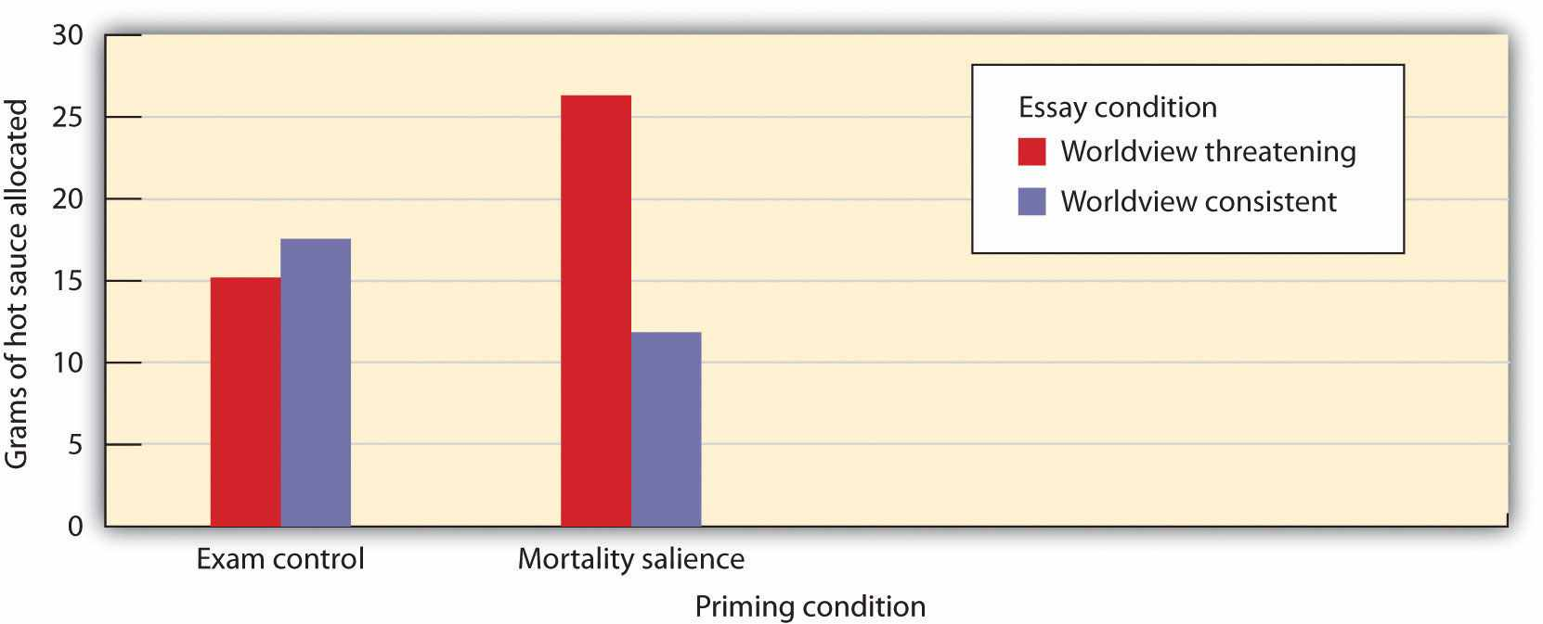
A threat to one’s worldview increased aggression but only for participants who had been thinking about their own death. Data are from McGregor et al. (1998).
Just as negative feelings can increase aggression, positive affect can reduce it. In one study (Baron & Ball, 1974), ^{[41]} participants were first provoked by an experimental confederate. Then the participants were, according to random assignment, shown either funny cartoons or neutral pictures. When the participants were given an opportunity to retaliate by giving shocks as part of an experiment on learning, those who had seen the positive cartoons gave fewer shocks than those who had seen the neutral pictures.
It seems that feeling good about ourselves, or feeling good about others, is incompatible with anger and aggression. You can see that this is in essence the flip side of the results we discussed in Chapter 9 "Helping and Altruism" regarding altruism: Just as feeling bad leads us to aggress, feeling good makes us more likely to help and less likely to hurt others. This makes perfect sense, of course, since emotions are signals regarding the threat level around us. When we feel good, we feel safe and do not think that we need to aggress.
Of course, negative emotions do not always lead to aggression toward the source of our frustration. If we get a bad grade from our teacher or a ticket from a police officer, it is not likely that we will directly aggress against him or her. Rather, we may displace our aggression onto others, and particularly toward others who seem similar to the source of our frustration (Miller, Pedersen, Earleywine, & Pollock, 2003). ^{[42]}Displaced aggression occurs when negative emotions caused by one person trigger aggression toward a different person. A recent meta-analysis has found clear evidence that people who are provoked but are unable to retaliate against the person who provoked them are more aggressive toward an innocent other person, and particularly toward people who are similar in appearance to the true source of the provocation, in comparison to those who were not previously provoked (Marcus-Newhall, Pedersen, Carlson, & Miller, 2000). ^{[43]}
It is clear that negative affect increases aggression. And you will recall that emotions that are accompanied by high arousal are more intense than those that have only low levels of arousal. Thus it would be expected that aggression is more likely to occur when we are more highly aroused, and indeed this is the case. For instance, in his important research on arousal, Dolf Zillmann (Zillman, Hoyt, & Day, 1974; Zillman, Katcher, & Milavsky, 1972) ^{[44]} found that many types of stimuli that created arousal, including riding on a bicycle, listening to an erotic story, and experiencing loud noises, tended to increase both arousal as well as aggression. Arousal probably has its effects on aggression in part through the misattribution of emotion. If we are experiencing arousal that was actually caused by a loud noise or by any other cause, we might misattribute that arousal as anger toward someone who has recently frustrated or provoked us.

Can We Reduce Negative Emotions by Engaging in Aggressive Behavior?
We have seen that when we are experiencing strong negative emotions accompanied by arousal, such as when we are frustrated, angry, or uncomfortable, or anxious about our own death, we may be more likely to aggress. However, if we are aware that we are feeling these negative emotions, we might try to find a solution to prevent ourselves from lashing out at others. Perhaps, we might think, if we can release our negative emotions in a relatively harmless way, then the probability that we will aggress might decrease. Maybe you have tried this method. Have you ever tried to yell really loud, hit a pillow, or kick something when you are angry, with the hopes that doing so will release your aggressive tendencies?
The idea that engaging in less harmful aggressive actions will reduce the tendency to aggress later in a more harmful way, known as catharsis, is an old one. It was mentioned as a way of decreasing violence by the Greek philosopher Aristotle and was an important part of the theories of Sigmund Freud. Many others believe in catharsis too. Russell, Arms, and Bibby (1995) ^{[45]} reported that more than two-thirds of the people they surveyed believed in catharsis, agreeing with statements that suggested that participating in and observing aggressive sports and other aggressive activities is a good way to get rid of one’s aggressive urges. People who believe in the value of catharsis use it because they think that doing so is going to make them feel better (Bushman, Baumeister, & Phillips, 2001). ^{[46]} The belief in catharsis leads people to engage in popular techniques such as venting and cathartic therapies, even though numerous studies have shown that these approaches are not effective.
It is true that reducing negative affect and arousal can reduce the likelihood of aggression. For instance, if we are able to distract ourselves from our negative emotions or our frustration by doing something else, rather than ruminating on it, we can feel better and will be less likely to aggress. However, as far as social psychologists have been able to determine, attempting to remove negative emotions by engaging in or observing aggressive behaviors (that is, the idea of catharsis) simply does not work.
In one relevant study, Bushman, Baumeister, and Stack (1999) ^{[47]} first had their participants write an article about their opinions about a social topic such as abortion. Then they convinced them that another participant had read the article and provided very negative feedback about it. The other person said such things as, “This is one of the worst essays I have read!” Then the participants read a message suggesting that catharsis really did work. (It claimed that engaging in aggressive action is a good way to relax and reduce anger.) At this point half of the participants were allowed to engage in a cathartic behavior—they were given boxing gloves, some instructions about boxing, and then got a chance to hit a punching bag for two minutes.
Then all the participants got a chance to engage in aggression with the same person who had angered them earlier. The participant and the partner played a game in which the losing person on each trial received a blast of noise. At the beginning of each trial each participant was permitted to set the intensity of the noise that the other person would receive if he or she lost the trial, as well as the duration of the loser’s suffering, because the duration of the noise depended on how long the winner pressed the button.
Contrary to the catharsis hypothesis, the students who punched the punching bag did not release and reduce their aggression as the message they had read suggested would happen. Rather, these students actually set a higher noise level and delivered longer bursts of noise than did the participants who did not get a chance to hit the punching bag. It seems that if we hit a punching bag, punch a pillow, or scream as loud as we can, with the idea of releasing our frustration, the opposite occurs—rather than decreasing aggression, these behaviors in fact increase it (Bushman et al., 1999). ^{[48]}Participating in aggression simply makes us more, not less, aggressive.
One prediction that could be derived from the catharsis idea is that countries that are currently fighting wars would show less domestic aggression than those that are not. After all, the citizens in these countries read about the war in the newspapers and see images of it on TV on a regular basis—wouldn’t that reduce their needs and desires to aggress in other ways? Again, the answer is no. Rather than decreasing, aggressionincreases when the country that one lives in is currently or recently fighting a war. In an archival study, Archer and Gartner (1976) ^{[49]} found that countries that were in wars experienced significant postwar increases in their rates of homicide. These increases were large in magnitude, occurred after both large wars and smaller wars, with several types of homicide rate indicators, in victorious as well as defeated nations, in nations with both improved and worsened postwar economies, among both men and women offenders, and among offenders of several age groups. Homicide rate increases occurred with particular consistency among nations with large numbers of combat deaths.
The increases in aggression that follow from engaging in aggressive behavior are not unexpected—and they occur for a variety of reasons. For one, engaging in a behavior that relates to violence, such as punching a pillow, increases our arousal. Furthermore, if we enjoy engaging in the aggressive behavior, we may be rewarded, making us more likely to engage in it again. And aggression reminds us of the possibility of being aggressive in response to our frustrations. In sum, relying on catharsis by engaging in or viewing aggression is dangerous behavior—it is more likely to increase the flames of aggression than to put them out. It is better to simply let the frustration dissipate over time or perhaps to engage in other nonviolent but distracting activities.

KEY TAKEAWAYS
- The ability to aggress is part of the evolutionary adaptation of humans. But aggression is not the only, nor always the best, approach to dealing with conflict.
- The amygdala plays an important role in monitoring fearful situations and creating aggressive responses to them. The prefrontal cortex serves as a regulator to our aggressive impulses.
- The male sex hormone testosterone is closely associated with aggression in both men and women. The neurotransmitter serotonin helps us inhibit aggression.
- Negative emotions, including fear, anger, pain, and frustration, particularly when accompanied by high arousal, may create aggression.
- Contrary to the idea of catharsis, social psychological research has found that engaging in aggression does not reduce further aggression.

EXERCISES AND CRITICAL THINKING
- Review a time when you acted in an aggressive way. What do you think caused the behavior? Were there particular negative emotions that were responsible?
- Consider a time when you or someone you know engaged in an aggressive act with the goal of reducing further aggression (catharsis). Was the attempt successful?

[1] Buss, D. M., & Duntley, J. D. (Eds.). (2006). The evolution of aggression. Madison, CT: Psychosocial Press.
[2] Berkowitz, L. (1993). Aggression: Its causes, consequences and control. New York, NY: McGraw-Hill.
[3] Lagerspetz, K. M., & Lagerspetz, K. Y. (1971). Changes in the aggressiveness of mice resulting from selective breeding, learning and social isolation. Scandinavian Journal of Psychology, 12(4), 241–248.
[4] Coie, J. D., & Dodge, K. A. (1998). Aggression and antisocial behavior. In N. Eisenberg & W. Damon (Eds.), Handbook of child psychology (5th ed., Vol. 3, pp. 779–862). Hoboken, NJ: John Wiley & Sons; Dubow, E. F., Huesmann, L. R., & Boxer, P. (2003). Theoretical and methodological considerations in cross-generational research on parenting and child aggressive behavior. Journal of Abnormal Child Psychology, 31(2), 185–192; Raine, A. (1993).The psychopathology of crime: Criminal behavior as a clinical disorder. San Diego, CA: Academic Press.
[5] Tellegen, A., Lykken, D. T., Bouchard, T. J., Wilcox, K. J., Segal, N. L., & Rich, S. (1988). Personality similarity in twins reared apart and together. Journal of Personality and Social Psychology, 54(6), 1031–1039.
[6] Caspi, A., McClay, J., Moffitt, T., Mill, J., Martin, J., Craig, I. W.…Poulton, R. (2002). Role of genotype in the cycle of violence in maltreated children. Science, 297(5582), 851–854.
[7] Caspi, A., McClay, J., Moffitt, T., Mill, J., Martin, J., Craig, I. W.Caspi, A., McClay, J., Moffitt, T., Mill, J., Martin, J., Craig, I. W., et al.#8230;Poulton, R. (2002). Role of genotype in the cycle of violence in maltreated children. Science, 297(5582), 851–854.
[8] Daly, M., & Wilson, M. (Eds.). (1998). The evolutionary social psychology of family violence. Mahwah, NJ: Lawrence Erlbaum; Daly, M., & Wilson, M. (Eds.). (1999). An evolutionary psychological perspective on homicide. Thousand Oaks, CA: Sage.
[9] Morris, J. S., Frith, C. D., Perrett, D. I., & Rowland, D. (1996). A differential neural response in the human amygdala to fearful and happy facial expressions. Nature, 383(6603), 812–815; Phelps, E. A., O’Connor, K. J., Cunningham, W. A., Funayama, E. S., Gatenby, J. C., Gore, J. C., & Banaji, M. R. (2000). Performance on indirect measures of race evaluation predicts amygdala activation. Journal of Cognitive Neuroscience, 12(5), 729–738.
[10] Gibson, K. R. (2002). Evolution of human intelligence: The roles of brain size and mental construction. Brain Behavior and Evolution, 59, 10–20.
[11] Davidson, R. J., Jackson, D. C., & Kalin, N. H. (2000). Emotion, plasticity, context, and regulation: Perspectives from affective neuroscience. Psychological Bulletin, 126(6), 890–909; Davidson, R. J., Putnam, K. M., & Larson, C. L. (2000). Dysfunction in the neural circuitry of emotion regulation—A possible prelude to violence. Science, 289(5479), 591–594.
[12] Dabbs, J. M., Jr., Hargrove, M. F., & Heusel, C. (1996). Testosterone differences among college fraternities: Well-behaved vs. rambunctious. Personality and Individual Differences, 20(2), 157–161.
[13] Dabbs, J. M., Jr., Hargrove, M. F., & Heusel, C. (1996). Testosterone differences among college fraternities: Well-behaved vs. rambunctious. Personality and Individual Differences, 20(2), 157–161.
[14] Banks, T., & Dabbs, J. M., Jr. (1996). Salivary testosterone and cortisol in delinquent and violent urban subculture. Journal of Social Psychology, 136(1), 49–56.
[15] Cashdan, E. (2003). Hormones and competitive aggression in women. Aggressive Behavior, 29(2), 107–115.
[16] Cohen, D., Nisbett, R. E., Bosdle, B., & Schwarz, N. (1996). Insult, aggression, and the southern culture of honor: An “experimental ethnography.” Journal of Personality and Social Psychology, 70, 945–960.
[17] Gladue, B. A., Boechler, M., & McCaul, K. D. (1989). Hormonal response to competition in human males. Aggressive Behavior, 15(6), 409–422; Mazur, A., Booth, A., & Dabbs, J. M. (1992). Testosterone and chess competition. Social Psychology Quarterly, 55(1), 70–77.
[18] Kruesi, M. J., Hibbs, E. D., Zahn, T. P., & Keysor, C. S. (1992). A 2-year prospective follow-up study of children and adolescents with disruptive behavior disorders: Prediction by cerebrospinal fluid 5-hydroxyindoleacetic acid, homovanillic acid, and autonomic measures?Archives of General Psychiatry, 49(6), 429–435; Virkkunen, M., de Jong, J., Bartko, J. J., & Linnoila, M. (1989). Psychobiological concomitants of history of suicide attempts among violent offenders and impulsive fire setters. Archives of General Psychiatry, 46(7), 604–606.
[19] Virkkunen, M., Nuutila, A., Goodwin, F. K., & Linnoila, M. (1987). Cerebrospinal fluid monoamine metabolite levels in male arsonists. Archives of General Psychiatry, 44(3), 241–247.
[20] Berman, M. E., McCloskey, M. S., Fanning, J. R., Schumacher, J. A., & Coccaro, E. F. (2009). Serotonin augmentation reduces response to attack in aggressive individuals. Psychological Science, 20(6), 714–720.
[21] Soubrié, P. (1986). Reconciling the role of central serotonin neurons in human and animal behavior. Behavioral and Brain Sciences, 9(2), 319–335.
[22] Berman, M. E., McCloskey, M. S., Fanning, J. R., Schumacher, J. A., & Coccaro, E. F. (2009). Serotonin augmentation reduces response to attack in aggressive individuals. Psychological Science, 20(6), 714–720.
[23] Abbey, A., Ross, L. T., McDuffie, D., & McAuslan, P. (1996). Alcohol and dating risk factors for sexual assault among college women. Psychology of Women Quarterly, 20(1), 147–169.
[24] Bushman, B. J. (Ed.). (1997). Effects of alcohol on human aggression: Validity of proposed explanations. New York, NY: Plenum Press; Graham, K., Osgood, D. W., Wells, S., & Stockwell, T. (2006). To what extent is intoxication associated with aggression in bars? A multilevel analysis. Journal of Studies on Alcohol, 67(3), 382–390; Ito, T. A., Miller, N., & Pollock, V. E. (1996). Alcohol and aggression: A meta-analysis on the moderating effects of inhibitory cues, triggering events, and self-focused attention. Psychological Bulletin, 120(1), 60–82.
[25] Bushman, B. J., & Cooper, H. M. (1990). Effects of alcohol on human aggression: An integrative research review. Psychological Bulletin, 107(3), 341–354.
[26] Séguin, J. R., & Zelazo, P. D. (2005). Executive function in early physical aggression. In R. E. Tremblay, W. W. Hartup, & J. Archer (Eds.), Developmental origins of aggression (pp. 307–329). New York, NY: Guilford Press.
[27] Steele, C. M., & Southwick, L. (1985). Alcohol and social behavior: I. The psychology of drunken excess. Journal of Personality and Social Psychology, 48(1), 18–34.
[28] Bushman, B. J., & Cooper, H. M. (1990). Effects of alcohol on human aggression: An integrative research review. Psychological Bulletin, 107(3), 341–354.
[29] Bartholow, B. D., & Heinz, A. (2006). Alcohol and aggression without consumption: Alcohol cues, aggressive thoughts, and hostile perception bias. Psychological Science, 17(1), 30–37.
[30] Bègue, L., Subra, B., Arvers, P., Muller, D., Bricout, V., & Zorman, M. (2009). A message in a bottle: Extrapharmacological effects of alcohol on aggression. Journal of Experimental Social Psychology, 45(1), 137–142.
[31] Berkowitz, L., & Heimer, K. (1989). On the construction of the anger experience: Aversive events and negative priming in the formation of feelings. In L. Berkowitz (Ed.), Advances in experimental social psychology (Vol. 22, pp. 1–37). San Diego, CA: Academic Press.
[32] Berkowitz, L. (1989). Frustration-aggression hypothesis: Examination and reformulation.Psychological Bulletin, 106(1), 59–73; Dollard, J., Miller, N., & Doob, L. (1939). Frustration and aggression. New Haven, CT: Yale University Press.
[33] Griffit, W., & Veitch, R. (1971). Hot and crowded: Influence of population density and temperature on interpersonal affective behavior. Journal of Personality and Social Psychology, 17(1), 92–98.
[34] Anderson, C. A., Anderson, K. B., Dorr, N., DeNeve, K. M., & Flanagan, M. (2000). Temperature and aggression. In M. P. Zanna (Ed.), Advances in experimental social psychology (Vol. 32, pp. 63–133). San Diego, CA: Academic Press.
[35] Bushman, B. J., Wang, M. C., & Anderson, C. A. (2005). Is the curve relating temperature to aggression linear or curvilinear? Assaults and temperature in Minneapolis reexamined.Journal of Personality and Social Psychology, 89(1), 62–66.
[36] Reifman, A. S., Larrick, R. P., & Fein, S. (1991). Temper and temperature on the diamond: The heat-aggression relationship in major league baseball. Personality and Social Psychology Bulletin, 17(5), 580–585.
[37] Anderson, C. A., & DeLisi, M. (2011). Implications of global climate change for violence in developed and developing countries. In J. Forgas, A. Kruglanski, & K. Williams (Eds.), Social conflict and aggression. New York, NY: Psychology Press.
[38] Berkowitz, L. (1993). Pain and aggression: Some findings and implications. Motivation and Emotion, 17(3), 277–293.
[39] McGregor, H. A., Lieberman, J. D., Greenberg, J., Solomon, S., Arndt, J., Simon, L., & Pyszczynski, T. (1998). Terror management and aggression: Evidence that mortality salience motivates aggression against worldview-threatening others. Journal of Personality and Social Psychology, 74(3), 590–605.
[40] McGregor, H. A., Lieberman, J. D., Greenberg, J., Solomon, S., Arndt, J., Simon, L., & Pyszczynski, T. (1998). Terror management and aggression: Evidence that mortality salience motivates aggression against worldview-threatening others. Journal of Personality and Social Psychology, 74(3), 590–605.
[41] Baron, R. A., & Ball, R. L. (1974). The aggression-inhibiting influence of nonhostile humor.Journal of Experimental Social Psychology, 10(1), 23–33.
[42] Miller, N., Pedersen, W. C., Earleywine, M., & Pollock, V. E. (2003). A theoretical model of triggered displaced aggression. Personality and Social Psychology Review, 7(1), 75–97.
[43] Marcus-Newhall, A., Pedersen, W. C., Carlson, M., & Miller, N. (2000). Displaced aggression is alive and well: A meta-analytic review. Journal of Personality and Social Psychology, 78(4), 670–689.
[44] Zillman, D., Hoyt, J. L., & Day, K. D. (1974). Strength and duration of the effect of aggressive, violent, and erotic communications on subsequent aggressive behavior.Communication Research, 1(3), 286–306; Zillman, D., Katcher, A. H., & Milavsky, B. (1972). Excitation transfer from physical exercise to subsequent aggressive behavior. Journal of Experimental Social Psychology, 8(3), 247–259.
[45] Russell, G. W., Arms, R. L., & Bibby, R. W. (1995). Canadians’ beliefs in catharsis. Social Behavior and Personality, 23(3), 223–228.
[46] Bushman, B. J., Baumeister, R. F., & Phillips, C. M. (2001). Do people aggress to improve their mood? Catharsis beliefs, affect regulation opportunity, and aggressive responding.Journal of Personality and Social Psychology, 81(1), 17–32.
[47] Bushman, B. J., Baumeister, R. F., & Stack, A. D. (1999). Catharsis, aggression, and persuasive influence: Self-fulfilling or self-defeating prophecies? Journal of Personality and Social Psychology, 76(3), 367–376.
[48] Bushman, B. J., Baumeister, R. F., & Stack, A. D. (1999). Catharsis, aggression, and persuasive influence: Self-fulfilling or self-defeating prophecies? Journal of Personality and Social Psychology, 76(3), 367–376.
[49] Archer, D., & Gartner, R. (1976). Violent acts and violent times: A comparative approach to postwar homicide rates. American Sociological Review, 41(6), 937–963.

10.3 The Violence Around Us: How the Social Situation Influences Aggression

LEARNING OBJECTIVES
- Review the situational variables that increase and decrease aggression.
- Explain the different effects of reward, punishment, and modeling on aggression.
- Review the influences of viewing violent behavior on aggression and explain why these effects might occur.
Although emotions and biology are critical, they are not the only determinants of our aggression. Of particular importance to social psychologists is the role of the social situation.

Social Learning and Modeling: Is Aggression Learned?
As would be expected by principles of social reinforcement, if we are rewarded for being aggressive, we’ll likely aggress again, but if we are punished for our violence, we may subsequently curb our aggression. The child who gets a toy by hitting another child and taking it is likely to continue being aggressive in the future, particularly if he or she is not punished for the action. Children who are more aggressive are also often seen as more competent, in part because they can use their aggression to get their way (Hawley, 2007). ^{[1]} Björkqvist et al. (2001) ^{[2]} found that girls who use nonphysical aggression reported being less lonely and were more likely to have higher status than did nonaggressive girls. In another study, aggressive boys were more likely to be accepted by their peers than were nonaggressive boys (Salmivalli, Kaukiainen, & Lagerspetz, 2000). ^{[3]} Aggression seems to be paying off for these students.
Some aggression is learned through modeling the violence that we see all around us every day (Bandura & Walters, 1959). ^{[4]} In his important research on aggression (see Video Clip 1), Albert Bandura demonstrated that children learned new aggressive behaviors by observing aggressive models (Bandura, 1973). ^{[5]} Bandura argued that we don’t just imitate the specific behaviors that we see, but that viewing aggression changes our schemas and our attitudes about aggression. Watching a parent hitting the other parent may not only increase a child’s likelihood of hitting but may also increase his or her beliefs that “hitting is OK” and that “one way to solve problems is by hitting.” Modeling teaches new ideas about aggression and can help explain why exposure to violence increases aggressive behavior in the long run (Huesmann & Kirwil, 2007). ^{[6]}

Video Clip 1
Bandura’s Studies on Modeling Aggression
Modeling is particularly problematic for children who grow up in violent families. These children are not only the victims of aggression, but they also see violence being inflicted on their parents and siblings. Because children learn how to be parents in large part by modeling the actions of their parents, it is no surprise that there is a strong correlation between family violence in childhood and violence as an adult. Children who witness their parents being violent or who are themselves abused are more likely as adults to inflict abuse on their partners and children (Heyman & Slep, 2002). ^{[7]} In turn, their own children are also more likely to interact violently with each other and to aggress against their parents (Patterson, Dishion, & Bank, 1984).^{[8]}
Although rewards clearly increase aggression, do you think that punishment decreases it? Judicial systems are based in large part on punishing people for being aggressive, with fines, jail terms, and even the death penalty being used as punishments. It has been argued that the dramatic decrease in crime in New York City during the 1990s was due to the “zero tolerance” policy of then Mayor Guiliani, in which the police gave tickets for even minor crimes such as vandalism and jaywalking.
There is, however, a problem with using punishment to reduce aggression, particularly when the punishment is itself aggressive. The problem is that the punishment may be modeled, which can increase the aggressive behaviors that we are trying to stop. In a recent meta-analysis, Gershoff (2002) ^{[9]} found that although children who were spanked by their parents were more likely to immediately comply with the parents’ demands, they were also more aggressive, showed less ability to control aggression, and had poorer mental health in the long term. The problem seems to be that children who are punished for bad behavior may be more likely to change their behavior only for external reasons, rather than internalizing the norms of being good for its own sake.
Punishment is most effective when it is intense, prompt (before the person can derive much pleasure from the aggression), applied consistently and with certainty, perceived as justified, and replaced by a more desirable alternative behavior (Berkowitz, 1993).^{[10]} But even if punishment occurs under these ideal conditions, it may only suppress aggressive behavior temporarily (Baron & Richardson, 1994; Berkowitz, 1993). ^{[11]}
One example of the use of violence to attempt to stop violence is capital punishment—the use of the death penalty. Although banned in many countries, capital punishment is used in the United States in some cases of premeditated homicide. Although many people believe that capital punishment deters crime, there is little evidence that it actually does (Archer, Gartner, & Beittel, 1983). ^{[12]} For one, the time period between the crime and the punishment is many years long, which makes it less effective as a deterrent. Second, most of the crimes that are punished by the death penalty involve emotional aggression and are not premeditated. They occur during arguments or while the perpetrator is under the influence of alcohol or recreational drugs. In these cases even if the perpetrator has knowledge of the death penalty, this knowledge is not likely to have much effect on reducing crime. And capital punishment also means that many innocent people are wrongly executed for crimes they did not commit.

Violence Creates More Violence: Television, Video Games, and Handguns
The average American child watches over four hours of television every day, and these programs contain both physical and nonphysical aggression (Coyne & Archer, 2005).^{[13]} Furthermore, the amount, intensity, and graphic nature of the violence that children view continues to escalate every year. It has been estimated that by the age of 12, the average American child has seen over 8,000 murders and 100,000 acts of violence (Huston et al., 1992). ^{[14]} At the same time, children are also exposed to violence in movies, video games, and virtual reality games, as well as in popular music and music videos that include violent lyrics and imagery.
Given your knowledge about the importance of the social situation, it might not surprise you to hear that these situational exposures to violence have an effect on aggressive behavior, and in fact they do. The evidence is impressive and clear: The more media violence people, including children, view, the more aggressive they are likely to be (Anderson et al., 2003; Cantor et al., 2001). ^{[15]} The relation between viewing TV violence and aggressive behavior is about as strong as the relation between smoking and cancer or between studying and academic grades (Bushman & Huesmann, 2010). ^{[16]} If you watch a lot of violence, you are likely to become aggressive!

Figure 10.5
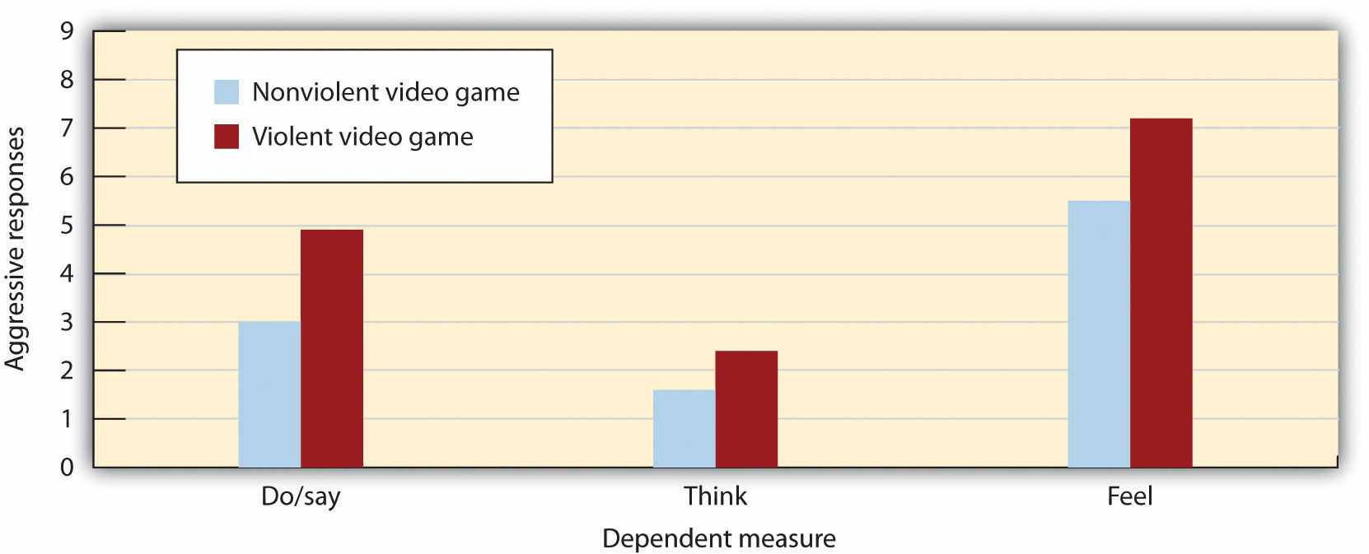
Participants who had recently played a violent video game expressed significantly more violent responses to a story than did those who had recently played a nonviolent video game. Data are from Bushman and Anderson (2002). ^{[17]}
The evidence is so clear because it has come through the accumulation of many studies conducted over many years, using a variety of research designs. These studies have included laboratory and field experiments, as well as both cross-sectional and longitudinal correlational studies, and have used people from many different cultures. In the correlational studies, many potential common-causing variables, such as intelligence, family background, socioeconomic status, and personality, have been controlled. The potential for reverse causation has been eliminated through studies that have shown that viewing violence at a young age tends to predict aggressive behavior when the child is older, more than the other way around. Furthermore, laboratory studies in which people have been randomly assigned to view either violent or nonviolent material have shown the same results (Paik & Comstock, 1994; Zillman & Weaver, 1999). ^{[18]} In one recent study, Coyne, Archer, and Eslea (2004) ^{[19]} found that adolescents who viewed either physical or nonphysical aggression were subsequently more likely to behave in an aggressive manner that those who viewed no aggression.

Research Focus
The Effects of Violent Video Games on Aggression
It is clear that watching TV violence can increase aggression, but what about violent video games? These games are more popular than ever and also more graphically violent. Children spend countless hours playing video games, many of which involve engaging in extremely violent behaviors. The games often require the player to take the role of a violent person, to identify with the character, to select victims, and of course to kill people. These behaviors are rewarded by winning points and moving on to higher levels and are repeated over and over.
Again, the answer is clear—playing violent video games leads to aggression. A recent meta-analysis (Anderson & Bushman, 2001) ^{[20]} reviewed 35 research studies that had tested the effects of playing violent video games on aggression. The studies included both experimental and correlational studies, with both male and female participants in both laboratory and field settings. They found that exposure to violent video games is significantly linked to increases in aggressive thoughts, aggressive feelings, psychological arousal (including blood pressure and heart rate), as well as aggressive behavior. Furthermore, playing more video games was found to relate to less altruistic behavior.
Bushman and Anderson (2002) ^{[21]} directly assessed the effects of viewing violent video games on aggressive thoughts and behavior. In one of their studies, participants were randomly assigned to play either a violent or a nonviolent video game for 20 minutes. Each participant played one of four violent video games (Carmageddon, Duke Nukem, Mortal Kombat, or Future Cop) or one of four nonviolent video games (Glider Pro, 3D Pinball, Austin Powers, or Tetra Madness).
Participants then read a story—for instance, this one about Todd—and were asked to list 20 thoughts, feelings, and actions about how they would respond if they were Todd:
Todd was on his way home from work one evening when he had to brake quickly for a yellow light. The person in the car behind him must have thought Todd was going to run the light because he crashed into the back of Todd’s car, causing a lot of damage to both vehicles. Fortunately, there were no injuries. Todd got out of his car and surveyed the damage. He then walked over to the other car.
As you can see in Figure 10.5, the students who had played one of the violent video games responded much more aggressively to the stories than did those who played the nonviolent games. In fact, their responses were often extremely aggressive. They said things like “Call the guy an idiot,” “Kick the other driver’s car,” “This guy’s dead meat!” and “What a dumbass!” Other studies have found similar results (Konijn, Nije Bijvank, & Bushman, 2007), ^{[22]} and longitudinal studies in the United States and in Japan have shown that playing violent video games predicts aggressive behaviors and thoughts several months later, even after controlling for initial level of aggression (Anderson, Gentile, & Buckley, 2007; Anderson et al., 2008). ^{[23]}

Why Does Viewing Violence Lead to Aggression?
There is strong evidence that viewing aggression on TV, playing violent video games, and exposure to violence in general tends to increase the likelihood of aggression. But why might viewing violence increase aggression?
Perhaps the strongest possibility is also the simplest—that viewing violence increases the cognitive accessibility of violence. When we see violence, violence is then activated in memory and becomes ready to guide our subsequent thinking and behavior in more aggressive ways. One way of understanding this process is shown in Figure 10.6 "Priming Aggression". According to this model, the activation from the viewed violence spreads automatically in memory from the perceived violent acts to other aggressive ideas and in the end increases the likelihood of engaging in violence (Anderson, Benjamin, & Bartholow, 1998). ^{[24]}

Figure 10.6 Priming Aggression
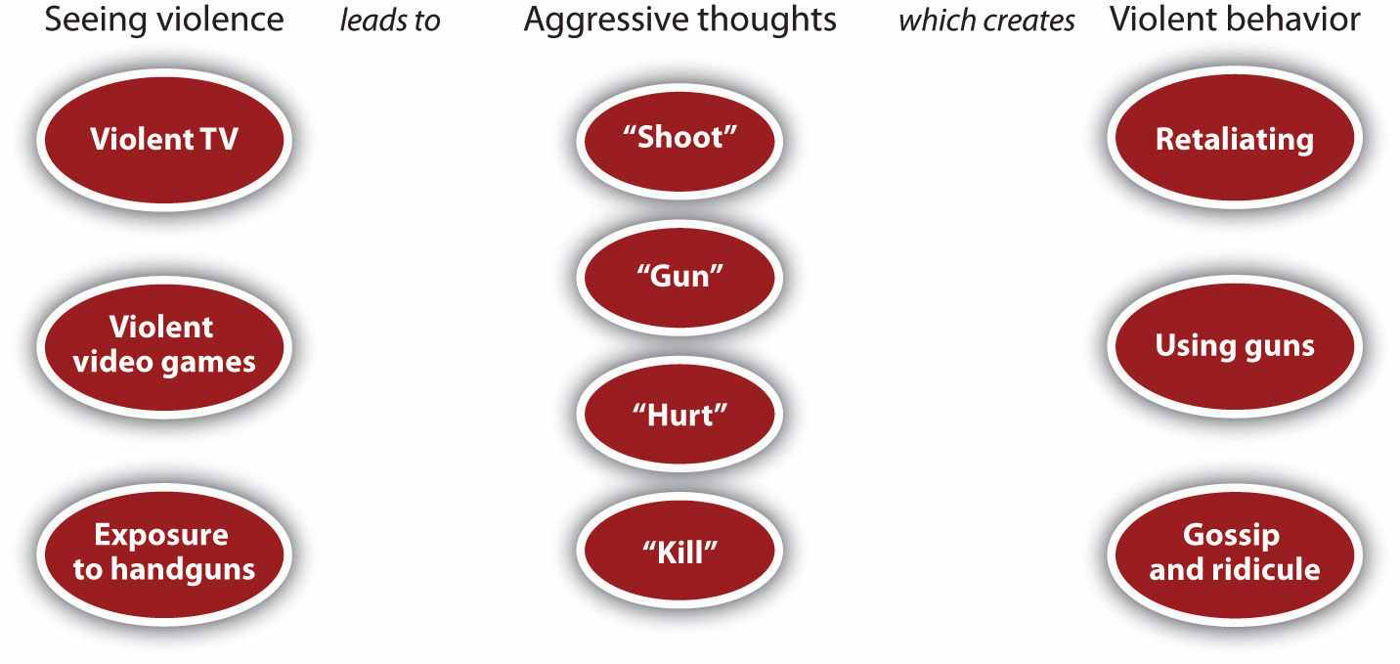
Adapted from Anderson et al. (1998). ^{[25]}
In the United States, most homicides are perpetrated with handguns. Every day, thousands of children bring guns to school, and gun-related violence kills an American child every three hours (Geen & Donnerstein, 1998; O’Donnell, 1995). ^{[26]}People who keep guns in their home are likely to be killed by that gun—particularly at the hands of a family member—and are also likely to kill themselves with it (Cummings, Koepsell, Grossman, Savarino, & Thompson, 1997; Wintemute, Parham, Beaumont, Wright, & Drake, 1999). ^{[27]}
Although it is true that it is people and not the guns themselves that do the killing, principles of social psychology make it clear why possessing guns is so dangerous. Guns provide cues about violence, which makes it more likely that people will respond to provocation with aggression. In any particular situation of conflict or confrontation, we have several choices. We might try to escape the situation, we might confront the person in a nonviolent way, or we might choose to use violence. The presence of guns reminds us that we may respond with violence. When guns are around, violence is highly cognitively accessible, and this accessibility increases the likelihood of responding to provocation with violence.
Research has shown that the presence of guns provides a highly salient cue, which reminds us that aggression is a possible response to threat. Anderson, Benjamin, and Bartholow (1998) ^{[28]} found that just having participants think about guns primed thoughts about aggression. But the link does not end there. In addition to priming aggressive thoughts and feelings, viewing handguns also increases violent behavior, particularly when we are provoked (Carlson, Marcus-Newhall, & Miller, 1990). ^{[29]}
In one relevant study (Berkowitz & Lepage, 1967), ^{[30]} male university students were given either one or seven painful electrical shocks, supposedly from another student, and then were given an opportunity to shock this person in return. In some cases a 12-gauge shotgun and a .38-caliber revolver were lying on the table near the shock key, whereas in other conditions two badminton racquets were near the key. The researchers found, first, that the students who had been shocked more times returned significantly more shocks to the partner than did those who had been shocked only once. But what about the presence of the guns? The researchers found that the guns did not significantly increase aggression for the participants who had received only one shock, but it did increase aggression for those who had received seven shocks. The presence of the guns seems to have elicited more aggressive responses from those who had been most provoked by the shocks. Given what you know about the importance of situational effects on priming, these results may not surprise you.
Another way that viewing violence increases aggression is through modeling. Children (and even adults) may simply imitate the violence they observe. Indeed, there is substantial evidence that people do copy the aggression that they read about or see in the media. For instance, when John Hinckley Jr. attempted to assassinate President Ronald Reagan in 1981, he was influenced by the violence that he had recently viewed in the movie Taxi Driver, as well as an infatuation with the movie actress Jodi Foster. Research also has found strong evidence for copycat suicides. The rate of suicide in the general population increases significantly in the months after famous people, for instance Marilyn Monroe or Kurt Cobain, commit suicide (Phillips & Carstensen, 1986). ^{[31]} In short, viewing violence teaches us how and when we should be aggressive.
Another outcome of viewing large amounts of violent material is desensitization,the tendency to become used to, and thus less influenced by, a stimulus. When we first see violence, we are likely to be shocked, aroused, and even repulsed by it. However, as we see more and more violence over time, we become habituated to it, such that subsequent exposures produce fewer and fewer negative emotional responses. In the end, we may begin to see violence as a normal part of everyday life and become accepting of it.
In sum, continually viewing violence substantially changes how we think about and how our brains respond to the events that occur to us (Bartholow, Bushman, & Sestir, 2006). ^{[32]} Frequent exposure to violence primes aggression and makes aggressive behavior more likely (Molitor & Hirsch, 1994). ^{[33]} And viewing aggression frequently makes that aggression seem more normal and less negative. If we create for ourselves a world that contains a lot of violence, we become more distrustful and more likely to behave aggressively in response to conflict (Nabi & Sullivan, 2001). ^{[34]}

KEY TAKEAWAYS
- Aggression can be explained in part by the general principles of learning, including reinforcement, punishment, and modeling.
- Reinforcement is more effective than punishment in reducing aggression.
- Viewing violence in TV shows, movies, and video games tends to create aggression in the viewer.
- Exposure to violence increases aggression through reinforcement, through modeling, by priming cognitions related to aggression, and through desensitization.

EXERCISES AND CRITICAL THINKING
- Describe a time when you were reinforced or punished for your aggressive behavior or when someone you knew was. Was the attempt to reduce aggression successful?
- Give an example of how children or adults might model aggressive behavior from the media.
- Do you or people you know watch a lot of TV violence or play violent video games? How do you think this exposure is influencing you or them?

[1] Hawley, P. H. (Ed.). (2007). Social dominance in childhood and adolescence: Why social competence and aggression may go hand in hand. Mahwah, NJ: Lawrence Erlbaum.
[2] Björkqvist, K., Osterman, K., Lagerspetz, K. M. J., Landau, S. F., Caprara, G. V., & Fraczek, A. (Eds.). (2001). Aggression, victimization and sociometric status: Findings from Finland, Israel, Italy and Poland. Hauppauge, NY: Nova Science Publishers.
[3] Salmivalli, C., Kaukiainen, A., & Lagerspetz, K. (2000). Aggression and sociometric status among peers: Do gender and type of aggression matter? Scandinavian Journal of Psychology, 41(1), 17–24.
[4] Bandura, A., & Walters, R. H. (1959). Adolescent aggression. New York, NY: Ronald Press.
[5] Bandura, A. (1973). Aggression: A social learning analysis. Englewood Cliffs, NJ: Prentice-Hall.
[6] Huesmann, L. R., & Kirwil, L. (2007). Why observing violence increases the risk of violent behavior by the observer. In D. J. Flannery, A. T. Vazsonyi, & I. D. Waldman (Eds.), The Cambridge handbook of violent behavior and aggression (pp. 545–570). New York, NY: Cambridge University Press.
[7] Heyman, R. E., & Slep, A. M. S. (2002). Do child abuse and interparental violence lead to adulthood family violence? Journal of Marriage and Family, 64(4), 864–870.
[8] Patterson, G. R., Dishion, T. J., & Bank, L. (1984). Family interaction: A process model of deviancy training. Aggressive Behavior, 10(3), 253–267.
[9] Gershoff, E. T. (2002). Corporal punishment by parents and associated child behaviors and experiences: A meta-analytic and theoretical review. Psychological Bulletin, 128(4), 539–579.
[10] Berkowitz, L. (1993). Aggression: Its causes, consequences and control. New York, NY: McGraw-Hill.
[11] Baron, R. A., & Richardson, D. R. (1994). Human aggression (2nd ed.). New York, NY: Plenum Press; Berkowitz, L. (1993). Aggression: Its causes, consequences and control. New York, NY: McGraw-Hill.
[12] Archer, D., Gartner, R., & Beittel, M. (1983). Homicide and the death penalty: A cross-national test of a deterrence hypothesis. Journal of Criminal Law and Criminology, 74(3), 991–1013.
[13] Archer, J., & Coyne, S. M. (2005). An integrated review of indirect, relational, and social aggression. Personality and Social Psychology Review, 9(3), 212–230.
[14] Huston, A. C., Donnerstein, E., Fairchild, H. H., Feshbach, N. D., Katz, P. A., Murray, J. P.,…Rubinstein, E. A. (1992). Big world, small screen: The role of television in American society. Lincoln, NE: University of Nebraska Press.
[15] Anderson, C. A., Berkowitz, L., Donnerstein, E., Huesmann, L. R., Johnson, J. D., Linz, D.,… Wartella, E. (2003). The influence of media violence on youth. Psychological Science in the Public Interest, 4(3), 81–110; Cantor, J., Bushman, B. J., Huesmann, L. R., Groebel, J., Malamuth, N. M., Impett, E. A.,…Smith, S. (Eds.). (2001). Some hazards of television viewing: Fears, aggression, and sexual attitudes. Thousand Oaks, CA: Sage.
[16] Bushman, B. J., & Huesmann, L. R. (2010). Aggression. In S. T. Fiske, D. T. Gilbert, & G. Lindzey (Eds.), Handbook of social psychology (Vol. 2, 5th ed., pp. 833–863). Hoboken, NJ: John Wiley & Sons.
[17] Bushman, B. J., & Anderson, C. A. (2002). Violent video games and hostile expectations: A test of the general aggression model. Personality and Social Psychology Bulletin, 28(12), 1679–1686.
[18] Paik, H., & Comstock, G. (1994). The effects of television violence on antisocial behavior: A meta-analysis. Communication Research, 21(4), 516–546; Zillman, D., & Weaver, J. B., III. (1999). Effects of prolonged exposure to gratuitous media violence on provoked and unprovoked hostile behavior. Journal of Applied Social Psychology, 29(1), 145–165.
[19] Coyne, S. M., Archer, J., & Eslea, M. (2004). Cruel intentions on television and in real life: Can viewing indirect aggression increase viewers’ subsequent indirect aggression? Journal of Experimental Child Psychology, 88(3), 234–253.
[20] Anderson, C. A., & Bushman, B. J. (2001). Effects of violent video games on aggressive behavior, aggressive cognition, aggressive affect, physiological arousal, and prosocial behavior: A meta-analytic review of the scientific literature. Psychological Science, 12(5), 353–359.
[21] Bushman, B. J., & Anderson, C. A. (2002). Violent video games and hostile expectations: A test of the general aggression model. Personality and Social Psychology Bulletin, 28(12), 1679–1686.
[22] Konijn, E. A., Nije Bijvank, M., & Bushman, B. J. (2007). I wish I were a warrior: The role of wishful identification in the effects of violent video games on aggression in adolescent boys.Developmental Psychology, 43(4), 1038–1044.
[23] Anderson, C. A., Gentile, D. A., & Buckley, K. E. (2007). Violent video game effects on children and adolescents: Theory, research, and public policy. New York, NY: Oxford University Press; Anderson, C. A., Sakamoto, A., Gentile, D. A., Ihori, N., Shibuya, A., Naito, M.,…Kobayashi, K. (2008). Longitudinal effects of violent video games on aggression in Japan and the United States. Pediatrics, 122(5), e1067–e1072.
[24] Anderson, C. A., Benjamin, A. J., Jr., & Bartholow, B. D. (1998). Does the gun pull the trigger? Automatic priming effects of weapon pictures and weapon names. Psychological Science, 9(4), 308–314.
[25] Anderson, C. A., Benjamin, A. J., Jr., & Bartholow, B. D. (1998). Does the gun pull the trigger? Automatic priming effects of weapon pictures and weapon names. Psychological Science, 9(4), 308–314.
[26] Geen, R. G., & Donnerstein, E. (Eds.). (1998). Human aggression: Theories, research, and implications for social policy. San Diego, CA: Academic Press; O’Donnell, C. R. (1995). Firearm deaths among children and youth. American Psychologist, 50(9), 771–776.
[27] Cummings, P., Koepsell, T. D., Grossman, D. C., Savarino, J., & Thompson, R. S. (1997). Association between the purchase of a handgun and homicide or suicide. American Journal of Public Health, 87(6), 974–978; Wintemute, G. J., Parham, C. A., Beaumont, J. J., Wright, M., & Drake, C. (1999). Mortality among recent purchasers of handguns. New England Journal of Medicine, 341(21), 1583–1589.
[28] Anderson, C. A., Benjamin, A. J., Jr., & Bartholow, B. D. (1998). Does the gun pull the trigger? Automatic priming effects of weapon pictures and weapon names. Psychological Science, 9(4), 308–314.
[29] Carlson, M., Marcus-Newhall, A., & Miller, N. (1990). Effects of situational aggression cues: A quantitative review. Journal of Personality and Social Psychology, 58(4), 622–633.
[30] Berkowitz, L., & Lepage, A. (1967). Weapons as aggression-eliciting stimuli. Journal of Personality and Social Psychology, 7(2, Pt.1), 202–207.
[31] Phillips, D. P., & Carstensen, L. L. (1986). Clustering of teenage suicides after television news stories about suicide. New England Journal of Medicine, 315(11), 685–689.
[32] Bartholow, B. D., Bushman, B. J., & Sestir, M. A. (2006). Chronic violent video game exposure and desensitization to violence: Behavioral and event-related brain potential data.Journal of Experimental Social Psychology, 42(4), 532–539.
[33] Molitor, F., & Hirsch, K. W. (1994). Children’s toleration of real-life aggression after exposure to media violence: A replication of the Drabman and Thomas studies. Child Study Journal, 24(3), 191–207.
[34] Nabi, R. L., & Sullivan, J. L. (2001). Does television viewing relate to engagement in protective action against crime? A cultivation analysis from a theory of reasoned action perspective. Communication Research, 28(6), 802–825.

10.4 Personal and Cultural Influences on Aggression

LEARNING OBJECTIVES
- Summarize the individual difference variables related to aggression.
- Explain how men and women differ, on average, in terms of aggression.
- Give examples of some cultural differences in aggression.
The occurrence of aggression is still another example of the interaction between person variables and situation variables. Although the social situation is extremely important, it does not influence everyone equally—not all people become aggressive when they view violence. You may be able to watch a lot of violent television and play a lot of violent video games without ever being aggressive yourself. On the other hand, other people may not be so lucky—remember that, on average, watching violence doesincrease aggression. Just as we may know some people who smoked cigarettes all their lives but never got lung cancer, I would still not recommend that anyone start smoking. The problem is that we don’t know if we are going to be affected until it is too late.
Let’s consider in this section the personality variables that are known to relate to aggression and how these variables may interact with the influence of the social situation.

Individual Differences in Aggression
Aggression occurs when we feel that we are being threatened by others, and thus personality variables that relate to perceived threat also predict aggression. Aggression is particularly likely among people who feel that they are being rejected by others whom they care about (Downey, Irwin, Ramsay, & Ayduk, 2004). ^{[1]} In addition, people who experience a lot of negative affect, and particularly those who tend to perceive others as threatening, are likely to be aggressive (Crick & Dodge, 1994). ^{[2]}When these people see behavior that may or not be hostile in intent, they tend to think that it is aggressive, and these perceptions can increase their aggression.
People also differ in their general attitudes toward the appropriateness of using violence. Some people are simply more likely to believe in the value of using aggression as a means of solving problems than are others. For many people, violence is a perfectly acceptable method of dealing with interpersonal conflict, and these people are more aggressive (Anderson, 1997; Dill, Anderson, & Deuser, 1997). ^{[3]} The social situation that surrounds people also helps determine their beliefs about aggression. Members of youth gangs find violence to be acceptable and normal (Baumeister, Smart, & Boden, 1996), ^{[4]} and membership in the gang reinforces these beliefs. For these individuals, the important goals are to be respected and feared, and engaging in violence is an accepted means to this end (Horowitz & Schwartz, 1974). ^{[5]}
Perhaps you believe that people with low self-esteem would be more aggressive than those with high self-esteem. In fact, the opposite is true. Research has found that individuals with inflated or unstable self-esteem are more prone to anger and are highly aggressive when their high self-image is threatened (Kernis, Brockner, & Frankel, 1989; Baumeister et al., 1996). ^{[6]} For instance, classroom bullies are those boys who always want to be the center of attention, who think a lot of themselves, and who cannot take criticism (Salmivalli & Nieminen, 2002). ^{[7]} It appears that these people are highly motivated to protect their inflated self-concepts and react with anger and aggression when it is threatened.

Figure 10.7 Self-Perceptions, Aggression, and Altruism
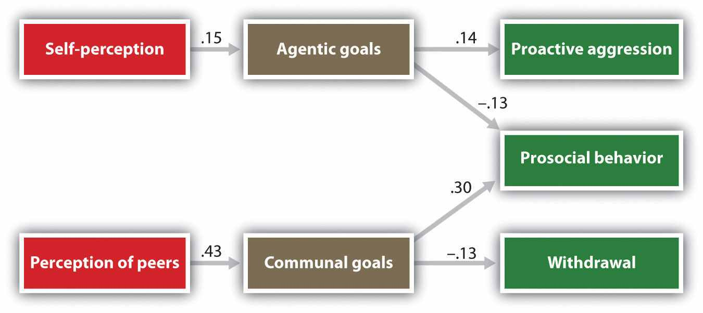
Children who saw themselves, and who were seen by peers, as having self-concerned motives were more aggressive and less altruistic than were children who were rated as more caring of others. Data are from Salmivalli et al. (2005). ^{[8]}
Underlying these observed individual differences in aggression are the fundamental motives of self-concern and other-concern. Salmivalli, Ojanen, Haanpaa, and Peets (2005) ^{[9]} asked fifth- and sixth-grade children to complete a number of measures describing themselves and their preferred relationships with others. In addition, each of the children was given a roster of the other students in their class and was asked to check off the names of the children who were most aggressive and most helpful. As you can see in Figure 10.7 "Self-Perceptions, Aggression, and Altruism", the underlying personality orientations of the children influenced how they were perceived by their classmates, and in a way that fits well with our knowledge about the role of self- and other-concern. Children who rated goals of self-concern highly (agreeing that it was important for instance that “others respect and admire me”) were more likely to be rated as acting aggressively, whereas children for whom other-concern was seen as more important (agreeing with statements such as “I feel close to others”) were more likely to be seen as altruistic.

Gender Differences in Aggression
Given what we know about the tendency toward self-enhancement and a desire for status, you will not be surprised to learn that there is a universal tendency for men to be more violent than women (Archer & Coyne, 2005; Crick & Nelson, 2002). ^{[10]} In comparison to women and girls, who use more nonphysical aggression such as shouting, insulting, spreading rumors, and excluding others from activities, men and boys prefer more physical and violent aggression—behaviors such as hitting, pushing, tripping, and kicking (Österman et al., 1998). ^{[11]}
Strong gender differences in aggression have been found in virtually every culture that has been studied. Worldwide, about 99% of rapes are committed by men, as are about 90% of robberies, assaults, and murders (Graham & Wells, 2001). ^{[12]} Among children, boys show higher rates of physical aggression than girls do (Loeber & Hay, 1997), ^{[13]} and even infants differ, such that infant boys tend to show more anger and poorer emotional regulation in comparison to infant girls. These findings will probably not surprise you because aggression, as we have seen, is due in large part to desires to gain status in the eyes of others, and (on average) men are more concerned about this than are women.
Although these gender differences exist, they do not mean that men and women are completely different, or that women are never aggressive. Both men and women respond to insults and provocation with aggression. In fact, the differences between men and women are smaller after they have been frustrated, insulted, or threatened (Bettencourt & Miller, 1996). ^{[14]} And men and women seem to use similar amounts of verbal aggression (Graham & Wells, 2001). ^{[15]}
Gender differences in violent aggression are caused in part by hormones. Testosterone, which occurs at higher levels in boys and men, plays a significant role in aggression, and this is in part responsible for these differences. And the observed gender differences in aggression are almost certainly due, in part, to evolutionary factors. During human evolution, women primarily stayed near the home, taking care of children and cooking, whereas men engaged in more aggressive behaviors, such as defense, hunting, and fighting. Thus men probably learned to aggress, in part, because successfully fulfilling their duties required them to be aggressive. In addition, there is an evolutionary tendency for males to be more competitive with each other in order to gain status. Men who have high social status are more attractive to women, and having status allows them to attract the most desirable, attractive, and healthy mates (Buss & Shackelford, 1997). ^{[16]}
But gender differences are not entirely determined by biology and evolution; many of these differences are the result of social learning. Imagine for a moment that 10-year-old Jean comes home from school and tells her father that she got in a big fight at school. How do you think he would respond to her? Now, imagine that her twin brother Jake comes home and reports the same thing. I think you can imagine that the father’s response would be different in this case. Boys are more likely to be reinforced for being aggressive than are girls. Aggressive boys are often the most popular children in elementary schools (Rodkin, Farmer, Pearl, & Van Acker, 2000) ^{[17]} because they can use their aggressiveness to gain and maintain social status. On the other hand, girls who successfully use nonphysical aggression may also gain social benefits.
Eagly and her colleagues have proposed that gender differences in aggression stem primarily from social norms and expectations about the appropriate roles of men and women (Eagly, 1987; Eagly & Wood, 1991). ^{[18]} Eagly notes that in many nations, women are expected to have more highly developed other-oriented attributes, such as friendliness and emotional expressivity and that when women do aggress, they use aggression as a means of expressing anger and reducing stress. Men, on the other hand, are socialized to value more self-oriented attributes, such as independence and assertiveness, and they are more likely to use aggression to attain social or material rewards (Campbell, Muncer, & Gorman, 1993). ^{[19]} One meta-analysis found that participants were more likely to indicate that men, rather than women, would and should engage in the most aggressive behaviors (Eagly & Steffen, 1986). ^{[20]}Essentially, and suggesting that these different roles may be in part learned, the majority of males and females, worldwide, agree that males are both more likely and more willing to commit physically aggressive acts.

Cultural and Societal Differences in Aggression
The United States continues to be an extremely violent country, much more so than other countries that are similar to it in many ways, such as Canada, Australia, New Zealand, and the Western European countries. On the other hand, other countries in Eastern Europe, Africa, Asia, and South America have more violence than does the United States. These differences show that cultures vary dramatically in how, and how much, their members aggress against each other.
When children enter a violent culture such as that of the United States, they may be socialized to be even more violent. In a study of students at a high school near Detroit, Michigan, Souweidane and Huesmann (1999) ^{[21]} found that the children who had been born in the United States were more accepting of aggression than were children who had emigrated from the Middle East, especially if they did so after the age of 11. And in a sample of Hispanic schoolchildren in Chicago, children who had been in the United States longer showed greater approval of aggression (Guerra, Huesmann, & Zelli, 1993). ^{[22]}
In addition to differences across cultures, there are also regional differences in the incidences of violence, for example, in different parts of the United States. The next section describes one of these differences—variations in a social norm that condones and even encourages responding to insults with aggression, known as theculture of honor.

Research Focus
The Culture of Honor
The homicide rate is significantly higher in the Southern and the Western states but lower in the Eastern and Northern states. One explanation for these differences is in terms of variation in cultural norms about the appropriate reactions to threats against one’s social status. These cultural differences apply primarily to men; some men react more violently than others when they believe that others are threatening them. The social norm that condones and even encourages responding to insults with aggression (the culture of honor) leads even relatively minor conflicts or disputes to be seen as challenges to one’s social status and reputation and can therefore trigger aggressive responses. The culture of honor is more prevalent in areas that are closer to the equator, including the southern parts of the United States.
In one series of experiments (Cohen, Nisbett, Bosdle, & Schwarz, 1996), ^{[23]}researchers investigated how White male students who had grown up either in the Northern or in the Southern regions of the United States responded to insults. The experiments, which were conducted at the University of Michigan, involved an encounter in which the research participant was walking down a narrow hallway. The experimenters enlisted the help of a confederate who did not give way to the participant but who rather bumped into the participant and insulted him. Compared with Northerners, students from the South who had been bumped were more likely to think that their masculine reputations had been threatened, exhibited greater physiological signs of being upset, had higher testosterone levels, engaged in more aggressive and dominant behavior (gave firmer handshakes), and were less willing to yield to a subsequent confederate.

Figure 10.8
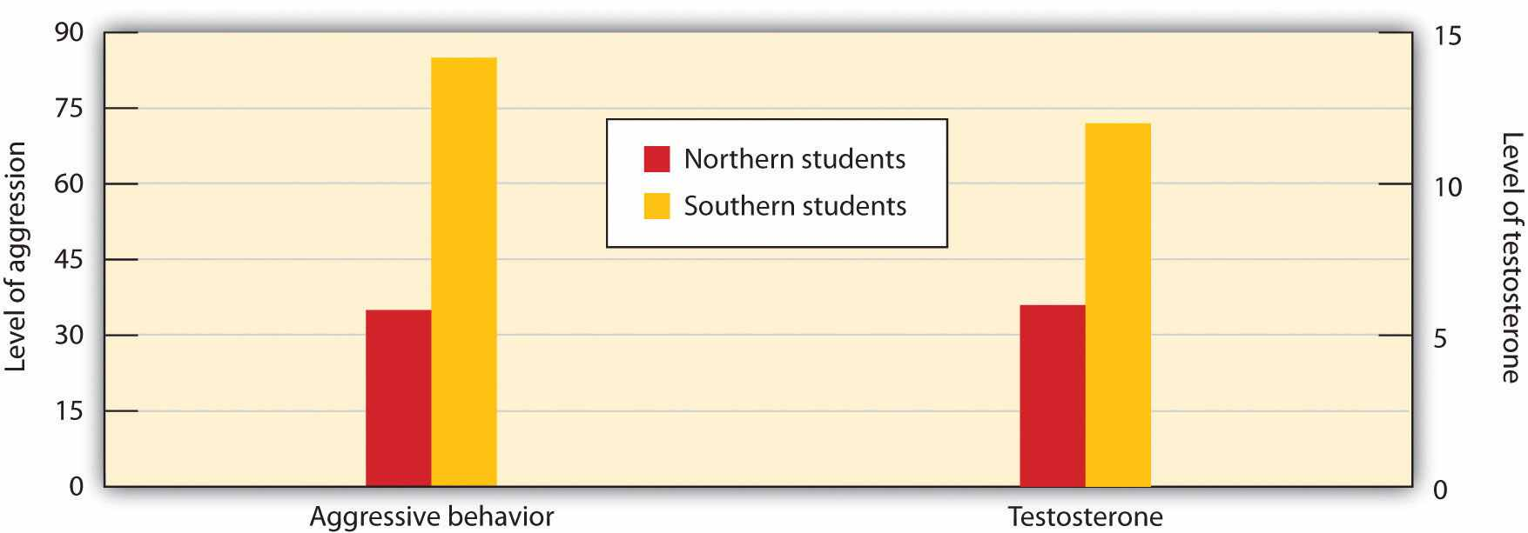
Students from Southern states expressed more anger and had greater levels of testosterone after being insulted than did students from Northern states (Cohen, Nisbett, Bosdle, & Schwarz, 1996). ^{[24]}
In another test of the impact of culture of honor, Cohen and Nisbett (1997) ^{[25]}sent letters to employers all over the United States from a fictitious job applicant who admitted having been convicted of a felony. To half the employers, the applicant reported that he had impulsively killed a man who had been having an affair with his fiancée and then taunted him about it in a crowded bar. To the other half, the applicant reported that he had stolen a car because he needed the money to pay off debts. Employers from the South and the West, places in which the culture of honor is strong, were more likely than employers in the North and East to respond in an understanding and cooperative way to the letter from the convicted killer, but there were no cultural differences for the letter from the auto thief.
A culture of honor, in which defending the honor of one’s reputation, family, and property is emphasized, may be a risk factor for school violence. More students from culture-of-honor states (i.e., Southern and Western states) reported having brought a weapon to school in the past month than did students from non-culture-of-honor states (i.e., Northern and Eastern states). Furthermore, over a 20-year period, culture-of-honor states had more than twice as many school shootings per capita as non-culture-of-honor states, suggesting that acts of school violence may be a response of defending one’s honor in the face of perceived social humiliation (Brown, Osterman, & Barnes, 2009). ^{[26]}
One possible explanation for regional differences in the culture of honor involves the kind of activities typically engaged in by men in the different regions (Nisbett & Cohen, 1996). ^{[27]} While people in the Northern parts of the United States were usually farmers who grew crops, people from Southern climates were more likely to raise livestock. Unlike the crops grown by the Northerners, the herds were mobile and vulnerable to theft, and it was difficult for law enforcement officials to protect them. To be successful in an environment where theft was common, a man had to build a reputation for strength and toughness, and this was accomplished by a willingness to use swift, and sometimes violent, punishment against thieves. Areas in which livestock raising is more common also tend to have higher status disparities between the wealthiest and the poorest inhabitants (Henry, 2009). ^{[28]}People with low social status are particularly likely to feel threatened when they are insulted and are particularly likely to retaliate with aggression.
In summary, as in virtually every case, a full understanding of the determinants of aggression requires taking a person-situation approach. Although biology, social learning, the social situation, and culture are all extremely important, we must keep in mind that none of these factors alone predicts aggression but that they work together to do so. For instance, we have seen that testosterone predicts aggressive behavior. But this relationship is stronger for people with low socioeconomic status than for those with higher socioeconomic status (Dabbs & Morris, 1990). ^{[29]} And children who have a genetic predisposition to aggression are more likely to become aggressive if they are abused as children (Caspi et al., 2002). ^{[30]} It seems that biological factors may predispose us to aggression, but that social factors act as triggers—a classic example of interactionism at work.

Social Psychology in the Public Interest
Preventing Violence
The social psychological study of aggression represents a classic example of the conundrum faced by social psychologists: Although we have developed a good understanding of the causes of aggression—and that understanding gets clearer every day—what exactly to do about it is an even more difficult question. Human aggression has remained with us since the beginning of time, and it is difficult to imagine that it is going to disappear soon.
Stopping the cycle of violence that characterizes so many families, neighborhoods, cities, and countries will not be easy. On the other hand, if we are serious about it, then we have a good idea where to begin to try to make a difference, because the principles that we have discussed in this chapter form a foundation both for understanding the causes of violence and for potentially reducing it. One thing that is certain is that reducing the prevalence of violence must involve changes in cognitions and emotions, as well as behavior. Also, this work must begin with children of very young ages, before aggressive behaviors, thoughts, and feelings become so well developed that they are difficult to change (Zigler, Taussig, & Black, 1992). ^{[31]}
With increasing life experiences, our schemas about the world become more well-defined and stable, and these established knowledge structures become more difficult to change. Not surprisingly, attempts at treating or rehabilitating violent adults (including such things as “boot camps,” individual and group therapy, and “scared straight” programs) have not been that successful. One problem is that these approaches do not address the wide range of factors that contribute to the development and maintenance of violent behavior. The most successful interventions appear to be those that address both person and situation factors, and which do so at a relatively young age.
To prevent the cycle of violence from beginning, we must reduce exposure to violence, particularly among children. There is no question that viewing violence breeds more violence. The more violence we see or participate in, and the more violence we experience, the more we commit. The relationship is not perfect, and it does not hold for everyone, but it is clear. Just as smoking cigarettes causes cancer, so viewing aggression causes violence. And just as many states and countries have developed advertising campaigns, taxes, and laws to reduce the use of cigarettes, particularly among minors, so we must work to reduce the exposure, particularly of children, to violent material. Governments can and have been involved in this effort (Huesmann & Skoric, 2003), ^{[32]} but the primary source will be parents, who must find out what their children are watching on TV, in movies, and on the Internet—as well as what video games they are playing—and monitor and restrict their use.
People must work to dispel the popular notion that engaging in aggressive actions is cathartic. When we attempt to reduce aggression by punching a pillow or pounding on our computer keyboard, we are bound to fail. The arousal and negative emotions that result from engaging in aggression do not reduce but rather increase the likelihood of engaging in more aggression. It is better to simply let the frustration dissipate over time, for instance, by distracting oneself with laughter or other activities than to attempt to fight aggression with more aggression.
We need to help people control their emotions. Most violence is emotional aggression—the result of negative affect and high arousal. We need to better teach children to think about how they are feeling, to consider the sources of their negative emotions, and to learn ways to respond to them that do not involve aggression. When we think more carefully about our situation, rather than simply responding in an emotional way, we can more carefully choose the most effective responses when we are frustrated or angry (Berkowitz, 1993). ^{[33]}
We must also work at the societal and government level by creating and enforcing laws that punish those who are aggressive, by increasing controls on the presence and availability of handguns and violent material more generally, and by creating programs to help the many victims of sexual and physical violence. In schools, it is essential that administrators, teachers, and staff become aware of the potential for violence and make themselves available as resources for students. School systems must have explicit policies that prohibit and specify sanctions for any student who teases, threatens, excludes, or otherwise mistreats another individual. Legislation designed to stop cyberbullying has been introduced in a number of U.S. states including New York, Missouri, Rhode Island, and Maryland.
Reducing the large income disparities between the poorest and the richest members of society will also be important. As a result of upward comparison, poverty creates frustration that begets violence.
Children (and adults) must be better educated about the causes of violence, because understanding the causes can help us learn to be less aggressive. Furthermore, because abuse of alcohol and other drugs so often leads to violence, better education about the effects of such substances, as well as support for individuals who need help dealing with them, is an important investment, not only for these individuals but also for the people around them.
We must also work to improve the situation in which children find themselves. Children who grow up in abusive homes learn that aggression is the norm; it is not surprising that they then respond to social problems through aggression. We must help these families learn to use reward rather than punishment and particularly to avoid violent punishment, which leads children to model the violent behavior. If we can reduce the extent of violence within families, then children who grow up in those families will likely be less violent themselves.
And we must help people find alternatives to violence by encouraging them to think about others more positively rather than as threats to their own status and self-worth. If we can increase other-concern, for instance, by helping children learn to better communicate with each other, and at the same time increase people’s positive feelings about themselves, we will create more positive social situations that reduce violence and aggression.

KEY TAKEAWAYS
- There are individual differences in aggression, for instance, in terms of how people respond to negative emotions.
- Men are more physically aggressive, but there are few differences between men and women in nonphysical aggression.
- Different cultures have different norms about aggression as well as different rates of aggressive behavior. The culture of honor is an example.

EXERCISES AND CRITICAL THINKING
- Consider yourself and people you know in terms of individual differences related to aggression, as well as gender and cultural influences on aggression. Do the variables we discussed in this section predict their likelihood of aggressing?
- Consider a case in which you or someone you know is frustrated, angry, or experiencing other emotions that may lead to aggressive behavior. What techniques might you use to prevent the aggression from occurring?
- Create a print, web, or video advertisement that conveys information that would help students learn to be less aggressive.

[1] Downey, G., Irwin, L., Ramsay, M., & Ayduk, O. (Eds.). (2004). Rejection sensitivity and girls’ aggression. New York, NY: Kluwer Academic/Plenum Publishers.
[2] Crick, N. R., & Dodge, K. A. (1994). A review and reformulation of social information-processing mechanisms in children’s social adjustment. Psychological Bulletin, 115(1), 74–101.
[3] Anderson, C. A. (1997). Effects of violent movies and trait hostility on hostile feelings and aggressive thoughts. Aggressive Behavior, 23(3), 161–178; Dill, K. E., Anderson, C. A., & Deuser, W. E. (1997). Effects of aggressive personality on social expectations and social perceptions. Journal of Research in Personality, 31(2), 272–292.
[4] Baumeister, R. F., Smart, L., & Boden, J. M. (1996). Relation of threatened egotism to violence and aggression: The dark side of high self-esteem. Psychological Review, 103(1), 5–33.
[5] Horowitz, R., & Schwartz, G. (1974). Honor, normative ambiguity and gang violence.American Sociological Review, 39(2), 238–251.
[6] Kernis, M. H., Brockner, J., & Frankel, B. S. (1989). Self-esteem and reactions to failure: The mediating role of overgeneralization. Journal of Personality and Social Psychology, 57(4), 707–714; Baumeister, R. F., Smart, L., & Boden, J. M. (1996). Relation of threatened egotism to violence and aggression: The dark side of high self-esteem. Psychological Review, 103(1), 5–33.
[7] Salmivalli, C., & Nieminen, E. (2002). Proactive and reactive aggression among school bullies, victims, and bully-victims. Aggressive Behavior, 28(1), 30–44.
[8] Salmivalli, C., Ojanen, T., Haanpaa, J., & Peets, K. (2005). “I’m OK but you’re not” and other peer-relational schemas: Explaining individual differences in children’s social goals.Developmental Psychology, 41(2), 363–375.
[9] Salmivalli, C., Ojanen, T., Haanpaa, J., & Peets, K. (2005). “I’m OK but you’re not” and other peer-relational schemas: Explaining individual differences in children’s social goals.Developmental Psychology, 41(2), 363–375.
[10] Archer, J., & Coyne, S. M. (2005). An integrated review of indirect, relational, and social aggression. Personality and Social Psychology Review, 9(3), 212–230; Crick, N. R., & Nelson, D. A. (2002). Relational and physical victimization within friendships: Nobody told me there’d be friends like these. Journal of Abnormal Child Psychology, 30(6), 599–607.
[11] Österman, K., Björkqvist, K., Lagerspetz, K. M. J., Kaukiainen, A., Landau, S. F., Fraczek, A., & Caprara, G. V. (1998). Cross-cultural evidence of female indirect aggression. Aggressive Behavior, 24(1), 1–8.
[12] Graham, K., & Wells, S. (2001). The two worlds of aggression for men and women. Sex Roles, 45(9–10), 595–622.
[13] Loeber, R., & Hay, D. (1997). Key issues in the development of aggression and violence from childhood to early adulthood. Annual Review of Psychology, 371–410.
[14] Bettencourt, B., & Miller, N. (1996). Gender differences in aggression as a function of provocation: A meta-analysis. Psychological Bulletin, 119, 422–447.
[15] Graham, K., & Wells, S. (2001). The two worlds of aggression for men and women. Sex Roles, 45(9–10), 595–622.
[16] Buss, D. M., & Shackelford, T. K. (1997). Human aggression in evolutionary psychological perspective. Clinical Psychology Review, 17(6), 605–619.
[17] Rodkin, P. C., Farmer, T. W., Pearl, R., & Van Acker, R. (2000). Heterogeneity of popular boys: Antisocial and prosocial configurations. Developmental Psychology, 36(1), 14–24.
[18] Eagly, A. H. (1987). Sex differences in social behavior: A social-role interpretation. Hillsdale, NJ: Lawrence Erlbaum; Eagly, A. H., & Wood, W. (1991). Explaining sex differences in social behavior: A meta-analytic perspective. Personality and Social Psychology Bulletin, 17, 306–315.
[19] Campbell, A., Muncer, S., & Gorman, B. (1993). Sex and social representations of aggression: A communal-agentic analysis. Aggressive Behavior, 19(2), 125–135.
[20] Eagly, A. H., & Steffen, V. J. (1986). Gender and aggressive behavior: A meta-analytic review of the social psychology literature. Psychological Bulletin, 100, 309–330.
[21] Souweidane, V., & Huesmann, L. R. (1999). The influence of American urban culture on the development of normative beliefs about aggression in Middle-Eastern immigrants.American Journal of Community Psychology, 27(2), 239–254.
[22] Guerra, N. G., Huesmann, L. R., & Zelli, A. (1993). Attributions for social failure and adolescent aggression. Aggressive Behavior, 19(6), 421–434.
[23] Cohen, D., Nisbett, R. E., Bosdle, B., & Schwarz, N. (1996). Insult, aggression, and the southern culture of honor: An “experimental ethnography.” Journal of Personality and Social Psychology, 70, 945–960.
[24] Cohen, D., Nisbett, R. E., Bosdle, B., & Schwarz, N. (1996). Insult, aggression, and the southern culture of honor: An “experimental ethnography.” Journal of Personality and Social Psychology, 70, 945–960.
[25] Cohen, D., & Nisbett, R. E. (1997). Field experiments examining the culture of honor: The role of institutions in perpetuating norms about violence. Personality and Social Psychology Bulletin, 23(11), 1188–1199.
[26] Brown, R. P., Osterman, L. L., & Barnes, C. D. (2009). School violence and the culture of honor. Psychological Science, 20(11), 1400–1405.
[27] Nisbett, R. E., & Cohen, D. (1996). Culture of honor: The psychology of violence in the South. Boulder, CO: Westview Press.
[28] Henry, P. J. (2009). Low-status compensation: A theory for understanding the role of status in cultures of honor. Journal of Personality and Social Psychology, 97(3), 451–466.
[29] Dabbs, J. M., & Morris, R. (1990). Testosterone, social class, and antisocial behavior in a sample of 4,462 men. Psychological Science, 1(3), 209–211.
[30] Caspi, A., McClay, J., Moffitt, T., Mill, J., Martin, J., Craig, I. W.,…Poulton, R. (2002). Role of genotype in the cycle of violence in maltreated children. Science, 297(5582), 851–854.
[31] Zigler, E., Taussig, C., & Black, K. (1992). Early childhood intervention: A promising preventative for juvenile delinquency. American Psychologist, 47(8), 997–1006.
[32] Huesmann, L. R., & Skoric, M. M. (Eds.). (2003). Regulating media violence: Why, how and by whom? Mahwah, NJ: Lawrence Erlbaum.
[33] Berkowitz, L. (1993). Aggression: Its causes, consequences, and control. New York, NY: McGraw-Hill.

10.5 Thinking Like a Social Psychologist About Aggression
This chapter has reviewed how social psychologists understand human aggression and violence. These actions surround us every day and cause much pain for many people. We have seen how social psychologists study aggression, their understanding of why it occurs, and how we might attempt to reduce it. Did you learn something about human aggression that surprised you and that helps you better understand social tragedies, such as school shootings, violence in sports, and even terrorism?
Perhaps you were surprised that social psychologists consider aggression to be primarily about self-concern. Although violence is designed to harm others, this is not usually its underlying goal or its underlying cause. Violence is more about the self and threats to it. We react violently when we feel badly about ourselves, for instance, when we feel that our status is threatened or when we are experiencing other negative emotions. But because you are thinking like a social psychologist, you will realize how important the self-concept is—so important, indeed, that threats against it can result in extremely violent acts.
Think about the recent school shootings in the United States and in other countries. And think of other events, such as wars, terrorism, and even genocides, that have occurred over the past century and even in your lifetime. Does your new understanding of aggression help you better understand that how unusual and unexpected events such as these—which go against our natural desires to trust, respect, and care for others—occur, and how they are understandable outcomes of the nature of human beings?
Aggression is another example of the person-situation interaction. Some people are naturally more aggressive than others, but the social situation may either increase or decrease the likelihood that aggression actually occurs. Think for a moment about your personality and about the situations that you spend time in. Are these likely to create aggression? If so, how might you change your behavior to reduce the likelihood of being aggressive?
Because you are now more aware of the variables that cause aggression, I hope that you will work harder to try to prevent it—both in yourself and others. Can you see how alcohol abuse can be harmful because it may lead to sexual and physical violence? Can you see how even nonviolent aggression, such as gossiping, spreading rumors, and bullying, can be harmful to the self-concept of others and have unexpected negative outcomes? Do you see now the strong influence of viewing violence, for instance on TV and in video games, can increase aggression? Can you see why catharsis doesn’t work? Perhaps now you can also understand how you and others can learn to react more calmly to the frustrations that provoke you.
I hope you will apply this new knowledge in your everyday life. We must all work harder to reduce our own aggression and to help others reduce theirs.

10.6 Chapter Summary
Aggression refers to behavior that is intended to harm another individual. To determine whether or not a behavior is aggressive, we must determine the intent of the perpetrator. The level of intent that underlies an aggressive behavior creates the distinction between emotional or impulsive aggression (which refers to aggression that occurs with only a small amount of forethought or intent) and instrumental or cognitive aggression (which is intentional and planned). Aggression can be nonphysical as well as physical, and nonphysical aggression can be very damaging to its victims.
The ability to be aggressive to others, at least under some circumstances, is part of our fundamental human makeup. Because aggression helps in both our individual survival as well as in the survival of our genes, human beings need to be able to aggress. Under the right situation, if we feel that our self is threatened, almost all of us will aggress.
Aggression is controlled in large part by the area in the core of the brain known as the amygdala. Although the amygdala helps us perceive and respond to danger, and this may lead us to aggress, other parts of the brain—including the prefrontal cortex—help us control and inhibit our aggressive tendencies. Hormones and chemicals such as testosterone, serotonin, and alcohol also relate to our tendencies to aggress.
We are more likely to aggress when we are experiencing negative emotions—a signal that the self is threatened. Frustration occurs when we feel that we are not obtaining the important goals that we have set for ourselves, and frustration increases aggression. Other negative emotions, including pain and the fear of our own death, also increase aggression. These effects are heightened when we are also experiencing arousal. On the other hand, feeling good about ourselves, or feeling good about others, appears to be incompatible with anger and aggression.
Although catharsis, the idea that engaging in less harmful aggressive actions will reduce the tendency to aggress later in a more harmful way, is a theory that is endorsed by many people, there is no evidence that catharsis actually occurs. If we hit a punching bag, pound on a pillow, or scream as loud as we can with the idea of releasing our frustration, the opposite occurs—rather than decreasing aggression, these behaviors in fact increase it. Participating in aggression simply makes us more, not less, aggressive.
As would be expected by principles of social reinforcement, if we are rewarded by being aggressive, we’ll likely aggress again, but if we are punished for our violence, we may subsequently curb our aggression. And we learn aggression by modeling others, an outcome that is particularly problematic for children who grow up in violent families. Although rewarding aggression can increase it, there is, however, a problem with using punishment to reduce aggression: The punishment can be modeled, which can increase the aggressive behaviors that we are trying to stop.
The evidence is clear that the more media violence (including video games) we view, the more aggressive we are likely to be. If you watch a lot of violence, you are likely to be aggressive. Viewing violence increases the cognitive accessibility of violence, leads us to model that behavior, and desensitizes us to violence. In short, continually viewing violence substantially changes how we think about and respond to the events that occur to us.
Aggression occurs when we feel that we are being threatened by others, and thus personality variables that relate to perceived threat also predict aggression. Gender differences in aggression have been found in virtually every culture that has been studied. These differences in violent aggression are caused by hormones, by evolutionary factors, and also by social learning.
There are cultural differences, both across and within societies, in the observed level of violence. The social norm that condones and even encourages responding to insults with aggression is known as the culture of honor. The culture of honor leads even relatively minor conflicts or disputes to be seen as challenges to one’s social status and reputation and can therefore trigger aggressive responses.
Although biology, social learning, the social situation, and culture are all extremely important, we must keep in mind that none of these factors alone predicts aggression, but that they work together to do so.
Our knowledge about aggression forms a foundation for potentially for reducing violence. To prevent the cycle of violence from beginning, we must reduce exposure to violence, help people control their emotions, and work at the societal and government level to create and enforce laws that punish those who are aggressive.
This chapter has reviewed how social psychologists understand aggression. Hopefully you now have a better understanding of the causes of aggression and may also work harder to try to prevent it—both in yourself and others.

Chapter 11

Working Groups: Performance and Decision Making

Groupthink and Presidential Decision Making
In 2003, President George Bush, in his State of the Union address, made specific claims about Iraq’s weapons of mass destruction. The president claimed that there was evidence for “500 tons of sarin, mustard and VX nerve agent; mobile biological weapons labs” and “a design for a nuclear weapon.”
But none of this was true, and in 2004, after the war was started, Bush himself called for an investigation of intelligence failures about such weapons preceding the invasion of Iraq.
Many Americans were surprised at the vast failure of intelligence that led the United States into war. In fact, Bush’s decision to go to war based on erroneous facts is part of a long tradition of decision making in the White House.
Psychologist Irving Janis popularized the term groupthink in the 1970s to describe the dynamic that afflicted the Kennedy administration when the president and a close-knit band of advisers authorized the ill-fated Bay of Pigs invasion in Cuba in 1961. The president’s view was that the Cuban people would greet the American-backed invaders as liberators who would replace Castro’s dictatorship with democracy. In fact, no Cubans greeted the American-backed force as liberators, and Cuba rapidly defeated the invaders.
The reasons for the erroneous consensus are easy to understand, at least in hindsight. Kennedy and his advisers largely relied on testimony from Cuban exiles, coupled with a selective reading of available intelligence. As is natural, the president and his advisers searched for information to support their point of view. Those supporting the group’s views were invited into the discussion. In contrast, dissenters were seen as not being team players and had difficulty in getting a hearing. Some dissenters feared to speak loudly, wanting to maintain political influence. As the top team became more selective in gathering information, the bias of information that reached the president became ever more pronounced.
A few years later, the administration of President Lyndon Johnson became mired in the Vietnam War. The historical record shows that once again, few voices at the very top levels of the administration gave the president the information he needed to make unbiased decisions. Johnson was frequently told that the United States was winning the hearts and minds of the Vietnamese but was rarely informed that most Vietnamese viewed the Americans as occupiers, not liberators. The result was another presidential example of groupthink, with the president repeatedly surprised by military failures.
How could a president, a generation after the debacles at the Bay of Pigs and in Vietnam, once again fall prey to the well-documented problem of groupthink? The answer, in the language of former Treasury Secretary Paul O’Neill, is that Vice President Dick Cheney and his allies formed “a praetorian guard that encircled the president” to block out views they did not like. Unfortunately, filtering dissent is associated with more famous presidential failures than spectacular successes.
Source: Levine, D. I. (2004, February 5). Groupthink and Iraq. San Francisco Chronicle. Retrieved from http://www.sfgate.com/cgi-bin/article.cgi?file=/chronicle/archive/2004/02/05/EDGV34OCEP1.DTL.
Although people and their worlds have changed dramatically over the course of our history, one fundamental aspect of human existence remains essentially the same. Just as our primitive ancestors lived together in small social groups of families, tribes, and clans, people today still spend a great deal of time in social groups. We go to bars and restaurants, we study together in groups, and we work together on production lines and in businesses. We form governments, play together on sports teams, and use Internet chat rooms and users groups to communicate with others. It seems that no matter how much our world changes, humans will always remain social creatures. It is probably not incorrect to say that the human group is the very foundation of human existence; without our interactions with each other, we would simply not be people, and there would be no human culture.
We can define a social group as a set of individuals with a shared purpose and who normally share a positive social identity. While social groups form the basis of human culture and productivity, they also produce some of our most profound disappointments. Groups sometimes create the very opposite of what we might hope for, such as when a group of highly intelligent advisers lead their president to make a poor decision, when a peaceful demonstration turns into a violent riot, or when the members of a clique at a high school tease other students until they become violent.
In this chapter, we will first consider how social psychologists define social groups. This definition will be important not only in this chapter, which deals with small groups working on projects or making decisions, but also in Chapter 12 "Stereotypes, Prejudice, and Discrimination" and Chapter 13 "Competition and Cooperation in Our Social Worlds", in which we will discuss relationships between larger social groups. In this chapter, we will also see that effective group decision making is important in business, education, politics, law, and many other areas (Kovera & Borgida, 2010; Straus, Parker, & Bruce, 2011). ^{[1]} We will close the chapter with a set of recommendations for improving group performance.
Taking all the data together, one psychologist once went so far as to comment that “humans would do better without groups!” (Buys, 1978). ^{[2]} What Buys probably meant by this comment, I think, was to acknowledge the enormous force of social groups and to point out the importance of being aware that these forces can have both positive and negative consequences (Allen & Hecht, 2004; Kozlowski & Ilgen, 2006; Larson, 2010; Levi, 2007; Nijstad, 2009). ^{[3]} Keep this important idea in mind as you read this chapter.

[1] Kovera, M. B., & Borgida, E. (2010). Social psychology and law. In S. T. Fiske, D. T. Gilbert, & G. Lindzey (Eds.), Handbook of social psychology (5th ed., Vol. 2, pp. 1343–1385). Hoboken, NJ: John Wiley & Sons; Straus, S. G., Parker, A. M., & Bruce, J. B. (2011). The group matters: A review of processes and outcomes in intelligence analysis. Group Dynamics: Theory, Research, and Practice, 15(2), 128–146.
[2] Buys, B. J. (1978). Humans would do better without groups. Personality and Social Psychology Bulletin, 4, 123–125.
[3] Allen, N. J., & Hecht, T. D. (2004). The “romance of teams”: Toward an understanding of its psychological underpinnings and implications. Journal of Occupational and Organizational Psychology, 77(4), 439–461. doi: 10.1348/0963179042596469; Kozlowski, S. W. J., & Ilgen, D. R. (2006). Enhancing the effectiveness of work groups and teams. Psychological Science in the Public Interest, 7(3), 77–124. doi: 10.1111/j.1529–1006.2006.00030.x; Larson, J. R., Jr. (2010). In search of synergy in small group performance. New York, NY: Psychology Press; Levi, D. (2007). Group dynamics for teams (2nd ed.). Thousand Oaks, CA: Sage; Nijstad, B. A. (2009). Group performance. New York, NY: Psychology Press.

11.1 Understanding Social Groups

LEARNING OBJECTIVES
- Define the factors that create social groups.
- Define the concept of social identity, and explain how it applies to social groups.
- Review the stages of group development and dissolution.

Although it might seem that we could easily recognize a social group when we come across one, it is actually not that easy to define what makes a group of people a social group. Imagine, for instance, a half dozen people waiting in a checkout line at a supermarket. You would probably agree that this set of individuals should not be considered a social group because the people are not meaningfully related to each other. And the individuals watching a movie at a theater or those attending a large lecture class might also be considered simply as individuals who are in the same place at the same time but who are not connected as a social group.
Of course, a group of individuals who are currently in the same place may nevertheless easily turn into a social group if something happens that brings them “together.” For instance, if a man in the checkout line of the supermarket suddenly collapsed on the floor, it is likely that the others around him would quickly begin to work together to help him. Someone would call an ambulance, another might give CPR, and another might attempt to contact his family. Similarly, if the movie theater were to catch on fire, a group would quickly form as the individuals attempted to leave the theater. And even the class of students might come to feel like a group if the instructor continually praised it for being the best (or the worst) class that she has ever had. It has been a challenge to characterize what the “something” is that makes a group a group, but one term that has been used is entitativity (Campbell, 1958; Lickel et al., 2000). ^{[1]}Entitativity refers to something like “groupiness”—the perception, either by the group members themselves or by others, that the people together are a group.

Similarity
One determinant of entitativity is a cognitive one—the perception of similarity. A group can only be a group to the extent that its members have something in common; at minimum, they are similar because they all belong to the group. If a collection of people are interested in the same things, share the same opinions and beliefs, or work together on the same task, then it seems they should be considered—by both themselves and others—to be a group. However, if there are a lot of differences among the individuals, particularly in their values, beliefs, and behaviors, then they are not likely to be seen as a group.
People generally get together to form groups precisely because they are similar—they are all interested in playing poker, listening to rock and roll, or passing a chemistry test. And groups tend to fall apart because the group members become dissimilar and thus no longer have enough in common to keep them together (Crump, Hamilton, Sherman, Lickel, & Thakkar, 2010; Miles & Kivlighan, 2008). ^{[2]}

Communication, Interdependence, and Group Structure
Although similarity is critical, it is not the only factor that creates a group. Groups have more entitativity when the group members have frequent interaction and communication with each other. Although communication can occur in groups that meet together in a single place, it can also occur among individuals who are at great distances from each other. The members of a research team who communicate regularly via Skype, for instance, might have frequent interactions and feel as if they are a group even though they never or rarely meet in person.
Interaction is particularly important when it is accompanied by interdependence—the extent to which the group members are mutually dependent upon each other to reach a goal. In some cases, and particularly in working groups, interdependence involves the need to work together to successfully accomplish a task. Individuals playing baseball are dependent upon each other to be able to play the game and also to play well. Each individual must do his or her job in order for the group to function. And we are also interdependent when we work together to write a research article or create a class project. When group members are interdependent, they report liking each other more, tend to cooperate and communicate with each other to a greater extent, and may be more productive (Deutsch, 1949). ^{[3]}
Still another aspect of working groups whose members spend some time working together and that makes them seem “groupy” is that they develop group structure—the stable norms and roles that define the appropriate behaviors for the group as a whole and for each of the members. The relevant social norms for groups include customs, traditions, standards, and rules, as well as the general values of the group. These norms tell the group members what to do to be good group members and give the group more entitativity. Effective groups also develop and assign social roles (the expected behaviors) to group members. For instance, some groups may be structured such that they have a president, a secretary, and many different working committees.

Social Identity
Although cognitive factors such as perceived similarity, communication, interdependence, and structure are part of what we mean by being a group, they do not seem to be sufficient. Groups may be seen as groups even if they have little independence, communication, or structure. Partly because of this difficulty, an alternative approach to thinking about groups, and one that has been very important in social psychology, makes use of the affective feelings that we have toward the groups that we belong to. Social identity refers to the part of the self-concept that results from our membership in social groups (Hogg, 2003). ^{[4]} Generally, because we prefer to remain in groups that we feel good about, the outcome of group membership is a positive social identity—our group memberships make us feel good about ourselves.
According to the social identity approach, a group is a group when the members experience social identity—when they define themselves in part by the group that they belong to and feel good about their group membership (Hogg, 2003, 2010). ^{[5]} This identity might be seen as a tendency on the part of the individual to talk positively about the group to others, a general enjoyment of being part of the group, and a feeling of pride that comes from group membership. Because identity is such an important part of group membership, we may attempt to create it to make ourselves feel good, both about our group and about ourselves. Perhaps you know some people—maybe you are one—who wear the clothes of their crowd or school to highlight their identity with the group because they want to be part of, and accepted by, the other group members.

The Stages of Group Development
Although many groups are basically static, performing the same types of tasks day in and day out, other groups are more dynamic. In fact, in almost all groups there is at least some change; members come and go, and the goals of the group may change. And even groups that have remained relatively stable for long periods of time may suddenly make dramatic changes, for instance, when they face a crisis, such as a change in task goals or the loss of a leader. Groups may also lose their meaning and identity as they successfully meet the goals they initially set out to accomplish.
One way to understand group development is to consider the potential stages that groups generally go through. As you can see in Figure 11.1 "Stages of Group Development", the stages involve forming, storming, norming and performing, andadjourning. The group formation stage occurs when the members of the group come together and begin their existence as a group. In some cases, when a new group, such as a courtroom jury, forms to accomplish a goal, the formation stage occurs relatively quickly and is appropriately considered the group’s first stage. In other cases, however, the process of group formation occurs continually over a long period of time, such as when factory workers leave their jobs and are replaced by new employees, or when a fraternity or sorority recruits new members every year to replace the old ones who leave at the end of the school year.

Figure 11.1 Stages of Group Development
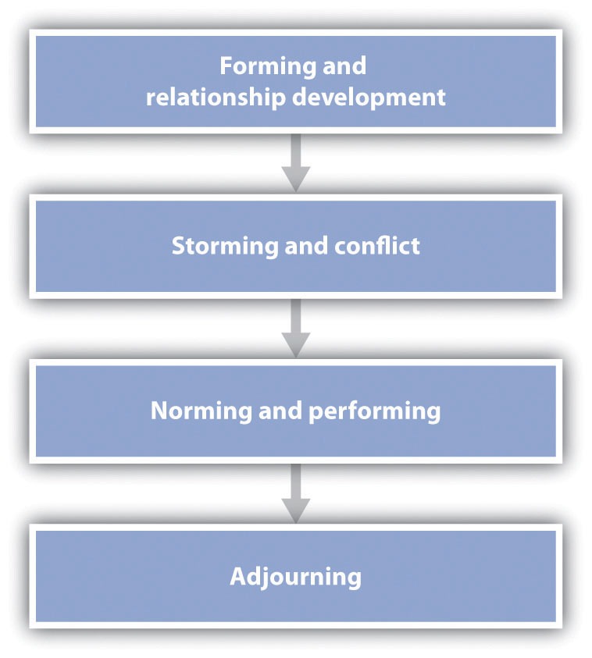
This figure represents a general model of the phases of group development, beginning with group formation and ending with adjournment. It should be kept in mind, however, that the stages are not necessarily sequential, nor do all groups necessarily pass through all stages.

The development stage is important for the new members as well as for the group itself. During this time, the group and the individual will exchange knowledge about appropriate norms, including the existing group structures, procedures, and routines. The individual will need to learn about the group and determine how he or she is going to fit in. And the group may be inspecting the individual’s characteristics and appropriateness as a group member. This initial investigation process may end up with the individual rejecting the group or the group rejecting the individual.
If the group formation stage can be compared to childhood, there is no doubt that the next stage—storming—can be compared to adolescence. As the group members begin to get to know each other, they may find that they don’t always agree on everything. In this stage, members may attempt to make their own views known, expressing their independence and attempting to persuade the group to accept their ideas. Storming may occur as the group first gets started, and it may recur at any point during the group’s development, particularly if the group experiences stress caused by a negative event, such as a setback in progress toward the group goal. In some cases, the conflict may be so strong that the group members decide that the group is not working at all and they disband. In fact, field studies of real working groups have shown that a large percentage of new groups never get past the forming and storming stages before breaking up (Kuypers, Davies, & Hazewinkel, 1986). ^{[6]}
Although storming can be harmful to group functioning and thus groups must work to keep it from escalating, some conflict among group members may in fact be helpful to the group. Sometimes the most successful groups are those that have successfully passed through a storming stage, because conflict may increase the productivity of the group, unless the conflict becomes so extreme that the group disbands prematurely (Rispens & Jehn, 2011). ^{[7]} Groups that experience no conflict at all may be unproductive because the members are bored, uninvolved, and unmotivated, and because they do not think creatively or openly about the topics of relevance to them. In order to progress, the group needs to develop new ideas and approaches, and this requires that the members discuss their different opinions about the decisions that the group needs to make.
Assuming that the storming does not escalate too far, the group will move into a stage in which the appropriate norms and roles for the group are developed, allowing the group to establish a routine and effectively work together. At this stage—the norming and performing stage—the individual group members may report great satisfaction and identification with the group, as well as strong group identity. Groups that have effectively reached this stage have the ability to meet goals and survive challenges. And at this point, the group becomes well tuned to its task and is able to perform the task efficiently.
In one interesting observational study of the group development process in real groups, Gersick (1988, 1989) ^{[8]} observed a number of teams as they worked on different projects. The teams were selected such that they were all working within a specific time frame, but the time frame itself varied dramatically—from 8 to 25 meetings held over periods ranging from 11 days to 6 months. Despite this variability, Gersick found that each of the teams followed a very similar pattern of norming and performing. In each case, the team established well-defined norms regarding its method of attacking its task in its very first meeting. And each team stayed with this approach, with very little deviation, during the first half of the time it had been allotted. However, midway through the time it had been given to complete the project (and regardless of whether that was after 4 meetings or after 12), the group suddenly had a meeting in which it decided to change its approach. Then, each of the groups used this new method of performing the task during the rest of its allotted time. It was as if a sort of alarm clock went off at the halfway point, which led each group to rethink its approach.
Most groups eventually come to an end—the adjournment stage. In some cases, this is because the task for which the group was formed has been completed, whereas in other cases, it occurs because the group members have developed new interests outside the group. In any case, because people who have worked in a group have likely developed a strong identification with the group and the other group members, the adjournment phase is frequently stressful, and participants may resist the breakup. Faced with these situations, individuals frequently plan to get together again in the future, exchanging addresses and phone numbers, even though they may well know that it is unlikely they will actually do so. Sometimes it is useful for the group to work ahead of time to prepare members for the breakup.

KEY TAKEAWAYS
- Social groups form the foundation of human society—without groups, there would be no human culture. Working together in groups, however, may lead to a variety of negative outcomes as well.
- Similarity, communication, interdependence, and group structure are variables that make a collection of individuals seem more like a group—the perception of group entitativity.
- Most groups that we belong to provide us with a positive social identity—the part of the self-concept that results from our membership in social groups.
- One way to understand group development is to consider the potential stages that groups generally go through. The normal stages are forming, storming, norming and performing, and adjourning.

EXERCISES AND CRITICAL THINKING
- Consider some of the social groups that you belong to. Which of the variables that we discussed in this section make them seem more like a group?
- Consider groups that provide a particularly strong social identity for their members. Why do you think social identity is so strong in these groups, and how does the experience of identity influence the group members’ behavior?

[1] Campbell, D. T. (1958). Common fate, similarity and other indices of the status of aggregate persons as social entities. Behavioral Science, 3, 14–25; Lickel, B., Hamilton, D. L., Wieczorkowska, G., Lewis, A., Sherman, S. J., & Uhles, A. N. (2000). Varieties of groups and the perception of group entitativity. Journal of Personality and Social Psychology, 78(2), 223–246.
[2] Crump, S. A., Hamilton, D. L., Sherman, S. J., Lickel, B., & Thakkar, V. (2010). Group entitativity and similarity: Their differing patterns in perceptions of groups. European Journal of Social Psychology, 40(7), 1212–1230. doi: 10.1002/ejsp.716; Miles, J. R., & Kivlighan, D. M., Jr. (2008). Team cognition in group interventions: The relation between coleaders’ shared mental models and group climate. Group Dynamics: Theory, Research, and Practice, 12(3), 191–209. doi: 10.1037/1089–2699.12.3.191
[3] Deutsch, M. (1949). An experimental study of the effects of cooperation and competition upon group processes. Human Relations, 2, 199–231.
[4] Hogg, M. A. (2003). Social identity. In M. R. Leary & J. P. Tangney (Eds.), Handbook of self and identity (pp. 462–479). New York, NY: Guilford Press.
[5] Hogg, M. A. (2003). Social identity. In M. R. Leary & J. P. Tangney (Eds.), Handbook of self and identity (pp. 462–479). New York, NY: Guilford Press; Hogg, M. A. (2010). Human groups, social categories, and collective self: Social identity and the management of self-uncertainty. In R. M. Arkin, K. C. Oleson, & P. J. Carroll (Eds.), Handbook of the uncertain self (pp. 401–420). New York, NY: Psychology Press.
[6] Kuypers, B. C., Davies, D., & Hazewinkel, A. (1986). Developmental patterns in self-analytic groups. Human Relations, 39(9), 793–815.
[7] Rispens, S., & Jehn, K. A. (2011). Conflict in workgroups: Constructive, destructive, and asymmetric conflict. In D. De Cremer, R. van Dick, & J. K. Murnighan (Eds.), Social psychology and organizations (pp. 185–209). New York, NY: Routledge/Taylor & Francis Group.
[8] Gersick, C. J. (1988). Time and transition in work teams: Toward a new model of group development. Academy of Management Journal, 31(1), 9–41; Gersick, C. (1989). Marking time: Predictable transitions in task groups. Academy of Management Journal, 32, 274–309.

11.2 Group Process: The Pluses and Minuses of Working Together

LEARNING OBJECTIVES
- Describe the situations under which social facilitation and social inhibition might occur, and review the theories that have been used to explain these processes.
- Outline the effects of member characteristics, process gains, and process losses on group performance.
- Summarize how social psychologists classify the different types of tasks that groups are asked to perform.
- Explain the influence of each of these concepts on group performance: groupthink, information sharing, brainstorming, and group polarization.
When important decisions need to be made, or when tasks need to be performed quickly or effectively, we frequently create groups to accomplish them. Many people believe that groups are effective for making decisions and performing other tasks (Nijstad, Stroebe, & Lodewijkx, 2006), ^{[1]} and such a belief seems commonsensical. After all, because groups have many members, they will also have more resources and thus more ability to efficiently perform tasks and make good decisions. However, although groups sometimes do perform better than individuals, this outcome is not guaranteed. Let’s consider some of the many variables that can influence group performance.

Social Facilitation and Social Inhibition
In one of the earliest social psychological studies, Norman Triplett (1898) ^{[2]}investigated how bicycle racers were influenced by the social situation in which they raced. Triplett found something very interesting—the racers who were competing with other bicyclers on the same track rode significantly faster than bicyclers who were racing alone, against the clock. This led Triplett to hypothesize that people perform tasks better when the social context includes other people than when they do the tasks alone. Subsequent findings validated Triplett’s results, and other experiments have shown that the presence of others can increase performance on many types of tasks, including jogging, shooting pool, lifting weights, and working on math and computer problems (Geen, 1989; Guerin, 1983; Robinson-Staveley & Cooper, 1990; Strube, Miles, & Finch, 1981). ^{[3]} The tendency to perform tasks better or faster in the presence of others is known as social facilitation.
Although people sometimes perform better when they are in groups than they do alone, the situation is not that simple. Perhaps you can remember a time when you found that a task you could perform well alone (e.g., giving a public presentation, playing the piano, shooting basketball free throws) was not performed as well when you tried it with, or in front of, others. Thus it seems that the conclusion that being with others increases performance cannot be entirely true and that sometimes the presence of others can worsen our performance. The tendency to perform tasks more poorly or slower in the presence of others is known as social inhibition.
To study social facilitation and social inhibition, Hazel Markus (1978) ^{[4]} gave research participants both an easy task (putting on and tying their shoes) and an unfamiliar and thus more difficult task (putting on and tying a lab coat that tied in the back). The research participants were asked to perform both tasks in one of three social situations—alone, with a confederate present who was watching them, or with a confederate present who sat in the corner of the room repairing a piece of equipment without watching. As you can see in Figure 11.2 "Group Task Performance", Markus found first that the difficult task was performed more slowly overall. But she also found an interaction effect, such that the participants performed the easy task faster but the more difficult task slower when a confederate was present in the room. Furthermore, it did not matter whether the other person was paying attention to their performance or whether the other person just happened to be in the room working on another task—the mere presence of another person nearby influenced performance.

Figure 11.2 Group Task Performance
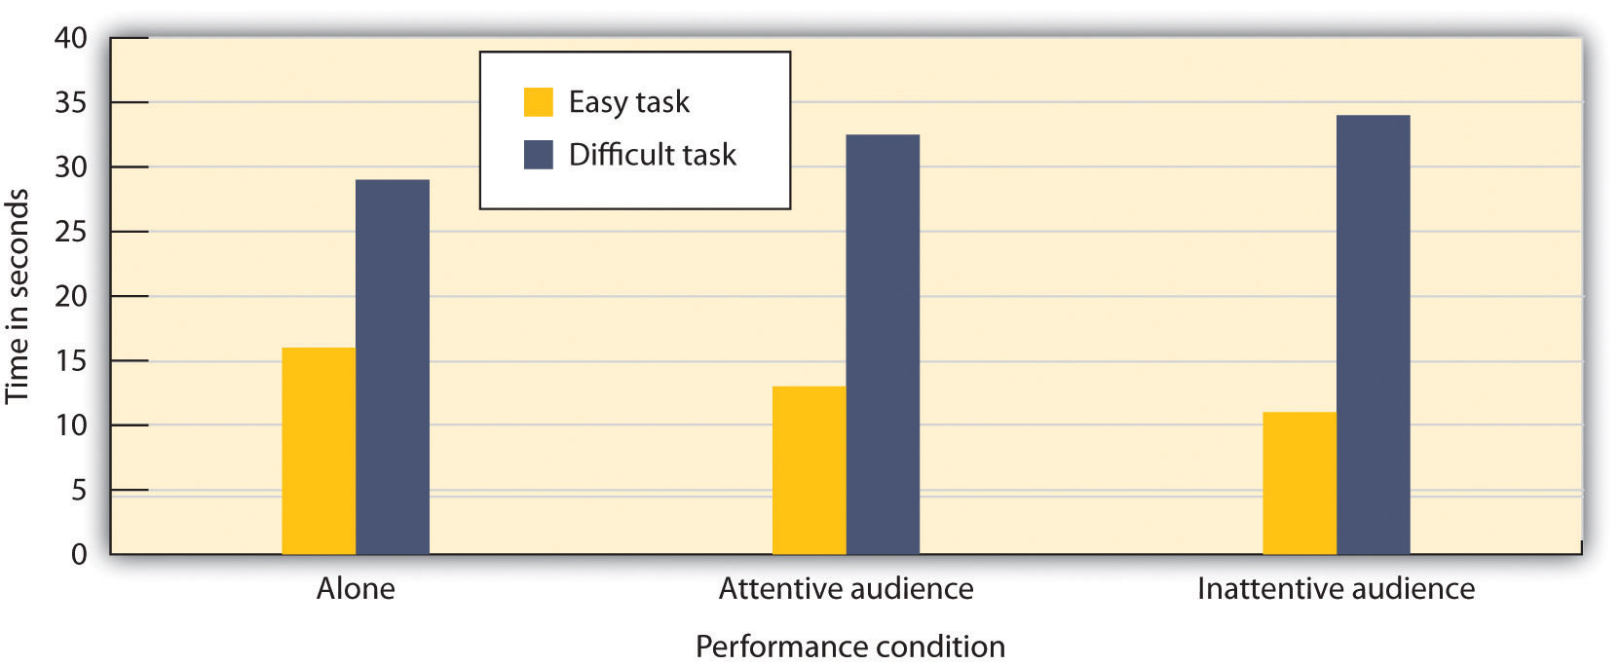
In this experiment, participants were asked to perform a well-learned task (tying their shoes) and a poorly learned task (putting on a lab coat that tied in the back). There is both a main effect of task difficulty and a task-difficulty-by-performance-condition interaction. Data are from Markus (1978). ^{[5]}
These results convincingly demonstrated that working around others could either help or hinder performance. But why would this be? One explanation of the influence of others on task performance was proposed by Robert Zajonc (1965). ^{[6]} As shown inFigure 11.3 "Explaining Social Facilitation and Social Inhibition", Zajonc made use of the affective component of arousal in his explanation. Zajonc argued that when we are with others, we experience more arousal than we do when we are alone, and that this arousal increases the likelihood that we will perform the dominant response—the action that we are most likely to emit in any given situation.

Figure 11.3 Explaining Social Facilitation and Social Inhibition
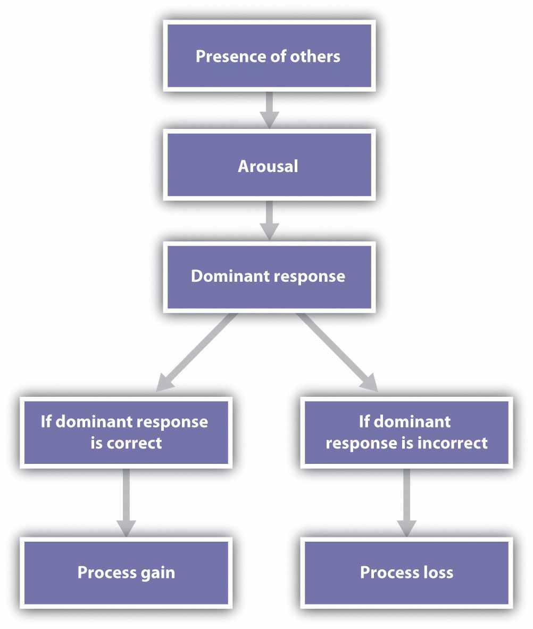
According to the social facilitation model of Robert Zajonc (1965), ^{[7]}the mere presence of others produces arousal, which increases the probability that the dominant response will occur. If the dominant response is correct, the task is performed better, whereas if the dominant response is incorrect, the task is performed more poorly.
The important aspect of Zajonc’s theory was that the experience of arousal and the resulting increase in the performance of the dominant response could be used to predict whether the presence of others would produce social facilitation or social inhibition. Zajonc argued that if the task to be performed was relatively easy, or if the individual had learned to perform the task very well (a task such as pedaling a bicycle or tying one’s shoes), the dominant response was likely to be the correct response, and the increase in arousal caused by the presence of others would improve performance. On the other hand, if the task was difficult or not well learned (e.g., solving a complex problem, giving a speech in front of others, or tying a lab apron behind one’s back), the dominant response was likely to be the incorrect one; and because the increase in arousal would increase the occurrence of the (incorrect) dominant response, performance would be hindered.
Zajonc’s theory explained how the presence of others can increase or decrease performance, depending on the nature of the task, and a great deal of experimental research has now confirmed his predictions. In a meta-analysis, Bond and Titus (1983) ^{[8]} looked at the results of over 200 studies using over 20,000 research participants and found that the presence of others did significantly increase the rate of performance on simple tasks and decrease both the rate and the quality of performance on complex tasks.
One interesting aspect of Zajonc’s theory is that because it only requires the concepts of arousal and dominant response to explain task performance, it predicts that the effects of others on performance will not necessarily be confined to humans. Zajonc reviewed evidence that dogs ran faster, chickens ate more feed, ants built bigger nests, and rats had more sex when other dogs, chickens, ants, and rats, respectively, were around (Zajonc, 1965). ^{[9]} In fact, in one of the most unusual of all social psychology experiments, Zajonc, Heingartner, and Herman (1969) ^{[10]} found that cockroaches ran faster on straight runways when other cockroaches were observing them (from behind a plastic window) but that they ran slower, in the presence of other roaches, on a maze that involved making a difficult turn, presumably because running straight was the dominant response, whereas turning was not.
Although the arousal model proposed by Zajonc is perhaps the most elegant, other explanations have also been proposed to account for social facilitation and social inhibition. One modification argues that we are particularly influenced by others when we perceive that the others are evaluating us or competing with us (Szymanski & Harkins, 1987). ^{[11]} This makes sense because in these cases, another important motivator of human behavior—the desire to enhance the self—is involved in addition to arousal. In one study supporting this idea, Strube and his colleagues (Strube, Miles, & Finch, 1981) ^{[12]} found that the presence of spectators increased the speed of joggers only when the spectators were facing the joggers and thus could see them and assess their performance.
The presence of others who expect us to do well and who are thus likely to be particularly distracting has been found to have important consequences in some real-world situations. For example, Baumeister and Steinhilber (1984) ^{[13]} found that professional athletes frequently performed more poorly than would be expected in crucial games that were played in front of their own fans (such as the final baseball game of the World Series championship).

Process Losses and Process Gains
Working in groups has some benefits. Because groups consist of many members, group performance is almost always better than the performance of an individual acting alone, and group decisions are generally more accurate than the decisions of any one individual. Many heads are better than one in terms of knowledge, memory, physical strength, and other abilities. The group from the National Aeronautics and Space Administration that worked together to land a human on the moon, a rock band whose members are writing a new song together, or a surgical team in the middle of a complex operation may coordinate their efforts so well that is clear that the same outcome could never have occurred if the individuals had worked alone, or in another group of less well-suited individuals. In these cases, the knowledge and skills of the individuals seem to work together to be effective, and the outcome of the group appears to be enhanced. When groups work better than we would expect, given the individuals who form them, we call the outcome a process gain.
There are at least some data suggesting that groups may in some cases experience process gains. For instance, weber and Hertel (2007) ^{[14]} found in a recent meta-analysis that individuals can in some cases exert higher motivation when working in a group compared with working individually, resulting in increased group performance. This is particularly true for less capable, inferior group members who seem to become inspired to work harder when they are part of a group. On the other hand, there are also costs to working in groups—for instance, the disastrous decision made by the team of advisors to President Kennedy that led to the unsuccessful invasion of Cuba in 1961, as well as countless other poor decisions. In these cases, the groups experience process losses. A process loss is an outcome in situations in which groups perform more poorly than we would expect, given the characteristics of the members of the group.
One way to think about the benefits of groups is to compare the potential productivityof the group—that is, what the group should be able to do, given its membership—with the actual productivity of the group. For example, on a rope-pulling task, the potential group productivity (the strength with which the group should pull when working together) would be calculated as the sum of all the individual inputs. The difference between the expected productivity of the group and the actual productivity of the group (i.e., the extent to which the group is more or less than the sum of its parts) is determined by the group process, defined as the events that occur while the group is working together on the task. When the outcome of the group performance is better than would be expected on the basis of the members’ characteristics (the group pulls harder than expected), there is a process gain; when the outcome of the group performance is worse than would be expected on the basis of the members’ characteristics, there is a process loss. Mathematically, we can write the following equation to express this relationship:
actual productivity = potential productivity − process loss + process gain.
As you can see, group performance is another example of a case in which person and situation variables work together because it depends on both the skills of the people in the group and the way these resources are combined as the group members work together.

Person Variables: Group Member Characteristics
No matter what type of group we are considering, the group will naturally attempt to recruit the best people they can find to help them meet their goals.Member characteristics are the relevant traits, skills, or abilities of the individual group members. On a rope-pulling task, for instance, the member characteristic is the ability of each of group member to pull hard on the rope on his or her own. In addition to having different skills, people differ in personality factors that relate to group performance. Some people are highly motivated to join groups and to make positive contributions to those groups, whereas others are more wary of group membership and prefer to meet their goals working alone. Furthermore, when they are in groups, people may be expected to respond somewhat differently in group interactions, because each is using the group to meet his or her own social and personal goals.
The extent to which member skill influences group performance varies across different group tasks. On an automobile assembly line, performing the task requires only relatively minimal skills, and there is not a lot of coordination among the individuals involved. In this case, it is primarily the number and skill of the individuals who are working on the task that influences the group outcome. In other cases, such as a surgical team or a work team within a corporation, the group includes individuals with a wide variety of different skills, each working at very different tasks. In cases such as these, communication and coordination among the group members is essential, and thus group process will be very important. As an example of variation in the importance of member skills, Jones (1974) ^{[15]} found that the skill of individual baseball players accounted for 99% of the team performance on baseball teams (and thus group process accounted for only 1%) but that the skill of individual basketball players accounted for only 35% of the team performance on basketball teams (and thus group process accounted for 65%).

The Importance of the Social Situation: Task Characteristics
Although the characteristics of the group members themselves are critical, they represent only the person part of the equation. To fully understand group performance, we must also consider the particulars of the group’s situation—for instance, the task that the group needs to accomplish. Let’s now consider some of the different types of tasks that might be performed by groups and how they might influence performance (Hackman & Morris, 1975; Straus, 1999). ^{[16]} These classifications are summarized as follows:
- Task division
  - Divisible. A task in which the work can be divided up among individuals.
  - Unitary. A task in which the work cannot be divided up among individuals.
- Task combination
  - Additive. A task in which the inputs of each group member are added together to create the group performance.
  - Compensatory or averaging. A task in which the group input is combined such that the performance of the individuals is averaged.
- Group member performance
  - Disjunctive. A task in which the group’s performance is determined by its best group member.
  - Conjunctive. A task in which the group’s performance is determined by its worst member.
- Task assessment
  - Maximizing. A task that involves performance that is measured by how rapidly the group works or how much of a product they are able to make.
  - Intellective. A task that involves the ability of the group to make a decision or a judgment.
- Task clarity
  - Criterion. A task in which there is a clearly correct answer to the problem that is being posed.
  - Judgmental. A task in which there is no clearly correct answer to the problem that is being posed.
One basic distinction concerns whether the task can be divided into smaller subtasks or has to be done as a whole. Building a car on an assembly line or painting a house is a divisible task, because each of the group members working on the job can do a separate part of the job at the same time. Groups are likely to be particularly productive on divisible tasks when the division of the work allows the group members to specialize in those tasks that they are best at performing. Writing a group term paper is facilitated if one group member is an expert typist, another is an expert at library research, and so forth. Climbing a mountain or moving a piano, on the other hand, is a unitary task, because it has to be done all at once and cannot be divided up. In this case, specialization among group members is less useful, because each group member has to work on the same task at the same time.
Another way of classifying tasks is by the way the contributions of the group members are combined. On an additive task, the inputs of each group member are added together to create the group performance, and the expected performance of the group is the sum of group members’ individual inputs. A tug of war is a good example of an additive task because the total performance of a team is expected to be the sum of all the team members’ individual efforts.
On a compensatory (averaging) task, however, the group input is combined such that the performance of the individuals is averaged rather than added. Imagine that you wanted to estimate the current temperature in your classroom, but you had no thermometer. One approach to getting an estimate would be to have each of the individuals in your class make his or her estimate of the temperature and then average the estimates together to create a group judgment. On decisions such as this, the average group judgment is likely to be more accurate than that made by most individuals (Armstrong, 2001; Surowiecki, 2004). ^{[17]}
Another task classification involves comparing tasks in which the group performance is dependent upon the abilities of the best member or members of the group with tasks in which the group performance is dependent upon the abilities of the worst member or members of the group. When the group’s performance is determined by the best group member, we call it a disjunctive task. Consider what might happen when a group is given a complicated problem to solve, such as this horse-trading problem:
A man buys a horse for $50. He later decides he wants to sell his horse and he gets $60. He then decides to buy it back and pays $70. However, he can no longer keep it, and he sells it for $80. Did he make money, lose money, or break even? Explain why.
The correct answer to the problem is not immediately apparent, and each group member will attempt to solve the problem. With some luck, one or more of the members will discover the correct solution, and when that happens, the other members will be able to see that it is indeed the correct answer. At this point, the group as a whole has correctly solved the problem, and the performance of the group is thus determined by the ability of the best member of the group.
In contrast, on a conjunctive task, the group performance is determined by the ability of the group member who performs most poorly. Imagine an assembly line in which each individual working on the line has to insert one screw into the part being made and that the parts move down the line at a constant speed. If any one individual is substantially slower than the others, the speed of the entire line will need to be slowed down to match the capability of that individual. As another example, hiking up a mountain in a group is also conjunctive because the group must wait for the slowest hiker to catch up.
Still another distinction among tasks concerns the specific product that the group is creating and how that group output is measured. An intellective task involves the ability of the group to make a decision or a judgment and is measured by studying either the processes that the group uses to make the decision (such as how a jury arrives at a verdict) or the quality of the decision (such as whether the group is able to solve a complicated problem). A maximizing task, on the other hand, is one thatinvolves performance that is measured by how rapidly the group works or how much of a product they are able to make (e.g., how many computer chips are manufactured on an assembly line, how many creative ideas are generated by a brainstorming group, how fast a construction crew can build a house).
Finally, we can differentiate intellective task problems for which there is an objectively correct decision from those in which there is not a clear best decision. On acriterion task, the group can see that there is a clearly correct answer to the problem that is being posed. Some examples would be finding solutions to mathematics or logic problems, such as the horse-trading problem.
On some criterion tasks, the correct answer is immediately seen as the correct one once it is found. For instance, what is the next letter in each of the following two patterns of letters?
J F M A M _
O T T F F _
In criterion problems such as this one, as soon as one of the group members finds the correct answer, the problem is solved because all the group members can see that it is correct. Criterion tasks in which the correct answer is obvious once it is found are known as “Eureka!” or “Aha!” tasks (Lorge, Fox, Davitz, & Brenner, 1958), ^{[18]} named for the response that we have when we see the correct solution.
In other types of criterion-based tasks, there is an objectively correct answer, although that answer is not immediately obvious. For instance, consider again the horse-trading problem. In this case, there is a correct answer, but it may not be apparent to the group members even when it is proposed by one or more of them (for this reason, we might call this a “non-Eureka” task). In fact, in one study using the horse-trading problem, only 80% of the groups in which the correct answer was considered actually decided upon that answer as the correct one after the members had discussed it together.
In still other criterion-based tasks, experts must be used to assess the quality or creativity of the group’s performance. Einhorn, Hogarth, and Klempner (1977) ^{[19]}asked groups of individuals to imagine themselves as a group of astronauts who are exploring the moon but who have become stranded from their base. The problem is to determine which of the available pieces of equipment (e.g., oxygen bottles, a rope, a knife) they should take with them as they attempt to reach the base. To assess group performance, experts on the difficulties of living in space made judgments about the quality of the group decisions. Non-Eureka tasks represent an interesting challenge for groups because even when they have found what they think is a good answer, they may still need to continue their discussion to convince themselves that their answer is the best they can do and that they can therefore stop their deliberation.
In contrast to a criterion task, in a judgmental task there is no clearly correct answer to the problem. Judgmental tasks involve such decisions as determining the innocence or guilt of an accused person in a jury or making an appropriate business decision. Because there is no objectively correct answer on judgmental tasks, the research approach usually involves studying the processes that the group uses to make the decision rather than measuring the outcome of the decision itself. Thus the question of interest on judgmental tasks is not “Did the group get the right answer?” but rather “How did the group reach its decision?”

Process Losses Due to Difficulties in Coordination and Motivation
Process losses are caused by events that occur within the group that make it difficult for the group to live up to its full potential. In one study, Ringelmann (1913; reported in Kravitz & Martin, 1986) ^{[20]} investigated the ability of individuals to reach their full potential when working together on tasks. Ringelmann had individual men and groups of various numbers of men pull as hard as they could on ropes while he measured the maximum amount that they were able to pull. Because rope pulling is an additive task, the total amount that could be pulled by the group should be the sum of the contributions of the individuals. However, as shown in Figure 11.4 "The Ringelmann Effect", although Ringelmann did find that adding individuals to the group increased the overall amount of pulling on the rope (the groups were better than any one individual), he also found a substantial process loss. In fact, the loss was so large that groups of three men pulled at only 85% of their expected capability, whereas groups of eight pulled at only 37% of their expected capability.

Figure 11.4 The Ringelmann Effect
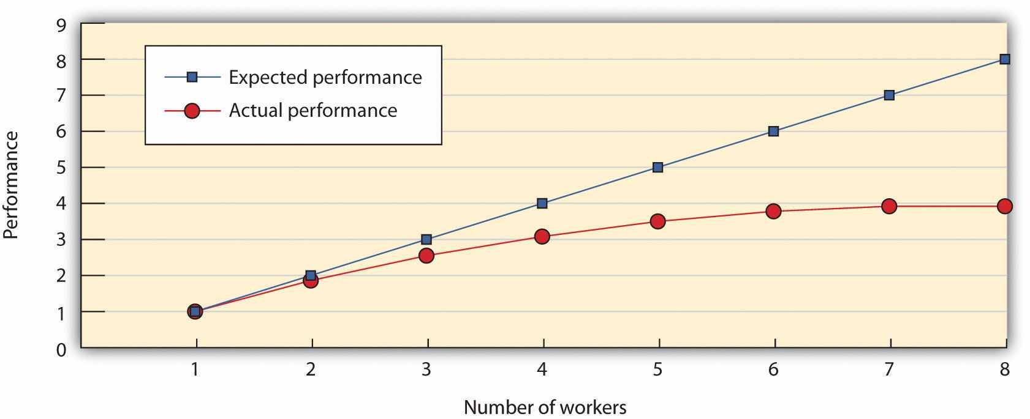
Ringelmann found that although more men pulled harder on a rope than fewer men did, there was a substantial process loss in comparison with what would have been expected on the basis of their individual performances.
This type of process loss, in which group productivity decreases as the size of the group increases, has been found to occur on a wide variety of tasks, including maximizing tasks such as clapping and cheering and swimming (Latané, Williams, & Harkins, 1979; Williams, Nida, Baca, & Latané, 1989), ^{[21]} and judgmental tasks such as evaluating a poem (Petty, Harkins, Williams, & Latané, 1977). ^{[22]} Furthermore, these process losses have been observed in different cultures, including India, Japan, and Taiwan (Gabrenya, Wang, & Latané, 1985; Karau & Williams, 1993). ^{[23]}
Process losses in groups occur in part simply because it is difficult for people to work together. The maximum group performance can only occur if all the participants put forth their greatest effort at exactly the same time. Since, despite the best efforts of the group, it is difficult to perfectly coordinate the input of the group members, the likely result is a process loss such that the group performance is less than would be expected, as calculated as the sum of the individual inputs. Thus actual productivity in the group is reduced in part by coordination losses.
Coordination losses become more problematic as the size of the group increases because it becomes correspondingly more difficult to coordinate the group members. Kelley, Condry, Dahlke, and Hill (1965) ^{[24]} put individuals into separate booths and threatened them with electrical shock. Each person could avoid the shock, however, by pressing a button in the booth for 3 seconds. But the situation was arranged such that only one person in the group could press the button at one time, and so the group members needed to coordinate their actions. Kelley et al. found that larger groups had significantly more difficulty coordinating their actions to escape the shocks than did smaller groups.
In addition to being influenced by the coordination of activities, group performance is influenced by self-concern on the part of the individual group members. Since each group member is motivated at least in part by individual self-concerns, each member may desire, at least in part, to gain from the group effort without having to contribute very much. You may have been in a work or study group that had this problem—each group member was interested in doing well but also was hoping that the other group members would do most of the work for them. A group process loss that occurs when people do not work as hard in a group as they do when they are alone is known associal loafing (Karau & Williams, 1993). ^{[25]}

Research Focus
Differentiating Coordination Losses From Social Loafing
Latané, Williams, and Harkins (1979) ^{[26]} conducted an experiment that allowed them to measure the extent to which process losses in groups were caused by coordination losses and by social loafing. Research participants were placed in a room with a microphone and were instructed to shout as loudly as they could when a signal was given. Furthermore, the participants were blindfolded and wore headsets that prevented them from either seeing or hearing the performance of the other group members. On some trials, the participants were told (via the headsets) that they would be shouting alone, and on other trials, they were told that they would be shouting with other participants. However, although the individuals sometimes did shout in groups, in other cases (although they still thought that they were shouting in groups) they actually shouted alone. Thus Latané and his colleagues were able to measure the contribution of the individuals, both when they thought they were shouting alone and when they thought they were shouting in a group.
Latané et al.’s results are presented in in the following figure, which shows the amount of sound produced per person. The top line represents the potential productivity of the group, which was calculated as the sum of the sound produced by the individuals as they performed alone. The middle line represents the performance of hypothetical groups, computed by summing the sound in the conditions in which the participants thought that they were shouting in a group of either two or six individuals, but where they were actually performing alone. Finally, the bottom line represents the performance of real two-person and six-person groups who were actually shouting together.

Figure 11.5Coordination and Motivation Losses in Working Groups
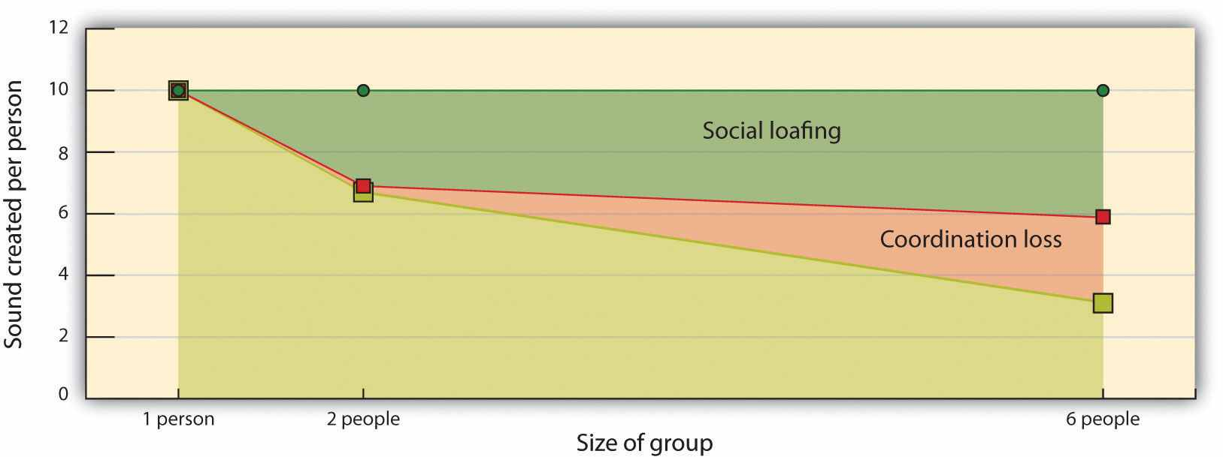
Individuals who were asked to shout as loudly as they could shouted much less so when they were in larger groups, and this process loss was the result of both motivation and coordination losses. Data from Latané, Williams, and Harkins (1979). ^{[27]}
The results of the study are very clear. First, as the number of people in the group increased (from one to two to six), each person’s individual input got smaller, demonstrating the process loss that the groups created. Furthermore, the decrease for real groups (the lower line) is greater than the decrease for the groups created by summing the contributions of the individuals. Because performance in the summed groups is a function of motivation but not coordination, and the performance in real groups is a function of both motivation and coordination, Latané and his colleagues effectively showed how much of the process loss was due to each.

Process Losses Due to Group Conformity Pressures: Groupthink
Even if groups are able to get beyond the process losses that result from coordination difficulties and social loafing, they can make effective decisions only when they are able to make use of the advantages that come with group membership. These advantages include the ability to pool the information that is known to each of the members and to test out contradictory ideas through group discussion. Group decisions can be better than individual decisions only when the group members act carefully and rationally—considering all the evidence and coming to an unbiased, fair, and open decision. However, these conditions are not always met in real groups.
As we saw in the chapter opener, one example of a group process that can lead to very poor group decisions is groupthink. Groupthink occurs when a group that is made up of members who may actually be very competent and thus quite capable of making excellent decisions nevertheless ends up making a poor one as a result of a flawed group process and strong conformity pressures (Baron, 2005; Janis, 2007). ^{[28]}Groupthink is more likely to occur in groups in which the members are feeling strong social identity—for instance, when there is a powerful and directive leader who creates a positive group feeling, and in times of stress and crisis when the group needs to rise to the occasion and make an important decision. The problem is that groups suffering from groupthink become unwilling to seek out or discuss discrepant or unsettling information about the topic at hand, and the group members do not express contradictory opinions. Because the group members are afraid to express ideas that contradict those of the leader or to bring in outsiders who have other information, the group is prevented from making a fully informed decision. Figure 11.6 "Antecedents and Outcomes of Groupthink" summarizes the basic causes and outcomes of groupthink.

Figure 11.6 Antecedents and Outcomes of Groupthink
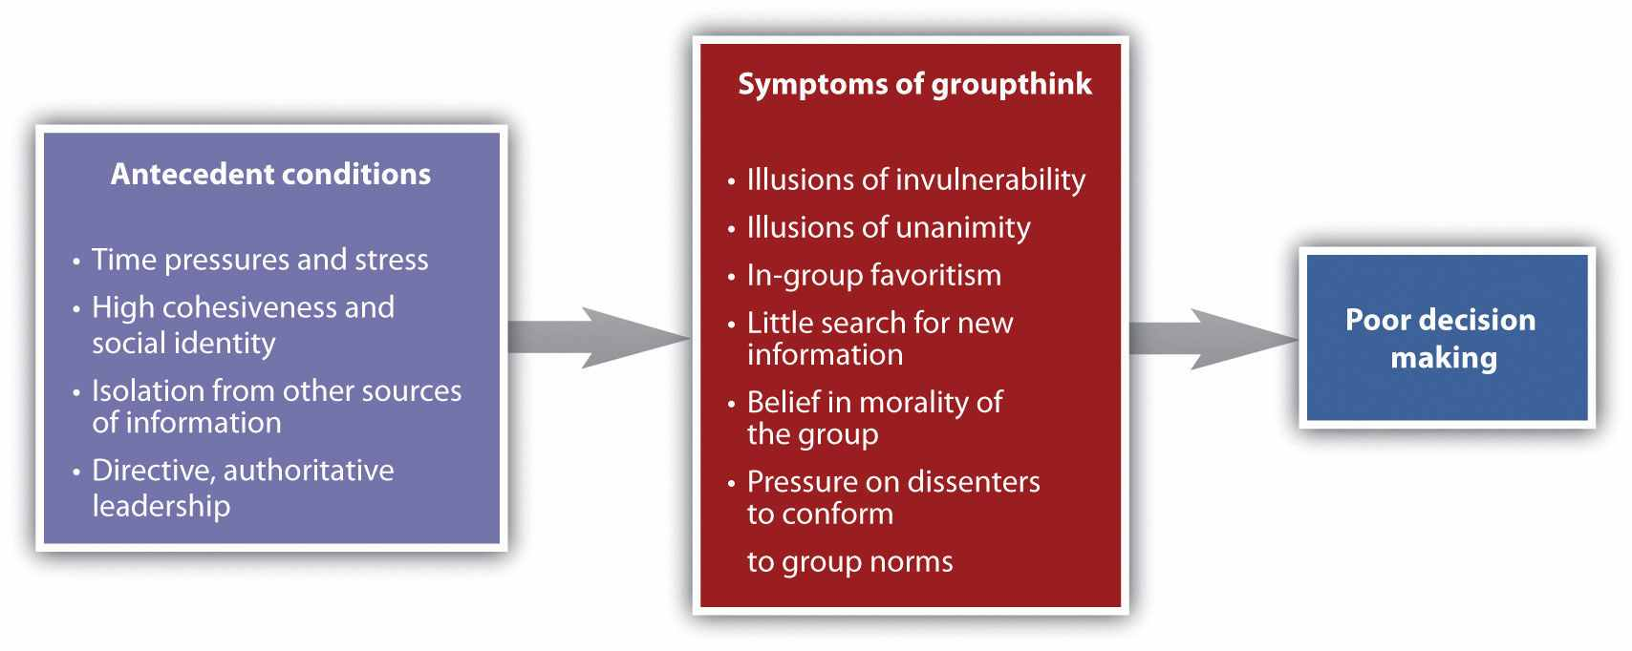
Although at least some scholars are skeptical of the importance of groupthink in real group decisions (Kramer, 1998), ^{[29]} many others have suggested that groupthink was involved in a number of well-known and important, but very poor, decisions made by government and business groups. Decisions analyzed in terms of groupthink include the decision to invade Iraq made by President George Bush and his advisers; the decision of President John Kennedy and his advisers to commit U.S. forces to help with an invasion of Cuba, with the goal of overthrowing Fidel Castro in 1962; and the lack of response to warnings on an attack on Pearl Harbor, Hawaii, in 1941.
Careful analyses of the decision-making process in these cases have documented the role of conformity pressures. In fact, the group process often seems to be arranged to maximize the amount of conformity rather than to foster free and open discussion. In the meetings of the Bay of Pigs advisory committee, for instance, President Kennedy sometimes demanded that the group members give a voice vote regarding their individual opinions before the group actually discussed the pros and cons of a new idea. The result of these conformity pressures is a general unwillingness to express ideas that do not match the group norm.
The pressures for conformity also lead to the situation in which only a few of the group members are actually involved in conversation, whereas the others do not express any opinions. Because little or no dissent is expressed in the group, the group members come to believe that they are in complete agreement. In some cases, the leader may even select individuals (known as mindguards) whose job it is to help quash dissent and to increase conformity to the leader’s opinions.
An outcome of the high levels of conformity found in these groups is that the group begins to see itself as extremely valuable and important, highly capable of making high-quality decisions, and invulnerable. In short, the group members develop extremely high levels of conformity and social identity. Although this social identity may have some positive outcomes in terms of a commitment to work toward group goals (and it certainly makes the group members feel good about themselves), it also tends to result in illusions of invulnerability, leading the group members to feel that they are superior and that they do not need to seek outside information. Such a situation is conducive to terrible decision making and resulting fiascos.

Cognitive Process Losses: Lack of Information Sharing
Although group discussion generally improves the quality of a group’s decisions, this will only be true if the group discusses the information that is most useful to the decision that needs to be made. One difficulty is that groups tend to discuss some types of information more than others. In addition to the pressures to focus on information that comes from leaders and that is consistent with group norms, discussion is influenced by the way the relevant information is originally shared among the group members. The problem is that group members tend to discuss information that they all have access to while ignoring equally important information that is available to only a few of the members (Faulmüller, Kerschreiter, Mojzisch, & Schulz-Hardt, 2010; Reimer, Reimer, & Czienskowski (2010). ^{[30]}

Research Focus
Poor Information Sharing in Groups
In one demonstration of the tendency for groups to preferentially discuss information that all the group members know about, Stasser and Titus (1985) ^{[31]}used an experimental design based on the hidden profile task, as shown in the following table. Students read descriptions of two candidates for a hypothetical student body presidential election and then met in groups to discuss and pick the best candidate. The information about the candidates was arranged such that one of the candidates (Candidate A) had more positive qualities overall in comparison with the other (Candidate B). Reflecting this superiority, in groups in which all the members were given all the information about both candidates, the members chose Candidate A 83% of the time after their discussion.

Table 11.1 Hidden Profiles
Group member | Information favoring Candidate A | Information favoring Candidate B
X | a1, a2 | b1, b2, b3
Y | a1, a3 | b1, b2, b3
Z | a1, a4 | b1, b2, b3
This is an example of the type of “hidden profile” that was used by Stasser and Titus (1985) ^{[32]} to study information sharing in group discussion. (The researchers’ profiles were actually somewhat more complicated). The three pieces of favorable information about Candidate B (b1, b2, and b3) were seen by all of the group members, but the favorable information about Candidate A (a1, a2, a3, and a4) was not given to everyone. Because the group members did not share the information about Candidate A, Candidate B was erroneously seen as a better choice.
However, in some cases, the experimenters made the task more difficult by creating a “hidden profile,” in which each member of the group received only part of the information. In these cases, although all the information was potentially available to the group, it was necessary that it be properly shared to make the correct choice. Specifically, in this case, in which the information favoring Candidate B was shared, but the information favoring Candidate A was not, only 18% of the groups chose A, whereas the others chose the inferior candidate. This occurred because although the group members had access to all the positive information collectively, the information that was not originally shared among all the group members was never discussed. Furthermore, this bias occurred even in participants who were given explicit instructions to be sure to avoid expressing their initial preferences and to review all the available facts (Stasser, Taylor, & Hanna, 1989). ^{[33]}
Although the tendency to share information poorly seems to occur quite frequently, at least in experimentally created groups, it does not occur equally under all conditions. For one, groups have been found to better share information when the group members believe that there is a correct answer that can be found if there is sufficient discussion (Stasser & Stewart, 1992), ^{[34]} and groups also are more likely to share information if they are forced to continue their discussion even after they believe that they have discussed all the relevant information (Larson, Foster-Fishman, & Keys, 1994). ^{[35]} These findings suggest that an important job of the group leader is to continue group discussion until he or she is convinced that all the relevant information has been addressed.
The structure of the group will also influence information sharing (Stasser & Taylor, 1991). ^{[36]} Groups in which the members are more physically separated and thus have difficulty communicating with each other may find that they need to reorganize themselves to improve communication. And the status of the group members can also be important. Group members with lower status may have less confidence and thus be unlikely to express their opinions. Wittenbaum (1998) ^{[37]}found that group members with higher status were more likely to share new information. However, those with higher status may sometimes dominate the discussion, even if the information that they have is not more valid or important (Hinsz, 1990). ^{[38]} Groups are also likely to share unique information when the group members do not initially know the alternatives that need to be determined or the preferences of the other group members (Mojzisch & Schulz-Hardt, 2010; Reimer, Reimer, & Hinsz, 2010). ^{[39]}
Findings showing that groups neither share nor discuss originally unshared information have very disconcerting implications for group decision making because they suggest that group discussion is likely to lead to very poor judgments. Not only is unshared information not brought to the table, but because the shared information is discussed repeatedly, it is likely to be seen as more valid and to have a greater influence on decisions as a result of its high cognitive accessibility. It is not uncommon that individuals within a working group come to the discussion with different types of information, and this unshared information needs to be presented. For instance, in a meeting of a design team for a new building, the architects, the engineers, and the customer representatives will have different and potentially incompatible information. Thus leaders of working groups must be aware of this problem and work hard to foster open climates that encourages information sharing and discussion.

Brainstorming: Is It Effective?
One technique that is frequently used to produce creative decisions in working groups is known as brainstorming. The technique was first developed by Osborn (1953)^{[40]} in an attempt to increase the effectiveness of group sessions at his advertising agency. Osborn had the idea that people might be able to effectively use their brains to “storm” a problem by sharing ideas with each other in groups. Osborn felt that creative solutions would be increased when the group members generated a lot of ideas and when judgments about the quality of those ideas were initially deferred and only later evaluated. Thus brainstorming was based on the following rules:
- Each group member was to create as many ideas as possible, no matter how silly, unimportant, or unworkable they were thought to be.
- As many ideas as possible were to be generated by the group.
- No one was allowed to offer opinions about the quality of an idea (even one’s own).
- The group members were encouraged and expected to modify and expand upon other’s ideas.
Researchers have devoted considerable effort to testing the effectiveness of brainstorming, and yet, despite the creativeness of the idea itself, there is very little evidence to suggest that it works (Diehl & Stroebe, 1987, 1991; Stroebe & Diehl, 1994).^{[41]} In fact, virtually all individual studies, as well as meta-analyses of those studies, find that regardless of the exact instructions given to a group, brainstorming groups do not generate as many ideas as one would expect, and the ideas that they do generate are usually of lesser quality than those generated by an equal number of individuals working alone who then share their results. Thus brainstorming represents still another example of a case in which, despite the expectation of a process gain by the group, a process loss is instead observed.
A number of explanations have been proposed for the failure of brainstorming to be effective, and many of these have been found to be important. One obvious problem is social loafing by the group members, and at least some research suggests that this does cause part of the problem. For instance, Paulus and Dzindolet (1993) ^{[42]} found that social loafing in brainstorming groups occurred in part because individuals perceived that the other group members were not working very hard, and they matched they own behavior to this perceived norm. To test the role of social loafing more directly, Diehl and Stroebe (1987) ^{[43]} compared face-to-face brainstorming groups with equal numbers of individuals who worked alone; they found that face-to-face brainstorming groups generated fewer and less creative solutions than did an equal number of equivalent individuals working by themselves. However, for some of the face-to-face groups, the researchers set up a television camera to record the contributions of each of the participants in order to make individual contributions to the discussion identifiable. Being identifiable reduced social loafing and increased the productivity of the individuals in the face-to-face groups; but the face-to-face groups still did not perform as well as the individuals.
Even though individuals in brainstorming groups are told that no evaluation of the quality of the ideas is to be made, and thus that all ideas are good ones, individuals might nevertheless be unwilling to state some of their ideas in brainstorming groups because they are afraid that they will be negatively evaluated by the other group members. When individuals are told that other group members are more knowledgeable than they are, they reduce their own contributions (Collaros & Anderson, 1969), ^{[44]} and when they are convinced that they themselves are experts, their contributions increase (Diehl & Stroebe, 1987). ^{[45]}
Although social loafing and evaluation apprehension seem to cause some of the problem, the most important difficulty that reduces the effectiveness of brainstorming in face-to-face groups is that being with others in a group hinders opportunities for idea production and expression. In a group, only one person can speak at a time, and this can cause people to forget their ideas because they are listening to others, or to miss what others are saying because they are thinking of their own ideas. This problem—which is caused entirely by the social situation in the group—is known asproduction blocking. Considered another way, production blocking occurs because although individuals working alone can spend the entire available time generating ideas, participants in face-to-face groups must perform other tasks as well, and this reduces their creativity.
Diehl and Stroebe (1987) ^{[46]} demonstrated the importance of production blocking in another experiment that compared individuals with groups. In this experiment, rather than changing things in the real group, they created production blocking in the individual conditions through a turn-taking procedure, such that the individuals, who were working in individual cubicles, had to express their ideas verbally into a microphone, but they were only able to speak when none of the other individuals was speaking. Having to coordinate in this way decreased the performance of individuals such that they were no longer better than the face-to-face groups.
Follow-up research (Diehl & Stroebe, 1991) ^{[47]} showed that the main factor responsible for productivity loss in face-to-face brainstorming groups is that the group members are not able to make good use of the time they are forced to spend waiting for others. While they are waiting, they tend to forget their ideas because they must concentrate on negotiating when it is going to be their turn to speak. In fact, even when the researchers gave the face-to-face groups extra time to perform the task (to make up for having to wait for others), they still did not reach the level of productivity of the individuals. Thus the necessity of monitoring the behavior of others and the delay that is involved in waiting to be able to express one’s ideas reduce the ability to think creatively (Gallupe, Cooper, Grise, & Bastianutti, 1994). ^{[48]}
Although brainstorming is a classic example of a group process loss, there are ways to make it more effective. One variation on the brainstorming idea is known as thenominal group technique (Delbecq, Van de Ven, & Gustafson, 1975). ^{[49]} The nominal group technique capitalizes on the use of individual sessions to generate initial ideas, followed by face-to-face group meetings to discuss and build on them. In this approach, participants first work alone to generate and write down their ideas before the group discussion starts, and the group then records the ideas that are generated. In addition, a round-robin procedure is used to make sure that each individual has a chance to communicate his or her ideas. Other similar approaches include the Delphi technique (Clayton, 1997; Hornsby, Smith, & Gupta, 1994) ^{[50]} and Synectics (Stein, 1978). ^{[51]}
Contemporary advances in technology have created the ability for individuals to work together on creativity tasks via computer. These computer systems, generally known asgroup support systems, are used in many businesses and other organizations. One use involves brainstorming on creativity tasks. Each individual in the group works at his or her own computer on the problem. As he or she writes suggestions or ideas, they are passed to the other group members via the computer network, so that each individual can see the suggestions of all the group members, including one’s own.
A number of research programs have found that electronic brainstorming is more effective than face-to-face brainstorming (Dennis & Valacich, 1993; Gallupe, Cooper, Grise, & Bastianutti, 1994; Siau, 1995), ^{[52]} in large part because it reduces the production blocking that occurs in face-to-face groups. Groups that work together virtually rather than face-to-face have also been found to be more likely to share unique information (Mesmer-Magnus, DeChurch, Jimenez-Rodriguez, Wildman, & Schuffler, 2011). ^{[53]}
Each individual has the comments of all the other group members handy and can read them when it is convenient. The individual can alternate between reading the comments of others and writing his or her own comments and therefore is not required to wait to express his or her ideas. In addition, electronic brainstorming can be effective because it reduces evaluation apprehension, particularly when the participants’ contributions are anonymous (Connolly, Routhieaux, & Schneider, 1993; Valacich, Jessup, Dennis, & Nunamaker, 1992). ^{[54]}
In summary, the most important conclusion to be drawn from the literature that has studied brainstorming is that the technique is less effective than expected because group members are required to do other things in addition to being creative. However, this does not necessarily mean that brainstorming is not useful overall, and modifications of the original brainstorming procedures have been found to be quite effective in producing creative thinking in groups. Techniques that make use of initial individual thought, which is later followed by group discussion, represent the best approaches to brainstorming and group creativity. When you are in a group that needs to make a decision, you can make use of this knowledge. Ask the group members to spend some time thinking about and writing down their own ideas before the group begins its discussion.

Group Polarization
One common task of groups is to come to a consensus regarding a judgment or decision, such as where to hold a party, whether a defendant is innocent or guilty, or how much money a corporation should invest in a new product. Whenever a majority of members in the group favors a given opinion, even if that majority is very slim, the group is likely to end up adopting that majority opinion. Of course, such a result would be expected, since, as a result of conformity pressures, the group’s final judgment should reflect the average of group members’ initial opinions.
Although groups generally do show pressures toward conformity, the tendency to side with the majority after group discussion turns out to be even stronger than this. It is commonly found that groups make even more extreme decisions, in the direction of the existing norm, than we would predict they would, given the initial opinions of the group members. Group polarization is said to occur when, after discussion, the attitudes held by the individual group members become more extreme than they were before the group began discussing the topic (Brauer, Judd, & Gliner, 2006; Myers, 1982). ^{[55]}
Group polarization was initially observed using problems in which the group members had to indicate how an individual should choose between a risky, but very positive, outcome and a certain, but less desirable, outcome (Stoner, 1968). ^{[56]} Consider the following question:
Frederica has a secure job with a large bank. Her salary is adequate but unlikely to increase. However, Frederica has been offered a job with a relatively unknown startup company in which the likelihood of failure is high and in which the salary is dependent upon the success of the company. What is the minimum probability of the startup company’s success that you would find acceptable to make it worthwhile for Frederica to take the job? (choose one)
1 in 10, 3 in 10, 5 in 10, 7 in 10, 9 in 10
Research has found group polarization on these types of decisions, such that the group recommendation is more risky (in this case, requiring a lower probability of success of the new company) than the average of the individual group members’ initial opinions. In these cases, the polarization can be explained in terms of diffusion of responsibility (Kogan & Wallach, 1967). ^{[57]} Because the group as a whole is taking responsibility for the decision, the individual may be willing to take a more extreme stand, since he or she can share the blame with other group members if the risky decision does not work out.
But group polarization is not limited to decisions that involve risk. For instance, in an experiment by Myers and Kaplan (1976), ^{[58]} groups of students were asked to assess the guilt or innocence of defendants in traffic cases. The researchers also manipulated the strength of the evidence against the defendant, such that in some groups the evidence was strong and in other groups the evidence was weak. This resulted in two groups of juries—some in which the majority of the students initially favored conviction (on the basis of the strong evidence) and others in which a majority initially favored acquittal (on the basis of only weak evidence). The researchers asked the individuals to express their opinions about the guilt of the defendant both before and after the jury deliberated.
As you can see in Figure 11.7 "Group Polarization", the opinions that the individuals held about the guilt or innocence of the defendants were found to be more extreme after discussion than they were, on average, before the discussion began. That is, members of juries in which the majority of the individuals initially favored conviction became more likely to believe the defendant was guilty after the discussion, and members of juries in which the majority of the individuals initially favored acquittal became more likely to believe the defendant was innocent after the discussion. Similarly, Myers and Bishop (1970) ^{[59]} found that groups of college students who had initially racist attitudes became more racist after group discussion, whereas groups of college students who had initially antiracist attitudes became less racist after group discussion. Similar findings have been found for groups discussing a very wide variety of topics and across many different cultures.

Figure 11.7 Group Polarization
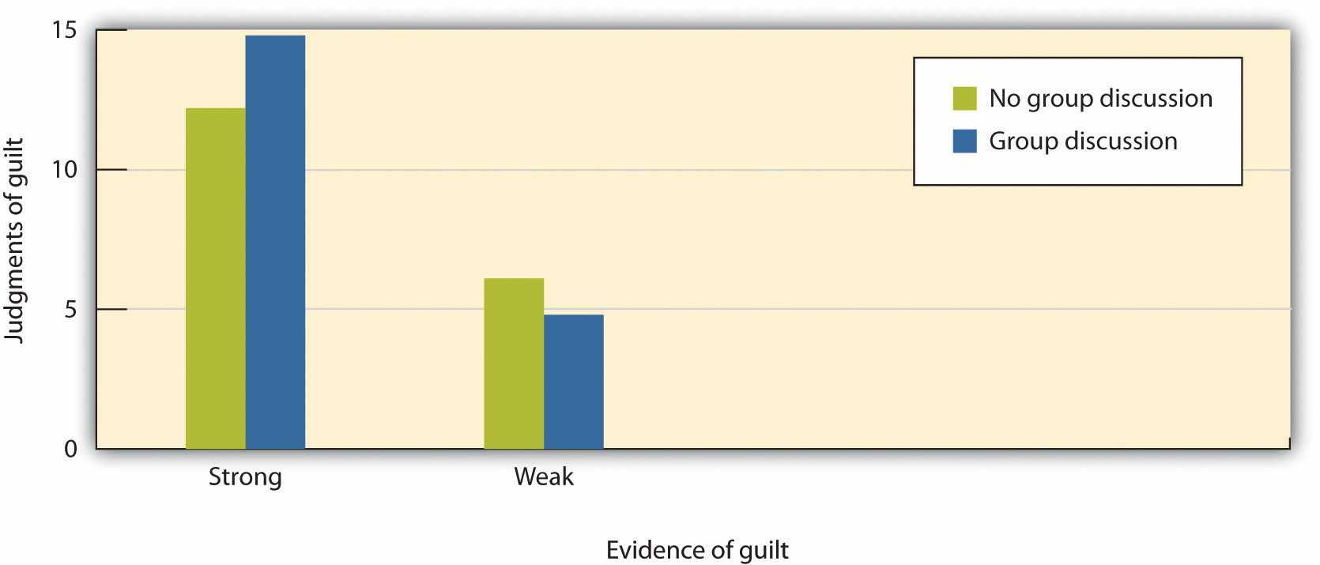
The juries in this research were given either strong or weak evidence about the guilt of a defendant and then were either allowed or not allowed to discuss the evidence before making a final decision. Demonstrating group polarization, the juries that discussed the case made significantly more extreme decisions than did the juries that did not discuss the case. Data are from Myers and Kaplan (1976). ^{[60]}
Group polarization does not occur in all groups and in all settings but tends to happen when two conditions are present: First, the group members must have an initial leaning toward a given opinion or decision. If the group members generally support liberal policies, their opinions are likely to become even more liberal after discussion. But if the group is made up of both liberals and conservatives, group polarization would not be expected. Second, group polarization is strengthened by discussion of the topic. For instance, in the research by Myers and Kaplan (1976) ^{[61]} just reported, in some experimental conditions the group members expressed their opinions but did not discuss the issue, and these groups showed less polarization than groups that discussed the issue.
Group polarization has also been observed in important real-world contexts, including financial decision-making in group and corporate boardrooms (Cheng & Chiou, 2008; Zhu, 2010), ^{[62]} and it may also occur in other situations. It has been argued that the recent polarization in political attitudes in the United States (the “blue” Democratic states versus the “red” Republican states) is occurring in large part because each group spends time communicating with other like-minded group members, leading to more extreme opinions on each side. And it has been argued that terrorist groups develop their extreme positions and engage in violent behaviors as a result of the group polarization that occurs in their everyday interactions (Drummond, 2002; McCauley, 1989). ^{[63]} As the group members, all of whom initially have some radical beliefs, meet and discuss their concerns and desires, their opinions polarize, allowing them to become progressively more extreme. Because they are also away from any other influences that might moderate their opinions, they may eventually become mass killers.
Group polarization is the result of both cognitive and affective factors. The general idea of the persuasive arguments approach to explaining group polarization is cognitive in orientation. This approach assumes is that there is a set of potential arguments that support any given opinion and another set of potential arguments that refute that opinion. Furthermore, an individual’s current opinion about the topic is predicted to be based on the arguments that he or she is currently aware of. During group discussion, each member presents arguments supporting his or her individual opinions. And because the group members are initially leaning in one direction, it is expected that there will be many arguments generated that support the initial leaning of the group members. As a result, each member is exposed to new arguments supporting the initial leaning of the group, and this predominance of arguments leaning in one direction polarizes the opinions of the group members (Van Swol, 2009). ^{[64]} Supporting the predictions of persuasive arguments theory, research has shown that the number of novel arguments mentioned in discussion is related to the amount of polarization (Vinokur & Burnstein, 1978) ^{[65]} and that there is likely to be little group polarization without discussion (Clark, Crockett, & Archer, 1971). ^{[66]}
But group polarization is in part based on the affective responses of the individuals—and particularly the social identity they receive from being good group members (Hogg, Turner, & Davidson, 1990; Mackie, 1986; Mackie & Cooper, 1984). ^{[67]} The idea here is that group members, in their desire to create positive social identity, attempt to differentiate their group from other implied or actual groups by adopting extreme beliefs. Thus the amount of group polarization observed is expected to be determined not only by the norms of the ingroup but also by a movement away from the norms of other relevant outgroups. In short, this explanation says that groups that have well-defined (extreme) beliefs are better able to produce social identity for their members than are groups that have more moderate (and potentially less clear) beliefs.
Group polarization effects are stronger when the group members have high social identity (Abrams, Wetherell, Cochrane, & Hogg, 1990; Hogg, Turner, & Davidson, 1990; Mackie, 1986). ^{[68]} Diane Mackie (1986) ^{[69]} had participants listen to three people discussing a topic, supposedly so that they could become familiar with the issue themselves to help them make their own decisions. However, the individuals that they listened to were said to be members of a group that they would be joining during the upcoming experimental session, members of a group that they were not expecting to join, or some individuals who were not a group at all. Mackie found that the perceived norms of the (future) ingroup were seen as more extreme than those of the other group or the individuals, and that the participants were more likely to agree with the arguments of the ingroup. This finding supports the idea that group norms are perceived as more extreme for groups that people identify with (in this case, because they were expecting to join it in the future). And another experiment by Mackie (1986)^{[70]} also supported the social identity prediction that the existence of a rival outgroup increases polarization as the group members attempt to differentiate themselves from the other group by adopting more extreme positions.
Taken together then, the research reveals that another potential problem with group decision making is that it can be polarized. These changes toward more extreme positions have a variety of causes and occur more under some conditions than others, but they must be kept in mind whenever groups come together to make important decisions.

Social Psychology in the Public Interest
Decision Making by a Jury
Although many other countries rely on the decisions of judges in civil and criminal trials, the jury is the foundation of the legal system in the United States. The notion of a trial by one’s peers is based on the assumption that average individuals can make informed and fair decisions when they work together in groups. But given all the problems facing groups, social psychologists and others frequently wonder whether juries are really the best way to make these important decisions and whether the particular composition of a jury influences the likely outcome of its deliberation (Lieberman, 2011). ^{[71]}
As small working groups, juries have the potential to produce either good or poor decisions, depending on many of the factors that we have discussed in this chapter (Bornstein & Greene, 2011; Hastie, 1993; Winter & Robicheaux, 2011).^{[72]} And again, the ability of the jury to make a good decision is based on both person characteristics and group process. In terms of person variables, there is at least some evidence that the jury member characteristics do matter. For one, individuals who have already served on juries are more likely to be seen as experts, are more likely to be chosen as jury foreperson, and give more input during the deliberation (Stasser, Kerr, & Bray, 1982). ^{[73]} It has also been found that status matters—jury members with higher-status occupations and education, males rather than females, and those who talk first are more likely be chosen as the foreperson, and these individuals also contribute more to the jury discussion (Stasser et al., 1982). ^{[74]} And as in other small groups, a minority of the group members generally dominate the jury discussion (Hastie, Penrod, & Pennington, 1983), ^{[75]} And there is frequently a tendency toward social loafing in the group (Najdowski, 2010). ^{[76]} As a result, relevant information or opinions are likely to remain unshared because some individuals never or rarely participate in the discussion.
Perhaps the strongest evidence for the importance of member characteristics in the decision-making process concerns the selection of death-qualified juries in trials in which a potential sentence includes the death penalty. In order to be selected for such a jury, the potential members must indicate that they would, in principle, be willing to recommend the death penalty as a punishment. Potential jurors who indicate being opposed to the death penalty cannot serve on these juries. However, this selection process creates a potential bias because the individuals who say that they would not under any condition vote for the death penalty are also more likely to be rigid and punitive and thus more likely to find defendants guilty, a situation that increases the chances of a conviction for defendants (Ellsworth, 1993). ^{[77]}
Although there are at least some member characteristics that have an influence upon jury decision making, group process, as in other working groups, plays a more important role in the outcome of jury decisions than do member characteristics. Like any group, juries develop their own individual norms, and these norms can have a profound impact on how they reach their decisions. Analysis of group process within juries shows that different juries take very different approaches to reaching a verdict. Some spend a lot of time in initial planning, whereas others immediately jump right into the deliberation. And some juries base their discussion around a review and reorganization of the evidence, waiting to take a vote until it has all been considered, whereas other juries first determine which decision is preferred in the group by taking a poll and then (if the first vote does not lead to a final verdict) organize their discussion around these opinions. These two approaches are used about equally often but may in some cases lead to different decisions (Hastie, 2008). ^{[78]}
Perhaps most important, conformity pressures have a strong impact on jury decision making. As you can see in the following figure, when there are a greater number of jury members who hold the majority position, it becomes more and more certain that their opinion will prevail during the discussion. This is not to say that minorities cannot ever be persuasive, but it is very difficult for them. The strong influence of the majority is probably due to both informational conformity (i.e., that there are more arguments supporting the favored position) and normative conformity (people are less likely to want to be seen as disagreeing with the majority opinion).

Figure 11.8Conformity in Juries
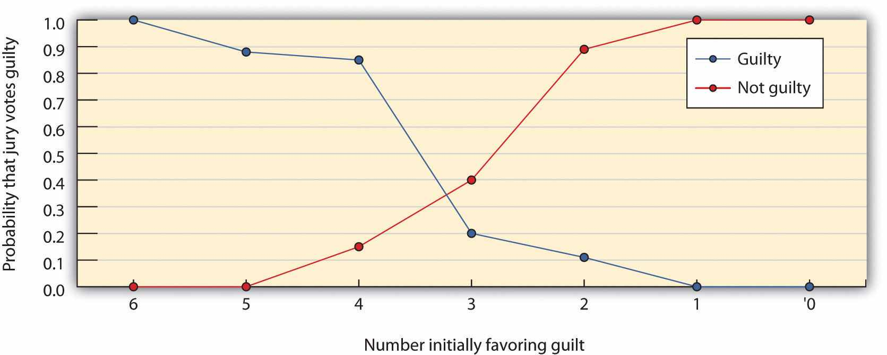
This figure shows the decisions of six-member mock juries that made “majority rules” decisions. When the majority of the six initially favored voting guilty, the jury almost always voted guilty, and when the majority of the six initially favored voting innocent, the jury almost always voted innocence. The juries were frequently hung (could not make a decision) when the initial split was three to three. Data are from Stasser, Kerr, and Bray (1982). ^{[79]}
Research has also found that juries that are evenly split (three to three or six to six) tend to show a leniency bias by voting toward acquittal more often than they vote toward guilt, all other factors being equal (MacCoun & Kerr, 1988). ^{[80]} This is in part because juries are usually instructed to assume innocence unless there is sufficient evidence to confirm guilt—they must apply a burden of proof of guilt “beyond a reasonable doubt.” The leniency bias in juries does not always occur, although it is more likely to occur when the potential penalty is more severe (Devine et al., 2004; Kerr, 1978). ^{[81]}
Given what you now know about the potential difficulties that groups face in making good decisions, you might be worried that the verdicts rendered by juries may not be particularly effective, accurate, or fair. However, despite these concerns, the evidence suggests that juries may not do as badly as we would expect. The deliberation process seems to cancel out many individual juror biases, and the importance of the decision leads the jury members to carefully consider the evidence itself.

KEY TAKEAWAYS
- Although groups may sometimes perform better than individuals, this will occur only when the people in the group expend effort to meet the group goals and when the group is able to efficiently coordinate the efforts of the group members.
- The benefits or costs of group performance can be computed by comparing the potential productivity of the group with the actual productivity of the group. The difference will be either a process loss or a process gain.
- Group member characteristics can have a strong effect on group outcomes, but to fully understand group performance, we must also consider the particulars of the group’s situation.
- Classifying group tasks can help us understand the situations in which groups are more or less likely to be successful.
- Some group process losses are due to difficulties in coordination and motivation (social loafing).
- Some group process losses are the result of groupthink—when a group, as result of a flawed group process and strong conformity pressures, makes a poor judgment.
- Process losses may result from the tendency for groups to discuss information that all members have access to while ignoring equally important information that is available to only a few of the members.
- Brainstorming is a technique designed to foster creativity in a group. Although brainstorming often leads to group process losses, alternative approaches, including the use of group support systems, may be more effective.
- Group decisions can also be influenced by group polarization—when the attitudes held by the individual group members become more extreme than they were before the group began discussing the topic.
- Understanding group processes can help us better understand the factors that lead juries to make better or worse decisions.

EXERCISES AND CRITICAL THINKING
- Consider a time when a group that you belonged to experienced a process loss. Which of the factors discussed in this section do you think were important in creating the problem?
- If you or someone you knew had a choice to be tried by either a judge or a jury, which would you choose, and why?

[1] Nijstad, B. A., Stroebe, W., & Lodewijkx, H. F. M. (2006). The illusion of group productivity: A reduction of failures explanation. European Journal of Social Psychology, 36(1), 31–48. doi: 10.1002/ejsp.295
[2] Triplett, N. (1898). The dynamogenic factors in pacemaking and competition. American Journal of Psychology, 9(4), 507–533.
[3] Geen, R. G. (1989). Alternative conceptions of social facilitation. In P. Paulus (Ed.),Psychology of group influence (2nd ed., pp. 15–51). Hillsdale, NJ: Lawrence Erlbaum; Guerin, B. (1983). Social facilitation and social monitoring: A test of three models. British Journal of Social Psychology, 22(3), 203–214; Robinson-Staveley, K., & Cooper, J. (1990). Mere presence, gender, and reactions to computers: Studying human-computer interaction in the social context. Journal of Experimental Social Psychology, 26(2), 168–183; Strube, M. J., Miles, M. E., & Finch, W. H. (1981). The social facilitation of a simple task: Field tests of alternative explanations. Personality and Social Psychology Bulletin, 7(4), 701–707.
[4] Markus, H. (1978). The effect of mere presence on social facilitation: An unobtrusive test.Journal of Experimental Social Psychology, 14, 389–397.
[5] Markus, H. (1978). The effect of mere presence on social facilitation: An unobtrusive test.Journal of Experimental Social Psychology, 14, 389–397.
[6] Zajonc, R. B. (1965). Social facilitation. Science, 149, 269–274.
[7] Zajonc, R. B. (1965). Social facilitation. Science, 149, 269–274.
[8] Bond, C. F., & Titus, L. J. (1983). Social facilitation: A meta-analysis of 241 studies.Psychological Bulletin, 94(2), 265–292.
[9] Zajonc, R. B. (1965). Social facilitation. Science, 149, 269–274.
[10] Zajonc, R. B., Heingartner, A., & Herman, E. M. (1969). Social enhancement and impairment of performance in the cockroach. Journal of Personality and Social Psychology, 13(2), 83–92.
[11] Szymanski, K., & Harkins, S. G. (1987). Social loafing and self-evaluation with a social standard. Journal of Personality and Social Psychology, 53(5), 891–897.
[12] Strube, M. J., Miles, M. E., & Finch, W. H. (1981). The social facilitation of a simple task: Field tests of alternative explanations. Personality and Social Psychology Bulletin, 7(4), 701–707.
[13] Baumeister, R. F., & Steinhilber, A. (1984). Paradoxical effects of supportive audiences on performance under pressure: The home field disadvantage in sports championships. Journal of Personality and Social Psychology, 47(1), 85–93.
[14] weber, B., & Hertel, G. (2007). Motivation gains of inferior group members: A meta-analytical review. Journal of Personality and Social Psychology, 93(6), 973–993.
[15] Jones, M. B. (1974). Regressing group on individual effectiveness. Organizational Behavior and Human Decision Processes, 11(3), 426–451.
[16] Hackman, J., & Morris, C. (1975). Group tasks, group interaction processes, and group performance effectiveness: A review and proposed integration. In L. Berkowitz (Ed.), Advances in experimental social psychology (Vol. 8, pp. 45–99). New York, NY: Academic Press; Straus, S. G. (1999). Testing a typology of tasks: An empirical validation of McGrath’s (1984) group task circumplex. Small Group Research, 30(2), 166–187. doi: 10.1177/104649649903000202
[17] Armstrong, J. S. (2001). Principles of forecasting: A handbook for researchers and practitioners. Norwell, MA: Kluwer Academic Publishers; Surowiecki, J. (2004). The wisdom of crowds: Why the many are smarter than the few and how collective wisdom shapes business, economies, societies, and nations (1st ed.). New York, NY: Doubleday.
[18] Lorge, I., Fox, D., Davitz, J., & Brenner, M. (1958). A survey of studies contrasting the quality of group performance and individual performance. Psychological Bulletin, 55(6), 337–372.
[19] Einhorn, H. J., Hogarth, R. M., & Klempner, E. (1977). Quality of group judgment.Psychological Bulletin, 84(1), 158–172.
[20] Kravitz, D. A., & Martin, B. (1986). Ringelmann rediscovered: The original article. Journal of Personality and Social Psychology, 50, 936–941.
[21] Latané, B., Williams, K., & Harkins, S. (1979). Many hands make light the work: The causes and consequences of social loafing. Journal of Personality and Social Psychology, 37(6), 822–832; Williams, K. D., Nida, S. A., Baca, L. D., & Latane, B. (1989). Social loafing and swimming: Effects of identifiability on individual and relay performance of intercollegiate swimmers. Basic and Applied Social Psychology, 10(1), 73–81.
[22] Petty, R. E., Harkins, S. G., Williams, K. D., & Latané, B. (1977). The effects of group size on cognitive effort and evaluation. Personality and Social Psychology Bulletin, 3(4), 579–582.
[23] Gabrenya, W. K., Wang, Y., & Latané, B. (1985). Social loafing on an optimizing task: Cross-cultural differences among Chinese and Americans. Journal of Cross-Cultural Psychology, 16(2), 223–242; Karau, S. J., & Williams, K. D. (1993). Social loafing: A meta-analytic review and theoretical integration. Journal of Personality and Social Psychology, 65(4), 681–706.
[24] Kelley, H. H., Condry, J. C., Jr., Dahlke, A. E., & Hill, A. H. (1965). Collective behavior in a simulated panic situation. Journal of Experimental Social Psychology, 1, 19–54.
[25] Karau, S. J., & Williams, K. D. (1993). Social loafing: A meta-analytic review and theoretical integration. Journal of Personality and Social Psychology, 65(4), 681–706.
[26] Latané, B., Williams, K., & Harkins, S. (1979). Many hands make light the work: The causes and consequences of social loafing. Journal of Personality and social Psychology, 37(6), 822–832.
[27] Latané, B., Williams, K., & Harkins, S. (1979). Many hands make light the work: The causes and consequences of social loafing. Journal of Personality and Social Psychology, 37(6), 822–832.
[28] Baron, R. S. (2005). So right it’s wrong: Groupthink and the ubiquitous nature of polarized group decision making. In M. P. Zanna (Ed.), Advances in experimental social psychology (Vol. 37, pp. 219–253). San Diego, CA: Elsevier Academic Press; Janis, I. L. (2007). Groupthink. In R. P. Vecchio (Ed.), Leadership: Understanding the dynamics of power and influence in organizations (2nd ed., pp. 157–169). Notre Dame, IN: University of Notre Dame Press.
[29] Kramer, R. M. (1998). Revisiting the Bay of Pigs and Vietnam decisions 25 years later: How well has the groupthink hypothesis stood the test of time? Organizational Behavior and Human Decision Processes, 73(2–3), 236–271.
[30] Faulmüller, N., Kerschreiter, R., Mojzisch, A., & Schulz-Hardt, S. (2010). Beyond group-level explanations for the failure of groups to solve hidden profiles: The individual preference effect revisited. Group Processes and Intergroup Relations, 13(5), 653–671; Reimer, T., Reimer, A., & Czienskowski, U. (2010). Decision-making groups attenuate the discussion bias in favor of shared information: A meta-analysis. Communication Monographs, 77(1), 121–142.
[31] Stasser, G., & Titus, W. (1985). Pooling of unshared information in group decision making: Biased information sampling during discussion. Journal of Personality and Social Psychology, 48(6), 1467–1478.
[32] Stasser, G., & Titus, W. (1985). Pooling of unshared information in group decision making: Biased information sampling during discussion. Journal of Personality and Social Psychology, 48(6), 1467–1478.
[33] Stasser, G., Taylor, L. A., & Hanna, C. (1989). Information sampling in structured and unstructured discussions of three- and six-person groups. Journal of Personality and Social Psychology, 57(1), 67–78.
[34] Stasser, G., & Stewart, D. (1992). Discovery of hidden profiles by decision-making groups: Solving a problem versus making a judgment. Journal of Personality & Social Psychology, 63, 426–434.
[35] Larson, J. R. J., Foster-Fishman, P. G., & Keys, C. B. (1994). The discussion of shared and unshared information in decision-making groups. Journal of Personality and Social Psychology, 67, 446–461.
[36] Stasser, G. M., & Taylor, L. A. (1991). Speaking turns in face-to-face discussions. Journal of Personality and Social Psychology, 60, 675–684.
[37] Wittenbaum, G. M. (1998). Information sampling in decision-making groups: The impact of members’ task-relevant status. Small Group Research, 29(1), 57–84.
[38] Hinsz, V. B. (1990). Cognitive and consensus processes in group recognition memory performance. Journal of Personality and Social Psychology, 59(4), 705–718.
[39] Mojzisch, A., & Schulz-Hardt, S. (2010). Knowing others’ preferences degrades the quality of group decisions. Journal of Personality and Social Psychology, 98(5), 794–808; Reimer, T., Reimer, A., & Hinsz, V. B. (2010). Naïve groups can solve the hidden-profile problem. Human Communication Research, 36(3), 443–467.
[40] Osborn, A. F. (1953). Applied imagination. Oxford, England: Scribner’s.
[41] Diehl, M., & Stroebe, W. (1987). Productivity loss in brainstorming groups: Toward the solution of a riddle. Journal of Personality and Social Psychology, 53(3), 497–509; Diehl, M., & Stroebe, W. (1991). Productivity loss in idea-generating groups: Tracking down the blocking effect. Journal of Personality and Social Psychology, 61(3), 392–403; Stroebe, W., & Diehl, M. (1994). Why groups are less effective than their members: On productivity losses in idea-generating groups. European Review of Social Psychology, 5, 271–303.
[42] Paulus, P. B., & Dzindolet, M. T. (1993). Social influence processes in group brainstorming. Journal of Personality and Social Psychology, 64(4), 575–586.
[43] Diehl, M., & Stroebe, W. (1987). Productivity loss in brainstorming groups: Toward the solution of a riddle. Journal of Personality and Social Psychology, 53(3), 497–509.
[44] Collaros, P. A., & Anderson, I. R. (1969). Effect of perceived expertness upon creativity of members of brainstorming groups. Journal of Applied Psychology, 53, 159–163.
[45] Diehl, M., & Stroebe, W. (1987). Productivity loss in brainstorming groups: Toward the solution of a riddle. Journal of Personality and Social Psychology, 53(3), 497–509.
[46] Diehl, M., & Stroebe, W. (1987). Productivity loss in brainstorming groups: Toward the solution of a riddle. Journal of Personality and Social Psychology, 53(3), 497–509.
[47] Diehl, M., & Stroebe, W. (1991). Productivity loss in idea-generating groups: Tracking down the blocking effect. Journal of Personality and Social Psychology, 61(3), 392–403.
[48] Gallupe, R. B., Cooper, W. H., Grise, M.-L., & Bastianutti, L. M. (1994). Blocking electronic brainstorms. Journal of Applied Psychology, 79(1), 77–86.
[49] Delbecq, A. L., Van de Ven, A. H., & Gustafson, D. H. (1975). Group techniques for program planning: A guide to nominal group and delphi processes. Glenview, IL: Scott, Foresman.
[50] Clayton, M. J. (1997). Delphi: A technique to harness expert opinion for critical decision-making tasks in education. Educational Psychology, 17(4), 373–386. doi: 10.1080/0144341970170401; Hornsby, J. S., Smith, B. N., & Gupta, J. N. D. (1994). The impact of decision-making methodology on job evaluation outcomes: A look at three consensus approaches. Group and Organization Management, 19(1), 112–128.
[51] Stein, M. I. (1978). Methods to stimulate creative thinking. Psychiatric Annals, 8(3), 65–75.
[52] Dennis, A. R., & Valacich, J. S. (1993). Computer brainstorms: More heads are better than one. Journal of Applied Psychology, 78, 531–537; Gallupe, R. B., Cooper, W. H., Grise, M.-L., & Bastianutti, L. M. (1994). Blocking electronic brainstorms. Journal of Applied Psychology, 79(1), 77–86; Siau, K. L. (1995). Group creativity and technology. Psychosomatics, 31, 301–312.
[53] Mesmer-Magnus, J. R., DeChurch, L. A., Jimenez-Rodriguez, M., Wildman, J., & Shuffler, M. (2011). A meta-analytic investigation of virtuality and information sharing in teams.Organizational Behavior and Human Decision Processes, 115(2), 214–225.
[54] Connolly, T., Routhieaux, R. L., & Schneider, S. K. (1993). On the effectiveness of group brainstorming: Test of one underlying cognitive mechanism. Small Group Research, 24(4), 490–503; Valacich, J. S., Jessup, L. M., Dennis, A. R., & Nunamaker, J. F. (1992). A conceptual framework of anonymity in group support systems. Group Decision and Negotiation, 1(3), 219–241.
[55] Brauer, M., Judd, C. M., & Gliner, M. D. (2006). The effects of repeated expressions on attitude polarization during group discussions. In J. M. Levine & R. L. Moreland (Eds.), Small groups (pp. 265–287). New York, NY: Psychology Press; Myers, D. G. (1982). Polarizing effects of social interaction. In H. Brandstatter, J. H. Davis, & G. Stocher-Kreichgauer (Eds.),Contemporary problems in group decision-making (pp. 125–161). New York, NY: Academic Press.
[56] Stoner, J. A. (1968). Risky and cautious shifts in group decisions: The influence of widely held values. Journal of Experimental Social Psychology, 4, 442–459.
[57] Kogan, N., & Wallach, M. A. (1967). Risky-shift phenomenon in small decision-making groups: A test of the information-exchange hypothesis. Journal of Experimental Social Psychology, 3, 75–84.
[58] Myers, D. G., & Kaplan, M. F. (1976). Group-induced polarization in simulated juries.Personality and Social Psychology Bulletin, 2(1), 63–66.
[59] Myers, D. G., & Bishop, G. D. (1970). Discussion effects on racial attitudes. Science, 169(3947), 778–779. doi: 10.1126/science.169.3947.778
[60] Myers, D. G., & Kaplan, M. F. (1976). Group-induced polarization in simulated juries.Personality and Social Psychology Bulletin, 2(1), 63–66.
[61] Myers, D. G., & Kaplan, M. F. (1976). Group-induced polarization in simulated juries.Personality and Social Psychology Bulletin, 2(1), 63–66.
[62] Cheng, P.-Y., & Chiou, W.-B. (2008). Framing effects in group investment decision making: Role of group polarization. Psychological Reports, 102(1), 283–292; Zhu, H. (2009). Group polarization on corporate boards: Theory and evidence on board decisions about acquisition premiums, executive compensation, and diversification. (Doctoral dissertation). University of Michigan, Ann Arbor, Michigan.
[63] Drummond, J. T. (2002). From the Northwest Imperative to global jihad: Social psychological aspects of the construction of the enemy, political violence, and terror. In C. E. Stout (Ed.), The psychology of terrorism: A public understanding (Vol. 1, pp. 49–95). Westport, CT: Praeger Publishers/Greenwood Publishing Group; McCauley, C. R. (1989). Terrorist individuals and terrorist groups: The normal psychology of extreme behavior. In J. Groebel & J. H. Goldstein (Eds.), Terrorism: Psychological perspectives (p. 45). Sevilla, Spain: Universidad de Sevilla.
[64] Van Swol, L. M. (2009). Extreme members and group polarization. Social Influence, 4(3), 185–199.
[65] Vinokur, A., & Burnstein, E. (1978). Novel argumentation and attitude change: The case of polarization following group discussion. European Journal of Social Psychology, 8(3), 335–348.
[66] Clark, R. D., Crockett, W. H., & Archer, R. L. (1971). Risk-as-value hypothesis: The relationship between perception of self, others, and the risky shift. Journal of Personality and Social Psychology, 20, 425–429.
[67] Hogg, M. A., Turner, J. C., & Davidson, B. (1990). Polarized norms and social frames of reference: A test of the self-categorization theory of group polarization. Basic and Applied Social Psychology, 11(1), 77–100; Mackie, D. M. (1986). Social identification effects in group polarization. Journal of Personality and Social Psychology, 50(4), 720–728; Mackie, D. M., & Cooper, J. (1984). Attitude polarization: Effects of group membership. Journal of Personality and Social Psychology, 46, 575–585.
[68] Abrams, D., Wetherell, M., Cochrane, S., & Hogg, M. (1990). Knowing what to think by knowing who you are: Self-categorization and the nature of norm formation, conformity, and group polarization. British Journal of Social Psychology, 29, 97–119; Hogg, M. A., Turner, J. C., & Davidson, B. (1990). Polarized norms and social frames of reference: A test of the self-categorization theory of group polarization. Basic and Applied Social Psychology, 11(1), 77–100; Mackie, D. M. (1986). Social identification effects in group polarization. Journal of Personality and Social Psychology, 50(4), 720–728.
[69] Mackie, D. M. (1986). Social identification effects in group polarization. Journal of Personality and Social Psychology, 50(4), 720–728.
[70] Mackie, D. M. (1986). Social identification effects in group polarization. Journal of Personality and Social Psychology, 50(4), 720–728.
[71] Lieberman, J. D. (2011). The utility of scientific jury selection: Still murky after 30 years.Current Directions in Psychological Science, 20(1), 48–52.
[72] Bornstein, B. H., & Greene, E. (2011). Jury decision making: Implications for and from psychology. Current Directions in Psychological Science, 20(1), 63–67; Hastie, R. (1993). Inside the juror: The psychology of juror decision making. New York, NY: Cambridge University Press; Winter, R. J., & Robicheaux, T. (2011). Questions about the jury: What trial consultants should know about jury decision making. In R. L. Wiener & B. H. Bornstein (Eds.), Handbook of trial consulting (pp. 63–91). New York, NY: Springer Science + Business Media.
[73] Stasser, G., Kerr, N. L., & Bray, R. M. (1982). The social psychology of jury deliberations: Structure, process and product. In N. L. Kerr & R. M. Bray (Eds.), The psychology of the courtroom (pp. 221–256). New York, NY: Academic Press.
[74] Stasser, G., Kerr, N. L., & Bray, R. M. (1982). The social psychology of jury deliberations: Structure, process and product. In N. L. Kerr & R. M. Bray (Eds.), The psychology of the courtroom (pp. 221–256). New York, NY: Academic Press.
[75] Hastie, R., Penrod, S. D., & Pennington, N. (1983). Inside the jury. Cambridge, MA: Harvard University Press.
[76] Najdowski, C. J. (2010). Jurors and social loafing: Factors that reduce participation during jury deliberations. American Journal of Forensic Psychology, 28(2), 39–64.
[77] Ellsworth, P. C. (1993). Some steps between attitudes and verdicts. In R. Hastie (Ed.),Inside the juror: The psychology of juror decision making. New York, NY: Cambridge University Press.
[78] Hastie, R. (2008). What’s the story? Explanations and narratives in civil jury decisions. In B. H. Bornstein, R. L. Wiener, R. Schopp, & S. L. Willborn (Eds.), Civil juries and civil justice: Psychological and legal perspectives (pp. 23–34). New York, NY: Springer Science + Business Media.
[79] Stasser, G., Kerr, N. L., & Bray, R. M. (1982). The social psychology of jury deliberations: Structure, process and product. In N. L. Kerr & R. M. Bray (Eds.), The psychology of the courtroom (pp. 221–256). New York, NY: Academic Press.
[80] MacCoun, R. J., & Kerr, N. L. (1988). Asymmetric influence in mock jury deliberation: Jurors’ bias for leniency. Journal of Personality and Social Psychology, 54(1), 21–33.
[81] Devine, D. J., Olafson, K. M., Jarvis, L. L., Bott, J. P., Clayton, L. D., & Wolfe, J. M. T. (2004). Explaining jury verdicts: Is leniency bias for real? Journal of Applied Social Psychology, 34(10), 2069–2098; Kerr, N. L. (1978). Severity of prescribed penalty and mock jurors’ verdicts. Journal of Personality and Social Psychology, 36(12), 1431–1442.

11.3 Improving Group Performance

LEARNING OBJECTIVE
- Review the ways that people can work to make group performance more effective.
As we have seen, it makes sense to use groups to make decisions because people can create outcomes working together that any one individual could not hope to accomplish alone. In addition, once a group makes a decision, the group will normally find it easier to get other people to implement it because many people feel that decisions made by groups are fairer than those made by individuals. And yet, as we have also seen, there are also many problems associated with groups that make it difficult for them to live up to their full potential. In this section, let’s consider this issue more fully: What approaches can we use to make best use of the groups that we belong to, helping them to achieve as best as is possible? Training groups to perform more effectively is possible, if appropriate techniques are used (Salas et al., 2008). ^{[1]}
Perhaps the first thing we need to do is to remind our group members that groups are not as effective as they sometimes seem. Group members often think that their group is being more productive than it really is, and that their own groups are particularly productive. For instance, people who participate in brainstorming groups report that they have been more productive than those who work alone, even if the group has actually not done all that well (Paulus, Dzindolet, Poletes, & Camacho, 1993; Stroebe, Diehl, & Abakoumkin, 1992). ^{[2]}
The tendency to overvalue the productivity of groups is known as theillusion of group effectivity, and it seems to occur for several reasons. For one, the productivity of the group as a whole is highly accessible, and this productivity generally seems quite good, at least in comparison with the contributions of single individuals. The group members hear many ideas expressed by themselves and the other group members, and this gives the impression that the group is doing very well, even if objectively it is not. And on the affective side, group members receive a lot of positive social identity from their group memberships. These positive feelings naturally lead them to believe that the group is strong and performing well. Thus the illusion of group effectivity poses a severe problem for group performance, and we must work to make sure that group members are aware of it. Just because we are working in groups does not mean that we are making good decisions or performing a task particularly well—group members, and particularly the group leader, must always monitor group performance and attempt to motivate the group to work harder.

Motivating Groups to Perform Better by Appealing to Self-Interest
In addition to helping group members understand the nature of group performance, we must be aware of their self-interest goals. Group members, like all other people, act at least in part for themselves. So anything we can do to reward them for their participation or to make them enjoy being in the group more will be helpful.
Perhaps the most straightforward approach to getting people to work harder in groups is to provide rewards for performance. Corporations reward their employees with raises and bonuses if they perform well, and players on sports teams are paid according to their successes on the playing field. However, although incentives may increase the effort of the individual group members and thus enhance group performance, they also have some potential disadvantages for group process.
One potential problem is that the group members will compare their own rewards with those of others. It might be hoped that individuals would use their coworkers as positive role models (upward social comparison), which would inspire them to work harder. For instance, when corporations set up “employee of the week” programs, which reward excellence on the part of individual group members, they are attempting to develop this type of positive comparison.
On the other hand, if group members believe that others are being rewarded more than they are for what they perceive as the same work (downward social comparison), they may change their behavior to attempt to restore equity. Perhaps they will attempt to work harder in order to receive greater rewards for themselves. But they may instead decide to reduce their effort to match what they perceive as a low level of reward (Platow, O’Connell, Shave, & Hanning, 1995). ^{[3]} It has been found, for instance, that workers who perceive that their pay is lower than it should be are more likely to be absent from work (Baron & Pfefer, 1994; Geurts, Buunk, & Schaufeli, 1994). ^{[4]} Taken together then, incentives can have some positive effects on group performance, but they may also create their own difficulties.
But incentives do not have to be so directly financial. People will also work harder in groups when they feel that they are contributing to the group and that their work is visible to and valued by the other group members (Karau & Williams, 1993; Kerr & Bruun, 1983). ^{[5]} One study (Williams, Harkins, & Latané, 1981) ^{[6]} found that when groups of individuals were asked to cheer as loudly as they could into a microphone placed in the center of the room, social loafing occurred. However, when each individual was given his or her own personal microphone and thus believed that his or her own input could be measured, social loafing was virtually eliminated. Thus when our contributions to the group are identifiable as our own, and particularly when we receive credit for those contributions, we feel that our performance counts, and we are less likely to loaf.
It turns out that the size of the group matters in this regard. Although larger groups are more able than smaller ones to diversify into specialized roles and activities, and this is likely to make them efficient in some ways (Bond & Keys, 1993; Miller & Davidson-Podgorny, 1987), ^{[7]} larger groups are also more likely to suffer from coordination problems and social loafing. The problem is that individuals in larger groups are less likely to feel that their effort is going to make a difference to the output of the group as a whole or that their contribution will be noticed and appreciated by the other group members (Kerr & Bruun, 1981). ^{[8]}
In the end, because of the difficulties that accompany large groups, the most effective working groups are of relatively small size—about four or five members. Research suggests that in addition to being more efficient, working in groups of about this size is also more enjoyable to the members, in comparison with being in larger groups (Mullen, Symons, Hu, & Salas, 1989). ^{[9]} However, the optimal group size will be different for different types of tasks. Groups in which the members have high ability may benefit more from larger group size (Yetton & Bottger, 1983), ^{[10]} and groups that have greater commitment or social identity may suffer less from motivational losses, even when they are large (Hardy & Latané, 1988). ^{[11]}
Groups will also be more effective when they develop appropriate social norms. If the group develops a strong group identity and the group members care about the ability of the group to do a good job (e.g., a cohesive sports or military team), the amount of social loafing is reduced (Harkins & Petty, 1982; Latané, Williams, & Harkins, 1979).^{[12]} On the other hand, some groups develop norms that prohibit members from working up to their full potential and thus encourage loafing (Mullen & Baumeister, 1987). ^{[13]} It is also important for the group to fully define the roles that each group member should play in the group and help the individuals accomplish these roles.

Cognitive Approaches: Improving Communication and Information Sharing
Even if we are successful in encouraging the group members to work hard toward the group goals, groups may fail anyway because they do not gather and share information openly. However, the likelihood of poor information search and information sharing, such as that which occurs in groupthink, can be reduced by creating situations that foster open and full discussion of the issues.
One important method of creating adequate information sharing is to ensure that the group has plenty of time to make its decision and that it is not rushed in doing so. Of course, such a luxury is not always possible, but better decisions are likely to be made when there is sufficient time. Having plenty of time prevents the group from coming to premature consensus and making an unwise choice. Time to consider the issues fully also allows the group to gain new knowledge by seeking information and analysis from outside experts.
One approach to increasing full discussion of the issues is to have the group break up into smaller subgroups for discussion. This technique increases the amount of discussion overall and allows more group members to air more ideas. In some decision-making groups, it is standard practice to set up several independent groups that consider the same questions, each carrying on its deliberations under a separate leader; the subgroups then meet together to make the final decision.
Within the group itself, conversation can be encouraged through the use of a devil’s advocate—an individual who is given the job of expressing conflicting opinions and forcing the group (in a noncombative way) to fully discuss all the alternatives. Because the opinions of the devil’s advocate challenge the group consensus and thus may hinder quick group decision making and group identity, the individual who takes the job may not be particularly popular in the group. For this reason, the group leader should formally assign the person to the role and make it clear that this role is an essential part of group functioning. The job can profitably be given to one of the most qualified group members and may sometimes rotate from person to person. In other cases, it may be useful to invite an expert or another qualified individual who is not a regular member of the group to the decision-making meetings to give his or her input. This person should be encouraged to challenge the views of the core group.
The group leader is extremely important in fostering norms of open discussion in decision-making groups. An effective leader makes sure that he or she does not state his or her opinions early but rather, allows the other group members to express their ideas first and encourages the presentation of contrasting positions. This allows a fuller discussion of pros and cons and prevents simple agreement by conformity. Leaders also have the ability to solicit unshared information from the group members, and they must be sure to do so, for instance, by making it clear that each member has important and unique information to share and that it is important to do so. Leaders may particularly need to solicit and support opinions from low-status or socially anxious group members. Some decision-making groups even have a “second-chance meeting” before a final decision is made. In this final meeting, the goal is to explicitly consider alternatives and allow any lingering doubts to be expressed by group members.
One difficulty with many working groups is that once they have developed a set of plans or strategies, these plans become established social norms, and it becomes very difficult for the group to later adopt new, alternative, and perhaps better, strategies. As a result, even when the group is having difficulty performing effectively, it may nevertheless stick with its original methods; developing or reformulating strategies is much less common. The development of specific strategies that allow groups to break out of their existing patterns may be useful in these cases. Hackman and Morris (1975)^{[14]} suggest that it can be helpful to have outside observers who are experts in group process provide feedback about relevant norms and encourage the groups to discuss them. In some cases, the consultation may involve restructuring the group by changing the status hierarchy, the social norms, or the group roles, for instance. These changes may help reduce conflict and increase effective communication and coordination.

Setting Appropriate Goals
One aspect of planning that has been found to be strongly related to positive group performance is the setting of goals that the group uses to guide its work (Latham & Locke, 1991; Weldon & Weingart, 1993). ^{[15]} Groups that set specific, difficult, and yet attainable goals (e.g., “Improve sales by 10% over the next 6 months”) are much more effective than groups that are given goals that are not very clear (“Let’s sell as much as we can!”). In addition, groups that set clear goals produce better attendance. Goals have been found to be even more important in determining performance than are other incentives, including rewards such as praise and money.
Setting goals appears to be effective because it increases member effort and expectations of success, because it improves cooperation and communication among the members, and because it produces better planning and more accurate monitoring of the group’s work. Specific goals may also result in increased commitment to the group (Locke & Latham, 1990; Weldon, Jehn, & Pradhan, 1991), ^{[16]} and when the goals are successfully attained, there is a resulting feeling of accomplishment, group identity and pride, a commitment to the task, and a motivation to set even higher goals. Moreover, there is at least some evidence that it is useful to let the group choose its own goals rather than assigning goals to the group (Haslam, Wegge, & Postmes, 2009). ^{[17]} Groups tend to select more challenging goals, and because they have set them themselves, they do not need to be convinced to accept them as appropriate. However, even assigned goals are effective as long as they are seen as legitimate and attainable (Latham, Winters, & Locke, 1994). ^{[18]}
One potential problem associated with setting goals is that the goals may turn out to be too difficult. If the goals that are set are too high to actually be reached, or if the group perceives that they are too high even if they are not, the group may become demoralized and reduce its effort (Hinsz, 1995). ^{[19]} Groups that are characterized by a strong social identity and a sense of group efficacy—the belief that they can accomplish the tasks given to them—have been found to perform better (Little & Madigan, 1997; Silver & Bufanio, 1996, 1997). ^{[20]} Fortunately, over time, groups frequently adjust their goals to be attainable.

Group Member Diversity: Costs and Benefits
As we have seen, most groups tend to be made up of individuals who are similar to each other. This isn’t particularly surprising because groups frequently come together as a result of common interests, values, and beliefs. Groups also tend to recruit new members who are similar to the current members, in the sense that they have personalities, beliefs, and goals that match those of the existing members (Graves & Powell, 1995). ^{[21]}
There are some potential advantages for groups in which the members share personalities, beliefs, and values. Similarity among group members will likely help the group reach consensus on the best approaches to performing a task and may lead it to make decisions more quickly and effectively. Groups whose members are similar in terms of their personality characteristics work better and have less conflict, probably at least in part because the members are able to communicate well and to effectively coordinate their efforts (Bond & Shiu, 1997). ^{[22]} In some cases, a group may even ostracize or expel members who are dissimilar, and this is particularly likely when it is important that the group make a decision or finish a task quickly and the dissimilarity prevents achieving these goals (Kruglanski & webster, 1991). ^{[23]}
Although similarity among group members may be useful in some cases, groups that are characterized by diversity among members—for instance, in terms of personalities, experiences, and abilities—might have some potential advantages (Crisp & Turner, 2011; Jackson & Joshi, 2011; van Knippenberg & Schippers, 2007). ^{[24]} For one, assuming that people are willing to express them, diverse interests, opinions, and goals among the group members may reduce tendencies toward conformity and groupthink. Diverse groups may also be able to take advantage of the wider range of resources, ideas, and viewpoints that diversity provides, perhaps by increasing discussion of the issues and therefore improving creative thinking. Bantel and Jackson (1989) ^{[25]} appraised the diversity of top management teams in 199 banks and found that the greater the diversity of the team in terms of age, education, and length of time on the team, the greater the number of administrative innovations. Diversity has also been found to increase positive attitudes among the group members and may increase group performance and creativity (Gurin, Peng, Lopez, & Nagda, 1999; McLeod, Lobel, & Cox, 1996; Nemeth, Brown, & Rogers, 2001). ^{[26]}
Extreme levels of diversity, however, may be problematic for group process. One difficulty is that it may be harder for diverse groups to get past the formation stage and begin to work on the task, and once they get started, it may take more time for them to make a decision. More diverse groups may also show more turnover over time (Wagner, Pfeffer, & O’Reilly, 1984), ^{[27]} and group diversity may produce increased conflict within the group (Kim, 1988). ^{[28]}
Diversity in gender and ethnic background in group members may be either beneficial or harmful to a group. In terms of potential benefits, men and women bring different orientations to the group, as do members of different ethnic groups, and this diversity in background and skills may help group performance. In a meta-analysis of gender diversity, Wendy Wood (1987) ^{[29]} found that there was at least some evidence that groups composed of both men and women tended to outperform same-sex groups (either all males or all females) at least in part because they brought different, complementary skills to the group. However, she also found that groups made up only of men performed well on tasks that involved task-oriented activities, whereas groups of women did better on tasks that involved social interaction. Thus, and again supporting the importance of the person-by-situation interaction, the congruency of members and tasks seems more important than either member characteristics or group characteristics alone.
However, although ethnic and gender diversity may have at least some benefits for groups, there are also some potential costs to diversity. Tsui, Egan, and O’Reilly (1992)^{[30]} found that highly diverse groups had lower cohesion and lower social identity in comparison with groups that were more homogeneous. Furthermore, if there are differences in status between the members of the different ethnic or gender groups (such as when men have higher status than women), members of the group with lower status may feel that they are being treated unfairly, particularly if they feel that they do not have equal opportunities for advancement, and this may produce intergroup conflict. And problems may also result if the number of individuals from one group is particularly small. When there are only a few (token) members of one group, these individuals may be seen and treated stereotypically by the members of the larger group (Kanter, 1977). ^{[31]}
In sum, group diversity may produce either process losses or process gains, but it is difficult to predict which will occur in any given group. When the diversity experience is not too extreme, and when the group leaders and group members treat the diversity in a positive way, diversity may encourage greater tolerance and also have a variety of positive group functions for the group (Crisp & Turner, 2011; Nishii & Mayer, 2009).^{[32]}

KEY TAKEAWAYS
- A variety of approaches may be taken to help groups avoid group process losses and to increase the likelihood of process gains.
- It is important to help group members avoid the illusion of group effectivity and to monitor group performance.
- Providing rewards for performance may increase the effort of the individual group members, but if the rewards are not perceived as equitable, they may also lead to upward social comparison and a reduction in effort by other members.
- People will work harder in groups when they feel that they are contributing to the group and that their work is visible to and valued by the other group members. This is particularly likely in smaller groups.
- Adequate information sharing is more likely when the group has plenty of time to make its decision and is not rushed in doing so. The group leader is extremely important in fostering norms of open discussion.
- Groups that set specific, difficult, and yet attainable goals have been found to be more effective than groups that are given goals that are not very clear.
- Group diversity may produce either process losses or process gains, but it is difficult to predict which will occur in any given group.

EXERCISES AND CRITICAL THINKING
- Analyze each of the following in terms of the principles discussed in this chapter.
  - In 1986, the scientists at NASA launched the space shuttle Challenger in weather that was too cold, which led to an explosion on liftoff and the death of the seven astronauts aboard. Although the scientists had debated whether or not to launch the shuttle, analyses of the decision-making process in this case found that rather than obtaining unbiased information from all the relevant individuals, many of those in the know were pressured to give a yes response for the launch. Furthermore, the decision to launch was made as the result of a yes vote from only four of the responsible decision makers, while the opinions of the others were ignored. In January 2003, a very similar event occurred when the space shuttle Columbia burned and crashed on reentry into Earth’s atmosphere. Analysis of the decision making leading to this decision suggests that the NASA team members again acted in isolation, again without fully considering the knowledge and opinions of all the team members, and again with disastrous consequences.
  - John, Sarah, Billy, and Warren were assigned to work on a group project for their psychology class. However, they never really made much progress on it. It seemed as if each of them was waiting for the other person to call a meeting. They finally met a couple of days before the paper was due, but nobody seemed to do much work on it. In the end, they didn’t get a very good grade. They realized that they might have done better if they had each worked alone on the project.
- Imagine that you were working on a group project that did not seem to be going very well. What techniques might you use to motivate the group to do better?
- Consider a time when you experienced a process gain in a group. Do you think the gain was real, or was the group influenced by the illusion of group effectivity?

[1] Salas, E., Diaz-Granados, D., Klein, C., Burke, C. S., Stagl, K. C., Goodwin, G. F., & Halpin, S. M. (2008). Does team training improve team performance? A meta-analysis. Human Factors, 50(6), 903–933.
[2] Paulus, P. B., Dzindolet, M. T., Poletes, G., & Camacho, L. M. (1993). Perception of performance in group brainstorming: The illusion of group productivity. Personality and Social Psychology Bulletin, 19(1), 78–89; Stroebe, W., Diehl, M., & Abakoumkin, G. (1992). The illusion of group effectivity. Personality and Social Psychology Bulletin, 18(5), 643–650.
[3] Platow, M. J., O’Connell, A., Shave, R., & Hanning, P. (1995). Social evaluations of fair and unfair allocators in interpersonal and intergroup situations. British Journal of Social Psychology, 34(4), 363–381.
[4] Baron, J., & Pfefer, J. (1994). The social psychology of organizations and inequality. Social Psychology Quarterly, 57(3), 190–209; Geurts, S. A., Buunk, B. P., & Schaufeli, W. B. (1994). Social comparisons and absenteeism: A structural modeling approach. Journal of Applied Social Psychology, 24(21), 1871–1890.
[5] Karau, S. J., & Williams, K. D. (1993). Social loafing: A meta-analytic review and theoretical integration. Journal of Personality and Social Psychology, 65(4), 681–706; Kerr, N. L., & Bruun, S. E. (1983). Dispensability of member effort and group motivation losses: Free-rider effects. Journal of Personality and Social Psychology, 44(1), 78–94.
[6] Williams, K., Harkins, S. G., & Latané, B. (1981). Identifiability as a deterrant to social loafing: Two cheering experiments. Journal of Personality and Social Psychology, 40(2), 303–311.
[7] Bond, M. A., & Keys, C. B. (1993). Empowerment, diversity, and collaboration: Promoting synergy on community boards. American Journal of Community Psychology, 21, 37–57; Miller, N., & Davidson-Podgorny, G. (1987). Theoretical models of intergroup relations and the use of cooperative teams as an intervention for desegregated settings in Review of Personality and Social Psychology. Newbury Park, CA: Sage.
[8] Kerr, N. L., & Bruun, S. E. (1981). Ringelmann revisited: Alternative explanations for the social loafing effect. Personality and Social Psychology Bulletin, 7(2), 224–231.
[9] Mullen, B., Symons, C., Hu, L.-T., & Salas, E. (1989). Group size, leadership behavior, and subordinate satisfaction. Journal of General Psychology, 116(2), 155–170.
[10] Yetton, P., & Bottger, P. (1983). The relationships among group size, member ability, social decision schemes, and performance. Organizational Behavior and Human Decision Processes, 32(2), 145–159.
[11] Hardy, C. J., & Latané, B. (1988). Social loafing in cheerleaders: Effects of team membership and competition. Journal of Sport and Exercise Psychology, 10(1), 109–114.
[12] Harkins, S. G., & Petty, R. E. (1982). Effects of task difficulty and task uniqueness on social loafing. Journal of Personality and Social Psychology, 43(6), 1214–1229; Latané, B., Williams, K., & Harkins, S. (1979). Many hands make light the work: The causes and consequences of social loafing. Journal of Personality and Social Psychology, 37(6), 822–832.
[13] Mullen, B., & Baumeister, R. F. (1987). Group effects on self-attention and performance: Social loafing, social facilitation, and social impairment. In C. Hendrick (Ed.), Group processes and intergroup relations (pp. 189–206). Thousand Oaks, CA: Sage.
[14] Hackman, J., & Morris, C. (1975). Group tasks, group interaction processes, and group performance effectiveness: A review and proposed integration. In L. Berkowitz (Ed.), Advances in experimental social psychology (Vol. 8, pp. 45–99). New York, NY: Academic Press.
[15] Latham, G. P., & Locke, E. A. (1991). Self-regulation through goal setting. Organizational Behavior and Human Decision Processes, 50(2), 212–247; Weldon, E., & Weingart, L. R. (1993). Group goals and group performance. British Journal of Social Psychology, 32, 307–334.
[16] Locke, E., & Latham, G. (1990). A theory of goal setting and task performance. Englewood Cliffs, NJ: Prentice Hall; Weldon, E., Jehn, K. A., & Pradhan, P. (1991). Processes that mediate the relationship between a group goal and improved group performance. Journal of Personality and Social Psychology, 61(4), 555–569.
[17] Haslam, S. A., Wegge, J., & Postmes, T. (2009). Are we on a learning curve or a treadmill? The benefits of participative group goal setting become apparent as tasks become increasingly challenging over time. European Journal of Social Psychology, 39(3), 430–446.
[18] Latham, G. P., Winters, D. C., & Locke, E. A. (1994). Cognitive and motivational effects of participation: A mediator study. Journal of Organizational Behavior, 15(1), 49–63.
[19] Hinsz, V. B. (1995). Goal setting by groups performing an additive task: A comparison with individual goal setting. Journal of Applied Social Psychology, 25(11), 965–990.
[20] Little, B. L., & Madigan, R. M. (1997). The relationship between collective efficacy and performance in manufacturing work teams. Small Group Research, 28(4), 517–534; Silver, W. S., & Bufanio, K. M. (1996). The impact of group efficacy and group goals on group task performance. Small Group Research, 27(3), 347–359; Silver, W. S., & Bufanio, K. M. (1997). Reciprocal relationships, causal influences, and group efficacy: A reply to Kaplan. Small Group Research, 28(4), 559–562.
[21] Graves, L. M., & Powell, G. M. (1995). The effect of sex similarity on recruiters’ evaluations of actual applicants: A test of the similarity-attraction paradigm. Personnel Psychology, 48, 85–98.
[22] Bond, M. H., & Shiu, W. Y.-F. (1997). The relationship between a group’s personality resources and the two dimensions of its group process. Small Group Research, 28(2), 194–217.
[23] Kruglanski, A. W., & webster, D. M. (1991). Group members’ reactions to opinion deviates and conformists at varying degrees of proximity to decision deadline and of environmental noise. Journal of Personality and Social Psychology, 61, 212–225.
[24] Crisp, R. J., & Turner, R. N. (2011). Cognitive adaptation to the experience of social and cultural diversity. Psychological Bulletin, 137(2), 242–266. doi: 10.1037/a002184; Jackson, S. E., & Joshi, A. (2011). Work team diversity. In S. Zedeck (Ed.), APA handbook of industrial and organizational psychology, Vol 1: Building and developing the organization. (pp. 651–686). Washington, DC: American Psychological Association; van Knippenberg, D., & Schippers, M. C. (2007). Work group diversity. Annual Review of Psychology, 58(1), 515–541.
[25] Bantel, K. A., & Jackson, S. E. (1989). Top management and innovations in banking: Does the composition of the top team make a difference? Strategy Management Journal, 10(S1), 107–124.
[26] Gurin, P., Peng, T., Lopez, G., & Nagda, B. A. (1999). Context, identity, and intergroup relations. In D. A. Prentice & D. T. Miller (Eds.), Cultural divides: Understanding and overcoming group conflict (pp. 133–170). New York, NY: Russell Sage Foundation; McLeod, P. L., Lobel, S. A., & Cox, T. H. (1996). Ethnic diversity and creativity in small groups. Small Group Research, 27(2), 248–264; Nemeth, C., Brown, K., & Rogers, J. (2001). Devil’s advocate versus authentic dissent: Stimulating quantity and quality. European Journal of Social Psychology, 31(6), 707–720. doi: 10.1002/ejsp.58
[27] Wagner, W., Pfeffer, J., & O’Reilly, C. I. (1984). Organizational demography and turnover in top management groups. Administrative Science Quarterly, 29, 74–92.
[28] Kim, Y. Y. (1988). Communication and cross cultural adaptation: A stereotype challenging theory. Clevedon, England: Multilingual Matters.
[29] Wood, W. (1987). Meta-analytic review of sex differences in group performance.Psychological Bulletin, 102(1), 53–71. doi: 10.1037/0033–2909.102.1.53
[30] Tsui, A. S., Egan, T. D., & O’Reilly, C. A. (1992). Being different: Relational demography and organizational attachment. Administrative Science Quarterly, 37(4), 549–579.
[31] Kanter, R. M. (1977). Some effects of proportions on group life: Skewed sex ratios and responses to token women. American Journal of Sociology, 82, 965–990.
[32] Crisp, R. J., & Turner, R. N. (2011). Cognitive adaptation to the experience of social and cultural diversity. Psychological Bulletin, 137(2), 242–266. doi: 10.1037/a002184; Nishii, L. H., & Mayer, D. M. (2009). Do inclusive leaders help to reduce turnover in diverse groups? The moderating role of leader–member exchange in the diversity to turnover relationship.Journal of Applied Psychology, 94(6), 1412–1426. doi: 10.1037/a0017190

11.4 Thinking Like a Social Psychologist About Social Groups
This chapter has looked at the ways in which small working groups come together to perform tasks and make decisions. I hope you can see now, perhaps better than you were able to before, the advantages and disadvantages of using groups. Although groups can perform many tasks well, and although people like to use groups to make decisions, groups also come with their own problems.
Since you are likely to spend time working with others in small groups—almost everyone does—I hope that you can now see how groups can succeed and how they can fail. Will you use your new knowledge about social groups to help you be a more effective group member and to help the groups you work in become more effective?
Because you are thinking like a social psychologist, you will realize that groups are determined in part by their personalities—that is, the member characteristics of the group. But you also know that this is not enough and that group performance is also influenced by what happens in the group itself. Groups may become too sure of themselves, too full of social identity and with strong conformity pressures, making it difficult for them to succeed. Can you now see the many ways that you—either as a group member or as a group leader—can help prevent these negative outcomes?
Your value as a group member will increase when you make use of your knowledge about groups. You now have many ideas about how to recognize groupthink and group polarization when they occur and how to prevent them. And you can now see how important group discussion is. When you are in a group, you must work to get the group to talk about the topics fully, even if the group members feel that they have already done enough. Groups think that they are doing better than they really are, and you must work to help them overcome this overconfidence.

11.5 Chapter Summary
This chapter has focused on the decision making and performance of small working groups. Because groups consist of many members, group performance is almost always better, and group decisions generally more accurate, than that of any individual acting alone. On the other hand, there are also costs to working in groups—we call them process losses.
A variety of research has found that the presence of others can create social facilitation—an increase in task performance—on many types of tasks. However, the presence of others sometimes creates poorer individual performance—social inhibition. According to Robert Zajonc’s explanation for the difference, when we are with others, we experience more arousal than we do when we are alone, and this arousal increases the likelihood that we will perform the dominant response—the action that we are most likely to emit in any given situation. Although the arousal model proposed by Zajonc is perhaps the most elegant, other explanations have also been proposed to account for social facilitation and social inhibition.
One determinant of the perception of a group is a cognitive one—the perception of similarity. A group can only be a group to the extent that its members have something in common. A group also has more entitativity when the group members have frequent interaction and communication with each other. Interaction is particularly important when it is accompanied by interdependence—the extent to which the group members are mutually dependent upon each other to reach a goal. And a group that develops group structure is also more likely to be seen as a group. The affective feelings that we have toward the group we belong to—social identity—also help to create an experience of a group. Most groups pass through a series of stages—forming, storming, norming and performing, and adjourning—during their time together.
We can compare the potential productivity of the group—that is, what the groupshould be able to do, given its membership—with the actual productivity of the group by use of the following formula:
actual productivity = potential productivity − process loss + process gain.
The actual productivity of a group is based in part on the member characteristics of the group—the relevant traits, skills, or abilities of the individual group members. But group performance is also influenced by situational variables, such as the type of task needed to be performed. Tasks vary in terms of whether they can be divided into smaller subtasks or not, whether the group performance on the task is dependent on the abilities of the best or the worst member of the group, what specific product the group is creating, and whether there is an objectively correct decision for the task.
Process losses are caused by events that occur within the group that make it difficult for the group to live up to its full potential. They occur in part as a result of coordination losses that occur when people work together and in part because people do not work as hard in a group as they do when they are alone—social loafing.
An example of a group process that can lead to very poor group decisions is groupthink. Groupthink occurs when a group, which is made up of members who may actually be very competent and thus quite capable of making excellent decisions, nevertheless ends up making a poor decision as a result of a flawed group process and strong conformity pressures. And process losses occur because group members tend to discuss information that they all have access to while ignoring equally important information that is available to only a few of the members.
One technique that is frequently used to produce creative decisions in working groups is brainstorming. However, as a result of social loafing, evaluation apprehension, and production blocking, brainstorming also creates a process loss in groups. Approaches to brainstorming that reduce production blocking, such as group support systems, can be successful.
Group polarization occurs when the attitudes held by the individual group members become more extreme than they were before the group began discussing the topic. Group polarization is the result of both cognitive and affective factors.
Group members frequently overvalue the productivity of their group—the illusion of group effectivity. This occurs because the productivity of the group as a whole is highly accessible and because the group experiences high social identity. Thus groups must be motivated to work harder and to realize that their positive feelings may lead them to overestimate their worth.
Perhaps the most straightforward approach to getting people to work harder in groups is to provide rewards for performance. This approach is frequently, but not always, successful. People also work harder in groups when they feel that they are contributing to the group and that their work is visible to and valued by the other group members.
Groups are also more effective when they develop appropriate social norms—for instance, norms about sharing information. Information is more likely to be shared when the group has plenty of time to make its decision. The group leader is extremely important in fostering norms of open discussion.
One aspect of planning that has been found to be strongly related to positive group performance is the setting of goals that the group uses to guide its work. Groups that set specific, difficult, and yet attainable goals perform better. In terms of group diversity, there are both pluses and minuses. Although diverse groups may have some advantages, the groups—and particularly the group leaders—must work to create a positive experience for the group members.
Your new knowledge about working groups can help you in your everyday life. When you find yourself in a working group, be sure to use this information to become a better group member and to make the groups you work in more productive.

Chapter 12

Stereotypes, Prejudice, and Discrimination

Beating of Gay Man Leads to Hate Crime Prosecution in New Mexico
On February 27, 2005, James Maestas, a Latino gay man from Santa Fe, New Mexico, and his companion, Joshua Stockham, were leaving a restaurant when they were approached by five men who started to become violent toward them. One of the assailants, who was 19 years old at the time, stood over Maestas and repeatedly punched him in the face and head.
Maestas was taken to St. Vincent Regional Medical Center in Santa Fe where he was treated for a broken nose and a concussion. Because he was kicked so hard in the abdomen, he also required the help of a respirator to breathe.
In the months that followed the attack, people gathered for a vigil to show their support for Maestas and even donated almost $50,000 to help pay his medical bills.
Maestas made a full recovery and said he had plans to begin classes at Santa Fe Community College. He hoped he could sit down one day and have a friendly talk with his attackers.
The assailants were charged with aggravated battery and conspiracy and tried under New Mexico’s hate crimes law, which added time to their sentences.
Source: LGBT Hate Crimes Project. (2010). James Maestas. Retrieved fromhttp://www.lgbthatecrimes.org/doku.php/james_maestas.
Contemporary increases in globalization and immigration are leading to more culturally diverse populations in the United States and in many other countries. People from minority groups now account for over one third of the U.S. population, as well as most of the growth in its labor force. Older people are working longer, women are becoming more equally represented in a wide variety of jobs, and the ethnic mix of most occupations is also increasing (U.S. Census Bureau, 2011). ^{[1]}
These changes will create many benefits for society and for the individuals within it. Gender, cultural, and ethnic diversity can improve creativity and group performance, facilitate new ways of looking at problems, and allow multiple viewpoints on decisions (Mannix & Neale, 2005; van Knippenberg & Schippers, 2007). ^{[2]} On the other hand, as we have seen in many places in this book, perceived similarity is an extremely important determinant of liking. Members of culturally diverse groups may be less attracted to each other than are members of more homogeneous groups, may have more difficulty communicating with each other, and in some cases may actively dislike and even engage in aggressive behavior toward each other.
The principles of social psychology, including the ABCs—affect, behavior, and cognition—apply to the study of stereotyping, prejudice, and discrimination, and social psychologists have expended substantial research efforts studying these concepts (Figure 12.1). The cognitive component in our perceptions of group members is thestereotype—the positive or negative beliefs that we hold about the characteristics of social groups. We may decide that “Italians are romantic,” that “old people are boring,” or that “college professors are nerds.” And we may use those beliefs to guide our actions toward people from those groups. In addition to our stereotypes, we may also develop prejudice—an unjustifiable negative attitude toward an outgroup or toward the members of that outgroup. Prejudice can take the form of disliking, anger, fear, disgust, discomfort, and even hatred—the kind of affective states that can lead to behavior such as the gay bashing you just read about. Our stereotypes and our prejudices are problematic because they may create discrimination—unjustified negative behaviors toward members of outgroups based on their group membership.
Although violence against members of outgroups is fortunately rare, stereotypes, prejudice, and discrimination nevertheless influence people’s lives in a variety of ways. Stereotypes influence our academic performance (Shapiro & Neuberg, 2007), ^{[3]} the careers that we chose to follow (Zhang, Schmader, Forbes, 2009), ^{[4]} our experiences at work (Fiske & Lee, 2008), ^{[5]} and the amount that we are paid for the work that we do (Jackson, 2011; Wood & Eagly, 2010). ^{[6]}

Figure 12.1
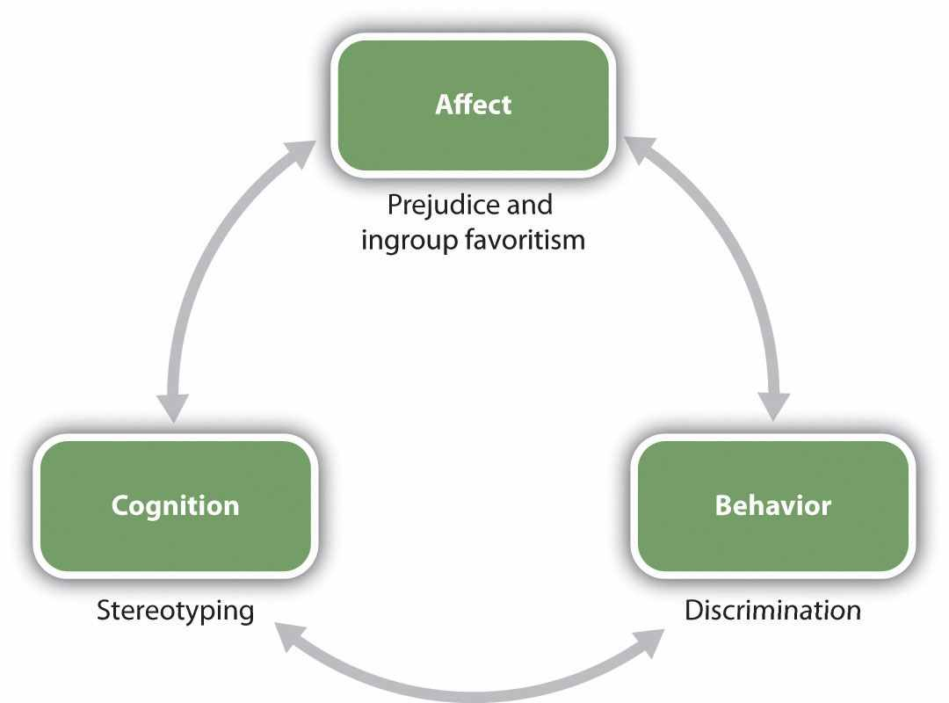
Relationships among social groups are influenced by the ABCs of social psychology.
Stereotypes and prejudice have a pervasive and often pernicious influence on our responses to others, and also in some cases on our own behaviors. To take one example, social psychological research has found that our stereotypes may in some cases lead to stereotype threat—performance decrements that are caused by the knowledge of cultural stereotypes. Spencer, Steele, and Quinn (1999) ^{[7]} found that when women were reminded of the (untrue) stereotype that “women are poor at math” they performed more poorly on math tests than when they were not reminded of the stereotype, and other research has found stereotype threat in many other domains as well. We’ll consider the role of stereotype threat in more detail later in this chapter.
In one particularly disturbing line of research about the influence of prejudice on behaviors, Joshua Correll and his colleagues had White participants participate in an experiment in which they viewed photographs of White and Black people on a computer screen. Across the experiment, the photographs showed the people holding either a gun or something harmless such as a cell phone. The participants were asked to decide as quickly as possible to press a button to “shoot” if the target held a weapon but to “not shoot” if the person did not hold a weapon. Overall, the White participants tended to shoot more often when the person holding the object was Black than when the person holding the object was White, and this occurred even when there was no weapon present (Correll, Park, Judd, & Wittenbrink, 2007; Correll et al., 2007). ^{[8]}
Discrimination is a major societal problem because it is so pervasive, takes so many forms, and has such negative effects on so many people. Even people who are paid to be unbiased may discriminate. Price and Wolfers (2007) ^{[9]} found that White players in National Basketball Association games received fewer fouls when more of the referees present in the game were White, and Black players received fewer fouls when more of the referees present in the game where Black. The implication is—whether they know it or not—the referees were discriminating on the basis of race.
I’m sure that you have had some experiences where you found yourself responding to another person on the basis of a stereotype or a prejudice, and perhaps the fact that you did surprised you. Perhaps you then tried to get past these beliefs and to react to the person more on the basis of his or her individual characteristics. We like some people and we dislike others—this is natural—but we should not let a person’s skin color, gender, age, religion, or ethnic background make these determinations for us. And yet, despite our best intentions, we may end up making friends only with people who are similar to us and perhaps even avoiding people whom we see as different.
In this chapter, we will study the processes by which we develop, maintain, and make use of our stereotypes and our prejudices. We will consider the negative outcomes of those beliefs on the targets of our perceptions, and we will consider ways that we might be able to change those beliefs, or at least help us stop acting upon them. Let’s begin by considering the cognitive side of our group beliefs—focusing primarily on stereotypes—before turning to the important role of feelings in prejudice.

[1] U.S. Census Bureau. Retrieved from http://www.census.gov
[2] Mannix, E., & Neale, M. A. (2005). What differences make a difference? The promise and reality of diverse teams in organizations. Psychological Science in the Public Interest, 6(2), 31–55; van Knippenberg, D., & Schippers, M. C. (2007). Work group diversity. Annual Review of Psychology, 58(1), 515–541.
[3] Shapiro, J. R., & Neuberg, S. L. (2007). From stereotype threat to stereotype threats: Implications of a multi-threat framework for causes, moderators, mediators, consequences, and interventions. Personality and Social Psychology Review, 11(2), 107–130. doi: 10.1177/1088868306294790
[4] Zhang, S., Schmader, T., & Forbes, C. (2009). The effects of gender stereotypes on women’s career choice: Opening the glass door. In M. Barreto, M. K. Ryan, & M. T. Schmitt (Eds.), The glass ceiling in the 21st century: Understanding barriers to gender equality (pp. 125–150). Washington, DC: American Psychological Association.
[5] Fiske, S. T., & Lee, T. L. (2008). Stereotypes and prejudice create workplace discrimination. In A. P. Brief (Ed.), Diversity at work (pp. 13–52). Cambridge, UK: Cambridge University Press.
[6] Jackson, L. M. (2011). The psychology of prejudice: From attitudes to social action. Washington, DC: American Psychological Association; Wood, W., & Eagly, A. H. (2010). Gender. In S. T. Fiske, D. T. Gilbert, & G. Lindzey (Eds.), Handbook of social psychology (5th ed., Vol. 1, pp. 629–667). Hoboken, NJ: John Wiley & Sons.
[7] Spencer, S. J., Steele, C. M., & Quinn, D. M. (1999). Stereotype threat and women’s math performance. Journal of Experimental Social Psychology, 35, 4–28.
[8] Correll, J., Park, B., Judd, C. M., & Wittenbrink, B. (2007). The influence of stereotypes on decisions to shoot. European Journal of Social Psychology, 37(6), 1102–1117. doi: 10.1002/ejsp.450; Correll, J., Park, B., Judd, C. M., Wittenbrink, B., Sadler, M. S., & Keesee, T. (2007). Across the thin blue line: Police officers and racial bias in the decision to shoot.Journal of Personality and Social Psychology, 92(6), 1006–1023. doi: 10.1037/0022–3514.92.6.1006
[9] Price, J., & Wolfers, J. (2007). Racial discrimination among NBA referees. NBER Working Paper #13206. Cambridge, MA: National Bureau of Economic Research.

12.1 Social Categorization and Stereotyping

LEARNING OBJECTIVES
- Describe the fundamental process of social categorization and its influence on thoughts, feelings, and behavior.
- Define stereotypes and describe the ways that stereotypes are measured.
- Review the ways that stereotypes influence our behavior.
Thinking about others in terms of their group memberships is known associal categorization—the natural cognitive process by which we place individuals into social groups. Social categorization occurs when we think of someone as a man (versus a woman), an old person (versus a young person), a Black person (versus an Asian or White person), and so on (Allport, 1954/1979). ^{[1]} Just as we categorize objects into different types, so we categorize people according to their social group memberships. Once we do so, we begin to respond to those people more as members of a social group than as individuals.
Imagine for a moment that two college students, John and Sarah, are talking at a table in the student union at your college or university. At this point, we would probably not consider them to be acting as group members, but rather as two individuals. John is expressing his opinions, and Sarah is expressing hers. Imagine, however, that as the conversation continues, Sarah brings up an assignment that she is completing for her women’s studies class. It turns out that John does not think there should be a women’s studies program at the college, and he tells Sarah so. He argues that if there is a women’s studies program, then there should be a men’s studies program too. Furthermore, he argues that women are getting too many breaks in job hiring and that qualified men are the targets of discrimination. Sarah feels quite the contrary—arguing that women have been the targets of sexism for many, many years and even now do not have the same access to high-paying jobs that men do.
You can see that an interaction that began at individual level, as two individuals conversing, has now turned to the group level, in which John has begun to consider himself as a man, and Sarah has begun to consider herself as a woman. In short, Sarah is now arguing her points not so much for herself as she is as a representative of one of her ingroups—namely, women—and John is acting as a representative of one of his ingroups—namely, men. Sarah feels that her positions are correct, and she believes they are true not only for her but for women in general. And the same is true of John. You can see that these social categorizations may create some potential for misperception, and perhaps even hostility. And John and Sarah may even change their opinions about each other, forgetting that they really like each other as individuals, because they are now responding more as group members with opposing views.
Imagine now that while John and Sarah are still talking, some students from another college, each wearing the hats and jackets of that school, show up in the student union. The presence of these outsiders might change the direction of social categorization entirely, leading both John and Sarah to think of themselves as students at their own college. And this social categorization might lead them to become more aware of the positive characteristics of their college (the excellent basketball team, lovely campus, and intelligent students) in comparison with the characteristics of the other school. Now, rather than perceiving themselves as members of two different groups (men versus women), John and Sarah might suddenly perceive themselves as members of the same social category (students at their college).
Perhaps this example will help you see the flexibility of social categorization. We sometimes think of our relationships with others at the individual level and sometimes at the group level. And which groups we use in social categorization can change over time and in different situations. I think you would agree that you are more likely to categorize yourself as a member of your college or university when your basketball or football team has just won a really important game, or at your commencement day ceremony, than you would on a normal evening out with your family. In these cases, your membership as a university student is simply more salient and important than it is every day, and you are more likely to categorize yourself accordingly.

Spontaneous Social Categorization
Social categorization occurs spontaneously, without much thought on our part (Crisp & Hewstone, 2007). ^{[2]} Shelley Taylor and her colleagues (Taylor, Fiske, Etcoff, & Ruderman, 1978) ^{[3]} showed their research participants a slide and tape presentation of three male and three female college students who had supposedly participated in a discussion group. During the presentation, each member of the discussion group made a suggestion about how to advertise a college play. The statements were controlled so that across all the research participants, the statements made by the men and the women were of equal length and quality. Furthermore, one half of the participants were told that when the presentation was over, they would be asked to remember which person had made which suggestion, whereas the other half of the participants were told merely to observe the interaction without attending to anything in particular.
After they had viewed all the statements made by the individuals in the discussion group, the research participants were given a memory test (this was entirely unexpected for the participants who had not been given memory instructions). The participants were shown the list of all the statements that had been made, along with the pictures of each of the discussion group members, and were asked to indicate who had made each of the statements. The research participants were not very good at this task, and yet when they made mistakes, these errors were very systematic.
As you can see in Table 12.1 "Name Confusions", the mistakes were such that the statements that had actually been made by a man were more frequently wrongly attributed to another man in the group than to another woman, and the statements actually made by a woman were more frequently attributed to other women in the group than to a man. The participants evidently categorized the speakers by their gender, leading them to make more within-gender than across-gender confusions.
Interestingly, and suggesting that categorization is occurring all the time, the instructions that the participants had been given made absolutely no difference. There was just as much categorization for those who were not given any instructions as for those who were told to remember who said what. Other research using this technique has found that we spontaneously categorize each other on the basis of many other group memberships, including race, academic status (student versus teacher), social roles, and other social categories (Fiske, Haslam, & Fiske, 1991; Stangor, Lynch, Duan, & Glass, 1992). ^{[4]}

Table 12.1 Name Confusions
Instructions | Within race errors | Between race errors
Memory | 5.78 | 4.29
No memory | 6.57 | 4.36
Taylor, Fiske, Etcoff, and Ruderman (1978) ^{[5]} demonstrated that people categorized others spontaneously. Even without any instructions to categorize, people nevertheless confused others by their sex.
The conclusion is simple, if perhaps obvious: Social categorization is occurring all around us all the time. Indeed, social categorization occurs so quickly that people may have difficulty not thinking about others in terms of their group memberships (seeFigure 12.3).

The Benefits of Social Categorization
The tendency to categorize others is normally quite useful. In some cases, we categorize because doing so provides us with information about the characteristics of people who belong to certain social groups (Lee, Jussim, & McCauley, 1995). ^{[6]} If you found yourself lost in a city, you might look for a police officer or a taxi driver to help you find your way. In this case, social categorization would probably be useful because a police officer or a taxi driver might be particularly likely to know the layout of the city streets. Of course, using social categories will only be informative to the extent that the stereotypes held by the individual about that category are accurate. If police officers were actually not that knowledgeable about the city layout, then using this categorization would not be informative.
It has been argued that there is a kernel of truth in most stereotypes, and this seems to be the case. There is a correlation between how group members perceive the stereotypes of their own groups and how people from other groups perceive those same stereotypes (Judd & Park, 1993; Swim, 1994). ^{[7]} This truth may come in part from the roles that individuals play in society. For instance, the stereotypes (which are held by many people) that women are “nurturing” and that men are “dominant” may occur in part because, on average, men and women find themselves in different social roles within a culture (Eagly & Steffen, 1984). ^{[8]} In most cultures, men are more likely to be in higher-status occupations, such as doctors and lawyers, whereas women are more likely to play the role of homemakers and child-care workers. In this sense, the stereotypes are at least partly true for many of the members of the social category, in terms of their actual behaviors. Because men are more likely to be leaders than are women, they may well be, on average, more dominant; and because women are more likely to take care of children, they may, on average, act in a more nurturing way than do men.
On the other hand, we sometimes categorize others not because it seems to provide more information about them but because we may not have the time (or the motivation) to do anything more thorough. Using our stereotypes to size up another person might simply make our life easier (Macrae, Bodenhausen, Milne, & Jetten, 1994). ^{[9]}According to this approach, thinking about other people in terms of their social category memberships is a functional way of dealing with the world—things are complicated, and we reduce complexity by relying on our stereotypes.

The Negative Outcomes of Social Categorization
Although thinking about others in terms of their social category memberships has some potential benefits for the person who does the categorizing, categorizing others, rather than treating them as unique individuals with their own unique characteristics, has a wide variety of negative, and often very unfair, outcomes for those who are categorized.
One problem is that social categorization distorts our perceptions such that we tend to exaggerate the differences between people from different social groups while at the same time perceiving members of groups (and particularly outgroups) as more similar to each other than they actually are. This overgeneralization makes it more likely that we will think about and treat all members of a group the same way. Tajfel and Wilkes (1963) ^{[10]} performed a simple experiment that provided a picture of the potential outcomes of categorization. As you can see in Figure 12.4 "Perceptual Accentuation", the experiment involved having research participants judge the length of six lines. In one of the experimental conditions, participants simply saw six lines, whereas in the other condition, the lines were systematically categorized into two groups—one comprising the three shorter lines and one comprising the three longer lines.

Figure 12.4 Perceptual Accentuation
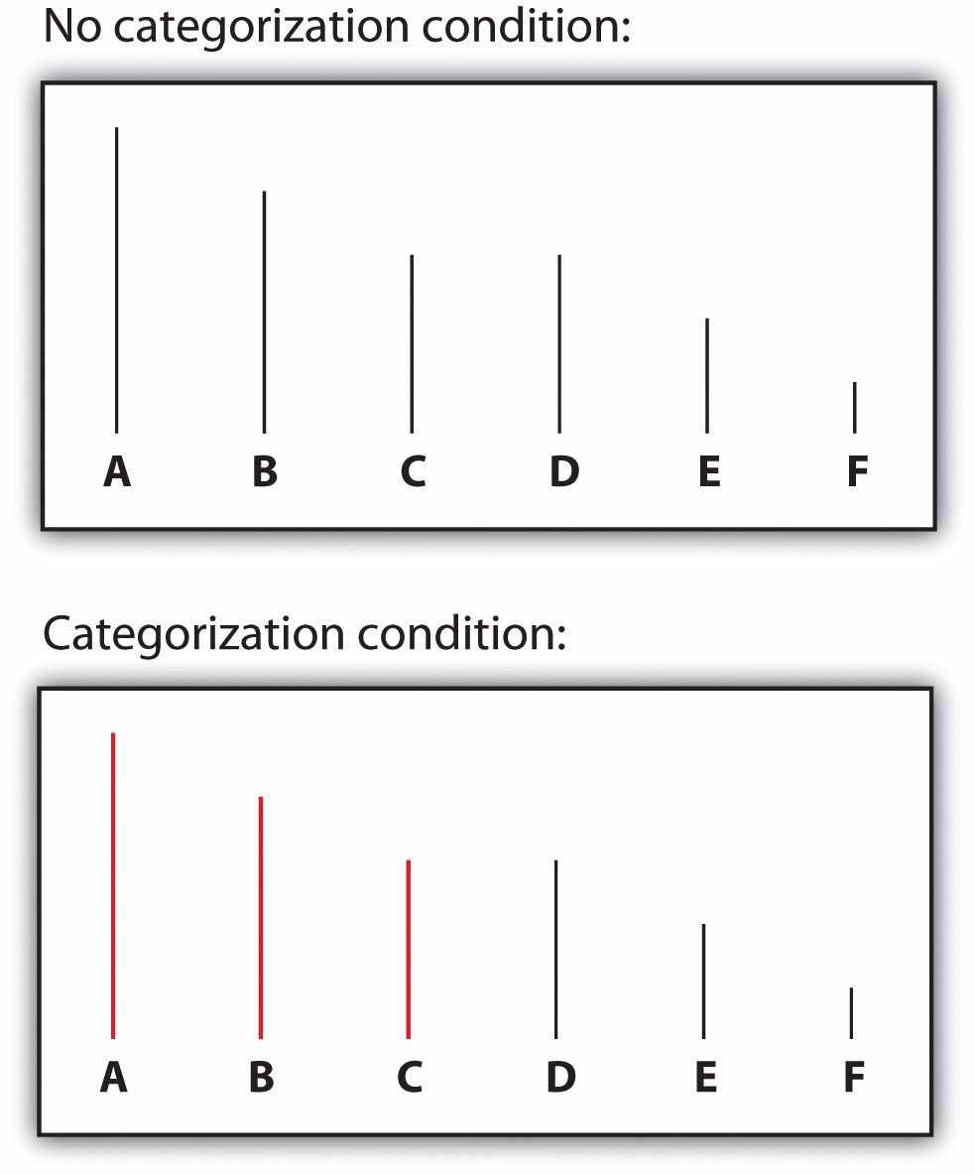
Lines C and D were seen as the same length in the noncategorized condition, but line C was perceived as longer than line D when the lines were categorized into two groups. From Tajfel (1970). ^{[11]}
Tajfel found that the lines were perceived differently when they were categorized, such that the differences between the groups and the similarities within the groups were emphasized. Specifically, he found that although lines C and D (which are actually the same length) were perceived as equal in length when the lines were not categorized, line D was perceived as being significantly longer than line C in the condition in which the lines were categorized. In this case, categorization into two groups—the “short lines group” and the “long lines group”—produced a perceptual bias such that the two groups of lines were seen as more different than they really were.
Similar effects occur when we categorize other people. We tend to see people who belong to the same social group as more similar than they actually are, and we tend to judge people from different social groups as more different than they actually are. The tendency to see members of social groups as similar to each other is particularly strong for members of outgroups, resulting in outgroup homogeneity—the tendency to view members of outgroups as more similar to each other than we see members of ingroups (Linville, Salovey, & Fischer, 1986; Ostrom & Sedikides, 1992; Meissner & Brigham, 2001). ^{[12]} I’m sure you’ve had this experience yourself, when you found yourself thinking or saying, “Oh, them, they’re all the same!”
Patricia Linville and Edward Jones (1980) ^{[13]} gave research participants a list of trait terms and asked them to think about either members of their own group (e.g., Blacks) or members of another group (e.g., Whites) and to place the trait terms into piles that represented different types of people in the group. The results of these studies, as well as other studies like them, were clear: People perceive outgroups as more homogeneous than the ingroup. Just as White people used fewer piles of traits to describe Blacks than Whites, young people used fewer piles of traits to describe elderly people than they did young people, and students used fewer piles for members of other universities than they did for members of their own university.
Outgroup homogeneity occurs in part because we don’t have as much contact with outgroup members as we do with ingroup members, and the quality of interaction with outgroup members is often more superficial. This prevents us from really learning about the outgroup members as individuals, and as a result, we tend to be unaware of the differences among the group members. In addition to learning less about them because we see and interact with them less, we routinely categorize outgroup members, thus making them appear more cognitively similar (Haslam, Oakes, & Turner, 1996).^{[14]}
Once we begin to see the members of outgroups as more similar to each other than they actually are, it then becomes very easy to apply our stereotypes to the members of the groups without having to consider whether the characteristic is actually true of the particular individual. If men think that women are all alike, then they may also think that they all have the same characteristics—they’re all “emotional” and “weak.” And women may have similarly simplified beliefs about men (they’re “insensitive,” “unwilling to commit,” etc.). The outcome is that the stereotypes become linked to the group itself in a set of mental representations (Figure 12.5). The stereotypes are “pictures in our heads” of the social groups (Lippman, 1922). ^{[15]} These beliefs just seem right and natural, even though they are frequently distorted overgeneralizations (Hirschfeld, 1996; Yzerbyt, Schadron, Leyens, & Rocher, 1994). ^{[16]}

Figure 12.5
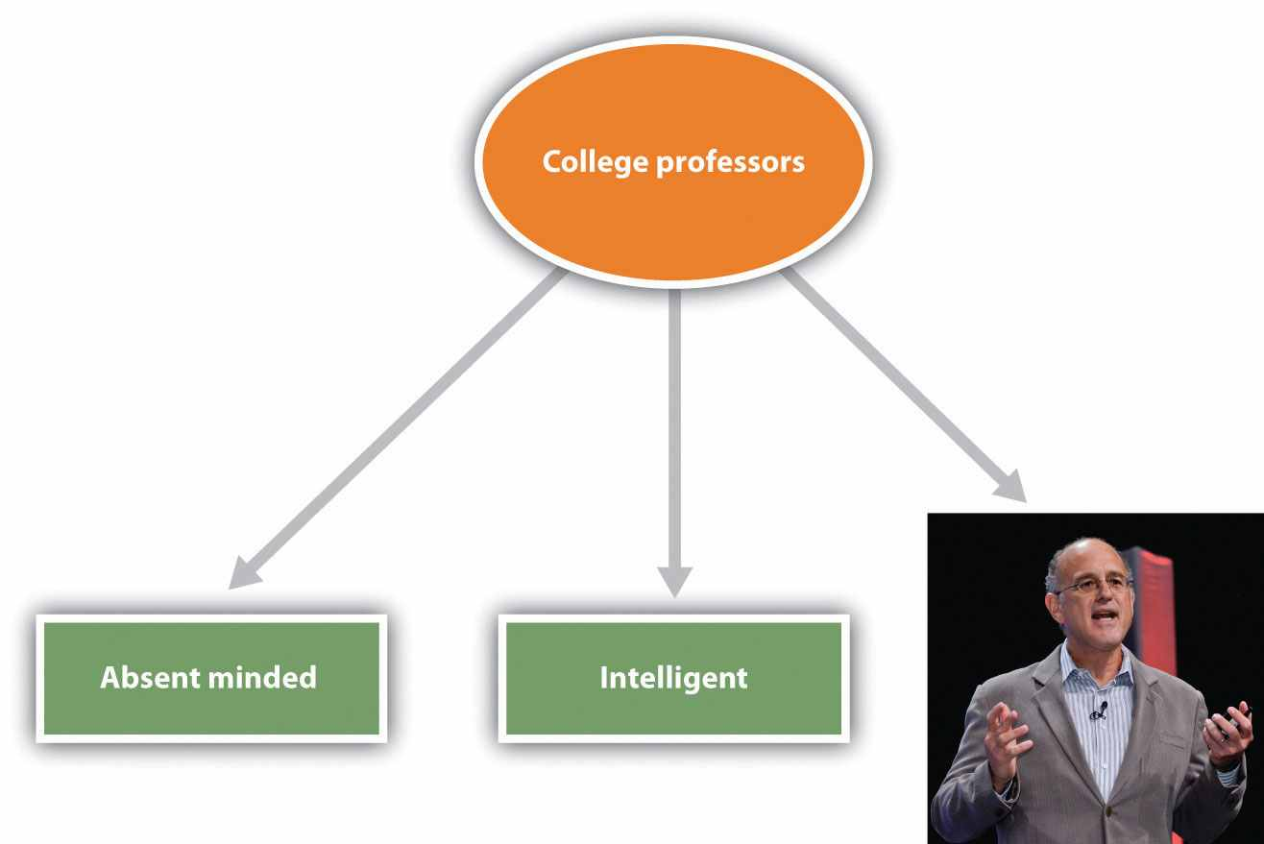
Stereotypes are the beliefs associated with social categories. The figure shows links between the social category of college professors and its stereotypes as a type of neural network or schema. The representation also includes one image (or exemplar) of a particular college professor whom the student knows.
Image courtesy of Dan Gilbert.
Our stereotypes and prejudices are learned through many different processes. This multiplicity of causes is unfortunate because it makes stereotypes and prejudices even more likely to form and harder to change. For one, we learn our stereotypes in part through our communications with parents and peers (Aboud & Doyle, 1996) ^{[17]} and from the behaviors we see portrayed in the media (Brown, 1995). ^{[18]} Even 5-year-old children have learned cultural norms about the appropriate activities and behaviors for boys and girls and also have developed stereotypes about age, race, and physical attractiveness (Bigler & Liben, 2006). ^{[19]} And there is often good agreement about the stereotypes of social categories among the individuals within a given culture. In one study assessing stereotypes, Stephanie Madon and her colleagues (Madon et al., 2001)^{[20]} presented U.S. college students with a list of 84 trait terms and asked them to indicate for which groups each trait seemed appropriate (Figure 12.6 "Current Stereotypes Held by College Students"). The participants tended to agree about what traits were true of which groups, and this was true even for groups of which the respondents were likely to never have met a single member (Arabs and Russians). Even today, there is good agreement about the stereotypes of members of many social groups, including men and women and a variety of ethnic groups.

Figure 12.6 Current Stereotypes Held by College Students
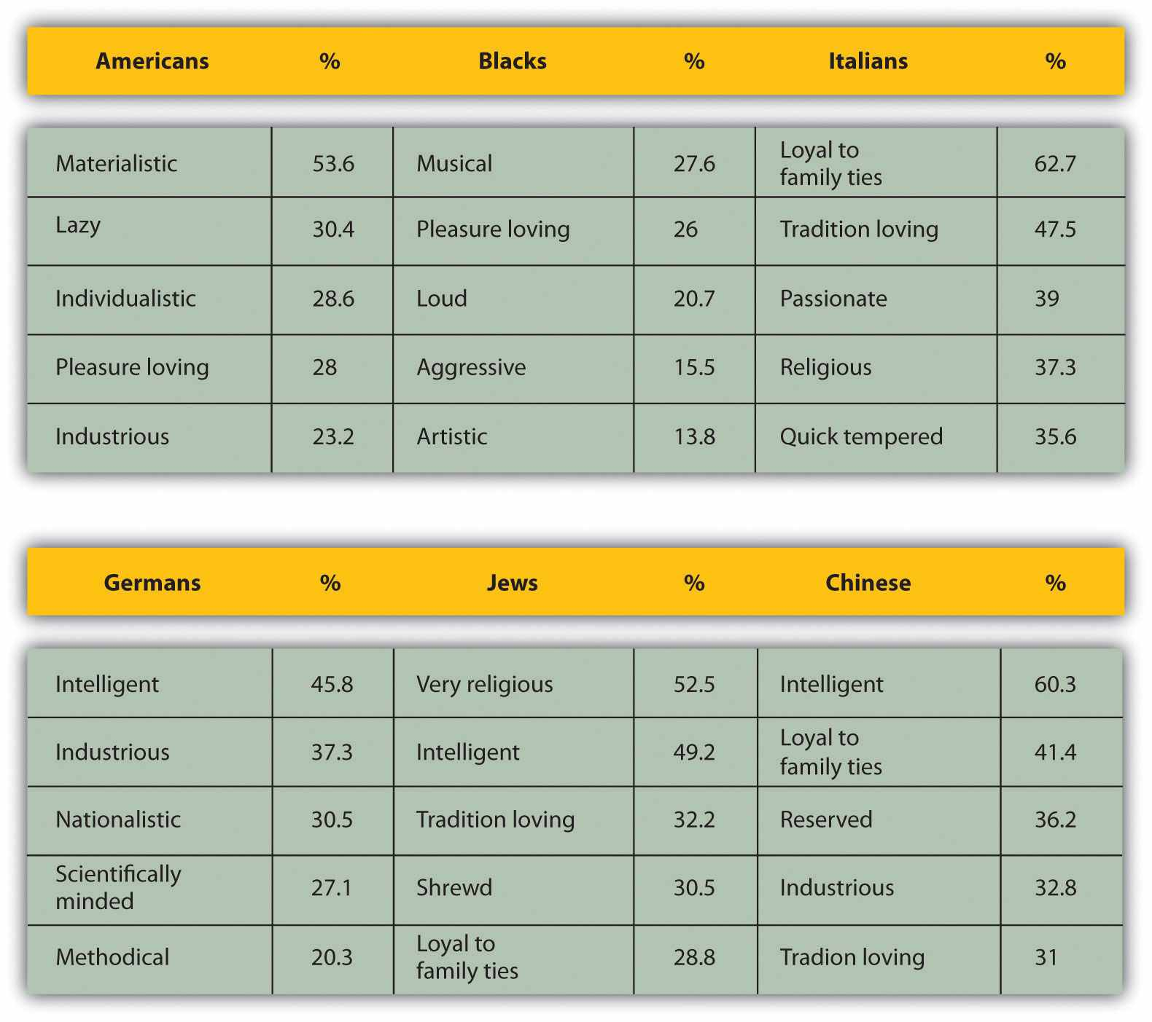
From Madon et al. (2001). ^{[21]}
Once they become established, stereotypes (like any other cognitive representation) tend to persevere. We begin to respond to members of stereotyped categories as if we already knew what they were like. Yaacov Trope and Eric Thompson (1997) ^{[22]} found that individuals addressed fewer questions to members of categories about which they had strong stereotypes (as if they already knew what these people were like) and that the questions they did ask were likely to confirm the stereotypes they already had.
In other cases, stereotypes are maintained because information that confirms our stereotypes is better remembered than information that disconfirms them. When we see members of social groups perform behaviors, we tend to better remember information that confirms our stereotypes than we remember information that disconfirms our stereotypes (Fyock & Stangor, 1994). ^{[23]} If we believe that women are bad drivers and we see a woman driving poorly, then we tend to remember it, but when we see a woman who drives particularly well, we tend to forget it. This is of course another example of the general principle of assimilation—we tend to perceive the world in ways that make it fit our existing beliefs more easily than we change our beliefs to fit the reality around us.
And stereotypes become difficult to change because they are so important to us—they become an integral and important part of our everyday lives in our culture. Stereotypes are frequently expressed on TV, in movies, and in chat rooms and blogs, and we learn a lot of our beliefs from these sources. Our friends also tend to hold beliefs similar to ours, and we talk about these beliefs when we get together with them (Schaller & Conway, 1999). ^{[24]} In short, stereotypes and prejudice are powerful largely because they are important social norms that are part of our culture (Guimond, 2000). ^{[25]}
Because they are so highly cognitively accessible, and because they seem so “right,” our stereotypes easily influence our judgments of and responses to those we have categorized. The social psychologist John Bargh once described stereotypes as “cognitive monsters” because their activation was so powerful and because the activated beliefs had such insidious influences on social judgment (Bargh, 1999). ^{[26]}Making things even more difficult, stereotypes are strongest for the people who are in most need of change—the people who are most prejudiced (Lepore & Brown, 1997).^{[27]}
Because stereotypes and prejudice often operate out of our awareness, and also because people are frequently unwilling to admit that they hold them, social psychologists have developed methods for assessing them indirectly. In the next section we will consider two of these approaches—the bogus pipeline procedure and theImplicit Association Test (IAT)

Research Focus
Measuring Stereotypes Indirectly
One difficulty in measuring stereotypes and prejudice is that people may not tell the truth about their beliefs. Most people do not want to admit—either to themselves or to others—that they hold stereotypes or that they are prejudiced toward some social groups. To get around this problem, social psychologists make use of a number of techniques that help them measure these beliefs more subtly and indirectly.
One indirect approach to assessing prejudice is called the bogus pipeline procedure (Jones & Sigall, 1971). ^{[28]} In this procedure, the experimenter first convinces the participants that he or he has access to their “true” beliefs, for instance, by getting access to a questionnaire that they completed at a prior experimental session. Once the participants are convinced that the researcher is able to assess their “true” attitudes, it is expected that they will be more honest in answering the rest of the questions they are asked because they want to be sure that the researcher does not catch them lying. The bogus pipeline procedure suggests that people may frequently mask their negative beliefs in public—people express more prejudice when they are in the bogus pipeline than they do when they are asked the same questions more directly.
Other indirect measures of prejudice are also frequently used in social psychological research, for instance—assessing nonverbal behaviors such as speech errors or physical closeness. One common measure involves asking participants to take a seat on a chair near a person from a different racial or ethnic group and measuring how far away the person sits (Sechrist & Stangor, 2001; Word, Zanna, & Cooper, 1974). ^{[29]} People who sit farther away are assumed to be more prejudiced toward the members of the group.
Because our stereotypes are activated spontaneously when we think about members of different social groups, it is possible to use reaction-time measures to assess this activation and thus to learn about people’s stereotypes and prejudices. In these procedures, participants are asked to make a series of judgments about pictures or descriptions of social groups and then to answer questions as quickly as they can, but without making mistakes. The speed of these responses is used to determine an individual’s stereotypes or prejudice.
The most popular reaction-time implicit measure of prejudice—the Implicit Association Test (IAT)—is frequently used to assess stereotypes and prejudice (Nosek, Greenwald, & Banaji, 2007). ^{[30]} In the IAT, participants are asked to classify stimuli that they view on a computer screen into one of two categories by pressing one of two computer keys, one with their left hand and one with their right hand. Furthermore, the categories are arranged such that the responses to be answered with the left and right buttons either “fit with” (match) the stereotype or do not “fit with” (mismatch) the stereotype. For instance, in one version of the IAT, participants are shown pictures of men and women and also shown words related to gender stereotypes (e.g., strong, leader, or powerful for men andnurturing, emotional, or weak for women). Then the participants categorize the photos (“Is this picture a picture of a man or a woman?”) and answer questions about the stereotypes (“Is this the word strong?) by pressing either the Yes button or the No button using either their left hand or their right hand.
When the responses are arranged on the screen in a “matching” way, such that the male category and the “strong” category are on the same side of the screen (e.g., on the right side), participants can do the task very quickly and they make few mistakes. It’s just easier, because the stereotypes are matched or associated with the pictures in a way that makes sense. But when the images are arranged such that the women and the strong categories are on the same side, whereas the men and the weak categories are on the other side, most participants make more errors and respond more slowly. The basic assumption is that if two concepts are associated or linked, they will be responded to more quickly if they are classified using the same, rather than different, keys.
Implicit association procedures such as the IAT show that even participants who claim that they are not prejudiced do seem to hold cultural stereotypes about social groups. Even Black people themselves respond more quickly to positive words that are associated with White rather than Black faces on the IAT, suggesting that they have subtle racial prejudice toward Blacks.
Because they hold these beliefs, it is possible—although not guaranteed—that they may use them when responding to other people, creating a subtle and unconscious type of discrimination. Although the meaning of the IAT has been debated (Tetlock & Mitchell, 2008), ^{[31]} research using implicit measures does suggest that—whether we know it or not, and even though we may try to control them when we can—our stereotypes and prejudices are easily activated when we see members of different social categories (Barden, Maddux, Petty, & Brewer, 2004).^{[32]}
Do you hold implicit prejudices? Try the IAT yourself, here:https://implicit.harvard.edu/implicit
Although in some cases the stereotypes that are used to make judgments might actually be true of the individual being judged, in many other cases they are not. Stereotyping is problematic when the stereotypes we hold about a social group are inaccurate overall, and particularly when they do not apply to the individual who is being judged (Stangor, 1995). ^{[33]} Stereotyping others is simply unfair. Even if many women are more emotional than are most men, not all are, and it is not right to judge any one woman as if she is.
In the end, stereotypes become self-fulfilling prophecies, such that our expectations about the group members make the stereotypes come true (Snyder, Tanke, & Berscheid, 1977; Word, Zanna, & Cooper, 1974). ^{[34]} Once we believe that men make better leaders than women, we tend to behave toward men in ways that makes it easier for them to lead. And we behave toward women in ways that makes it more difficult for them to lead. The result? Men find it easier to excel in leadership positions, whereas women have to work hard to overcome the false beliefs about their lack of leadership abilities (Phelan & Rudman, 2010). ^{[35]} And self-fulfilling prophecies are ubiquitous—even teachers’ expectations about their students’ academic abilities can influence the students’ school performance (Jussim, Robustelli, & Cain, 2009). ^{[36]}
Of course, you may think that you personally do not behave in these ways, and you may not. But research has found that stereotypes are often used out of our awareness, which makes it very difficult for us to correct for them. Even when we think we are being completely fair, we may nevertheless be using our stereotypes to condone discrimination (Chen & Bargh, 1999). ^{[37]} And when we are distracted or under time pressure, these tendencies become even more powerful (Stangor & Duan, 1991). ^{[38]}
Furthermore, attempting to prevent our stereotype from coloring our reactions to others takes effort. We experience more negative affect (particularly anxiety) when we are with members of other groups than we do when we are with people from our own groups, and we need to use more cognitive resources to control our behavior because of our anxiety about revealing our stereotypes or prejudices (Butz & Plant, 2006; Richeson & Shelton, 2003). ^{[39]} When we know that we need to control our expectations so that we do not unintentionally stereotype the other person, we may try to do so—but doing so takes effort and may frequently fail (Macrae, Bodenhausen, Milne, & Jetten, 1994). ^{[40]}

Social Psychology in the Public Interest
Stereotype Threat
Our stereotypes influence not only our judgments of others but also our beliefs about ourselves, and even our own performance on important tasks. In some cases, these beliefs may be positive, and they have the effect of making us feel more confident and thus better able to perform tasks. Because Asian students are aware of the stereotype that “Asians are good at math,” reminding them of this fact before they take a difficult math test can improve their performance on the test (Walton & Cohen, 2003). ^{[41]} On the other hand, sometimes these beliefs are negative, and they create negative self-fulfilling prophecies such that we perform more poorly just because of our knowledge about the stereotypes.
One of the long-standing puzzles in the area of academic performance concerns why Black students perform more poorly on standardized tests, receive lower grades, and are less likely to remain in school in comparison with White students, even when other factors such as family income, parents’ education, and other relevant variables are controlled. Claude Steele and Joshua Aronson (1995) ^{[42]}tested the hypothesis that these differences might be due to the activation of negative stereotypes. Because Black students are aware of the (inaccurate) stereotype that “Blacks are intellectually inferior to Whites,” this stereotype might create a negative expectation, which might interfere with their performance on intellectual tests through fear of confirming that stereotype.
In support of this hypothesis, Steele and Aronson’s research revealed that Black college students performed worse (in comparison with their prior test scores) on math questions taken from the Graduate Record Examination (GRE) when the test was described to them as being “diagnostic of their mathematical ability” (and thus when the stereotype was relevant) but that their performance was not influenced when the same questions were framed as “an exercise in problem solving.” And in another study, Steele and Aronson found that when Black students were asked to indicate their race before they took a math test (again activating the stereotype), they performed more poorly than they had on prior exams, whereas the scores of White students were not affected by first indicating their race.
Steele and Aronson argued that thinking about negative stereotypes that are relevant to a task that one is performing creates stereotype threat—performance decrements that are caused by the knowledge of cultural stereotypes. That is, they argued that the negative impact of race on standardized tests may be caused, at least in part, by the performance situation itself. Because the threat is “in the air,” Black students may be negatively influenced by it.
Research has found that the experience of stereotype threat can help explain a wide variety of performance decrements among those who are targeted by negative stereotypes. For instance, when a math task is described as diagnostic of intelligence, Latinos and particularly Latinas perform more poorly than do Whites (Gonzales, Blanton, & Williams, 2002). ^{[43]} Similarly, when stereotypes are activated, children with low socioeconomic status perform more poorly in math than do those with high socioeconomic status, and psychology students perform more poorly than do natural science students (Brown, Croizet, Bohner, Fournet, & Payne, 2003). ^{[44]} Even groups who typically enjoy advantaged social status can be made to experience stereotype threat. White men performed more poorly on a math test when they were told that their performance would be compared with that of Asian men (Aronson, Lustina, Good, Keough, & Steele, 1999), ^{[45]} and Whites performed more poorly than Blacks on a sport-related task when it was described to them as measuring their natural athletic ability (Stone, 2002). ^{[46]}
Stereotype threat is created in situations that pose a significant threat to self-concern, such that our perceptions of ourselves as important, valuable, and capable individuals are threatened. In these situations, there is a discrepancy between our positive concept of our skills and abilities and the negative stereotypes suggesting poor performance. When our stereotypes lead us to be believe that we are likely to perform poorly on a task, we experience a feeling of unease and status threat.
Research has found that stereotype threat is caused by both cognitive and affective factors. On the cognitive side, individuals who are experiencing stereotype threat show an impairment in cognitive processing that is caused by increased vigilance toward the environment and attempts to suppress their stereotypical thoughts. On the affective side, stereotype threat creates stress as well as a variety of affective responses including anxiety (Schmader, Johns, & Forbes, 2008). ^{[47]}
Stereotype threat is not, however, absolute—we can get past it if we try. What is important is to reduce the self-concern that is engaged when we consider the relevant negative stereotypes. Manipulations that affirm positive characteristics about oneself or one’s group are successful at reducing stereotype threat (Alter, Aronson, Darley, Rodriguez, & Ruble, 2010; Greenberg et al., 2003; McIntyre, Paulson, & Lord, 2003). ^{[48]} In fact, just knowing that stereotype threat exists and may influence performance can help alleviate its negative impact (Johns, Schmader, & Martens, 2005). ^{[49]}

KEY TAKEAWAYS
- Beliefs about the characteristics of the groups and the members of those groups are known as stereotypes.
- Prejudice refers to an unjustifiable negative attitude toward an outgroup.
- Stereotypes and prejudice may create discrimination.
- Stereotyping and prejudice begin from social categorization—the natural cognitive process by which we place individuals into social groups.
- Social categorization influences our perceptions of groups—for instance, the perception of outgroup homogeneity.
- Once our stereotypes and prejudices become established, they are difficult to change and may lead to self-fulfilling prophecies, such that our expectations about the group members make the stereotypes come true.
- Stereotypes may influence our performance on important tasks through stereotype threat.

EXERCISES AND CRITICAL THINKING
- Look again at the pictures in Figure 12.2, and consider your thoughts and feelings about each person. What are your stereotypes and prejudices about them? Do you think your stereotypes are accurate?
- On which (if any) social categories do you categorize others? Why do you (or don’t you) categorize? Is your behavior fair or unfair to the people you are categorizing?
- Think of a task that one of the social groups to which you belong is considered to be particularly good (or poor) at. Do you think the cultural stereotypes about your group have ever influenced your performance on a task?

[1] Allport, G. W. (1954/1979). The nature of prejudice. New York, NY: Doubleday.
[2] Crisp, R. J., & Hewstone, M. (Eds.). (2007). Multiple social categorization. San Diego, CA: Elsevier Academic Press.
[3] Taylor, S. E., Fiske, S. T., Etcoff, N. L., & Ruderman, A. J. (1978). Categorical and contextual bases of person memory and stereotyping. Journal of Personality and Social Psychology, 36(7), 778–793.
[4] Fiske, A. P., Haslam, N., & Fiske, S. T. (1991). Confusing one person with another: What errors reveal about the elementary forms of social relations. Journal of Personality and Social Psychology, 60(5), 656–674; Stangor, C., Lynch, L., Duan, C., & Glass, B. (1992). Categorization of individuals on the basis of multiple social features. Journal of Personality and Social Psychology, 62(2), 207–218.
[5] Taylor, S. E., Fiske, S. T., Etcoff, N. L., & Ruderman, A. J. (1978). Categorical and contextual bases of person memory and stereotyping. Journal of Personality and Social Psychology, 36(7), 778–793.
[6] Lee, Y. T., Jussim, L. J., & McCauley, C. R. (1995). Stereotype accuracy: Toward appreciating group differences. Washington, DC: American Psychological Association.
[7] Judd, C. M., & Park, B. (1993). Definition and assessment of accuracy in social stereotypes.Psychological Review, 100(1), 109–128; Swim, J. K. (1994). Perceived versus meta-analytic effect sizes: An assessment of the accuracy of gender stereotypes. Journal of Personality and Social Psychology, 66(1), 21–36.
[8] Eagly, A. H., & Steffen, V. J. (1984). Gender stereotypes stem from the distribution of women and men into social roles. Journal of Personality and Social Psychology, 46(4), 735–754.
[9] Macrae, C. N., Bodenhausen, G. V., Milne, A. B., & Jetten, J. (1994). Out of mind but back in sight: Stereotypes on the rebound. Journal of Personality and Social Psychology, 67(5), 808–817.
[10] Tajfel, H., & Wilkes, A. L. (1963). Classification and quantitative judgment. British Journal of Psychology, 54, 101–114.
[11] Tajfel, H. (1970). Experiments in intergroup discrimination. Scientific American, 223, 96–102.
[12] Linville, P. W., Salovey, P., & Fischer, G. W. (1986). Stereotyping and perceived distributions of social characteristics: An application to ingroup-outgroup perception. In J. F. Dovidio & S. L. Gaertner (Eds.), Prejudice, discrimination and racism (pp. 165–208). Orlando, FL: Academic Press; Ostrom, T. M., & Sedikides, C. (1992). Out-group homogeneity effects in natural and minimal groups. Psychological Bulletin, 112(3), 536–552; Meissner, C. A., & Brigham, J. C. (2001). Thirty years of investigating the own-race bias in memory for faces: A meta-analytic review. Psychology, Public Policy, and Law, 7, 3–35.
[13] Linville, P. W., & Jones, E. E. (1980). Polarized appraisals of out-group members. Journal of Personality and Social Psychology, 38, 689–703.
[14] Haslam, S. A., Oakes, P. J., & Turner, J. C. (1996). Social identity, self-categorization, and the perceived homogeneity of ingroups and outgroups: The interaction between social motivation and cognition. In Handbook of motivation and cognition: The interpersonal context (Vol. 3, pp. 182–222). New York, NY: The Guilford Press.
[15] Lippman, W. (1922). Public opinion. New York, NY: Harcourt & Brace.
[16] Hirschfeld, L. (1996). Race in the making: Cognition, culture and the child’s construction of human kinds. Cambridge, MA: MIT Press; Yzerbyt, V., Schadron, G., Leyens, J., & Rocher, S. (1994). Social judgeability: The impact of meta-informational cues on the use of stereotypes.Journal of Personality and Social Psychology, 66, 48–55.
[17] Aboud, F. E., & Doyle, A.-B. (1996). Parental and peer influences on children’s racial attitudes. International Journal of Intercultural Relations, 20, 371–383.
[18] Brown, R. (1995). Prejudice: Its social psychology. Cambridge, MA: Blackwell.
[19] Bigler, R. S., & Liben, L. S. (2006). A developmental intergroup theory of social stereotypes and prejudice. In R. V. Kail (Ed.), Advances in child development and behavior(Vol. 34, pp. 39–89). San Diego, CA: Elsevier.
[20] Madon, S., Guyll, M., Aboufadel, K., Montiel, E., Smith, A., Palumbo, P., et al. (2001). Ethnic and national stereotypes: The Princeton trilogy revisited and revised. Personality and Social Psychology Bulletin, 27(8), 996–1010. doi: 10.1177/0146167201278007
[21] Madon, S., Guyll, M., Aboufadel, K., Montiel, E., Smith, A., Palumbo, P., & Jussim, L. (2001). Ethnic and national stereotypes: The Princeton trilogy revisited and revised.Personality and Social Psychology Bulletin, 27(8), 996–1010. doi: 10.1177/0146167201278007
[22] Trope, Y., & Thompson, E. (1997). Looking for truth in all the wrong places? Asymmetric search of individuating information about stereotyped group members. Journal of Personality and Social Psychology, 73(2), 229–241.
[23] Fyock, J., & Stangor, C. (1994). The role of memory biases in stereotype maintenance.British Journal of Social Psychology, 33(3), 331–343.
[24] Schaller, M., & Conway, G. (1999). Influence of impression-management goals on the emerging content of group stereotypes: Support for a social-evolutionary perspective.Personality and Social Psychology Bulletin, 25, 819–833.
[25] Guimond, S. (2000). Group socialization and prejudice: The social transmission of intergroup attitudes and beliefs. European Journal of Social Psychology, 30(3), 335–354.
[26] Bargh, J. (Ed.). (1999). The cognitive monster: The case against the controllability of automatic stereotype effects. New York, NY: Guilford Press.
[27] Lepore, L., & Brown, R. (1997). Category and stereotype activation: Is prejudice inevitable? Journal of Personality and Social Psychology, 72(2), 275–287.
[28] Jones, E. E., & Sigall, H. (1971). The bogus pipeline: A new paradigm for measuring affect and attitude. Psychological Bulletin, 76(5), 349–364.
[29] Sechrist, G. B., & Stangor, C. (2001). Perceived consensus influences intergroup behavior and stereotype accessibility. Journal of Personality and Social Psychology, 80(4), 645–654; Word, C. O., Zanna, M. P., & Cooper, J. (1974). The nonverbal mediation of self-fulfilling prophecies in interracial interaction. Journal of Experimental Social Psychology, 10(2), 109–120.
[30] Nosek, B. A., Greenwald, A. G., & Banaji, M. R. (Eds.). (2007). The Implicit Association Test at age 7: A methodological and conceptual review. New York, NY: Psychology Press.
[31] Tetlock, P. E., & Mitchell, G. (2008). Calibrating prejudice in milliseconds. Social Psychology Quarterly, 71(1), 12–16.
[32] Barden, J., Maddux, W. W., Petty, R. E., & Brewer, M. B. (2004). Contextual moderation of racial bias: The impact of social roles on controlled and automatically activated attitudes.Journal of Personality and Social Psychology, 87(1), 5–22.
[33] Stangor, C. (1995). Content and application inaccuracy in social stereotyping. In Y. T. Lee, L. J. Jussim, & C. R. McCauley (Eds.), Stereotype accuracy: Toward appreciating group differences (pp. 275–292). Washington, DC: American Psychological Association.
[34] Snyder, M., Tanke, E. D., & Berscheid, E. (1977). Social perception and interpersonal behavior: On the self-fulfilling nature of social stereotypes. Journal of Personality and Social Psychology, 35(9), 656–666; Word, C. O., Zanna, M. P., & Cooper, J. (1974). The nonverbal mediation of self-fulfilling prophecies in interracial interaction. Journal of Experimental Social Psychology, 10(2), 109–120.
[35] Phelan, J. E., & Rudman, L. A. (2010). Prejudice toward female leaders: Backlash effects and women’s impression management dilemma. Social and Personality Psychology Compass, 4(10), 807–820. doi: 10.1111/j.1751–9004.2010.00306.x
[36] Jussim, L., Robustelli, S. L., & Cain, T. R. (2009). Teacher expectations and self-fulfilling prophecies. In K. R. Wenzel & A. Wigfield (Eds.), Handbook of motivation at school (pp. 349–380). New York, NY: Routledge/Taylor & Francis Group.
[37] Chen, M., & Bargh, J. A. (1999). Consequences of automatic evaluation: Immediate behavioral predispositions to approach or avoid the stimulus. Personality and Social Psychology Bulletin, 25(2), 215–224.
[38] Stangor, C., & Duan, C. (1991). Effects of multiple task demands upon memory for information about social groups. Journal of Experimental Social Psychology, 27(4), 357–378.
[39] Butz, D. A., & Plant, E. A. (2006). Perceiving outgroup members as unresponsive: Implications for approach-related emotions, intentions, and behavior. Journal of Personality and Social Psychology, 91(6), 1066–1079; Richeson, J. A., & Shelton, J. N. (2003). When prejudice does not pay: Effects of interracial contact on executive function. Psychological Science, 14(3), 287–290.
[40] Macrae, C. N., Bodenhausen, G. V., Milne, A. B., & Jetten, J. (1994). Out of mind but back in sight: Stereotypes on the rebound. Journal of Personality and Social Psychology, 67(5), 808–817.
[41] Walton, G. M., & Cohen, G. L. (2003). Stereotype lift. Journal of Experimental Social Psychology, 39(5), 456–467.
[42] Steele, C. M., & Aronson, J. (1995). Stereotype threat and the intellectual performance of African Americans. Journal of Personality and Social Psychology, 69, 797–811.
[43] Gonzales, P. M., Blanton, H., & Williams, K. J. (2002). The effects of stereotype threat and double-minority status on the test performance of Latino women. Personality and Social Psychology Bulletin, 28(5), 659–670.
[44] Brown, R., Croizet, J.-C., Bohner, G., Fournet, M., & Payne, A. (2003). Automatic category activation and social behaviour: The moderating role of prejudiced beliefs. Social Cognition, 21(3), 167–193.
[45] Aronson, J., Lustina, M. J., Good, C., Keough, K., & Steele, C. M. (1999). When White men can’t do math: Necessary and sufficient factors in stereotype threat. Journal of Experimental Social Psychology, 35, 29–24.
[46] Stone, J. (2002). Battling doubt by avoiding practice: The effects of stereotype threat on self-handicapping in White athletes. Personality and Social Psychology Bulletin, 28(12), 1667–1678.
[47] Schmader, T., Johns, M., & Forbes, C. (2008). An integrated process model of stereotype threat effects on performance. Psychological Review, 115(2), 336–356.
[48] Alter, A. L., Aronson, J., Darley, J. M., Rodriguez, C., & Ruble, D. N. (2010). Rising to the threat: Reducing stereotype threat by reframing the threat as a challenge. Journal of Experimental Social Psychology, 46(1), 166–171. doi: 10.1016/j.jesp.2009.09.014; Greenberg, J., Martens, A., Jonas, E., Eisenstadt, D., Pyszczynski, T., & Solomon, S. (2003). Psychological defense in anticipation of anxiety: Eliminating the potential for anxiety eliminates the effect of mortality salience on worldview defense. Psychological Science, 14(5), 516–519; McIntyre, R. B., Paulson, R. M., & Lord, C. G. (2003). Alleviating women’s mathematics stereotype threat through salience of group achievements. Journal of Experimental Social Psychology, 39(1), 83–90.
[49] Johns, M., Schmader, T., & Martens, A. (2005). Knowing is half the battle: Teaching stereotype threat as a means of improving women’s math performance. Psychological Science, 16(3), 175–179.

12.2 Ingroup Favoritism and Prejudice

LEARNING OBJECTIVES
- Review the causes and outcomes of ingroup favoritism.
- Summarize the results of Henri Tajfel’s research on minimal groups.
- Outline the personality and cultural variables that influence ingroup favoritism.
We have now seen that social categorization occurs whenever we think about others in terms of their category memberships rather than on the basis of other, more personal information about the individual. And we have seen that social categorization can have a variety of negative consequences for the people who are the targets of our stereotypes. But social categorization becomes even more important, and has even more powerful effects upon our reactions to others, when the categorization becomes more emotionally involving, and particularly when the categorization involves categorization into liked ingroups and potentially disliked outgroups (Amodio & Devine, 2006). ^{[1]}
Because our ancestors lived in small social groups that were frequently in conflict with other groups, it was evolutionarily functional for them to view members of other groups as different and potentially dangerous (Brewer & Caporael, 2006; Navarrete, Kurzban, Fessler, & Kirkpatrick, 2004). ^{[2]} Differentiating between “us” and “them” probably helped keep us safe and free from disease, and as a result, the human brain became very efficient in making these distinctions (Mahajan et al., 2011; Phelps et al., 2000; Van Vugt & Schaller, 2008; Zaraté, Stoever, MacLin, & Arms-Chavez, 2008). ^{[3]} The problem is that these naturally occurring tendencies may lead us to prefer people who are like us, and in some cases even to unfairly reject people from outgroups.

Liking “Us” More Than “Them”: Ingroup Favoritism
In his important research on group perceptions, Henri Tajfel and his colleagues (Tajfel, Billig, Bundy, & Flament, 1971) ^{[4]} demonstrated how incredibly powerful the role of self-concern is in group perceptions. He found that just dividing people into arbitrary groups produces ingroup favoritism—the tendency to respond more positively to people from our ingroups than we do to people from outgroups.
In Tajfel’s research, small groups of high school students came to his laboratory for a study supposedly concerning “artistic tastes.” The students were first shown a series of paintings by two contemporary artists, Paul Klee and Wassily Kandinsky. Supposedly on the basis of their preferences for each painting, the students were divided into two groups (they were called the X group and the Y group). Each boy was told which group he had been assigned to and that different boys were assigned to different groups. But none of them were told the group memberships of any of the other boys.
The boys were then given a chance to allocate points to other boys in their own group and to boys in the other group (but never to themselves) using a series of payoff matrices, such as those shown in Figure 12.7 "Examples of Matrices Used in the Minimal Intergroup Studies of Tajfel and His Colleagues". The charts divided a given number of rewards between two boys, and the boys thought that the rewards would be used to determine how much each boy would be paid for his participation. In some cases, the division was between two boys in the boy’s own group (the ingroup); in other cases, the division was between two boys who had been assigned to the other group (the outgroup); and in still other cases, the division was between a boy in the ingroup and a boy in the outgroup. Tajfel then examined the goals that the boys used when they divided up the points.

Figure 12.7 Examples of Matrices Used in the Minimal Intergroup Studies of Tajfel and His Colleagues
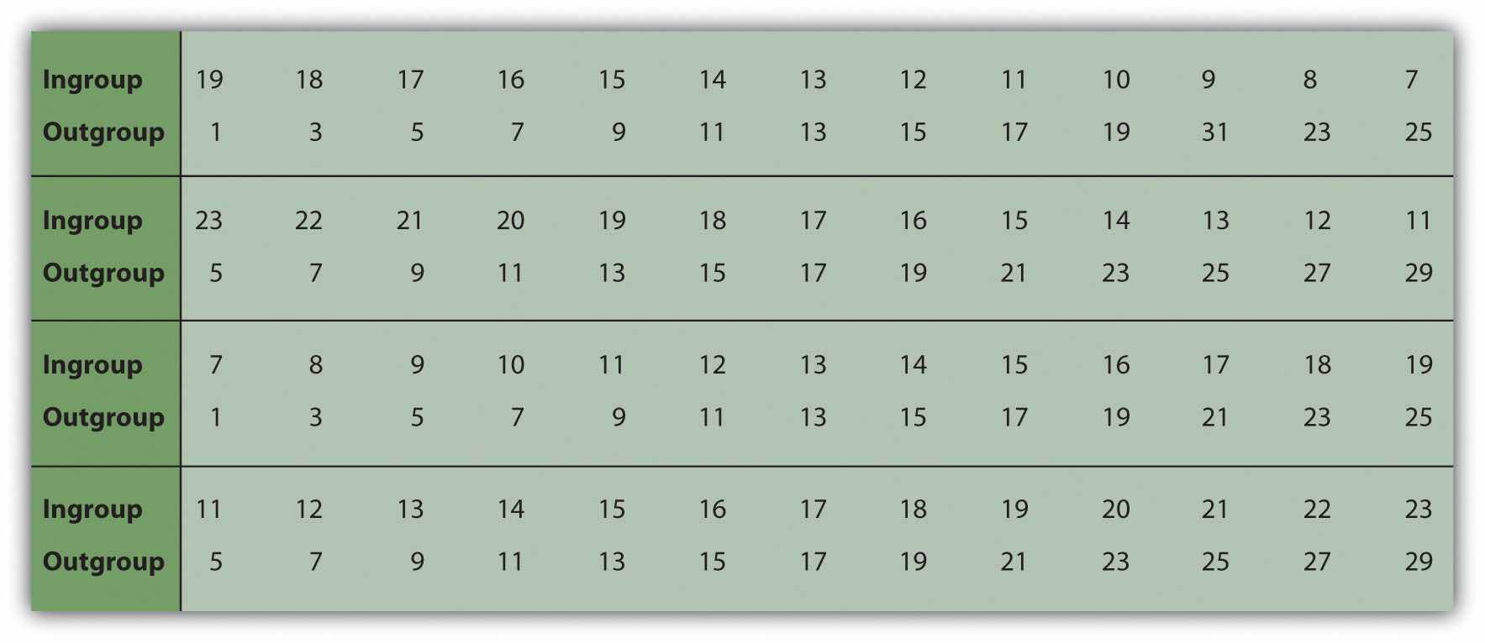
From Tajfel (1970). ^{[5]}
A comparison of the boys’ choices in the different matrices showed that they allocated points between two boys in the ingroup or between two boys in the outgroup in an essentially fair way, so that each boy got the same amount. However, fairness was not the predominant approach when dividing points between ingroup and outgroup. In this case, rather than exhibiting fairness, the boys displayed ingroup favoritism, such that they gave more points to other members of their own group in relationship to boys in the other group. For instance, the boys might assign 8 points to the ingroup boy and only 3 points to the outgroup boy, even though the matrix also contained a choice in which they could give the ingroup and the outgroup boys 13 points each. In short, the boys preferred to maximize the gains of the other boys in their own group in comparison with the boys in the outgroup, even if doing so meant giving their own group members fewer points than they could otherwise have received.
Perhaps the most striking part of Tajfel’s results is that ingroup favoritism was found to occur on the basis of such arbitrary and unimportant groupings. In fact, ingroup favoritism occurs even when the assignment to groups is on such trivial things as whether people “overestimate” or “underestimate” the number of dots shown on a display, or on the basis of a completely random coin toss (Billig & Tajfel, 1973; Locksley, Ortiz, & Hepburn, 1980). ^{[6]} Tajfel’s research, as well other research demonstrating ingroup favoritism, provides a powerful demonstration of a very important social psychological process: Groups exist simply because individuals perceive those groups as existing. Even in a case where there really is no group (at least no meaningful group in any real sense), we still perceive groups and still demonstrate ingroup favoritism.

The Outcomes of Ingroup Favoritism
The tendency to favor their ingroup develops quickly in young children, beginning at the age of 3 years and increasing up to about 6 years of age, and almost immediately begins to influence their behavior (Aboud, 2003; Aboud & Amato, 2001). ^{[7]} Young children show greater liking for peers of their own sex and race and typically play with same-sex others after the age of 3. And there is a norm that we should favor our ingroups: People like people who express ingroup favoritism better than those who are more egalitarian (Castelli & Carraro, 2010). ^{[8]} Ingroup favoritism is found for many different types of social groups, in many different settings, on many different dimensions, and in many different cultures (Bennett et al., 2004; Pinter & Greenwald, 2011). ^{[9]} Ingroup favoritism also occurs on trait ratings, such that ingroup members are rated as having more positive characteristics than are outgroup members (Hewstone, 1990). ^{[10]} People also take credit for the successes of other ingroup members, remember more positive than negative information about ingroups, are more critical of the performance of outgroup than of ingroup members, and believe that their own groups are less prejudiced than are outgroups (Shelton & Richeson, 2005). ^{[11]}
People also talk differently about their ingroups than their outgroups, such that they describe the ingroup and its members as having broad positive traits (“We aregenerous and friendly”) but describe negative ingroup behaviors in terms of the specific behaviors of single group members (“Our group member, Bill, hit someone”) (Maass & Arcuri, 1996; Maass, Ceccarielli, & Rudin, 1996; von Hippel, Sekaquaptewa, & Vargas, 1997). ^{[12]} These actions allow us to spread positive characteristics to all members of our ingroup but reserve negative aspects for individual group members, thereby protecting the group’s image.
People also make trait attributions in ways that benefit their ingroups, just as they make trait attributions that benefit themselves. This general tendency, known as theultimate attribution error, results in the tendency for each of the competing groups to perceive the other group extremely and unrealistically negatively (Hewstone, 1990). ^{[13]} When an ingroup member engages in a positive behavior, we tend to see it as a stable internal characteristic of the group as a whole. Similarly, negative behaviors on the part of the outgroup are seen as caused by stable negative group characteristics. On the other hand, negative behaviors from the ingroup and positive behaviors from the outgroup are more likely to be seen as caused by temporary situational variables or by behaviors of specific individuals and are less likely to be attributed to the group.

Ingroup Favoritism Has Many Causes
Ingroup favoritism has a number of causes. For one, it is a natural part of social categorization—we categorize into ingroups and outgroups because it helps us simplify and structure our environment. It is easy, and perhaps even natural, to believe in the simple idea that “we are better than they are.” People who report that they have strong needs for simplifying their environments also show more ingroup favoritism (Stangor & Leary, 2006). ^{[14]}
Ingroup favoritism also occurs at least in part because we belong to the ingroup and not the outgroup (Cadinu & Rothbart, 1996). ^{[15]} We like people who are similar to ourselves, and we perceive other ingroup members as similar to us. This also leads us to favor other members of our ingroup, particularly when we can clearly differentiate them from members of outgroups. We may also prefer ingroups because they are more familiar to us (Zebrowitz, Bronstad, & Lee, 2007). ^{[16]}
But the most important determinant of ingroup favoritism is simple self-enhancement. We want to feel good about ourselves, and seeing our ingroups positively helps us do so (Brewer, 1979). ^{[17]} Being a member of a group that has positive characteristics provides us with the feelings of social identity—the positive self-esteem that we get from our group memberships. When we can identify ourselves as a member of a meaningful social group (even if it is a relatively trivial one), we can feel better about ourselves.
We are particularly likely to show ingroup favoritism when we are threatened or otherwise worried about our self-concept (Maner et al., 2005; Solomon, Greenberg, & Pyszczynski, 2000). ^{[18]} And people express higher self-esteem after they have been given the opportunity to derogate outgroups, suggesting that ingroup favoritism does make us feel good (Lemyre & Smith, 1985; Rubin & Hewstone, 1998). ^{[19]}Furthermore, when individuals feel that the value of their ingroup is being threatened, they respond as if they are trying to regain their own self-worth—by expressing more positive attitudes toward ingroups and more negative attitudes toward outgroups (Branscombe, Wann, Noel, & Coleman, 1993; Spears, Doosje, & Ellemers, 1997). ^{[20]}Fein and Spencer (1997) ^{[21]} found that participants expressed less prejudice after they had been given the opportunity to affirm and make salient an important and positive part of their own self-concept. In short, when our group seems to be good, we feel good; when our group seems to be bad, we feel bad.
In some cases, we may be able to feel good about our group memberships even when our own individual outcomes are not so positive. Schmitt, Silvia, and Branscombe (2000) ^{[22]} had groups of female college students perform a creativity task and then gave them feedback indicating that although they themselves had performed very poorly, another woman in their group had performed very well. Furthermore, in some experimental conditions, the women were told that the research was comparing the scores of men and women (which was designed to increase categorization by gender). In these conditions, rather than being saddened by the upward comparison with the other woman, participants used the successful performance of the other woman to feel good about themselves, as women.

When Ingroup Favoritism Does Not Occur
Although people have a general tendency to show ingroup favoritism, there are least some cases in which it does not occur. One situation in which ingroup favoritism is unlikely is when the members of the ingroup are clearly inferior to other groups on an important dimension. The players on a baseball team that has not won a single game all season are unlikely to be able to feel very good about themselves as a team and are pretty much forced to concede that the outgroups are better, at least as far as playing baseball is concerned. Members of low-status groups show less ingroup favoritism than do members of high-status groups and may even display outgroup favoritism, in which they admit that the other groups are better than they are (Clark & Clark, 1947).^{[23]}
Another case in which people judge other members of the ingroup very negatively occurs when a member of one’s own group behaves in a way that threatens the positive image of the ingroup. A student who behaves in a way unbecoming to university students, or a teammate who does not seem to value the importance of the team, is disparaged by the other group members, often more than the same behavior from an outgroup member would be. The strong devaluation of ingroup members who threaten the positive image and identity of the ingroup is known as theblack sheep effect.

Personality and Cultural Determinants of Ingroup Favoritism
To this point, we have considered ingroup favoritism as a natural part of everyday life. Because the tendency to favor the ingroup is a normal byproduct of self-concern, most people do, by and large, prefer their ingroups over outgroups. And yet not everyone is equally ingroup-favoring in all situations. There are a number of individual difference measures that predict prejudice, and these differences become particularly likely to show up under circumstances in which the desire to protect the self becomes important (Guimond, Dambrun, Michinov, & Duarte, 2003). ^{[24]}
Some people are more likely than others to show ingroup favoritism because they are particularly likely to rely on their group memberships to create a positive social identity. These differences in group identification can be measured through self-report measures such as the Collective Self-Esteem Scale (Luhtanen & Crocker, 1992). ^{[25]}The scale assesses the extent to which the individual values his or her memberships in groups in public and private ways, as well as the extent to which he or she gains social identity from those groups. People who score higher on the scale show more ingroup favoritism in comparison with those who score lower on it (Stangor & Thompson, 2002). ^{[26]} The scale, from Luhtanen and Crocker (1992), ^{[27]} is shown in Table 12.2 "The Collective Self-Esteem Scale".

Table 12.2 The Collective Self-Esteem Scale
Membership | I am a worthy member of the social groups I belong to.
 | I feel I don’t have much to offer to the social groups I belong to [R].
 | I am a cooperative participant in the social groups I belong to.
 | I often feel I’m an unclean member of my social group [R].
Private | I often regret that I belong to some of the social groups I do [R].
 | In general, I’m glad to be a member of the social groups I belong to.
 | Overall, I often feel that the social groups of which I am a member are not worthwhile [R].
 | I feel good about the social groups I belong to.
Public | Overall, my social groups are considered good by others.
 | Most people consider my social groups, on the average, to be more ineffective than other social groups [R].
 | In general, others respect the social groups that I am a member of.
 | In general, others think that the social groups I am a member of are unworthy [R].
Identity | Overall, my group memberships have very little to do with how I feel about myself [R].
 | The social groups I belong to are an important reflection of who I am.
 | The social groups I belong to are unimportant in my sense of what kind of a person I am [R].
 | In general, belonging to social groups is an important part of my self-image.
[R] = Item is reversed before scoring.
Another personality dimension that relates to the desires to protect and enhance the self and the ingroup and thus also relates to greater ingroup favoritism, and in some cases prejudice toward outgroups, is the personality dimension of authoritarianism (Adorno, Frenkel-Brunswik, Levinson, & Sanford, 1950; Altemeyer, 1988). ^{[28]}Authoritarianism is a personality dimension that characterizes people who prefer things to be simple rather than complex and who tend to hold traditional and conventional values. Authoritarians are ingroup-favoring in part because they have a need to self-enhance and in part because they prefer simplicity and thus find it easy to think simply: “We are all good and they are all less good.” Political conservatives tend to show more ingroup favoritism than do political liberals, perhaps because the former are more concerned with protecting the ingroup from threats posed by others (Jost, Glaser, Kruglanski, & Sulloway, 2003; Stangor & Leary, 2006). ^{[29]}
People with strong goals toward other-concern display less ingroup favoritism and less prejudice. People who view it as particularly important to connect with and respect other people—those who are more focused on tolerance and fairness toward others—are less ingroup-favoring and more positive toward the members of groups other than their own. The desire to be fair and to accept others can be assessed by individual difference measures such as desire to control one’s prejudice (Plant & Devine, 1998)^{[30]} and humanism (Katz & Hass, 1988). ^{[31]}
Social dominance orientation (SDO) is a personality variable that refers to the tendency to see and to accept inequality among different groups (Pratto, Sidanius, Stallworth, & Malle, 1995). ^{[32]} People who score high on measures of SDO believe that there are and should be status differences among social groups, and they do not see these as wrong. High SDO individuals agree with statements such as “Some groups of people are simply inferior to other groups,” “In getting what you want, it is sometimes necessary to use force against other groups,” and “It’s OK if some groups have more of a chance in life than others.” Those who are low on SDO, on the other hand, believe that all groups are relatively equal in status and tend to disagree with these statements. People who score higher on SDO also show greater ingroup favoritism.
Stereotyping and prejudice also varies across cultures. Spencer-Rodgers, Williams, Hamilton, Peng, and Wang (2007) ^{[33]} tested the hypothesis that Chinese participants, because of their collectivist orientation, would find social groups more important than would Americans (who are more individualistic) and that as a result, they would be more likely to infer personality traits on the basis of group membership—that is, to stereotype. Supporting the hypothesis, they found that Chinese participants made stronger stereotypical trait inferences than Americans did on the basis of a target’s membership in a fictitious group.

KEY TAKEAWAYS
- Ingroup favoritism is a fundamental and evolutionarily functional aspect of human perception, and it occurs even in groups that are not particularly meaningful.
- Ingroup favoritism is caused by a variety of variables, but particularly important is self-concern: We experience positive social identity as a result of our membership in valued social groups.
- Ingroup favoritism develops early in children and influences our behavior toward ingroup and outgroup members in a variety of ways.
- Personality dimensions that relate to ingroup favoritism include authoritarianism and social dominance orientation—dimensions that relate to less ingroup favoritism include a desire to control one’s prejudice and humanism.
- There are at least some cultural differences in the tendency to show ingroup favoritism and to stereotype others.

EXERCISES AND CRITICAL THINKING
- Consider some of the important social groups to which you belong. Do your group memberships lead to ingroup favoritism or even prejudice?
- Describe a time when the members of one of your important social groups behaved in a way that increased group identity (e.g., showing the black sheep effect). What was the outcome of the actions?

[1] Amodio, D. M., & Devine, P. G. (2006). Stereotyping and evaluation in implicit race bias: Evidence for independent constructs and unique effects on behavior. Journal of Personality and Social Psychology, 91, 652–661.
[2] Brewer, M. B., & Caporael, L. R. (2006). An evolutionary perspective on social identity: Revisiting groups. In M. Schaller, J. A. Simpson, & D. T. Kenrick (Eds.), Evolution and social psychology (pp. 143–161). New York, NY: Psychology Press; Navarrete, C. D., Kurzban, R., Fessler, D. M. T., & Kirkpatrick, L. A. (2004). Anxiety and intergroup bias: Terror management or coalitional psychology? Group Processes & Intergroup Relations, 7(4), 370–397.
[3] Mahajan, N., Martinez, M. A., Gutierrez, N. L., Diesendruck, G., Banaji, M. R., & Santos, L. R. (2011). The evolution of intergroup bias: Perceptions and attitudes in rhesus macaques.Journal of Personality and Social Psychology, 100(3), 387–405. doi: 10.1037/a0022459; Phelps, E. A., O’Connor, K. J., Cunningham, W. A., Funayama, E. S., Gatenby, J. C., Gore, J. C.…Banaji, M. R. (2000). Performance on indirect measures of race evaluation predicts amygdala activation. Journal of Cognitive Neuroscience, 12(5), 729–738; Van Vugt, M., & Schaller, M. (2008). Evolutionary approaches to group dynamics: An introduction. Group Dynamics: Theory, Research, and Practice, 12(1), 1–6; Zaraté, M. A., Stoever, C. J., MacLin, M. K., & Arms-Chavez, C. J. (2008). Neurocognitive underpinnings of face perception: Further evidence of distinct person and group perception processes. Journal of Personality and Social Psychology, 94(1), 108–115.
[4] Tajfel, H., Billig, M., Bundy, R., & Flament, C. (1971). Social categorization and intergroup behavior. European Journal of Social Psychology, 1, 149–178.
[5] Tajfel, H. (1970). Experiments in intergroup discrimination. Scientific American, 223, 96–102.
[6] Billig, M., & Tajfel, H. (1973). Social categorization and similarity in intergroup behavior.European Journal of Social Psychology, 3, 27–52; Locksley, A., Ortiz, V., & Hepburn, C. (1980). Social categorization and discriminatory behavior: Extinguishing the minimal intergroup discrimination effect. Journal of Personality and Social Psychology, 39(5), 773–783. doi: 10.1037/0022–3514.39.5.773
[7] Aboud, F. E. (2003). The formation of in-group favoritism and out-group prejudice in young children: Are they distinct attitudes? Developmental Psychology, 39(1), 48–60; Aboud, F. E., & Amato, M. (2001). Developmental and socialization influences on intergroup bias. In R. Brown & S. Gaertner (Eds.), Blackwell handbook in social psychology (Vol. 4, pp. 65–85). New York, NY: Blackwell.
[8] Castelli, L., & Carraro, L. (2010). Striving for difference: On the spontaneous preference for ingroup members who maximize ingroup positive distinctiveness. European Journal of Social Psychology, 40(6), 881–890. doi: 10.1002/ejsp.740
[9] Bennett, M., Barrett, M., Karakozov, R., Kipiani, G., Lyons, E., Pavlenko, V.…Riazanova., T. (2004). Young children’s evaluations of the ingroup and of outgroups: A multi-national study.Social Development, 13(1), 124–141. doi: 10.1046/j.1467–9507.2004.00260.x; Pinter, B., & Greenwald, A. G. (2011). A comparison of minimal group induction procedures. Group Processes and Intergroup Relations, 14(1), 81–98. doi: 10.1177/1368430210375251
[10] Hewstone, M. (1990). The “ultimate attribution error”? A review of the literature on intergroup causal attribution. European Journal of Social Psychology, 20(4), 311–335.
[11] Shelton, J. N., & Richeson, J. A. (2005). Intergroup contact and pluralistic ignorance.Journal of Personality and Social Psychology, 88(1), 91–107.
[12] Maass, A., & Arcuri, L. (1996). Language and stereotyping. In C. N. Macrae, C. Stangor, & M. Hewstone (Eds.), Stereotypes and stereotyping (pp. 193–226). New York, NY: Guilford Press; Maass, A., Ceccarielli, R., & Rudin, S. (1996). Linguistic intergroup bias: Evidence for in-group-protective motivation. Journal of Personality and Social Psychology, 71(3), 512–526; von Hippel, W., Sekaquaptewa, D., & Vargas, P. (1997). The linguistic intergroup bias as an implicit indicator of prejudice. Journal of Experimental Social Psychology, 33(5), 490–509.
[13] Hewstone, M. (1990). The “ultimate attribution error”? A review of the literature on intergroup causal attribution. European Journal of Social Psychology, 20(4), 311–335.
[14] Stangor, C., & Leary, S. (2006). Intergroup beliefs: Investigations from the social side.Advances in Experimental Social Psychology, 38, 243–283.
[15] Cadinu, M. R., & Rothbart, M. (1996). Self-anchoring and differentiation processes in the minimal group setting. Journal of Personality and Social Psychology, 70(4), 661–677.
[16] Zebrowitz, L. A., Bronstad, P. M., & Lee, H. K. (2007). The contribution of face familiarity to ingroup favoritism and stereotyping. Social Cognition, 25(2), 306–338. doi: 10.1521/soco.2007.25.2.306
[17] Brewer, M. B. (1979). In-group bias in the minimal intergroup situation: A cognitive-motivational analysis. Psychological Bulletin, 86, 307–324.
[18] Maner, J. K., Kenrick, D. T., Becker, D. V., Robertson, T. E., Hofer, B., Neuberg, S. L., & Schaller, M. (2005). Functional projection: How fundamentally social motives can bias interpersonal perception. Journal of Personality and Social Psychology, 88, 63–75; Solomon, S., Greenberg, J., & Pyszczynski, T. (2000). Pride and prejudice: Fear of death and social behavior. Current Directions in Psychological Science, 9(6), 200–204.
[19] Lemyre, L., & Smith, P. M. (1985). Intergroup discrimination and self-esteem in the minimal group paradigm. Journal of Personality and Social Psychology, 49, 660–670; Rubin, M., & Hewstone, M. (1998). Social identity theory’s self-esteem hypothesis: A review and some suggestions for clarification. Personality and Social Psychology Review, 2, 40–62.
[20] Branscombe, N. R., Wann, D. L., Noel, J. G., & Coleman, J. (1993). In-group or out-group extremity: Importance of the threatened social identity. Personality and Social Psychology Bulletin, 19, 381–388; Spears, R., Doosje, B., & Ellemers, N. (1997). Self-stereotyping in the face of threats to group status and distinctiveness: The role of group identification. Personality and Social Psychology Bulletin, 23, 538–553.
[21] Fein, S., & Spencer, S. J. (1997). Prejudice as self-image maintenance: Affirming the self through derogating others. Journal of Personality and Social Psychology, 73, 31–44.
[22] Schmitt, M. T., Silvia, P. J., & Branscombe, N. R. (2000). The intersection of self-evaluation maintenance and social identity theories: Intragroup judgment in interpersonal and intergroup contexts. Personality and Social Psychology Bulletin, 26(12), 1598–1606.
[23] Clark, K., & Clark, M. (1947). Racial identification and preference in Negro children. In E. Maccoby, T. Newcomb, & E. Hartley (Eds.), Readings in social psychology (pp. 602–611). New York, NY: Holt, Rinehart & Winston.
[24] Guimond, S., Dambrun, M., Michinov, N., & Duarte, S. (2003). Does social dominance generate prejudice? Integrating individual and contextual determinants of intergroup cognitions. Journal of Personality and Social Psychology, 84(4), 697–721. doi: 10.1037/0022–3514.84.4.697
[25] Luhtanen, R., & Crocker, J. (1992). A collective self-esteem scale: Self-evaluation of one’s social identity. Personality and Social Psychology Bulletin, 18, 302–318.
[26] Stangor, C., & Thompson, E. P. (2002). Needs for cognitive economy and self-enhancement as unique predictors of intergroup attitudes. European Journal of Social Psychology, 32(4), 563–575. doi: 10.1002/ejsp.114
[27] Luhtanen, R., & Crocker, J. (1992). A collective self-esteem scale: Self-evaluation of one’s social identity. Personality and Social Psychology Bulletin, 18, 302–318.
[28] Adorno, T. W., Frenkel-Brunswik, E., Levinson, D. J., & Sanford, R. N. (1950). The authoritarian personality. New York, NY: Harper; Altemeyer, B. (1988). Enemies of freedom: Understanding right-wing authoritarianism. San Francisco, CA: Jossey-Bass.
[29] Jost, J. T., Glaser, J., Kruglanski, A. W., & Sulloway, F. J. (2003). Political conservatism as motivated social cognition. Psychological Bulletin, 129(3), 339–375; Stangor, C., & Leary, S. (2006). Intergroup beliefs: Investigations from the social side. Advances in Experimental Social Psychology, 38, 243–283.
[30] Plant, E. A., & Devine, P. G. (1998). Internal and external motivation to respond without prejudice. Journal of Personality and Social Psychology, 75(3), 811–832.
[31] Katz, I., & Hass, R. G. (1988). Racial ambivalence and American value conflict: Correlational and priming studies of dual cognitive structures. Journal of Personality and Social Psychology, 55, 893–905.
[32] Pratto, F., Sidanius, J., Stallworth, L. M., & Malle, B. F. (1995). Social dominance orientation: A personality variable predicting social and political attitudes. Journal of Personality and Social Psychology, 67, 741–763.
[33] Spencer-Rodgers, J., Williams, M. J., Hamilton, D. L., Peng, K., & Wang, L. (2007). Culture and group perception: Dispositional and stereotypic inferences about novel and national groups. Journal of Personality and Social Psychology, 93(4), 525–543.

12.3 Reducing Discrimination

LEARNING OBJECTIVES
- Review the causes of discrimination and the ways that we can reduce it.
- Summarize the conditions under which intergroup contact does or does not reduce prejudice and discrimination.
We have seen that social categorization is a basic part of human nature and one that helps us to simplify our social worlds, to draw quick (if potentially inaccurate) conclusions about others, and to feel good about ourselves. In many cases, our preferences for ingroups may be relatively harmless—we may prefer to socialize with people who share our race or ethnicity, for instance, but without particularly disliking the others. But categorizing others may also lead to prejudice and discrimination, and it may even do so without our awareness. Because prejudice and discrimination are so harmful to so many people, we must all work to get beyond them.
Discrimination influences the daily life of its victims in areas such as employment, income, financial opportunities, housing and educational opportunities, and medical care. Discrimination has been blamed for the large percentage of Blacks living in poverty and for their lack of access to high-paying jobs (Williams & Rucker, 1996). ^{[1]}Blacks have higher mortality rates than Whites for 8 of the 10 leading causes of death in the United States (Williams, 1999) ^{[2]} and have less access to and receive poorer-quality health care, even controlling for other variables such as level of health insurance. Suicide rates among lesbians and gays are substantially higher than rates for the general population, and it has been argued that this in part due to the negative outcomes of prejudice, including negative attitudes and resulting social isolation (Halpert, 2002). ^{[3]} And in some rare cases, discrimination even takes the form of hate crimes such as gay bashing.
More commonly, members of minority groups also face a variety of small hassles, such as bad service in restaurants, being stared at, and being the target of jokes (Swim, Hyers, Cohen, Fitzgerald, & Bylsma, 2003). ^{[4]} But even these everyday “minor” forms of discrimination can be problematic because they may produce anger and anxiety among stigmatized group members and may lead to stress and other psychological problems (Klonoff, Landrine, & Campbell, 2000; Klonoff, Landrine, & Ullman, 1999).^{[5]} Stigmatized individuals who report experiencing more exposure to discrimination or other forms of unfair treatment also report more depression, anger, and anxiety and lower levels of life satisfaction and happiness (Swim, Hyers, Cohen, & Ferguson, 2001). ^{[6]}
Of course most of us do try to keep our stereotypes and our prejudices out of mind, and we work hard to avoid discriminating (Richeson & Shelton, 2007). ^{[7]} But even when we work to keep our negative beliefs under control, this does not mean that they easily disappear. Neil Macrae and his colleagues (Macrae, Bodenhausen, Milne, & Jetten, 1994) ^{[8]} asked British college students to write a paragraph describing a skinhead (a member of a group that is negatively stereotyped in England). One half of the participants were asked to be sure to not use their stereotypes when they were judging him, whereas the other half simply wrote whatever came to mind. Although the participants who were asked to suppress their thoughts were able to do it, this suppression didn’t last very long. After they had suppressed their stereotypes, these beliefs quickly popped back into mind, making it even more likely that they would be used immediately later.
But stereotypes are not always and inevitably activated when we encounter people from other groups. We can and we do get past them, although doing so may take some effort on our part (Blair, 2002). ^{[9]} There are a number of techniques that we can use to try to improve our attitudes toward outgroups, and at least some of them have been found to be effective. Kawakami, Dovidio, Moll, Hermsen, and Russin (2000) ^{[10]} found that students who practiced responding in nonstereotypical ways to members of other groups became better able to avoid activating their negative stereotypes on future occasions. And a number of studies have found that we become less prejudiced when we are exposed to and think about group members who have particularly positive or nonstereotypical characteristics. For instance, Blair, Ma, and Lenton (2001) ^{[11]}asked their participants to imagine a woman who was “strong” and found that doing so decreased stereotyping of women. Similarly, Bodenhausen, Schwarz, Bless, and Wanke (1995) ^{[12]} found that when White students thought about positive Black role models—such as Oprah Winfrey and Michael Jordan—they became less prejudiced toward Blacks.

Reducing Discrimination by Changing Social Norms
One variable that makes us less prejudiced is education. People who are more educated express fewer stereotypes and prejudice in general. This is true for students who enroll in courses that are related to stereotypes and prejudice, such as a course on gender and ethnic diversity (Rudman, Ashmore, & Gary, 2001), ^{[13]} and is also true more generally—education reduces prejudice, regardless of what particular courses you take (Sidanius, Sinclair, & Pratto, 2006). ^{[14]}
The effects of education on reducing prejudice are probably due in large part to the new social norms that people are introduced to in school. Social norms define what is appropriate and inappropriate, and we can effectively change stereotypes and prejudice by changing the relevant norms about them. Jetten, Spears, and Manstead (1997) ^{[15]}manipulated whether students thought that the other members of their university favored equal treatment of others or believed that others thought it was appropriate to favor the ingroup. They found that perceptions of what the other group members believed had an important influence on the beliefs of the individuals themselves. The students were more likely to show ingroup favoritism when they believed that the norm of their ingroup was to do so, and this tendency was increased for students who had high social identification with the ingroup.
Sechrist and Stangor (2001) ^{[16]} selected White college students who were either high or low in prejudice toward Blacks and then provided them with information indicating that their prejudiced or unprejudiced beliefs were either shared or not shared by the other students at their university. Then the students were asked to take a seat in a hallway to wait for the next part of the experiment. A Black confederate was sitting in one seat at the end of the row, and the dependent measure was how far away the students sat from her.
As you can see in Figure 12.8 "The Role of Norms in Intergroup Behavior", high prejudice students who learned that other students were also prejudiced sat farther away from the Black confederate in comparison with high prejudice individuals who were led to believe that their beliefs were not shared. On the other hand, students who were initially low in prejudice and who believed these views were shared sat closer to the Black confederate in comparison with low prejudice individuals who were led to believe that their beliefs were not shared. These results demonstrate that our perceptions of relevant social norms can strengthen or weaken our tendencies to engage in discriminatory behaviors.

Figure 12.8 The Role of Norms in Intergroup Behavior
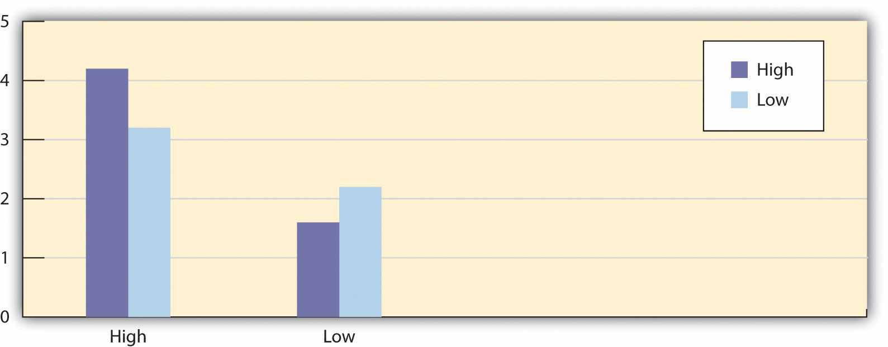
White college students who were low in prejudice toward Blacks sat closer to the Black confederate when they had been told that their beliefs were shared with other group members at their university. On the other hand, White college students who were high in prejudice sat farther away from the Black confederate when they had been told that their beliefs were shared with other group members at their university. Data are from Sechrist and Stangor (2001). ^{[17]}
The influence of social norms is powerful, and long-lasting changes in beliefs about outgroups will occur only if they are supported by changes in social norms. Prejudice and discrimination thrive in environments in which they are perceived to be the norm, but they die when the existing social norms do not allow it. And because social norms are so important, the behavior of individuals can help create or reduce prejudice and discrimination. Discrimination, prejudice, and even hate crimes such as gay bashing will be more likely to continue if people do not respond to or confront them when they occur.
What this means is that if you believe that prejudice is wrong, you must confront it when you see it happening. Czopp, Monteith, and Mark (2006) ^{[18]} had White participants participate in a task in which it was easy to unintentionally stereotype a Black person, and as a result, many of the participants did so. Then, confederates of the experimenter confronted the students about their stereotypes, saying things such as “Maybe it would be good to think about Blacks in other ways that are a little more fair?” or “It just seems that you sound like some kind of racist to me. You know what I mean?” Although the participants who had been confronted experienced negative feelings about the confrontation and also expressed negative opinions about the person who confronted them, the confrontation did work. The students who had been confronted expressed less prejudice and fewer stereotypes on subsequent tasks than did the students who had not been confronted.
As this study concluded, taking steps to reduce prejudice is everyone’s duty—having a little courage can go a long way in this regard. Confronting prejudice can lead other people to think that we are complaining and therefore to dislike us (Kaiser & Miller, 2001; Shelton & Stewart, 2004), ^{[19]} but confronting prejudice is not all negative for the person who confronts. Although it is embarrassing to do so, particularly if we are not completely sure that the behavior was in fact prejudice, when we fail to confront, we may frequently later feel guilty that we did not (Shelton, Richeson, Salvatore, & Hill, 2006). ^{[20]}

Reducing Prejudice Through Intergroup Contact
One of the reasons that people may hold stereotypes and prejudices is that they view the members of outgroups as different from them. We may become concerned that our interactions with people from different racial groups will be unpleasant, and these anxieties may lead us to avoid interacting with people from those groups (Mallett, Wilson, & Gilbert, 2008). ^{[21]} What this suggests is that a good way to reduce prejudice is to help people create closer connections with members of different groups. People will be more favorable toward others when they learn to see those other people as more similar to them, as closer to the self, and to be more concerned about them.
The idea that intergroup contact will reduce prejudice, known as thecontact hypothesis, is simple: If children from different ethnic groups play together in school, their attitudes toward each other should improve. And if we encourage college students to travel abroad, they will meet people from other cultures and become more positive toward them.
One important example of the use of intergroup contact to influence prejudice came about as a result of the important U.S. Supreme Court case Brown v. Board of Education in 1954. In this case, the Supreme Court agreed, based in large part on the testimony of psychologists, that busing Black children to schools attended primarily by White children, and vice versa, would produce positive outcomes on intergroup attitudes, not only because it would provide Black children with access to better schools, but also because the resulting intergroup contact would reduce prejudice between Black and White children. This strategy seemed particularly appropriate at the time it was implemented because most schools in the United States then were highly segregated by race.
The strategy of busing was initiated after the Supreme Court decision, and it had a profound effect on schools in the United States. For one, the policy was very effective in changing school makeup—the number of segregated schools decreased dramatically during the 1960s after the policy was begun. Busing also improved the educational and occupational achievement of Blacks and increased the desire of Blacks to interact with Whites, for instance, by forming cross-race friendships (Stephan, 1999). ^{[22]} Overall, then, the case of desegregating schools in the United States supports the expectation that intergroup contact, at least in the long run, can be successful in changing attitudes. Nevertheless, as a result of several subsequent U.S. Supreme Court decisions, the policy of desegregating schools via busing was not continued past the 1990s.
Although student busing to achieve desegregated schools represents one prominent example of intergroup contact, such contact occurs in many other areas as well. Taken together, there is substantial support for the effectiveness of intergroup contact in improving group attitudes in a wide variety of situations, including schools, work organizations, military forces, and public housing. Pettigrew and Tropp (2006) ^{[23]}conducted a meta-analysis in which they reviewed over 500 studies that had investigated the effects of intergroup contact on group attitudes. They found that attitudes toward groups that were in contact became more positive over time. Furthermore, positive effects of contact were found on both stereotypes and prejudice and for many different types of contacted groups.
The positive effects of intergroup contact may be due in part to increases in other-concern. Galinsky and Moskowitz (2000) ^{[24]} found that leading students to take the perspective of another group member—which increased empathy and closeness to the person—also reduced prejudice. And the behavior of students on college campuses demonstrates the importance of connecting with others and the dangers of not doing so. Sidanius, Van Laar, Levin, and Sinclair (2004) ^{[25]} found that students who joined exclusive campus groups, including fraternities, sororities, and minority ethnic organizations (such as the African Student Union), were more prejudiced to begin with and became even less connected and more intolerant of members of other social groups over the time that they remained in the organizations. It appears that memberships in these groups focused the students on themselves and other people who were very similar to them, leading them to become less tolerant of others who are different.
Although intergroup contact does work, it is not a panacea because the conditions necessary for it to be successful are frequently not met. Contact can be expected to work only in situations that create the appropriate opportunities for change. For one, contact will only be effective if it provides information demonstrating that the existing stereotypes held by the individuals are incorrect. When we learn more about groups that we didn’t know much about before, we learn more of the truth about them, leading us to be less biased in our beliefs. But if our interactions with the group members do not allow us to learn new beliefs, then contact cannot work.
When we first meet someone from another category, we are likely to rely almost exclusively on our stereotypes (Brodt & Ross, 1998). ^{[26]} However, when we get to know the individual well (e.g., as a student in a classroom learns to know the other students over a school year), we may get to the point where we ignore that individual’s group membership almost completely, responding to him or her entirely at the individual level (Madon et al., 1998). ^{[27]} Thus contact is effective in part because it leads us to get past our perceptions of others as group members and to individuate them.
When we get past group memberships and focus more on the individuals in the groups, we begin to see that there is a great deal of variability among the group members and that our global and undifferentiating group stereotypes are actually not that informative (Rothbart & John, 1985). ^{[28]} Successful intergroup contact tends to reduce the perception of outgroup homogeneity. Contact also helps us feel more positively about the members of the other group, and this positive affect makes us like them more.
Intergroup contact is also more successful when the people involved in the contact are motivated to learn about the others. One factor that increases this motivation isinterdependence—a state in which the group members depend on each other for successful performance of the group goals (Neuberg & Fiske, 1987). ^{[29]} The importance of interdependence can be seen in the success of cooperative learning techniques, such as the jigsaw classroom (Aronson, Blaney, Stephan, Sikes, & Snapp, 1978; Aronson, 2004). ^{[30]}
The jigsaw classroom is an approach to learning in which students from different racial or ethnic groups work together, in an interdependent way, to master material. The class is divided into small learning groups, where each group is diverse in ethnic and gender composition. The assigned material to be learned is divided into as many parts as there are students in the group, and members of different groups who are assigned the same task meet together to help develop a strong report. Each student then learns his or her own part of the material and presents this piece of the puzzle to the other members of his or her group. The students in each group are therefore interdependent in learning all the material. A wide variety of techniques, based on principles of the jigsaw classroom, are in use in many schools around the United States and the world, and research studying these approaches has found that cooperative, interdependent experiences among students from different social groups are effective in reducing negative stereotyping and prejudice (Stephan, 1999). ^{[31]}
In sum, we can say that contact will be most effective when it is easier to get to know, and become more respectful of, the members of the other group and when the social norms of the situation promote equal, fair treatment of all groups. If the groups are treated unequally, for instance, by a teacher or leader who is prejudiced and who therefore treats the different groups differently, or if the groups are in competition rather than cooperation, there will be no benefit. In cases when these conditions are not met, contact may not be effective and may in fact increase prejudice, particularly when it confirms stereotypical expectations (Stangor, Jonas, Stroebe, & Hewstone, 1996). ^{[32]} Finally, it is important that enough time be allowed for the changes to take effect. In the case of busing in the United States, for instance, the positive effects of contact seemed to have been occurring, but they were not happening particularly fast.
Let’s consider in the next section still another way that intergroup contact can reduce prejudice—the idea that prejudice can be reduced for people who have friends who are friends with members of the outgroup—the extended-contact hypothesis.

Research Focus
The Extended-Contact Hypothesis
Although the contact hypothesis proposes that direct contact between people from different social groups will produce more positive attitudes between them, recent evidence suggests that prejudice can also be reduced for people who have friends who are friends with members of the outgroup, even if the individual does not have direct contact with the outgroup members himself or herself. This hypothesis is known as the extended-contact hypothesis. Supporting this prediction, Wright, Aron, McLaughlin-Volpe, and Ropp (1997) ^{[33]} found in two correlational studies that college students who reported that their own friends had friends who were from another ethnic group reported more positive attitudes toward that outgroup than did students who did not have any friends who had outgroup friends, even controlling for the participants’ own outgroup friendships.
Wright et al. (1997) also tested the extended-contact hypothesis experimentally. Participants were four groups of 14 students, and each group spent a whole day in the lab. On arrival, 7 participants were assigned to the “green” group, and 7 to the “blue” group, supposedly on the basis of similar interests. To create strong ingroup identity and to produce competition between the groups, the group members wore blue and green t-shirts and engaged in a series of competitive tasks. Participants then expressed their initial thoughts and feelings about the outgroup and its members.
Then, supposedly as part of an entirely different study, one participant was randomly selected from each group, and the two were taken to a separate room in which they engaged in a relationship-building task that has been shown to quickly create feelings of friendship between two strangers. Then the two members from each team were then reunited with their original groups, where they were encouraged to describe their experience with the other group member in the friendship-building task.
In the final phase, the groups then engaged in another competitive task, and participants rated their thoughts and feelings about the outgroup and its members again. As you can see in the following figure, and supporting the extended-contact hypothesis, results showed that the participants (including those who did not participate in the closeness task themselves) were more positive toward the outgroup after than before the two team members had met. This study, as well as many other studies, supports the importance of cross-group friendships in promoting favorable outgroup attitudes (Page-Gould, Mendoza-Denton, & Tropp, 2008; Shook & Fazio, 2008). ^{[34]}

Figure 12.9The Extended-Contact Hypothesis
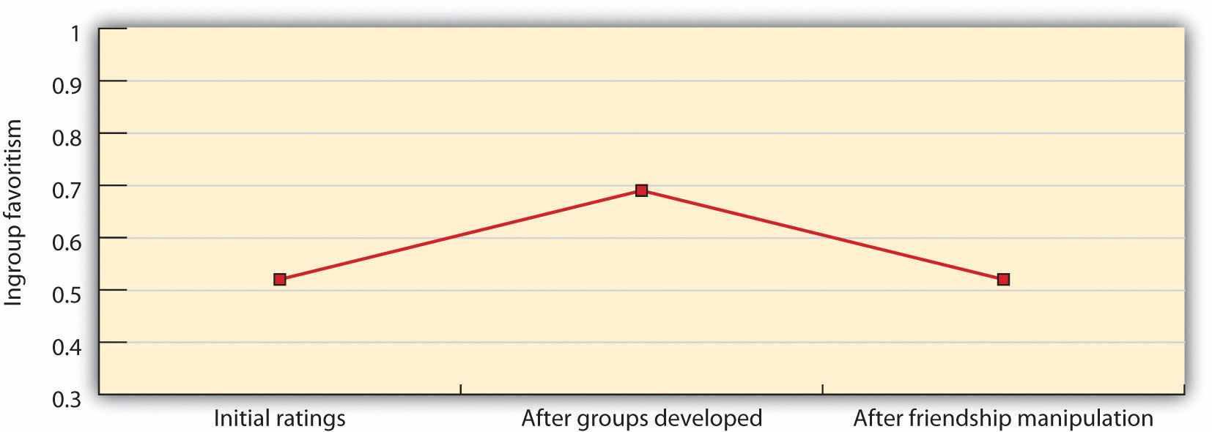
This figure shows how members of the two groups, which were in competition with each other, rated each other before and after the experimental manipulation of friendship. You can see that group relationships, which were becoming more negative, changed to being more positive after the intervention. Data are from Wright, Aron, McLaughlin-Volpe, and Ropp (1997). ^{[35]}

Moving Others Closer to Us: The Benefits of Recategorization
The research on intergroup contact suggests that although contact may improve prejudice, it may make it worse if it is not implemented correctly. Improvement is likely only when the contact moves the members of the groups to feel that they are closer to each other rather than further away from each other. In short, groups are going to have better attitudes toward each other when they see themselves more similarly to each other—when they feel more like one large group than a set of smaller groups.
This fact was demonstrated in a very convincing way in one of the most well known of all social psychological studies. In the “Robbers’ Cave Experiment,” Sherif, Harvey, White, Hood, and Sherif (1961) ^{[36]} studied the group behavior of 11-year-old boys at a summer camp. Although the boys did not know it, the researchers carefully observed the behaviors of the children during the camp session, with the goal of learning about how group conflict developed and how it might be resolved among the children.
During the first week of the camp, the boys were divided into two groups that camped at two different campsites. During this time, friendly relationships developed among the boys within each of the two groups. Each group developed its own social norms and group structure and became quite cohesive, with a strong positive social identity. The two groups chose names for themselves (the Rattlers and the Eagles), and each made their own group flag and participated in separate camp activities.
At the end of this one-week baseline period, it was arranged that the two groups of boys would become aware of each other’s presence. Furthermore, the researchers worked to create conditions that led to increases in each group’s social identity and at the same time created negative perceptions of the other group. The researchers arranged baseball games, a tug-of-war, and a treasure hunt and offered prizes for the group that won the competitions. Almost immediately, this competition created ingroup favoritism and prejudice, and discrimination quickly followed. By the end of the second week, the Eagles had sneaked up to the Rattlers’ cabin and stolen their flag. When the Rattlers discovered the theft, they in turn raided the Eagles’ cabin, stealing things. There were food fights in the dining room, which was now shared by the groups, and the researchers documented a substantial increase in name-calling and stereotypes of the outgroup. Some fistfights even erupted between members of the different groups.
The researchers then intervened by trying to move the groups closer to each other. They began this third stage of the research by setting up a series of situations in which the boys had to work together to solve a problem. These situations were designed to create interdependence by presenting the boys with superordinate goals—goals that were both very important to them and yet that required the cooperative efforts and resources of both the Eagles and the Rattlers to attain. These goals involved such things as the need to pool money across both groups in order to rent a movie that all the campers wanted to view, or the need to pull together on ropes to get a food truck that had become stuck back onto the road. As the children worked together to meet these goals, the negative perceptions of the group members gradually improved; there was a reduction of hostility between the groups and an emergence of more positive intergroup attitudes.
This strategy was effective because it led the campers to perceive both the ingroup and the outgroup as one large group (“we”) rather than as two separate groups (“us” and “them”). As differentiation between the ingroup and the outgroup decreases, so should ingroup favoritism, prejudice, and conflict. The differences between the original groups are still present, but they are potentially counteracted by perceived similarities in the second superordinate group. The attempt to reduce prejudice by creating a superordinate categorization is known as the goal of creating acommon ingroup identity (Gaertner & Dovidio, 2008), ^{[37]} and we can diagram the relationship as follows:
interdependence and cooperation → common ingroup identity → favorable intergroup attitudes.
A substantial amount of research has supported the predictions of the common ingroup identity model. For instance, Samuel Gaertner and his colleagues (Gaertner, Mann, Murrell, & Dovidio, 1989) ^{[38]} tested the hypothesis that interdependent cooperation in groups reduces negative beliefs about outgroup members because it leads people to see the others as part of the ingroup (by creating a common identity). In this research, college students were brought to a laboratory where they were each assigned to one of two teams of three members each, and each team was given a chance to create its own unique group identity by working together. Then, the two teams were brought into a single room to work on a problem. In one condition, the two teams were told to work together as a larger, six-member team to solve the problem, whereas in the other condition, the two teams worked on the problem separately.
Consistent with the expected positive results of creating a common group identity, the interdependence created in the condition where the teams worked together increased the tendency of the team members to see themselves as members of a single, larger team, and this in turn reduced the tendency for each group to show ingroup favoritism.
But the benefits of recategorization are not confined to laboratory settings—they also appear in our everyday interactions with other people. Jason Neir and his colleagues (Neir et al., 2001) ^{[39]} had Black and White interviewers approach White students who were attending a football game. The dependent measure was whether or not they agreed to help the interviewer by completing a questionnaire. However, the interviewers also wore hats representing either one of the two universities who were playing in the game. As you can see in Figure 12.10 "Recategorization and Helping Behavior", the data were analyzed both by whether the interviewer and the student were of the same race (either both White or one White and one Black) and also by whether they wore hats from the same or different universities. As expected on the basis of recategorization and the common ingroup identity approach, the White students were significantly more likely to help the Black interviewers when they wore a hat of the same university as that worn by the interviewee. The hat evidently led the White students to recategorize the interviewer as part of the university ingroup, leading to more helping. However, whether the individuals shared university affiliation did not influence helping for the White participants, presumably because they already saw the interviewer as a member of the ingroup (the interviewer was also White).

Figure 12.10 Recategorization and Helping Behavior
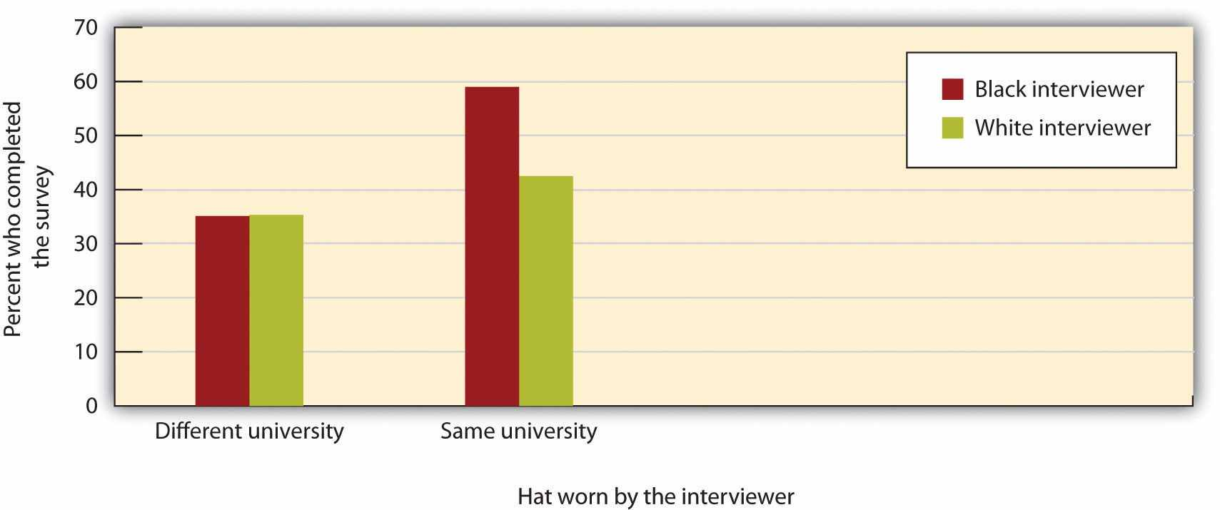
In this field study, White and Black interviewers asked White students attending a football game to help them by completing a questionnaire. The data were analyzed both by whether the request was to a White (ingroup) or Black (outgroup) student and also by whether the individual whose help was sought wore the same hat that they did or a different hat. Results supported the common ingroup identity model. Helping was much greater for outgroup members when hats were the same. Data are from Neir et al. (2001). ^{[40]}
Again, the implications of these results are clear and powerful. If we want to improve attitudes among people, we must get them to see each other as more similar and less different. And even relatively simple ways of doing so, such as wearing a hat that suggests an ingroup identification, can be successful.

KEY TAKEAWAYS
- Changing our stereotypes and prejudices is not easy, and attempting to suppress them may backfire. However, with appropriate effort, we can reduce our tendency to rely on our stereotypes and prejudices.
- One approach to changing stereotypes and prejudice is by changing social norms—for instance, through education and laws enforcing equality.
- Prejudice will change faster when it is confronted by people who see it occurring. Confronting prejudice may be embarrassing, but it also can make us feel that we have done the right thing.
- Intergroup attitudes will be improved when we can lead people to focus more on their connections with others. Intergroup contact, extended contact with others who share friends with outgroup members, and a common ingroup identity are all examples of this process.

EXERCISES AND CRITICAL THINKING
- Does your college or university support efforts to increase intergroup contact? If so, do the efforts seem to be successful in reducing prejudice?
- Have you ever confronted or failed to confront a person who you thought was expressing prejudice or discriminating? Why did you confront (or not confront) that person, and how did doing so make you feel?
- Imagine you are a teacher in a classroom and you see that some children expressing prejudice or discrimination toward other children on the basis of their race. What techniques would you use to attempt to reduce these negative behaviors?

[1] Williams, D. R., & Rucker, T. (Eds.). (1996). Socioeconomic status and the health of racial minority populations. New York, NY: Plenum Press.
[2] Williams, D. R. (1999). Race, socioeconomics status, and health: The added effect of racism and discrimination. In Adler, N. E., Boyce, T., Chesney, M. A., & Cohen, S. (1994). Socioeconomic status and health: The challenge of the gradient. American Psychologist, 49, 15-24.
[3] Halpert, S. C. (2002). Suicidal behavior among gay male youth. Journal of Gay and Lesbian Psychotherapy, 6, 53–79.
[4] Swim, J. K., Hyers, L. L., Cohen, L. L., Fitzgerald, D. C., & Bylsma, W. H. (2003). African American college students’ experiences with everyday racism: Characteristics of and responses to these incidents. Journal of Black Psychology, 29(1), 38–67.
[5] Klonoff, E. A., Landrine, H., & Campbell, R. (2000). Sexist discrimination may account for well-known gender differences in psychiatric symptoms. Psychology of Women Quarterly, 24, 93–99; Klonoff, E. A., Landrine, H., & Ullman, J. B. (1999). Racial discrimination and psychiatric symptoms among blacks. Cultural Diversity and Ethnic Minority Psychology, 5(4), 329–339.
[6] Swim, J. K., Hyers, L. L., Cohen, L. L., & Ferguson, M. J. (2001). Everyday sexism: Evidence for its incidence, nature, and psychological impact from three daily diary studies. Journal of Social Issues, 57(1), 31–53.
[7] Richeson, J. A., & Shelton, J. N. (2007). Negotiating interracial interactions: Costs, consequences, and possibilities. Current Directions in Psychological Science, 16(6), 316–320. doi: 10.1111/j.1467–8721.2007.00528.x
[8] Macrae, C. N., Bodenhausen, G. V., Milne, A. B., & Jetten, J. (1994). Out of mind but back in sight: Stereotypes on the rebound. Journal of Personality and Social Psychology, 67(5), 808–817.
[9] Blair, I. V. (2002). The malleability of automatic stereotypes and prejudice. Personality and Social Psychology Review, 6(3), 242–261.
[10] Kawakami, K., Dovidio, J. F., Moll, J., Hermsen, S., & Russin, A. (2000). Just say no (to stereotyping): Effects of training in the negation of stereotypic associations on stereotype activation. Journal of Personality and Social Psychology,78 (5), 871–888.
[11] Blair, I. V., Ma, J. E., & Lenton, A. P. (2001). Imagining stereotypes away: The moderation of implicit stereotypes through mental imagery. Journal of Personality and Social Psychology, 81(5), 828–841.
[12] Bodenhausen, G. V., Schwarz, N., Bless, H., & Wanke, M. (1995). Effects of atypical exemplars on racial beliefs: Enlightened racism or generalized appraisals? Journal of Experimental Social Psychology, 31, 48–63.
[13] Rudman, L. A., Ashmore, R. D., & Gary, M. L. (2001). “Unlearning” automatic biases: The malleability of implicit prejudice and stereotypes. Journal of Personality and Social Psychology, 81(5), 856–868.
[14] Sidanius, J., Sinclair, S., & Pratto, F. (2006). Social dominance orientation, gender, and increasing educational exposure. Journal of Applied Social Psychology, 36(7), 1640–1653.
[15] Jetten, J., Spears, R., & Manstead, A. S. R. (1997). Strength of identification and intergroup differentiation: The influence of group norms. European Journal of Social Psychology, 27(5), 603–609.
[16] Sechrist, G., & Stangor, C. (2001). Perceived consensus influences intergroup behavior and stereotype accessibility. Journal of Personality and Social Psychology, 80(4), 645–654.
[17] Sechrist, G., & Stangor, C. (2001). Perceived consensus influences intergroup behavior and stereotype accessibility. Journal of Personality and Social Psychology, 80(4), 645–654.
[18] Czopp, A. M., Monteith, M. J., & Mark, A. Y. (2006). Standing up for a change: Reducing bias through interpersonal confrontation. Journal of Personality and Social Psychology, 90(5), 784–803.
[19] Kaiser, C. R., & Miller, C. T. (2001). Stop complaining! The social costs of making attributions to discrimination. Personality and Social Psychology Bulletin, 27, 254–263; Shelton, N. J., & Stewart, R. E. (2004). Confronting perpetrators of prejudice: The inhibitory effects of social costs. Psychology of Women Quarterly, 28, 215–222.
[20] Shelton, J. N., Richeson, J. A., Salvatore, J., & Hill, D. M. (Eds.). (2006). Silence is not golden: The intrapersonal consequences of not confronting prejudice. Mahwah, NJ: Lawrence Erlbaum.
[21] Mallett, R. K., Wilson, T. D., & Gilbert, D. T. (2008). Expect the unexpected: Failure to anticipate similarities leads to an intergroup forecasting error. Journal of Personality and Social Psychology, 94(2), 265–277. doi: 10.1037/0022–3514.94.2.94.2.265
[22] Stephan, W. (1999). Reducing prejudice and stereotyping in schools. New York, NY: Teacher’s College Press.
[23] Pettigrew, T. F., & Tropp, L. R. (2006). A meta-analytic test of intergroup contact theory.Journal of Personality and Social Psychology, 90(5), 751–783.
[24] Galinsky, A. D., & Moskowitz, G. B. (2000). Perspective-taking: Decreasing stereotype expression, stereotype accessibility, and in-group favoritism. Journal of Personality and Social Psychology, 78(4), 708–724.
[25] Sidanius, J., Van Laar, C., Levin, S., & Sinclair, S. (2004). Ethnic enclaves and the dynamics of social identity on the college campus: The good, the bad, and the ugly. Journal of Personality and Social Psychology, 87(1), 96–110.
[26] Brodt, S. E., & Ross, L. D. (1998). The role of stereotyping in overconfident social prediction. Social Cognition, 16, 225–252.
[27] Madon, S., Jussim, L., Keiper, S., Eccles, J., Smith, A., & Palumbo, P. (1998). The accuracy and power of sex, social class, and ethnic stereotypes: A naturalistic study in person perception. Personality and Social Psychology Bulletin, 24(12), 1304–1318.
[28] Rothbart, M., & John, O. P. (1985). Social categorization and behavioral episodes: A cognitive analysis of the effects of intergroup contact. Journal of Social Issues, 41, 81–104.
[29] Neuberg, S. L., & Fiske, S. T. (1987). Motivational influences on impression formation: Outcome dependency, accuracy-driven attention, and individuating processes. Journal of Personality and Social Psychology, 53, 431–444.
[30] Aronson, E., Blaney, N., Stephan, C., Sikes, J., & Snapp, M. (1978). The jig-saw classroom. London, England: Sage; Aronson, E. (2004). Reducing hostility and building compassion: Lessons from the jigsaw classroom. In A. G. Miller (Ed.), The social psychology of good and evil (pp. 469–488). New York, NY: Guilford Press.
[31] Stephan, W. (1999). Reducing prejudice and stereotyping in schools. New York, NY: Teacher’s College Press.
[32] Stangor, C., Jonas, K., Stroebe, W., & Hewstone, M. (1996). Development and change of national stereotypes and attitudes. European Journal of Social Psychology, 26, 663–675.
[33] Wright, S. C., Aron, A., McLaughlin-Volpe, T., & Ropp, S. A. (1997). The extended contact effect: Knowledge of cross-group friendships and prejudice. Journal of Personality and Social Psychology, 73(1), 73–90.
[34] Page-Gould, E., Mendoza-Denton, R., & Tropp, L. R. (2008). With a little help from my cross-group friend: Reducing anxiety in intergroup contexts through cross-group friendship.Journal of Personality and Social Psychology, 95(5), 1080–1094. doi: 10.1037/0022–3514.95.5.1080; Shook, N. J., & Fazio, R. H. (2008). Interracial roommate relationships: An experimental field test of the contact hypothesis. Psychological Science, 19(7), 717–723. doi: 10.1111/j.1467–9280.2008.02147.x
[35] Wright, S. C., Aron, A., McLaughlin-Volpe, T., & Ropp, S. A. (1997). The extended contact effect: Knowledge of cross-group friendships and prejudice. Journal of Personality and Social Psychology, 73(1), 73–90.
[36] Sherif, M., Harvey, O. J., White, B. J., Hood, W. R., & Sherif, C. (1961). Intergroup conflict and cooperation: The robbers’ cave experiment. Norman, OK: University of Oklahoma Press.
[37] Gaertner, S. L., & Dovidio, J. F. (Eds.). (2008). Addressing contemporary racism: The common ingroup identity model. New York, NY: Springer Science + Business Media.
[38] Gaertner, S. L., Mann, J., Murrell, A., & Dovidio, J. F. (1989). Reducing intergroup bias: The benefits of recategorization. Journal of Personality and Social Psychology, 57(2), 239–249.
[39] Neir, J. A., Gaertner, S. L., Dovidio, J. F., Banker, B. S., Ward, C. M., & Rust, C. R. (2001). Changing interracial evaluations and behavior: The effects of a common group identity. Group Processes and Intergroup Relations, 4, 299–316.
[40] Neir, J. A., Gaertner, S. L., Dovidio, J. F., Banker, B. S., Ward, C. M., & Rust, C. R. (2001). Changing interracial evaluations and behavior: The effects of a common group identity. Group Processes and Intergroup Relations, 4, 299–316.

12.4 Thinking Like a Social Psychologist About Stereotyping, Prejudice, and Discrimination
This chapter has focused on the ways in which people from different social groups feel about, think about, and behave toward each other. In most cases, we have positive thoughts and feelings about others, and our interactions with them are friendly and positive. And yet in other cases, there is a potential for negative interactions, and in rare cases, even hostility and violence.
Look again at the pictures in Figure 12.2 and carefully consider your thoughts and feelings about each person. Does the image bring some stereotypes to mind? What about prejudices? How do you think your impressions of the individuals might influence your behavior toward them? Do you hold these beliefs yourself, or do you know people who do? Can you see how quickly you or other people might make judgments about these individuals, based on the culturally relevant stereotypes, and how those judgments might lead to discrimination? What might be the negative outcomes of the stereotypes on the person?
I hope that you can now see, perhaps more clearly than you did before, that social categorization is all around us. We think about other people in terms of their group memberships, and this is entirely natural. But perhaps you are now able to see the processes more fully. I hope you can see that categorization has some benefits—it allows us to think about ourselves as members of valued groups, for instance, but it also has some potential negative outcomes, including overgeneralized stereotyping and ingroup favoritism. I hope that you are now more aware how easily we categorize others, how quickly we learn stereotypes, and how fast ingroup favoritism develops and that you can better see the impact these processes have on our judgments of others.
You will now be able to see that prejudice, discrimination, and stereotypes reflect, respectively, the ABCs of affect, behavior, and cognition. And because you are thinking like a social psychologist, you will realize that prejudice is not unusual—that it results in large part from self-concern. We like our own groups because we feel good about them and see them as similar. But we can improve our attitudes toward outgroups by focusing on other concern—by being more inclusive and including more different people into our ingroups. Perhaps the best thing we can do is to recategorize such that we see all people as human beings; we are all in the same ingroup, and we should treat everyone the way we would like them to treat us—with respect.
I hope your new knowledge can help you in your own relationships with others. Is it possible that you have ingroup favoritism that you were not aware of? Or perhaps you hold stereotypes about other groups that you would like to avoid holding? You can now see, I think, how better to avoid being prejudiced yourself. And you are now perhaps more aware of the importance of social norms—we must work to prevent those norms from allowing prejudice. To stop prejudice, you must be willing to interact with people from other groups, and you must confront prejudice when you see it occurring. These behaviors may be difficult, but in the end they will help you be a better citizen.

12.5 Chapter Summary
The social groups that are part of a given nation or society become essential parts of the culture itself. We easily develop beliefs about the characteristics of the groups and the members of those groups (stereotypes) as well as prejudice (an unjustifiable negative attitude toward an outgroup). Our stereotypes and our prejudices are problematic because they may create discrimination—unjustified negative behaviors toward members of outgroups based on their group membership. Discrimination is a societal and health problem because it is so pervasive, takes so many forms, and has such negative effects on so many people.
Stereotyping and prejudice begin from social categorization—the natural cognitive process by which we place individuals into social groups. Social categorization is in many cases quite helpful and useful. In some cases, we might categorize others because doing so provides us with information about the characteristics of people who belong to certain social groups or categories. And we may categorize others because we may not have time to do anything more thorough.
A problem is that social categorization distorts our perceptions of others such that we tend to exaggerate the differences between social groups while at the same time perceiving members of groups (and particularly outgroups) as more similar to each other than they actually are. One particularly strong outcome of social categorization is outgroup homogeneity—the tendency to view members of outgroups as more similar to each other than we see members of ingroups.
Once we begin to categorize other people, and we start to see the members of those groups as more similar to each other than they actually are, it then becomes very easy to apply our stereotypes to the members of the groups, without having to consider whether the characteristic is actually true of the particular individual. If men think that women are all alike, then they may act toward all women in the same way, and doing so is unfair.
Our stereotypes and prejudices are learned through both cognitive and affective processes. Once they become established, stereotypes (like any other cognitive representation) tend to persevere—they are difficult to change. In the end, stereotypes become self-fulfilling prophecies, such that our expectations about the group members make the stereotypes come true. And our stereotypes also influence our performance on important tasks through stereotype threat.
Ingroup favoritism occurs on the basis of even arbitrary and unimportant groupings and is found for many different types of social groups, in many different settings, on many different dimensions, and in many different cultures.
The most important determinant of ingroup favoritism is simple self-enhancement. We want to feel good about ourselves, and being a member of a group that has positive characteristics provides social identity—the positive self-esteem that we get from our group memberships. In cases when our groups do not provide positive social identity, we must try to restore a positive self-worth. If we cannot leave the group, we may try to perceive the group as positively as possible, perhaps by focusing on dimensions on which the group does not compare so unfavorably.
Although it is assumed that most people gain at least some positive social identity through their group memberships, people differ in the extent to which they use their group memberships to create social identity. Personality dimensions related to prejudice include authoritarianism and social dominance orientation. And there is also at least some evidence that stereotyping varies across cultures.
Because social categorization is a basic human process that provides some benefits for us, stereotypes and prejudices are easy to develop but difficult to change. But stereotypes and prejudice are not inevitable.
The positive effects of education on reducing prejudice are probably due in large part to the new social norms that people experience in school, which people who do not go to school do not learn. True changes in beliefs will only occur if they are supported by changes in social norms. And because social norms are so important, the behavior of individuals can help create or reduce it. Prejudice will be more likely to continue if people allow it to by not responding to it or confronting it when it occurs.
Intergroup attitudes will be improved when we can lead people to focus relatively more on their concerns for others and relatively less on their desires to feel good about themselves. Intergroup contact is effective in this regard, although only under conditions that allow us to individuate others. And individuation is more successful when the people involved in the contact are interdependent, such as in cooperative educational contexts like the jigsaw classroom. Prejudice can also be reduced for people who have friends who are friends with members of the outgroup—the extended-contact hypothesis.
In the “Robbers’ Cave Experiment,” as well as in many other studies, it has been found that superordinate goals that help us see others as part of the same category as we are provide a common ingroup identity and are successful at improving intergroup attitudes.
You can now see how important social categorization is but also that it has many potential negative outcomes. You are now more aware how easily we categorize others, how quickly we learn stereotypes, and how fast ingroup favoritism develops, and you can better see the impact that these processes have on our judgments of others. You can use that new knowledge to help you avoid being prejudiced yourself and to help others from being prejudiced too. Doing so will be difficult, but in the end it will be useful.
But just because we have stereotypes or hold prejudices does not mean that we cannot change them or that we must act on them. If sports referees learn about their prejudices, they can work harder to overcome them, and they may well be successful. And when you learn about your own stereotypes and your own prejudices, and the effects of those beliefs on yourself and others, you may be able to change your own behavior and respond more appropriately to the stereotypes and prejudices expressed by others.

Chapter 13

Competition and Cooperation in Our Social Worlds

Chesapeake Bay Watermen Question Limits on Crab Harvests
In 2001, the crabbing industry in the Chesapeake Bay was on the verge of collapse. As a result, officials from the states of Maryland and Virginia imposed new regulations on overfishing. The restrictions limited fishing to just 8 hours per day and ended the crab season a month earlier than in the past. The aim of the new regulations was to reduce the crab harvest by 15%, which, in turn, was an attempt to maintain the $150-million-per-year industry.
But many crabbers did not agree that their fishing was responsible for this collapse. They felt that poor water quality had killed off underwater sea grasses that made the natural hiding places for small crabs, leaving them vulnerable to predatory fish. Fisherman Eddie Evans believes that the solution for reviving the crab population was to give out more fishing licenses.
“We've got millions and millions of fish in the bay,” Evans said. “If we could catch more fish it could help the crab population.”
Because the number of bay crabs was declining at a fast pace, though, government officials and conservation groups said there was a need for preventive measures. The U.S. Environmental Protection Agency confirmed the overexploitation of crab stocks and felt there was definite justification for the changes. Bill Goldsborough, a fishery scientist at the Chesapeake Bay Foundation, supports the curb on crab harvests.
“I would say most sincerely that what is being attempted here is a comprehensive effort, a bay-wide effort, that for over two years has utilized the best scientific information in an attempt to improve the fishery,” he said.
But many watermen felt their own needs were being overlooked. The new regulations, they said, would undoubtedly hurt the livelihood of many crabbers.
“The crabbers are going to be hurt and a lot of them will fall by the wayside,” said Larry Simns, president of the Maryland Watermen's Association.
On Smith Island, a small fishing community that is fully dependent on blue crab harvests, waterman Roland Bradshaw says that local incomes could fall by 25 percent as a result of the new regulations.
“This is our livelihood, this is my living. You probably might lose your boat or your home—either one,” Bradshaw said. “They're persecuting us. For the watermen, this is it.”
Source: Stoppkotte, K. (2001, May 10).Chesapeake Bay watermen question limits on crab harvests. National Geographic Today. Retrieved fromhttp://news.nationalgeographic.com/news/2001/05/0510_crabbing.html.
One of the most important themes of this book has been the extent to which the two human motives of self-concern and other-concern guide our everyday behavior. We have seen that although these two underlying goals are in many ways in direct opposition to each other, they nevertheless work together to create successful human outcomes. Particularly important is the fact that we cannot protect and enhance ourselves and those we care about without the help of the people around us. We cannot live alone—we must cooperate, work with, trust, and even provide help to other people in order to survive. The self-concern motive frequently leads us to desire to not do these things because they sometimes come at a cost to the self. And yet in the end, we must create an appropriate balance between self and other.
In this chapter, we revisit this basic topic one more time by considering the roles of self-concern and other-concern in social relationships between people and the social groups they belong to, and among social groups themselves. We will see, perhaps to a greater extent than ever before, how important our relationships with others are and how careful we must be to develop and use these connections. Most important, we will see again that helping others also helps us help ourselves.
Furthermore, in this chapter, we will investigate the broadest level of analysis that we have so far considered—focusing on the cultural and societal level of analysis. In so doing, we will consider how the goals of self-concern and other-concern apply even to large groups of individuals, such as nations, societies, and cultures, and influence how these large groups interact with each other.
Most generally, we can say that when individuals or groups interact they may take either cooperative or competitive positions (De Dreu, 2010; Komorita & Parks, 1994).^{[1]} When we cooperate, the parties involved act in ways that they perceive will benefit both themselves and others. Cooperation is behavior that occurs when we trust the people or groups with whom we are interacting and are willing to communicate and share with the others, expecting to profit ourselves through the increased benefits that can be provided through joint behavior. On the other hand, when we engage incompetition we attempt to gain as many of the limited rewards as possible for ourselves, and at the same time we may work to reduce the likelihood of success for the other parties. Although competition is not always harmful, in some cases one or more of the parties may feel that their self-interest has not been adequately met and may attribute the cause of this outcome to another party (Miller, 2001). ^{[2]} In these cases of perceived inequity or unfairness, competition may lead to conflict, in which the parties involved engage in violence and hostility (De Dreu, 2010). ^{[3]}
Although competition is normal and will always be a part of human existence, cooperation and sharing are too. Although they may generally look out for their own interests, individuals do realize that there are both costs and benefits to always making selfish choices (Kelley & Thibaut, 1978). ^{[4]} Although we might prefer to use as much gasoline as we want, or to buy a couple of new mp3s rather than contribute to the local food bank, at the same time we realize that doing so may have negative consequences for the group as a whole. People have simultaneous goals of cooperating and competing, and the individual must coordinate these goals in making a choice (De Dreu, 2010; Schelling, 1960/1980). ^{[5]}
We will also see that human beings, as members of cultures and societies, internalize social norms that promote other-concern, in the form of morality and social fairness norms, and that these norms guide the conduct that allows groups to effectively function and survive (Haidt & Kesebir, 2010). ^{[6]} As human beings, we want to do the right thing, and this includes accepting, cooperating, and working with others. And we will do so when we can. However, as in so many other cases, we will also see that the social situation frequently creates a powerful force that makes it difficult to cooperate and easy to compete.
A social dilemma is a situation in which the goals of the individual conflict with the goals of the group (Penner, Dovidio, Piliavin, & Schroeder, 2005; Suleiman, Budescu, Fischer, & Messick, 2004; Van Lange, De Cremer, Van Dijk, & Van Vugt, 2007). ^{[7]}Social dilemmas impact a variety of important social problems because the dilemma creates a type of trap: Even though an individual or group may want to be cooperative, the situation leads to competitive behavior. For instance, the watermen we considered in the chapter opener find themselves in a social dilemma—they want to continue to harvest as many crabs as they can, and yet if they all do so, the supply will continue to fall, making the situation worse for everyone.
Although social dilemmas create the potential for conflict and even hostility, those outcomes are not inevitable. People usually think that situations of potential conflict are fixed-sum outcomes, meaning that a gain for one side necessarily means a loss for the other side or sides (Halevy, Chou, & Murnighan, 2011). ^{[8]} But this is not always true. In some cases, the outcomes are instead integrative outcomes, meaning that a solution can be found that benefits all the parties. In the last section of this chapter, we will consider the ways that we can work to increase cooperation and to reduce competition, discussing some of the contributions that social psychologists have made to help solve some important social dilemmas (Oskamp, 2000a, 2000b). ^{[9]}

[1] De Dreu, C. K. W. (2010). Social conflict: The emergence and consequences of struggle and negotiation. In S. T. Fiske, D. T. Gilbert, & G. Lindzey (Eds.), Handbook of social psychology(5th ed., Vol. 2, pp. 983–1023). Hoboken, NJ: John Wiley & Sons; Komorita, S. S., & Parks, C. D. (1994). Social dilemmas. Dubuque, IA: Brown & Benchmark.
[2] Miller, D. T. (2001). Disrespect and the experience of injustice. Annual Review of Psychology, 52, 527–553.
[3] De Dreu, C. K. W. (2010). Social conflict: The emergence and consequences of struggle and negotiation. In S. T. Fiske, D. T. Gilbert, & G. Lindzey (Eds.), Handbook of social psychology(5th ed., Vol. 2, pp. 983–1023). Hoboken, NJ: John Wiley & Sons.
[4] Kelley, H. H., & Thibaut, J. W. (1978). Interpersonal relations: A theory of interdependence. New York, NY: John Wiley & Sons.
[5] De Dreu, C. K. W. (2010). Social conflict: The emergence and consequences of struggle and negotiation. In S. T. Fiske, D. T. Gilbert, & G. Lindzey (Eds.), Handbook of social psychology(5th ed., Vol. 2, pp. 983–1023). Hoboken, NJ: John Wiley & Sons; Schelling, T. (1960/1980).The strategy of conflict. Cambridge, MA: Harvard University Press.
[6] Haidt, J., & Kesebir, S. (2010). Morality. In S. T. Fiske, D. T. Gilbert, & G. Lindzey (Eds.),Handbook of social psychology (5th ed., Vol. 2, pp. 797–832). Hoboken, NJ: John Wiley & Sons.
[7] Penner, L. A., Dovidio, J. F., Piliavin, J. A., & Schroeder, D. A. (2005). Prosocial behavior: Multilevel perspectives. Annual Review of Psychology, 56, 365–392; Suleiman, R., Budescu, D. V., Fischer, I., & Messick, D. M. (Eds.). (2004). Contemporary psychological research on social dilemmas. New York, NY: Cambridge University Press; Van Lange, P. A. M., De Cremer, D., Van Dijk, E., & Van Vugt, M. (Eds.). (2007). Self-interest and beyond: Basic principles of social interaction. New York, NY: Guilford Press.
[8] Halevy, N., Chou, E. Y., & Murnighan, J. K. (2011). Mind games: The mental representation of conflict. Journal of Personality and Social Psychology. Retrieved fromhttp://search.ebscohost.com/login.aspx?direct=true&db=psyh&AN=2011-20586-001&site=ehost-live
[9] Oskamp, S. (2000a). Psychological contributions to achieving an ecologically sustainable future for humanity. Journal of Social Issues, 56(3), 373–390; Oskamp, S. (2000b). A sustainable future for humanity? How can psychology help? American Psychologist, 55(5), 496–508.

13.1 Conflict, Cooperation, Morality, and Fairness

LEARNING OBJECTIVES
- Review the situational variables that increase or decrease competition and conflict.
- Differentiate harm-based morality from social conventional morality, and explain how morality works to help people cooperate.
- Define distributive justice and procedural justice, and explain the influence of fairness norms on cooperation and competition.
Whether we cooperate or compete is determined, as are most human behaviors, in part by the characteristics of the individuals who are involved in the relationship and in part by the social situation that surrounds them. Let’s begin by considering first the situational determinants of competition and conflict.

Competition and Conflict
Conflict between individuals, between groups, and even between individuals and the social groups they belong to is a common part of our social worlds. We compete with other students to get better grades, and nations fight wars to gain territory and advantage. Businesses engage in competitive practices, sometimes in a very assertive manner, to gain market share. The behaviors of the parties that are in conflict are not necessarily designed to harm the others but rather are the result of the goals of self-enhancement and self-preservation. We compete to gain rewards for ourselves and for those with whom we are connected, and doing so sometimes involves trying to prevent the other parties from being able to gain the limited rewards for themselves.

Although competition does not necessarily create overt hostility, competition does sow the seeds for potential problems, and thus hostility may not be far off. One problem is that negative feelings tend to escalate when parties are in competition. In these cases, and particularly when the competition is intense, negative behavior on the part of one person or group may be responded to with even more hostile responses on the part of the competing person or group.
In his summer camp studies, Muzafer Sherif and his colleagues (Sherif, Harvey, White, Hood, & Sherif (1961)^{[1]} created intergroup competition between the boys in the Rattlers club and the boys in the Eagles club. When the Eagles began by stealing the flag from the Rattlers’ cabin, the Rattlers did not respond merely by stealing a flag in return but rather, replied with even more hostile and negative behaviors. It was as if “getting even” was not enough—an even greater retaliation was called for. Similar escalation happened during the Cold War, when the United States and the Soviet Union continued to increase their nuclear arsenals, and engaging in more and more aggressive and provocative behaviors, each trying to outdo the other. The magnitude of negative behaviors between the parties has a tendency to increase over time. As the conflict continues, each group perceives the other group more negatively, and these perceptions make it more difficult for the escalating conflict to be reversed.
This escalation in negative perceptions between groups that are in conflict occurs in part because conflict leads the groups to develop increasingly strong social identities. These increases in identity are accompanied by the development of even more hostile group norms, which are supported by the group members and their leaders and which sanction or encourage even more negative behaviors toward the outgroup. Conflict also leads to negative stereotypes of the outgroup, increases perceptions of the other groups as homogenous, and potentially even produces deindividuation and dehumanization of the outgroup (Staub, 2011). ^{[2]} The conflict also reduces the amount of interaction among members of the competing groups, which makes it more difficult to change the negative perceptions. The unfortunate outcome of such events is that initially small conflicts may become increasingly hostile until they get out of control. World wars have begun with relatively small encroachments, and duels to the death have been fought over small insults.
Conflict is sometimes realistic, in the sense that the goals of the interacting parties really are incompatible and fixed-sum. At a football game, for instance, only one team can win. And in a business world, there is a limited market share for a product. If one business does better by gaining more customers, then the other competing businesses may well do worse because there are fewer customers left for them.Realistic group conflict occurs when groups are in competition for objectively scarce resources, such as when two sports teams are vying for a league championship or when the members of different ethnic groups are attempting to find employment in the same factory in a city (Brewer & Campbell, 1976; Jackson, 1993). ^{[3]} Conflict results in these conditions because it is easy (and accurate) to blame the difficulties of one’s own group on the competition produced by the other group or groups.
Although many situations do create real conflict, some conflicts are more perceived than realistic because (although they may have a core of realistic conflict) they are based on misperceptions of the intentions of others or the nature of the potential rewards. In some cases, although the situation is perceived as conflicting, the benefits gained for one party do not necessarily mean a loss for the other party (the outcomes are actually integrative). For instance, when different supply businesses are working together on a project, each may prefer to supply more, rather than less, of the needed materials. However, the project may be so large that none of the businesses can alone meet the demands. In a case such as this, a compromise is perhaps possible such that the businesses may be able to work together, with each company supplying the products on which it makes a larger profit, therefore satisfying the needs of all the businesses. In this case, the parties may be better off working together than working on their own.

Although intergroup relationships that involve hostility or violence are obviously to be avoided, it must be remembered that competition or conflict is not always negative or problematic (Coser, 1956; Rispens & Jehn, 2011). ^{[4]} The Darwinian idea of “survival of the fittest” proposes that evolutionary progress occurs precisely because of the continued conflict among individuals within species and between different species as competing social groups. Over time, this competition, rather than being entirely harmful, increases diversity and the ability to adapt to changing environments.
Competition between social groups may also provide social comparison information, which can lead both groups to set higher standards and motivate them to greater achievement. And conflict produces increased social identity within each of the competing groups. For instance, in the summer camp study, Sherif noted that the boys in the Rattlers and the Eagles developed greater liking for the other members of their own group as well as a greater group identity as the competition between the two groups increased. In situations in which one nation is facing the threat of war with another nation, the resulting identity can be useful in combating the threat, for instance, by mobilizing the citizens to work together effectively and to make sacrifices for the country.

Cooperation: Social Norms That Lead Us to Be Good to Others
Although competition is always a possibility, our concern for others leads most relationships among individuals and among groups to be more benign and favorable. Most people get along with others and generally work together in ways that promote liking, sharing, and cooperation. In these situations, the interacting parties perceive that the gains made by others also improve their own chances of gaining rewards and that their goals are compatible. The parties perceive the situation as integrative and desire to cooperate. The players on a baseball team, for instance, may cooperate with each other—the better any one of them does, the better the team as a whole does. And in cooperative situations, it may in some cases even be beneficial to accept some personal costs (such as bunting a player on first base to second base, even though it means an out for the self) in order to further the goals of the group (by placing the other player in scoring position, thereby benefiting the team).
Because cooperation is evolutionarily useful for human beings, social norms that help us cooperate have become part of human nature. These norms include principles ofmorality and social fairness.

Morality
As we have seen in many places in this book, helping others is part of our human nature. And cooperation and helping are found in other animals as well as in humans. For instance, it has been observed that the highest-status chimpanzees in a group do not act selfishly all the time—rather, they typically share food with others and help those who seem to be in need (de Waal, 1996). ^{[5]} As humans, our desires to cooperate are guided in part by a set of social norms about morality that forms a basic and important part of our culture. All cultures have morality beliefs—the set of social norms that describe the principles and ideals, as well as the duties and obligations, that we view as appropriate and that we use to judge the actions of others and to guide our own behavior (Darley & Shultz, 1990; Haidt & Kesebir, 2010). ^{[6]}
Researchers have identified two fundamental types of morality—social conventional morality and harm-based morality (Turiel, Killen, & Helwig, 1987). ^{[7]}Social conventional morality refers to norms that are seen as appropriate within a culture but that do not involve behaviors that relate to doing good or doing harm toward others. There is a great deal of cultural variation in social conventional morality, and these norms relate to a wide variety of behaviors. Some cultures approve of polygamy and homosexuality, whereas others do not. In some cultures, it is appropriate for men and women to be held to different standards, whereas in other cultures, this is seen as wrong. Even things that seem completely normal to us in the West, such as dancing, eating beef, and allowing men to cook meals for women, are seen in other cultures as immoral.
If these conventions, as well as the fact that they are part of the moral code in these cultures, seem strange to you, rest assured that some of your own conventional beliefs probably seem just as strange to other cultures. Social conventions are in large part arbitrary and are determined by cultures themselves. Furthermore, social conventions change over time. Not so long ago in the United States, it was wrong for Blacks and Whites to marry, and yet that convention has now changed for the better. And soon it seems as if many states will fully accept gay marriages, a policy that seemed unheard of even a few years ago.
On the other hand, some of the most important and fundamental moral principles seem to be universally held by all people in all cultures and do not change over time. It has been found that starting at about age 10, children in most cultures come to a belief about harm-based morality—that harming others, either physically or by violating their rights, is wrong (Helwig & Turiel, 2002). ^{[8]} These fundamental and universal principles of morality involve rights, freedom, equality, and cooperation, and virtually all cultures have a form of the golden rule, which proscribes how we should treat other people (as we would have them treat us).
Morals are held and agreed to by all members of the culture. In most cases, morals are upheld through rules, laws, and other types of sanctions for their transgression. We give rewards to people who express our preferred morality, for instance, in the form of prizes, honors, and awards, and we punish those who violate our moral standards.
Morality has both a cognitive and an emotional component. Some judgments just feel wrong, even if we cannot put our finger on exactly why that is. For instance, I think you’d probably agree that it is morally wrong to kiss your sister or brother on the lips, although at a cognitive level, it’s difficult to say exactly why it’s wrong. Is it wrong to kill someone if doing so saves lives? Most people agree that they should flip the switch to kill the single individual in the following scenario:
A runaway trolley is headed for five people who will all be killed. The only way to save them is to hit a switch that will turn the trolley onto a different track where it will kill one person instead of five.
And yet even when morality seems cognitive, our emotions come into play. Although most people agree that the decision to kill the one person is rational, they would have a hard time actually doing it—harm-based morality tells us we should not kill.

Social Fairness
An essential part of morality involves determining what is “right” or “fair” in social interaction. We want things to be fair, we try to be fair ourselves, and we react negatively when we see things that are unfair. And we determine what is or is not fair by relying on another set of social norms, appropriately calledsocial fairness norms, which are beliefs about how people should be treated fairly(Tyler & Lind, 2001; Tyler & Smith, 1998). ^{[9]}
The preference for fairness has been proposed to be a basic human impulse (Tyler & Blader, 2000), ^{[10]} and when we perceive unfairness, we also experience negative emotional responses in brain regions associated with reward and punishment (Tabibnia, Satpute, & Lieberman, 2008). ^{[11]} The experience of unfairness is associated with negative emotions, including anger and contempt, whereas fairness is associated with positive emotions.
One type of social fairness, known as distributive fairness, refers to our judgments about whether or not a party is receiving a fair share of the available rewards. Distributive fairness is based on our perceptions of equity—the belief that we should each receive for our work a share proportionate to our contributions. If you and I work equally hard on a project, we should get the same grade on it. But if I work harder than you do, then I should get a better grade. Things seem fair and just when we see that these balances are occurring, but they seem unfair and unjust when they do not seem to be.
A second type of fairness doesn’t involve the outcomes of the work itself but rather our perceptions of the methods used to assign those outcomes. Procedural fairnessrefers to beliefs about the fairness (or unfairness) of the procedures used to distribute available rewards among parties (Schroeder, Steele, Woodell, & Bernbenek, 2003).^{[12]} Procedural fairness is important because in some cases we may not know what the outcomes are, but we may nevertheless feel that things are fair because we believe that the process used to determine the outcomes is fair. For instance, we may not know how much tax other people are paying, but we feel that the system itself is fair, and thus most of us endorse the idea of paying taxes (indeed, almost everyone in the United States pays their taxes). We do so not only out of respect for the laws that require us to but also because the procedure seems right and proper, part of the social structure of our society.
We believe in the importance of fairness in part because if we did not, then we would be forced to accept the fact that life is unpredictable and that negative things can occur to us at any time. Believing in fairness allows us to feel better because we can believe that we get what we deserve and deserve what we get. These beliefs allow us to maintain control over our worlds. To believe that those who work hard are not rewarded and that accidents happen to good people forces us to concede that we too are vulnerable.
Because we believe so strongly in fairness, and yet the world is not always just, we may distort our perceptions of the world to allow us to see it as more fair than it really is. One way to create a “just world” is to reinterpret behaviors and outcomes so that the events seem to be fair. Indeed Melvin Lerner and his colleagues (Lerner, 1980) ^{[13]} found one way that people do this is by blaming the victim: Interpreting the negative outcomes that occur to others internally so that it seems that they deserved them. When we see that bad things have happened to other people, we tend to blame the people for them, even if they are not at fault. Thus we may believe that poor people deserve to be poor because they are lazy, that crime victims deserve to be victims because they were careless, and that people with AIDS deserve their illness. In fact, the more threatened we feel by an apparent unfairness, the greater is our need to protect ourselves from the dreadful implication that it could happen to us, and the more we disparage the victim.

Reactions to Unfairness
Although everyone believes that things should be fair, doing so is a lot easier for those of us for whom things have worked out well. If we have high status, we will generally be content with our analysis of the situation because it indicates that we deserve what we got. We are likely to think, “I must have a good education, a good job, and plenty of money because I worked hard for it and deserve it.” In these cases, the reality supports our desires for self-concern, and there is no psychological dilemma posed. On the other hand, people with low status must reconcile their low status with their perceptions of fairness.
Although they do not necessarily feel good about it, individuals who have low status may nevertheless accept the existing status hierarchy, deciding that they deserve what little they have. This is particularly likely if these low-status individuals accept the procedural fairness of the system. People who believe that the system is fair and that the members of higher-status groups are trustworthy and respectful frequently accept their position, even if it is one of low status (Tyler, Degoey, & Smith, 1996). ^{[14]} In all societies, some individuals have lower status than others, and the members of low-status groups may perceive that these differences because they are an essential part of the society, are acceptable. The acceptance of one’s own low status as part of the proper and normal functioning of society is known as false consciousness (Jost & Banaji, 1994; Major, 1994). ^{[15]} In fact, people who have lower social status and who thus should be most likely to reject the existing status hierarchy are often the most accepting of it (Jost, Pelham, Sheldon, & Sullivan, 2003). ^{[16]}
But what about people who have not succeeded, who have low social status, and yet who also do not accept the procedural fairness of the system? How do they respond to the situation that seems so unfair? One approach is to try to gain status, for instance, by leaving the low-status group to which they currently belong. Individuals who attempt to improve their social status by moving to a new, higher-status group must give up their social identity with the original group and then increasingly direct their communication and behavior toward the higher-status groups in the hope of being able to join them.
Although it represents the most direct method of change, leaving one group for another is not always desirable for the individual or effective if it is attempted. For one, if individuals are already highly identified with the low-status group, they may not wish to leave it despite the fact that it is low status. Doing so would sacrifice an important social identity, and it may be difficult to generate a new one with the new group (Ellemers, Spears, & Doosje, 1997; Spears, Doosje, & Ellemers, 1997). ^{[17]} In addition, an attempt to leave the group is a likely response to low status only if the person perceives that the change is possible. In some situations, group memberships are constrained by physical appearance (such as when the low status is a result of one’s race or ethnicity) or cultural norms (such as in a caste system in which change is not allowed by social custom). And there may also be individual constraints on the possibility of mobility—if the individual feels that he or she does not have the skills or ability to make the move, he or she may be unlikely to attempt doing so.
When it does not seem possible to leave one’s low-status group, the individual may decide instead to use a social creativity strategy. Social creativity refers to the use of strategies that allow members of low-status groups to perceive their group as better than other groups, at least on some dimensions, which allows them to gain some positive social identity (Derks, van Laar, & Ellemers, 2007). ^{[18]} In the United States, for example, Blacks, who are frequently the target of negative stereotypes, prejudices, and discrimination, may react to these negative outcomes by focusing on more positive aspects of their group membership. The idea is that their cultural background becomes a positive, rather than a negative, aspect of their personality—“Black is Beautiful!” is one example.
Social creativity frequently takes the form of finding alternative characteristics that help the group excel. For example, the students at a college that does not have a particularly good academic standing may look to the superior performance of their sports teams as a way of creating positive self-perceptions and social identity. Although the sports team performance may be a less important dimension than academic performance overall, it does provide at least some positive feelings. Alternatively, the members of the low-status group might regain identity by perceiving their group as very cohesive or homogenous, emphasizing group strength as a positive characteristic.
When individual mobility is not possible, group members may consider mobilizing their group using collective action. Collective action refers to the attempts on the part of one group to change the social status hierarchy by improving the status of their own group relative to others. This might occur through peaceful methods, such as lobbying for new laws requiring more equal opportunity or for affirmative action programs, or it may involve resorts to violence, such as the 1960s race riots in the United States or the recent uprisings in Middle Eastern countries (Ellemers & Barreto, 2009; Leonard, Moons, Mackie, & Smith, 2011; Levine, Taylor, & Best, 2011). ^{[19]}
Collective action is more likely to occur when there is a perception on the part of the group that their low status is undeserved and caused by the actions of the higher-status group, when communication among the people in the low-status group allows them to coordinate their efforts, and when there is strong leadership to help define an ideology, organize the group, and formulate a program for action. Taking part in collective action—for instance, by joining feminist, or civil rights, or the “Occupy Wall Street” movements in the United States—is a method of maintaining and increasing one’s group identity and attempting to change the current social structure.

Social Psychology in the Public Interest
System Justification
We have argued throughout this book that people have a strong desire to feel good about themselves and the people they care about, and we have seen much evidence to support this idea. Most people believe that they and their own groups are important, valued, competent, and generally “better than average.” And most people endorse social policies that favor themselves and the groups to which they belong (Bobo, 1983; Sidanius & Pratto, 1999). ^{[20]}
If this is the case, then why do people who are of lower socioeconomic status so often support political policies that tax the poor more highly than they tax the rich and that support unequal income distributions that do not favor them? In short, why do people engage in system justification, even when the current state of affairs does not benefit them personally? Social psychologists have provided a number of potential explanations for this puzzling phenomenon.
One factor is that our perceptions of fairness or unfairness are not based on our objective position within the society but rather are more based on our comparison of our own status relative to the other people around us. For instance, poor people in the United States may not perceive that they have lower status because they compare their current state of affairs not with rich people but with the people who they are most likely to see every day—other poor people.
This explanation is supported by the fact that factors that increase the likelihood that lower-status individuals will compare themselves with higher-status people tend to reduce system justification beliefs, decrease life satisfaction, and lead to collective action. For instance, the civil rights riots of the 1960s occurred after Blacks had made many gains in the United States. At this time, they may have tended to reject the existing status system because they began to compare themselves with higher-status Whites rather than with other low-status Blacks, and this upward comparison made their relatively lower status seem more illegitimate and unfair (Gurr, 1970). ^{[21]}
A second explanation is based on the principles of procedural fairness. Our perceptions of fairness and our satisfaction with our own lives are determined in large part by the culture in which we live. In the United States, the culture provides a strong belief in fairness. Most people believe in the procedural fairness of the system itself and thus are willing to believe that systems and authorities are correct and proper and that inequality among groups and individuals is legitimate and even necessary. Furthermore, because believing otherwise would be highly threatening to the self-concept, poor people may be even more likely to believe in the correctness of these inequalities than are those of higher status (Jost, 2011; van der Toorn, Tyler, & Jost, 2011). ^{[22]}
To test this hypothesis, John Jost and his colleagues (Jost, Pelham, Sheldon, & Sullivan, 2003) ^{[23]} asked over 2,500 U.S. citizens the following question:
Some people earn a lot of money while others do not earn very much at all. In order to get people to work hard, do you think large differences in pay are
- absolutely necessary,
- probably necessary,
- probably not necessary,
- definitely not necessary.
As predicted by the idea that to believe otherwise is to accept that the social situation is unfair, Jost et al. found that poorer people were significantly more likely to think that large differences in pay were necessary and proper (responding “absolutely necessary” or “probably necessary”) than did wealthier people (see the following figure). You can see that social psychological principles—in this case, the idea of system justification—can be used to explain what otherwise would seem to be quite unexpected phenomena.

Figure 13.1
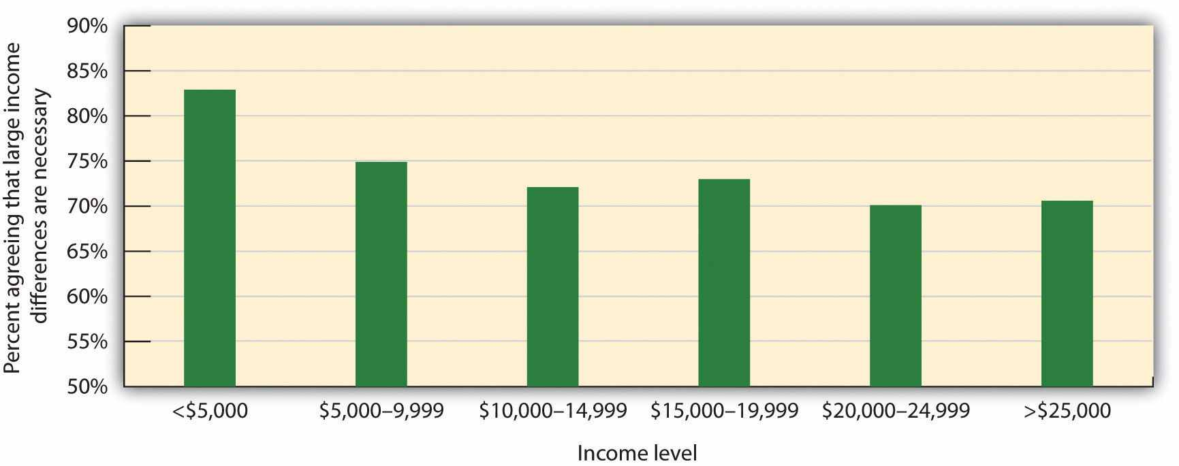
Poorer respondents reported finding the income differential between rich and poor more acceptable than did richer participants. Data are from Jost, Pelham, Sheldon, and Sullivan (2003). ^{[24]}

KEY TAKEAWAYS
- The individual goals of self-concern and other-concern help explain tendencies to cooperate or compete with others.
- Both competition and cooperation are common and useful reactions to social interaction dilemmas.
- The solutions to social dilemmas are more favorable when the outcomes are integrative rather than fixed-sum.
- Conflict is sometimes realistic, in the sense that the goals of the interacting parties really are incompatible. But in many cases, conflicts are more perceived than realistic.
- Our reactions to conflict are influenced by harm-based morality beliefs and social fairness norms.
- Individuals who have low status may nevertheless accept the existing status hierarchy, deciding that they deserve what little they have, a phenomenon known as false consciousness. Individuals with low status who to do not accept the procedural fairness of the system may use social creativity strategies or them may resort to collective action.

EXERCISES AND CRITICAL THINKING
- Consider a time when you were in a type of social dilemma, perhaps with friends or family. How did your self-concern and other-concern lead you to resolve the dilemma?
- Do you think that you or people you know are victims of system justification? How would you know if you or they were?
- Discuss an example of a person who is a member of a social group and who you believe has used social creativity strategies in an attempt to improve his or her self-image. What were the strategies, and were they successful?

[1] Sherif, M., Harvey, O. J., White, B. J., Hood, W. R., & Sherif, C. (1961). Intergroup conflict and cooperation: The robbers’ cave experiment. Norman, OK: University of Oklahoma Press.
[2] Staub, E. (2011). Overcoming evil: Genocide, violent conflict and terrorism. New York, NY: Oxford University Press.
[3] Brewer, M. B., & Campbell, D. T. (1976). Ethnocentrism and intergroup attitudes: East African evidence. New York, NY: Sage; Jackson, J. W. (1993). Realistic group conflict theory: A review and evaluation of the theoretical and empirical literature. The Psychological Record, 43(3), 395–413.
[4] Coser, L. A. (1956). The functions of social conflict. Glencoe, IL: The Free Press; Rispens, S., & Jehn, K. A. (2011). Conflict in workgroups: Constructive, destructive, and asymmetric conflict. In D. De Cremer, R. van Dick, & J. K. Murnighan (Eds.), Social psychology and organizations (pp. 185–209). New York, NY: Routledge/Taylor & Francis Group.
[5] de Waal, F. (1996). Good natured: The evolution of right and wrong in humans and other animals. Cambridge, MA: Harvard University Press.
[6] Darley, J. M., & Shultz, T. R. (1990). Moral rules: Their content and acquisition. Annual Review of Psychology, 41(4), 525–556; Haidt, J., & Kesebir, S. (2010). Morality. In S. T. Fiske, D. T. Gilbert, & G. Lindzey (Eds.), Handbook of social psychology (5th ed., Vol. 2, pp. 797–832). Hoboken, NJ: John Wiley & Sons.
[7] Turiel, E., Killen, M., & Helwig, C. (1987). Morality: Its structure, functions and vagaries. In J. Kagan & S. Lamb (Eds.), The emergence of morality in young children (pp. 55–243). Chicago, IL: University of Chicago Press.
[8] Helwig, C. C., & Turiel, E. (Eds.). (2002). Children’s social and moral reasoning. Malden, MA: Blackwell Publishing.
[9] Tyler, T. R., & Lind, E. A. (2001). Procedural justice. In J. Sanders & V. L. Hamilton (Eds.),Handbook of justice research in law (pp. 65–92). Dordrecht, Netherlands: Kluwer Academic Publishers; Tyler, T. R., & Smith, H. J. (1998). Social justice and social movements. In D. T. Gilbert, S. T. Fiske, & G. Lindzey (Eds.), The handbook of social psychology (4th ed., Vols. 1 and 2, pp. 595–629). New York, NY: McGraw-Hill.
[10] Tyler, T. R., & Blader, S. (2000). Cooperation in groups: Procedural justice, social identity, and behavioral engagement. New York, NY: Psychology Press.
[11] Tabibnia, G., Satpute, A. B., & Lieberman, M. D. (2008). The sunny side of fairness: Preference for fairness activates reward circuitry (and disregarding unfairness activates self-control circuitry). Psychological Science, 19(4), 339–347. doi: 10.1111/j.1467–9280.2008.02091.x
[12] Schroeder, D. A., Steele, J. E., Woodell, A. J., & Bernbenek, A. F. (2003). Justice in social dilemmas. Personality and Social Psychology Review, 7, 374–387.
[13] Lerner, M. J. (1980). The belief in a just world: A fundamental delusion. New York, NY: Plenum.
[14] Tyler, T., Degoey, P., & Smith, H. (1996). Understanding why the justice of group procedures matters: A test of the psychological dynamics of the group-value model. Journal of Personality and Social Psychology, 70(5), 913–930.
[15] Jost, J. T., & Banaji, M. R. (1994). The role of stereotyping in system-justification and the production of false consciousness. British Journal of Social Psychology, 33, 1–27; Major, B. (1994). From social inequality to personal entitlement: The role of social comparisons, legitimacy appraisals, and group membership. Advances in Experimental Social Psychology, 26, 293–348.
[16] Jost, J. T., Pelham, B. W., Sheldon, O., & Sullivan, B. N. (2003). Social inequality and the reduction of ideological dissonance on behalf of the system: Evidence of enhanced system justification among the disadvantaged. European Journal of Social Psychology, 33(1), 13–36.
[17] Ellemers, N., Spears, R., & Doosje, B. (1997). Sticking together or falling apart: In-group identification as a psychological determinant of group commitment versus individual mobility.Journal of Personality and Social Psychology, 72, 617–626; Spears, R., Doosje, B., & Ellemers, N. (1997). Self-stereotyping in the face of threats to group status and distinctiveness: The role of group identification. Personality and Social Psychology Bulletin, 23, 538–553.
[18] Derks, B., van Laar, C., & Ellemers, N. (2007). Social creativity strikes back: Improving motivated performance of low status group members by valuing ingroup dimensions.European Journal of Social Psychology, 37(3), 490–493. doi: 10.1002/ejsp.375
[19] Ellemers, N., & Barreto, M. (2009). Collective action in modern times: How modern expressions of prejudice prevent collective action. Journal of Social Issues, 65(4), 749–768. doi: 10.1111/j.1540–4560.2009.01621.x; Leonard, D. J., Moons, W. G., Mackie, D. M., & Smith, E. R. (2011). “We’re mad as hell and we’re not going to take it anymore”: Anger self-stereotyping and collective action. Group Processes and Intergroup Relations, 14(1), 99–111. doi: 10.1177/1368430210373779; Levine, M., Taylor, P. J., & Best, R. (2011). Third parties, violence, and conflict resolution: The role of group size and collective action in the microregulation of violence. Psychological Science, 22(3), 406–412. doi: 10.1177/0956797611398495
[20] Bobo, L. (1983). Whites’ opposition to busing: Symbolic racism or realistic group conflict?Journal of Personality and Social Psychology, 45, 1196–1210; Sidanius, J., & Pratto, F. (1999).Social dominance: An intergroup theory of social hierarchy and oppression. New York, NY: Cambridge University Press.
[21] Gurr, T. (1970). Why men rebel. Princeton, NJ: Princeton University Press.
[22] Jost, J. T. (2011). System justification theory as compliment, complement, and corrective to theories of social identification and social dominance. In D. Dunning (Ed.), Social motivation(pp. 223–263). New York, NY: Psychology Press; van der Toorn, J., Tyler, T. R., & Jost, J. T. (2011). More than fair: Outcome dependence, system justification, and the perceived legitimacy of authority figures. Journal of Experimental Social Psychology, 47(1), 127–138. doi: 10.1016/j.jesp.2010.09.003
[23] Jost, J. T., Pelham, B. W., Sheldon, O., & Sullivan, B. N. (2003). Social inequality and the reduction of ideological dissonance on behalf of the system: Evidence of enhanced system justification among the disadvantaged. European Journal of Social Psychology, 33(1), 13–36.
[24] Jost, J. T., Pelham, B. W., Sheldon, O., & Sullivan, B. N. (2003). Social inequality and the reduction of ideological dissonance on behalf of the system: Evidence of enhanced system justification among the disadvantaged. European Journal of Social Psychology, 33(1), 13–36.

13.2 How the Social Situation Creates Conflict: The Role of Social Dilemmas

LEARNING OBJECTIVES
- Explain the concepts of public goods and social dilemmas, and how these conflicts influence human interactions.
- Describe the principles of the prisoner’s dilemma game that make it an effective model for studying social dilemmas.
- Review the different laboratory games that have been used to study social dilemmas.
- Summarize the individual difference and cultural variables that relate to cooperation and competition.
If human beings are well-equipped to cooperate with each other, and if morality, social fairness, and other human features favor it, why are so many social relationships still competitive? If you guessed that the competition comes not so much from the people as it does from the nature of the social situation, then you would be correct. In short, competition is often caused by the social dilemma itself—the dilemma creates patterns whereby even when we want to be good, the situation nevertheless rewards us for being selfish. Ross and Ward (1995) ^{[1]} found that participants played a game more competitively when it was described as a “Wall Street Broker Game” than when the same game was called a “Community Game.” And other studies have found that subliminal priming of money or business materials (e.g., boardroom tables and business suits) increases competition (Kay, Wheeler, Bargh, & Ross, 2004; Vohs, Meed, & Goode, 2006). ^{[2]}
Social dilemmas occur when the members of a group, culture, or society are in potential conflict over the creation and use of shared public goods. Public goods arebenefits that are shared by a community at large and that everyone in the group has access to, regardless of whether or not they have personally contributed to the creation of the goods (Abele, Stasser, & Chartier, 2010). ^{[3]} In many cases, the public good involves the responsible use of a resource that if used wisely by the group as a whole will remain intact but if overused will be destroyed. Examples include the crabs in the Chesapeake Bay, water in local reservoirs, public beaches, and clean air. In other cases, the public good involves a service—such as public television or public radio—that is supported by the members of the community but that is used freely by everyone in the community.
Let’s consider first a case in which a social dilemma leads people to overuse an existing public good—a type of social dilemma called a harvesting dilemma. One example, called the commons dilemma, was proposed by Garrett Hardin (1968). ^{[4]}Hardin noted that in many towns in Europe, there was at one time a centrally located pasture, known as the commons, which was shared by the inhabitants of the village to graze their livestock. But the commons was not always used wisely. The problem was that each individual who owned livestock wanted to be able to use the commons to graze his or her own animals. However, when each group member took advantage of the commons by grazing many animals, the commons became overgrazed, the pasture died, and the commons was destroyed.
Although Hardin focused on the particular example of the commons, he noted that the basic dilemma of individual needs and desires versus the benefit of the group as whole could also be found in many contemporary public goods issues, including the use of limited natural resources and public land. In large cities, most people may prefer the convenience of driving their own car to work each day rather than taking public transportation. Yet this behavior uses up public goods (roads that are not clogged with traffic, and air that is free of pollution). People are lured into the dilemma by short-term self-interest, seemingly without considering the potential long-term costs of the behavior, such as air pollution and the necessity of building even more highways.
Social dilemmas such as the commons dilemma are arranged in a way that it is easy to be selfish because the personally beneficial choice (such as using water during a water shortage or driving to work alone in one’s own car) produces benefits for the individual, no matter what others do. Furthermore, social dilemmas tend to work on a type of “time delay.” Because the long-term negative outcome (the extinction of fish species or dramatic changes in the climate) is far away in the future, and yet the individual benefits are occurring right now, it is difficult to see how many costs there really are. The paradox, of course, is that if everyone takes the personally selfish choice in an attempt to maximize his or her own rewards, the long-term result is poorer outcomes for every individual in the group. Each individual prefers to make use of the public goods for himself or herself, whereas the best outcome for the group as a whole is to use the resources more slowly and wisely.
Another type of social dilemma—the contributions dilemma—occurs when the short-term costs of a behavior lead individuals to avoid performing it, and this may prevent the long-term benefits that would have occurred if the behaviors had been performed. An example of a contributions dilemma occurs when individuals have to determine whether or not to donate to the local public radio or television station. If most people do not contribute, the TV station may have lower quality programming, or even go off the air entirely, thus producing a negative outcome for the group as a whole. However, if enough people already contribute, then it is not in anyone’s own best interest to do so, because the others will pay for the programming for them. Contributions dilemmas thus encourage people to free ride, relying on other group members to contribute for them.

The Prisoner’s Dilemma
One method of understanding how individuals and groups behave in social dilemmas is to create such situations in the laboratory and observe how people react to them. The best known of these laboratory simulations is called the prisoner’s dilemma game(Poundstone, 1992). ^{[5]} The prisoner’s dilemma game is a laboratory simulation that models a social dilemma in which the goals of the individual compete with the goals of another individual (or sometimes with a group of other individuals). Like all social dilemmas, the prisoner’s dilemma makes use of the assumptions of social learning approaches to behavior that assume that individuals will try to maximize their own outcomes in their interactions with others.
In the prisoner’s dilemma, the participants are shown a payoff matrix in which numbers are used to express the potential outcomes for the each of the players in the game, given the decisions made by each player. The payoffs are chosen beforehand by the experimenter to create a situation that models some real-world outcome. Furthermore, in the prisoner’s dilemma, the payoffs are normally arranged as they would be in a typical social dilemma, such that each individual is better off acting in his or her immediate self-interest, and yet if all individuals act according to their self-interest, then everyone will be worse off.
In its original form, the prisoner’s dilemma involves a situation in which two prisoners (we’ll call them Frank and Malik) have been accused of committing a crime. The police have determined that the two worked together on the crime, but they have only been able to gather enough evidence to convict each of them of a more minor offense. In an attempt to gain more evidence and thus to be able to convict the prisoners of the larger crime, each prisoner is interrogated individually, with the hope that he will confess to having been involved in the more major crime in return for a promise of a reduced sentence if he confesses first. Each prisoner can make either the cooperative choice (which is to not confess) or the competitive choice (which is to confess).
The incentives for either confessing or not confessing are expressed in a payoff matrix such as the one shown in Figure 13.2 "The Prisoner’s Dilemma". The top of the matrix represents the two choices that Malik might make (either to confess that he did the crime or to not confess), and the side of the matrix represents the two choices that Frank might make (also to either confess or not confess). The payoffs that each prisoner receives, given the choices of each of the two prisoners, are shown in each of the four squares.

Figure 13.2 The Prisoner’s Dilemma
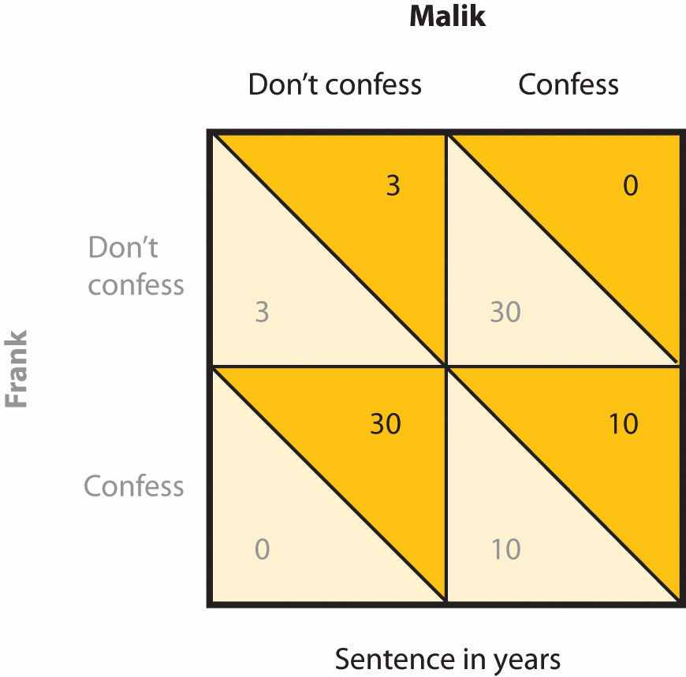
In the prisoner’s dilemma, two suspected criminals are interrogated separately. The payoff matrix indicates the outcomes for each prisoner, measured as the number of years each is sentenced to prison, as a result of each combination of cooperative (don’t confess) and competitive (confess) decisions. Outcomes for Malik are in the darker color, and outcomes for Frank are in lighter color.
If both prisoners take the cooperative choice by not confessing (the situation represented in the upper left square of the matrix), there will be a trial, the limited available information will be used to convict each prisoner, and each will be sentenced to a short prison term of 3 years. However, if either of the prisoners confesses, turning “state’s evidence” against the other prisoner, then there will be enough information to convict the other prisoner of the larger crime, and that prisoner will receive a sentence of 30 years, whereas the prisoner who confesses will get off free. These outcomes are represented in the lower left and upper right squares of the matrix. Finally, it is possible that both players confess at the same time. In this case, there is no need for a trial, and in return, the prosecutors offer a somewhat reduced sentence (of 10 years) to each of the prisoners.

Characteristics of the Prisoner’s Dilemma
The prisoner’s dilemma has two interesting characteristics that make it a useful model of a social dilemma. For one, the prisoner’s dilemma is arranged such that a positive outcome for one player does not necessarily mean a negative outcome for the other player (i.e., the prisoner’s dilemma is not a fixed-sum situation but an integrative one). If you consider again the matrix in Figure 13.2 "The Prisoner’s Dilemma", you can see that if one player takes the cooperative choice (to not confess) and the other takes the competitive choice (to confess), then the prisoner who cooperates loses, whereas the other prisoner wins. However, if both prisoners make the cooperative choice, each remaining quiet, then neither gains more than the other, and both prisoners receive a relatively light sentence. In this sense, both players can win at the same time.
Second, the prisoner’s dilemma matrix is arranged such that each individual player is motivated to take the competitive choice because this choice leads to a higher payoff regardless of what the other player does. Imagine for a moment that you are Malik, and you are trying to decide whether to cooperate (don’t confess) or to compete (confess). And imagine that you are not really sure what Frank is going to do. Remember that the goal of the individual is to maximize rewards. The values in the matrix make it clear that if you think that Frank is going to confess, you should confess yourself (to get 10 rather than 30 years in prison). And it is also clear that if you think Frank is not going to confess, you should still confess (to get 0 rather than 3 years in prison). So the matrix is arranged such that the “best” alternative for each player, at least in the sense of pure self-interest, is to make the competitive choice, even though in the end both players would prefer the combination in which both players cooperate to the one in which they both compete.
Although initially specified in terms of the two prisoners, similar payoff matrices can be used to predict behavior in many different types of dilemmas involving two or more parties and including choices between helping and not helping, working and loafing, and paying and not paying debts (weber & Messick, 2004). ^{[6]} For instance, we can use the prisoner’s dilemma to help us understand a contributions dilemma, such as why two roommates might not want to contribute to the housework. Each of them would be better off if they relied upon the other to clean the house. Yet if neither of them makes an effort to clean the house (the cooperative choice), the house becomes a mess and they will both be worse off.

Variations on the Prisoner’s Dilemma
In many cases, the prisoner’s dilemma game is played over a series of trials, in which players can modify their responses based on those given by their partners on previous trials. For example, the arms race between the Soviet Union and the United States during the Cold War can be seen as a social dilemma that occurs over time. Over a period of years, each country chooses whether to compete (by building nuclear weapons) or to cooperate (by not building nuclear weapons). And in each case, both countries feel that it is in their best interest to compete rather than cooperate.
The prisoner’s dilemma can also be expanded to be played by more than two players. The behavior of individuals leaving a crowed parking lot, as an example, represents a type of prisoner’s dilemma in which it is to each person’s individual benefit to try to be the first to leave. However, if each person rushes to the exit without regard for others, a traffic jam is more likely to result, which slows down the process for everyone. If all individuals take the cooperative choice—waiting until their turn—everyone wins.

Resource Dilemma Games
In addition to the prisoner’s dilemma, social dilemmas have been studied using games in which a group of individuals share a common pool of resources. In these resource dilemma games, the participants may extract or harvest resources from the pool, and it is to their individual advantage to do so. Furthermore, as the resources are used, the pool can replenish itself through a fixed schedule, which will allow the individuals to continue to harvest over long periods of time. Optimal use of the resource involves keeping the pool level up and harvesting only as much as will be replenished in the given time period. Overuse of the pool provides immediate gain for the individuals but has a long-term cost in the inability to make harvests at a later time.
In one version of a resource dilemma game (Edney, 1979), ^{[7]} the participants sit around a bowl of metal nuts, and the goal is to get as many nuts as one can. The experimenter adds nuts to the bowl such that the number of nuts in the bowl doubles every 10 seconds. However, the individual players are also motivated to harvest nuts for themselves and are allowed to take out as many nuts as they like at any time. In Edney’s research, rather than cooperating and watching the pool grow, the participants almost immediately acted in their self-interest, grabbing the nuts from the bowl. In fact, Edney reported that 65% of the groups never got to the first 10-second replenishment!

Research Focus
The Trucking Game
Another example of a laboratory simulation that has been used to study conflict is the trucking game. In the original research (Deutsch & Krauss, 1960), ^{[8]} pairs of women played the trucking game. Each woman was given $4 to begin with and was asked to imagine herself as the owner of one of two trucking companies (Acme or Bolt) that carried merchandise over the roads shown in the figure called “The Road Map From the Trucking Game”. Each time either player’s truck reached the destination on the opposite side of the board, she earned 60 cents, minus operating costs (1 cent for each second taken by the trip). However, the game was also arranged to create the potential for conflict. Each participant wanted to travel on the main road in order to get to the destination faster, but this road was arranged to be so narrow that only one truck could pass at a time. Whenever the two trucks met each other on this narrow road, one of them was eventually forced to back up. Thus there are two choices to getting to the destination. The players had to either take the long, winding roads, thus eliminating their profits (each player would lose 10 cents on each trip if they were forced to take the long road) or figure out a way to share the use of the one-lane road.

Figure 13.3The Road Map From the Trucking Game
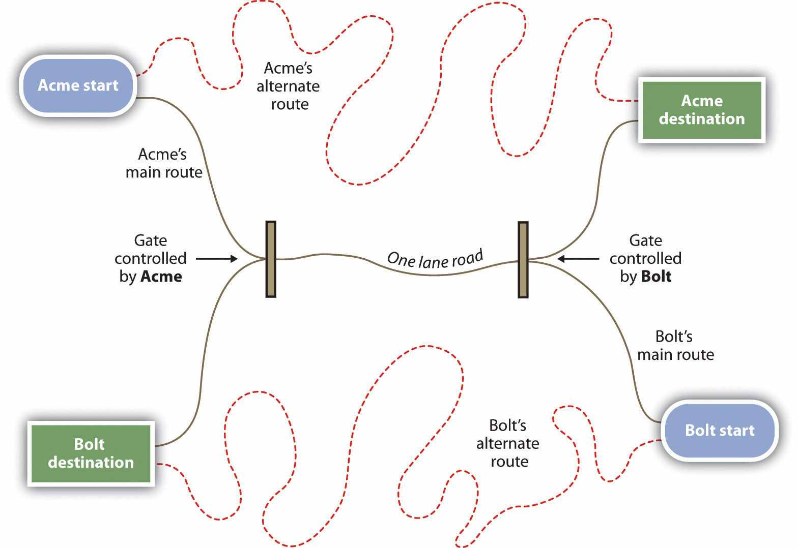
From Deutsch (1973). ^{[9]}

Figure 13.4Outcomes of a Trucking Game Study
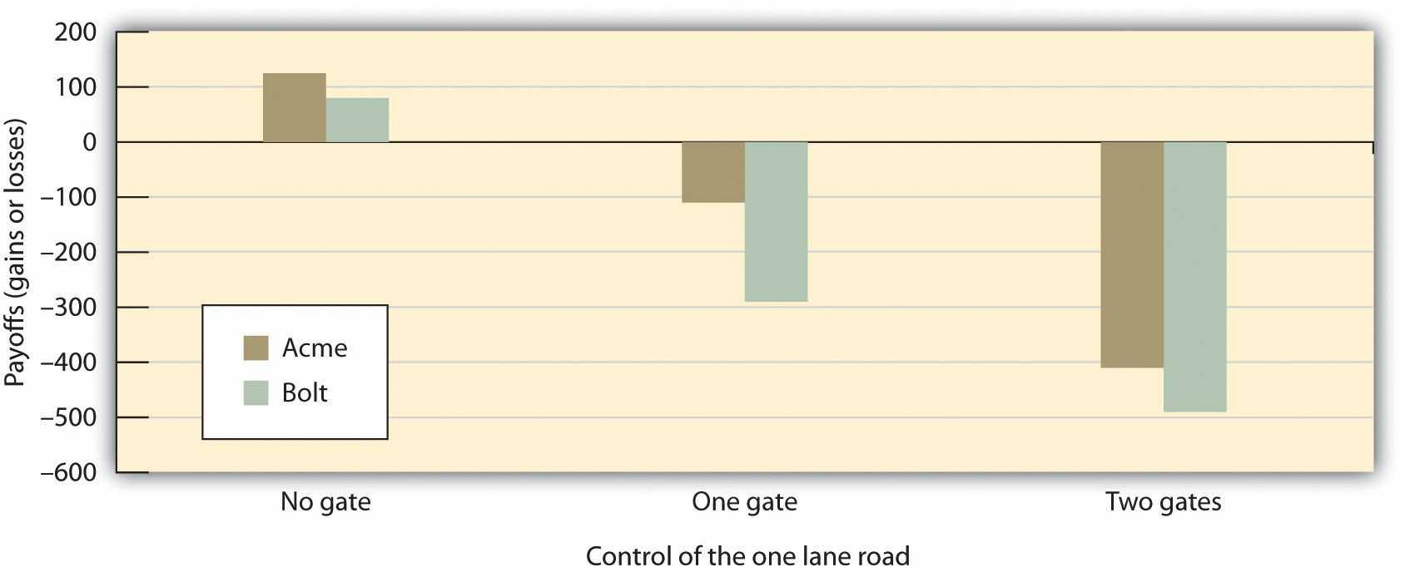
Data are from Deutsch and Krauss (1960). ^{[10]}
Deutsch and Krauss made the game even more interesting by creating experimental conditions in which either or both of the truck company owners had a gate that controlled access to the road. In the unilateral-threat condition, only Acme had a gate. Thus if Bolt attempted to use the main road, Acme could close the gate, forcing Bolt to back up and enabling Acme to reopen the gate and proceed quickly to the destination. In the bilateral-threat condition, both sides had gates, whereas in the no-threat condition, there were no gates.
As shown in the figure titled “Outcomes of a Trucking Game Study,” participants without gates soon learned to share the one-lane road, and, on average, each made a profit. However, threat in the form of a gate produced conflict and led to fewer profits, although in many cases the participants learned to deal with these problems over time and improved their payoffs as the game went on (Lawler, Ford, & Blegen, 1988; Shomer, Davis, & Kelley, 1966). ^{[11]} Participants lost the most money in the bilateral-threat condition in which both sides were given gates that they could control. In this situation, conflict immediately developed, and there were standoffs on the middle road that wasted time and prevented either truck from moving.
Two results of this study are particularly surprising. First, in the unilateral threat condition, both players (including Acme, who had control of the gate) made less money than did those in the no-threat condition (although it is true that in this condition, Acme did lose less than Bolt). Thus being able to threaten the other was not successful for generating overall profits. Second, in the conditions in which both individuals had gates, both individuals actually did worse than they did when only one individual had a gate. Thus when an opponent is able to threaten you, it may be to your benefit to not return with a threat of your own—the ability to counteract the threats of your partner may not always help you but rather may produce even more conflict and losses for both parties.

Who Cooperates and Who Competes?
Although we have to this point focused on how situational variables, such as the nature of the payoffs in the matrix, increase the likelihood that we will compete rather than cooperate, not everyone is influenced the same way by the situation—the personality characteristics of the individuals also matter. In general, people who are more self-oriented are more likely to compete, whereas people who are more other-oriented are more likely to cooperate (Balliet, Parks, & Joireman, 2009; Sagiv, Sverdlik, & Schwarz, 2011). ^{[12]} For instance, Campbell, Bush, Brunell, and Shelton (2005) ^{[13]} found that students who were highly narcissistic (i.e., very highly self-focused) competed more in a resource dilemma and took more of the shared resource for themselves than did the other people playing the game.

Research Focus
Self and Other Orientations in Social Dilemmas
Paul Van Lange and his colleagues (Van Lange, 1999; Van Lange & Kuhlman, 1994) ^{[14]} have focused on the person determinants of cooperation by characterizing individuals as one of two types—those who are “pro-social,” meaning that they are high on other-concern and value cooperation, and those who are “pro-self” and thus tend to behave in a manner that enhances their own outcomes by trying to gain advantage over others by making competitive choices.
Sonja Utz (2004) ^{[15]} tested how people who were primarily self-concerned would respond differently than those who were primarily other-concerned when the self-concept was activated. In her research, male and female college students first completed a measure designed to assess whether they were more pro-social or more pro-self in orientation. On this measure, the participants had to make choices about whether to give points to themselves or to another person on a series of tasks. The students who tended to favor themselves were classified as pro-self, whereas those tended to favor others were classified as pro-social.
Then all the students read a story describing a trip to a nearby city. However, while reading the story, half of the students (the self-priming condition) were asked to circle all the pronouns occurring in the story. These pronouns were arranged to be self-relevant and thus to activate the self-concept—“I,” “we,” “my,” and so forth. The students in the control condition, however, were instructed to circle the prepositions, which were not self-relevant (e.g., “of” and “after”).
Finally, the students participated in a series of games in which they had to make a choice between two alternative distributions of points between themselves and another person. As you can see in the following figure, the self-manipulation influenced the pro-self students (who were primarily self-oriented already) in a way that they became even less cooperative and more self-serving. However, the students who were initially pro-social became even more cooperative when the self-concept was activated.

Figure 13.5
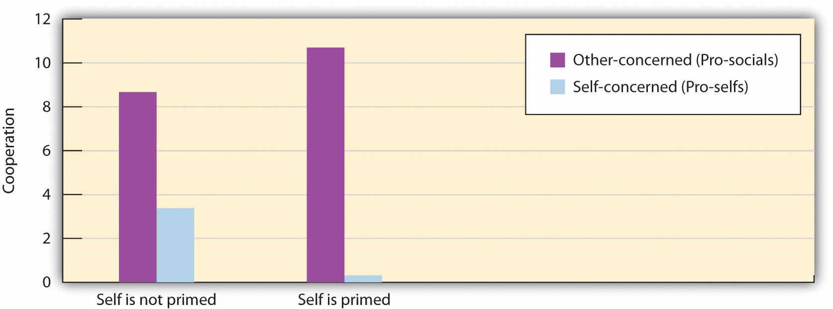
Priming the self-concept increased cooperation for those who were other-concerned but increased competition for those who were self-concerned. Data are from Utz (2004). ^{[16]}
Although it is possible that people are either self-concerned or other-concerned, another possibility is that people vary on both of these dimensions simultaneously, such that some people may be high on both self-concern and other-concern. Thedual-concern model of cooperation and competition (Pruitt & Rubin, 1986)^{[17]} is based on this approach, and the four resulting personality types are outlined inFigure 13.6 "The Dual-Concern Model".
The dual-concern model suggests that individuals will relate to social dilemmas, or other forms of conflict, in different ways, depending on their underlying personal orientations or as influenced by the characteristics of the situation that orient them toward a given concern. Individuals who are focused primarily on their own outcomes but who do not care about the goals of others are considered to be contending in orientation. These individuals are expected to try to take advantage of the other party, for instance, by withholding their contributions in social dilemmas. Those who are focused primarily on the others’ outcomes, however, will be yielding and likely to make cooperative choices. Individuals who are not concerned about the interests of either the self or others are inactive and unlikely to care about the situation or to participate in solving it at all.

Figure 13.6 The Dual-Concern Model
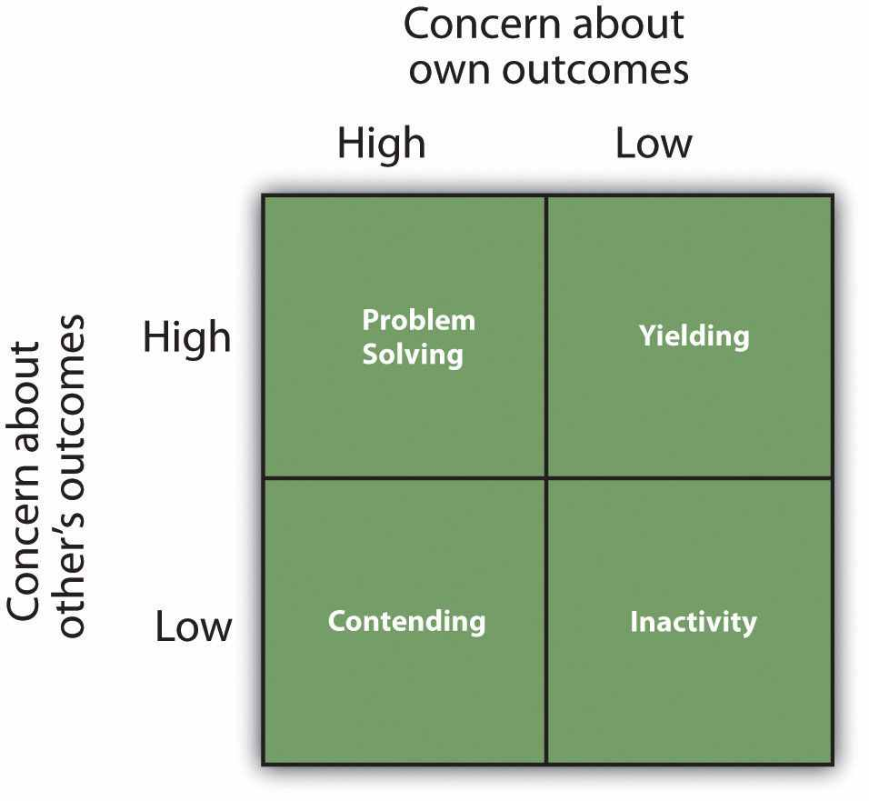
The interesting prediction of the dual-concern model is that being concerned with one’s own outcomes is not necessarily harmful to the possibility of cooperation. The individuals who are focused on maximizing their own outcomes but who are also concerned with the needs of the others (the problem solvers) are expected to be as likely to cooperate as are those who are yielding. In fact, the dual-concern model suggests that these individuals may be the best negotiators of all because they are likely to go beyond the trap posed by the dilemma itself, searching for ways to produce new and creative solutions through creative thinking and compromise.

Gender and Cultural Differences in Cooperation and Competition
You might be wondering whether men or women are more cooperative. Because women are on average more concerned about maintaining positive relationships with others, whereas men are on average more self-concerned, it might be expected that women might be more likely to cooperate than men. And some research has supported this idea. For instance, in terms of whether or not people accepted an initial offer that was made to them or demanded more, Babcock, Gelfand, Small, and Stayn (2006) ^{[18]}found that about half of the men they sampled negotiated a salary when they took their first job offer, whereas only about one eighth of the women reported doing so. Not surprisingly, women received substantially lower average annual starting salaries than did the men, a fact that is likely to contribute to the wage gap between men and women. And Small, Gelfand, Babcock, and Gettman (2007) ^{[19]} found that, overall, women were less likely than men to try to bargain for personal gain in an experimental task. Small and colleagues concluded that women felt that asking for things for themselves was socially inappropriate, perhaps because they perceive that they have less social power than do men.
Although at least some studies have found that there are gender differences, an interactionist approach to the situation is even more informative. It turns out that women compete less than men in some situations, but they compete about much as men do in other situations. For example, Bowles, Babcock, and McGinn (2005) ^{[20]}showed that the roles that are activated at the negotiation table (i.e., whether one is negotiating for oneself or on behalf of others) are important triggers for gender differences. Women negotiated as well as men when they were negotiating for others, but they negotiated less strongly than men did for themselves. And Kray, Galinsky, and Thompson (2002) ^{[21]} showed that gender differences in negotiation behavior are strongly affected by cognitive constructs that are accessible during negotiation. In general, gender differences in negotiation seem to occur in situations in which other-concern is highly accessible but are reduced or eliminated in situations in which other-concern is less accessible (Gelfand, Major, Raver, Nishii, & O’Brien, 2006). ^{[22]} A recent meta-analysis of 272 research results (Baillet, Li, Macfarlan, & van Vugt, 2011)^{[23]} found that overall, men and women cooperated equally. But men cooperated more with other men than women cooperated with other women. In mixed-sex interactions, women were more cooperative than men.
And there are also cultural differences in cooperation, in a direction that would be expected. For instance, Gelfand et al. (2002) ^{[24]} found that Japanese students—who are more interdependent and thus generally more other-concerned—were more likely to cooperate and achieved higher outcomes in a negotiation task than did students from the United States (who are more individualistic and self-oriented; Chen, Mannix, & Okumura, 2003). ^{[25]}

KEY TAKEAWAYS
- The behavior of individuals in conflict situations is frequently studied using laboratory games such as the prisoner’s dilemma game. Other types of laboratory games include resource dilemma games and the trucking game.
- Taken together, these games suggest that the most beneficial approach in social dilemmas is to maintain a balance between self-concern and other-concern.
- Individual differences in cooperation and competition, such as those proposed by the dual-concern model, show that individuals will relate to social dilemmas depending on their underlying personal orientations.
- Although women do compete less than men in some situations, they compete about as much as men do in other situations. There are cultural differences in cooperation.

EXERCISES AND CRITICAL THINKING
- Consider a time in which you were involved in a social dilemma. How did you respond to the problem?
- Review and critique the laboratory games that have been used to assess responses in social dilemmas. What are their strengths and the limitations?

[1] Ross, L., & Ward, A. (1995). Psychological barriers to dispute resolution. Advances in experimental social psychology, 27, 255–304. Retrieved fromhttp://search.ebscohost.com/login.aspx?direct=true&db=psyh&AN=2003-02325-006&site=ehost-live
[2] Kay, A. C., Wheeler, S. C., Bargh, J. A., & Ross, L. (2004). Material priming: The influence of mundane physical objects on situational construal and competitive behavioral choice.Organizational Behavior and Human Decision Processes, 95(1), 83–96. doi: 10.1016/j.obhdp.2004.06.003; Vohs, K. D., Mead, N. L., & Goode, M. R. (2006). The psychological consequences of money. Science, 314(5802), 1154–1156. doi: 10.1126/science.1132491
[3] Abele, S., Stasser, G., & Chartier, C. (2010). Conflict and coordination in the provision of public goods: A conceptual analysis of continuous and step-level games. Personality and Social Psychology Review, 14(4), 385–401. doi: 10.1177/1088868310368535
[4] Hardin, G. (1968). The tragedy of the commons. Science, 162(3859), 1243–1248.
[5] Poundstone, W. (1992). Prisoner’s dilemma. New York, NY: Doubleday.
[6] weber, J. M., & Messick, D. M. (2004). Conflicting interests in social life: Understanding social dilemma dynamics. In M. J. Gelfand & J. M. Brett (Eds.), The handbook of negotiation and culture (pp. 374–394). Palo Alto, CA: Stanford University Press.
[7] Edney, J. J. (1979). The nuts game: A concise commons dilemma analog. Environmental Psychology and Nonverbal Behavior, 3(4), 252–254.
[8] Deutsch, M., & Krauss, R. M. (1960). The effect of threat upon interpersonal bargaining.Journal of Abnormal and Social Psychology, 61, 181–189.
[9] Deutsch, M. (1973). The resolution of conflict. New Haven, CT: Yale University Press.
[10] Deutsch, M., & Krauss, R. M. (1960). The effect of threat upon interpersonal bargaining.Journal of Abnormal and Social Psychology, 61, 181–189.
[11] Lawler, E. J., Ford, R. S., & Blegen, M. A. (1988). Coercive capability in conflict: A test of bilateral deterrence versus conflict spiral theory. Social Psychology Quarterly, 51(2), 93–107; Shomer, R. W., Davis, A. H., & Kelley, H. H. (1966). Threats and the development of coordination: Further studies of the Deutsch and Krauss trucking game. Journal of Personality and Social Psychology, 4, 119–126.
[12] Balliet, D., Parks, C., & Joireman, J. (2009). Social value orientation and cooperation in social dilemmas: A meta-analysis. Group Processes and Intergroup Relations, 12(4), 533–547; Sagiv, L., Sverdlik, N., & Schwarz, N. (2011). To compete or to cooperate? Values’ impact on perception and action in social dilemma games. European Journal of Social Psychology, 41(1), 64–77.
[13] Campbell, W. K., Bush, C. P., Brunell, A. B., & Shelton, J. (2005). Understanding the social costs of narcissism: The case of the tragedy of the commons. Personality and Social Psychology Bulletin, 31(10), 1358–1368.
[14] Van Lange, P. A. M. (1999). The pursuit of joint outcomes and equality in outcomes: An integrative model of social value orientations. Journal of Personality and Social Psychology, 77, 337–349; Van Lange, P. A. M., & Kuhlman, D. M. (1994). Social value orientations and impressions of partner’s honesty and intelligence: A test of the might versus morality effect.Journal of Personality and Social Psychology, 67(1), 126–141.
[15] Utz, S. (2004). Self-activation is a two-edged sword: The effects of I primes on cooperation. Journal of Experimental Social Psychology, 40(6), 769–776.
[16] Utz, S. (2004). Self-activation is a two-edged sword: The effects of I primes on cooperation. Journal of Experimental Social Psychology, 40(6), 769–776.
[17] Pruitt, D. G., & Rubin, J. Z. (1986). Social conflict: Escalation, stalemate, and settlement. New York, NY: McGraw-Hill.
[18] Babcock, L., Gelfand, M., Small, D., & Stayn, H. (Eds.). (2006). Gender differences in the propensity to initiate negotiations. Mahwah, NJ: Lawrence Erlbaum.
[19] Small, D. A., Gelfand, M., Babcock, L., & Gettman, H. (2007). Who goes to the bargaining table? The influence of gender and framing on the initiation of negotiation. Journal of Personality and Social Psychology, 93(4), 600–613.
[20] Bowles, H. R., Babcock, L., & McGinn, K. L. (2005). Constraints and triggers: Situational mechanics of gender in negotiation. Journal of Personality and Social Psychology, 89(6), 951–965.
[21] Kray, L. J., Galinsky, A. D., & Thompson, L. (2002). Reversing the gender gap in negotiations: An exploration of stereotype regeneration. Organizational Behavior and Human Decision Processes, 87(2), 386–409.
[22] Gelfand, M. J., Major, V. S., Raver, J. L., Nishii, L. H., & O’Brien, K. (2006). Negotiating relationally: The dynamics of the relational self in negotiations. Academy of Management Review, 31(2), 427–451.
[23] Balliet, C., Li, N. P., Macfarlan, S. J., & Van Vugt, M. (2011, September 12). Sex differences in cooperation: A meta-analytic review of social dilemmas. Psychological Bulletin. doi: 10.1037/a0025354
[24] Gelfand, M. J., Higgins, M., Nishii, L. H., Raver, J. L., Dominguez, A., Murakami, F.,…Toyama, M. (2002). Culture and egocentric perceptions of fairness in conflict and negotiation.Journal of Applied Psychology, 87(5), 833–845.
[25] Chen, Y.-R., Mannix, E. A., & Okumura, T. (2003). The importance of who you meet: Effects of self- versus other-concerns among negotiators in the United States, the People’s Republic of China, and Japan. Journal of Experimental Social Psychology, 39(1), 1–15.

13.3 Strategies for Producing Cooperation

LEARNING OBJECTIVES
- Outline the variables that increase and decrease competition.
- Summarize the principles of negotiation, mediation, and arbitration.
When we are faced with situations in which conflict is occurring or has the potential to develop, it will be useful if we are aware of the techniques that will help us best deal with it. We may want to help two roommates realize that they will be better off taking the cooperative choice—by contributing to the household chores—and we may desire to try to convince people to take public transportation rather than their own car because doing so is better for the environment and in the end better for everyone. The problem, of course, is that although the parties involved may well realize the potential costs of continuing to behave selfishly or competitively, the social situation nevertheless provides a strong motivation to continue to take the selfish choice.
It is important to attempt to determine appropriate ways to encourage more responsible use of social resources because individualistic consumption of these supplies will make them disappear faster and may have overall negative effects on human beings (Oskamp & Schultz, 2006). ^{[1]}
It should be kept in mind that although social dilemmas are arranged such that competition is a likely outcome, they do not always end in collective disaster. Historical evidence shows, for example, that most of the commons grounds in England and other countries were, in fact, managed very well by local communities and were usually not overgrazed. Many British commons exist to this day. And even the Cold War between the United States and the Soviet Union, which inspired so much research into social dilemmas, had a peaceful end. In addition, findings from experimental social dilemma research involving repeated interactions between strangers suggest that the vast majority of interactions result in mutual cooperation (De Cremer & Van Vugt, 1999). ^{[2]}
Although the solutions are not simple, by examining the many studies that have focused on cooperation and conflict in the real world and in the lab, we can draw some conclusions about the specific characteristics that determine when and whether people cooperate or compete. These factors include the type of task, such as its rules and regulations; our perceptions about the task; the norms that are operating in the current situation; and the type and amount of communication among the parties. Furthermore, we can use approaches such as negotiation, arbitration, and mediation to help parties that are in competition come to agreement.

Task Characteristics and Perceptions
One factor that determines whether individuals cooperate or compete is the nature of the situation itself. The characteristics of some social dilemmas lead them to produce a lot of competitive responses, whereas others are arranged to elicit more cooperation. Thus one way to reduce conflict, when the approach is possible, is to change the rules of the task to reinforce more cooperation (Samuelson, Messick, Rutte, & Wilke, 1984).^{[3]} A class in which the instructor has decided ahead of time that only 10% of the students can get As will be likely to produce a competitive orientation among the students. On the other hand, if the instructor says that he or she would be quite happy to assign each student an A (assuming each individual deserves one!), a more cooperative orientation is likely to ensue. In general, cooperation will increase when it is more rewarded, and competition will increase when it is rewarded (Komorita & Parks, 1994). ^{[4]}
If societies really desire to maintain the public goods for their citizens, they will work to maintain them through incentives—for instance, by creating taxes such that each person is required to contribute his or her fair share to support them. A city or a state may add a carpool lane to the roadways, making it more desirable to commute with others and thereby help keep the freeways unclogged. Similarly, in terms of harvesting dilemmas, rules can be implemented that regulate the amount of the public good that can be taken by each individual member of the society. In a water crisis, rationing can be implemented in which individuals are allowed to use only a certain amount of water each month, thereby protecting the supply for all, or fishing limits can be imposed to maintain populations. People form governments in part to make sure that all individuals in the community contribute to public goods and obey the rules of cooperation. Leaders may also be elected by the group to help convince the members of the society that it is important just to follow the rules, thereby increasing cooperation (Tyler & Lind, 1992). ^{[5]}

Privatization
Another approach to increase the optimal use of resources is to privatize them—that is, to divide up the public good into smaller pieces so that each individual is responsible for a small share rather than trusting the good to the group as a whole. In a study by Messick and McClelland (1983) ^{[6]} using a resource game, individuals who were given their own private pool of resources to manage maintained them for an average of 31 trials of the game before they ran out. But individuals who were managing pools in groups maintained their pools for only about 10 trials and therefore gained much lower outcomes. In other experimental games, the outcomes are arranged such that the participants are either working for themselves or working for the joint outcomes of the group (Deutsch, 1949). ^{[7]} These studies have found that when individuals have control over their own outcomes rather than sharing the resources with others, they tend to use them more efficiently. In general, smaller groups are more cooperative than larger ones and also make better use of the resources that they have available to them (Gockel, Kerr, Seok, & Harris, 2008; Kerr & Bruun, 1983). ^{[8]}
One explanation for the difficulties of larger groups is that as the number of group members increases, each person’s behavior becomes less identifiable, which is likely to increase free riding. When people are allowed to monitor their water or energy use, they will use less of the public good (Siero, Bakker, Dekker, & van den Burg, 1996). ^{[9]}Furthermore, people feel that they can make less of a difference in the outcome of larger (versus smaller) groups, and so they are less likely to work toward the common group goals, even if their input is actually not less important or less likely to have an influence (Kerr, 1989). ^{[10]} Larger groups also lead people to feel more deindividuated, which may prevent them from conforming to group norms of cooperation. And in large groups, there is likely to be more difficulty coordinating the efforts of the individuals, and this may reduce cooperation. In a study by Kelley, Condry, Dahlke, and Hill (1965)^{[11]} in which participants had to coordinate their efforts in a type of crisis situation in which only one person could “escape” from a situation at a time, larger groups had more difficulty coordinating their activities and tended to perform more poorly. Again, the moral is straightforward: If possible, work in smaller rather than larger groups.
Decisions about whether to cooperate or compete are also influenced by expectations about the likely behavior of others. One factor that tends to produce conflict is that, overall, individuals expect others to take competitive, rather than cooperative, orientations (Sattler & Kerr, 1991), ^{[12]} and once they see the behavior of others, they are likely to interpret that behavior as being competitive, even if it is not. In a study by Maki, Thorngate, and McClintock (1979), ^{[13]} individuals viewed the decisions that had supposedly been made by other people who had participated in a prisoner’s dilemma task. Their task was to predict the choice that the partner had supposedly made from the payoff matrix. However, the choices had actually been selected, on the basis of a computer program, to take either competitive or cooperative orientations. Overall, across all the decisions, the participants were more accurate at making their predictions for partners who made competitive choices than for those who made cooperative choices, indicating that they expected the partners to be competitive and as a result tended to interpret their behaviors as being competitive.
The tendency to think that others will act in a competitive manner is more likely to cause problems when we are not sure what others are going to do. When we have a good idea of what the others in the situation are doing, we will likely match our responses to those of others. So when we see that others are cooperating, we are likely to cooperate as well. In other cases, for instance, when the group is very large, it is more difficult to be aware of or keep track of the behavior of others, and because there is less certainty about the behavior of others, taking the defensive (competitive) choice is more likely.
Another determinant of cooperation or competition is the prior norms of the individuals in the group (Pruitt, 1998). ^{[14]} If the norm in the situation favors cooperation, then cooperation is likely to ensue, but if the norm favors competition, then competition will probably result. The group or society may attempt to create or uphold social norms through appeals to appropriate social values. Sattler and Kerr (1991) ^{[15]} found that getting messages from others stressing the importance of cooperation increased cooperative behavior, particularly for individuals who were already motivated to be cooperative and when the partner actually played cooperatively. Group members may sometimes ostracize others who do not follow appropriate norms of group cooperation (Ouwerkerk, Kerr, Gallucci, & Van Lange, 2005). ^{[16]} And situations in which the parties in interaction are similar, friendly, or have a positive group identity have also been found to be more likely to cooperate (Brewer & Kramer, 1986; Karau & Williams, 1993). ^{[17]} Thus we should try to encourage groups to work together to create positive feelings in order to increase cooperation.

The Important Role of Communication
When communication between the parties involved in a conflict is nonexistent, or when it is hostile or negative in tone, disagreements frequently result in escalation of negative feelings and lead to conflict. In other cases, when communication is more open and positive, the parties in potential conflict are more likely to be able to deal with each other effectively, with a result that produces compromise and cooperation (Balliet, 2010). ^{[18]}
Communication has a number of benefits, each of which improves the likelihood of cooperation. For one, communication allows individuals to tell others how they are planning to behave and what they are currently contributing to the group effort, which helps the group learn about the motives and behaviors of the others and helps the group develop norms for cooperation. Communication has a positive effect because it increases the expectation that the others will act cooperatively and also reduces the potential of being a “sucker” to the free riding of others. Thus communication allows the parties to develop a sense of trust (Messick & Brewer, 1983). ^{[19]}
Once cooperative norms are in place, they can improve the possibilities for long-term cooperation because they produce a public commitment on the part of the parties to cooperate as well as an internalized obligation to honor those commitments (Kerr, Garst, Lewandowski, & Harris, 1997). ^{[20]} In fact, Norbert Kerr and his colleagues (Kerr, Ganst, Lewandowski, & Harris, 1997; Kerr & Kaufman-Gilliland, 1994) ^{[21]}have found that group discussion commits group members to act cooperatively to such an extent that it is not always necessary to monitor their behavior; once the group members have shared their intentions to cooperate, they will continue to do so because of a private, internalized commitment to it.
Communication can also allow the people working together to plan what they should do and therefore can help them better coordinate their efforts. For instance, in a resource dilemma game, discussion allows the group to monitor their withdrawals from the public good so that the pool is not depleted (Liebrand, 1984). ^{[22]} And if only a certain number of individuals need to contribute in a contributions dilemma in order for the public good to be maintained, communication may allow the group members to set up a system that ensures that this many, but not more, contribute in any given session.
Finally, communication may also help people realize the advantages, over the long term, of cooperating. If, as a result of communication, the individuals learn that the others are actually behaving cooperatively (something that might not have been apparent given prior misperceptions that make us overestimate the extent to which others are competing), this might increase the motivation to cooperate oneself. Alternatively, learning that others are behaving competitively and thus threatening the resources may help make it clear to all the parties that increased cooperation is essential (Jorgenson & Papciak, 1981). ^{[23]}
Perhaps the most important benefit of communication is the potential of learning that the goals of the parties involved in the conflict are not always incompatible (Thompson & Hrebec, 1996; Thompson, 1991). ^{[24]} A major barrier to increasing cooperation is that individuals expect both that situations are arranged such that they are fixed-sum and that others will act competitively to attempt to gain a greater share of the outcomes. Neither of these assumptions is necessarily true, however, and thus one potential benefit of communication is that the parties come to see the situation more accurately.
One example of a situation in which communication was successful is the meeting held at Camp David, Maryland, in 1978 between the delegates of Egypt and Israel. Both sides sat down together with then–U.S. President Carter to attempt to reach an accord over the fate of the Sinai Peninsula, which Israel had occupied for many years. Initially, neither side would budge, and attempts to divide the land in half were opposed by both sides. It appeared that there was a fixed-sum situation in which land was the important factor, and neither wanted to give it up. Over the course of discussion, communication prevailed. It became clear that what Egypt really wanted out of the deal was sovereignty over lands that were perceived as historically part of Egypt. On the other hand, what Israel valued the most was security. The outcome of the discussion was that Israel eventually agreed to return the land to Egypt in exchange for a demilitarized zone and the establishment of new Israeli air bases. Despite the initial perceptions, the situation turned out to be integrative rather than fixed-sum, and both sides were able to get what they wanted.
Laboratory studies have also demonstrated the benefits of communication. Leigh Thompson (1991) ^{[25]} found that groups in negotiation did not always effectively communicate, but those that did were more able to reach compromises that benefited both parties. Although the parties came to the situation expecting the game to be a fixed-sum situation, communication allowed them to learn that the situation was actually integrative—the parties had different needs that allowed them to achieve a mutually beneficial solution. Interestingly, Thompson found that it did not matter whether both parties involved in the dispute were instructed to communicate or if the communication came in the form of questions from only one of the two participants. In both cases, the parties who communicated viewed the other’s perspectives more accurately, and the result was better outcomes. Communication will not improve cooperation, however, if it is based on communicating hostility rather than working toward cooperation. In studies in which individuals played the trucking game, for instance, the communication was generally in the form of threats and did not reduce conflict (McClintock, Stech, & Keil, 1983). ^{[26]}

The Tit-for-Tat Strategy
In social dilemma games that are run over a number of trials, various strategies can be used by the parties involved. But which is the best strategy to use in order to promote cooperation? One simple strategy that has been found to be effective in such situations is known as tit-for-tat. The tit-for-tat strategy involves initially making a cooperative choice and then waiting to see what the other individuals do. If it turns out that they also make the cooperative choice (or if most of them do), then the individual again makes a cooperative choice. On the other hand, if the other group members compete, then the individual again matches this behavior by competing. This process continues such that the individual always does what the others have done on the trial before.
Computers have been used to simulate the behavior of individuals who use the tit-for-tat strategy over a series of interactions in comparison with other approaches for determining whether to cooperate or compete on each trial. The tit-for-tat strategy has been found to work better than straight cooperation or other types of strategies in producing cooperation from the parties (Axelrod, 2005; Fischer & Suleiman, 2004; Van Lange & Visser, 1999). ^{[27]}
The tit-for-tat strategy seems to be so effective because, first, it is “nice” in the sense that the individual first cooperates and signals a willingness to cooperate. Second, the strategy seems to be successful because, since it is relatively simple and easy to understand, others can clearly see how the choices are being determined. Furthermore, the approach sends a clear message that competitive choices on the part of the other will not be tolerated and that cooperation will always be reciprocated. The other party cannot take advantage of a person who is using tit-for-tat on more than one trial because if they try to do so, the result will always be retaliation in the form of a competitive choice on the next trial. Indeed, it has been found that having people play against a partner who uses the tit-for-tat strategy can help them learn to be more cooperative, particularly once they become aware what the strategy is and how it is being used (Sheldon, 1999). ^{[28]} The tit-for-tat strategy seems particularly effective because it balances self-concerned and other-concerned responses in an easy-to-understand way.
Despite the fact that it generally works better than most other strategies, tit-for-tat is not perfect. One problem is that because people are more likely to behave competitively than cooperatively, tit-for-tat is more likely to lead opponents to match noncooperative responses than to follow cooperation with cooperation, and thus tit-for-tat may in some cases produce a spiral of conflict (Kelley & Stahelski, 1970). ^{[29]} This is particularly likely if the opposing party never makes a cooperative choice, and thus the party using tit-for-tat never gets a chance to play cooperatively after the first round, or in cases in which there is some noise in the system and the responses given by the parties are not always perceived accurately. Variations of the tit-for-tat strategy in which the individual acts more cooperatively than demanded by the strategy (e.g., by giving some extra cooperative trials in the beginning or being extra cooperative on other trials) have been found to be helpful in this regard, although they do allow the opponent to exploit the side who is playing tit-for-tat.

Formal Solutions to Conflict: Negotiation, Mediation, and Arbitration
In some cases, conflict becomes so extreme that the groups feel that they need to work together to reach a compromise. Several methods are used in these cases, includingnegotiation, mediation, and arbitration.
Negotiation is the process by which two or more parties formally work together to attempt to resolve a perceived divergence of interest in order to avoid or resolve social conflict (Thompson, Wang, & Gunia, 2010). ^{[30]} The parties involved are often social groups, such as businesses or nations, although the groups may rely on one or a few representatives who actually do the negotiating. When negotiating, the parties who are in disagreement develop a set of communication structures in which they discuss their respective positions and attempt to develop a compromise agreement. To reach this agreement, each side makes a series of offers, followed by counteroffers from the other side, each time moving closer to a position that they can each agree on. Negotiation is successful if each of the parties finds that they have more to gain by remaining in the relationship or completing the transaction, even if they cannot get exactly what they want, than they would gain if they left the relationship entirely or continued the existing competitive state.
In some cases, negotiation is a type of fixed-sum process in which each individual wants to get as much as he or she can of the same good or commodity. For instance, in the sale of a property, if the seller wants the highest price possible, and the buyer wants the lowest price possible, the compromise will involve some sacrifice for each, or else it will not occur at all if the two parties cannot find a price on which they can agree. More often, the outcome of the negotiation is dependent upon the ability of the two parties to effectively communicate and to dispel negative misperceptions about the goals of the other party. When communication and trust are obtained in the situation, the parties may find that the situation is not completely fixed-sum but rather more integrative. The seller and buyer may be able to find an acceptable solution that is based on other aspects of the deal, such as the time that the deal is made or other costs and benefits involved. In fact, negotiators that maintain the assumption that the conflict is fixed-sum end up with lower individual and joint gain in comparison with negotiators who change their perceptions to be more integrative.
Negotiation works better when both sides have an open mind and do not commit themselves to positions. It has been argued that negotiation is most beneficial when you take a position and stick to it, no matter what, because if you begin to compromise at all, it will look like weakness or as if you do not really need all that you asked for. However, when negotiators do not allow any compromise, the negotiations are likely to break off without a solution.
Negotiation is often accompanied by conflict, including threats and harassment of the other party or parties. In general, individuals who are firm in their positions will achieve more positive outcomes as a result of negotiation, unless both sides are too firm and no compromise can be reached. However, positive and cooperative communication is an important factor in improving negotiation. Individuals who truthfully represent their needs and goals with the other party will produce better outcomes for both parties, in part because they become more aware of each other’s needs and are better able to empathize with them. Parties that are in negotiation should therefore be encouraged to communicate.
In some serious cases of disagreement, the parties involved in the negotiation decide that they must bring in outside help, in the form of a “third” party, to help them reach an equitable solution or to prevent further conflict. The third party may be called upon by the parties who are in disagreement, their use may be required by laws, or in some cases a third party may rather spontaneously appear (such as when a friend or coworker steps in to help solve a dispute). The goal of the third party is to help those who are in conflict to reach agreement without embarrassment to either party. In general, third-party intervention works better if it is implemented before the conflict is too great. If the level of conflict is already high, the attempts to help may increase hostility, and the disputants may not consent to third-party intervention.
Mediation involves helping to create compromise by using third-party negotiation(Wall & Lynn, 1993). ^{[31]} A mediator is a third party who is knowledgeable about the dispute and skilled at resolving conflict. During the mediation, the conflicting parties usually state the facts from their own perspective, which allows the mediator to determine each party’s interests and positions.
Mediators have a number of potential tactics that they can use, and they choose which ones seem best depending on the current state of affairs. These tactics include attempting to help the parties have more trust in each other, conferring with each of the parties separately, and helping them to accept the necessity of compromise. Through these tactics, the mediator may be able to reduce overt hostility and increase concern with understanding the others’ positions, which may lead to more integrative solutions. If necessary, the mediator may attempt to force the parties to make concessions, especially if there is little common ground to begin with. Mediation works best when both parties believe that a compromise is possible and think that third-party intervention can help reach it. Mediators who have experience and training make better mediators (Deutsch, 1994). ^{[32]}
Arbitrationis a type of third-party intervention that avoids negotiation as well as the necessity of any meetings between the parties in conflict. In the most common type of arbitration—binding arbitration—both sides agree ahead of time to abide by the decision of the third party (the arbitrator). They then independently submit their offers or desires along with their basis for their claims, and the arbitrator chooses between them. Whichever offer is chosen becomes the outcome, and there is no negotiation (Farber, 2005; Wolkinson & Ormiston, 2006). ^{[33]}Arbitration is particularly useful when there is a single decision to be made under time constraints, whereas negotiation may be better if the parties have a long-term possibility for conflict and future discussion is necessary.

KEY TAKEAWAYS
- The social situation has an important influence on choices to cooperate or compete, and it is important to understand these influences.
- Decisions about whether to cooperate or compete are also influenced by expectations about the likely behavior of others.
- Communication has a number of benefits, each of which improves the likelihood of cooperation.
- Negotiation, mediation, and arbitration can be used to help settle disputes.

EXERCISE AND CRITICAL THINKING
- Choose a real-world dispute among individuals or groups and analyze it using the principles we have considered in this chapter.

[1] Oskamp, S., & Schultz, P. W. (2006). Using psychological science to achieve ecological sustainability. In S. I. Donaldson, D. E. Berger, & K. Pezdek (Eds.), Applied psychology: New frontiers and rewarding careers (pp. 81–106). Mahwah, NJ: Lawrence Erlbaum.
[2] De Cremer, D., & Van Vugt, M. (1999). Social identification effects in social dilemmas: A transformation of motives. European Journal of Social Psychology, 29(7), 871–893. doi: 10.1002/(sici)1099–0992(199911)29:7<871::aid-ejsp962>3.0.co;2-i
[3] Samuelson, C. D., Messick, D. M., Rutte, C. G., & Wilke, H. (1984). Individual and structural solutions to resource dilemmas in two cultures. Journal of Personality and Social Psychology, 47(1), 94–104.
[4] Komorita, S. S., & Parks, C. D. (1994). Social dilemmas. Dubuque, IA: Brown & Benchmark.
[5] Tyler, T., & Lind, E. (1992). A relational model of authority in groups. Advances in Experimental Social Psychology, 25, 115–191.
[6] Messick, D. M., & McClelland, C. L. (1983). Social traps and temporal traps. Personality and Social Psychology Bulletin, 9, 105–110.
[7] Deutsch, M. (1949). An experimental study of the effects of cooperation and competition upon group processes. Human Relations, 2, 199–231.
[8] Gockel, C., Kerr, N. L., Seok, D.-H., & Harris, D. W. (2008). Indispensability and group identification as sources of task motivation. Journal of Experimental Social Psychology, 44(5), 1316–1321. doi: 10.1016/j.jesp.2008.03.011; Kerr, N. L., & Bruun, S. E. (1983). Dispensability of member effort and group motivation losses: Free-rider effects. Journal of Personality and Social Psychology, 44(1), 78–94.
[9] Siero, F. W., Bakker, A. B., Dekker, G. B., & van den Burg, M. T. C. (1996). Changing organizational energy consumption behaviour through comparative feedback. Journal of Environmental Psychology, 16(3), 235–246.
[10] Kerr, N. (1989). Illusions of efficacy: The effects of group size on perceived efficacy in social dilemmas. Journal of Experimental Social Psychology, 25, 287–313.
[11] Kelley, H. H., Condry, J. C., Jr., Dahlke, A. E., & Hill, A. H. (1965). Collective behavior in a simulated panic situation. Journal of Experimental Social Psychology, 1, 19–54.
[12] Sattler, D. N., & Kerr, N. L. (1991). Might versus morality explored: Motivational and cognitive bases for social motives. Journal of Personality and Social Psychology, 60(5), 756–765.
[13] Maki, J. E., Thorngate, W. B., & McClintock, C. G. (1979). Prediction and perception of social motives. Journal of Personality and Social Psychology, 37(2), 203–220.
[14] Pruitt, D. G. (1998). Social conflict. In D. T. Gilbert, S. T. Fiske, & G. Lindzey (Eds.), The handbook of social psychology (4th ed., Vol. 1 and 2, pp. 470–503). New York, NY: McGraw-Hill.
[15] Sattler, D. N., & Kerr, N. L. (1991). Might versus morality explored: Motivational and cognitive bases for social motives. Journal of Personality and Social Psychology, 60(5), 756–765.
[16] Ouwerkerk, J. W., Kerr, N. L., Gallucci, M., & Van Lange, P. A. M. (2005). Avoiding the social death penalty: Ostracism and cooperation in social dilemmas. In K. D. Williams, J. P. Forgas, & W. von Hippel (Eds.), The social outcast: Ostracism, social exclusion, rejection, and bullying (pp. 321–332). New York, NY: Psychology Press.
[17] Brewer, M. B., & Kramer, R. M. (1986). Choice behavior in social dilemmas: Effects of social identity, group size, and decision framing. Journal of Personality and Social Psychology, 50, 543–547; Karau, S. J., & Williams, K. D. (1993). Social loafing: A meta-analytic review and theoretical integration. Journal of Personality and Social Psychology, 65(4), 681–706.
[18] Balliet, D. (2010). Communication and cooperation in social dilemmas: A meta-analytic review. Journal of Conflict Resolution, 54(1), 39–57.
[19] Messick, D. M., & Brewer, M. B. (1983). Solving social dilemmas: A review. In L. Wheeler & P. Shaver (Eds.), Review of personality and social psychology (Vol. 4, pp. 11–44). Beverly Hills, CA: Sage.
[20] Kerr, N. L., Garst, J., Lewandowski, D. A., & Harris, S. E. (1997). That still, small voice: Commitment to cooperate as an internalized versus a social norm. Personality and Social Psychology Bulletin, 23(12), 1300–1311.
[21] Kerr, N. L., Garst, J., Lewandowski, D. A., & Harris, S. E. (1997). That still, small voice: Commitment to cooperate as an internalized versus a social norm. Personality and Social Psychology Bulletin, 23(12), 1300–1311; Kerr, N. L., & Kaufman-Gilliland, C. M. (1994). Communication, commitment, and cooperation in social dilemma. Journal of Personality and Social Psychology, 66(3), 513–529.
[22] Liebrand, W. B. (1984). The effect of social motives, communication and group size on behaviour in an N-person multi-stage mixed-motive game. European Journal of Social Psychology, 14(3), 239–264.
[23] Jorgenson, D. O., & Papciak, A. S. (1981). The effects of communication, resource feedback, and identifiability on behavior in a simulated commons. Journal of Experimental Social Psychology, 17, 373–385.
[24] Thompson, L., & Hrebec, D. (1996). Lose-lose agreements in interdependent decision making. Psychological Bulletin, 120(3), 396–409; Thompson, L. L. (1991). Information exchange in negotiation. Journal of Experimental Social Psychology, 27, 161–179.
[25] Thompson, L. L. (1991). Information exchange in negotiation. Journal of Experimental Social Psychology, 27, 161–179.
[26] McClintock, C. G., Stech, F. J., & Keil, L. J. (1983). The influence of communication on bargaining. In P. B. Paulus (Ed.), Basic group processes (pp. 205–233). New York, NY: Springer-Verlag.
[27] Axelrod, R. (2005). The success of tit-for-tat in computer tournaments. In M. H. Bazerman (Ed.), Negotiation, decision making and conflict management (Vol. 1–3, pp. 39–68). Northampton, MA: Edward Elgar Publishing; Fischer, I., & Suleiman, R. (2004). The emergence of tit-for-tat strategies. In R. Suleiman, D. V. Budescu, I. Fischer, & D. M. Messick (Eds.),Contemporary psychological research on social dilemmas (pp. 209–224). New York, NY: Cambridge University Press; Van Lange, P. A. M., & Visser, K. (1999). Locomotion in social dilemmas: How people adapt to cooperative, tit-for-tat, and noncooperative partners. Journal of Personality and Social Psychology, 77(4), 762–773. doi: 10.1037/0022–3514.77.4.762
[28] Sheldon, K. M. (1999). Learning the lessons of tit-for-tat: Even competitors can get the message. Journal of Personality and Social Psychology, 77(6), 1245–1253.
[29] Kelley, H. H., & Stahelski, A. J. (1970). Social interaction basis of cooperators’ and competitors’ beliefs about others. Journal of Personality and Social Psychology, 16, 66–91.
[30] Thompson, L. L., Wang, J., & Gunia, B. C. (2010). Negotiation. Annual Review of Psychology, 61, 491–515. doi: 10.1146/annurev.psych.093008.100458
[31] Wall, J. A., & Lynn, A. (1993). Mediation: A current review. Journal of Conflict Resolution, 37(1), 160–194.
[32] Deutsch, M. (1994). Constuctive conflict resolution: Principles, traning,and research.Journal of Social Issues, 1, 13–32.
[33] Farber, H. S. (2005). Splitting-the-difference in interest arbitration. Northampton, MA: Edward Elgar Publishing; Wolkinson, B. W., & Ormiston, R. (2006). The arbitration of work and family conflicts. In M. Pitt-Catsouphes, E. E. Kossek, & S. Sweet (Eds.), The work and family handbook: Multi-disciplinary perspectives, methods, and approaches (pp. 685–703). Mahwah, NJ: Lawrence Erlbaum.

13.4 Thinking Like a Social Psychologist About Cooperation and Competition
Now that you are familiar with the factors that lead us cooperate or compete, I hope you will use this information to be more aware of, and to guide, your own behaviors in situations of conflict. Are you now more aware of how easy it is to assume that others will compete rather than cooperate and of how events that seem to be fixed-sum may in fact be integrative? Can you see that at least some conflict is more perceived than realistic and that cooperation is frequently more advantageous to both the self and others than is competition? Does this knowledge make you think differently about how you will want to react to situations of potential conflict?
You may want to keep in mind that solutions to conflict may frequently be integrative, allowing both you or your party and the other individuals involved in the conflict to come to a mutually beneficial solution. Taking a problem-solving approach in which you keep not only your needs but also the needs of others in mind will be helpful.
You may find that you are now better able to use your social psychological knowledge to help reduce potentially dangerous situations of conflict. Social norms about morality and fairness lead us frequently to cooperate with others, but these principles may be undermined in conflict situations. Perhaps you will use your new knowledge to advocate for more cooperative positions regarding important social dilemmas, such as global warming and natural resource use. You can use the many approaches that help people cooperate to help you in this endeavor.

13.5 Chapter Summary
This chapter has examined how goals of self-concern and other-concern relate to our tendencies to cooperate or compete with others and how these individual goals can help us understand the behavior of large groups of people, such as nations, societies, and cultures. Most generally, we can say that when individuals or groups interact, they can take either cooperative or competitive positions. Competition frequently leads to conflict, in which the parties involved engage in violence and hostility. Although competition is normal and will always be a part of human existence, cooperation is also built in to the human repertoire.
One type of situation in which the goals of the individual conflict with the goals of the group is known as a social dilemma. Social dilemmas have an important impact on a variety of important social problems because the dilemma creates a type of trap in which even though the individual or group may want to be cooperative, the situation leads to competitive behaviors. Although social dilemmas create the potential for conflict and even hostility, such outcomes are not inevitable. The solutions to social dilemmas are more favorable when the outcomes are integrative rather than fixed-sum.
Conflict is sometimes realistic, in the sense that the goals of the interacting parties really are incompatible. However, although many situations do create real conflict, conflicts are often more perceived than realistic because they are based on misperceptions of the intentions of others or of the nature of the potential rewards.
As humans, our desires to cooperate are guided in part by a set of social norms about morality—the set of social norms that describe the principles and ideals, as well as the duties and obligations, that we view as appropriate and that we use to judge the actions of others and to guide our own behavior. Two types of morality are social conventional morality and harm-based morality.
An essential part of morality involves determining what is “right” or “fair” in social interaction. We determine what is or is not fair by relying on another set of social norms, called social fairness norms, which are beliefs about how people should be treated fairly. One type of social fairness, known as distributive fairness, refers to our judgments about whether or not we are receiving a fair share of the available rewards. Procedural fairness refers to beliefs about the fairness (or unfairness) of the procedures used to distribute available rewards among group members.
Individuals who have low status may nevertheless accept the existing status hierarchy, deciding that they deserve what little they have, a phenomenon known as false consciousness. Individuals with low status who do not accept the procedural fairness of the system may try to gain status, for instance, by leaving the low-status group to which they currently belong. Or they may use social creativity strategies that allow them to perceive their group as better than other groups, at least on some dimensions. Or they may resort to attempts at collective action to change the social status hierarchy by improving the status of their own group relative to others.
The behavior of individuals in conflict situations has frequently been studied using laboratory games in which conflict is simulated. In the prisoner’s dilemma game, the rewards to be gained for making a cooperative or a competitive choice are displayed in a payoff matrix. The matrix is arranged such that competition is most beneficial for each individual, and yet if the players each choose the cooperative choice, each of them will gain. Other types of laboratory games include resource dilemma games and the trucking game.
There are individual differences in cooperation and competition, such that those who are more self-oriented are more likely to compete, whereas those who are more other-oriented are more likely to cooperate. The dual-concern model suggests that individuals will relate to social dilemmas or other forms of conflict in different ways, depending on their underlying personal orientations. Although women do compete less than men in some situations, they compete about as much as men do in other situations. And there are also cultural differences in cooperation.
One factor that determines whether individuals cooperate or compete is the nature of the situation itself. If we can make the negative consequences of competition and the positive consequences of cooperation more salient, we will be likely to create more positive behaviors. Decisions about whether to cooperate or compete are also influenced by expectations about the likely behavior of others. Smaller groups are more cooperative than larger ones and also make better use of the resources that they have available to them. Communication has a number of benefits, each of which improves the likelihood of cooperation. In some cases, conflict can become so extreme that the groups feel that they need to work together to reach a compromise. Several methods are used in these cases, including negotiation, mediation, and arbitration.
Learning about the nature of cooperation and competition may help you think more creatively about how to respond to conflict in your everyday life, make you more aware of the benefits of cooperating, and lead you to actively try to promote cooperative behaviors in your community.

